

R , S 0 F T H M

F 0 R

M HANICAL

NG IN RS

Gulf Publishing Company Houston, Texas



### RULES OF THUMB FOR

MECHANICAL ENGINEERS

Copyright@ 1997 by Gulf Publishing Company,

Houston, Texas. All rights reserved. Printed in the United States of America. This book, or parts thereof, may not be reproduced in any form without permission of the publisher. 10 9 8 7 6 5 4 3

Gulf Publishing Company

Book Division

P.O. Box 2608 0 Houston, Texas 77252-2608

Library of CongrBs Cataloging-in-Publicadon Data

Rules of thumb for mechanical engineers : a manual of quick, accurate soluüons to everyday mechanical engineering problems / J. Edward Pope, editor ; in collaboration with Andrew Brewington . . . [et al.].  cm.

Includes bibliographical references and index.

ISBN 0-88415-790-3 (acid-free paper)

1. Mechanical engineering—Handbooks, manuals, etc. 1. Pope, J. Edward, 1956- Il. Brewington,

Andrew.

TJ151.R84 1996

621 96-35973

Printed on acid-free paper (00).

Contents

|  |  |  |  |
| --- | --- | --- | --- |
|  |  | Losses in Pipe Fittings and Valves | 10 |
| Fluid Properties |  | Pipes in Series | 10 |
| Density, Specific Volume, Specific Weight, |  | Pipes in Parallel | 10 |
| Specific Gravity, and Pressure | 2 | Open-Channel Flow | 11 |

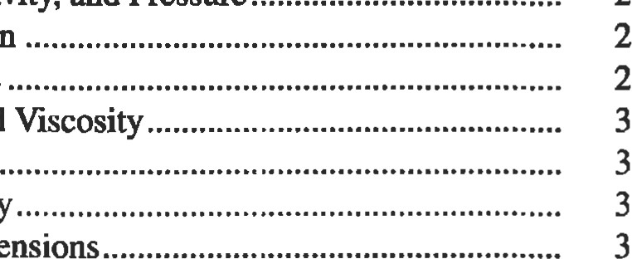1: Fluids, 1 Friction Factor and Darcy Equation

Surface TensionFrictionless Open-Channel Flow11 Vapor PressureLaminar Open-Channel Flow12

 Gas and Liquid Viscosity Turbulent Open-Channel Flow12

Bulk ModulusHydraulic Jump12

CompressibilityFluid Measurements13

|  |  |  |  |
| --- | --- | --- | --- |
| Fluid Statics | 4 | Flow Rate Measurement | 14 |
| Manometers and Pressure Measurements |  | Hot4M-re and Thin-Film Anemometry |  |
| Hydraulic Pressure on Surfaces | 4 | Open-Channel Flow Measurements | 15 |
| Buoyancy |  | Viscosity Measurements | 15 |
| Basic Equations | 5 | Other Topics | 16 |

 Units and Dimensions Pressure and Velocity Measurements13

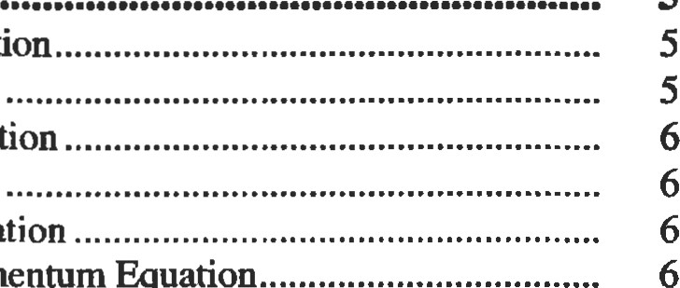

6

 Continuity Equation Unsteady Flow, Surge, and Water Hammer16

Euler's EquationBoundary Layer Concepts16 Bernoulli's Equation Lift and Drag16

Energy EquationOceanographic Flows17

Momentum Equation

|  |  |  |  |  |
| --- | --- | --- | --- | --- |
| Advanced Fluid Flow Concepts  Dimensional Analysis and Similitude Nondimensional Parameters |  | 7  7 |  |  |
| Equivalent Diameter and Hydraulic Radius | |  | |

Moment-of-Momentum Equation 2: Heat Transfer, 18

Pipe Flow

Introducdon 19

Conducdon 19

 Single Wall Conduction 19

Composite Wall Conducüon21

The Combined Heat Transfer Coefficient

Critical Radius of Insulation

Convection

Dimensionless Numbers

Correlations

Typical Convection Coefficient Values

Radiation

Emissivity

View Factors

Radiation Shields

Finite Element Analysis Boundary Conditions

2D Analysis

Transient Analysis

Evaluating Results

Heat Exchanger Classification

Types of Heat Exchangers

Shell-and-Tube Exchangers

Tube Arrangements and

Shell Configurations

Miscellaneous Data

Flow Regimes and Pressure Drop in Two-Phase

Heat Transfer

Flow Regimes

Flow Maps

Estimating Pressure Drop

3: Thermodynamics, 51

Thermodynamic Essentials

Phases of a Pure Substance

Thermodynamic Properties

Determining Properties

Types of Systems

Types of Processes.

The Zeroth Law of Thermodynamics

First Law of Thermodynamics

Work



First Law of Thermodynamics for Closed Systems

First Law of Thermodynamics for Open Systems

Second Law of Thermodynamics

Reversible Processes and Cycles

Thermodynamic Temperature Scale

Useful Expressions

Thermodynamic Cycles

Basic Systems and Systems Integration

Carnot Cycle

Rankine Cycle: A Vapor Power Cycle

Reversed Rankine Cycle: A Vapor Refrigeration Cycle.

Brayton Cycle: A Gas Turbine Cycle

Otto Cycle: A Power Cycle

22



23

24

26

27

27

29

29

29

30

30

31

33

33

38

40

42

42

42

46

48

52

53

56

56

57

58

58

58

58

58

59

59

59

59

60

60

61

61

62

63

Diesel Cycle: Another Power Cycle63

Gas Power Cycles with Regeneration

4: Mechanical seals, 66

Basic Mechanical Seal Components67

Sealing Points

Mechanical Seal Classifications68

Basic Seal Designs68

Basic Seal Arrangements72

Basic Design Principles

### Materials of Construction77 Desirable Design Features 79

Equipment Considerations80

Calculating Seal Chamber Pressure

Seal Flush Plans82

Integral Pumping Features85

Seal System Heat Balance

Flow Rate Calculation89

References91

5: Pumps and Compressors, 92

Pump Fundamentals and Design

|  |  |
| --- | --- |
| Pump and Head Terminology |  |
| Pump Design Parameters and Formulas | 93 |
| Types of Pumps  Centrifugal Pumps  Net Positive Suction Head (NPSH) and Cavitation | 94 |
| Pumping Hydrocarbons and Other Fluids | 96 |
| Recirculation  Pumping Power and Efficiency                Specific Speed of Pumps | 97 |
| Pump Similitude | 98 |
| Performance Curves.... ....                            Series and Parallel Pumping | 98 |
| Design Guidelines | 100 |
| Reciprocating Pumps | 103 |
| Compressors | 110 |
| Definitions  Performance Calculations for Reciprocating | 110 |
| Compressors  Estimating Suction and Discharge Volume Bottle Sizes for Pulsation Conn-ol for Reciprocating | 111 |
| Compressors | 114 |
| Compression Horsepower Determination | 117 |
| Generalized Compressibility Factor | 119 |

Centrifugal Compressor Performance Calculations120 Estimate HP Required to Compress Natural Gas123

Estimate Engine Cooling Water Requirements124

Estimate Fuel Requirements for Internal Combustion

Engines124 References124

6: Drivers, 125

Motors: Efficiency 126 Motors: Starter Sizes 127

Motors: Service Factor 127

Motors: Useful Equations

Motors:Relaüve Costs 128 Motors: Overloading 129

Steam Turbines: Steam Rate 129 Steam Turbines: Efficiency 129 Gas Turbines: Fuel Rates 130 Gas Wnes: Fuel Rates 132

Gas Expanders: Available Energ 132

7: Gears, 133

Ratios and Nomenclature 134

Spur and Helical Gear Design 134

Bevel Gear Design 139

Cylindrical Worm Gear Design 141

Materials 142

Summary of Gear Types 143

Buying Gears and Gear Drives 144

References144

8: Bearings, 145

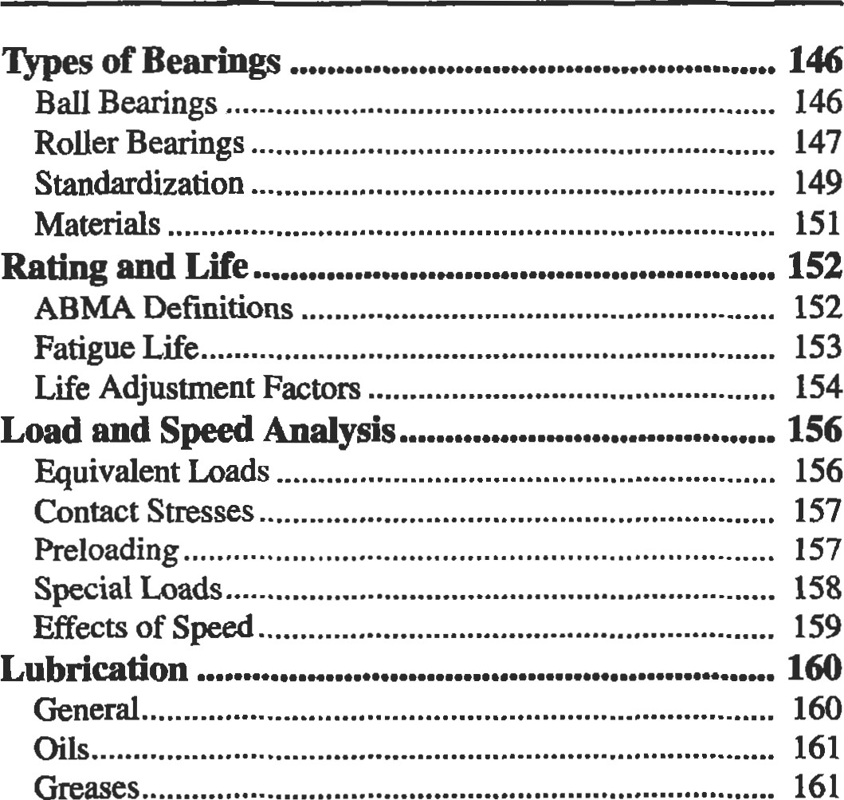

161

Greases

Lubricant Selection162

Lubricating Methods163

Relubrication164

Cleaning, Preservation, and Storage165

Mounting166

Shafting

Housings169

Bearing Clearance172

Seals174

Sleeve Bearings175

References177

9: Plplng and Pressure Vessels, 178

Process Plant Pipe179 Definitions and Sizing179

Pipe Specifications

Storing Pipe 188

189



to

Use

Transportation Pipe LinB190

Steel Pipe Design190 Gas Pipe Lines190 Liquid Pipe Lines192

Pipe Line Condition Monitoring195 Pig-based Monitoring Systems195

Coupons196

Manual Investigation196

Cathodic Protecüon197

Vessels206

Sü•ess Analysis206

Failures in Pressure Vessels207

Loadings208

Stress209

Procedure 1: General Vessel Formulas213

Procedure 2: Stresses in Heads Due to Internal

Pressure

|  |  |
| --- | --- |
| Joint Effciencies (ASME Code) | 217 |
| Properties of Heads | 218 |
| Volumes and Surface Areas of Vessel Sections | 220 |
| Maximum Length of Unstiffened Shells | 221 |
| Useful Formulas for Vessels | 222 |
| Material Selection Guide | |
| References 225 | |

10: Tribology, 226

Introduction227

Contact Mechanics227

Two-dimensional (Line) Herü Contact of Cylinders.. 227

Three-dimensional (Point) Hertz Contact229

Effect of Friction on Contact Stress232

Yield and Shakedown Criteria for Contacts232

Topography of Engineering Surfaces233 Definition of Surface Roughness233

Contact of Rough Surfaces234

Life Factors234

Friction235

Wear235

Lubrication236

References237

11: Vibration, 238

Vibration Definitions, Terminology, and

Symbols239

Solving the One Degree of Freedom System

Solving Multiple Degree of Freedom Systems ...e... 245

Vibration Measurements and Insfrumentaåon• 246

Table A: Spring Stiffness250

Table B: Natural Frequencies of Simple Systems.. 251 Table C: Longitudinal and Torsional Vibration of

Uniform Beams252

Table D: Bending (Transverse) Vibration of

Uniform Beams253

Table E: Natural Frequencies of Multiple DOF

Systems254

Table F: Planetary Gear Mesh Frequencies 255

Thble G: Rolling Element Bearing Frequencies and Bearing Defect Frequencies256

Table H: General Vibration Diagnostic

Frequencies257

References258

12: Materials, 259

|  |  |  |
| --- | --- | --- |
| Classes of Materials                            260 | | |
| Definitions                             260 | | |
| Metals                          262 | | |
| Steels               262 | | |
| Tool Steels | | |
| Cast Iron |  | 265 |
| Stainless Steels |  | 266 |
| Superalloys |  | 268 |
| Aluminum Alloys |  | 269 |
| Joining |  | 270 |
| Coatings |  | 273 |
| Corrosion |  | 276 |
| Powder Metallurgy |  | 279 |

Polymers281

Ceramics2M Mechanical Testing

Tensile Testing284 Fatigue Testing285 Hardness Testing286

Creep and Rupture Testing287

Forming288

Casting289

Case Studies290

Failure Analysis290

Corrosion291 References292

13: Stress and Strain, 294

Fundamentals of Stress and Strain295

|  |  |
| --- | --- |
| Inü•oduction | 295 |
| Definitions—Stress and Strain | 295 |
| Equilibrium | 297 |
| Compatibility | 297 |
| Saint-Venant's Principle | 297 |
| Superposition | 298 |

Plane Stress/Plane Strain298

Thermal Stresses298

Stress Concentrations299

Determination of Stress Concentration Factors300

Design Criteria for Structural Analysis305

General Guidelines for Effective Criteria305

Strength Design Factors305

Beam Analysis306

Limitations of General Beam Bending Equations307

Short Beams307

Plastic Bending307

Torsion308

Pressure Vessels309

Thin-walled Cylinders309 Thick-walled Cylinders309

Press Fits Between Cylinders310

Rotating Equipment310 Rotating Disks310 Rotating Shafts313

Flange Analysis315 Flush Flanges315 Undercut Flanges316

Mechanical Fasteners316

Threaded Fasteners317

Pins318

Rivets318

Welded and 319 Creep Rupture320 Finite Element Analysis320

Overview321

The Elements321

Modeling Techniques322

Advantages and Limitations of FEM323

Centroids and Moments of Inertia for Common

Shapes324

Beams: Shear, Moment, and Deflecüon Formulas for Common End Conditions325 References328

### 14: Fatigue, 329

Introduction330

Stages of Fatigue330

Design Approaches to Fatigue331 Crack Initiation Analysis331

Residual Sü•esses332



Notches332



Real World Loadings335

Temperature Interpolation337

Material Scatter338



Estimating Fatigue Properties338

Crack Propagation Analysis338

K—-The Su•ess Intensity Factor339 Crack Propagation Calculations342

Creep Crack Growth344 Inspection Techniques345

Strain Measurement 362

The Electrical Resistance Strain Gauge 363

Electrical Resistance Strain Gauge Data Acquisition..... 364

Liquid Level and Fluid Flow Measurement 366

Liquid Level Measurement 366

Fluid Flow Measurement368 References370

### 16: Engineering Economics, 372

|  |  |
| --- | --- |
| Simple Interest vs. Compound Interest  Nominal Interest Rate vs. Effective Annual | 373 |
| Interest Rate  Present Value of a Single Cash Flow To Be Received | 374 |
| in the Future | 374 |

|  |  |
| --- | --- |
| Future Value of a Single Investment | 375 |
| The Importance of Cash Flow Diagrams  Analyzing and Valuing Investments/Projects with | 375 |
| Multiple or Irregular Cash Flows | 375 |
| Perpetuities | 376 |
| Future Value of a Periodic Series of Investments | 377 |

|  |  |
| --- | --- |
| Annuities, Loans, and Leases  Gradients (Payouts/Payments with Constant | 377 |
| Growth Rates)  Analyzing Complex Investments and | 378 |
| Cash Flow Problems | 379 |

Time Value of Money: Concepts and Formulas .... 373

Decision and Evaluation Criteria for Investments

|  |  |
| --- | --- |
| Fluorescent Penetrant Inspection (FPI) | 345 |
| Magnetic Particle Inspection (MPI) | 345 |
| Radiography | 345 |
| Ultrasonic Inspection | 346 |
| Eddy-current Inspection | 347 |
| Evaluation of Failed Parts | 347 |

Nonmetallic Materials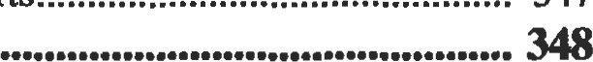

Fatigue349

Liability Issues350

References350

### 15: Instrumentation, 352

Introduction353

Temperature Measurement354

Fluid Temperature Measurement354 Surface Temperature Measurement358 Common Temperature Sensors358

Pressure Measurement359

Total Pressure Measurement360



Static/Cavity Pressure Measurement361

and Financial Projects380

Payback Method380

Accounting Rate of Return (ROR) Method381

Internal Rate of Return (IRR) Method382

Net Present Value (NPV) Method383 Sensitivity Analysis384

Decision Tree Analysis of Investments and

Financial Projects385 Accounting Fundamentals389

References and Recommended Reading393



Conversion Factors395

Systems of Basic Units399

Decimal Multiples and Fracdons of SI units399 Temperature Conversion Equations399

### Index, 400



Fluids

Bhabani P. Mohanty, Ph.D., Development Engineer, Allison Engine Company

|  |  |  |  |
| --- | --- | --- | --- |
| Fluid Stades | 4 | Laminar Open-Channel Flow |  |
| Manometers and Pressure Measurements |  | Turbulent Open-Channel Flow |  |
| Hydraulic Pressure on Surfaces |  | Hydraulic Jump | 12 |
| Buoyancy | 5 | Fluid Measurements | 13 |

### Fluid Properåes

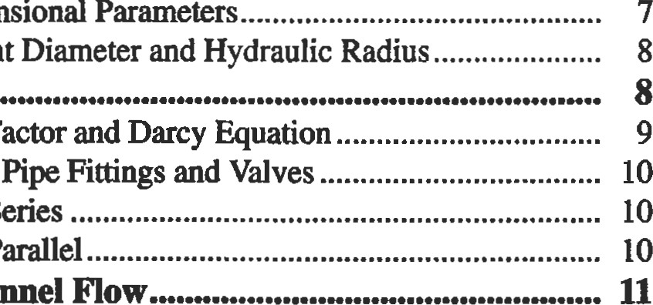

Nondimensional

Equivalent

Friction

Factor

Density, Specific Volume, Specific Weight,

Specific Gravity, and Pressure 2 Pipe Flow

Surface Tension

Vapor PressureLosses in Pipe

Gas and Liquid Viscosity Pipes in Series

Bulk ModulusPipes in Parallel

Compressibility Open-Channel Flow

Units and Dimensions Frictionless Open-Channel Flow 11

Pressure and Velocity Measurements13

Basic Equations Flow Rate Measurement14

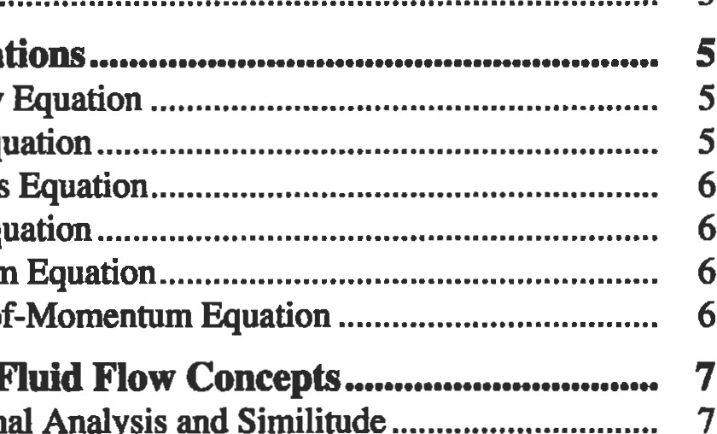

Moment-of-Momenmm

Advanced

Fluid

Dimensional

Analysis

and

Similitude

Continuity Equation Hot-Wi.re and Thin-Film Anemomeüy

Euler's Equaüon Open-Channel Flow Measurements

Bernoulli's Equation Viscosity Measurements

Energy Equation Other Topio16



Momentum Equation

Unsteady Flow, Surge, and Water Hammer16

Boundary Layer Concepts16

Lift and Drag

Oceanographic Flows

Thumb

### FLUID PROPERTIES

Afluid is defined as a "substance that deforms continuously when subjected to a shear stress" and is divided into two categories: ideal and real. A fluid that has zero viscosity, is incompressible, and has uniform velocity disüibution is called an idealfluid. Realfluids are called either

Newtonian or non-Newtonian. A Newtonian fluid has a lin-

|  |
| --- |
| Density, Speclflc Volume, Specific Weight, Specific Gravity, and Pressure |

ear relationship between the applied shear stress and the resulting rate of deformation; but in a non-Newtonian fluid, the relationship is nonlinear. Gases and thin liquids are Newtonian, whereas thick, long-chained hydrocarbons are non-Newtonian.

The density p is defined as mass per unit volume. In inconsistent systems it is defined as lbm/cft, and in consistent systems it is defined as slugs/cft. The density of a gas can be found from the ideal gas law:

p=p/RT (1)

where p is the absolute pressure, R is the gas constant, and T is the absolute temperature.

The density of a liquid is usually given as follows:

* The specific volume vs is the reciprocal of density: vs = l/p
* The specific weight y is the weight per unit volume:
* The specific gravity s of a liquid is the ratio of its weight to the weight of an equal volume of water at standard temperature and pressure. The s of petroleum products can be found from hydrometer readings using API (American Pefroleum Institute) scale.
* The fluid pressure p at a point is the ratio of normal force to area as the area approaches a small value. Its unit is usually lbs/sq. ina (psi). It is also often measured as the equivalent height h of a fluid column, through the relation:

|  |
| --- |
| Y = pg |

|  |  |
| --- | --- |
| Surface Tension |  |
| Near the free surface of a liquid, because the cohesive force between the liquid molecules is much greater than that between an air molecule and a liquid molecule, there is a resultant force acting towards the interior of the liquid. This force, called the surface tension, is proportional to the | product of a surface tension coeffcient and the length of the free surface. This is what forms a water droplet or a mercury globule. It decreases with increase in temperature, and depends on the contacting gas at the free surface. |
| Vapor Pressure |  |

p =Yh

Molecules that escape a liquid surface cause the evaporation process. The pressure exerted at the surface by these free molecules is called the vapor pressure. Because this is caused by the molecular activity which is a function of the temperature, the vapor pressure of a liquid also is a funcüon of the temperature and increases with it. Boiling occurs when the pressure above the liquid surface equals (or is less than) the vapor pressure of the liquid. This phenomenon, which may sometimes occur in a fluid system network, causing the fluid to locally vaporize, is called cavitation.

|  |
| --- |
| Gas and Liquid Viscosity |

Viscosity is the property of a fluid that measures its resistance to flow. Cohesion is the main cause of this resistance. Because cohesion drops with temperature, so does viscosity. The coefficient of viscosity is the proportional* ity constant in Newton's law of viscosity that states that the shear stress in the fluid is directly proportional to the velocity gradient, as represented below:

du

|  |  |
| --- | --- |
| Bulk Modulus |  |
| A liquid's compressibility is measured in terms of its bulk modulus of elasticity. Compressibility is the percentage change in unit volume per unit change in pressure:  öv/v öp | The bulk modulus of elasticity K is its reciprocal:  K is expressed in units of pressure. |
| Compressibility |  |
| Compressibility of liquids is defined above. However, for a gas, the application of pressure can have a much greater effect on the gas volume. The general relationship is governed by the perfect gas law: | where p is the absolute pressure, vs is the specific volume, R is the gas constant, and T is the absolute temperature. |
| Units and Dlmensions |  |

(2) dy

The above is often called the absolute or dynamic viscosity. There is another form of the viscosity coefficient called the kinemaüc viscosity v, that is, the ratio of viscosity to mass density:

#### v = Wp

Remember that in U.S. customary units, unit of mass density p is slugs per cubicfoot.

One must always use a consistent set of units. Primary units are mass, length, time, and temperature. A unit system is called consistent when unit force causes a unit mass to achieve unit acceleration. In the U.S. system, this system is represented by the (pound) force, the (slug) mass, the (foot) length, and the (second) time. The slug mass is defined as the mass that accelerates to one ft/sec2 when subjected to one pound force (lbf). Newton's second law, F = ma, establishes this consistency between force and mass units. If the mass is ever referred to as being in lbm (inconsistent system), one must first convert it to slugs by dividing it by 32.174 before using it in any consistent equation.

Because of the confusion between weight (lbf) and mass (lbm) units in the U.S. inconsistent system, there is also a similar confusion between density and specific weight units. It is, therefore, always better to resort to a consistent system for engineering calculations.

|  |
| --- |
| mumb  FLUID STATICS |

|  |
| --- |
| Manometers and Pressure Measurements |

Fluid statics is the branch of fluid mechanics that deals with cases in which there is no relative motion between fluid elements. In other words, the fluid may either be in rest or at constant velocity, but certainly not accelerating. Since there is no relative motion between fluid layers, there are no shear stresses in the fluid under static equilibrium. Hence, all free bodies in fluid statics have only normal forces on their surfaces.

Pressure is the same in all directions at a point in a static fluid. However, if the fluid is in motion, pressure is defined as the average of three mutually perpendicular normal compressive sfresses at a point:

P = (PX + Py + pz)/3

Pressure is measured either from the zero absolute pressure or from standard atmospheric pressure. If the reference point is absolute pressure. the pressure is called the absolute pressure, whereas if the reference point is standard atmospheric (14.7 psi), it is called the gage pressure. A barometer is used to get the absolute pressure. One can make a simple barometer by filling a tube with mercury and inverting it into an open container filled with mercury. The mercury column in the tube will now be supported only by the atmospheric pressure applied to the exposed mercury surface in the container. The equilibrium equation may be written as:

where h is the height ofmercury column in inches, and 0.491 above expression, we neglected the vapor pressure for mercury. But if we use any other fluid instead of mercury, the vapor pressure may be significant. The equilibrium equation may then be:

where 0.0361 is the water density in pounds per cubic inch, and s is the specific gravity of the fluid. The consistent equation for variation of pressure is

where p is in lb/ft2, y is the specific weight of the fluid in lb/ft3, and h is infeet. The above equation is the same as p = ywsh, where is the specific weight of water (62.4 lb/ft3) and s is the specific gravity of the fluid.

|  |  |
| --- | --- |
| is the density of mercury in pounds per cubic inch. In the | ter fluid. |
| Hydraulic Pressure on Surfaces |  |

Manometers are devices used to determine differential pressure. A simple U-tube manometer (with fluid of specific weight y) connected to two pressure points will have a differential column of height h. The differential pressure will then be Ap = (P2 — PD = Corrections must be made if high-density fluids are present above the manome-

For a horizontal area subjected to static fluid pressure, the resultant force passes through the centroid of the area. If the plane is inclined at an angle 0, then the local pressure will vary linearly with the depth. The average pressure occurs at the average depth:

1

pava = — (hi + h2) sin e (3)

 2

However, the center of pressure will not be at average depth but at the centroid of the triangular or pressure distribution, which is also known as the pressure prism.

|  |
| --- |
| Buoyancy |

The resultant force on a submerged body by the fluid around it is called the buoyantforce, and it always acts upwards. If v is the volume of the fluid displaced by the submerged (wholly or partially) body, y is the fluid specific weight, and Fbuoyant is the buoyant force, then the relation between them may be written as:

buoyant = v X Y (4)

The principles of buoyancy make it possible to determine the volume, specific gravity, and specific weight of an unknown odd-shaped object by just weighing it in two different fluids of kiown specific weights and h. This is possible by writing the two equilibrium equations:

|  |
| --- |
| BASIC EQUATIONS |

(5)

In derivations of any of the basic equaüons in fluids, the concept of control volume is used. A conm)l volume is an arbiü•ary space that is defined to facilitate analysis of a flow region. It should be remembered that all fluid flow situations obey the following rules:

1. Newton's Laws of Moüon
2. The Law of Mass Conservation (Continuity Equaüon)
3. 1st and 2nd Laws of Thermodynamics
4. Proper boundary conditions

|  |  |  |  |  |  |  |
| --- | --- | --- | --- | --- | --- | --- |
| |  |  | | --- | --- | | Contlnulty Equation |  | | For a continuous flow system, the mass within the fluid remains constant with dm/dt = O. If the flow | Q is defined as Q = A.V, the conünuity equation takes the following useful form:  = p2A2V2 (6) | | Euler's Equation |  |   Under the assumptions of: (a) frictionless, (b) flow When p is either a function of pressure p or is constant, the along a streamline, and (c) steady flow; Euler's equation Euler's equation can be integrated. The most useful rela- |

Apart from the above relations, other equations such as Newton's law of viscosity may enter into the derivation process, based on the particular situation. For detailed procedures, one should refer to a textbook on fluid mechanics.

takes the form:

dp

— + g.dz + v.dv = 0

P

tionship, called Bemoulli's equation, is obtained by integrating Euler's equaüon at constant density p.

(7)

#### Bernoulli's Equation

Bernoulli's equation can be thought of as a special form of energy balance equation, and it is obtained by integrating Euler's equation defined above.

V2 P z + + —- = constant (8) 2g pg

The constant of integration above remains the same along a sueamline in steady, frictionless, incompressible flow. The term z is called the potential head, the term v2/2g is the dynamic head, and the p/pg term is called the static head. All these terms represent energy per unit weight. The equation characterizes the specific kinetic energy at a given point within the flow cross-section. While the above form is convenient for liquid problems, the following form is more convenient for gas flow problems:

#### pv2

|  |  |  |  |  |  |  |  |  |  |  |  |  |
| --- | --- | --- | --- | --- | --- | --- | --- | --- | --- | --- | --- | --- |
| |  |  | | --- | --- | | Energy Equation |  |   The energy equation for steady flow through a control where qheat is heat added per unit mass and wshaft is the shaft volume is: work per unit mass of fluid.  qheat 1-11 = wshaft + —+ gz  gz  +  (10)     |  |  |  |  |  | | --- | --- | --- | --- | --- | | The linear momentum equation states that the resultant | d (mv) |  |  |  | | force F acting on a fluid contml volume is equal to the rate of change of linem• momentum inside the control volume plus the net exchange of linear momentum from the  boundary. Newton's second law is used to derive its form: | = dt | pvdV + | pvv.dA | (11) |   Moment-of-Momentum Equation |

 + — + p = constant (9)

The moment-of-momentum equation is obtained by taking the vector cross-product of F detailed above and the position vector r of any point on the line of acüon, i.e., r x F. Remember that the vector product of these two vectors is also a vector whose magnitude is Fr sine and direcüon is normal to the plane containing these two basis vectors and obeying the cork-screw convention. This equation is of great value in certain fluid flow problems, such as in turbomachineries. The equations outlined in this section consütute the fundamental governing equations of flow.

|  |  |  |  |  |  |  |  |  |  |  |  |  |  |  |  |  |  |  |
| --- | --- | --- | --- | --- | --- | --- | --- | --- | --- | --- | --- | --- | --- | --- | --- | --- | --- | --- |
| |  |  |  |  | | --- | --- | --- | --- | | field, and they have been obtained through a mathematical | Force |  | MLT-2 | | analysis of various forces acting on the fluids. The math- | Discharge |  |  | | ematical analysis is done through Buckingham's Pi Theo- | Pressure  Acceleraüon | a | ML-IT-2 LT-2 | | rem. This theorem states that, in a physical system de- | Density | p | ML-4 |   ADVANCED FLUID FLOW CONCEPTS   |  |  | | --- | --- | | Often in fluid mechanics, we come across certain terms, such as Reynolds number, Prandtl number, or Mach number, that we have come to accept as they are. But these are extremely useful in unifying the fundamental theories in this | Table 1  Dimensions of Selected Physical Variables    Physlcal Variable Symbol Dimension |   scribed by n quanüties in which there are m dimensions, Specific weightML-2T-2 these n quantities can be rearranged into (n-m) nondimen- Dynamic viscosiW  Kinemaüc viscosity  sional parameters. Table 1 gives dimensions of some phys- Surface tmsionMT¯2 ical variables used in fluid mechanics in terns of basic mass Bulk modulus of elasticityML-IT-2 (M), length (L), and time (T) dimensions. Gravity LT-2  Dimensional Analysis and Similitude |

|  |  |
| --- | --- |
| Nondlmenslonal Parameters |  |

Most of these nondimensional parameters in fluid mechanics are basically ratios of a pair of fluid forces. These forces can be any combination of gravity, pressure, viscous, elastic, inertial, and surface tension forces. The flow system variables from which these parameters ar obtained ate: velocity V, the density p, pressure drop AP, gravity g, viscosity p, surface tension o, bulk modulus of elasticity K, and a few linear dimensions of l.

These nondimensional parameters allow us to make studies on scaled models and yet draw conclusions on the prototypes. This is primarily because we are dealing with the ratio of forces rather than the forces themselves. The model and the prototype are dynamically similar if (a) they are geomefrically similar and (b) the ratio of pertinent forces are also the same on both.

The following five nondimensional parameters are of great value in fluid mechanics.

Reynolds Number

Reynolds number is the ratio of inerdal forces to viscous forces:

#### R=P-Y! (12)

This is particularly important in pipe flows and aircraft model studies. The Reynolds number also characterizes different flow regimes (laminar, turbulent, and the transition between the two) through a critical value. For example, for the case of flow of fluids in a pipe, a fluid is considered turbulent if R is greater than 2,000. Otherwise, it is taken to be laminar. A turbulent flow is characterized by random movement of fluid particles.

Froude Number

Froude number is the ratio of inertial force to weight:

(13) gl

This number is useful in the design of spillways, weirs, channel flows, and ship design.

Weber Number

Weber number is the ratio of ineül forces to surface tension forces.

v21p

(14)

This parameter is significant in gas-liquid interfaces where surface tension plays a major role.

Mach Number

Mach number is the raüo of inertial forces to elasüc forces:

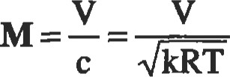 (15) where c is the speed of sound in the fluid medium, k is the of specific heats, and T is the absolute temperature. This parameter is very important in applications where are near or above the local sonic velocity. Examples are fluid machineries, aircraft flight, and gas turbine engines.

Pressure Coefficient

Pressure coefficient is the ratio of pressure forces to inertial forces:

Ap Ah



 pv2/2 - pv2/2g (16)

This coefficient is important in most fluid flow situations.

##### Equivalent Diameter and Hydraulic Radius

The equivalent diameter (D ) is defined as four times the hydraulic radius (rD. These two quantities are widely used in open-channel flow situations. If A is the cross-sectional area of the channel and P is the wettedperimeter of the channel, then:

(17)

If a pipe is not flowing full, carc should be taken to compute the wetted perimeter. ms is discussed later in the section for open channels. Ihe hydraulic radii for some common channel configurations are given in Table 2.

Table 2

|  |  |  |  |  |  |  |  |  |  |  |  |  |
| --- | --- | --- | --- | --- | --- | --- | --- | --- | --- | --- | --- | --- |
| Note that for a circular pipe flowing full of fluid,   |  |  |  | | --- | --- | --- | |  | Square duct with each side a | a14 | | and for a square duct of sides and flowing full, | Rectangular duct with sides a and b Ellipücal duct with axes a and b | a/4 | | 4a2 | Semicircle of diameter D |  | | Deq = 4rh  4a | Shallow fiat layer of depth h | h |   4(nD2 / 4) Cireular pipe of diameter D  D = 4rh =Annular section of inside dia d and (D-d)/4  dia  PIPE FLOW |

Hydraulic Radii for Common Channel Configurations

In internal flow of fluids in a pipe or a duct, consideration must be given to the presence of frictional forces acting on the fluid. When the fluid flows inside the duct, the layer of fluid at the wall must have zero velocity, with progressively increasing values away from the wall, and reaching maximum at the centerline. The disüibuüon is parabolic.

|  |
| --- |
| Friction Factor and Darcy Equation |

The pipe flow equation most commonly used is the Darcy-Weisbach equation that prescribes the head loss hf to be:

hf = f—- (18)

where L is the pipe length, D is the internal pipe diameter, V is the average fluid velocity, and f is the Moody friction factor (nondimensional) which is a function of several nondimensional quantities:

###### pVD e

f=f (19)

where (PV DIV.) is the Reynolds number R, and e is the specific sulface mughness of the pipe material. The Moody friction chart is probably the most convenient method of getting the value of f (see Figure 1). For laminar pipe flows

(Reynolds number R less than 2,000), f = — because

R' head loss in laminar flows is independent of wall roughness.

If the duct or pipe is not of circular cross-section, an equivalent hydraulic diameter D as defined earlier is used in these calculations.

The Swamy and Jain empirical equation may be used to calculate a pipe design diameter directly. The relationship is:

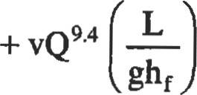  4.75 5.2 0.04

D=O.66 e l 25 LQ2(20)

ghf

where e is in ft, Q is in cfs, L is in ft, v is in ft2/s, g is in ft/s2, and hf is in ft.lb/lb units.

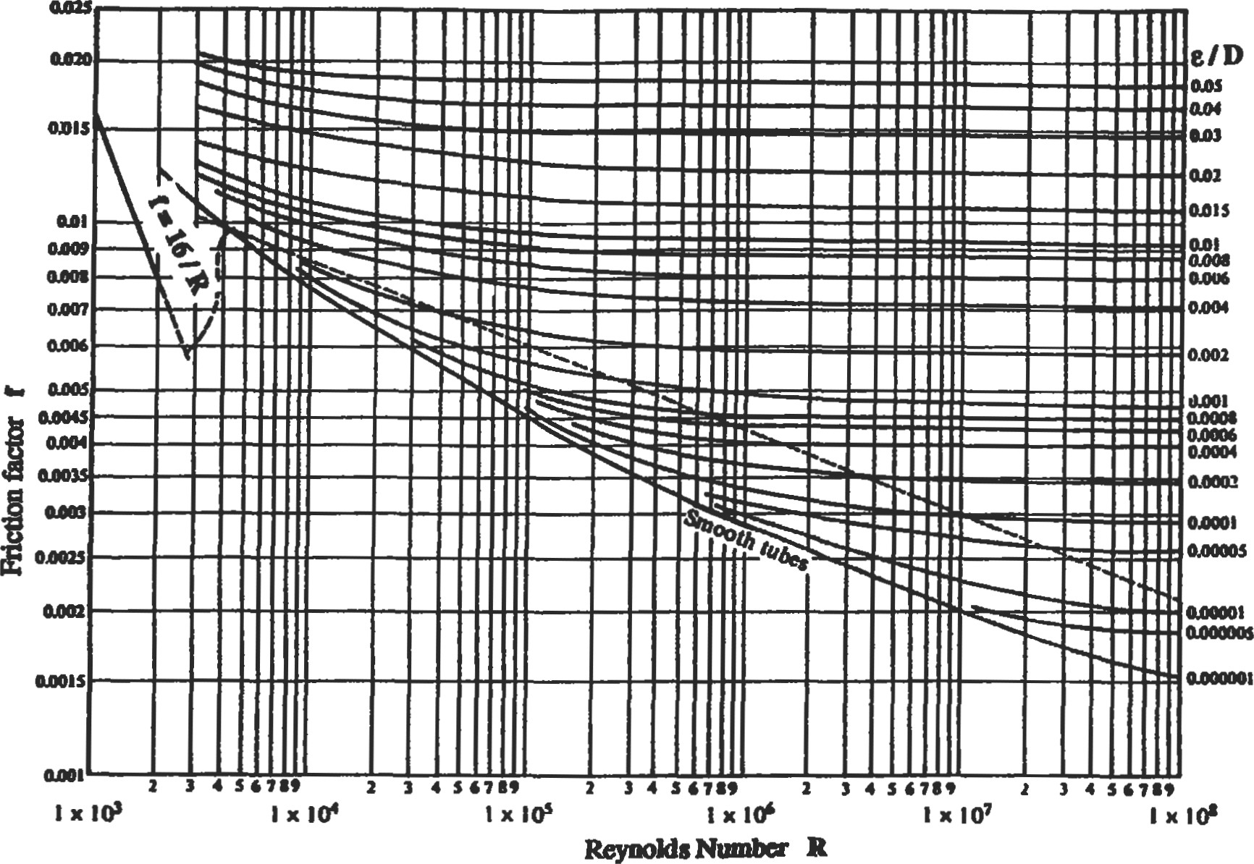

Figure 1. Fiction factor vs. Reynolds number.

|  |  |  |  |
| --- | --- | --- | --- |
| Losses In Pipe Fittings and Valves |  | |  |
| In addition to losses due to friction in a piping system, there are also losses associated with flow through valves and fittings. These are called minor losses, but must be accounted for if the system has a lot of such fittings. These are freated as equivalent frictional losses. The minor loss may be freated either as a pressure drop Ap = —KpV2/2 or as a head loss Ah = —KV2/(2g). The value of the loss coefficient K is obtained through experimental data. For valves and fittings, manufacturers provide this value. It may also be calculated from the equivalent length concept: K = fLJD, where Le is the equivalent pipe length that has the same frictional loss. Table 3 gives these values for some common fittings, | Table 3  K Values for Common Fittings | |  |
| Type of Fiting |  |  |
| 45-degree elbow  90-degæe bend  Diaphragm valve, open  Diaphragm valve, half open  Diaphragm valve, % open  Gate valve, open  Gate valve, half open  Globe valve, wide open  Globe valve, half open  Tee junction  Union and coupling  Water meter | 0.35  0.75  2.30  4.30  21.00  0.17  4.50  6.40  9.50  1.00  0.04  7.00 | 17  35  115  215  1050  9  225  320  475  50  2  350 |

For sudden enlargements in a pipe from diameter DI to

a larger diameter D2, the K value is obtained from:

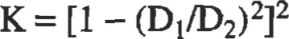

For sudden conü•actions in the pipeline from a larger diameter D2 to a smaller diameter DI, the value of the loss coefficient is:

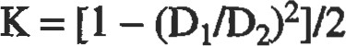

|  |  |
| --- | --- |
| Pipes In Series |  |
| Pipes connected in tandem can be solved by a method of equivalent lengths. This procedure lets us replace a series pipe system by a single pipeline having the same discharge and the same total head loss. As an example, if we have two pipes in series and if we select the first secüon as reference, then the equivalent length of the second pipe is obtained by: | 5  1.42 (21)  'Ihe values offl and f2 are approximated by selecting a discharge within the range intended for the two pipes. |
| Pipes In Parallel |  |

The above relations should serve as guidelines. Corrections should be made for enlargements and confracüons that are gradual. Use values of K for fittings whenever furnished by the manufacturer.

A common way to increase capacity of an existing line is to install a second one parallel to first. The flow is divided in a way such that the friction loss is the same in both (in series pipes, these losses are cumulative), but the discharge is cumulative. For an of three pipes in parallel:

|  |  |  |  |
| --- | --- | --- | --- |
| h —h = hn--——entry | Pexit | exit | (22) |
| Q=Ql+Q2+Q3 |  |  | (23) |

P

where and zexät are elevations at the two points.

If discharge Q is known, then the solution procedure uses this equal loss principle iteratively to find the solution (flow and head loss).

The pipe network system behaves in an analogous fashion to a DC elecüical circuit, and can be solved in an analogous manner by those familiar with the elecffical circuit analysis.

|  |
| --- |
| OPEN-CHANNEL FLOW |

|  |
| --- |
| Frictionless Open-Channel Flow |

Study of open channels is important in the study of river flow and irrigation canals. The mechanics of flow in open channels is more complicated than that in pipes and ducts because of the presence of a free surface. Unlike closed conduit flow, the specific roughnessfactor e for open-channel flows is dependent on the hydraulic state of the channel. The flow is called uniform if the cross-section of the flow doesn't vary along the flow direction. Most open-channel flow situations are of turbulent nature. Therefore, a major part of the empirical and semi-empirical study has been done under the full turbulence assumption (Reynolds number R greater than 2,000 to 3,000).

Flow in Venturi Flume

In the case of flow in a Venturi flume (Figure 2), where the width of the channel is deliberately changed to measure the flow rate, we can obtain all relations by applying Bernoulli's equation at the free surface, and the continuity equation, which are:

Free Surface

|  |  |  |
| --- | --- | --- |
|  | hi | h2 |
|

(Side View)

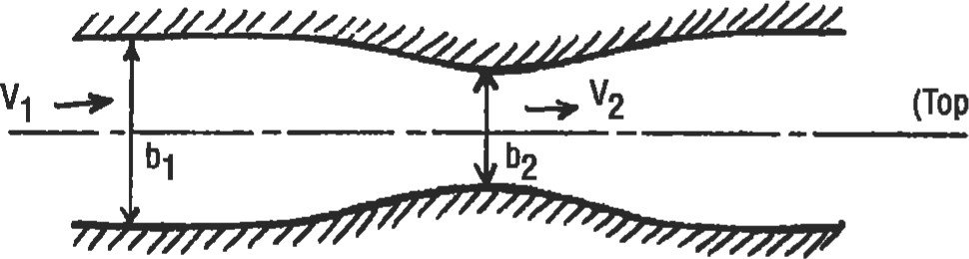

(Top

View)

Figure 2. Flow in a Venturi flume.



= V2b2h2

hi —h2

2g ¯ 1/t$h3 —

Flow Over a Channel Rise

In the case of flow in a constant width (b) horizontal rectangular channel with a small rise on the floor (Figure 3), the relations are:

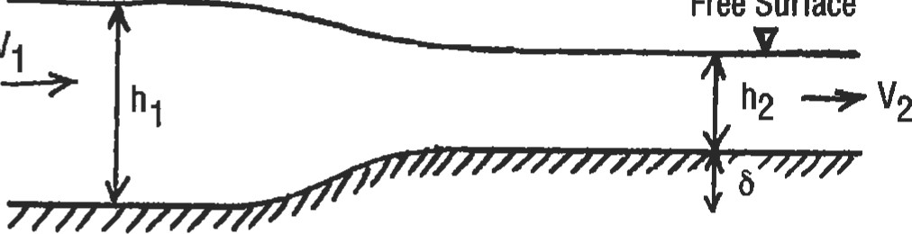

Free

Surface

Figure 3. Open-channel flow over a rise.

V12/2+ghl =V22 /2+g (h2 +5)

Q = Vlbhl =

2gb2h12 2gb2h;

Note that the sum of the two terms h + Q2/(2gb2h2) is called the specific head, H. The criücal specific head I-Ic and the critical depth hc can be found by taking the derivative of above term and equating it to zero.

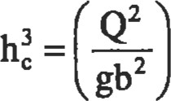



Note that for a given specific head and flow rate, two different depths of h are possible. The Froude number V2/(gh) specifies the flow characteristics of the channel flow. If it is less than unity, it is called subcritical, or tranquil, flow. If it is more than unity, it is called supercritical, or rapid, flow.

Flow Through a Siuice Gate

In the case offlow generated when a sluice gate that renins water in a resa•voir is pm•üally raised (Figure 4), by combining Bernoulli's equation and the continuity we get:

ho —

2gb2h2

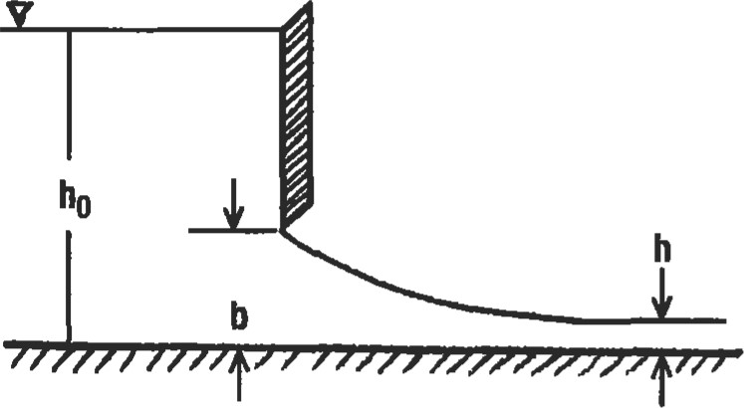

The maximum flow rate is given by:

8 

 = gho

b

Here too, die Froude number is a measure of flow rate. Maximum flow rate is present when the Froude number is unity. By raising the gate from its closed position, the flow discharge is increased until a maximum discharge is obtained, and the depth downstream is two-thirds of the reservoir depth. If the gate is raised beyond this height, the flow rate actually drops.

|  |  |
| --- | --- |
| Figure 4. Flow through a sluice gate. | above the crest. |
| Laminar Open-Channel Flow |  |

The above analysis and observaüon is also true for flow over the crest of a dam, and the same equaüon for max flow rate is valid—where ho is the water level in the reservoir measured from the crest level, and h is the water level

Considering the effects of viscosity, the steady laminar flow down an inclined plane (angle a), the velocity distibution is given by:

u = (2h — y) y sin a

|  |  |
| --- | --- |
| Turbulent Open-Channel Flow |  |
| The wall shear stress due to friction in a steady, uniform, one-dimensional open-channel flow is given by:  = pg (sin a) MP | where A is the cross-sectional area of the channel, P is the wetted perimeter, and a is the downward sloping angle. |
| Hydraulic Jump |  |

211

where y is the distance from the bottom surface of the channel (in a direction perpendicular to the flow direcThe volume flow per unit width (q) is given by:

q = udy = h3 sin a

When a rapidly flowing fluid suddenly comes across a slowly flowing channel of a larger cross-secüonal area, there is a sudden jump in elevaüon of the liquid surface. This happens because of conversion of energy to potential energy, the n•ansition being quite turbulent. This phenomenon of steady nonuniform flow is called the hydraulicjump.

By applying the continuity and momentum equaüons, the increased depth Y2 can be expressed as:

|  |
| --- |
|  |
| 4 |

2

The subscripts 1 and 2 represent flow conditions before and after the hydraulic jump. Through the energy equation, the losses due to this hydraulic jump as represented by hjump can be found:

3

_ (Y2 -YI) hjump 

4YIY2

This phenomenon is often used at the bottom of a spillway to diffuse most of the fluid kinetic energy, and also as an effective way of mixing in a mixing chamber.

The Froude numbers Fl and F2 for a rectangular channel section before and after the jump are related by:

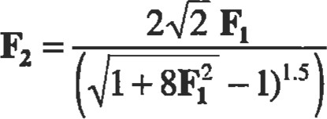

|  |
| --- |
| FLUID MEASUREMENTS  Total energy in a fluid flow consists of pressure head, ve- The gravitational head is negligible; hence, if we know two locity head, and potential head: of the three remaining variables (H, p, and V), we can find the other. In addition to the above, flow measurement also involves flow discharge, turbulence, and viscosity. p 2g  Pressure and Velocity Measuremenb |

where the dimensionless Froude number F = VIVE". The Froude number before the jump is greater than 1, and is less than I after the jump.

Static pressure is measured by either a piezometer opening or a static tube (Figure 5 [a]). The piezometer tap, a smooth opening on the wall normal to the surface, can measure the pressure head directly in feet of fluid: hp = p/p. In the flow region away from the wall, the static tube probe may be introduced, directed upstream with the end closed. The static pressure tap must be located far enough downfrom the nose of the probe. The probe must also be aligned parallel to the flow direction.

Stagnation pressure (or 'total pressure") is measured by a pitot tube (Figure 5 [b]), an open-ended tube facing directly into the flow, where the flow is brought to rest isermpically (no loss). At point of zero velocity, pt = p + pV2/2. Often, both the static tube and the pitot tube are combined to make one "pitot-static" probe (Figure 5 [c]), which will in effect measure velocity of the flow. The two ends are connected to a manometer whose fluid has a specific gravity So. By applying Bernoulli's equation between the two points:

|  |
| --- |
| (a) Static tube and piezometer (b) Pttot tube  total  pressure  pt  (c)  Pitot-static  tube  static  pressure  p  Figure 5. Pressure and velocity measurements. |

 2(pt2gAh -S)/S

If the pitot probe is used in subsonic compressible flow, the compressible fonn of the stagnaüon pressure should be used:

7/(7-1)

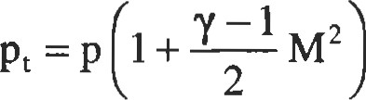

2

By knowing the stagnation and static pressures, and also the static temperature, the mach number at that point can also be found:

|  |  |  |  |  |  |
| --- | --- | --- | --- | --- | --- |
| Rate Measurement  Flow rate in a Venturi meter (Figure 6 [a]) is given by: Flow rate in an orifice meter (Figure 6 is given by:   |  |  | | --- | --- | | 2 | (p, — P2)/p + g (z} —z2) |   Q=CvA2 Q = com   |  |  |  | | --- | --- | --- | | Flow rate in a flow nozzle (Figure 6 | is given by: | where Cv, Cn, and Co are the corresponding discharge co- |   efficients for the three types of Ineters, and are functions  Q=CnA2 of the Reynolds number. These are obtained through experimental tests.  (a)  Venturi  meter  (b)  Flow  nonle  (c)  Orifice  Meter  Figure 6. Flow measurement devices.  Hot-Wire and Thin-Film Anemometry |

YRT

Air velocities may be measured by vane anemometers where the vanes drive generators that directly indicate the air velocity. They can be made very sensitive to extremely low air currents. Gas velocities may be measured with hot-wire anemometers. The principle of operation of these devices is the fact that the resistance to flow of electricity through a thin platinum wire is a function of cooling due to air around it.

= Rref [1 + U - Tref)]

12 = hA - Tfluid)

where h is the convective heat transfer coefficient between wire and gas, A is wire surface area, I is the current in amperes, R is resistance of the wire, and T is temperature.

The same principle is applied in hot-film anemometers to measure liquid velocities. Here the probe is coated with a thin metallic film that provides the resistance. The film is usually coated with a very thin layer of insulating material to increase the durability and other problems associated with local boiling of the liquid.

|  |
| --- |
| Open-Channel Flow Measuremenb |

A weir is an obstruction in the flow path, causing flow to back up behind it and dien flow over or through it (Figure 7). Height of the upstream fluid is a of the flow rate. Bernoulli's equation establishes the weir relaüonship:

#### Q=C-L 2gH3 =CcLHlS

where Cc is the contraction coemcient (3.33 in U.S. units and 1.84 in meü•ic units), L is the width of weir, and h is the head of liquid above the weir. Usually, a coefficient is multiplied to account for the velocity head. For a V-notch weir, the equation may be written as:

8

15

|  |
| --- |
| Figure 7. Rectangular and V-notch weirs.  Viscosity Measurements |

For a 90-degree V-notch weir, this equation may be approximated to Q = CvH2•5, where cv is 2.5 in U.S. units and 1.38 in medic units.

Three types of devices are used in viscosity measurements: capillary tube viscometer, Saybolt viscometer, and taüng viscometer. In a capillary tube arrangement (Figure 8),

ApTtD4

128QL

The reservoir level is maintained constant, and Q is determined by measuring the volume of flow over a specific frne

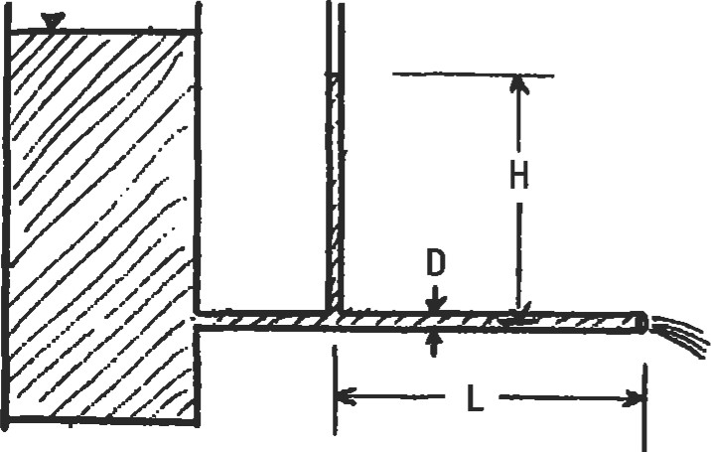

Figure 8. Capillary tube viscometer.

period. The Saybolt viscometer operates under the same principle.

In the rotating viscometer (Figure 9), two concentric cylinders of which one is stationary and the other is rotating (at constant rpm) are used. The torque transmitted from one to the other is measured through spring deflection.

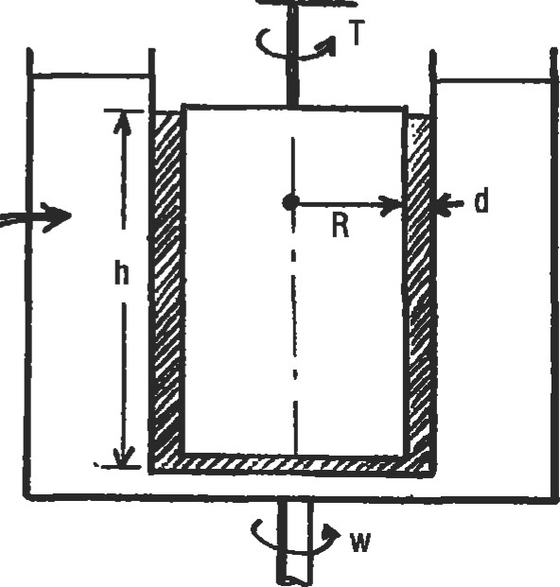

Constant

Temperature

Bath

Figure 9. Rotating viscometer.

|  |
| --- |
| The shear stress t is a function of this torque T. Knowing shear stress, the dynamic viscosity may be calculated from  2nR3ho Newton's law of viscosity.  OTHER TOPICS  Unsteady Flow, Surge, and Water Hammer |

Study of unsteady flow is essential in dealing with hydraulic transients that cause noise, fatigue, and wear. It deals with calculation of pressures and velocities. In closed circuits, it involves the unsteady linear momentum equation along with the unsteady confrluity equation. If the nonlinear friction terms are introduced, the system of equaüons becomes too complicated, and is solved using iterative, computer-based algorithms.

Surge is the phenomenon caused by turbulent resistance in pipe systems that gives rise to oscillations. A sudden reduction in velocity due to flow consh•icdon (usually due to valve closure) causes the pressme to rise. This is called water hammer Assuming the pipe material to be inelastic, the time taken for the water hammer shock wave from a fitting to the pipe-end and back is determined by: t = (2L)/c; the conesponding pressure rise is given by: Ap = (pcAv)/gc.

|  |
| --- |
| Boundary Layer Concepts |

In open-channel systems, the surge wave phenomenon usually results from a gate or obstruction in the flow path. The problem needs to be solved through iterative solution of continuity and momentum equations.

|  |  |
| --- | --- |
| Lift and Drag |  |

For most fluids we (water or air) that have low viscosity, the Reynolds number PU 1.1B is quite high. So inertia forces are predominant over viscous ones. However, near a wall, the viscosity will cause the fluid to slow down, and have zero velocity at the wall. Thus the study of most real fluids can be divided into two regimes: (1) near the wall, a thin viscous layer called the boundary layer; and (2) outside of it, a nonviscous fluid. This boundary layer may be laminar or turbulent. For the classic case of a flow over a flat plate, this transition takes place when the Reynolds number reaches a value of about a million. The boundary layer ö is as a function of the distance x from the leading edge of the plate by:

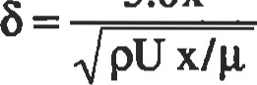5.0K

where U and are the fluid velocity and viscosity, respectively.

Lift and drag are forces experienced by a body moving through a fluid. Coefficients of lift and drag (CL and CD) are used to determine the effectiveness of the object in producing these two principal forces:

L = —pV2 ACL

D = —pV2ACD

where A is the reference area (usually projection of the object's area either parallel or normal to the flow direction), p is the density, and V is the flow velocity.

|  |
| --- |
| Oceanographic Flows |

The pressure change in the ocean depth is dp = pgD, the same as in any static fluid. Neglecting salinity, compressibility, and thermal variations, that is about 44.5 psi per 100 feet of depth. For accurate determinadon, these effects must be considered because the temperature reduces nonlinearly with depth, and density increases linearly with salinity.

The periods of an ocean wave vary from less than a second to about 10 seconds; and the wave propagation speeds vary from a ft/sec to about 50 ft/sec. If the wavelength is small compared to the water depth, the wave speed is independent of water depth and is a function only of the wavelength:

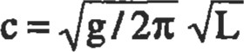

Tide is caused by the combined effects of solar and lunar gravity. The average interval between successive high waters is about 12 hours and 25 minutes, which is exactly one half of the lunar period of appearance on the earth. The lunar tidal forces are more than twice that of the solar ones. The spüg tides are caused when both are in unison, and the neap tides are caused when they are 90 degrees out of phase.



Heat Transfer

Chandran B. Santanam, Ph.D., Senior Staff Development Engineer, GM Powertrain Group J. Edward Pope, Ph.D., Senior Project Engineer, Allison Advanced Development Company

|  |  |  |  |  |  |  |
| --- | --- | --- | --- | --- | --- | --- |
| Typical Convection Coefficient Values | | | 26 | Flow Maps |  | 46 |
| Radiation  Emissivity  View Factors  Radiation Shields  Finite Element Analysis  Boundary Conditions  2D Analysis  Transient Analysis. |  | | 26  27  27  29  29  29  30  30  31 | Estimating Pressure Drop |  | 48 |
|  |  |
| Evaluating Results............... | |

Nicholas P. Cheremisjnoff, Ph.D., Consulting Engineer

|  |  |  |
| --- | --- | --- |
| Introduction | 19 | Heat Exchanger Classification |
| Conduction | 19 | Types of Heat Exchangers                               33 |
| Single Wall Conduction | 19 | Shell-and-Tube Exchangers                              36 |
| Composite Wall Conduction .... ..... ..... ......... | 21 | Tube Arrangements and Baffles .... .... .                            38 |
| The Combined Heat Transfer Coefficient | 22 | Shell Configurations |
| Critical Radius of Insulation | 22 | Miscellaneous Data                              42 |
| Convection | 23 | Flow Regimes and Pressure Drop in Two-Phase |

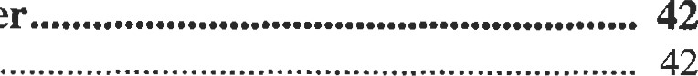 Dimensionless Numbers.. 23 Heat Transfer

Correlations24 Flow Regimes

Tensfer

INTRODUCTION

|  |  |
| --- | --- |
| This chapter will cover the three basic types of heat transfer: conduction, convection, and radiation. Addition- | Table 2  Physical Constants Important in Heat Transfer |

|  |  |  |
| --- | --- | --- |
| Constant Name | Value | Unite |
| Avagadro's number Gu constant  constant  Speed of light in vacuum  Stefan-Bolmnann consunt  1 pressure | 6.022169*1028  53.3  6.626196*1 C-u  1-38062210-23  91372300  1.712"0-8  14.7 | '(mot-I  J.s  ft/eec  Btumr/sq.nr*  psi |

al sections will cover finite element analysis, heat exchangers, and two-phase heat transfer.

Parameters commonly used in heat transfer analysis are listed in Table 1 along with their symbols and units. Table 2 lists relevant physical constants.

Table 1

Parameters Commonly Used in Heat Tansfer Analysis



|  |  |  |
| --- | --- | --- |
| Parameters | Units | Symbols |



|  |  |  |
| --- | --- | --- |
| Length |  |  |
|  | pound mass | m |
| Time  Current | hour or seconds |  |
| TemperatutE | Fahrenheit or Rankine |  |
| Acceleration | feet/secs2 | a |
| Velocity | ft/sec |  |
| Density | pound/cu. ft | p |

 Area sq. feet

Volume cubic feet

Viscosity lbWfVsq. sec

Force pound

Kinematic viscosity feet2/sec2

|  |  |  |
| --- | --- | --- |
| Specific heat | BtUhrnb/OF | Cp |
| Thermal conductivity | Btu. Wft2n-,rPF |  |
| Heat energy | Btu |  |
| Convection coefficient | Btu/sq. nmr/0F | h |
| Hydraulic diameter | feet | Dh |
| Gravitational constant | Ibm.ft/lbf.sec2 |  |



CONDUCTION

### Single Wall Conduction

If two sides of a flat wall are at different temperatures, conduction will occur (Figure l). Heat will flow from the hotter location to the colder point according to the equation:

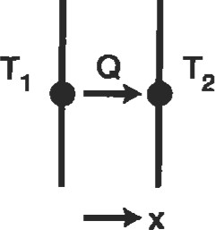

Figure 1. Conduction through a single wall.

k

(Tl - T2) Area

Thickness

For a cylindrical system, such as in pipes (Figure 2), the equation becomes:

Q = (k) (length)

In (ro/ri)

### nwmb

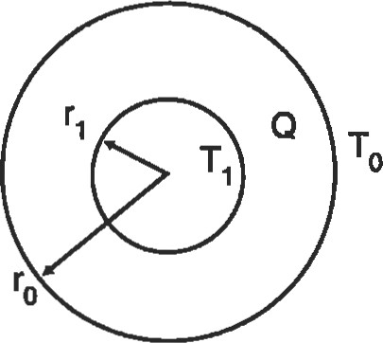

Figure 2. Conduction through a cylinder.

The equation for cylindrical coordinates is slightly different because the area changes as you move radially outward. As Figure 3 shows, the temperature profile will be a straight line for a flat wall. The profile for the pipe will flatten as it moves radially outward. Because area increases with radius, conduction will increase, which reduces the thermal gradient. If the thickness of the cylinder is small, relative to the radius, the cartesian coordinate equation will give an adequate answer. Thermal conductivity is a material property, with of

Btu



(hr) (foot) (OF)

FLAT WALL CYLINDER

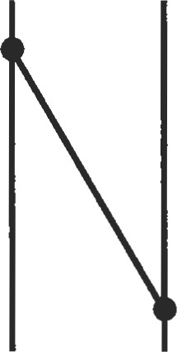 Temp. 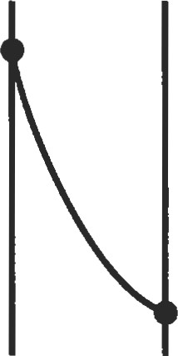

x Radius

Figure 3. Temperature profile for flat wall and cylinder.

Tables 3 and 4 show conducüvities for metals and common building mataials. Note that the materials that are good elecfrical conductors (silver, copper, and aluminum), are also good conductors of heat. Increased conduction will tend to equalize temperatures within a component.

Example. Consider a flat wall with:

Thickness = I foot

Table 3

Thermal ConductMty of Various Materials at OOC

|  |  |  |
| --- | --- | --- |
| Material |  | |
| W/m•OC | Btu/h.n.'F |
| Metals:  Silv« (pure)  Copper (pure)  Altrninum (pure)  Nickel (pure)  Iron (pure) steel, 1 % C  Lead (pure)    Quartz, parallel to axis  MagnBite  Marble  Sandstone  Glass, window  Maple or oak  Sawdust  Glass wool Liquids: Mercury Wat«  Lubricating oil, SAE 50  Freon 12, ca2Fz    Hydrogen  Helium  Air  Water vapor (saturated)  Carbon dioxide | 410  385  202  93  73  43  35  16.3  41.6  4.15  2.08-2.94  1.83  0.78  0.17  0.059  0.038  8.21  0.5%  0.540  0.147  0.073  0.175  0.141  0.024  0.0206  0.0146 | 237  117  54  42  25  20.3  9.4  24  1.2-1.7  1.06  0.45  0.034  0.022  4,74  0.327  0.312 0.085  o.u2  0.101  0.081  0.0139 0.0119  o.oou4 |

Source: Holman [11. Reprinted with permission of McGraw-Hill.

Area = 1 foot2

Q = 1,000 Btufhour

For aluminum, k = 132, AT = 7.580F

For stainless steel, k = 9, AT = 111.1 OF

Sources

1. Holman, J. P., Heat Transfer. New York: McGraw-Hill, 1976.
2. Cheremisinoff, N. P., Heat Transfer Pocket Handbook. Houston: Gulf Publishing Co., 1984.

Tansfer

Table 4

Thermal Conductivities of Wpical Insulating and Building Materials

Thermal

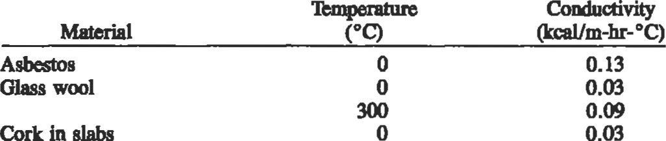

0.03

in

|  |  |  |
| --- | --- | --- |
|  | 50 |  |
|  | 50 | 0.05 |
| Slag wool |  | 0.05  0.07 |
| Common brick | 25 | 0.34 |
| R)rcelai.n | 95 | 0.89 |
|  | 1,100 | 1.70 |
| Concree |  | 1.2 |
| Fresh earth |  | 2.0 |
| Glass | 15 | 0.60 |
| (pine):  fibers | 15 | o. 13 |
| Parallel fibers | 20 | 0.30 |
| Burnt clay | 15 | 0.80 |

Carborundum 16.0

Source: Cheremlsinoff 12]

Composite Wall Conduction

For the multiple wall system in Figure 4, the heat trans- Obviously, Q and Area are the same for both walls. The fer rates are: term thermal resistance is often used:

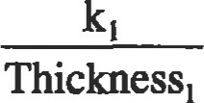thickness

QI_2 =(Tl -T2) Area

k

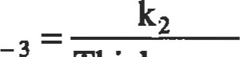High values of thermal resistance indicate a good insula-

### (T2 -T3) Area

Thickness2 tion. For the entire system of walls in Figure 4, the overall heat transfer becomes:

1

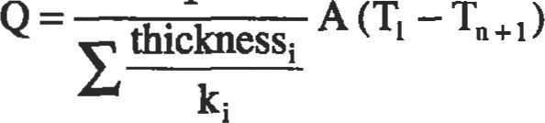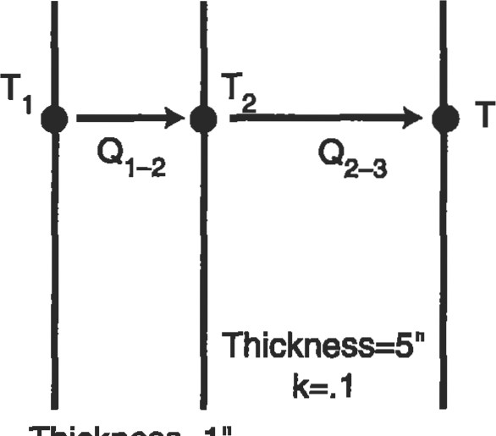3

The effective thermal resistance of the enüre system is:

Reff = ERi = Ethicknessi

For a cylindrical system, effective thermal resistance is:

Thickness—I

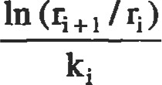 = E Ri = E

Figure 4. Conduction through a composite wall.

|  |  |
| --- | --- |
| An overall heat transfer coeffcient may be used to account for the combined effects of convection and conduction. Consider the problem shown in Figure 5. Convecüon occurs between fre gas (TD and the left side of the wall 02). Heat is then conducted to the right side of the wall (T3). Overall heat transfer may be calculated by: | Tl -T3  1 /(hA) + thickness /(kA)  The overall heat fransfer coefficient is:  1 |

Note that the temperature difference across each wall is Wall 2 proportional to the thermal effectiveness of each wall. Thickness = 5. foot Also note that the overall thermal effecüveness is dominated by the component with the largest thermal effectiveness.

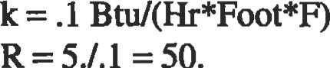

5./.1

=

50.

|  |  |
| --- | --- |
| Wall 1  Thickness = 1. foot    R = 1./1. = 1. | The overall thermal resistance is 51.  Because only 2% of the total is contributed by wall 1, its effect could be ignored without a significant loss in ac- |
| The Combined Heat Transfer Coefficient |  |

#### (1 / h) + (thickness/ k)

|  |  |
| --- | --- |
| Figure 5. Combined convection and conducion through a wall. | uncertainties may be rolled into one coefficient instead of adjusting two variables. |

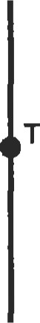Heat transfer may be calculated by:

2 3 

Although the overall heat transfer coemcient is simpler to use, it does not allow for calculation ofT2. This appmach is parücularly useful when matching test data, because all

### Critical Radius of Insulation

Consider the pipe in Figure 6. Here, conduction occurs through a layer of insulation, then convects to the environment. Maximum heat occurs when:

k outer h

This is the critical radius of insulation. If the outer radius is less than this critical value, adding insulation will cause an increase in heat transfer. Although the increased insulation reduces conducüon, it adds surface area, which increases convection. This is most likely to occur when convection is low (high h), and the insulation is poor (high k).

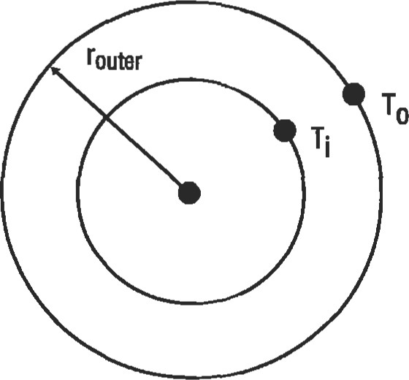

Figure 6. Pipe wrapped with insulation.

### CONVECTION

|  |
| --- |
| Dimensionless Numbers |

While conduction calculations are straightforward, convection calculations are much more diffcult. Numerous correlation types are available, and goodjudgment must be exercised in selection. Most correlations are valid only for a specific range of Reynolds numbers. Often, different relationships are used for various ranges. The user should note that these may yield discontinuities in the relationship between convection coefficient and Reynolds number.

Many correlations are based on dimensionless numbers, which are used to establish similitude among cases which might seem very different. Four dimensionless numbers are particularly significant:

Reynolds Number

The Reynolds number is the rado of flow momentum rate (i.e., inertia force) to viscous force.

 pumDh _ GDh g g

The Reynolds number is used to determine whether flow is laminar or turbulent. Below a criücal Reynolds number, flow will be laminar. Above a Reynolds number, flow will be turbulent. Generally, different correlations will be used to determine the convection coefficient in the laminar and turbulent regimes. The convection coefficients are usually significantly higher in the turbulent regime.

Nusselt Number

The Nusselt number characterizes the similarity of heat transfer at the interface between wall and fluid in different systems. It is basically a ratio of convecüon to conductance:

k

Prandtl Number

The Prandtl number is the ratio of momentum diffusivity to thermal diffusivity of a fluid:

#### gcp k

It is solely dependent upon the fluid properties:

* For gases, Pr= .7 to 1.0
* For water, Pr= I to 10
* For liquid metals, Pr = .001 to .03
* For oils, 50. to 2000.

In most correlations, the Prandtl number is raised to the .333 power. Therefore, it is not a good investment to spend a lot of time determining Prandtl number for a gas. Just using .85 should be adequate for most analyses.

Grashof Number

The Grashof number is used to determine the heat fransfer coeffcient under free convecüon condiüons. It is basically a raüo between the buoyancy fomes and viscous forces.

g(Tw p2

2

Heat requires circulation, therefore, the Grashof number (and heat ü-ansfer coefficient) will rise as the buoyancy forces increase and the viscous forces decrease.

|  |
| --- |
| Correlations |

Heat fransfer correlations are empirical relationships. They are available for a wide range of configurations. This book will address only the most common types:

' Pipe flow

* Average flat plate
* Flat plate at a specific location
* Free convecüon
* Tube bank
* Cylinder in cross-flow

The last two correlations are particularly important for heat exchangers.

Pipe Flow

This correlation is used to calculate the convection coefficient between a fluid flowing through a pipe and the pipe wall

Re =

For turbulent flow (Re > 10,000):

h = .023KRe•8 x Prn

n = .3 if surface is hotter than the fluid = .4 if fluid is hotter than the surface

This correlaüon [l] is valid for 0.6 Pr 160 and IJD 2 10. For laminar flow [2]:

N = 4.36

#### NxK

Average Flat Plate

This correlation is used to calculate an average conveccoefficient for a fluid flowing across a flat plate [3].

pVL

For turbulent flow (Re > 50,000):

h = .037 KRe•8 x Pr33/L For laminar flow:

h = .664KRe•5 x Pr•33/L

Flat Plate at a Speciflc Locatlon

This correlation is used to calculate a convection coefficient for a fluid flowing across a flat plate at a specified distance (X) from the start [3].

##### pvx

For turbulent flow (Re > 50,000):

h = .0296KRe•8 x Pr•33/X For laminar flow:

h = .332KRe•5 x Pr33/X

smic Free Convectlon

Free convection calculaüons are based on the product of the Grashof and Prandtl numbers. Based on this product, the Nusselt number can be read from Figure 7 (vertical plates) or Figure 8 (horizontal cylinders) [6].

Tube Bank

The following correlaüon is useful for in-line banks of tubes, such as might occur in a heat exchanger [5]:

Flow pAmm

It is valid for Reynolds numbers between 2,000 and 40,000 through tube banks more than 10 rows deep. For less than 10 rows, a correction factor must be applied (.64 for 1 row, .80 for 2 rows, .90 for 4 rows) to the convecüon co-

efficient.

Obtaining C and CEXP from the table (see also Figure 9, in-line tube rows):

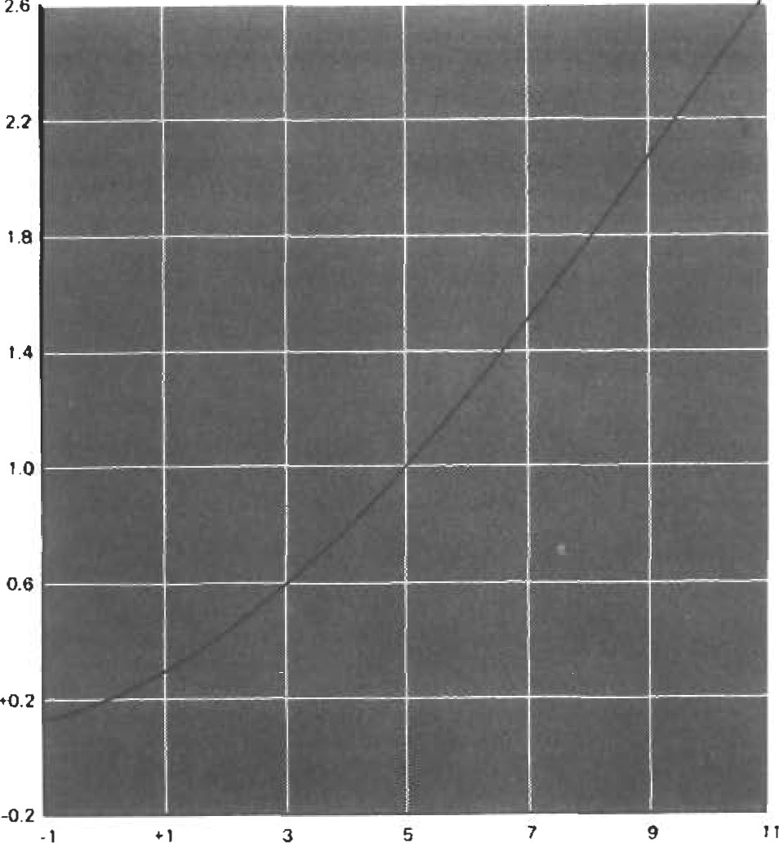

log (Gr, prn

Figure 7. Free convection heat transfer correlation for vertical plates (Reprinted with permission of McGraw-Hill.)

?12

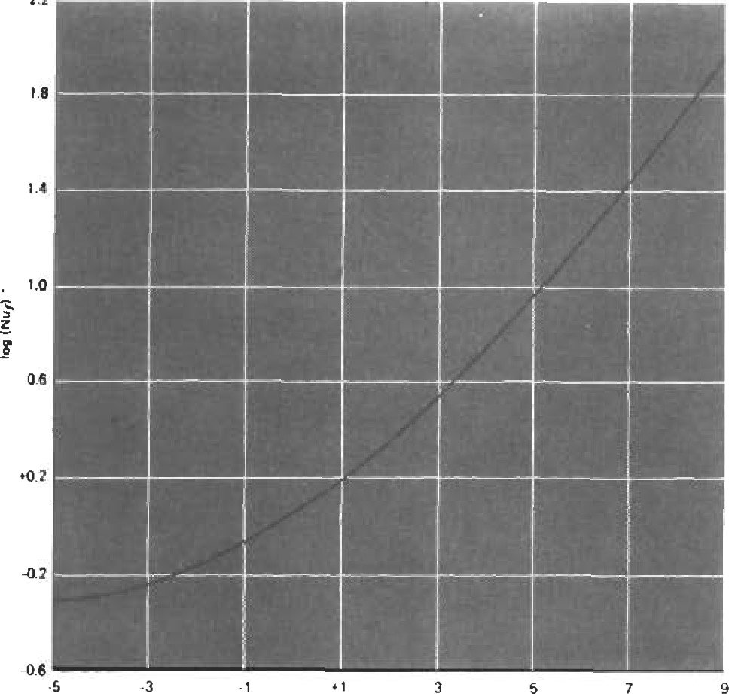

log Prn

Figure 8. Free convection heat transfer correlation for horizontal cylinders [6]. (Reprinted with permission of McGraw-Hill.)

(a)

Figure 9. Nomenclature for in-line tube banks [6].

(Reprinted with permission of McGraw-Hill.)

Cylinder in Cross-flow

The following correlation is useful for any case in which a fluid is flowing around a cylinder [61:

Re = pV2r/g

c = .989 CEXP = .330 4 < Re < 40 c = .911 CEXP = .385

40 < Re < 4000 c = .683 CEXP = .466

4000 < Re < 40,000 c = .193= .618

40,000 < Re < 400,000 c = .0266 CEXP = .805

N = C x reCEXP pr.333

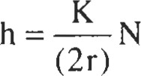

Sources

l . Dittus, F. W. and Boater, L. M. K.. University of California Publications on Engineering, Vol. 2, Berkeley. 1930, p. 443.

H = (CK/D) (Re)CEXP (Pr/.7).333

Sn/D



sp/D c CEXP c CEXP c CEXP c CEXP

1.25 .386 .592 .305 .608 .111 .704 .0703 .752

.407 .586 .278 .620 .112 .702 .0753 .744

2.0 .464 .570 .332 .602 .254 .632 .220 .648 .322 .601 .396 .584 .415 .581 .317 *608

flow 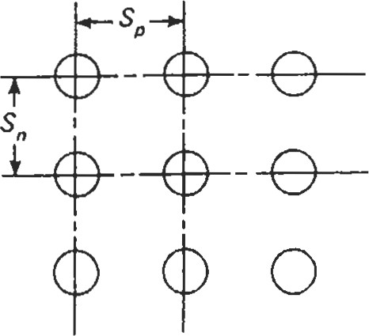

1. Kays, W. M. and Crawford, M. E., Convective Heat and Mass Transfer New York: McGraw-Hill, 1980.
2. Incropera, F. P. and Dewitt, D. P., Fundanentals ofHeü md Mass Transfer New York: John Wiley and Sons, 1990.
3. McAdams, W. H., Heat Transmission. New York: McGraw-Hi11, 1954.
4. Grimson, E. D., "Correlation and Utilizaüon of New Data on Flow Resistance and Heat Transfer for Cross Flow of Gases over Tube Banks," Transactions ASME, vol. 59, 1937, pp. 583-594.

|  |  |  |  |  |  |  |
| --- | --- | --- | --- | --- | --- | --- |
| |  |  |  | | --- | --- | --- | | Typical Convection Coefficient Values |  |  | | After calculating convection coefficients, the analyst should always check the values and make sure they are reasonable. This table shows representative values: | Air, free convection  Water, free convection  Air or steam, forced convection  Oil or oil mist, forced convection  Water, forced convection Boiling water  Condensing water vapor | 5-20  5-50  0-300  50-2,000  500-10,ooo  900-100,000 |   RADIATION |

1. Holman, J. P., Heat Transfer. New York: McGraw-Hill, 1976.

The radiation heat transfer between two components is calculated by:



o is the Stefan-Bolümann constant and has a value of 1.714 x 10-8 Btu /(hr x ft2 x OR4). Al is the area of component 1, and Fl - 2 is the view factor (also called a shape factor), which represents the fracüon of energy leaving component 1 that strikes component 2. By the reciprocity theorem:

AlFl-2=A2F2-l

El and E2 are the of surfaces 1 and 2, respectively. These values will always be between I (perfect absorption) and O (perfect reflection). Some materials, such as glass, allow transmission of radiation. In this book, we will neglect this possibility, and assume that all radiation is either reflected or absorbed.

Before spending much time contemplating radiation heat transfer, the analyst should first decide whether it is significant. Since radiation is a function of absolute temperature to the fourth power, its significance increases rapidly as temperature increases. The following table shows this clearly. Assuming emissivities and view factors of 1, the equivalent h column shows the convecüon coefficient required to give the same heat transfer. In most cases, radiaüon can be safely ignored at temperatures below 5000F. Above 1,0000F, radiation must generally be accounted for.

|  |  |
| --- | --- |
| Temperawres | Equivalent h |
| 200-100  500-400  1 ,ooo-900  1 ,500-1 ,400  2,000-1 ,900 | 1.57  5.18  19.24  47.80  96.01 |

|  |  |  |  |  |  |  |  |  |  |  |  |  |  |  |  |  |  |  |  |  |  |  |  |  |  |  |  |  |  |  |  |  |  |  |  |  |  |  |  |  |  |  |  |  |  |  |  |  |  |  |  |  |  |  |  |  |  |  |  |  |  |  |  |  |  |  |  |  |  |  |  |  |  |  |  |  |  |  |  |  |  |  |  |  |  |  |  |  |  |  |  |  |
| --- | --- | --- | --- | --- | --- | --- | --- | --- | --- | --- | --- | --- | --- | --- | --- | --- | --- | --- | --- | --- | --- | --- | --- | --- | --- | --- | --- | --- | --- | --- | --- | --- | --- | --- | --- | --- | --- | --- | --- | --- | --- | --- | --- | --- | --- | --- | --- | --- | --- | --- | --- | --- | --- | --- | --- | --- | --- | --- | --- | --- | --- | --- | --- | --- | --- | --- | --- | --- | --- | --- | --- | --- | --- | --- | --- | --- | --- | --- | --- | --- | --- | --- | --- | --- | --- | --- | --- | --- | --- | --- | --- | --- |
| Emissivity   |  |  | | --- | --- | | Table 5 shows emissivities of various materials. Esti- | Table 5 | | mation of emissivity is always difficult, but several generalizations can be made: | Nomal Total Emissivities of Different Surfaces |   ' Highly polished metallic surfaces usually have very low   |  |  |  |  | | --- | --- | --- | --- | | emissiviües. | Ahmimnm (highly polished, 98.3% pure) | 4-40 — 1070 | 0.039 - 0.057 | | • Emissivity increases with temperature for all metallic | Bmss (highly polished)  73.2% cu, 26.7% Zn | 476 - 674 | 0.028 - 0.031 | | surfaces. | 82.9% cu, 17.0% zn | 530 | 0.030 | | • Emissivity for nonmetallic surfaces are much higher | Copper  R)liRhed | 242 | 0.023 | | than for metallic surfaces, and decrease wiül temperature. | mae @ 11100F Molten-sto | 390 - 1110  1970 2330 | 0.57  0.16 - 0.13 | | • Emissivity is very dependent upon surface conditions. | Gold | 440 - 1160 | 0.018 - 0.035 | | The formation of oxide layers and increased surface | Iron and steel:  blished, electrolytic iron | 350 - 440 | 0.052 - 0.064 | | roughness increases emissivity. Therefore, new com- | blished inn | soo - 1800 | 0.144 - 0.377 | | ponents will generally have lower emissivities than | Sheet iron Cast iron | 1650 - 1900  1620 1810 | 0.55 - 0.60  0.70 | | ones that have been in service. | Leæi (unoxidized) | 260  440 | 0.057 0.075 | |  | Mercury | 32 - 212 | 0.09 0.12 | | Source | Nickel (technically pure, polished) Platinum (pure) | 440 710  440  1160 | 0.07 0.087  0.054 - 0.104 | |  | Silver (pure) | 440  11«) | 0.0198 - 0.0324 | | Cheremisinoff, N. P., Heat Transfer Pocket Handbook. | Rdractories and miscellaneous materials  74 - 700 | | 0.93-0.96 | | Houston: Gulf Publishing Co., 1984. | Brick, red 70 | | 0.93 | |  | FüanEnt 1900 - | | 0.526 | |  | Candle soot 206 - 520 | | 0.952 | |  | Lampblack 100 - 700 | | -0.945 | |  | 72 | | 0.937 | |  | 70 | | 0.903 | |  | 50 190 | | 0.91 | |  | k)rcelain, glued 72 | | 0.924 |   75  View Factors |

Exact calculation of view factors is often difficult, but they can often be estimated reasonably well.

Concentric Cylinders

Neglecting end effects, the view factor from the inner cylinder to the outer cylinder is always 1 , regardless of radii (Figure 10). The view factor from the outer cylinder to the inner one is the ratio of the radii rinner/r ter. The radiation which does not strike the inner cylinder 1 — (rinner/router) strikes the outer cylinder.

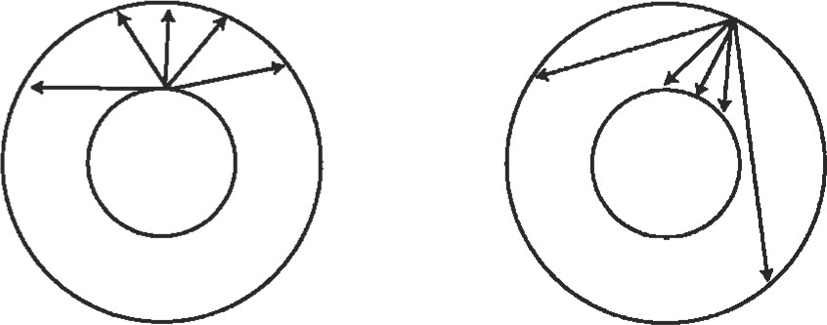

All radiation from inside Radiation from outside cylinder cylinder strikes outside cylinder strikes inside cylinder and outside cylinder.

Figure 10. Radiation view factors for concentric cir-

Parallel Rectangles

Figure I l shows the view factors for parallel rectangles. Note that the view factor increases as the size of the rectangles increase, and the distance between them decreases.

Perpendicular Rectangles

Figure 12 shows view factors for perpendicular rectangles. Note that the view factor increases as Al becomes long

Ratio X/D

Figure 12. Radiation view factors for perpendicular rectangles. (Reprinted with permission of McGraw-Hill.)

and thin (Y/X = . l) and A2 becomes large (Z/X = 10). In this arrangement, the view factor can never exceed .5, because at least half of the radiation leaving Al will go towards the other side, away from A2.

Source

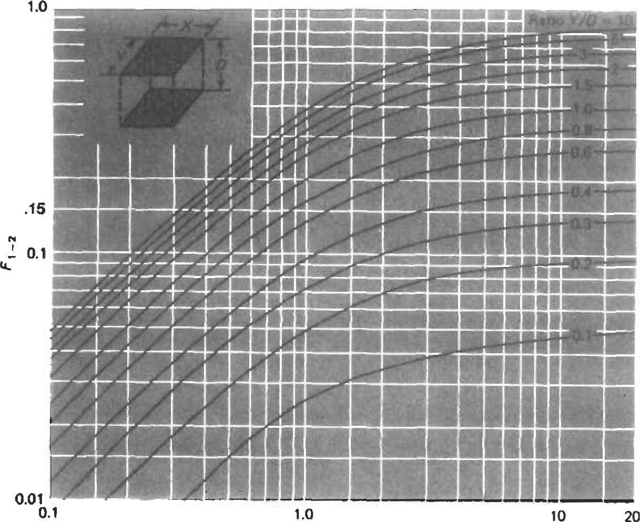Holman, J. P., Heat Transfer. New York: McGraw-Hill, 1976.

Figure 1 1. Radiation view factors for parallel rectangles. (Reprinted with permission of McGraw-Hill.)

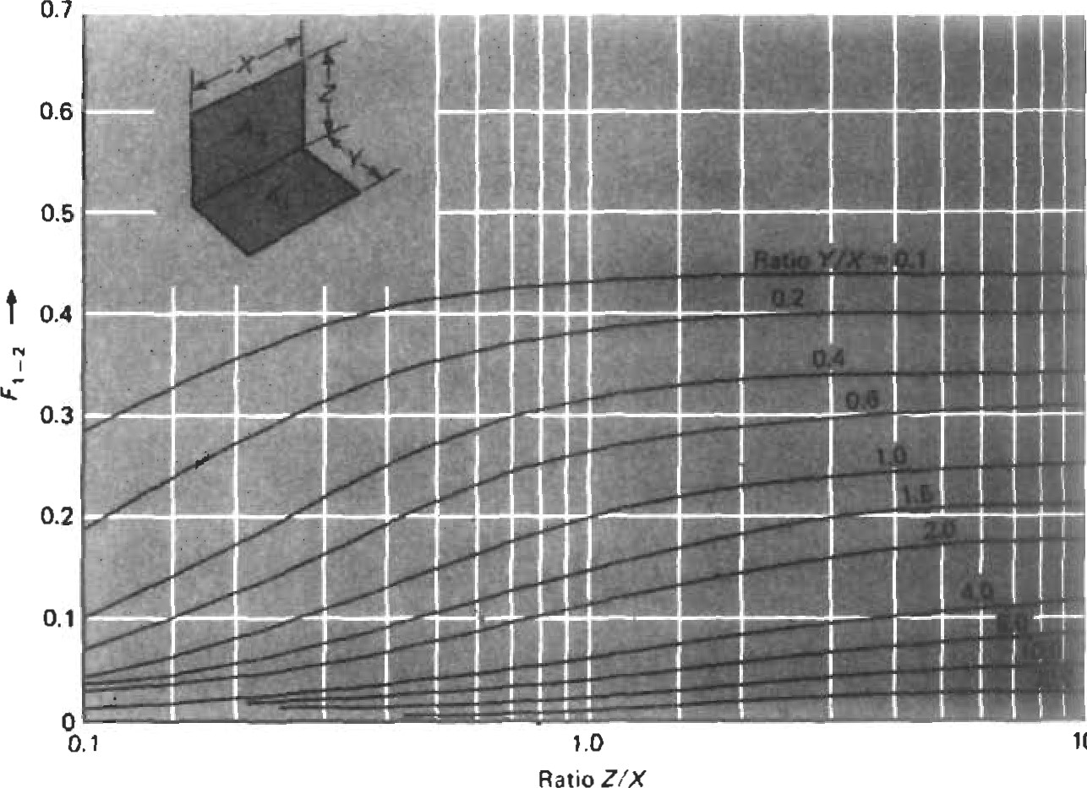

10

|  |
| --- |
| Radiation Shlelds |

|  |
| --- |
| FINITE ELEMENT ANALYSIS |

In many designs, a radiation shield can be employed to reduce heat transfer. This is typically a thin piece of sheet metal which blocks the radiation path from the hot surface to the cool surface. Of course, the shield will heat up and begin to radiate to the cool surface. If we assume the two surfaces and the shield all have the same emissivity, and all view factors are 1, the overall heat transfer will be cut in half.

|  |
| --- |
| Boundary Conditions |

With today's computers and software, finite element analysis (FEA) can be used for most heat ü•ansfer analysis. Heat transfer generally does not require as fine a model as is required for sü•ess analysis (to obtain stresses, derivatives of deflection must be calculated, which is an inherently inaccurate process). While FEA can accurately analyze complex geometries, it can also generate garbage if used improperly. Care should be exercised in creating the finite element model, and results should be checked thoroughly.

Convection coefficients must be assigned to all element faces where convecüon will occur. Temperatures may be assigned in two ways:

* Fixed temperature
* Channels

Channels are flowing streams of fluid. As they exchange heat with the component, their temperature will increase or decrease. The channel temperatures will be applied to the element faces exposed to that channel. Conduction properties for all materials must be provided. Material density and specific heats must also be provided for a transient analysis. Precise calculation of radiaüon with FEA may be difficult, because view factors must be calculated between every set of radiating elements. This can add up quickly, even for a small model. Three options are available:

* Software is available to automatically calculate view factors for finite element models.
* Instead of modeling interactive radiation between two surfaces, it may be possible to have each radiate to an environment with a known temperature. Each environment temperature should be an average temperature of the opposite surface. This may require an iteration or two to get the environment temperature right. This probably is not a good option for ü•ansient analysis, because the environment temperatures will be constantly changing.
* For problems at low temperatures, or with high convecüon coeffcients, radiation may be eliminated from the model with little loss in accuracy.

Some problems require modeling internal heat generadon. The most common cases are bearing races, which generate heat due to friction, and internal heating due to electric currents.

Where two components contact, the conduction across this boundary is dependant upon the contact pressures, and the roughness of the two surfaces. For most finite element analyses, the two components may be joined so that full conduction occurs across the boundary.

|  |
| --- |
| 2D Analysis |

For many problems, 2D or axisymmetric analysis is used. This may require adjusting the heat transfer coefficients. Consider the bolt hole in Figure 13. The total surface area of the bolt hole is TtDL, but in the finite element model, the surface area is only DL. In FEA, it is important the total hA product is correct. Therefore, the heat transfer coefficient should be multiplied by lt. Similarly, for transient analysis, it is necessary to model the proper mass. If the wrong mass is modeled, the component will react too quickly (too little mass), or too slowly (too much mass) during a transient.

The user should keep in mind the limitations of 2D FEA. Consider the turbine wheel in Figure 14. The wheel is a solid of revolution, with 40 discontinuous blades attached to it. gential direction. In reality, the portions of the wheel directly under the blades will be hotter than those portions between the blades. Therefore, Location A will be hotter than Location B. Location A will also respond more quickly during a transient. If accurate temperatures in this region are desired, then 3D FEA is required. If the analyst is only interested in accurate bore temperatures, then 2D analysis should be adequate for this problem.

|  |  |  |
| --- | --- | --- |
| |  |  | | --- | --- | | Figure 13. Convection coefficients must be adjusted for holes in 2D finite element models. | Figure 14.2D finite element models cannot account for variation in the third dimension. Point A will actually be hotter than point B due to conduction from the blades. |   These blades absorb heat from the hot gases coming out of the combuster and conduct it down into the wheel. 2D Blade FEA assumes that temperature does not vary in the tan-  WheelWheel Rim  Circumference is  2TtDLooking Forward  Transient Analysis |

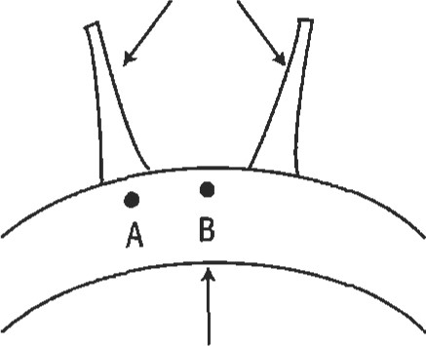Blades

Transient FEA has an added degree of difficulty, because boundary conditions vary with time. Often this can be accomplished by scaling boundary temperatures and convection coefficients.

Consider the problem in Figure 15. A plate is exposed to air in a cavity. This cavity is fed by 6000F air and 1000F air. Test data indicate that the environment temperatures range from 5000F at the top to 4000F at the bottom. The environment temperatures at each location (1—8) may be considered to be a function of the source (maximum) and sink (minimum) temperatures:



Here, the source temperature is 6000F and the sink temperature is 1000F. The environment temperatures at locations 1, 2, 3, and 4 are 90%, 80%, 70%, and 60%, respectively, of this difference. These percentages may be assumed to be constant, and the environment temperatures throughout the mission may be calculated by merely plugging in the source and sink temperatures.

source ¯ Tsink)

Air

1. 5000F
2. 4500F
3. 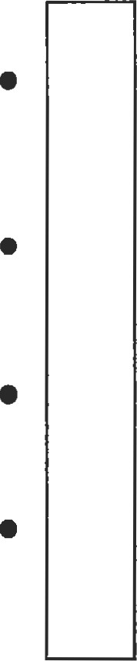400% e

IOOOF

A.ir

For yeater accuracy, Fi may be allowed to vary from one condiüon to another (i.e., idle to max), and linearly interpolate in between.

Two approaches are available to account for the varying convection coeffcients:

* h may be scaled by changes in flow and density.

|  |
| --- |
| Figure 15. The environment temperatures (1-4) may be considered to be a function of the source (60009 and the sink (10009 temperatures.  Evaluating Results |

* The parameters on which h is based (typically flow, pressure, and temperature) are scaled, and the appropriate correlation is evaluated at each point in the mission.

While FEA allows the analyst to calculate temperatures for complex geometries, the resulting output may be difficult to interpret and check for errors. Some points to keep in mind are:

* Heat always flows perpendicular to the isotherms on a temperature plot. Figure 16 shows temperatures of a metal rod partially submerged in 2000F water. The rest of the rod is exposed to 700F air. Heat is flowing upward through the rod. If heat were flowing from side to side, the isotherms would be verdcal.
* Channels often show errors in a finite element model more clearly than the component temperatures. Temperatures within the component are evened out by conduction and are therefore more difficult to detect.
* Temperatures should be viewed as a function of source and sink temperatures (Fi = [Ti —  — Tsink])• Figure 17 shows a plot of these values for the problem in Figure 18. These values should always be between O and 1. If different conditions are analyzed (i.e., max and idle), Fi should generally not vary greatly from one condiüon to the other. If it does, the analyst should examine why, and make sure there is no error in the

B 190

c 180

* 1. 170
  2. 160

 150

* 1. 140
  2. 130

 120

J 110

|  |  |  |
| --- | --- | --- |
| 70cF  Air  Direction of Heat How |  | Air |
|  |
|  |
|  |
|  |
|  |
|  |
|  |
| c |
| Water  'Ox200.o Min 100.0 |  | 2000F  Water |
|  |
|  |

* 100

O K

|  |
| --- |
| direction of heat flow. |

Figure 16. Finite element model of a cylinder in 2000F water and 700F air. Isotherms are perpendicular to the

 1.00

|  |  |  |
| --- | --- | --- |
| Air |  | Air |
|  |
|  |
|  |
|  |
| D |
|  |
| 2DOOF  Water  • Max 1.00 O Min .23 |  | 2DOOF  Water |
|  |

B .90

c .80

1. .70
2. .60
3. .50
4. .40
5. .30

 .20

Flgure 17. Component temperatures should always be between the sink and source temperatures.

model. When investigaüng these differences, the analyst should keep two points in mind:

1. Radiation effects increase dramatically as temperature increases.
2. As radiaüon and convection effects decrease, conducfion becomes more significant, which tends to even out component temperatures.

* For transients, it is recommended that selected component and channel temperatures be plotted against time. The analyst should examine the response rates. Those regions with high surface area-to-volume ratios and high convecüon coeffcients should respond

quickly.

* To check a model for good connections between components, apply different temperatures to two ends of the model. Verify that the temperatures on both sides of the boundaries are reasonable. Figures 18a and 18b show two cases in which 1,000 degrees has been applied on the left, and 100 degrees on the right. Figure 18a shows a flange where contact has been modeled along the mating surfaces, and there is little discontinuity in the isotherms across the boundary. Figure 18b shows the same model whee contact has been modeled along only the top secüon of the mating surfaces. Note that the temperaWres at lower mating surfaces differ by over 100 degrees.

B no c 

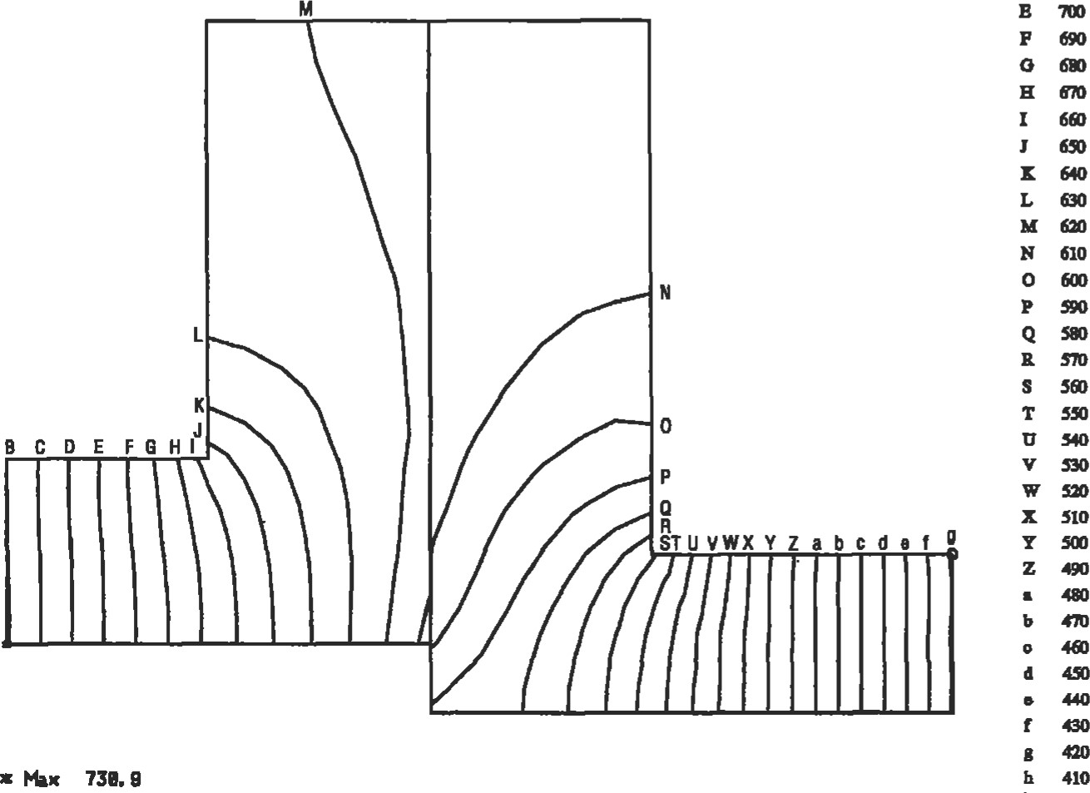

710

400

i

D B

F

G

Figure 18a. 1 ,OOOO F temperatures were applied to the left flange and 1000F to the right flange. Shown here is good mating of the two flanges with little temperature difference across the boundary.

|  |  |  |  |  |
| --- | --- | --- | --- | --- |
| 1. 800 2. no   c  D 740  F 700  o 680  H 660  1   1. 620 2. 600 L 580 3. 560 4. 540   o 520   1. soo 2. 480 3. 460 4. 440 5. 420 Figure 18b.1 ,OOOOF temperatures U 400 were applied to the left flange and v 380 1000 F to the right flange. Shown here  |  |  | | --- | --- | | * 787. e  O Min 351.3 | w 360 is poor mating with a large x 340 temperature difference across the  HEAT EXCHANGER CLASSIFICATION | | Types of Heat Exchangers |  | |

Heat transfer equipment can be specified by either service or type of construction. Only principle types are briefly described here. Table 6 lists major types of heat exchangers.

The most well-known design is the shell-and-tube heat exchanger. It has the advantages of being inexpensive and easy to clean and available in many sizes, and it can be designed for moderate to high pressure without excessive cost. Figure 19  its design features, which include a bundle of parallel tubes enclosed in a cylindrical casing called a shell.

The basic types of shell-and-tube exchangers are the fixed-tube sheet unit and the partially restrained tube sheet. In the former, both tube sheets are fastened to the shell. In this type of construcüon, differential expansion of the shell and tubes due to different operating metal temperatures or different materials of construction may require the use of an expansion joint or a packed joint. The second type has only one resfrained tube sheet located at the channel end. Differential expansion problems are avoided by using a freely riding floating tube sheet or U-tubes at the other end. Also, the tube bundle of this type is removable for maintenance and mechanical cleaning on the shell side.

Shell-and-tube exchangers are generally designed and fabricated to the standards of the Tubular Exchanger Manufacturers Association (TEMA) [1]. The TEMA standards list three mechanical standards classes of exchanger construcüon: R, C, and B.

There are large numbers of applications that do not require this type of construction. These are characterized by low fouling and low corrosivity tendencies. Such units are considered low-maintenance items.

Services falling in this category are water-to-water exchangers, air coolers, and similar nonhydrocarbon appliTable 6

Summary of Types of Heat Exchangers

|  |  |  |
| --- | --- | --- |
| Type | Major Characteristics | Application |
| Shell and tube  Air cooled heat exchangers  Double pipe  Extended surface  Brazed plate fin  Spiral wound  Scraped surface  Bayonet tube  Falling film coolers  Worm coolers  Barometric condenser  Cascade coolers  Impervious graphite | Bundle of tubes encased in a cylindrical shell Rectangular tube bundles mounted on frame, with air used as the cooling medium  Pipe within a pipe; inner pipe may be finned or plain  Externally finned tube  Series of plates separated by corrugated fins  Spirally wound tube coils within a shell Pipe within a pipe, with rotating blades scraping the inside wall of the inner pipe  Tube element consists of an outer and inner tube  Vertical units using a thin film of water in tubes  Pipe coils submerged in a box of water  Direct contact of water and vapor  Cooling water flows over series of tubes  Constructed of graphite for corrosion protection | Always the first type of exchanger to consider Economic where cost of cooling water is high  For small units  Services where dle outside tube resistance is appreciably greater than the inside resistance. Also used in debottlenecking existing units  Cryogenic services: all fluids must be clean  Cryogenic services: fluids must be clean  Crystallization cooling applications  Useful for high temperature difference between shell and tube fluids  Special cooling applications  Emergency cooling  Where mutual solubilities of water and process fluid permit  Special cooling applications for very corrosive process fluids  Used in very highly corrosive heat exchange services |

cations, as well as some light-duty hydrocarbon services such as light ends exchangers, offsite lube oil heaters, and some tank suction heaters. For such services, Class C construction is usually considered. Although units fabricated to either Class R or Class C standards comply with all the requirements of the pertinent codes (ASME or other national codes), Class C units are designed for maximum economy and may result in a cost saving over Class R.

Air-cooled heat exchangers are another major type composed of one or more fans and one or more heat transfer bundles mounted on a frame [2]. Bundles normally consist of finned tubes. The hot fluid passes through the tubes, which are cooled by air supplied by the fan. The choice of air cool-

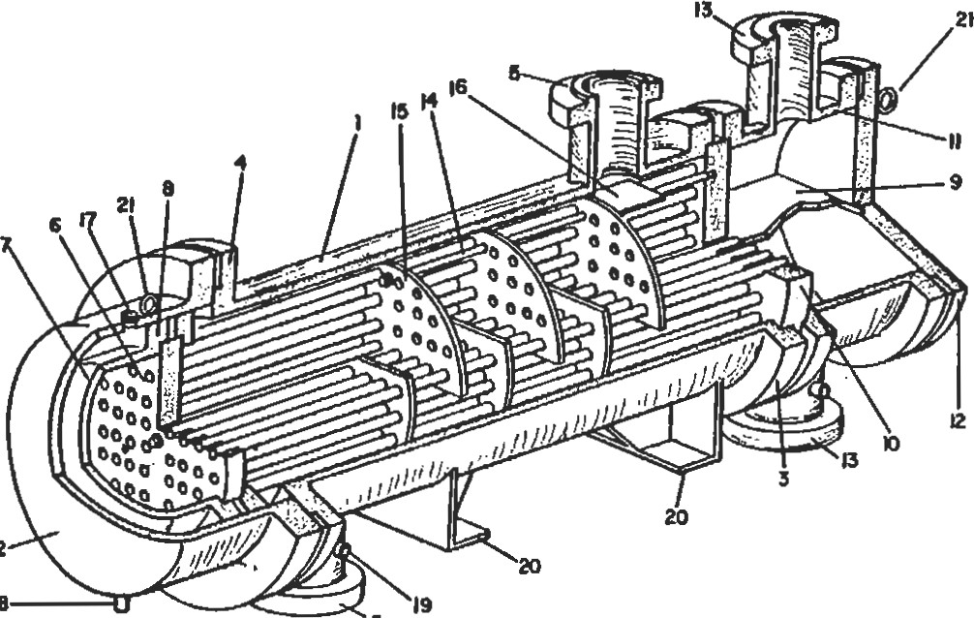

2

18

5

1. SHELL e. FLOATING HEAD FLANGE  TRANSVERSE BAFFLES OR

|  |  |  |
| --- | --- | --- |
| 2. SHELL COVER | e. CHANNEL PARTITION | SUPPORT PLATES |
| 3. SHELL CHANNEL | STATIONARY TUBESHEET | 10. IMPINGEMENT BAFFLE |
| 4. SHELL COVER END FVANGE | 11. CHANNEL | 17. VENT CONNECTION |
| 5. SHELL NOZZLE | 12. CHANNEL COVEN | 18. DRAIN CONNECTION |
| 6. FLOATING TUBESHEET | 'a. CHANNEL NOZZLE | w. TEST CONNECTION |

FLOATING HEAD 14. TIE RODS ANO SPACER8 20. SWPORT SADDLES



21. LIFTING RING Figure 19. Design features of shell-and-tube exchangers [3].

ers or condensers over conventional shell-and-tube equipment depends on economics.

Air-cooled heat exchangers should be considered for use in locations requiring cooling towers, where expansion of once-through cooling water systems would be required, or where the nature of cooling causes frequent fouling problems. They are frequently used to remove high-level heat, with water cooling used for final "trim" cooling.

These designs require relatively large plot areas. They are frequently mounted over pipe racks and process equipment such as drums and exchangers, and it is therefore important to check the heat losses from surrounding equipment to evaluate whether there is an effect on the air inlet temperature.

Double-pipe exchangers are another class that consists of one or more pipes or tubes inside a pipe shell. These exchangers almost always consist of two straight lengths connected at one end to form a U or "hair-pin." Although some double-pipe sections have bare tubes, the majority have longitudinal fins on the outside of the inner tube. These units are readily dismantled for cleaning by removing a cover at the return bend, disassembling both front end closures, and withdrawing the heat transfer element out the rear.

This design provides countercurrent or true concurrent flow, which may be of particular advantage when very close temperature approaches or very long temperature ranges are needed. They are well suited for high-pressure applications, because of their relatively small diameters. Designs incorporate small flanges and thin wall sections, which are advantageous over conventional shell-and-tube equipment. Double-pipe sections have been designed for up to 16,500 kPa gauge on the shell side and up to 103,400 kPa gauge on the tube side. Metal-to-metal ground joints, ring joints, or confined O-rings are used in the front end closures at lower pressures. Commercially available single tube double-pipe sections range from 50-mm through 100-mm nominal pipe size shells, with inner tubes varying from 20mm to 65-mm pipe size.

DesiY1s having multiple tube elements contain up to tubes within the outer pipe shell. The inner tubes, which may be either bare or finned, are available with outside diameters of 15.875 mm to 22.225 mm. Normally only bare tubes are used in sections containing more than 19 tubes. Nominal shell sizes vary from 100 mm to 400 mm pipe.

Extended surface exchangers are composed of tubes with either longitudinal or fransverse helical fins. An extended surface is best employed when the heat transfer properties of one fluid result in a high resistance to heat flow and those of the other fluid have a low resistance. The fluid with the high resistance to heat flow contacts the fin surface.

Spiral tube heat exchangers consist of a group of concentric spirally wound coils, which are connected to tube sheets. Designs include countercurrent flow, elimination of differential expansion problems, compactness, and provision for more than two fluids exchanging heat. These units are generally employed in cryogenic applications.

Scraped-surface exchangers consist of a rotating element with a spring-loaded scraper to wipe the heat transfer surface. They are generally used in plants where the process fluid crystallizes or in units where the fluid is fouling or highly viscous.

These units are of double-pipe consüuction. The inner pipe houses the scrapers and is available in 150-, 200-, and 300-mm nominal pipe sizes. The exterior pipe forms an annular passage for the coolant or refrigerant and is sized as required. Up to ten 300 mm sections or twelve of the smaller individual horizontal sections, connected in series or series/parallel and stacked in two vertical banks on a suitable structure, is the most common arrangement. Such an arrangement is called a "stand."

A bayonet-type exchanger consists of an outer and imer tube. The inner tube serves to supply the fluid to the annulus between the outer and inner tubes, with the heat u•ansfer occurring through the outer tube only. Frequently, the outer tube is an expensive alloy material and the inner tube is carbon steel. These designs are useful when there is an extremely high temperature difference between shell side and tube side fluids, because all parts subject to differential expansion are free to move independently of each other. They are used for change-of-phase service where twophase flow against gravity is undesirable. These units are sometimes installed in process vessels for heating and cooling purposes. Costs per unit area for these units are relatively high.

Worm coolers consist of pipe coils submerged in a box filled with water. Although worm coolers are simple in conthey are costly on a unit area basis. Thus they are restricted to special applications, such as a case where emergency cooling is required and there is but one watersupply source. The box contains enough water to cool liquid pump-out in the event of a unit upset and cooling water failure.

A direct contact condenser is a small contacting tower through which water and vapor pass together. The vapor is condensed by direct contact heat exchange with water droplets. A special type of direct contact condenser is a barometric condenser that operates under a vacuum. These units should be used only where coolant and process fluid mutual solubilities are such that no water polluüon or product contamination problems are created. Evaluation of process fluid loss in the coolant is an important consideration.

A cascade cooler is composed of a series of tubes mounted horizontally, one above the other. Cooling water from a distributing trough drips over each tube and into a drain. Generally, the hot fluid flows countercurrent to the water. Cascade coolers are employed only where the process fluid is highly corrosive, such as in sulfuric acid cooling.

Impervious graphite heat exchangers are used only in highly corrosive heat exchange service. 'IYpical applications are in isobutylene extraction and in dimer and acid concentration plants. The principal construction types are cubic graphite, block type, and shell-and-tube graphite exchangers. Cubic graphite exchangers consist of a center cubic block of impervious graphite that is cross drilled to provide passages for the process and service fluids. Headers are bolted to the sides of the cube to provide for fluid Also, the cubes can be interconnected to obtain additional surface area. Block-type graphite exchangers consist of an impervious graphite block enclosed in a cylindrical shell. The process fluid (tube side) flows through axial passages in the block, and the service fluid (shell side) flows through cross passages in the block. Shelland-tube-type graphite exchangers are like other shelland-tube exchangers except that the tubes, tube sheets, and heads are constructed of impervious graphite.

|  |
| --- |
| Sources 2. API Standard 661, "Air-Cooled Heat Exchangers for  General Refinery Services."  I. Standams ofTubular Exchanger MamCactuær 's Associa- 3. Cheremisinoff, N. P, Heat Transfer Pocket Handbook. non, 7th Ed., TEMA, Tarrytown, NY, 1988. Houston: Gulf Publishing Co., 1984.  Shell-and-Tube Exchangers |

This section provides general information on shell-andtube heat exchanger layout and flow arrangements. Design details are concerned with several issues—principal ones being the number of required shells, the type and length of tubes, the arrangement of heads, and the tube bundle arrangement.

The total number of shells necessary is largely determined by how far the outlet temperature of the hot fluid is cooled below the outlet temperature of the other fluid (known as the "extent of the temperature cross"). The "cross" determines the value of Fn, the temperature correction factor; this factor must always be equal to or greater than 0.800. (The value of Fn drops slowly between 1.00 and 0.800, but then quickly approaches zero. A value of Fn less than 0.800 cannot be predicted accurately from the usual information used in process designs.) Increasing the number of shells permits increasing the extent of the cross and/or the value of Fn.

The total number of shells also depends on the total surface area since the size of the individual exchanger is usually limited because of handling considerations.

Exchanger tubes are commonly available with either smooth or finned outside surfaces. Selection of the type of surface is based on applicability, availability, and cost.

The conventional shell-and-tube exchanger tubing is the smooth surface type that is readily available in any material used in exchanger manufacture and in a wide range of wall thicknesses. With low-fin tubes, the fins increase the outside area to approximately times that of a smooth tube.

Tube length is affected by availability and economics. Tube lengths up to 7.3 m are readily obtainable. Longer tubes (up to 12.2 m for carbon steel and 21.3 m for copper alloys) are available in the United States.

The cost of exchanger surface depends upon the tube length, in that the longer the tube, the smaller the bundle diameter for the same area. The savings result from a decrease in the cost of shell flanges with only a nominal increase in the cost of the longer shell. In the practical range of tube lengths, there is no cost penalty for the longer tubes since length extras are added for steel only over 7.3 m and for copper alloys over 9.1 m.

A disadvantage of longer tubes in units (e.g., condensers) located in a su-ucture is the increased cost of the longer platforms and additional structure required. Longer tube bundles also require greater tube pulling area, thereby possibly increasing the plot area requirements.

Exchanger tubing is supplied on the basis of a nominal diameter and either a minimum or average wall thickness. For exchanger tubing, the nominal tube diameter is the outside tube diameter. The inside diameter varies with the nominal tube wall thickness and wall thickness tolerance. Minimum wall tubing has only a plus tolerance on the wall thickness, resulting in the nominal wall thickness being the minimum thickness. Since average wall tubing has a plus-or-minus tolerance, the actual wall thickness can be greater or less than the nominal thickness. The allowable tolerances vary with the tube material, diameter, and fablication method.

Tube inserts are short sleeves inserted into the inlet end of a tube. They are used to prevent erosion of the tube itself due to the inlet turbulence when erosive fluids are handled, such as streams containing solids. When it is suspected that the tubes will be subject to erosion by solids in the tube side fluid, tube inserts should be specified. Insert material, length, and wall thickness should be given. Also, inserts are occasionally used in cooling-water service to prevent oxygen attack at the tube ends. Inserts should be cemented in place.

The recommended TEMA head types are shown in Figme 20. The stationaryfront head of shell-and-tube exchangers is commonly referred to as the channel. Some common TEMA stationa.ry head types and their applications are as follows:

Type A—Features a removable channel with a removable cover plate. It is used with fixed-tube sheet, U-tube, and removable-bundle exchanger designs. This is the most common stationary head type.

Type B—Features a removable channel with an integal cover. It is used with fixed-tube sheet, U-tube, and removable-bundle exchanger design.

|  |  |  |  |  |  |  |  |  |  |  |  |  |  |  |  |  |  |  |  |  |  |  |  |  |  |  |  |  |  |  |  |  |  |  |  |  |  |  |  |  |  |  |  |  |  |  |
| --- | --- | --- | --- | --- | --- | --- | --- | --- | --- | --- | --- | --- | --- | --- | --- | --- | --- | --- | --- | --- | --- | --- | --- | --- | --- | --- | --- | --- | --- | --- | --- | --- | --- | --- | --- | --- | --- | --- | --- | --- | --- | --- | --- | --- | --- | --- |
| |  |  |  |  |  |  | | --- | --- | --- | --- | --- | --- | |  | ÆONT END  STATIONAY |  | SHEU mes |  | HUD TYPES | |  | AND  COVER |  | ONE pass SHRL |  | FIXED TUBESH&T  LIKE AA" STATIONARY HEAD | |  |  |  |  | |  | BO€NET 11MTEGRAL COVER) | | G | sm.JT FLOW |  | FIXED TUBESHET  LIKE STATONARY HEAD | |  | CHANNEL INTEGRA WITH  SHEET AND REAAOVABLE cova |  |  | P | OUTSIDE  HEAD | | s | FLOATING HEAD  WITH LACKING DEVICE | |  | DIVIDED FLOW | |  | CHANNQ  TUBE-  %EET ANO | |  |  | |  |  | |  | U.WBE bWOL.E | |  | SPEaAL HGH | | x | CROSS FLOW | |  | ROATING TUBESHEET |   Figure 20. TEMA heat exchanger head types. (Copyright O  by 7übular Exchanger Manufacturers Asociaüon.) |

Types C and N—The channel with a removable cover is integral with the tube sheet. Type C is attached to the shell by a flanged joint and is used for U-tube and removable bundles. Type N is integral with the shell and is used with fixed-tube sheet designs. The use of Type N heads with U-tube and removable bundles is not recommended since the channel is integral with the tube bundle, which complicates bundle maintenance.

Type D—This is a special high pressure head used when the tube-side design pressure exceeds approximately 6,900 kPa gauge. The channel and tube sheet are integral forged consu•uction. The channel cover is attached by special high pressure bolting.

The TEMA rear head nomenclature defines exchanger tube bundle type and common arrangements as follows:

Type L—Similar in construction to the Type A stationary head. It is used with fixed-tube sheet exchangers when mechanical cleaning of the tubes is required.

TYpe M—Similar in construction to the Type B stationary head. It is used with fixed-tube sheet exchangers.

Type N—Similar in construction to the Type N stationary head. It is used with fixed-tube sheet exchangers.

Type P—Called an outside packed floaüng head. The design features an integral rear channel and tube sheet with a packed joint seal (stumng box) against the shell. It is not normally used due to the tendency of packed joints to leak. It should not be used with hydrocarbons or toxic fluids on the shell side.

Type S—Constructed with a floating tube sheet contained between a split-ring and a mbe-sheet cover. The tube assembly is free to move within the shell cover. Ohe shell cover must be a removable design to allow access to the floating head assembly.) qypeT Constructed with a floating tube sheet bolted directly to the tube sheet cover. It can be used with either an integral or removable (common) shell cover.

Type U—This head type designates that the tube bundle is constructed of U-tubes.

Type W—A floaüng head design that utilizes a packed joint to separate the tube-side and shell-side fluids. The packing is compressed against the tube sheet by the shell/rear cover bolted joint. It should never be used with hydrocarbons or toxic fluids on either side.

Tube bundles are designated by 'IEMA rear head nomenclature (see Figure 20). Principal types are briefly described below.

Fixed-tube sheet exchangers have both tube sheets attached directly to the shell and are the most economical exchangers for low design pressures. This type of construction should be considered when no shell-side cleaning or inspection is required, or when in-place shell-side chemical cleaning is available or applicable. Differential thermal expansion between tubes and shell limits applicability to moderate temperature differences.

Welded fixed-tube sheet construction cannot be used in some cases because of problems in welding the tube sheets to the shells. Some material combinations that rule out fixed-tube sheets for this reason are carbon steel with aluminum or any of the high copper alloys (TEMA—Rear Head Types L, M, or N).

U-tube exchangers represent the greatest simplicity of design, requiring only one tube sheet and no expansion joint or seals while permitting individual tube differential thermal expansion. U-tube exchangers are the least expensive units for high tube-side design pressures. The tube bundle can be removed from the shell, but replacement of indiviülal tubes (except for ones on the outside of the bundle) is impossible.

|  |  |
| --- | --- |
| ciuded (TEMA—Rear Head Type U). | Houston: Gulf Publishing Co., 1984. |
| Tube Arangements and Baffles |  |

Although the U-bend portion of the tube bundle provides heat surface, it is ineffective compared to the straight tube length surface area. Therefore, when the effective surface area for U-tube bundles is calculated, only the surface area of the straight portions of the tubes is inA pull-thmughfloating head exchanger has a fixed tube sheet at the channel end and a floating tube sheet with a separate cover at the rear end. The bundle can be easily removed from the shell by disassembling only the front cover. The floating head flange and bolt design require a relatively clearance between the bundle and shell, particularly as the design pressures increase. Because of this clearance, the pull-through bundle has fewer tubes per shell size than other types of construction do. The bundle-to-shell clearance, which decreases shell-side heat capability, should be blocked by sealing strips or dummy tubes to reduce shell-size fluid bypassing. Mechanical cleaning of both the shell and tube sides is possible (TEMA—Rear Head Type T).

A split-ring floating head exchanger has a fixed-tube sheet at the channel end and a floating tube sheet that is sandwiched between a split-ring and a separate cover. The floating head assembly moves inside a shell cover of a larger diameter than that of the shell. Mechanical cleaning of both the shell and tube is possible (TEMA—Rear Head Type S).

There are two variaüons of outside packedfloating head designs: the lantern ring type and the stuffing box type. In the lantern ring design, the floating head slides against a lantern ring packing, which is compressed between the shell flange and the shell cover. The stuffing box design is similar to the lantern ring type, except that the seal is against an extension of the floating tube sheet and the tube sheet cover is attached to the tube sheet extension by means of a split-ring. (TEMA—Rear Head Types P or W).

Sources

1. Standams of Tubular Exchanger Manufacturer 's Associati0L 7th Ed., TEMA, Tarrytown, NY, 1988.
2. Cheremisinoff, N. P., Heat Transfer Pocket Handbook.

The following are some general notes on tube layout and baffle arrangements for shell-and-tube exchangers. There are four types of tube layouts with respect to the shell-side crossflow direction between baffle tips: square (900), rotated square (45 0), triangular (300), and rotated triangular (600). The four types are shown in Figure 21.

Use of triangular layout (300) is preferred (except in some reboilers). An exchanger with triangular layout costs less per square meter and fransfers more heat per square meter than one with a square or rotated square layout. For this reason, üiangular layout is preferred where applicable.

Rotated square layouts are preferable for laminar flow, because of a higher heat transfer coefficient caused by induced turbulence. In turbulent flow, especially for pressuredrop limited cases, square layout is preferred since the heat transfer coefficient is equivalent to that of rotated square layout while the pressure drop is somewhat less.

Tube layout for removable bundles may be either square (900), rotated square (45 0), or triangular (300). Nonremovable bundles (fixed-tube sheet exchangers) are always triangular (300 ) layout.

The tube pitch (VT) is defined as the center-to-center distance between adjacent tubes (see Figure 21). Common pitches used are given in Table 7.

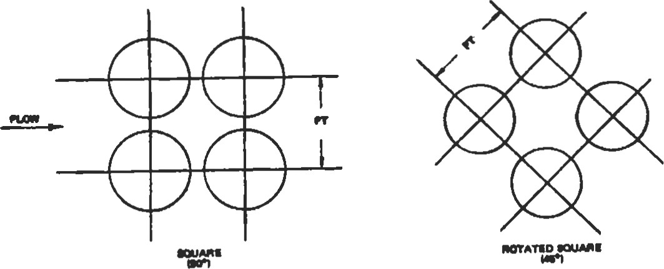

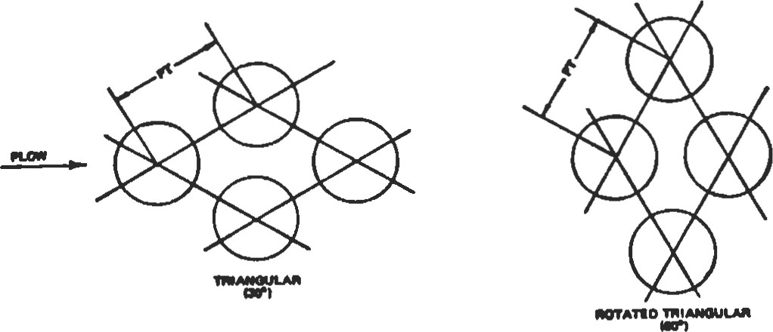

###### Figure 21. Tube layouts

Table 7

Common Tube Pitch Values

|  |  |  |  |
| --- | --- | --- | --- |
| Ibbe Size | Triangular (mm) | Square  (mm) | Heaviest  Recommended WI (mm) |
| 19.05 mm O.D.  19.05 mm O.D.  25.4 mm O.D.  38.1 mm O.D.  > 38.1 mm | 23.81  25.40  31.75  47.63 Use 1.25 times the outside diameter | 25.40  31.75  47.63 | 2.77  3.40  4.19 |

The column "Heaviest Recommended Wall" is based on the maximum allowable tube sheet distortion resulting from rolling the indicated tube into a tube sheet having the minimum permissible ligament width at the listed pitch. The ligament is that portion of the tube sheet between two adjacent tube holes.

Tubes are supported by baffles that restrain tube vibration from fluid impingement and channel fluid flow on the shell side. Two types of baffles are generally used: segmental and double segmental. Types are illustrated in Figure 22.

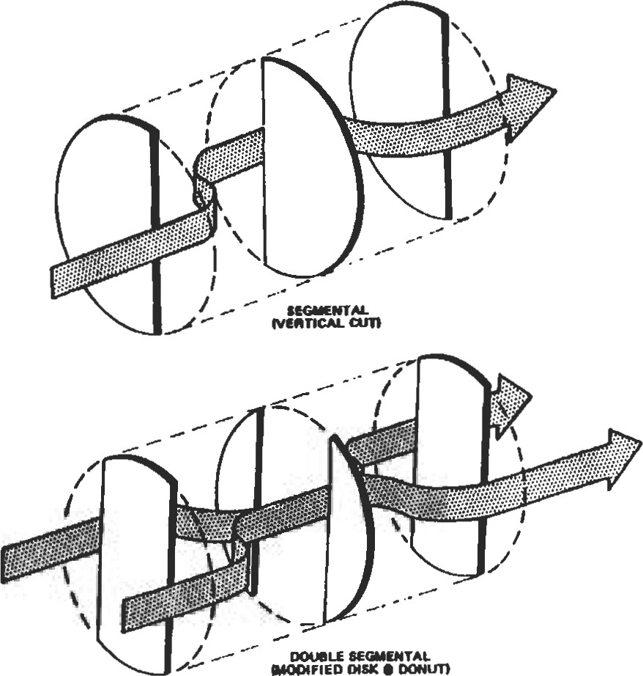

e

Figure 22. Types of shell baffles [21.

The baffle cut is the portion of the baffle "cut" away to provide for fluid flow past the chord of the baffle. For segmental baffles, this is the ratio of the chord height to shell diameter in percent. Segmental baffle cuts are usually about 25%, although the maximum practical cut for tube support is approximately 48%.

Double segmental baffle cut is expressed as the ratio of window area to exchanger cross sectional area in percent. Normally the window areas for the single central baffle and the area of the central hole in the double baffle are equal and are 40% of the exchanger cross-sectional area. This allows a baffle overlap of approximately 10% of the exchanger cross-sectional area on each side of the exchanger. However, there must be enough overlap so that at least one row of tubes is supported by adjacent segments.

Bane pitch is defined as the longitudinal spacing between baffles. The maximum baffle pitch is a function of tube size and, for no change of phase flow, of shell diameter. If there is no change of phase in the shell-side fluid, the baffle pitch should not exceed the shell inside diameter. Otherwise, the fluid would tend to flow parallel with the tubes, rather than perpendicular to them, resulting in a poorer heat transfer coefficient.

Impingement banes are required on shell-side inlet nozzles to protect the bundle against impingement by the incoming fluid when the fluid:

1. is condensing
2. is a liquid vapor mixture

3, contains abrasive material

4. is entering at high velocity

In addition, TEMA requires bundle impingement protection when nozzle values of pu2 (fluid density, kg/m3, times

l. 2,230 kg/m-s2 for noncorrosive, nonabrasive, singlephase fluids

2. 744 kg/m-s2 for all other liquids

Also, the minimum bundle entrance area should equal or exceed the inlet nozzle area and should not produce a value of pu2 greater than 5,950 kg/m-s2, per TENfA. Impingement baffles can be either flat or curved. In order to maintain a maximum tube count, the impingement plate is sometimes located in a conical nozzle opening or in a dome cap above the shell. The impingement plate material should be at least as good as that of the tubes.

Sources

1. Standards of Tubular Manufacturers Association, 7th Ed, TEMA, Tarrytown, NY, 1988.

|  |  |
| --- | --- |
| velocity squared m2/s2) exceed: | Houston: Gulf Publishing Co., 1984. |
| Shell Configurations |  |

1. Cheremisinoff, N. P., Heat Transfer Pocket Handbook.

'Ihe following notes summarize design features of shells for shell-and-tube heat exchangers.

The single-pass shell is the most common shell construction used. The shell-side inlet and outlet nozzles are located at opposite ends of the shell. The nozzles can be placed on opposite or adjacent sides of the shell, depending on the number and type of baffles used. A typical oneshell pass exchanger with horizontal segmental baffles is illustrated in Figure 23 [A] (TEMA E).

A two-pass shell uses a longitudinal baffle to direct the shell-side flow. An exchanger with two shell passes is shown in Figure 23 [B]. Note that both the shell inlet and outlet nozzles are adjacent to the stationary tube sheets. A shell-side temperature range exceeding 195 0C should be avoided, since greater temperature ranges result in excessive heat leakage through the baffle, as well as thermal stresses in the baffle, shell, and tube sheet.

The longitudinal baffle can be either welded or removable. Since there are severe design and cost penalties associated with the use of welded baffles in floating head exchangers, this type of design should be used only with fixed-tube sheet units that do not require expansion joints. Removable longitudinal baffles require the use of flexible light gauge sealing strips or a packing device between the baffle and the shell, to reduce fluid leakage from one side to the other (TEMA F).

A divided flow shell has a central inlet nozzle and two outlet nozzles, or vice-versa. A divided flow exchanger is illustrated in Figure 23 [C]. This type is generally used to reduce pressure drop in a condensing service. In minimizing pressure drop the shell fits in as follows:

* + E shell with segrnental baffles
  + E shell with double segmental baffles

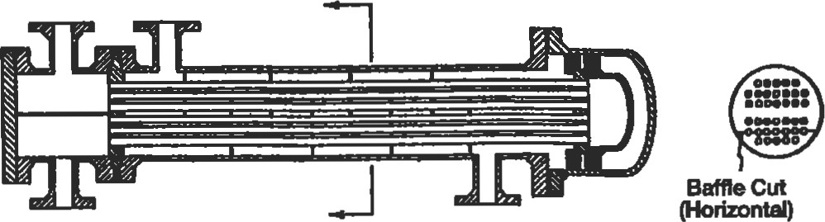

SINGLE PASS SHELL

(A)

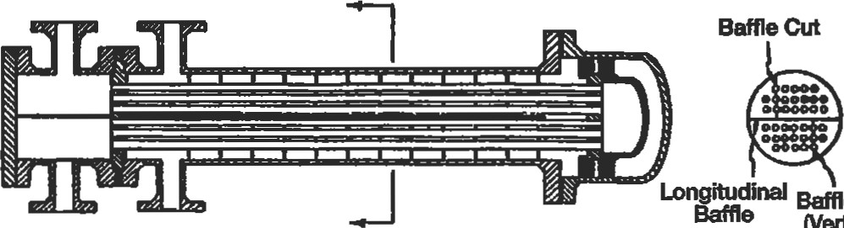Bane Cu

(Vertical)

TWO PASS SHE-L

%fleCut

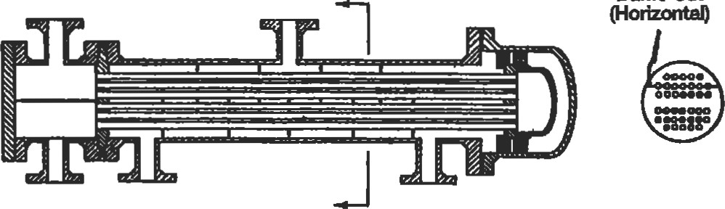

DIVIDED FLOW SHELL

Figure 23. (A) Single-pass shell; (B) two-pass shell; (C) divided flow shell [2].

* + J shell with segmental baffles
  + J shell with double segmental baffles
  + E shells in parallel with segmental baffles
  + E shells in parallel with double segmental baffles

' J shells in parallel with segmental baffles

' J shells in parallel with double segmental baffles

Generally, for most designs, double segmental baffles are used with J shells.

Double segmental baffles in a divided-flow exchanger normally have a vertical cut. This baffle arrangement also requires that there be an odd number of total baffles, but there must also be an odd number of baffles in each end ofthe shell. The center baffle for this arrangement is normally similar to die center bame used with segmental cut. The baffles on each side of the central baffle and the last baffle toward the ends of the shell have solid centers with cutaway edges.

The choice of whether to stack shells depends on maintenance considerations, as well as on the amount of plot area available. Stacking shells requires less area and frequently less piping. Normally, shells are not stacked more than two high. However, stacked heat exchangers are more costly to maintain, because of accessibility.

If sumcient plot area is available, the following guidelines apply:

l. If the fluids are known to be clean and noncorrosive, the shells should usually be stacked.

1. If the fluids ate moderately clean or slightly corrosive, the shells may be stacked.
2. If the fluids are very dirty or corrosive, the shells should not be stacked, to allow for ease of maintenance.

Sources

1. Standards of Tubular Exchanger Manufacturer's Association, 7th Ed., TEMA, Tarrytown, NY, 1988.
2. Cheremisinoff, N. P., Heat Transfer Pocket Handbook. Houston: Gulf Publishing Co., 1984.

|  |  |  |  |  |  |  |  |  |  |  |  |  |  |  |  |  |  |  |  |  |  |  |  |  |  |  |  |  |  |  |  |  |  |  |  |  |  |  |  |  |  |  |  |  |  |  |  |  |  |  |  |  |  |  |  |  |  |  |  |  |  |  |  |  |  |  |  |  |  |  |  |  |  |  |  |  |  |  |  |  |  |  |  |  |  |  |  |  |  |  |  |  |  |  |
| --- | --- | --- | --- | --- | --- | --- | --- | --- | --- | --- | --- | --- | --- | --- | --- | --- | --- | --- | --- | --- | --- | --- | --- | --- | --- | --- | --- | --- | --- | --- | --- | --- | --- | --- | --- | --- | --- | --- | --- | --- | --- | --- | --- | --- | --- | --- | --- | --- | --- | --- | --- | --- | --- | --- | --- | --- | --- | --- | --- | --- | --- | --- | --- | --- | --- | --- | --- | --- | --- | --- | --- | --- | --- | --- | --- | --- | --- | --- | --- | --- | --- | --- | --- | --- | --- | --- | --- | --- | --- | --- | --- | --- | --- | --- |
| |  |  |  |  | | --- | --- | --- | --- | | Design-related data are given in Tables 8 through 10. | Table 9 | | | | Table 8 provides typical tube dimensions and tube surface | Themal Conductivities of Materials of Construction | | | | areas per unit length. Table 9 gives thennal conductivities | Conducüvity, k, | | | | of materials commonly used for exchanger consu•uction. | Composiöon | | | | Table 10 gives recommended maximum number of tube | Adrniral.ty | 71 cu-28 zn-l Sn | 111 | | passes as a function of tube size. | Type 316 stainless steel Type 304 suinless steel | 1. Cr-12 Ni-2 Mo 2. Cr-8 Ni | 16  16 | |  | Brus | 70 cu-30 Zan | 99 | |  | Red brass | 85 cu-15 Zan | 159 | | Source | Alumimun bmss | 76 cu-nzu-2 Al | 100 | |  | Cupro-nickA | 90 Ni | 71 | |  | Cupro-nickel | 70 Cu-30Ni | 29 | | Cheremisinoff, N. R, Heat Transfer Pocket Handbook. | M01El | 67 Ni-30 cu-1.4 | 26 | | Houston: Gulf Publishing Co., 1984. |  |  | 19 | |  | Cubon steal |  | 45 | |  | Carbon-moly | 0.5 Mo | 43  386  35 | |  | Ni&l |  | 62  19 | |  | Chrome-moly steel | 1 Cr-O.5 Mo | 42 | | Table 8 |  | 21/4 Cr-O.5 Mo | 38 | | Tube Dimensions and Surface Areas Per Unit Length |  | 5 Cr-O.5 Mo  12 Cr-l Mo | 35  28 |  |  |  |  |  |  |  | | --- | --- | --- | --- | --- | --- | | do = |  |  | Inernal | External Surmce |  | | O.D. of |  | I.D. of |  | Length |  | | Ibbing (mm) | (mm) | Tubing (mm) | (mm9 | (sq ft/ft) | Table 10 |   Miscellaneous Data    19.05 2.77 13.51 143.8 0.0598 Maximum Number of nabe Passes  19.05 2.11 14.83 172.9 0.0598  19.05 1.65 1ß.8 0.0598  19.05 1.24 16.56 215.5 0.0598  25.40 3.40 18.59 271.6 0.0798 I.D. (mm) Number of nxbe hoes  25.40 2.77 19.86  0.0798 <250 4  25.40 2.11 21..18 352.3 0.0798 <510 6  25.40 1.65 22.10 383.2 0.0798 510-<70 8  38.10 3.40 31.29 769.0 0.1197 70-<1 020 10  38.10 2.77 32.56 832.9 0.119712  38.10 2.11 33.88 901.3 0.119714    FLOW REGIMES AND PRESSURE DROP IN TWO-PHASE HEAT TRANSFER  Flow Regimes |

Standard practice for heat exchanger analysis is to first identify the flow regimes and then employ the appropriate correlations.

Vertical Upward Concurent Flow

Flows of this type are shown in Figure 24.

Bubbly flow. In this type, the gas or vapor phase is disüibuted as discrete bubbles in a continuous liquid phase. At one extreme, the bubbles may be small and spherical, and at the other the bubbles may be large with a spherical cap and a flat tail.

Slug flw. The gas or vapor bubbles are approximately the diameter of the pipe. The nose of the bubble has a charac-

WISPY- ANNULAR BUBBLY FLOW nua FLOW CHURN FLOW ANNULAR FLOW

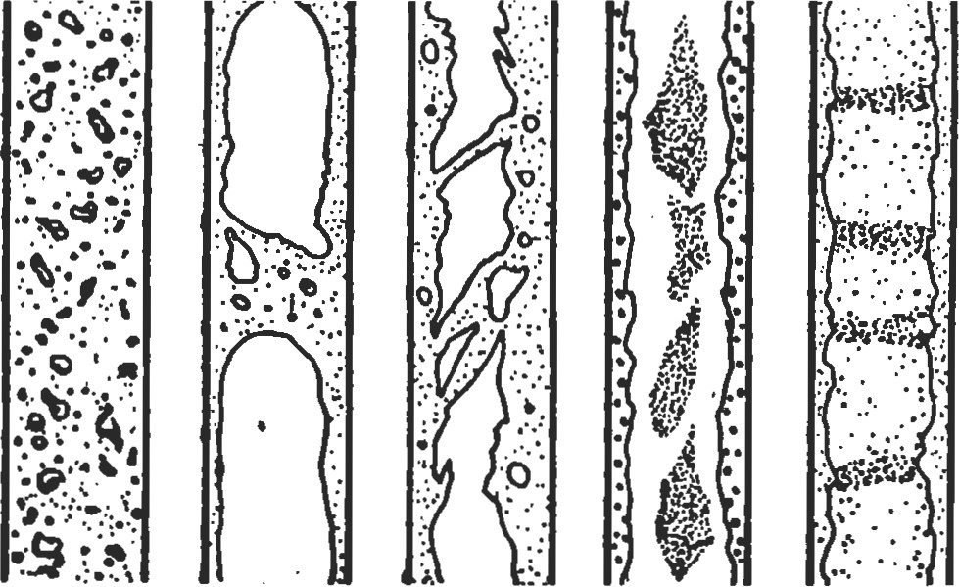

Figure 24. Flow patterns in vertical concurrent flow [1].

teristic spherical cap, and the gas in the bubble is separated from the pipe wall by a slowly descending liquid film. The liquid flow is contained in liquid slugs that separate successive gas bubbles. Slugs may or may not contain smaller entrained gas bubbles carried in the wake of the large bubble. The length of the main gas bubble varies.

Churn flow. Formed by the breakdown of the large vapor bubbles in slug flow. The gas or vapor flows chaotically through the liquid that is mainly displaced to the channel wall. The flow has a time-varying character and hence is called "churn flow." This region is also sometimes referred to as semi-annular or slug-annular flow.

Wispy-annular flow. The flow takes the form of a relatively thick liquid film on the walls of the pipe together with a considerable amount of liquid entrained in a central gas or vapor core. The liquid in the film is aerated by small gas bubbles and the entrained liquid phase appears as large droplets which have agglomerated into long irregular filaments or wisps. This generally occurs at high mass velocities.

Annular flow. A liquid film forms at the pipe wall with a continuous central gas or vapor core. Large amplitude coherent waves are usually present on the surface of the film, and the continuous break up of these waves forms a source for droplet entrainment, which occurs in varying amounts in the central gas core.

Vertical Heated Channel Upward Flow

Heat flux through the channel wall alters the flow pattern from that which would have occurred in a long unheated channel at the same local flow conditions. These changes occur due to:

I . The departure from thermodynamic equilibrium coupled with the presence of radial temperature profiles in the channel.

2. The departure from local hydrodynamic equilibrium throughout the channel.

Figure 25 shows a vertical tubular channel heated by a uniform low heat flux and fed with liquid just below the saturation temperature.

BOILING REGIME 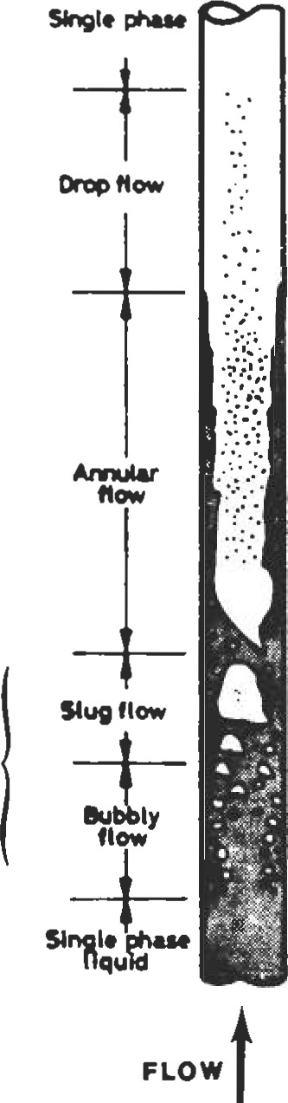

Figure 25. Flow patterns in a vertical evaporator tube [21.

In the initial single-phase region, the liquid is heated to the saturation temperature. A thermal boundary layer forms at the wall, and a radial temperature profile forms. At some distance from the inlet, the wall temperature and the conditions for the formation of vapor (nucleation) at the wall are satisfied. Vapor forms at preferred positions on the tube surface. Vapor bubbles grow from these sites finally detaching to form a bubbly flow. With the production of more vapor, the bubble population increases with length and coalescence occurs, forming slug flow, which in turn gives way to annular flow further along the channel. Close to this point the formation of vapor at sites on the wall may cease and further vapor formation will result from evaporation at the liquid-film vapor-core interface. Increasing velocities in the vapor core cause entrainment of liquid in the form of droplets. The depletion of the liquid from the film by this entrainment and by evaporation finally causes the film to dry out completely. Droplets continue to exist and are slowly evaporated until only single-phase vapor is present.

Figure 26 shows the flow patterns of liquid-vapor flow in a heated pipe as a function of wall heat flux. Liquid enters the pipe at a constant flow rate and at a temperature lower than the saturation temperature. As the heat flux increases, the vapor appears closer and closer to the pipe inlet. The local boiling length is the extent of pipe where bubbles form at the wall and condense in the liquid core where the liquid temperature is still lower than the saturation temperature. Vapor forms by:

l . Wall nucleation

2. Direct vaporization on the interfaces located in the flow itself

INCREASING HEAT 'LUX

OF

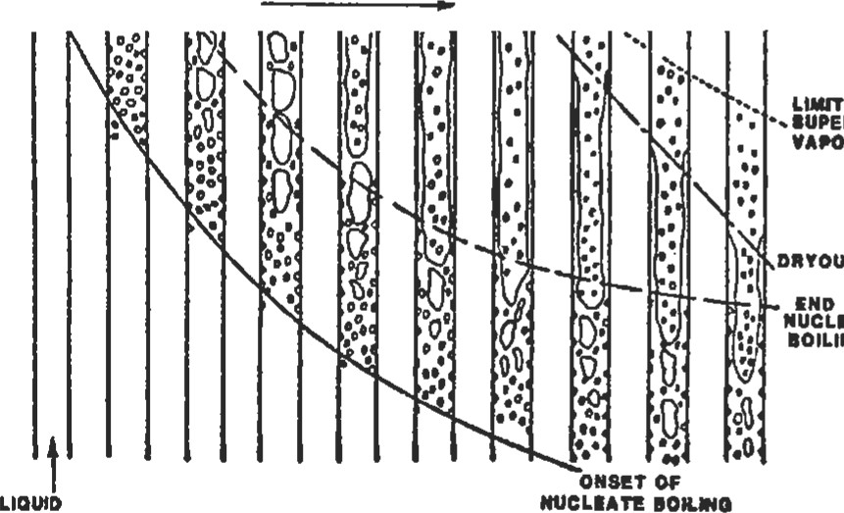

D"OUT

OF

NUCLEATE

BOILING

8UPERHEATED

VAPOR nea10N

CONSTANT

'LOWRATE

Figure 26. Convective boiling in a heated channel [3].

(With permission of Elsevier Science Ltd.)

There is progressively less liquid between the wall and the interfaces. Consequently, the thermal resistance decreases along with the wall temperature, resulting in an end to wall nucleation. In annular flow, the liquid film flow rate decreases through evaporation and entrainment of droplets, although some droplets are redeposited. In heat flux controlled systems, when the film is completely dried out, the wall temperature rises very quickly and can exceed the melting temperature of the wall (called dryout). Flow patterns are shown in Figure 27.

In upward bubbly flow, bubbles are spread over the entire pipe cross-section whereas in the downward flow bubbles gather near the pipe axis.

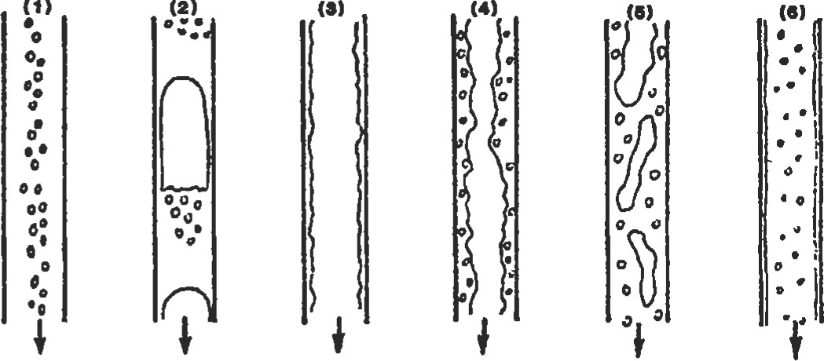

Figure 27. Air-water flow patterns in a downward concurrent flow in a vertical pipe: (1) bubbly, (2) slug, (3) falling film, (4) bubbly falling film, (5) churn, and (6) dispersed annular flow [4].

At higher gas flow rates (but a constant liquid flow rate) the bubbles agglomerate into large gas pockets. The tops of these gas plugs are dome-shaped whereas the lower exis flat with a bubbly zone underneath. This slugflow is generally more stable than in the upward case.

With annular flow, at small liquid and gas flow rates, a liquid film flows down the wall (falling film flow). If the liquid flow rate is higher, the bubbles are entrained within the film (bubbly falling film). At greater liquid and gas flow rates churnflow exists, which can evolve into dispersed annular flow for very high gas flow rates.

Horizontal Concurrent Flow

The flow patterns for this type of flow are shown in Figure 28.

Bubbly flow (froth flow). This resembles the case in vertical flow except that the vapor bubbles tend to travel in the upper half of the pipe. At moderate gas and liquid velocities, the entire pipe cross-section contains bubbles. At higher velocities, a flow pattern equivalent to the wispy-annular pattern exists.

Plug flow. This is similar to slug flow in the vertical direction. Again, the gas bubbles tend to travel in the upper half of the pipe

Stratlfled flow. This pattern only occurs at very low liquid and vapor velocities. The two phases flow separately with a relatively smooth interface.

Wavy flow. As the vapor velocity is increased, the interface becomes disturbed by waves traveling in the direction of flow.

Slug flow. At higher vapor velocities the waves at the interface break up to form a frothy slug which is propagat-

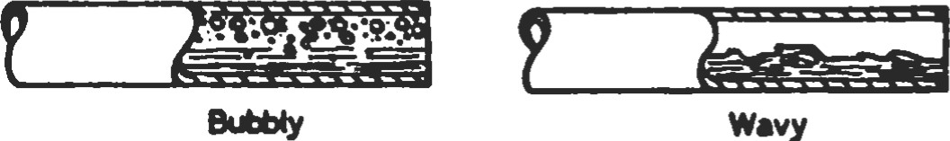



Plug Slug



*ratified Amular



Figure 28. Flow patterns in horizontal flow [ll.

ed along the channel at a high velocity. The upper surface of the tube behind the wave is wetted by a residual film, which drains into the bulk of the liquid.

Annular flow. At higher vapor velocities a gas core forms with a liquid film around the periphery of the pipe. The film may or may not be continuous around the entire circumference but it will be thicker at the base of the pipe.

Flow pattems formed during the generation of vapor in horizontal tubular channels are influenced by departures from thermodynamic and hydrodynamic equilibrium. Figure 29 shows a horizontal tubular channel heated by a uniform low heat flux and fed with liquid just below the saturation temperature. The sequence of flow patterns corresponds to a relatively low inlet velocity (<l m/s). Note the intermittent drying and rewetting of the upper surfaces of the tube in wavy flow and progressive drying out over long tube lengths of the upper circumference of the tube wall in mnular flow. At higher inlet liquid velocities, the influence of gravity is less obvious, the phase distribution becomes more symmetrical, and the flow patterns become closer to those in vertical flow.

Flow Normal to Tube Banks

The flow patterns in the crossflow zones are shown in Figure 30.

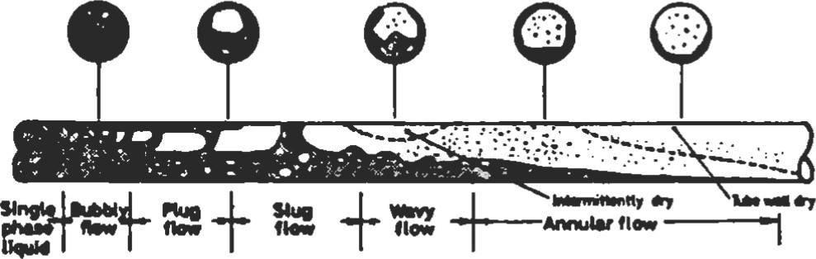

Figure 29. Flow pattems in a horizontal tube evaporator [2].

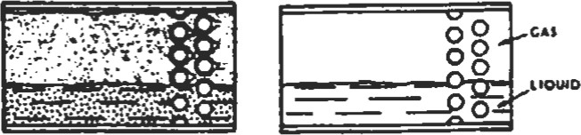HORIZONTAL FLOU

8TRATFED- STRATIFIED

SPRAY FLOW FLOW

VERTICAL a VERTICAL

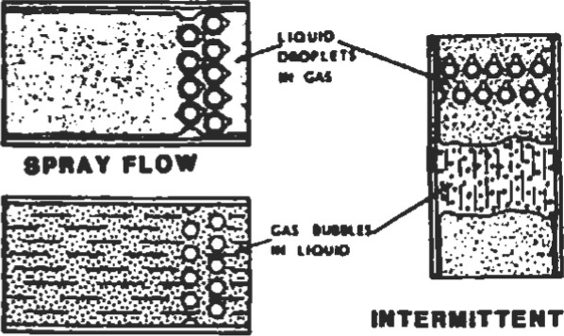

INTERMITTENT

FLOW

HORIZONTAL

FLO'SFLOW

BUBBLY FLOW

Figure 30. Shell-side two-phase flow patterns [51. (With permission of ASME.)

Spray flow. This occurs at high mass flow qualities with liquid carried along by the gas as a spray.

Bubbly flow. This occurs at low mass flow qualities with the gas distributed as discrete bubbles in the liquid.

Intermittent flow. Intermittent slugs of liquid are propelled cyclically by the gas.

Stratified-spray flow. The liquid and gas tend to separate with liquid flowing along the bottom. The gas-phase is entrained as bubbles in the liquid layer and liquid droplets are carried along by the gas as a spray.

Statified flow. The liquid and gas are completely separated.

Spray and bubbly flows occur for either vertical up-anddown flow or horizontal side-to-side flow. Intermittent flow only occurs with vertical up-and-down flow and stratifiedspray and stratified flow with horizontal side-to-side flow.

Sources

l . Cheremisinoff, N. P., Heat Transfer Pocket Handbook, Houston: Gulf Publishing Co., 1984.

1. Collier, J. G. , Convective Boiling and Condensation. New York: McGraw-Hill, 1972.
2. Hewitt, G. F. and Hall-Taylor, N. S., Annular Two-Phase Flow. London: Pergamon Press, 1970.
3. Oshinowo, T. and Charles, M. E. , in Can. Journ. of Chem. Engrg., 52: 25-35, 1974.
4. Grant, 1. D. R. and Chisholm, D. in Trans ASME, Journai ofHeat Transfer, 101 (Series C): 38-42, 1979.

|  |
| --- |
| Flow Maps |

A flow pattern map is a two-dimensional representation of the flow pattern existence domains. The respective patterns may be represented as areas on a graph, the coordinates of which are the actual superficial-phase velocities (jl orjg). The coordinate systems are different according to various authors, and so far there is no agreement on the best coordinate system.

Vertical Upward Flow

Figure 31 shows a flow pattern map based on observations on low-pressure air-water and high-pressure steamwater flow in small diameter (1—3 cm) vertical tubes [4]. The axes are the superficial momentum fluxes of the liquid (pjl) and vapor (pgjg ) phases, respectively. These superficial momentum fluxes can also be expressed in terms of mass velocity G and the vapor quality x:

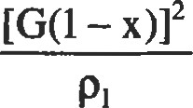(Gx)2

Pljl =; pgJ: = (1)

Figure 31 should be considered as a rough guide only.

Vertical Downward Flow

Figure 32 shows one investigator's chart [2]. Data are based on two-component mixtures of air and different liquids flowing in a pipe 25.4 mm in diameter at a pressure of around 1.7 bar. The abscissa and ordinate are the quantities Fr/'(Ä and 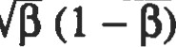 (where is the liquid holdup fraction) which are calculated at the test section pressure and temperature. The Froude number, Fr, is defined by:

(.jg + jl)2/gdi (2)

where g = acceleration due to the gravity di = pipe diameter A = a coefficient that accounts for the liquid physical properties A = (Wgw) [(pl/pw) (c/ow)(3)

where u = liquid viscosity p = liquid density

 = liquid surface tension

Subscript w refers to water at 200C and 1 bar.

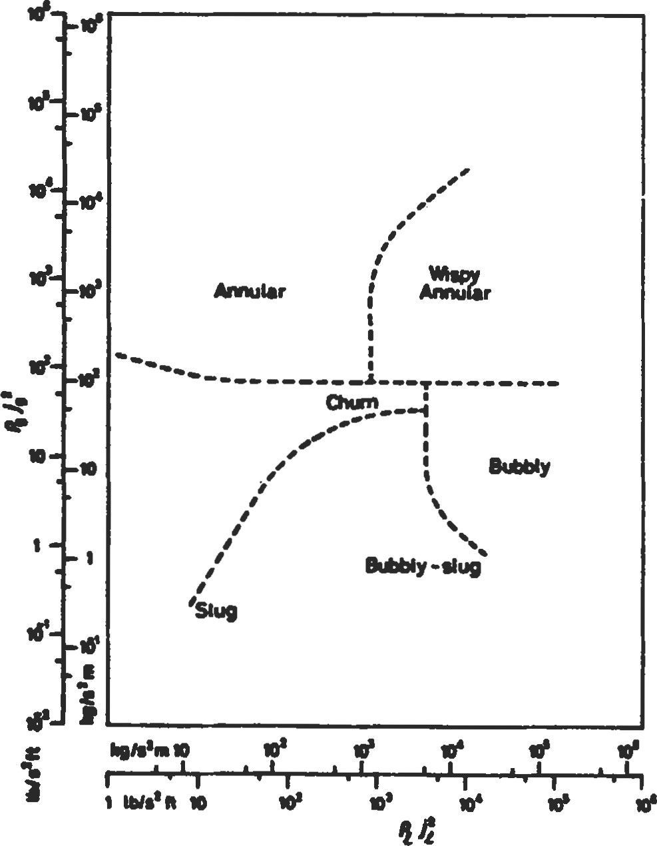

Figure 31. Flow pattern map for vertical upward flow [4]. (With permission of Ae Technology plc.)

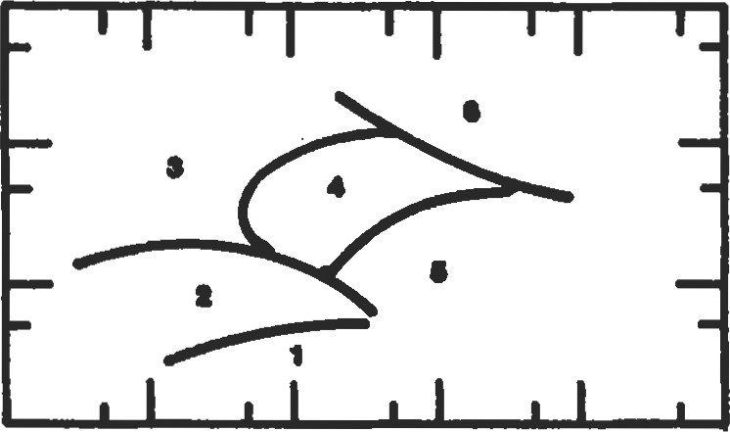100

10

1

.10

.10 1 10 too 1000 10 000

Figure 32. Now pattem map for downward flow: (1) bubbly, (2) slug falling film, (3) falling film, (4) bubbly falling film, (5) chum, and (6) dispersed annular flow

Horizontal Flow

The well-known Baker plot consists of a plot of Gg/X and GlXv/Gg, where Gg and Gl are the superficial mass velocities of the vapor and liquid phases, respectively [5]. The factors and V are:

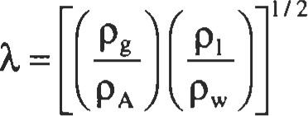 (4)

and

1/3

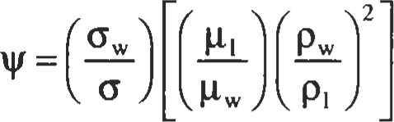 (5)

Baker's map has been modified by many investigators. Mandhane et al. [6] based a map upon 5,935 data points, I , 178 of which concern air-water flows. Its coordinates are the superficial velocities jl and jg calculated at the test section pressure and temperature. The map is shown in Figure 33 and is valid for the parameter ranges given in Table l l .

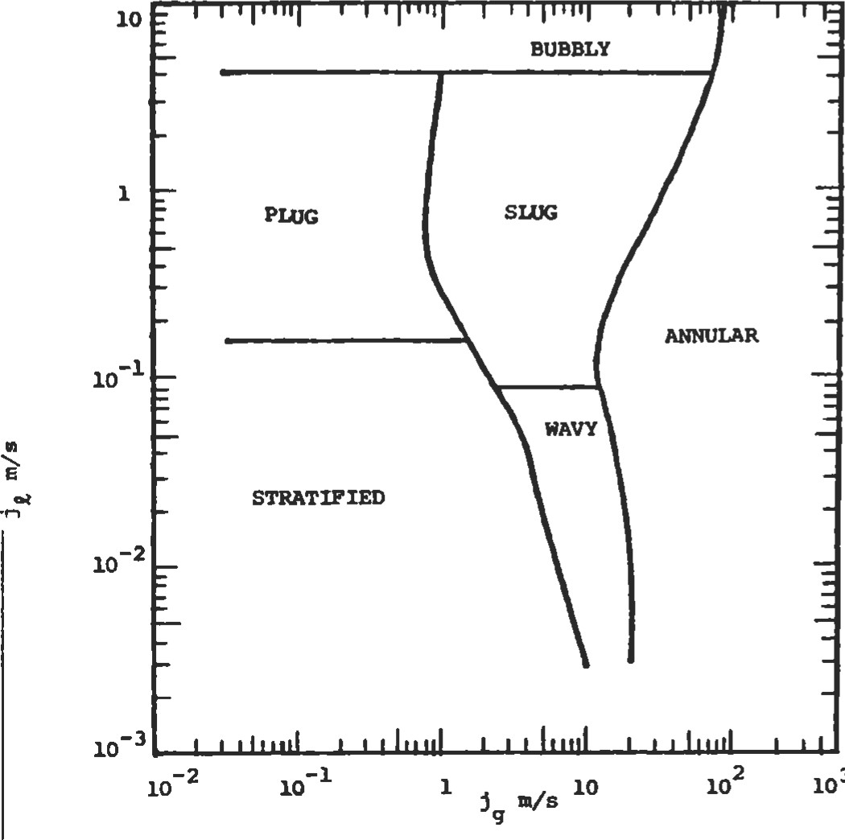

3

Figure 33. Flow map proposed by Mandhane et al.

[6]. (With permission of Elsevier Science Ltd.)

Flow Normal to Tube Banks

Flow pattern maps for both vertical and horizontal flow normal to the tube banks are given in Figure 34. The parameters of these maps are those of Baker [5], modified according to Bell, et al. [7]. It is a plot of superficial gas ve-

Table 11

Parameter Ranges for the Flow Map Proposed by Mandhane et al.

|  |  |
| --- | --- |
| Conditions | Range of Values |
| Pipe inner diameter  Liquid demity  Gas density  Liquid viscosity  Gas viscosity  Surface tension  Liquid superficial velocity  Gas superficial velocity | 12.7 - 165.1 mm  705 - 1 kg-m 3  0.80 - 50.5 kg m 3  3 X 10¯4 _ 9 x 10 -2 Pa  10 - 5 - 2.2 x 10 -5 Pa  24 - 103 mN-m-l  0.09 - 731 cm-s  0.04 171 m-s-l |

Source: Mandhane [61.

|  |
| --- |
| FLOW  VERTICAL FLOW |
| FLOW  HORIZONTAL FLOW |

.01

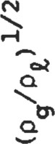1

.01

1 10

###### 1/3

/o (s /mkg)

Figure 34. Shell-side flow pattern maps [3]. (With permission of ASME.)

locity vs. superficial liquid velocity with physical property terms attached. Superficial is used in the sense that the total flow area and not the actual phase flow area is used to evaluate the phase velocity. The flow area referred to is the minimum cross-sectional area for flow through the tube bank.

Sources

1. Cheremisinoff, N. P., Heat Transfer Pocket Handbook. Houston: Gulf Publishing Co., 1984.
2. Oshinowo, T. and Charles, M. E., in Can. Journ. of Chem. Engrg., 52: 25-35, 1974.
3. Grant, 1. D. R. and Chisholm, D. in Transactions ASME, Journal off-leat Transfer; 101 (Series C): 38-42, 1979. 4. Hewitt, G. F. and D. N. Roberts, "Studies of Two-Phase Flow Patterns by Simultaneous X-Ray and Flash Photography," AERE-M2159, H.M.S.O., 1969. Copyright AEA Technology plc.
4. Baker, O. in Oil Journ., 53 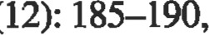 1954.
5. Mandhane, J. M., Gregory, G. A., and Aziz, K. in Intl. Journ. ofMu1ti Flow, 1: 533-537, 1974.

|  |
| --- |
| Estimating Pressure Drop |

1. Bell, K. J., Taborek, J., and Fenoglio, E, Chem. Engrg. Progress, Symposium Series (Heat Transfer—Minneapolis), 66 (102): 150-165, 1970.

Two-phase drop in a shell-and-tube heat exchanger consists of friction, momentum change, and gravity:

AP = APf+ + APg (6)

The entrance and exit pressure losses, usually considered in a compact heat exchanger application, are neglected because of

* 1. The lack of two-phase data for these pressure losses
  2. Their small contribution to the total pressure drop for tubular exchangers

The evaluation of AP due to momentum and gravity effects is generally based on a homogeneous model.

Homogeneous Flow Model

This is the simplest two-phase flow model. The basic premise is that a real two-phase flow can be replaced by a single-phase flow with the density of the homogeneous mixture defined by:

Vhm = VI (l — X) + VgX

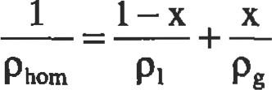 (7B)

where v is the specific volume. Subscripts I and g denote liquid and gas phases and x is the quality (the ratio of gas mass flow rate to total [gas + liquid] mass flow rate).

Ihe pressure drop/rise due to an elevation change is:

 L sin 0 (8)

Angle e is measured from the horizontal. The + sign stands for a downflow, and the — sign stands for an upflow. Gravity pressure drop predictions from this theory are good for high quality and high pressure applications. When APg is predominant (one half to two thirds of the AP), such as for low velociües and low pressure applications, the following equation, which takes into account the velocity slip between two phases via the void fraction u (the ratio of gas volume to total volume), should be used:

APg = ± (PI (1 - a) + pea) (g/gc) L sin e; for > 0.5 APtotal (9)

The momentum pressure drop/rise from the homogeneous model is:

APm 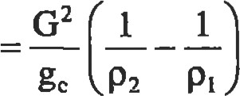 (10)

P2 and p 1 are the densities of homogeneous mixtures at the exchanger (tube) outlet and inlet, respectively. They are individually evaluated using Equation 7. G is the mass velocity.

Separated Flow Model

Here, the two phases are artificially segregated into two streams. Each stream (vapor and liquid) is under the same pressure gradient but not necessarily with the same velocity. The separated flow model reduces to the homogeneous flow model if the mean velocities of the two streams are the same. The best known separated flow model is the Lockhart and Martinelli correlation [2]. In the Lockhart-Martinelli method, the two fluid streams are considered segregated. The conventional pressure-drop friction-factor relationship is applicable to individual streams. The liquid- and gasphase pressure drops are considered equal irrespective of the flow patterns. denotes the ratio of a two-phase frictional pressure drop to a single-phase frictional pressure drop for the liquid flowing alone in the tube:

 APf

(1 1)

And for vapor:

 APf

(12)

where APg is the single-phase frictional pressure drop for the gas flowing alone in the tube.

X2 is the ratio of a single-phase pressure drop for the liquid phase flowing alone in the tube to that for the gas phase flowing alone in the tube.

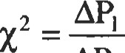 (13)

APg

The correlation is shown in Figure 35 and the curves can be represented in equation form as:

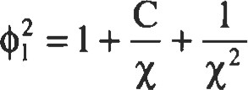 (14)

or

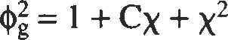 (15)

where the value of C is dependent upon the four possible single-phase flow regimes.

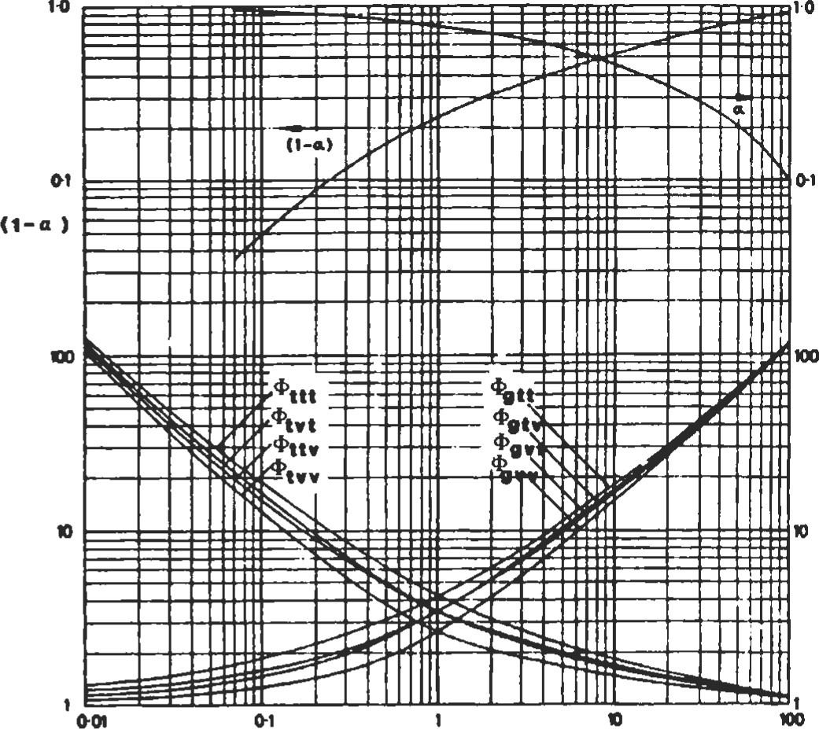

PARAMETER X

Figure 35. Lockhart-Martinelli correlation (With permission of ASME.)

|  |  |  |  |
| --- | --- | --- | --- |
| Liquid | Gas |  | c |
| Turbulent  Viscous Turbulent  Viscous | Turbulent  Turbulent  Viscous  Viscous | (tt)  (vt)  (tv)  (w) | 20  12  (16)  10  5 |

The two-phase frictional pressure drop by the Lockhart-Martinelli method is determined as follows. First, from the amount of liquid and gas flow rates, and using corresponding friction factors or appropriate correlations, API and APg are calculated. The liquid flow is considered to occupy the entire cross-section for the API evaluation, and the gas flow occupies the whole cross-section for the APg evaluation. The parameter X is then calculated from Equation 13. The value of C is determined from Equation 16 and or are computed from Equations 14 and 15. The twophase frictional pressure drop is then calculated from the definition of 

The Lockhart-Martinelli method was developed for two component adiabatic flows at a pressure close to atmospheric. Martinelli and Nelson [3] extended this method for forced convection boiling for all pressures up to the critical point. The mixture of steam and water was considered "turbulentturbulent." They presented graphically as a function of the quality x and the system pressure as shown in Figure 36.

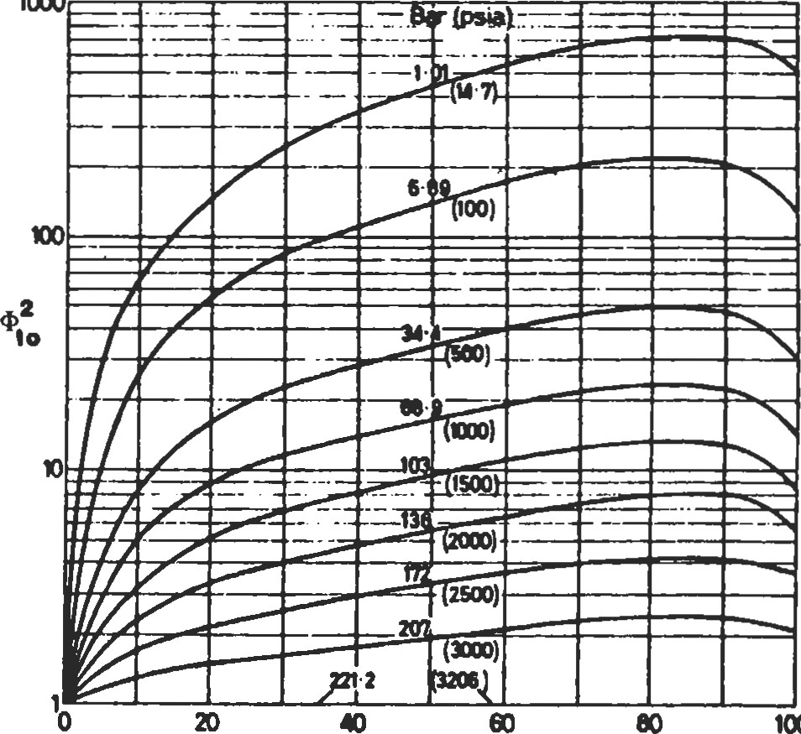

1000

100

MASS QUALITY, WT. %

Figure 36. MartinelIi-Nelson correlation

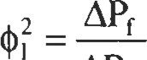 (17) APIO

where APIO is the frictional pressure drop for the liquid flow alone, in the same tube, with a mass flow rate equal to the total mass flow rate of the two-phase flow.

The Martinelli-Nelson experimental curves of vs. x show breaks in the slope due to changes in flow regimes. Surface tension is not included although it may have a significant influence at high pressure near the critical point. The Martinelli-Nelson method provides more correct results than the homogeneous model for low mass velocities (G < I ,360 kg/m2s). In contrast, the homogeneous model provides better results for high mass velocities.

Chisholm gives the following correlation for flow of evaporating two-phase mixtures that accounts for some of the effects neglected in other methods [4].

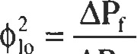

APIo

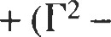l ) [Bx( 2 -n)/2 (l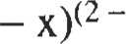n)/2 + X (18)

n is the exponent in the Blasius relation for friction factor f = Cl/Ren, with n = 0.25 for the turbulent flow. These discussions are inclusive of tube flow only.

|  |  |
| --- | --- |
| r 2 = APg0/APlo | (20) |
| C = (m/pg) l /2/K + K (pg/Pl) l/2 | (21) |
| K = velocity ratio = jg/jl | (22) |

Two-phase pressure-drop correlations for the shell-side flow are available for a segmentally baffled shell-and-tube exchanger. The frictional pressure drop consists of two components, one associated with the crossflow zone and the other with the window zone. Grant and Chisholm determined the components of the pressure drop [4]. The twophase crossflow zone and window zone frictional pressure drops are given by Equation 18 with values of B given in Table 12. Values of exponent n for the crossflow zone are: n = 0.46 for horizontal side-to-side flow, and n = 0.37 for vertical up-and-down flow.

Table 12

Values of B for Two-Phase Frictional Pressure-Drop

Evaluation in Crossflow and Window-Flow Zones by Equation 18

|  |  |  |
| --- | --- | --- |
| Zone | Horizontal | Vertical  Up and Down Flow |
| Crossflow  Spray and bubble  Stratified and  Stratified spray  Window (n = 0) | 0.75  0.25 | 1.0  (pdPhom)0 25 |

Sources

l . Cheremisinoff, N. P., Heat Transfer Pocket Handbook.

Houston: Gulf Publishing Co., 1984.

1. Lockhart, R. W. and Martinelli, R. C. , in Chem. Engrg. Prog., 45: 39-48, 1949.
2. Martinelli, R. C. and Nelson, D. B. , in Transactions ASME, 70: 695, 1948.
3. Chisholm, D., Intl. Joum. ofHeat and Mass Transfer, 16: 347-358, 1973.

where



### Thermodynamics

Bhabani P. Mohanty, Ph.D., Development Engineer, Allison Engine Company

Thermodynamic Essentials52 Thermodynamic Temperature Scale 59

Phases of a Pure Substance52 Useful Expressions

Thermodynamic Properties53

Determining Properties55

Types of Systems56 Carnot Cycle

Types of Processes56 Rankine Cycle: A Vapor Power Cycle

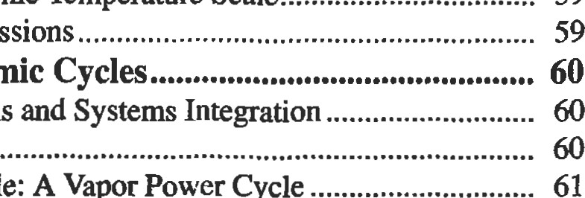

Thermodynamic

Basic

Systems

61

The Zeroth Law of ThermodynamicsReversed Rankine Cycle: A Vapor

First Law of Thermodynamics58 Refrigeration Cycle

|  |  |  |  |  |
| --- | --- | --- | --- | --- |
| Heat | 58 | Otto Cycle: A Power Cycle |  | 63 |
| First Law of Thermodynamics for Closed Systems | 58 | Diesel Cycle: Another Power Cycle |  | 63 |

 Work58 Brayton Cycle: A Gas Turbine Cycle

First Law of Thermodynamics for Open Systems Gas Power Cycles with Regeneration

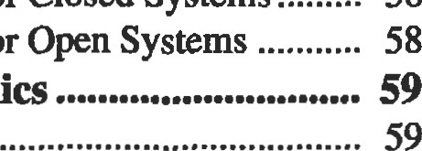

59

Second Law of Thermodynamics

Reversible Processes and Cycles

#### THERMODYNAMIC ESSENTIALS

|  |
| --- |
| Phases of a Pure Substance |

Thermodynamics is the subject of engineering that predicts how much energy can be extracted from a working fluid and the various ways of achieving it. Examples of such areas of engineering interest are stearn power plants that generate electricity, internal combustion engines that power automobiles, jet engines that power airplanes, and diesel locomotives that pull freight. The working fluid that is the medium of such energy transfer may be either steam or gases generated by fuel-air mixtures.

The process of energy fransfer from one form to another is dependent on the properties of the fluid medium and phases of this substance. While we are aware of basically three phases of any substance, namely solid, liquid, and gaseous, for the purposes of thermodynamic analysis we must define several other intermediate phases. They are:

* Solid: The material in solid state does not take the shape of the container that holds it.
* Subcooled liquid: The liquid at a condition below its boiling point is called subcooled because addition of a little more heat will not cause evaporation.
* Saturated liquid: The state of liquid at which addition of any extra heat will cause it to vaporize.
* Saturated vapor: The state of vapor that is at the verge of condensing back to liquid state. An example is steam at 2120F and standard atmospheric pressure.
* Liquid vapor mix: The state at which both liquid and vapor may coexist at the same temperature and pressure. When a substance exists in this state at the satutemperature, its quality is a mass ratio defined as follows:

m

quality = vapor

mvapor + mliquid

' Superheated vapor: The state of vapor at which extraction of any small amount of heat will not cause con-



* Ideal gas: At a highly superheated state of vapor, the gas obeys certain ideal gas laws to be explained later in this chapter.
* Real gas: At a highly superheated state of vapor, the gas is in a state that does not satisfy ideal gas laws.

Because the phase of a substance is a function of three properties, namely pressure, temperature, and volume, one can draw a three-dimensional phase diagram of the substance. But in practice, a two-dimensional phase diagram is more useful (by keeping one of the three properties constant). Figure 1 is one such example in the pressurevolume plane. The region of interest in this figure is the liquid-vapor regime.

|  |
| --- |
| Solid  an  Isothenn  Criical  isotherm |

p

Figure 1. The p-v diagram.

|  |
| --- |
| •mermodynamics  Thermodynamic Properties |

There are two types of thermodynamic properties: extensive and intensive. Extensive properties, such as mass and volume, depend on the total mass of the substance present. Energy and entropy also fall into d)is category. Intensive properties are only definable at a point in the substance. If the substance is uniform and homogeneous, the value of the intensive property will be the same at each point in the substance. Specific volume, pressure, and temperature are examples of these properties.

Intensive properties are independent of the amount of matter, and it is possible to convert an extensive parameter to an intensive one. Following are die properties that govem thermodynamics.

Mass (m) is a measure of the amount of matter and is expressed in pounds-mass (lbm ) or in pound-moles.

Volume (V) is a measure of the space occupied by the matter. It may be measured directly by measuring its physical dimensions, or indirectly by measuring the amount of a fluid it displaces. Unit is ft3 .

volume (v) is the volume per unit mass. The unit is given in ft3/lbm.

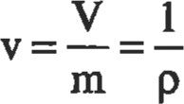

Density (p) is the mass per unit volume. It is reciprocal of the specific volume described above.

Temperature (T) is the propeny that depends on the energy content in the matter. Addiüon of heat causes the temperature to rise. The Zemth Law ofThermodynamics defines temperature. This law states that heat flows from one source to another only if there is a temperature difference between the two. In other words, two systems are in thermal equilibrium if they are at the same temperature. The temperature units are established by familiar freezing and boiling points of water (320F and 2120F, respectively).

The relationship between the Fahrenheit and Celsius scales is:

T OF=32+ - T OC

In all thermodynamic calculations, absolute temperatures must be used unless a temperature difference is involved. The absolute temperature scale is independent of properties of any particular substance, and is known as Rankine and Kelvin scales as defined below:





The pressure, volume, and temperature are related by the so-called ideal gas law, which is:



where R is the proportionality constant.

Pressure (p) is the normal force exerted per unit surface

hessure measured from the surrounding atmosphere is called the gage pressure, and if measured from the absolute vacuum, it is called the absolute pressure.

Pabs = Patm + Pgage

Its unit is either psi or inches of water:

1 atm = 14.7 psi = 407 inches of water = 1 bar

Internal energy (u, U) is the energy associated with the existence of matter and is unrelated to its position or velocity (as represented by potential and kinetic energies). It is a function of temperature alone, and does not depend on the process or path taken to attain that temperature. It is also known as specific internal energy. Its unit is Btu/lbm. Another form of internal energy is called the molar intemal

mumb

energy, and is represented as U. Its unit is Btu/pmole. These two are related by u = U/M; u is an intensive property like p, v, and T.

Enthalpy (h, H) is a property representing the total useful energy content in a substance. It consists of intemal energy andflow energy pV. Thus, H = U + pV/J (Btu/pmole) h = u + pv/J (Btu/lbm)

Like internal energy, enthalpy also has the unit of energy, which is force times length. But they are expressed in the heat equivalent of energy, which is Btu in the US. customary system and Joule in the metric system.

The J term above is called the Joule 's constant. Its value is 778 ft.lbf/Btu. It is used to cause the two energy components in enthalpy to have equivalent units. Enthalpy, like internal energy, is also an intensive property that is a function only of the state of the system.

Entropy (s, S) is a quandtative measure of the degradation that energy experiences as a result of changes in the universe. In other words, it measures unavailable energy. Like energy, it is a conceptual property that cannot be measured directly. Because entropy is used to measure the degree of irreversibility, it must remain constant if changes in the universe are reversible, and must always increase during irreversible changes.

For an isothermal process (at constant temperature To), the change in entropy is a function of energy transfer. If Q is the energy transfer per lbm, then the change in entropy is given by:

As = —

Nonisothermal processes follow these relationships:

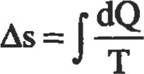

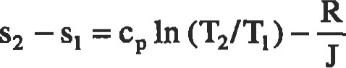In (P2/pD

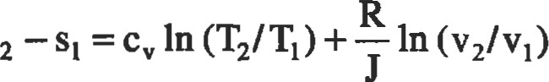

Specific heat (C): The slope of a constant pressure line on an h-T plot is called specific heat at constant pressure, and the slope at constant volume on a u-T plot is called specific heat at constant volume.

cp = dh/dT, = du/dT

R cp - cv, k = Cp/Cv

because du = dh — RdT for an ideal gas. Values of Cp, Cv, k, and R for a few gases are given in Table 1. R is in ft — lbf/lbm — OR, and Cp, cv are in Btu/lbm — OF.

Latent heats is defined as the amount of heat added per unit mass to change the phase of a substance at the same pressure. There is no change in temperature during this phase change process. The heat released or absorbed by a mass m is Q = m(LH), where LH is the latent heat. If the phase change is from solid to liquid, it is called the latent heat offusion. When it is from liquid to vapor, it is called the latent heat ofvaporization. Solid-to-vapor transition is known as the latent heat of sublimation. Fusion and vaporization values for water at 14.7 psi are 143.4 and 970.3 Btu/lbm, respectively.

Table 1

Gas Properties

|  |  |  |  |  |  |
| --- | --- | --- | --- | --- | --- |
| Gas | Mol. Wt |  | c, | k |  |
| Acetylene  Air  Ammonia  Carbon dioxide  Carbon monoxide  Chlorine  Et•tane  Helium Hydrogen  Methane  Nitrogen Oxygen Propane  Steam  Sulphur dioxide | 26.00  29.00  17.00  44.00  28.00  70.90  30.07  4.00  2.00  16.00  28.00  32.00  44.09  18.00  64.10 | 0.350  0.240  0.523  0.205  0.243  0.115  0.422  1.250  3.420  0.593  0.247  0.217  0.404  0.460  0.154 | 0.2737  0.1714  0.4064  0.1599  0.1721  0.0865  0.3570  0.7540  2.4350  0.4692  0.1761  0.1549  0.3600  0.3300  0.1230 | 1.30  1.40  1.32  1.28  1.40  1.33  1.18  1.66  1.41  1.32  1.40  1.40  1.12  1.28  1.26 | 59.4  53.3  91.0  35.1  55.2  21.8  51.3  386.3  766.8  96.4  55.2  48.3  35.0  85.8  24.0 |

|  |
| --- |
| Thermodynamics  Determining Properties |

Ideal Gas

A gas is considered ideal when it obeys certain laws. Usually, the gas at very low pressure/high temperature will fall into this state. One of the laws is Boyle's law: PV = constant; the other is Charles' law: VA' = constant. Combining these two widl Avogadro's hypothesis, which states that "equal volumes of different gases with the same temperature and pressure contain the sarne number of molecules," we at the general law for the ideal gas (equation of state):

##### pv

where R* is called the universal gas constant. Note that R* = MR, where M is the molecular weight and R is the specific gas constant. If there are n moles, the above equation may be reformatted:

pv = nR*T = mRT

where m is the mass: m = nM.

Table 2 provides the value of R*, the universal gas constant, in different units:

Table 2

Univeßal Gas Consunt Values

|  |  |
| --- | --- |
| Value of | Unit |
| 1.314  1.9869  1545  0.7302  8.3144  1.9872 | (atm — mol  BTU/Ob - mol OR)  (bf - - mol OR)  (atm ftY(Ib — mol OR)  J/(gm — mol cal/(gm — mol |

Van der Waals Equation

The ideal gas equation may be corrected for its two worst assumptions, i.e., infinitesimal molecular size and no intermolecular forces, by the following

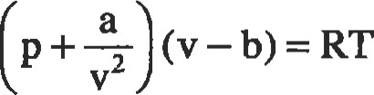

where a/v2 accounts for the intermolecular attraction forces and b accounts for the finite size of the gas molecules.

In theory, equations of state may be developed that relate any property of a system to any two other properties. However, in practice, this can be quite cumbersome. This is why engineers resort to property tables and charts that are readily available. Following are some of the most widely used property charts:

* p-v diagram: Movement along an isotherm represents expansion or compression and gives density or specific volume as a ftlnction of pressure (see Figure 1). The 1?gion below the critical isotherm T = Tc corresponds to temperatures below the critical temperature where it is possible to have more than one phase in equilibrium.
* T-s diagram: This is the most useful chart in representing the heat and power cycles (see Figure 2). A line of constant pressure isobar is shown along with the critical isobar P = Pc. This chart might also include lines of constant volume (isochores) or constant enthalpy

(isenthalps).

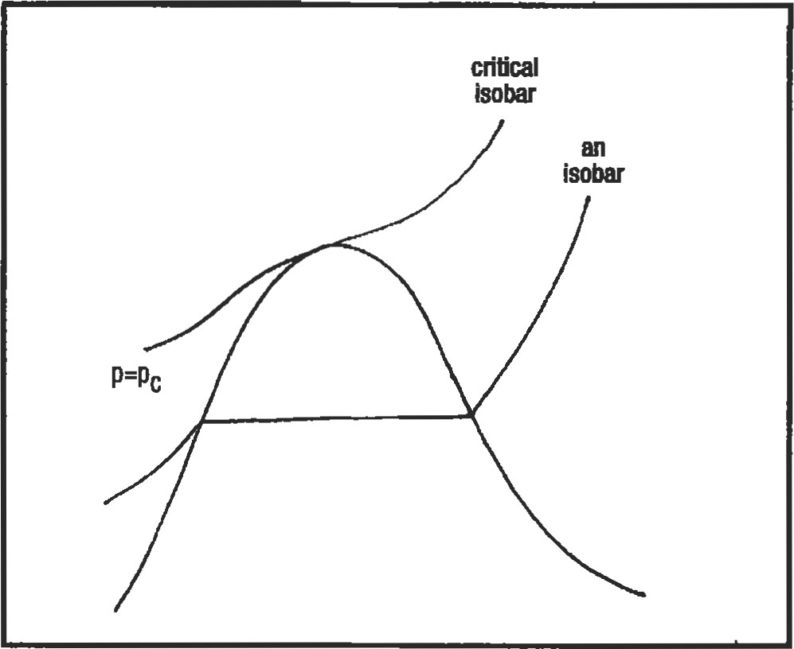

s

Figure 2. The T-s diagram.

Thumb

|  |
| --- |
| isobars (psi) std atmosphere (14.7 psi)  moisture)  isotherms ('F)  constant superheat (OF)  saturation line |

moisture content) are shown. Above it are the fines of conStant superheat and constant temperature. Isobars are also superimposed on top.

The properües may also be found through various tables with greater accuracy. These are:

a

* Steam tables, which give specific volume, enthalpy, entropy, and internal energy as funcüons of temperature.
* Superheat tables, which give specific volume, enthalpy, and entropy for combinations of pressure and temperature. These in the superheated regime.
* Compressed liquid tables, which give properties at the saturation state and corrections to these values for various pressures.

Entropy S (BbJlb.0R) • Gas tables, which are essentially superheat tables for various gases. Properties are given as functions of tem-

Figure 3. The Mollier chart (h-s diagram). perature alone.

' h-s diagram: This is also called the Mollier chart (Figure 3). It is used to determine property changes between the superheated vapor and the liquid-vapor regions. Below the saturation line, lines of quality (constant

|  |  |  |  |
| --- | --- | --- | --- |
| Types of Systeß | |  | |
| Matter enclosed by a well-defined boundary is called a thermodynamic system. Everything outside is called the envimnment. The volume of the enclosed region is called the control volume, and its surface is the contml surface. I-mere is no mass exchange across the boundary, it is called a closed | | system as opposed to an open system. The most important system is a "steady flow open system," where the rate of mass exchange at the entry and exit are the same. Pumps, turbines, and boilers fall into this category. | |
| Types of Processes | |  | |
| A process is defined in terms of specific changes to be accomplished. Two types of energy transfers may take place across a system boundary: thermal energy transfer (heat) and mechanical energy (work). Any process must have a well-defined objective for energy transfer. Below are definitions of  processes and the relationships between variables in the processes. The equations are in a per lbm basis, but can be converted to a 1b — mol basis by substituting V for v, H for h, and R* for R: | Isothemal: a constant temperature process (T2 = TD  P2 = Pi(V l/V2)  = VI(Pl/P2)  Q = W = T (h - In (V2/Vl) W = Q T (h - SD = RT In (V2/Vl)    = + (Q/T) = R In (V2/Vl) = R In (PI/pD h2 = hi | |

Isobaric: a constant pressure process (P2 = PI)

T2=Tl (V2/Vl)

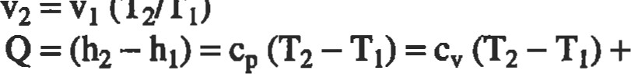(T2rrl) p(V2-Vl)

u2 = ul + (T2 — TD = cyp (v2 — vD/R =

S2 = + cp In(T2/T1) = cp In(v2/v1) h2 — hi = Q = % (T2 — TD =kp (v2 — vD/(k — 1) Isochoric: a constant volume process (v2 = vD.

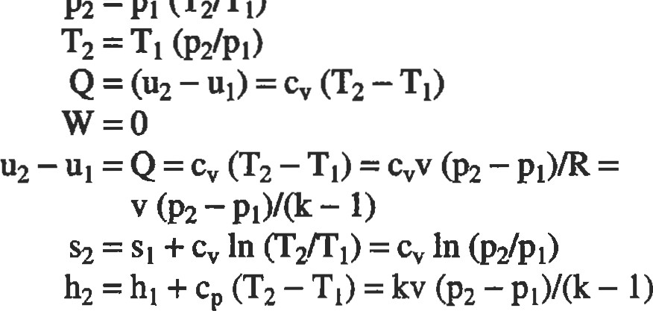

P2=Pl

Adiabatic: a process during which no heat is u•ansferred between the system and its sun•oundings (Q = 0). Many real systems in which there is little time for heat may be assumed to be adiabatic. Adiabatic processes can further be divided into two categories: isentropic and isenthalpic.

T/T

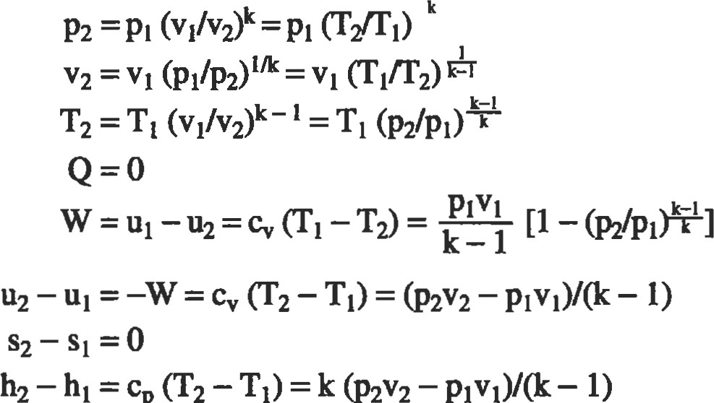

-

cp

-

-

Thennodynemlcs

Iseüoplc: a constant entropy process (steady flow) (Q =

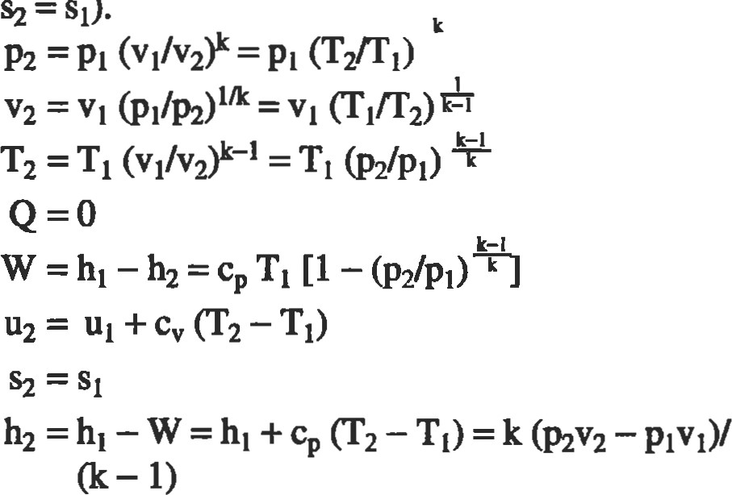

O,

=

SD.

Isenthalpic: a constant enthalpy process (steady flow).

Also known as a throttling process (Q = O, W = O).

###### T2=TI

s.2 = Sl + R In (PI/P2) = + R In (v2/v1) h2 = hi

Polyüopic: a process in which the working fluid properties obey the polyü•opic law: = W}.

|  |
| --- |
| —  The Zeroth Law of Themodynamlcs |

P2 = Pi = PI ('VT))

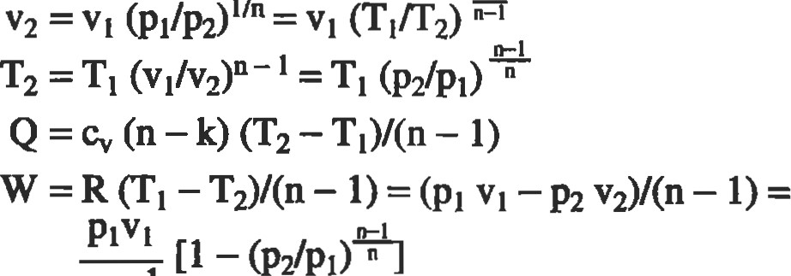

n—l

The Zeroth Law of Thermodynamics defines temperature. This law states that heat flows from one source to another only if there is a temperature difference between the two. Therefore, two systems are in thermal equilibrium if they are at the same temperature.

|  |
| --- |
| Thumb  FIRST LAW OF THERMODYNAMICS |

|  |  |
| --- | --- |
| Work |  |
| Work may be done by (WouD or on (Win) a system. In thermodynamics, we are more interested in work done by a system Wout, considered positive, which causes the energy of the system to reduce. Work is a path funcüon. Since it does not depend on the state of the system or of the sub- | stance, it is not a property of the system. In a p-v diagram, work is the following integral: |
| Heat |  |
| Heat is the thermal energy transferred because of temperature difference. It is considered positive if it is added to the system, that is, Qin. A unit of heat is the same as energy, that is, ft.lbf; but a more popular format is Btu:  1Btu = 778.17/ft.1bf = 252/ca10ries = 1,055/Jou1es | Like work, it is a path function, and not a property of the system. If there is no heat transferred between the system and the surroundings, the process is called adiabatic. |
| First Law of Thermodynamics for Closed Systems |  |

The first law of thermodynamics establishes the principle of conservation of energy in thermodynamic systems. In thamodynamics, unlike in purely mechanical systems, dansformaüon of energy takes place between different sources, such as chemical, mechanical, and electrical. The two basic forms of energy transfer are work done and heat transfer.

Briefly, the first law states that "energy can not be created or desü•oyed." This means that all forms of energy (heat and work) entering or leaving a closed system must be accounted for. This also means that heat entering a closed system must either increase the temperature (in the form of U) and/or be used to perform useful work W:

First Law of Thermodynamics for Open Systems

The law for open systems is basically Bernoulli's equation extended for nonadiabatic processes. For systems in which the mass flow rate is constant, it is known as the steady flow energy equation. On a per unit mass basis, this equation is:

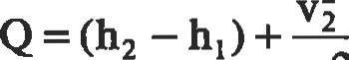-VI g(Z2 -4) W

2gJ

Q=AU+

Note that the Joule's constant was used to convert work to its heat equivalent (ft.lbf to Btu).

Both sides may be multiplied by the mass flow rate (md0t) to get the units in Btu or be multiplied by (md0tJ) to get the in ft — lbf.

The above equation may be applied to any thennodynamic device that is continuous and has steady flow, such as turbines, pumps, compressors, boilers, condensers, nozzles, or throttling devices.

###### SECOND LAW OF THERMODYNAMICS

|  |
| --- |
| Reversible Processes and Cycles |

All thermodynamic systems adhere to the principle of conservation of energy (the first law). The second law describes the resuictions to all such processes, and is often called the Kelvin-Planck-Clausius Law. The statement of this law: "It is impossible to create a cyclic process whose only effect is to üansfer heat from a lower temperature to a higher temperature."

A reversible process is one that can be reversed without any resultant change in either the system or the surroundings; hence, it is also an ideal process. A reversible process is always more efficient than an irreversible process. The four phenomena that may render a process irreversible are: (1) friction, (2) unresü•ained expansion, (3) d•ansfer of heat across a finite temperature difference, and (4) mixing of different substances.

A cycle is a series of processes in which the system always returns to the same thermodynamic state that it started from. Any energy conversion device must operate in a cycle. Cycles that produce work ouQut called power cycles, and ones that pump heat from lower to higher temperature are called refrigeration cycles. Thermal efficiency for a power cycle is given by:

|  |  |
| --- | --- |
| Themodynamic Temperature Scale |  |
| If we run a Carnot cycle engi.ne between the temperatures corresponding to boiling water and melting ice, it can be shown that the efficiency of such an engine will be 26.8%. Although water is used as an example, the effciency of such an engine is actually independent of the working fluid | used in the cycle. Because = 1 — (Q/QH), the value of QL/QH is 0.732. This sets up both our Kelvin and Rankine scales once we establish the differential. In Kelvin scale, it is 100 degrees; in Rankine scale, it is 180 degrees. |
| Useful Expressions |  |

qthermal = q• ¯—Wout + Qout Qin whereas the coeficients ofperformance for refrigerators and heat pumps are defined as qjn/Win and respectively.

* Change in internal energy:

du = T ds — P dv

* Change in enthalpy:

###### dh=Tds+vdP

* Change in entropy:

ds = cvdTrr + Rdv/v

* Volumetric efficiency is a measure of the ability of an engine to 'breathe," and may be determined from the following equation: volume of air brought into cylinder at ambient conditions piston displacement

' Mean effective pressure (mep) is net work output, in inch-lbf per cubic inch of piston displacement. It is applicable only to reciprocating engines, and effectively is the average gage pressure acting on the piston during a power stroke.

* Work done:

(mep) (Vdsp) = (mep) It (bore)2 (stroke)/4

* Brake-specific fuel consumption (bsfc):

fuel rate in lbm/hr bsfc = bhp

|  |
| --- |
| mumb  THERMODYNAMIC CYCLES |

|  |
| --- |
| Basic Systems and Systems Integration |

A thermodynamic cycle can be either open or closed. In an open cycle, the working fluid is constantly input to the system (as in an aircraft jet engine); but in a closed cycle, the working fluid recirculates within the system (as in a refrigerator). A vapor cycle is one in which there is a phase change in the working fluid. A gas cycle is one in which a gas or a mixture of gases is used, as the fluid that does not undergo phase change.

While, in theory, a cycle diagram explains the thermodynamic cycle, it takes a real device to achieve that energy process. The change of property equations for these devices can be derived from the steady-flow energy equation. Following is a list of these devices:

* Heat exchangers: transfer energy from one fluid to another.
* Pumps: considered adiabatic devices that elevate the total energy content of the fluid.

The Camot cycle (Figure 4) is an ideal power cycle, but it cannot be implemented in pracüce. Its importance lies in the fact that it sets the maximum attainable thermal efflciency for any heat engine. rlhe four processes involved are:

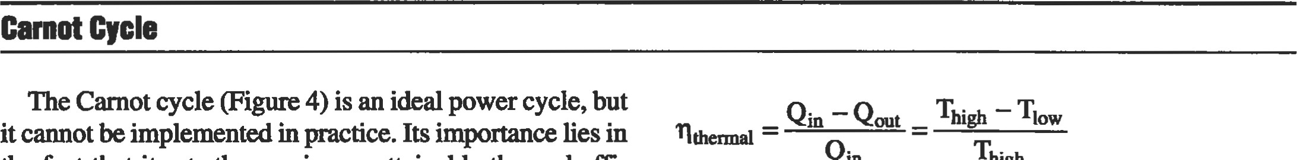

Qin

high

1-2 Isothermal expansion of saturated liquid to saturated gas

2-3 Isenüopic expansion

34 Isothermal compression

4-1 Isentropic compression

The heat flow in and out of the system and the turbine and compressor work terms are:

Qin Thigh (S2 ¯ SD = h2 — hl

Qout = Tlow (S3 ¯ S4) = h3 — h4

Wnub=h2-h3

Wcomp = hi — h4

The thermal efficiency of the cycle is:

* narbines: adiabaüc extraction of energy from the fluid with a drop in temperature and pressure. Compressors: similar to pumps in principle.  Condensers: remove heat of evaporation from fluid and reject to the environment.
* Nozzles: convert the fluid energy to kinetic energy; adiabatic; no work is performed.

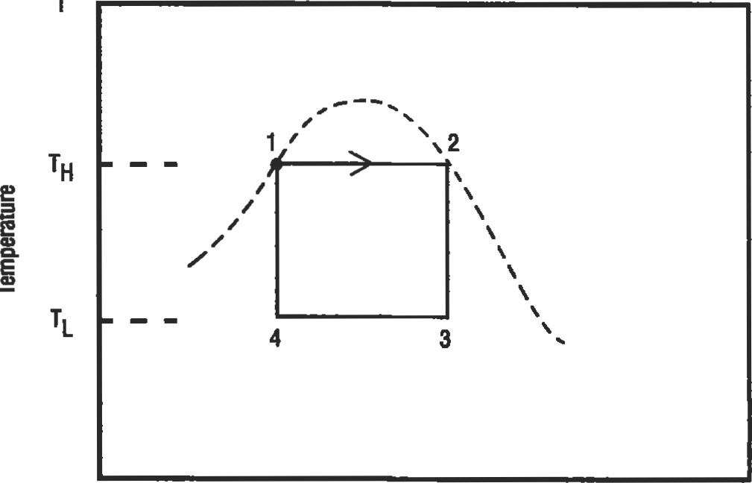

Entropy S

Flgure 4. Camot cycle.

|  |
| --- |
| Ranklne Cycle: A Vapor Power Cycle |

The Rankine cycle (Figure 5) is similar to the Carnot cycle. The difference is that compression takes place in the liquid region. This cycle is implemented in a steam power plant. The five processes involved are:

1-2 Adiabatic compression to boiler pressure

2-3 Heaüng to fluid saturaüon temperature

34 Vaporization in the boiler

4-5 Adiabatic expansion in the turbine

5-1 Condensation

The heat flow in and out of the system and the turbine and compressor work terms are:

qin = h4 — h2 qout= h5 — hi

Wnuo=m-h5 -hi = VI (PE PI)/J

The thermal efficiency of the cycle is:

|  |  |
| --- | --- |
| |  | | --- | | isothem  superheating  lower condenser temp. |   s  wout  Win  Qin  Figure 5. Rankine cycle.  Reversed Ranklne Cycle: A Vapor Refrigeration Cycle |

qin ¯qout _ (h4 —h5) — (h2 — hi) nthermal = qin

The reversed Rankine cycle (Figure 6) is also similar to the Carnot cycle. The difference is that compression takes place in the liquid region. This cycle is implemented in a steam power plant. The four processes involved are:

1-2 Isentropic compression; raise temperature and pressure

2-3 Reject heat to high temperature

3-4 Expander reduces pressure and temperature to initial value 4-1 Fluid changes dry vapor at constant pressure; heat added

The heat flow in and out of the system and the turbine and compressor work terms are:

qin hl ¯ h4 qout = h2 ¯ h3

Wturb=hl -h2 Wcomp=m-h3

The thermal emciency of the cycle is:

qin ¯ qout nthermal

qin hi — h4

Thumb

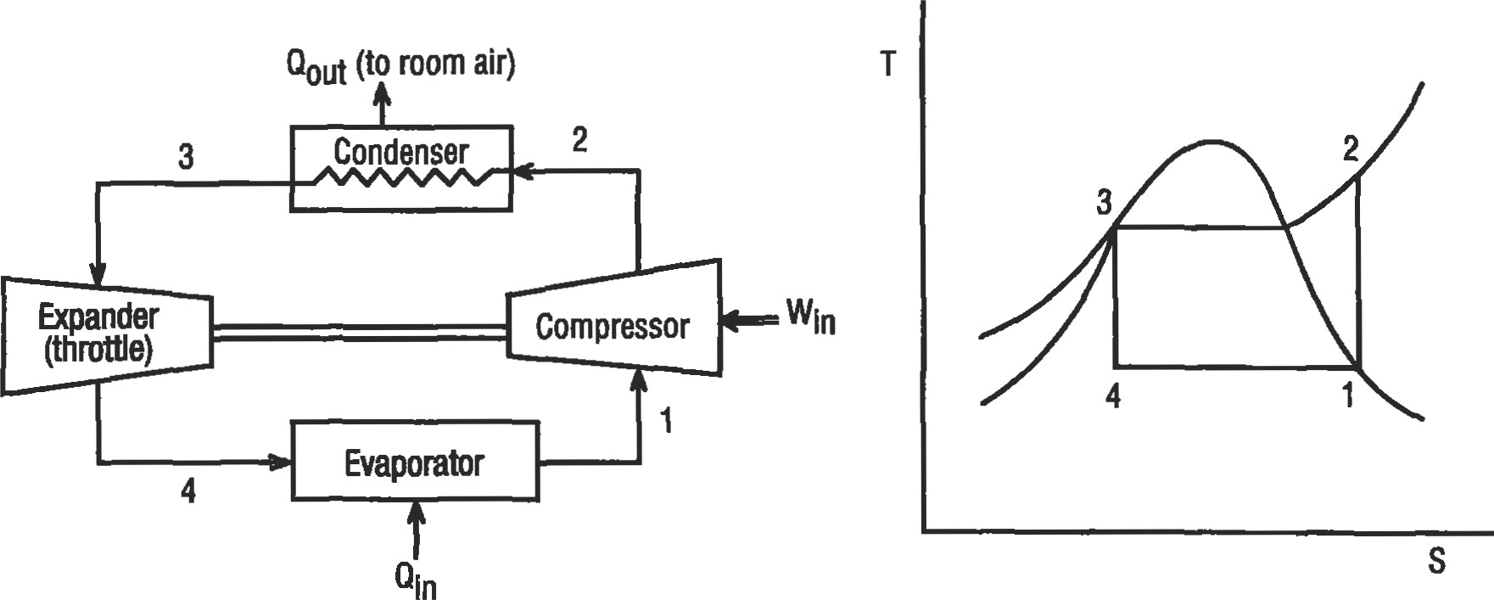

Figure 6. Reversed Rankine cycle (vapor refrigeration system).

Brayton Cycle: A Gas Turbine Cycle

|  |  |
| --- | --- |
| The Brayton cycle (Figure 7) uses an air-fuel mixture to keep the combustion temperature as close to the metallurgical limits as possible. A major portion of the work output from the turbine is used to dlive the compressor. The remainda may be either shaft output (perhaps to drive a pry peller, as in a turboprop, or drive a fan, as in a turbofan) or nozzle expansion to generate thrust (as in a turbojet engine). The four processes involved are:  1-2 Adiabatic compression (in compressor)  2-3 Heat addition at constant pressure (in combustor) | The heat flow into the system and the turbine and com pressor work output terms are:    % 03 ¯ T4) = h3 — m,    The thermal efficiency of the cycle is: |

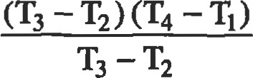3-4 Adiabatic expansion (in turbine) othermal ¯

4-1 Heat rejection at constant pressure

Fuel

|  |
| --- |
| 3  2  4  1 |

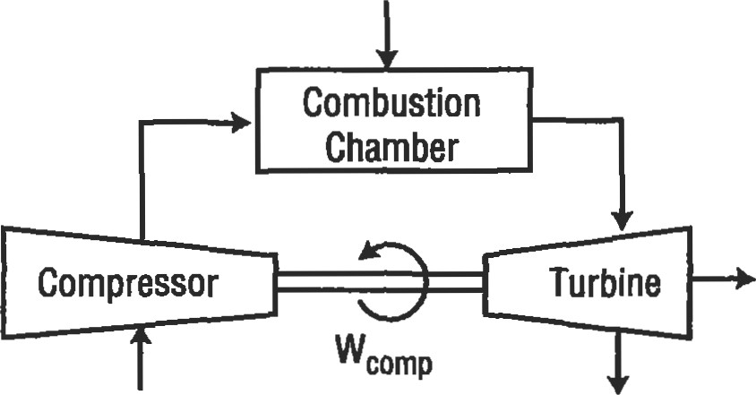wnet

Inlet Exhaust

Air Products

S Figure 7. Brayton cycle (gas turbine engine).

Otto Cycle: A Power Cycle

The Otto cycle (Figure 8) is a four-stroke cycle as represented by an idealized internal combustion engine. The four processes involved are:

1-2 compression

2-3 Heat addition at constant volume

3-4 Adiabaüc expansion

4-1 Heat rejection at constant volume

The heat flow in and out of the system and the work input and work output terms are:

|  |
| --- |
| R=Compression ratio  3  Qout  1 |

P

VI

qin (TV T2), TD

Win = (T2 - Tl), wout= (T3 -T4)

The thermal efficiency of the cycle is:

nthermal ¯ q in

|  |
| --- |
| 3  wout  Win  1 Qout |

|  |
| --- |
| Figure 8. Otto cycle (ideal closed system).  Diesel Cycle: Another Power Cycle |

S

In a diesel engine, only air is compressed; fuel is introduced only at the end of the compresü)n stoke. 'Ihat is why it is often referred to as a compression-ignition engine. This cycle (Figure 9) uses the heat of the compression process to start the combustion process. The four processes involved are:

1-2 Adiabatic compression

2-3 Heat addition at constant pressure

34 Adiabatic expansion (power stroke)

4-1 Heat rejection at constant volume

The heat flow in and out of the system and the work input and work output terms are:

qin = Cp (T3 ¯ T2)' qout = cv (T4 — T l)

Win = cv (T2 ¯ Tl)' Wout = cv 03 ¯ T4) + (cp

The thermal efficiency of the cycle is:

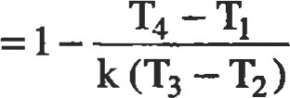qin ¯ qout

Othermal =

q in

|  |  |  |  |  |  |  |
| --- | --- | --- | --- | --- | --- | --- |
| Thumb   |  |  |  |  |  |  | | --- | --- | --- | --- | --- | --- | | |  |  | | --- | --- | | 2 | 3  1 | |  | | |  | | --- | | 3  2  4  Gut | |   s  Figure 9. Diesel cycle.  Gas Power Cycles with Regeneration |

Use of regeneration is an effective way of increasing the thermal efficiency of the cycle, particularly at low compressor pressure raüos. The Sürling and Ericsson cycles are such attempts to get efficiencies close to that of the ideal Carnot cycle.

Stlrllng Cycle

This cycle (Figure 10) can come to attain the thermal efficiency very close to that of a Carnot cycle. 'Ihe isothermal processes can be attained by reheating and intercooling. This cycle is suitable for application in reciprocating machinery. The four processes involved are:

|  |
| --- |
| Qin  2  Qout  Qout |

1

1-2 Heat addition at constant volume (compression) 2-3 Isothermal expansion with heat addition (energy input and power

3-4 Heat rejection at constant volume

4-1 Isothermal compression with heat rejection

In an ideal regenerator, the quantity of heat rejected during 34 is stored in the regenerator and then is restored to the working fluid during the process 1-2. But in reality, there is some loss in between.

The heat flow in and out of the system and the work input and work output terms are:

|  |
| --- |
| Qout |

s

Figure 10. Stifling cycle.

|  |
| --- |
| 3  2  Qout  1 4 |

p 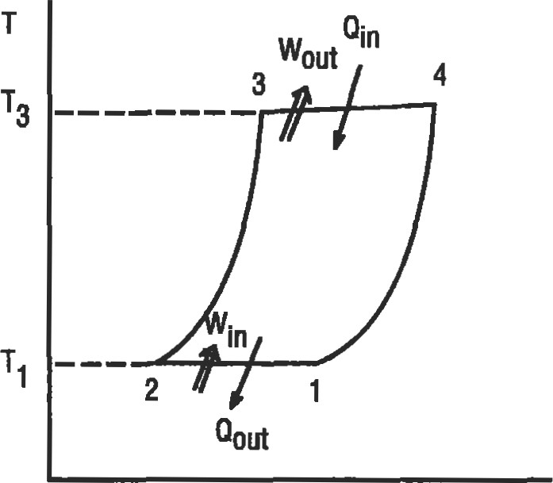

s

Figure 11. Ericsson cycle.

qin= (11-2 + q2-3

Win W = Qout Wout —— W2-3 = Qin

The thermal efficiency of the cycle is:

qthermal =

Ericsson Cycle

This cycle (Figure 11) can also come very close to attaining the thermal emciency of a Camot cycle. The isothermal processes can be attained by reheating and intercooling. Its Qlicaüon is most appropriate to rotafing machinery.

The four processes involved are:

1-2 Isothermal compression (energy rejection)

2-3 Heat addition at constant pressure

34 Isothermal expansion (energy input and power output)

4-1 Heat rejection at constant pressure

The heat flow in and out of the system and the work input and work output terms are:



Win = wout =

The thermal effciency of the cycle is:

Othermal =

### Mechanical Seals

Todd R. Monroe, P.E., Houston, Texas

Perry C. Monroe, P.E., Monroe Technical Services, Houston, Texas

|  |  |  |  |  |
| --- | --- | --- | --- | --- |
| Basic Mechanical Seal Components | | 67 | Equipment Considerations | 80 |
| Sealing Points | | 67 | Calculating Seal Chamber Pressure | 81 |
| Mechanical Seal Classifications | | 68 | Seal Flush Plans | 82 |
| Basic Seal Designs |  | 68 | Integral Pumping Features | 85 |
| Basic Seal Arrangements |  | 72 | Seal System Heat Balance | 87 |
| Basic Design Principles |  | 74 | Flow Rate Calculation | 89 |
| Materials of Construction  Desirable Design Features |  | 77  79 | References | 91 |

66

#### BASIC MECHANICAL SEAL COMPONENTS

|  |  |
| --- | --- |
| cluding the spring retainer, springs, and gland ring. The purpose of the spring retainer is to mechanically drive the rotating seal face, as well as house the springs. The springs are a vital component for assuring that the seal faces remain in contact during any axial movement from normal seal face wear, or face misalignment. | Figure 1. Mechanical seal components. (Courtesy of John Crane, Inc.) |

All mechanical seals are constructed with three basic groups of parts. The first and most important group is the mechanical seal faces, shown in Figure l . The rotating seal face is attached to the shaft, while the stationary seal face is held fixed to the equipment case via the gland ring.

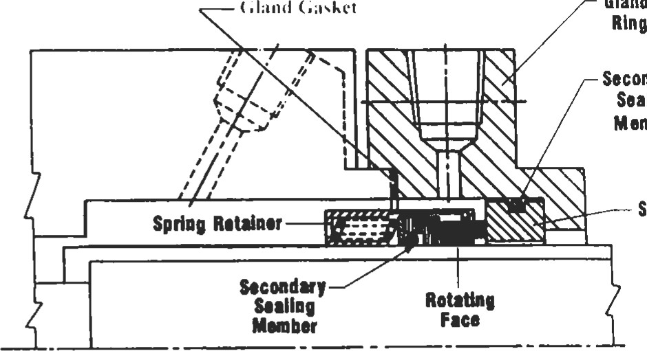

Gland

Secondary

Sealing

Member

The next group of seal components is the secondary sealing members. In Figure l, these members consist of a Stationary

Face wedge ring located under the rotating face, an O-ring located on the stationary face, and the gland ring gasket.

The third group of components is the seal hardware, in-

#### SEALING POINTS

There are four main sealing points in a mechanical seal (see Figure 2). The primary sealing point is at the seal faces, Point A. This sealing point is achieved by utilizing two very flat, lapped surfaces, perpendicular to the shaft, that create a very treacherous leakage path. Leakage is further minimized by the rubbing contact between the rotating and stationary faces. In most cases, these two faces are made of one hard material, like tungsten carbide, and a relatively soft material such as carbon-graphite. The carbon seal face generally has the smaller contact area, and is the wearing face. The O.D. and I.D. of the wearing face represent the "seal face dimensions," and are also generically referred to as the "seal face" throughout this chapter.

The second leakage path, Point B, is along the shaft under the rotating seal face. This path is blocked by the secondary O-ring. An additional secondary O-ring, Point C, is used to prevent leakage between the gland ring and the stationary seal face. Point D is the gland ring gasket which prevents leakage between the equipment case and the gland.

Poi't D

Glu•d G.sket Point C

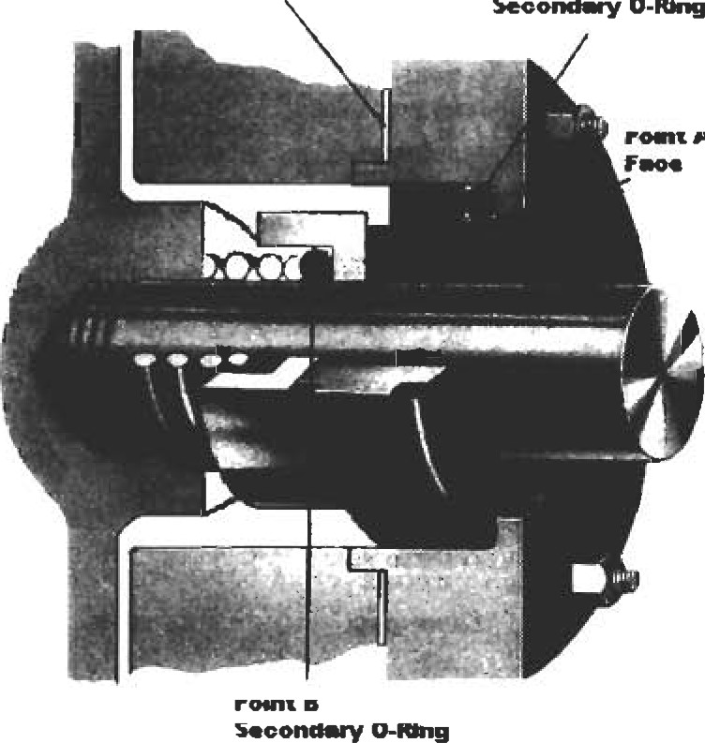

Second—y

O-u.g

A

Figure 2. Sealing points. (Courtesy of Durametallic

Corp.)

|  |  |  |
| --- | --- | --- |
| MECHANICAL SEAL CLASSIFICATIONS   |  |  | | --- | --- | | Mechanical seals can be categorized by certain design characteristics or by the arrangement in which they're used. Figure 3 outlines these classifications. None of these designs, or arrangements, are inherently better than the | other. Each has a specific use, and a good understanding of the differences will allow the user to properly apply and maintain each seal type. |   By Arrangement    By  Design  Figure 3. Mechanical seal classifications. (Courtesy of Durametallic Corp.)  BASIC SEAL DESIGNS  Pusher Seals |

The characteristic design of a pusher seal is the dynamic O-ring at the rotating seal face (see Figure 4). This O-ring must move axially along the shaft or sleeve to compensate for any shaft or seal face misalignment as well as normal face wear. The advantages of a pusher seal are that the design can be used for very high-pressure applications (as much as 3,000 psig), the metal components are robust and

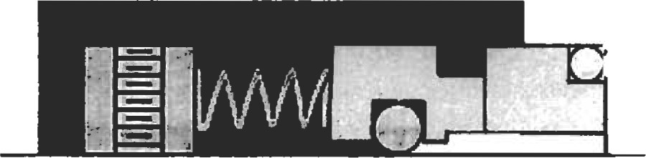

Figure 4. Basic pusher seal. (Courtesy of Durametallic Corp.)

come in special alloy materials, and the design is well suited for special applications.

The disadvantages of the pusher design are related to the dynamic O-ring. In a corrosive service, the constant relative motion between the dynamic O-ring and shaft wears away at the protective oxide layer of the shaft or sleeve material, causing fretting corrosion. The fretting will wear a groove in the shaft or sleeve, providing a leakage path for the sealed fluid.

An additional limitation of the dynamic O-ring is the problem of "hang-up," shown in Figure 5. In applications where the sealed fluid can "salt-out" or oxidize, like caustic or hydrocarbons, the normal seal weepage can build under the seal faces and prevent forward movement, thereby creating a leakage path.

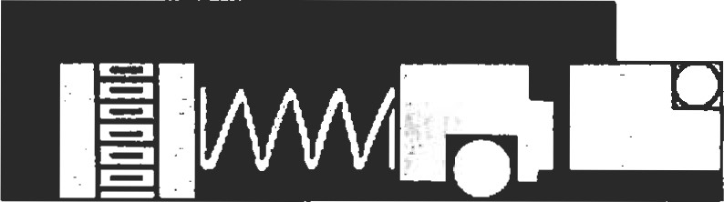

Figure 5. Dynamic O-ring "hang-up." (Courtesy of Durametallic Corp.)

Another characteristic of the pusher seal design is the use of coil springs for providing mechanical closing force. These springs can be either a single coil spring (Figure 6) or a multiple arrangement of springs (Figure 7). Mechanical seals using a single coil spring are widely used because of their simple design, and the large spring cross-section is good for corrosion resistance. The disadvantages of the single coil are that the applied spring force is very nonuniform

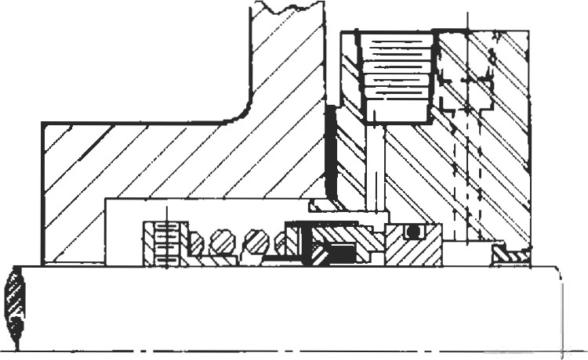

Figure 6. Single coil spring.

and can cause waviness and distortion to the seal face in larger sizes. In addition, the spring can distort at high surface speeds.

Multispring seals (Figure 7) use a series of small coil springs spaced circumferentially around the seal face. This spacing provides a uniform face loading, minimizing the waviness and distortion atü•ibuted to spring forces. The multispring arrangement is also less susceptible to high-speed spring distortion under 4,500 fpm.

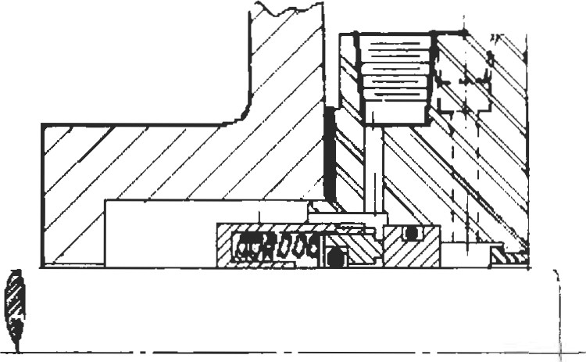

|  |
| --- |
| Non-Pusher Seals |

Figure 7. Multi-spring seal. (Courtesy ofJohn Crane, Inc.)

The characteristic design feature of the non-pusher, or bellows, seal is the lack of a dynamic O-ring. As shown in Figure 8, the non-pusher seal design has a static O-ring in the drive collar of the rotating seal face unit. This is made posSible by the bellows, which acts as a pressure containing device, as well as the spring force component. This unique feature provides advantages over the pusher seal in that the static



Figure 8. Welded metal-bellows, non-pusher seal. (Courtesy of Durametallic Corp.)



Figure 9. Static o-ring, no hang-ups. (Courtesy of Durametallic Corp.)

O-ring virtually eliminates the problem of fretting corrosion and seal face hang-up, as shown in Figure 9.

There are two basic bellows seal designs available: the metal bellows and the elastomeric bellows. Figure 8 depicts a welded metal bellows design, constructed from a series of thin metal leaflets that are laser welded together at the top and bottom to form a pressure-containing spring. The elastomeric bellows (Figure 10) consists of a large rubber bellows, or boot, that is energized by a single coil spring.

While the non-pusher seal has several advantages over the pusher seal, the bellows also provides this seal design with its limitations. In the case of the welded metal bellows, the thin cross-section of the leaflets, .005" to .009", limits

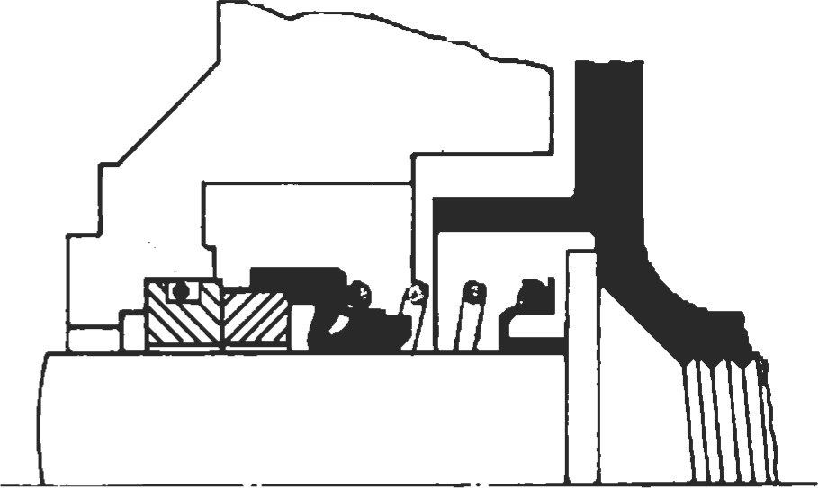

Figure 10. Elastomeric bellows seal.

|  |
| --- |
| Unbalanced Seals |

the pressure at which the design should be applied to 250 psig. This limitation is due to the pressure acting on the unsupported seal face, causing severe face deflections. The thin leaflets also limit the corrosion allowance to .002" for chemical services. The elastomeric bellows design is not as pressure limited, but does possess the same limitations as a single coil spring design, in addition to limited chemical resistance of the elastomeric bellows.

For all mechanical seals, the pressure of the sealed fluid exerts a hydraulic force on the seal face. The axial component of this hydraulic force is known as the hydraulic closing force. Unbalanced seal designs have no provisions for reducing the amount of closing force exerted on the seal face, and for pusher seals, the characteristic trait of this design is for the seal faces to be above the balance diameter, as shown in Figure I I. The balance diameter can be determined by locating the innermost point at which pressure can act on the seal faces. For almost all pusher seal designs, that point is the I.D. of the dynamic O-ring.

A more detailed discussion of seal balancing can be found in the Basic Design Principles section of this chapter. The point to be made here is that the unbalanced seal design is the preferred design for low-pressure applications. Seal face weepage is directly related to the closing force acting on the seal face; the higher the closing force,

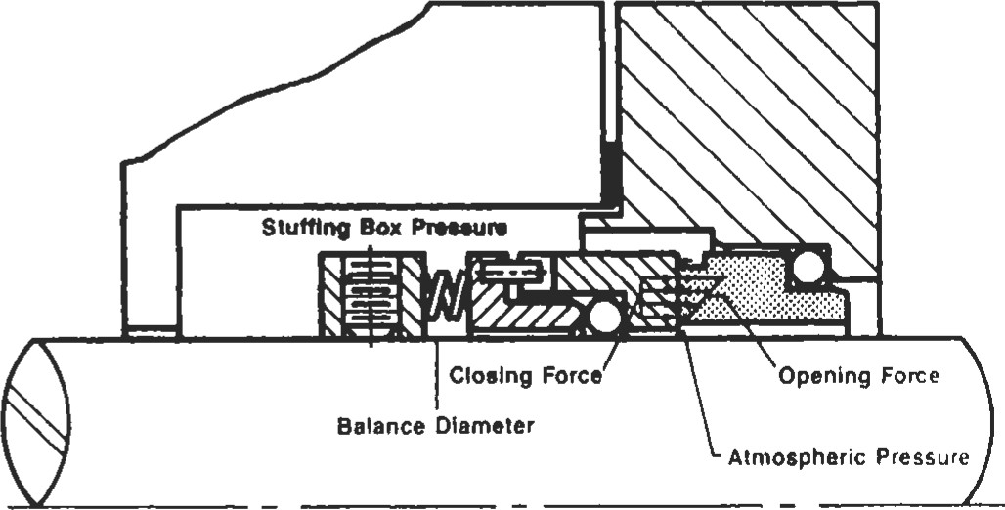

Figure 11. Unbalanced seal. (Courtesy of Durametallic Corp.)

the lower the seal face weepage. Unbalanced seal designs inherently have higher closing forces and therefore less seal weepage at lower pressures. Additionally, unbalanced seals are more stable during off-design equipment conditions such as cavitation, high vibration, or misalignment. The only disadvantage to the unbalanced seal design is the pressure limitations. The closing force exerted at the seal face can reach a point where it overcomes the stiffness of the lubricating fluid and literally squeezes the fluid from between the seal faces. This is a destructive condition that should be avoided. Figure 12 lists some recommended pressure limits for unbalanced seals, based on seal size and speed [3].

|  |  |  |
| --- | --- | --- |
| Seal ID (In) | Shaft Speed (rpm) | Sealing Pressure (psig) |
|  | Up to 1800 | 175 |
| 1801 to 3600 |  |
| over 2 | Up to 1800 |
| 1801 to 3600 |  |

Figure 12. Application limits for unbalanced seals. (Courtesy of Durametallic Corp.)

|  |  |  |
| --- | --- | --- |
| Balanced Seals |  | |
| It is apparent from our discussion of unbalanced seal designs that the primary purpose of a balanced seal is to reduce the hydraulic closing force acting on the seal face, and therefore provide a seal design suitable for high-pressure applications. For pusher seals, the primary trait of a balanced seal design is the seal faces dropping below the balance diameter, as shown in Figure 13. The shaft or sleeve now has a stepped diameter which allows the seal face dimensions to be reduced. This reduction now exposes more of the front side of the rotating seal face to the seal chamber pressure. Because pressure acts in all directions, this increased exposure opposes or negates a larger portion of the pressure and effectively reduces the closing force acting on the seal face. This reduction of the closing force allows for the maintenance of a good lubrication film between the seal faces at pressures as high as 1,500 psig for a single pusher seal. | While ical step design stepped  Figure  Corp.) | the use of a balanced pusher seal requires a physin the shaft or sleeve, a non-pusher or bellows seal is inherently balanced and therefore requires no sleeve. This can be an important advantage for medium-pressure applications.    13. Balanced seal. (Courtesy of Durametallic |
| Flexible Rotor Seals |  |  |

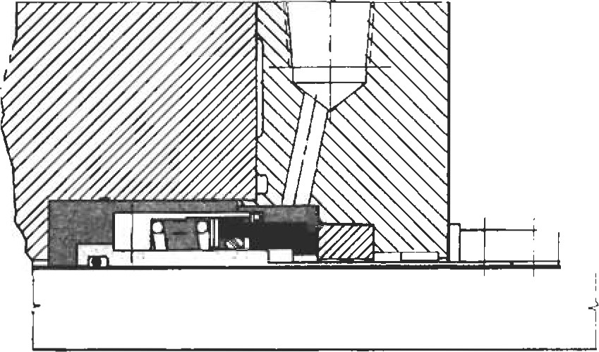Flexible rotor seal designs (Figure 14) make up the vast majority of the mechanical seals in service. Some of the advantages of the flex rotor design are less cost, less axial space required, and that the springs or bellows are "self-cleaning" due to the effects of centrifugal force. The disadvantages are a speed limitation of 4,500 fpm and the inability to handle severe seal face misalignment. Because the gland ring is bolted directly to the equipment case, the stationary seal face is prone to misalignment due to pipe strain or thermal expansion of the equipment case. For each revolution of the shaft, the flexible rotor must axially compensate for the out- Figure 14. Flexible rotor. (Courtesy of John Crane, Inc.) of-perpendicularity of the stationary seal face. As discussed earlier with fretting corrosion, this can be very detrimental to reliable seal performance.

##### Flexible Stator Seals

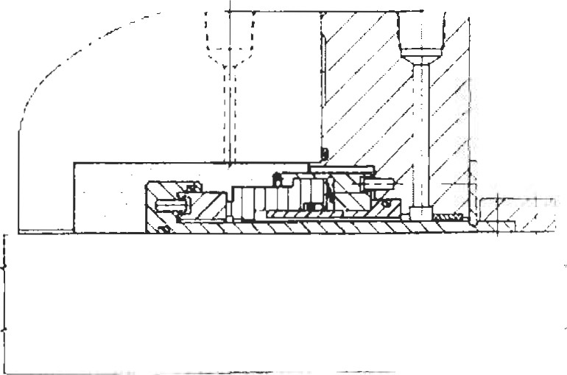Flexible stator seal designs (Figure 15) make up a smaller, but very necessary, part of the mechanical seals in service. It stands to reason that the disadvantages of the flexible rotor design would be addressed with this design. The primary advantage of the flexible stator design is its ability to handle severe seal face misalignment caused by equipment case distortion by making a one-time adjustment to the rotating seal face. This is of great importance for large, hot equipment in the refining and power markets. The flexible stator is also the design of choice for operating speeds above 4,500 fpm.

###### Figure 15. Flexible stator. (Courtesy of John Crane, Inc.)

The disadvantages of the flexible stator are higher cost, increased axial space requirements, and the limitation of being applied in services with less than 5% solids.

#### BASIC SEAL ARRANGEMENTS

##### Single Inside Seals

The single inside seal (Figure 16) is by far the most common seal arrangement used and, for single seals, is the arrangement of choice. The most important consideration for this arrangement is that the seal faces are lubricated by the sealed fluid, and therefore the sealed fluid must be compatible with the environment. Toxic or hazardous fluids should not be handled with a single seal. From an emissions standpoint, volatile organic compounds (VOCs) have been effectively contained with emissions of 500 ppm using a single seal [6]. For corrosive services, the seal must operate in the fluid, so material considerations must be reviewed.

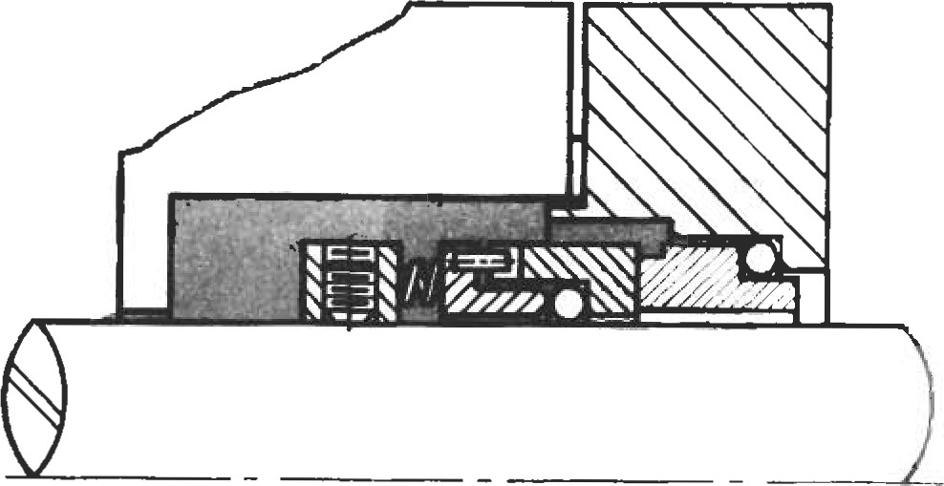

Figure 16. Single inside seal. (Courtesy of Durametallic Corp.)

|  |  |
| --- | --- |
| Single Outside Seals |  |
| While single outside seals (Figure 17) are not the arrangement of choice, certain situations dictate their usage. Equipment with a very limited seal chamber area is a good candidate for an outside seal. Economics will also impact the use of a single outside seal. To prevent the need for very expensive metallurgies in highly corrosive applications, outside seals are sometimes employed. Because all the metal parts are on the atmospheric side of the seal, only the seal faces and secondary sealing members are exposed to the corrosive product. If outside seals must be used, always use a balanced seal design. | Figure 17. Single outside seal. (Courtesy of Durametallic Corp.) |
| Double Seals |  |

Double seals are used when the product being sealed is incompatible with a single-seal design. As discussed earlier, toxic or hazardous chemicals require special considerations and must be handled with a multiple-seal arrangement. Highly corrosive products can also be safely contained with a double-seal arrangement. The primary purpose of the double seal is to isolate the sealed fluid from the atmosphere, and create an environment in which a mechanical seal can survive. This is accomplished by using two seals that operate in a different fluid, called a barrier fluid. The barrier fluid is there to provide clean, noncorrosive lubrication to the seal faces. To assure that the seals are being lubricated by the barrier fluid, the pressure of the barrier fluid is maintained at 15—25 psig higher than the product in the seal chamber area. This weepage requires that the barrier fluid be chemically compatible with the product.

There are two different arrangements for a double seal; the back-to-back arrangement (Figure 18) and the face-to-face arrangement (Figure 19). The advantage of the back-to-back arrangement is that none of the metal seal parts are exposed to the product. This is an ideal arrangement for highly corrosive chemicals. The major disadvantage to this arrangement is that it will not take pressure reversals. Under upset conditions, should the barrier pressure be lost, the inboard seal (left seal on Figure 18) would be pushed open, exposing the seal, and possibly the environment, to the product.

Face-to-face double-seal arrangements are designed to accommodate pressure reversals. Should the barrier pressure be lost, the only effect to the seal would be that the seal faces are lubricated by the product instead of the barrier

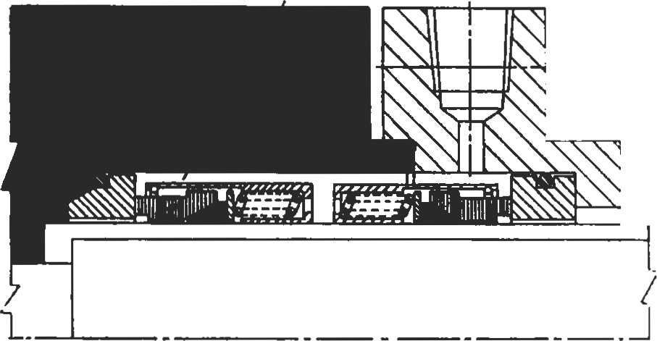

###### Figure 18. Double seal—back-to-back. (Courtesy of John Crane, Inc.)

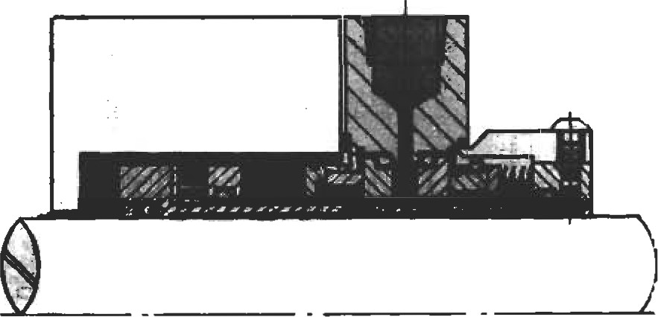

###### Figure 19. Face-to-face dual seal. (Courtesy of Durametallic Corp.)

fluid. While this condition could only be tolerated by the seal for a short time, the potentially major failure of the back-to-back arrangement has been avoided. The disadvantage of the face-to-face arrangement is that one of the seals must operate in the product. This virtually eliminates its use in highly corrosive products.

|  |  |  |  |  |
| --- | --- | --- | --- | --- |
| Tandem Seals   |  |  | | --- | --- | | Tandem seals are used when a single seal design is compatible with the product, but emissions to the environment must be severely limited, such as with VOCs. The classical arrangement of a tandem seal is two seals in series, as shown in Figure 20. The primary seal (on the left) functions just like a single seal in that it contains all the pressure and is lubricated by the product. The secondary seal (on the  seal to and is lubri- | Face-to-face tandem seal arrangements are also avail able, and are identical to Figure 19. The only difference between the double and tandem seal in this case, with the exception of their purpose, is that the double seal has a pressurized barrier fluid and the tandem seal has a nonpressurized barrier fluid. |  |  |  | | --- | --- | | contain the pressure, and the product, until a controlled shutdown of the equipment can be arranged. | Figure 20. Tandem seal. (Courtesy of John Crane, Inc.) |   right) serves as a backup the primary cated by a nonpressurized barrier fluid. The secondary seal also serves as a second "defense" for containing emissions. Under normal conditions, weepage from the primary seal is contained in the nonpressurized barrier fluid and typically vented off to a flare system. In the event that the primary seal should fail, the secondary seal is in place to  BASIC DESIGN PRINCIPLES  Seal Balance Ratio |

As a means of quantifying the amount, or percent, of balance for a mechanical seal, a ratio can be made between the seal face area above the balance diameter versus the total seal face area. This ratio can also be expressed as the area of the seal face exposed to hydraulic closing force versus the total seal face area. In either case, referring to Figure 21, the mathematical expression for the balance ratio of an inside seal design is:



OD 2 — BD Balance Ratio =

OD 2 - ID 2

where: OD = seal face outside diameter

ID = seal face inside diameter

BD = balance diameter of the seal

As a general rule of thumb, balanced seal designs use a balance ratio of 0.75 for water and nonflashing hydrocar-

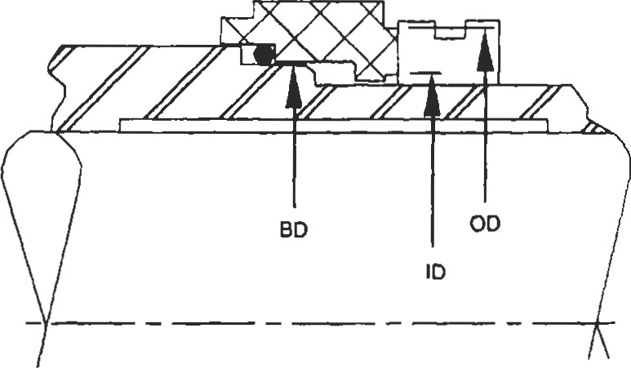

Figure 21. Balance ratio for inside seal. (API-682. Courtesy of American Petroleum Institute.)

bons. For flashing hydrocarbons, which are fluids with a vapor pressure greater than atmospheric pressure at the service temperature, the balance ratio is typically 0.80 to

0.85. Unbalanced seal designs typically have a ratio of

1.25 to 1.35.

|  |
| --- |
| Seal Hydraulics |

As previously discussed, all mechanical seals are af-

fected by hydraulic forces due to the pressure in the seal chamber. Both mechanical and hydraulic forces act on the seal face, and are shown in Figure 22. The total net forces acting on the seal face can be expressed as:

Total = Fc _ Fo + Fsp

where: FC = closing force

Fo = opening force

Fsp = mechanical spring force

The hydraulic closing force can be described mathematically as:

— (OD 2 -

4

where: OD = seal face outside diameter (in.)

BD = balance diameter (in.)

Dp = AP across seal face (psi)

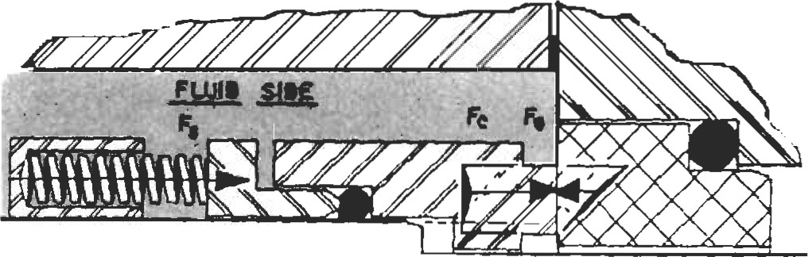

Figure 22. Mechanical seal force diagram. (Courtesy of Durametallic Corp.)

The mechanical closing force, or spring force, is expressed as Fsp. The amount of spring force is a function of the wire diameter, the number of springs, and the length of displacement. For mechanical seal designs, the range can be from 5 to 15 lbs of force per inch of OD circumference.

As a general rule, values of 5 to 7 lbs are typically used.

The hydraulic opening force can be expressed as:

— (OD 2 

4

where: OD = seal face outside diameter (in.)

ID = seal face inside diameter (in.)

D = AP across seal face (psi)

K = pressure drop factor

The pressure drop factor K shown in the opening force equation can be viewed as a percentage factor for quantifying the amount of differential pressure that is converted to opening force as the fluid migrates across the seal face. Seal faces act as pressure-reducing devices, and their shape has great impact on the K factor. Figure 23 shows various examples of K values and how they affect pressure drop [91. A value of K = I (100%) is known as a converging sealface, where all of the differential pressure is used for opening force and the seal relies totally on spring force to remain closed. For a diverging seal face, K = 0 (0%), none of the differential pressure is used for opening force. For normal flat seal faces, where K = 0.5 (50%), half the differential pressure is used for opening force. This can also be expressed as a linear pressure drop across the seal face, and is commonly used for hydraulic calculations.

Fluid types also affect the pressure drop factor. For light hydrocarbons, the liquid generally flashes to a gas as it migrates across the seal face. As the liquid expands, it creates higher opening forces, and is expressed as K = 0.5 to 0.8. As a general rule, K = 0.5 is used for nonflashing liquids. and K = 0.75 is used for flashing liquids.

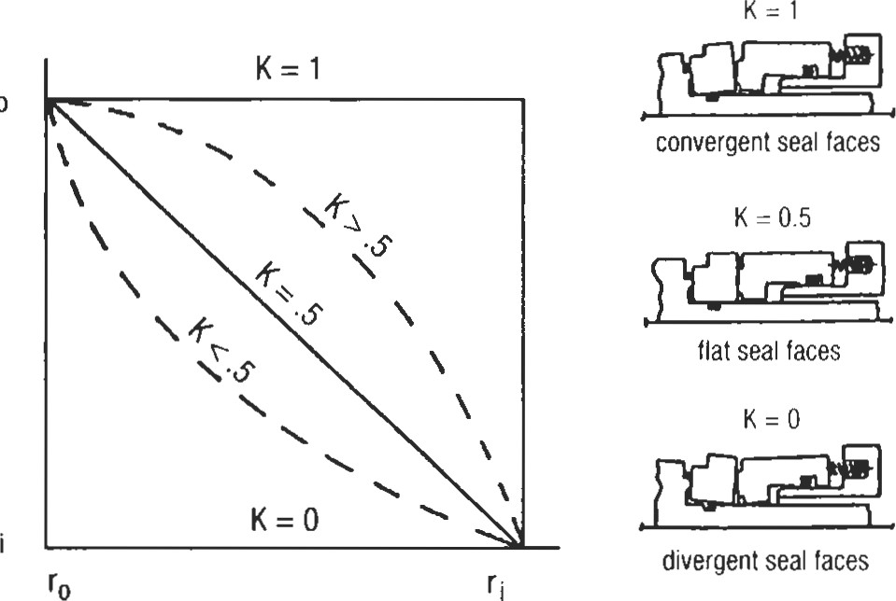

Figure 23. Pressure drop factor K.

|  |  |  |  |  |  |  |
| --- | --- | --- | --- | --- | --- | --- |
| Seal Face Pressure   |  |  | | --- | --- | |  | PTOta1 (PSI) = | | FC FO Fsp Total — — + | where: Dp = AP across seal face (psi)  B = seal balance raüo  K = pressure drop factor | | where: A = — (OD2 — 11)2 ) | Psp = spring pressure (psi) |   Seal face pressure, or unit loading, is the most common term used when discussing the effects of chamber pressure on the seal faces. The total seal face pressure can be determined by dividing the equation by the seal face area:  Toml = 4 4  sp  Basic Seal Lubrication |

Basic seal lubrication occurs as the seal chamber pressure drives the fluid across the seal faces, foming it through the asperities in the seal face caused by surface roughness, porosity, or waviness. Depending on the seal design and the type of lubricating fluid, one of three basic lubricaüon modes can be used (see Figure 24).

The most common mode of lubricaüon is boundary lubrication. In this case, the lubricant remains as a fluid all the way across the face, but is not visible on the low-pressure side. This mode is common when sealing oils, acids, and other nonflashing liquids in low- to medium-pressure applications.

The next lubrication mode is called phase transformation, and is characteristic of flashing liquids and *-pressure applications. As the fluid migrates across the face, heat generated from fluid shear or rubbing contact elevates the fluid temperature above the vapor pressure, causing a phase change from liquid to vapor. As discussed in the section on pressure drop factors, this vaporization can greatly increase opening forces and must be considered in the design

The third mode of lubrication isfidlfluidfilm, and is characterized by visible leakage on the low pressure side of the seal face. This lubrication mode is used primarily in high performance, noncontacting seals, where seal face wear is virtually eliminated.

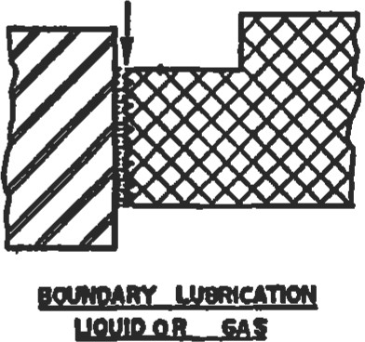

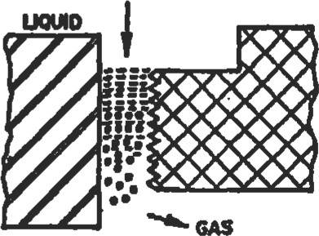

PHA* TNNSFORMA"ON

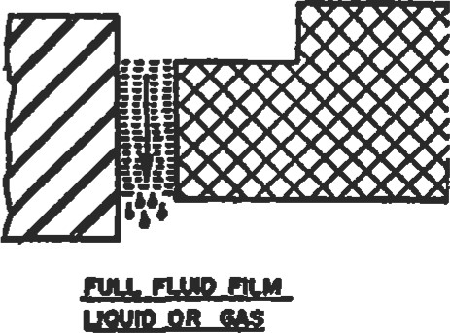

Figure 24. Lubrication modes. (Courtesy of DurameWlic

Corp.)

|  |
| --- |
| MATERIALS OF CONSTRUCTION  Hardware material can be made from almost all available metals. These metals are governed by ASTM standards, and will not be discussed in this section.  Seal Face Materials |

The old saying goes that the perfect seal face material would have the hardness of a diamond, the  of alloy steel, the heat transfer abilities of a super conductor, and the self-lubricating properties of teflon. While a compromise to this "standard" is certainly necessary, there are a few seal face materials that come close to these ideal properties. The three best materials available are also the most common face materials used in the petrochemical indusffy.• tungsten carbide, silicon carbide, and carbon-graphite.

Tungsten Carbide

Tungsten carbide is a very popular seal face material due to its good wear characteristic, good corrosion resistance, and durability. The material has a very high modulus of elasticity and is well suited for high-pressure applications where face distortion is a problem. Tungsten carbide typically comes in two grades: nickel bound or cobalt bound. The user must be aware that all tungsten carbides are not created equal. Mechanical seal grade tungsten carbide should have very fine grains, with a maximum of 6%—8% binder material. Depending on the function, some commercial grade tungsten carbides can have as much as 50% binder material.

For mechanical seal applications, tungsten carbide coatings should also be avoided because of problems with coating cracks. The best material configuration for tungsten carbide is a solid homogeneous ring.

Silicon Carbide

Silicon carbide has many of the same good qualities as tungsten carbide, but also contains superior hardness, thermal conductivity, and a very low friction coefficient. If not for the brittle nature of silicon carbide, it would indeed be the ideal seal face material. This material typically comes in two grades: reaction bonded and alpha sintered.

The primary characterisüc of reaction-bonded silicon carbide is the 8%—12% free silicon found in the structure. Under conditions of seal face contact, this free silicon can vaporize, leaving behind free carbon atoms at the interface. This reduces the frictional heat at the faces, and promotes good wear characteristic. The disadvantage to reactionbonded dlicon carbide is also the free silicon, which reduces chemical resistance. Chemicals like caustic or hydrofluoric acid will leach out the free silicon and severely limit good seal performance.

Alpha sintered silicon carbide, on the other hand, has no free silicon in the material structure. This provides a seal face material that is virtually inert to any chemicals, but does not offer the superior wear characteristics found in reactionbonded materials.

Carbon-Graphite

Carbon-graphite is by far the most commonly used seal face material, and is used almost exclusively as the wearing face of a mechanical seal. Carbon-graphite offers outstanding anüfriction properties as well as exceptional chemical resistance. This material does have a low modulus of elasticity and is therefore susceptible to distortion in highpressure applications. There are many hundreds of different carbon grades available, and like tungsten carbide, they are not all created equal. Reputable mechanical seal manufacturers expend great effort in evaluating and testing suitable mechanical seal carbon grades. To assure good reliable seal performance, stick to the grades offered by the seal manufacturers.

|  |
| --- |
| Seal Face Compatibility |

There are a few general items to keep in mind when applying various seal face combinations:

|  |  |  |  |  |  |  |  |
| --- | --- | --- | --- | --- | --- | --- | --- |
|  |  |  |  | co |  |  |  |
| Ceramic | D | x | x | D | D | x | ABCD |
| Stellite | x | D | D | x | x | D | ACDE |
| Tungsten Carbide (Nickel Bound) | x | D | BCD | ABD | ABCD |  | BCDE |
| Silicon Carblde  (Reaction Bonded) | D | x |  | ABD | ABD | x | ABDE |
| Silicon Carbide  (Alpha Sintered) | D | x | BCD | ABD | ABCD | x | ABCD |
| Bronze | x |  |  | x | x | x | x |
| Carbon | ABCD | ACDE | BCD | ABDE | ABCD | x | ABCD |

* 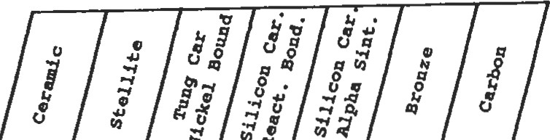One of the seal face materials should be harder than the other, like tungsten carbide versus carbon-graphite.

Codes : A — Acids diluted and concentrated Water and water solution

 Caustics diluted and concentrated

D — Oil and lubricants Dry running

X — Not recoramended

Figure 25. Seat face compatibility. (Courtesy of Durametallic Corp.)

* For abrasive services, both seal face materials should be harder than the abrasive particles, such as tungsten carbide versus silicon carbide.
* For fluids with a viscosity less than 0.4 cp, one of the seal face materials should be carbon-graphite.

Additionally, not all seal face materials work well together. Figure 25 outlines various seal face con-Ibinations for different types of fluids [4]. Figure 26 shows typical tenlperature limitations for cornmon seal face materials [ l l.

|  |  |  |  |
| --- | --- | --- | --- |
|  |  |  | |
|  |  |
| Stellite Face | Welded Stellite Face on Metal Ring | 350 | 177 |
| Tung-Car | Solid tungsten Carbide Ring | 750 | 400 |
| Bronze | Solid Leaded Bronze Ring | 350 | 177 |
| Ceremlc | Solid Pure Ceramic Ring | 350 | 177 |
| Carbon | Solid Carbon-Graphic Ring | 525 | 275 |
| Silicon-Carbide | Solid Silicon Carbide Ring | 800 | 427 |

Figure 26. Temperature limitations of seal face materials. (Courtesy of Durametallic Corp.)

Secondary Sealing Materials

|  |  |  |  |
| --- | --- | --- | --- |
|  |  |  |  |
| Buna N  (Ni tri I e) | O—Ring | -40 | +225 |
| Neoprene | O—Ri ng | -40 | +225 |
| Vi ton | O -Ring |  |  |
| EPR/EPT | O-Ring | -40 | +350 |
| Kal rez | O—Ring | O | +500 |
| Teflon | Square Ring | -100 | +450 |
| Wedge/V—Ri ng | -100 | +350 |
| Gasket | -100 | +350 |
| Glass Filled  Tenon | Gasket | -175 | +450 |
| Graphi te | Square Ring | -450 | +750 |
| Spi ral Wound | Gasket | -450 | +1200 |
| Sythetic  Organic  Fiber With tri i e | Gasket | -175 | +700 |

Secondary sealing members must be made from materials that are capable of sealing between two different surfaces. Ideally, resilient materials such as elastomeric orings should be used whenever temperature and chemical conditions will allow. For more severe conditions, such as high-temperature or corrosive environments, specialized materials like pure graphite or teflon must be used. These materials offer no resilience and must be formed into different shapes, such as wedges or squares, and be mechanically energized. Figure 27 shows temperature limits for the most common secondary sealing materials [ l ].

Figure 27. Temperature limitations of secondary seal materials. (Courtesy of Durameta//ic Corp.)

DESIRABLE DESIGN FEATURES

Much has been said about the sealing members of a mechanical seal. There are also many design features that should be considered for the mechanical seal hardware.

Gland Rings

The following is a list of design features that should be considered for mechanical seal gland rings:

* Gland rings should be designed to withstand maximum seal chamber design pressure, and should be sufficiently rigid to avoid any distortion that would impair reliable seal performance.
* A minimum pilot length of 0.125" should be used to properly align the seal to the stationary housing. This consideration would not apply for carüidge seal designs using centering tabs.
* The seal flush should enter thmugh the gland ring and be located directly over the seal faces. The minimum pipe tap diameter should be h" NPT
* Confined gland ring gaskets should be used when space and design limitations permit. Examples would be o-rings or spiral wound gaskets.
* Gland rings should be bolted to the seal chamber with a minimum of four bolts.
* Throttle bushings should be of a nonsparking and nongalling material, with a minimum of 0.025" diametrical clearance.
* The stationary seal face should be mounted in the gland ring with a circumferential O-ring or other flexible sealing element. Clamp-type arrangements should be avoided.

Metal sleeves are used with mechanical seals to both tect the equipment shaft, in the case of hook type sleeves, and provide a means of installing a seal as a complete unit, as with the caffidge sleeve design. The carbidge seal is the design of choice unless space or other design limitations exist. The following are desirable features for sleeve

* Shaft sleeves should have a minimum wall thickness of

0.100".

* Materials of construction should be stainless steel as a minimum.
* All shaft sleeves should be "relieved" on the I.D. for ease of installaüon.
* Shaft sleeves should be manufactured to tolerances suitable for a maximum sleeve run-out of 0.002" TIR when mounted on the shaft.
* Shaft sleeve sealing members (o-rings, gaskets, etc.) should be located as close to the equipment intemals as possible.
* Cartridge sleeve designs should be mechanically secured to the shaft and be capable of maintaining position at maximum discharge pressure. The sleeve should be positively driven with the use of drive keys or dog-point set screws.

|  |
| --- |
| EQUIPMENT CONSIDERATIONS  Equipment Checks |

One of the most important considerations for reliable seal performance is the operating condition of the equipment. Many times, mechanical seal failures are a direct result of poor equipment maintenance. High vibration, misalignment, pipe strain, and many other detrimental conditions cause poor mechanical seal life. There are also several dimensional checks that are often overlooked.

|  |  |
| --- | --- |
| Axial Shaft Movement |  |
| Axial shaft movement (Figure 28) can be measured by placing a dial indicator at the end of the shaft and gently tapping or pulling the shaft back and forth. The indicator movement should be no more than 0.010" TIR [1]. | Radial Bearing  Thrust  Figure 28. Checking pump for axial shaft movement.  (Courtesy of Durametallic Corp.) |
| Radial Shaft Movement |  |

Because half of the seal is rotating with the shaft, and the other half is fixed to a stationary housing, the dimensional relationships of concentricity and "squareness" are very important. The centrifugal pump is by far the most common piece of rotating equipment utilizing a mechanical seal. For this reason, the dimensional checks will be referenced to the shaft and seal chamber for a centrifugal pump.

There are two types of radial shaft movement (Figure 29) that need to be inspected. The first type is called shaft deflection, and is a good indication of bearing conditions and bearing housing fits. To measure, install the dial indicators as shown, and lift up or push down on the end of the shaft. The indicator movement should not exceed 0.002" TIR

The second type of radial shaft movement is called shaft run-out, and is a good way to check for a bent shaft condition. To measure, install the dial indicators as shown in

Radlai Bearing

Thrust 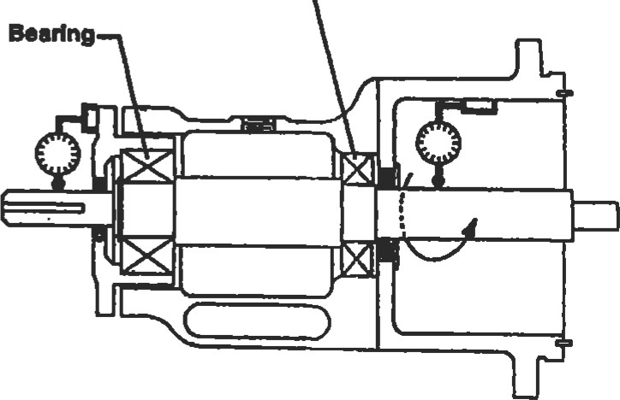Beadng

Figure 29. Checking pump for radial shaft movement.

(Courtesy of Durametallic Corp.)

|  |  |  |  |  |  |  |
| --- | --- | --- | --- | --- | --- | --- |
| |  |  | | --- | --- | | Seal Chamber Face Run-Out |  | | Figure 29, and slowly turn the shaft. The indicator movement should not exceed 0.003" TR [1].  As stated earlier, because the stationary portion of the mechanical seal bolts directly to the pump case, it is very important that the face of the seal chamber be perpendicular to the shaft center-line. To check for "out-of-squareness," mount the dial indicator directly to the shaft, as shown in Figure 30. Sweep the indicator around the face of the seal housing by slowly turning the shaft. The indicator movement should not exceed 0.005" TIR [1]. | Radlat  Beadng  Figure 30. Checking pump for seal chamber face runout. (Courtesy of Durametallic Corp,) | | Seal Chamber Bore Concentricity |  |   There are several stationary seal components that have close diametrical clearances to the shaft, such as the throttle bushing. For this reason, it is important for the seal chamber to be concentric with the pump shaft. Addidonally, for gland ring designs with O.D. pilots, the outer register must also be concenü•ic. To measure, install the dial indicators as shown in Figure 31. The indicator movement should not exceed 0.005" TIR [l].  Radial  Bearing  Flgure 31. Checking pump for seal chamber b0Ee concentricity. (Courtesy of Durametallic Corp.)  CALCULATING SEAL CHAMBER PRESSURE |

The seal chamber pressure is a very important data point for selecting both the proper seal design and seal flush scheme. Unformnately, fre seal chamber pressure varies considerably with different pump designs and impeller styles. Some pumps operate with chamber pressures close to suction pressure, while others are near discharge pressure. The easiest and most accurate way to determine the seal chamber pressure on an existing pump is simply to measure it. Install a pressure gauge into a tapped hole in the seal chamber, and record the results with the pump running. The second most accurate method for determining seal chamber pressure is to consult the pump manufacturer. If neither of these two methods is feasible, there are ways of estimating the seal chamber pressure on standard pumps.

|  |
| --- |
| Single-Stage Pumps |

The majority of overhung process pumps use wear rings and balance holes in the impeller to help reduce the pressure in the seal chamber. The estimated chamber pressure for this arrangement can be calculated with the following

= + 0.15 (Pd - Ps)

where: Pb = seal chamber pressure (psi)

Ps = pump suction pressure (psi)

Pd = pump discharge pressure

|  |  |  |
| --- | --- | --- |
| high, pump designers will remove the back wear ring and | (Pb) is typically equal to the pump | pressure (PO. |
| Multistage Pumps |  |  |

In some special cases, where the suction pressure is very balance holes in an effort to reduce the loading on the thrust bearing. In this case, the seal chamber pressure (Pb) will be equal to discharge pressure (Pd).

Another common technique for reducing seal chamber pressure is to incorporate pump-out vanes in the back of impeller. This is used primarily with ANSI-style pumps, and can be estimated with the equation:

+ 0.25 (Pd-Ps)

The final type of single-stage pump is the double suction pump, and for this pump design, the seal chamber pressure

Horizontal multistage pumps typically are "between bearing" designs, and have two seal chambers. On the low-pressure end of the pump, the seal chamber pressure (Pb) is usually equal to the pump suction pressure (Ps). On the high-pressure end of the pump, a balance piston and pressure balancing line is typically incorporated to reduce both the thrust load and the chamber pressure. Assuming that the balance line is open and clear, the seal pressure is estimated to be:

+ 75 psi

|  |
| --- |
| SEAL FLUSH PLANS |

The seal chamber pressure for vertical multistaged pumps can vary greatly with the pump design. The seal chamber can be located either in the suction stream or the discharge stream, and can incorporate a pressure balancing line, with a 'breakdown" bushing, on high-pressure applicaüons. Vertical pumps tend to experience more radial movement than horizontal pumps, and for this reason the effecüveness of the balancing line becomes a fmction of bushing wear. With so many variables, it is difficult to esümate the pressure in the sealing chamber. The best appmach is either to measure the pressure directly, or consult the manufacturer.

As previously discussed, different seal designs are used in different seal arrangements to handle a vast array of different fluid applications. In every case, the seal must be provided with a clean lubricating fluid to perform properly. This fluid can be the actual service fluid, a barrier fluid, or an injected fluid from an external source. All these options requite a different flushing or piping scheme. In an effort to organize and easily refer to the different seal flush piping plans, the American Petroleum Institute (API) developed a numbering system for centrifugal pumps that is now universally used [7]. The following is a brief discussion of the most commonly used piping schemes, and where they are used.

|  |
| --- |
| Single Seals |

API Plan 11

The API Plan I I (Figure 32) is by far the most commonly used seal flush scheme. The seal is lubricated by the pumped fluid, which is recirculated from the pump discharge nozzle through a flow restriction orifice and injected into the seal chamber. In this case, the chamber pressure must be less than the discharge pressure. The Plan I I also serves as a means of venting gases from the seal chamber area as liquids are introduced in the pump. This is a very important function for preventing dry running conditions, and when at all possible, the piping should connect to the top of the gland. The API Plan I l is primarily used for clean, cool services.

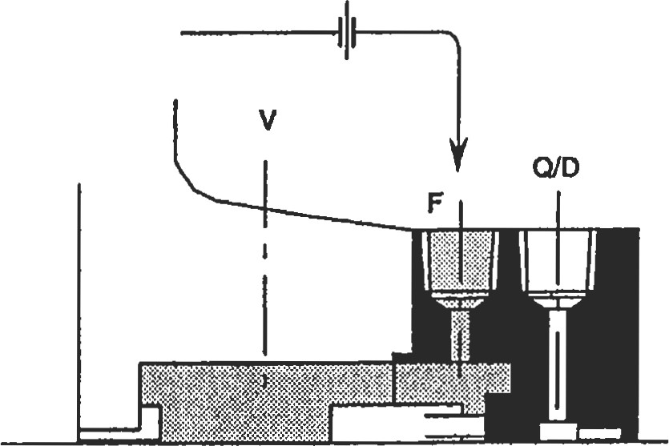

Figure 32. API Plan 1 1 . (API-682. Courtesy of American

Petroleum Institute.)

API Plan 13

The API Plan 13 (Figure 33) is very similar to the Plan I l , but uses a different recirculation path. For pumps with a seal chamber pressure equal to the discharge pressure, the Plan 13 seal flush is used. Here, the pumped fluid goes across the seal faces, out the top of the gland ring, through a restricting orifice, and into the pump suction. This piping plan is also used primarily in clean, cool applications.

API Plan 21

Figure 34 shows the arrangement for an API Plan 21. This plan is used when the pumpage is to hot to provide good lubrication to the seal faces. A heat exchanger is added in the piping to reduce the fluid temperature before it is in-

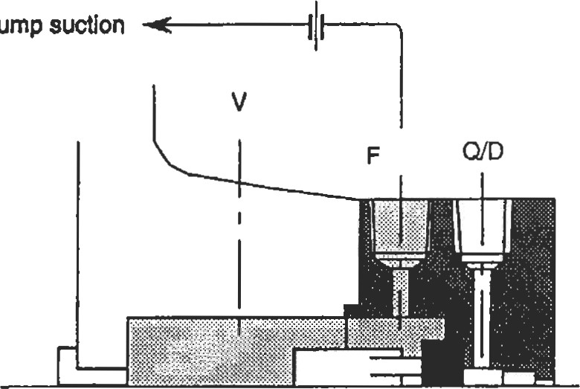

To

pump

Figure 33. API Plan 13. (API-682. Courtesy ofAmerican Petroleum Institute.)

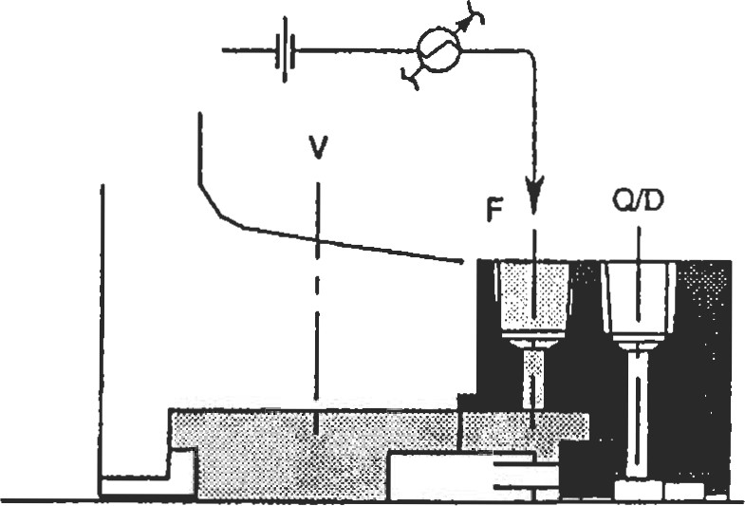

Figure 34. API Plan 21. (API-682. Courtesy of American Petroleum Institute.)

troduced into the seal chamber. The heat removal requirement for this plan can be quite high, and is not always the most economical approach.

API Plan 23

The API Plan 23 is also used to cool the seal flush, but utilizes a more economical approach. For the Plan 21 , the fluid passes through the heat exchanger one time before it is injected into the seal chamber and then introduced back into the pumping stream. The Plan 23 (Figure 35) recirculates only the fluid that is in the seal chamber. In this case, an internal pumping device is incorporated into the seal design, which circulates a fixed volume of fluid out of the seal chamber through a heat exchanger and back to the gland ring. This greatly reduces the amount of heat removal nec-

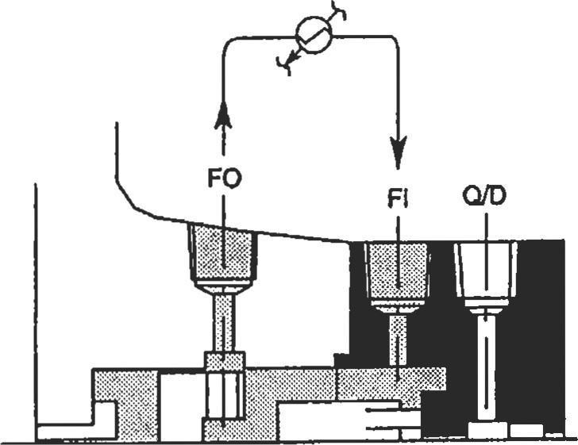

Figure 35. API Plan 23. (API-682 Courtesy of American Petroleum Institute.)

essary to achieve a certain flush temperature (and in the process industry, heat is always money). This flush plan is primarily used in boiler feed water applications.

API Plan 32

The last seal flush plan for single seals is API Plan 32, shown in Figure 36. Unlike the previous piping plans, this

API Plan 52

Tandem seals consist of two mechanical seals. The primary, or inboard, seal always operates in the pumped fluid, and therefore utilizes the same seal flush plans as the single seals. The secondary, or outboard, seal must operate in a self-contained, nonpressurized barrier fluid. The API Plan 52, shown in Figure 37, illustrates the piping scheme for the barrier fluid. An integral pumping device is used to circulate the barrier fluid from the seal chamber up to the reservoir. Here, the barrier fluid is typically cooled and gravity-fed back to the seal chamber. The reservoir is generally vented to a flare header system to allow the primary seal weepage to exit the reservoir.

arrangement does not use the pumped fluid as a seal flush. In this case, a clean, cool, compatible seal flush is taken from an external source and injected into the seal chamber. This arrangement is used primtu•ily in abrasive slun-y applications.

From extemal 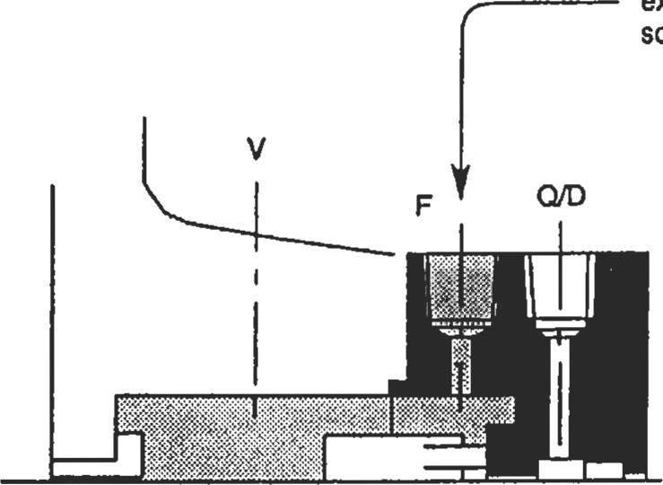source

Figure 36. API Plan 32. (API-682. Courtesy of American Petroleum Institute.)

Figure 37. API Plan 52. (API-682. Courtesy of American

Petroleum Institute.)

|  |  |  |
| --- | --- | --- |
| Double Seals   |  |  | | --- | --- | | API Plan 53  Double seals also consist of two mechanical seals, but in this case, both seals must be lubricated by the barrier fluid. For this reason, the barrier fluid must be pressurized to 15 to 25 psi above the seal chamber pressure. The API Plan 53 (Figure 38) is very similar to Plan 52, with the exception of the external pressure source. This pressure source is typically an inert gas, such as nitrogen. | API Plan 54  The API Plan 54 (Figure 39) uses a pressurized, external barrier fluid to replace the reservoir arrangement. This piping arrangement is typically used for low-pressure applications where local service water can be used for the barrier fluid.  Extemal source |   To Extemal Pressure  Source  Figure 39. API Plan 54. (API-682. Courtesy of American Petroleum Institute.)  Figure 38. API Plan 53. (API-682. Courtesy ofAmerican Petroleum Institute.)  INTEGRAL PUMPING FEATURES |

Many seal flush piping plans require that the seal lubricant be circulated through a heat exchanger or reservoir. While there are several different ways to accomplish this, the most reliable and cost-effective approach is with an integral pumping feature. There are many different types of integral pumping devices available, but the most common are the radial pumping ring and the axial pumping screw.

|  |
| --- |
| Radial Pumping Ring |

The radial pumping ring, shown in Figure 40, operates much like a centrifugal pump. The slots in the circumference of the ring carry the fluid as the shaft rotates. When each slot, or volute, passes by the low-pressure area of the discharge tap located in the seal housing, the fluid is pushed out into the seal piping. This design is very dependent on peripheral speed, close radial clearance, and the configuration of the discharge port. A tangential discharge port will produce four times the flow rate, and two times the pressure, of a radial discharge tap. Higher-viscosity fluids also have a negative effect on the output of the radial pumping

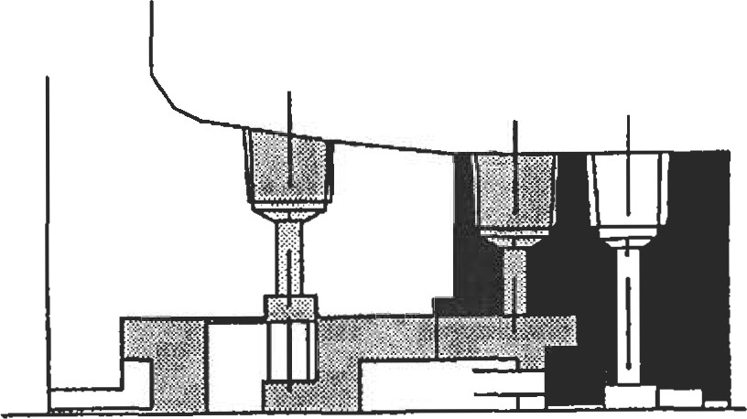

|  |  |  |
| --- | --- | --- |
| American Petroleum Institute.) | curve. (Courtesy of | Durametallic Corp.) |
| Axial Pumping Screw |  |  |

Figure 40. Radial pumping ring. (API-682. Courtesy of

ring. Fluids with a viscosity higher than 150 SSU, such as oils, will reduce the flow rate by 0.25 and the pressure by 0.5. Figure 41 shows the performance of a typical radial pumping ring [ l ].

|  |
| --- |
| Flow for Water  0.262  liquids  and |

|  |  |  |  |
| --- | --- | --- | --- |
| 2.5 5 10  2000 fpm (10.2 mJs) | 15 20 | 25 | 30 |
| 1000 fpm ( 5.1 m/s) | Feet of Head |  |  |

2.0

c 1.5

c 1.0

.5

Figure 41. Typical radial pumping ring performance

The axial pumping screw, shown on the outboard seal of

Figure 42, consists of a rotating unit with an O.D. thread

and a smooth walled housing. This is called a single-act-

ing pumping screw. Double-acting screws are also avail-

able for improved performance and utilize a screw on both

the rotating and stationary parts. Unlike the screw thread of a fastener, these screw threads have a square or rectangular cross-section and multiple leads. The axial pumping screw does have better performance characteristics than the radial pumping ring, but while gaining in popularity, the axial pumping screw is still primarily used on high-performance seal designs.

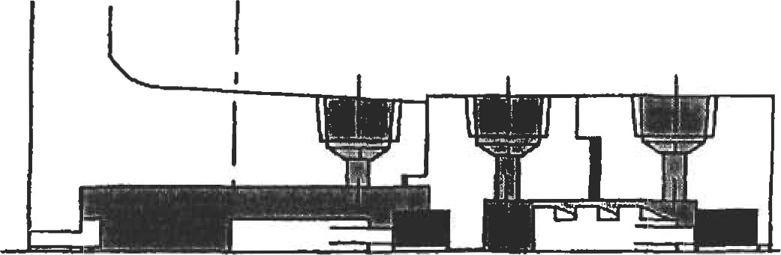

Figure 42. Axial pumping screw. (API-682. Courtesy of American Petroleum Institute.)

|  |
| --- |
| Piping Considerations  Integral pumping features are, by their design, very in- • Minimize number of fitdngs used. Eliminate elbows efficient flow devices. Consequently, the layout of the seal and tees where possible, using long radius bent pipe as piping can have a great impact on performance. The fol- a replacement.  lowing are some general rules for the piping: • Wha•e possible, uülize piping that is one size larger than the seal chamber pipe connections.   * Slope the piping a minimum of h" per foot, and eliminate any areas where a vapor pocket could form. * Provide a minimum of 10 pipe diameters of straight pipe length out of the seal housing before any directional changes are made.   SEAL SYSTEM HEAT BALANCE |

Excessive heat is a common enemy for the mechanical seal and to reliable seal performance. Understanding the sources of heat, and how to quantify the amount of heat, is for maintaining long seal life. The total heat load (QTota1) can be stated as:

QTotal = Qsgh + Qhs

where: Qtotal = total heat load (btu/hr)

Qsgh = seal generated heat (btu/hr)

QB = heat soak (btu/hr)

Seal-generated heat is produced primarily at the seal faces. This heat can be generated by the shearing of the lubricant between the seal faces, contact between the different asperities in the face materials, or by actual dry running conditions at the face. Any one, or all, of these heat-generating can take place at the same time. A heat value can be obtained from the following equation [2]:

0.077 x P x V x fxA

where Qsgh = seal generated heat (btu/hr)

P = seal face pressure (psi) V = mean velocity (ft/min) f = face friction factor

A = seal face contact area (in2) and

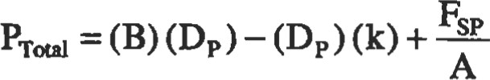

The face factor (f) is similar to a coemcient of friction, but is more tailored to the different lubricating condiüons and fluids being sealed than to the actual material properties. The following values can be used as a general rule:

f = 0.05 for light hydrocarbons f= 0.07 for water and medium hydrocarbons

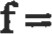0.10 for oils

For a graphical approach to determining seal-generated heat values, see Figure 43 [21.

|  |
| --- |
| TYPICAL SEAL GENERATED HEAT VALVES    Figure 43. Typical seal-generated heat values. (Courtesy of Du- |

rameta//ic Corp.)

Heat soak (Qhs) is the conductive heat flow that results from a temperature differential between the seal chamber and the surrounding environment. For a typical pump application, this would be the temperature differential between the chamber and the back of the pump impeller. Obviously, seals using an API Plan I l or 13 would have no heat soak. But for Plans 21 or 23, where the seal flush is cooled, there would be a positive heat flow from the pump to the seal chamber. Radiant or convected heat losses from the seal chamber walls to the atmosphere are negligible.

There are many variables that affect heat soak values, such as materials, surface configurations, or film coefficients. In the case of a pump, heat can transfer down the shaft, or through the back plate, and can be constncted from several different materials. To make calculating the heat soak values simpler, a graphical chart, shown in Figure 44, has been provided which is specifically tailored for mechanical seals in centrifugal pump applications [8].

|  |
| --- |
| Flgure 44. Heat-soak curve for 316 stainless steel. (Courtesy of Durametallic Corp.)  FLOW UTE CALCULATION |

Once the heat load of the sealing system has been determined, removing the heat becomes an important factor. Seal applications with a high heat soak value will typically require a heat exchanger to help with heat removal. In this case, assistance from the seal manufacturer is required to size the exchanger and determ.ine the proper seal flush flow rate. For simpler applications, such as those using API Plans Il, 13, or 32, heat removal requirements can be detennined from a simple flow rate calculaüon. Using values for seal-generated heat and heat soak, when required, a flow rate value can be obtained from the following equation [2]:

FLOW (gpm) =

500 x cp x S.G. x AT

where: specific heat (btu/lb-0F) S.G. = specific gravity

AT = allowable temperature rise (OF)

The allowable temperature rise (AT) will vary depending on the fluid being sealed. For fluids that are very close to the flashing temperature, the temperature rise should not exceed 5—1 OO F. For nonflashing fluids, the maximuln allowable temperature rise is 200 F. Once the flow is deterrnined. Figure 45 can be used to obtain the proper orifice size [51.

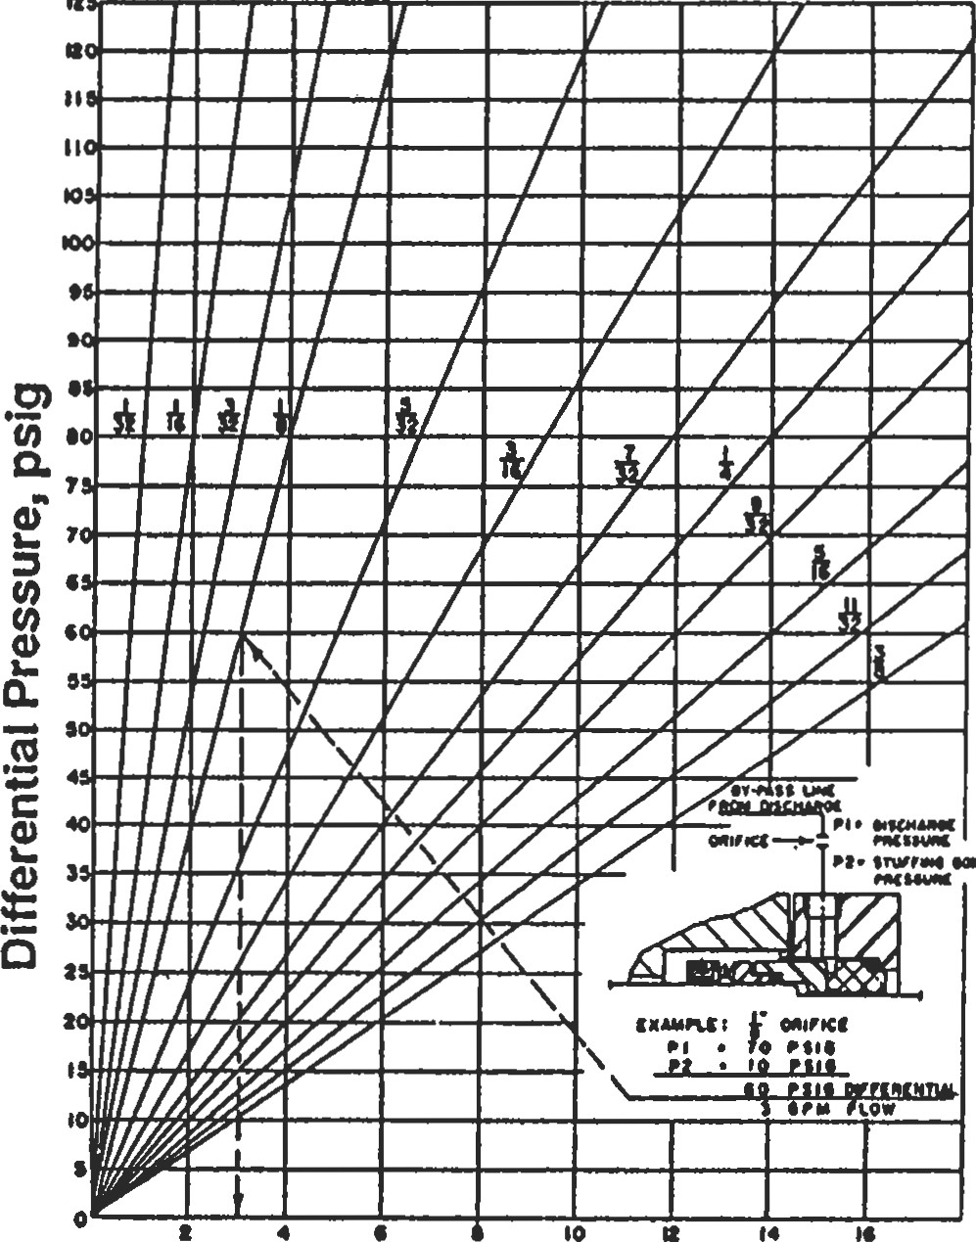

##### Flow Rate, GPM

Figure 45. Graph of water flow through a sharp-edged orifice. (Courtesy of Durametallic Corp.)

##### REFERENCES

1. Durametallic Corporation, "Guide to Modem Mechanical Sealing," Dura Seal Manual, 8th Ed.
2. Durametallic Corporation, "Sizing and Selecüng Sealing Systems," Technical Data SD-1162A.
3. Durametallic Corporation, "Dura Seal Pressure-Velocity Limits," Technical Data SD-1295C.
4. Durametallic Corporation, "Dura Seal Selection Guide," Technical Data SD-634-91.
5. Durametallic Corporation, "Dura Seal Recommendations for Fugitive Emissions Control in Refinery and Chemical Plant Service," Technical Data SD-1475.
6. Durametallic Corporation, "Achieve Fugitive Emissions Compliance with Dura Seal Designs," Technical Data SD-1482B.
7. API Standard 682, "Shaft Sealing Systems for Centrifugal and Rotary Pumps," 1st Ed., October 1994.
8. Adams, Bill, "Applications of Mechanical Seals in High Temperature Services," Mechanical Seal Engineering Seminar, ASME South Texas Section, October 1985.
9. Will, Thomas P., Jr., "Mechanical Seal Application Audit," Mechanical Seal Engineering Seminar, ASYI.E South Texas Section, November 1985.



### Pumps and Compressors

Bhabani P. Mohanty, Ph.D., Development Engineer, Allison Engine Company

E. W. McAllister, P.E., Houston, Texas

Pump Fundamentals and Design93

Pump and Head Terminology

Pump Design Parameters and Formulas 93

Types of Pumps 94 Cenü•ifugal Pumps 95

Net Posiüve Suction Head (NPSH) and Cavitaüon

Pumping Hydll)carbons and Other Fluids 96

Reciwulation 97

Pumping Power and Effciency

Specific Speed of Pumps

Pump Similitude

Performance Curves

Series and Parallel Pumping 99

Design Guidelines 100

Reciprocating Pumps103 Compressors110 Definitions110

Performance Calculations for Reciprocating

Compressors111

Estimating Suction and Discharge Volume Bottle

Sizes for Pulsation Conüol for Reciprocating

Compressors

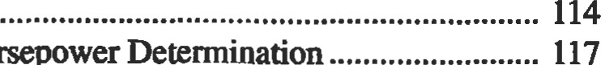 Compressor Horsepower 117

Generalized Compressibility Factor119

Centrifugal Compressor Performance Calculations120 Esümate HP Required to Compress Natural Gas123

Estimate Engine Cooling Water Requirements124

Estimate Fuel Requirements for Intemal Combustion

Engines124

References

92

#### PUMP FUNDAMENTALS AND DESIGN

Pumps convert mechanical energy inputinto fluidenergy. in a separate chapter. This chapter pertains specifically to They are just the opposite of turbines. Many of the basic pumps from an engineering point of view. engineering facts regarding fluid mechanics are discussed

Pump and Head Terminology

Symibol Variable end Unit

flow capacity (gallorwminute or gpm) now (ft3/second) gpm  flow (gallons/minute) pressure (psi) barrel (42 gallons) bpd = barele/day bph — barreWhour bhp  brake horsepower whp  water horsepower g = acceleration due to gravity (32.16 ft/sec) torque (ft. lbs) temperature (OF) s — specific gravity of fluid



Q



P

D = impeller dian•teter (inch)  pump efficiency (in decimal)

N = revoluton per minute (rpm)



H - total specific head heat(ft)

velocity (fVsec) area (sq. in.)

NPSH net positive suction head (ft of water) efficiency p = density specific weight of liquid



=

##### Pump Design Parameters and Formulas

|  |  |
| --- | --- |
| Following are the pump design parameters in detail:  Flow Capacity: The quantity of fluid discharged in unit time. It can be expressed in one of the following popular units: cfs, gpm, bph, or bpd.  gpm = 449 x cfs = 0.7 x bph (4)  Head: This may also be called the specific energy, i.e., energy supplied to the fluid per unit weight. This quantity may be obtained through Bernoulli's equation. The head is the height to which a unit weight of the fluid may be raised by the energy supplied by the pump.  H = 2.31 x (5) | The velocity head is defined as the pressure equivalent of the dynamic energy required to produce the fluid velocity.  Power: Energy consumed by the pump per unit üme for supplying liquid energy in the form of pressure.  bhp = Q x H x x e) = Q x x e) (6)  Efficiency: The ratio of useful hydraulic work done to the actual work input. It consists of the product of three components: the volumeüic efficiency, the hydraulic efficiency, and the mechanical efficiency.  (7)  The overall efficiency varies from 50% for small pumps to 90% for large ones. |

##### Types of Pumps

|  |  |
| --- | --- |
| Pumps fall into two distinct categories: dynamic pumps and positive displacement pumps.  Dynamic pumps are of two types: cenffifugal and axial. They are characterized by the way in which energy is converted from the high liquid velocity at the inlet into pressure head in a diffusing flow passage. Dynamic pumps have a lower efficiency than positive displacement pumps. But their advantages lie in the output of relatively high flow rates compared to their sizes, and their low maintenance costs. They also operate at relatively higher speeds.  Positive displacement pumps are of several types, including reciprocating, rotary screw, and gear pumps. These | pumps operate by forcing a fixed volume of fluid from the inlet pressure section to the discharge section of the pump. In reciprocating pumps, this is done intermittently; and in others this is done continuously. These types of pumps are physically larger than the dynamic pumps for comparable capacity, and they operate at relatively lower speeds.  Table 1 shows major pump types, their characteristics, and their applications.  Source  Cheremisinoff, N. P., Fluid Flow Pocket Handbook Houston: Gulf Publishing co., 1984. |

Table 1

Major Pump Types

 R&dw

No. Of

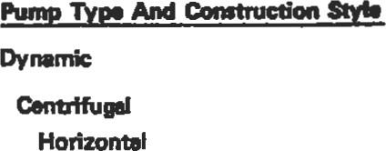

hd

Dbönquätitv Comtudon Matu60n Commone

Capacity wrie head.

Low to medium specific need.

|  |  |  |  |  |
| --- | --- | --- | --- | --- |
| Two proce wpe | 2 impellen emitæred beyond bearinß.. | 2 |  | For heads single —Oility. |
| Sn*• sago imö•ller betwen bearinø | Impeller beween barinß; czing   or uialty split. | 1 |  | For high f10E ECO m head. |
| Chnical | pattems designed thin for ooct allow; | 1 |  | prn.it•e and ratirv. |

 Single st. w•hung, Xocæs wpe Impeller centilmmd bearinß. Horizont81 1 Most common SWIe uæd in proceæ —rvioæ-

dunyflow pææß, eræion eon&ol  Hifi nial cleatm—. feawms.



Low

speed;

in

and momr "dozd in pc—re 1 Low limiB for und shell; no suaffing box.

spltt —sing Noalæ usually in bonom half of caing.Multi Low For moderate •mperawre-p—lre mtin*. Ouwr —sing confine inner sock of Multi Low For high temperzturere—ure ratin*.



|  |  |  |  |  |  |
| --- | --- | --- | --- | --- | --- |
| Verdcal |  |  |  |  |  |
| Engle wpe | Verdc•l orimmion. | Ver%el | 1 |  | me used primuily to exploit low NPS" requirerrænc |
| Multisam pro—z wpe | kny saga, low hed/nge. |  | Mulü | Medium | head capabiliy, NP8H requiremmt. |
| ln.-tine | Atmnged for in-llne a |  |  |  | Allom cost iavG6•d piping sysenz |
| High | Spæ& 380 tvs, heed to Ino m |  |  | Medium | Attac%w mst for high head"" fl". |
|  | imn•rsed in wmp for    convenience md priming e. |  | 1 |  | Low cost ins•tnm. |
|  | V'" tong *afB |  | Multi | Medium | Waer well d*wr at Ode. |
| (Pro*er) | Propeller i.ed impeller, LBually   size. | Vertical | 1 |  | A few appli—dom in &lemicd plano end refineries |
| Turbine (Repnzadw) | Fltnd impeller; now peet lib around perfph%Y. |  | 1.2 | Med. to | hed Brformence.  virwdly indoendent of heed. |



|  |  |  |  |  |  |
| --- | --- | --- | --- | --- | --- |
| Ræiproccting |  |  |  |  |  |
| plunpc | Sow spee&; wlæ, stuffing  to ær. |  | 1 |  | Driwn steam engine or ffrou*l cruticc—æ. |
| kiering | Small unio wifi mæision wn&ol |  | 1 | Medlum | Diaphrayn ind pecked plu.r |
|  | No stiffing box; can be pneum6ælly or hydtulically etuaOd. |  | 1 | High | for dwries;  prone m failure. |
|  | 1 , 2 or 3 screw mton |  | 1 |  | For vicoäty, hWt pmwre. |
| Gear | ln•nneiing par |  |  |  | For hWi  moder•u  p—m. |

modera•E

##### Centrifugal Pumps

Centrifugal pumps are made in a variety of configurations, such as horizontal, vertical, radial split, and axial split casings. The choice is a function of hydraulic requirements such as the desired pressure and desired flow rate. Other important points to consider are the space limitations at the installation site and the ease of maintenance.

Centrifugal pumps are well-suited either for large volume applications or for large (volume/pressure) ratio applications at smaller volumes. The system variables that dictate the selection are fluid viscosity, fluid specific gravity, head requirement, and the system throughput. These pumps may be used in a series, a parallel, or a series-parallel combination to achieve system objectives.

Power needed to drive the pump is the sum of the power required to overcome all the losses in the system and the power needed to provide the required fluid energy at the system outlet.

Figure 1 shows the vector relationships at the pump inlet and outlet in terms of flow and velocity diangles. The pump head is the difference of total (static and dynamic) heads between the pump's inlet and outlet:

P2 -Pl C; -C?

(1) pg

The vfrtual head (theoretical maximum head for a given set of operating conditions) is given by:

u2C2 cos — ulCl cos oti

(2)

Liquid entering a pump usually moves along the impeller, in which case = 90 degrees and the above relation becomes:

L12C2 cosot2 2

1 — —2 cos

u2 g g(21tr2b) tanß2 (3)

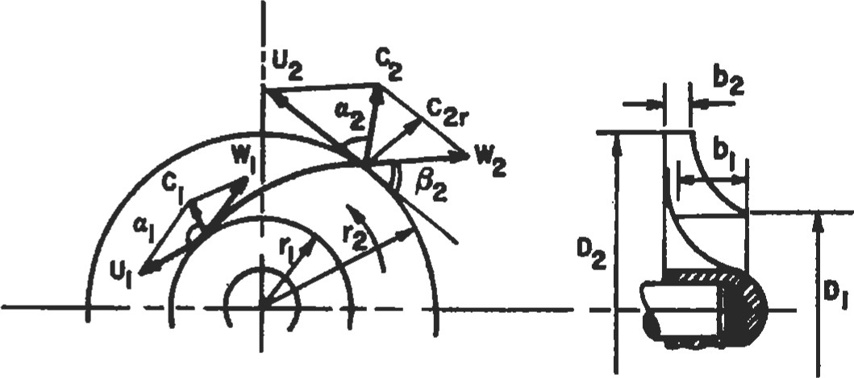

Figure 1. Flow and velocity tiangles for centrifugal impellers

where V represents the volumeü•ic rate of flow through the pump and (21tr2b) represents the cross-section of the flow leaving the impeller.

###### Source

Cheremisinoff, N. P., Fluid Flow Pocket Handbook. Houston: Gulf Publishing Co., 1984.

|  |
| --- |
| Net Posltlve Suction Head (NPSH) and Cavltatlon |

The net positive suction head (NPSH) represents any extra energy added to unit weight of liquid. Mathematically,

NPSH = —V? _ pa —Pv — Vs (8) 2g

where pa is the atmospheric pressure, is the vapor pressure of liquid, y is the specific weight of the liquid, zs is the head, and V is the reference velocity. The NPSH should always be above the vapor pressure of the liquid being pumped. This is important for safe and reliable pump operation. NPSH is given in feet of head above the vapor pressure required at the pump centerline. The NPSH requirement increases as the pump capacity increases. Hence, it is important to consider the range of flow requirements during the pump selection time. However, too much of an operational margin is not good either, because the pump efficiency at the low end of the design range will be lower too. The available NPSH should be about 10 to 15 percent higher than the required NPSH, no more and no less.

When a liquid flows into a space where its pressure is reduced to vapor pressure, it boils and vapor packets develop in it. These bubbles are carried along they meet a region of higher pressure, where they collapse. This is called cavitation, and creates a very high localized pressure

Pumping Hydrocarbons and Other Fluids

It should be remembered that the NPSH specification by a manufacturer is for use with cold water. It does not change much for small changes in water temperature. But for hydrocarbons, these values may be lowered to account for the slower vapor release properties of such complex organic liquids.

The head developed by a pump is independent of the liquid being pumped. (The required horsepower, of course, is dependent on the fluid's specific gravity.) Because of this that causes piting of the region. Cavitation lowers efficiency of the fluid machine. It is always accompanied by noise and The parameter o is defined as:

P-Pv (9) pv2 /2

where p is the absolute pressure at the point, is the vapor pressure of liquid, p is the density of the liquid, and V is the reference velocity. This parameter is a nondimensional parameter similar to the pressure coeffcient. A hydraulic system is designed to prevent cavitation. The following points should be remembered when addressing

cavitation:

1. Avoid low pressures if at all possible. Pressurize the supply tank.
2. Reduce the fluid temperature.
3. Use a larger pipe diameter, and Educe minor losses in the pipe.
4. Use special cavitation-resistant materials or coatings.
5. Small amounts of air entrained into the fluid systems reduce the amount of cavitation damage.
6. The available NPSH should always be more than the required NPSH.

independence, pump performance curves from water tests are applicable to other Newtonian fluids such as gasoline or alcohol.

The above independence is not true for high-viscosity fluids. Therefore, correction factors have been experimentally established for certain high-viscosity fluids. These correction factors (in limited viscosity and size ranges) may be applied to water curves under the underlying assumptions.

A pump runner produces work QYH, where H is the pump head. The energy added by the pump can be determined by writing Bemoulli's equation using the entry and exit points of the pump:

2 

_ Pexit Pinlet exit Vinlet exit ¯ Zinlet (10)

p P 2gc 2gc

The pump output is measured in water horsepower, or whp; whereas the input horsepower to die pump shaft is called the brake horsepower, or bhp. These two are related by:

bhp = (11)

|  |  |
| --- | --- |
| Recirculation |  |
| A recirculation problem is just the opposite of a cavitaüon problem. Cavitation occurs when a pump is forced to operate at a flow rate higher than the intended rate. But if the pump is operated at a rate considerably lower than the | one it was designed for, this causes recirculation. It results in noise and vibration because the fluid energy is reduced through fluid shear and internal friction. |
| Pumping Power and Efficiency |  |

mp = (bhp — whp)

I.xge horsepower pumps are usually powered by threephase inducüon motors, whose synchronous speed is:

120f

 (12)

|  |
| --- |
| The difference between the two is called thefriction horsepower, or ftp:  Specific Speed of Pumps |

Knowing the number of poles Npoles (always an even number), and the frequency f in cycles/second (Hz), one can calculate the synchronous speed. The actual speed is about 4 to 8 percent lower than the synchronous speed. This difference is characterized as slip. To obtain the pump operating speed, one could use either gear or belt drives.

The specific speed of a homologous unit is widely used as the criterion for selecüon of a pump for a specific purpose. It can be used to avoid cavitation or to select the most nomical pump for a given system layout. The specific speed of a series is defined for the point of best emciency—-one that delivers unit discharge at unit head—and is given by:

NQ112

(13)

 H3/4

|  |
| --- |
| Pump Similitude  Two geometrically similar pumps are said to be homol- power ogous when pN3D5 |

Cenüifugal pumps have low specific speeds, mixed flow pumps have higher values, and axial flow pumps have even higher values. The specific speed of centrifugal pumps may vay between 1,000 to 15,000, but values above 12,000 are considered impractical. Whenever possible, a value below 8,500 is usually recommended. Note that the relation above is dimensional in nature. Hence the value of NS depends on the units of discharge and head involved. The above values were given in U.S. customary units, where Q is in gallons per minute and H is the NPSH infeet offluid. 3 = Constant

where the flow rate Q is equal to CdA i,fiifi, Cd being the discharge coefficient, A is a reference area, and H is the head. Rearranging terms in the equation above, the homologous condition may also be specified as:

= Constant

N2D2

A systematic Buckingham's Pi Theorem analysis of the functional form for the pump characteristics shows that the nondimensional parameters for a pump may be expressed as:

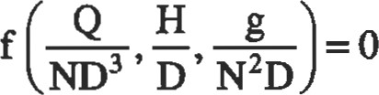

ND

(14)

One might draw as many conclusions about pump similitude from the above functional relationship as there are rearrangements that can be made of the terms. As an example, because power is proportional to YQH, the nondimensional power may be derived to be

Example 1

A pump delivers 400 gal/min at 3,000 rpm. How much will it deliver at 2,500 rpm?

Solution. Within design limits of the pump, the discharge will be approximately proportional to the speed, Q2/Q1 = N2/Nl. Hence Q2 = Qi. N2/Nl = = 333.33 gal/min. Similarly, for a given pump design, the head varies as the square of speed, and the power as the cube of speed.

Example 2

Develop a relation for power P in terms of speed N and impeller diameter D.

Solution: From our pump similitude analysis earlier:

Q = ND3 and N2D2

From our in fluids:

|  |
| --- |
| Performance Curves |

P = YQH = Yklk2N3D5 =(15)

The power required to run a pump depends on two purposes: first, to overcome all the losses in the related flow circuits; and second, to supply the energy to the fluid for the specified task. The first part of the power requirement (to overcome losses) is called the brake horsepower (bhp), and it is the absolute minimal required power even when the volumeü•ic flow rate is zero. The various losses that it accounts for include mechanical friction losses in various components, frictional losses at the impeller, losses due to fluid turbulence, and leakage losses. With increasing flow rate requirements, the bhp increases even for zero head. Figure 2 shows the head-discharge relations.

Figure 3 typifies a manufacturer's performance curve of a pump. In a carpet plot like this one, for any two given values, the rest of the pumping variables may be computed by interpolation and careful extrapolation.

Figure 4 shows the effect of speed change on the pump's performance. Like Figures 2 and 3, this is again a typical sample. For actual curves, one must consult the pump's manufacturer.

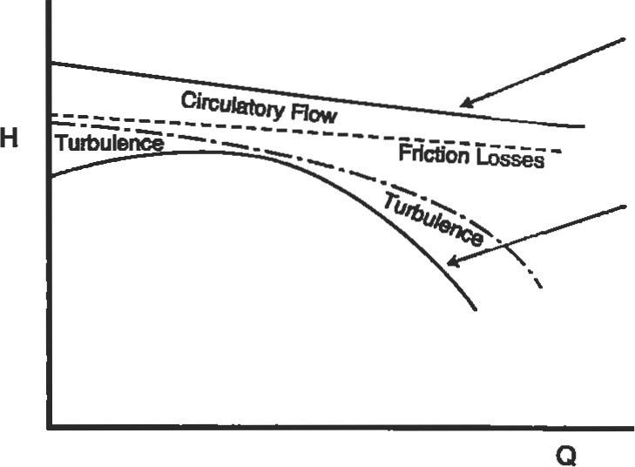Theoretical H-Q curve

AMual H-Q Curve

Figure 2. Head-discharge (H-Q) relationship.

|  |  |  |  |  |
| --- | --- | --- | --- | --- |
| 8  teo  'h  O  200  CAPACITY (GPM)  Figure 3. Characteristics of a centrifugal pump [61.  Gallons Per Minute  Figure 4. Centrifugal pump performance data for speed change  Sources  Cheremisinoff, N. P., Fluid Flow Pocket Handbook. Hous- McAllister, E. W. (Ed.), Pipe Line Rules ofThumb Hand-   |  |  | | --- | --- | | ton: Gulf Publishing Co., 1984. | book, 3rd Ed. Houston: Gulf Publishing co., 1993. | | Series and Parallel Pumping |  | |

Pumps may be operated in series, in parallel, or in any series-parallel combination. When connected in series, the total available head is the sum total of all heads at a given rate of flow. When connected parallel, the total flow is the sum total of all flows at a given value of head. In other words, series pumping is called pressure additive; and parallel pumping is calledflow additive. (See Figures 5 and 6.) The same rules are applied to determine the total head or flow calculations for any series-parallel combination

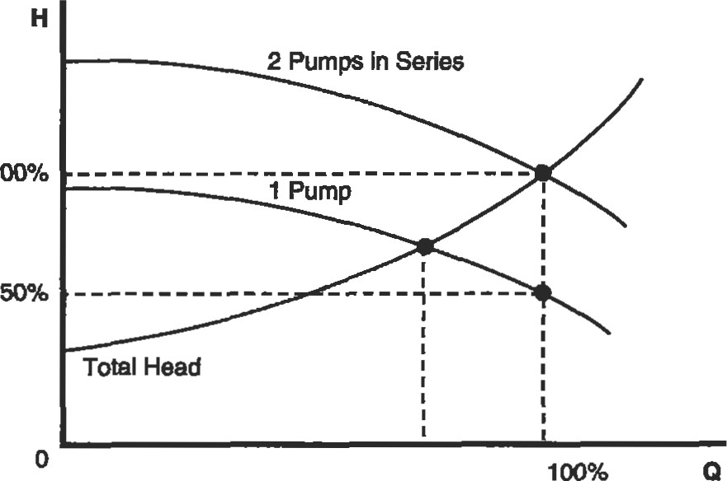

100%

Figure 5. Effect of series pumping on H-Q curve.

|  |  |
| --- | --- |
| 2 | |
|
| Total Head |  |

100%

100% 

Figure 6. Effect of parallel pumping on H-Q curve.

of pumps. When connected in series, one pump's discharge is connected to another's suction; but pumps in parallel share a common suction and a common discharge line. It is important to match the pumps that are in parallel so that they develop the same head at the same flow rate.

Multiple units are often used to allow a variety of pumping conditions to be met without throttling, and therefore wasting, power.

|  |
| --- |
| Design Guldellnes |

Plpewo*

The fluids secüon in this book should be consulted for pipe calculations, but a general guideline for calQ11±g pipe bore size is:

|  |  |  |  |  |
| --- | --- | --- | --- | --- |
| |  | | --- | | lit/ min | | 0.145 | | |  | | --- | | gal / min  20 | |

Borepipe  inches (16) Table 2 lists common flow velocides in commewial use and Table 3 lists recommended flow velocities based on the fluid's specific gravity SG.

Operating Perfomanee

Table 4 provides a summary of operating limitations of

different types of pumps.

Table 2

Common Flow Velocities in Commercial Practice

|  |  |  |  |  |
| --- | --- | --- | --- | --- |
| Medium | Piping |  | Velocity m/sec | Remarks |
| Water | Piston pumps  Feed pumps of steam boilers  Piping for condenæte and sludge  Gruel, send and other substancæ  Piping for cold water Piping for cold nter up to 50mm diameter up to 100mm diameter up to 200mm diameter above 200mm diameter Piping for cooling  Pressure Wter  Delivery piping in mines  Supply to Wter turbines  Municipal mains, main feed pipings municipal system | suction deliwry suction del iwry suction delivery  deliwry deliwy suction max. max. max.  suction delivery | 05—1.5  1.0-20  0.3-0.5  2.0-2.6  0.3-05  10-20  0.5-2.0  1.o—3.o  1.0  13  1.7  2.0  0.7-1 s  1.o-2.o 150-300  ID—IS  30—7 n  1.o-2.o  05—1.2 | The piping is •elected accord ing to its length. A lower velocity is chosen long piping. a higher velocity for short piping (does not apply to delivery of liquids consolid particJes)  In special cases up to 5m/  Low heed  High heed  Normally 0.8 to 0.7mIsec |
| Petrol Oils | Benzol, oil Heew |  | os—2.o | to viscosity |
| Hydrocarbons |  | suction | 0.3—0B |  |
| Air | Low.rzsure  High-pressun piping |  | 12—15  20—25 |  |
| Steam | For steam lirm up to 4MP8  High-presure stem  Superheated stem  Low-præsure heating steam  Exhaust steam | | 39--80  10—15  15—40 | Velocitiæ must be chosen economizlly according to the length of the piping |

Table 3

Recommended Flow Velocities Based on Fluids SG

|  |  |  |  |  |  |  |  |  |  |  |  |  |  |  |
| --- | --- | --- | --- | --- | --- | --- | --- | --- | --- | --- | --- | --- | --- | --- |
| Pipe  Diameter  inch mm | | SG - 1.0 m/wc | | Power Driven Pumß  SG - 0.75 SG ft/—c ft./öc | | | | os mlæc | SG ft/•c | Turbine Driwn Pumps  10 SG - 0.75 SG ft/»c | | | | m/ec |
| 2  3  4  6  8  10  12  14 16 and | 50  75  100  150  200  250  300  350  400 over | 6.00  7.00  8.00  9.00  10.00 1 1.00  11.50  11.75  12.00 | .80  2.10  2.40  2.75  3.00  3.25  3.50  3.65 |  | 7.00  8.00  9.00  10.00  11.25  12.00  12.50  13.00  13.00 | 2 10  2.40  2.75  3.00  3.40  3.65  4.00  4.00 | 7.5  8.5  10.0  12.0  13.0  14.0  14.5  15.0  15.0 | 2.30  2.60  3.00  3.65  4 DO  420  4.40  4.50  4.60 | 5.00  5.50  6.00  6.50  6.75  7.00 | 1.50  1.70  180  200  2.10  2.15  2.15  2.15  2.15 | 5.50  6.00  6.50  7.00  7.75  8.00  8.00  8.00 | 1 .70  IBO  2.00  2.15  2.30  2.35  2.40  2.40 | 6.00  6.50  8.00  8.50  9.00  9.25  9.50 | 1.80  2.00  2.15  2.40  2.60  2.75  2.80  2.90  2.90 |

Table 4

Summary of Operating Performances of Pumps



C.atMagal

Horizontal

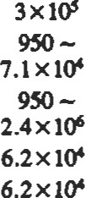Single-gage overhung  1-320 950 - 150 492 2-6 6.6-20 650 1.01 20-0 455 851

2-nage overhung 1—75425 13ß

2-6.7 6.6-22 430 0.67 20-75 455 851

Single-nge impeller205 401 -851

between barings  1-2500 335 1099 2-7.6 6.6—25 650 1.01 30-90 205 401

 3.9-20 6.50 1.01 20-75

6573 239 . 7.6 4.9-25 650 1.01 20—80 455 851

15H 65120 394

|  |  |  |  |  |  |  |  |  |  |  |  |  |
| --- | --- | --- | --- | --- | --- | --- | --- | --- | --- | --- | --- | --- |
|  | L | 0.1 -1250 | 95 1.2x1M | 1500 | 4922 | 2-6 | 6.6-20 | 430 | 0.67 | 20-10 | 540 | |
| Mulü. boriz. QIit | M | 1-700 | 950 - | 1675 |  | 2—6 | 6.6-20 | 430 | 0.67 | 6590 | 205-20 401 -500 | |
| Multi. , barrel type | M | 1-550 | 950 - | 1675 |  | 2-6 | 66 | 430 | 0.67 | 40-75 | 455 | 851 |
| Single-nge process  Multinge | M  M  M  L | 1 -650  1-5000  1-750  0.3 -25 | 950 -  950 -  4.8xW    285 - | 245  1830  215  ITO | 705  5907 | 0.3-6  0.3—6  2-6  2.4-12  0.3-6.7 | 1-20  1-20    7.9-39.8  1-22 | 650  430  430  109  430 | 1.01  0.67  0.67  0.17  0.67 | 20-85  25-90  20-80  10 -so  40-75 | 345    260  260 | 653 |
|  |  |  | 950 - | 60 | 197 | 0.3--6 | 1-20 | 430 | 0.67 | 30-75 | 205 | 401 |
| Multi. well | M | 0.3-25 | 285 - | 1830 |  | —2 | 6.6 |  | 1.01 | 65-85 | 65 | 149 |
| A.ül (pmpella) nubine (regeoerative) | H  M | 1-6500  0.1 — 125 | 950 95 - | 12  760 | 39.4  2493 | 2-2.5 | 6.6 - 8.2 |  | 0.17 | 55-85 | 120 |  |
| Bsüve molaæmau |  |  |  |  |  | 3.7 | 12 | 1100 | 1.71 | 55-85 | 290 | 554 |
| Pinon, plunger | M | 1-650 | 950 6.2 x IOS | (kPa)  345000 | Osi) 50038 | 4.6  3.7 | 15.1  12J | 1100  750 | 1.71  1.46 | -20 | 290 | 554 |
| Muring | L | 0-1 |  | 517000 | 74985 |  |  | (ssu) | (ssu) |  |  |  |
|  | L  M  M | 0.1-6  0.1 -125  0.1 -320 | 95 -    95 — | 34500  20700 | 3002  493 | -3  -3 | -9.8  -9.8 |  |  | 50-80  50—80 | 260  345 | 653 |



MH—moderately high; H—high; M—medium; L-—low

Vacuum Systems

Given two parameters, (a) rate of evacuation and (b) final pressure to be realized, determine the size and number of pumps required for the job. The evacuation time is related to the system parameters by the following equation:

2.3V

Timeminutes logio ¯

where: V = volume to be evacuated (liters), Qe = effective pump speed (liters/min), and PI and P2 are initial and final pressures (torr).

Note that mechanical pumps are not suitable for producing parüal pressures less than about 10-3 torr. Highly specialized pumps are used for the purpose.

Noise

The following formula can be used to esümate the general noise level of a centrifugal pump within plus or minus 2 dB. 2010%0 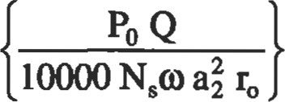 (18)

where PO is total pressure rise across the impeller (bar), Q is the flow rate (m3/min), NS is the specific speed, o is the angular speed (rad/sec), and a2 is the impeller outside radius (cm); ro is width of impeller at outlet (cm).

Noise may also be controlled by changing operaüng conditions of the pump. The blade frequency noise levels can change about 10 dB by changing the operating point of the pump. Minimum noise levels usually do happen at flow rates around 15% above the design operating point.

Sources

Cheremisinoff, N. P., Fluid Flow Pocket Handbook. Houston: Gulf Publishing Co., 1984.

Warring, R. H., Pumping Manual, .7th Ed. Houston: Gulf Publishing Co., 1984.

|  |
| --- |
| Reciprocatlng Pumps |

A. How a Reciprocating Pump Works

A reciprocating pump Is a positive displacement mechanism with liquid discharge pressure being limited only by the strength of the structural pans. Liquid volume or capacity delivered is constant regardless of pressure, and is varied only by speed changes.

Chareteristics of a GASO reciprocating pump are 1) positive displacement of liquid, 2) high pulsations caused by the sinusoidal motion of the piston, 3) high volumetric efficiency, and 4) pump maintenance cost.

1. Plunpr or Piston Rod Load

Plunger or piston "rod tod' is an important power end design consideration for reciprocating pumps. Rod toad is the force caused by the liquid pressure acting on the face of the piston or plunger. This bad is directty to the power frame assembly and is normally the limiting factor in determining maximum discharge pressure ratings. This load is directly proportbnal to the pump guage discharge pressure and portional to the square of the plunger or piston diameter. Occasimally, almable liquw end pressures limit the allc«able rod load to a value below the design rod bad. IT IS IMPORTANT THAT LIQUID END PRESSURES DO NOT EXCEED PUBLISHED LIMITS.

1. Calculations of Volumetric Efflclency

Volumetric efficiency (Ev) is defined as the ratio of plunger or *ton displacement to liquW displacement. The volurnetric efficiency calculation depends upon the intemal configuratbn of eEh individual liquid body, the piston size, and the compressibility of the liquid being pumped.

1. Tools for Liquid Pulntbn Control, Inlet and Discharge

Pulsation Control Tools ("PCT", often referred to as "dampeners" or "stabilizers") are used on the inlet and discharge piping to protect the pumping mechanism and piping by reducing the high pulsations within the liquid caused by the motions of the slider-crank mechanism. A properly located and charged pulsation control tool may reduce the length of pipe used in the acceleration head equation to a value of 5 to 15 nominal pipe diameters. Figure 5 is a suggested piping system for power pumps. The pulsation control tools are specialty required to compensate for inadequately designed or otd/adapted supply and discharge systems.

1. Acceleration Head

Whenever a column Of liquid is accelerated or decelerated, pressure surges exist. This condttjon is found on the inlet side of the pump as well as the discharge side. Not only can the surges cause vibration in the inlet line, but they can restrict and impede the ftow of liquid and cause incomplete filling of the inlet valve chamber. The magnitude of the surges and how they will react in the system is impossible to predict without an extremely complex and costly analysis of the system. Since the behavior of the natural frequencies in the system is not easily predictable, as much of the surge as possible must be eliminated at the source. Proper installation of an inlet pulsation control PCT will absorb a large percentage of the surge before it can travel into the system. The function of the PCT is to absorb the "peak" of the surge and feed it back at the low part of the cycle. The best position for the PCT is in the liquid supply line as close to the pump as possible, or attached to the blind flange side of the pump inlet. In either location, the surges will be dampened and harmful vibrations reduced.

RECIPROCATING PUMPS FLOW CHARACTERISTICS

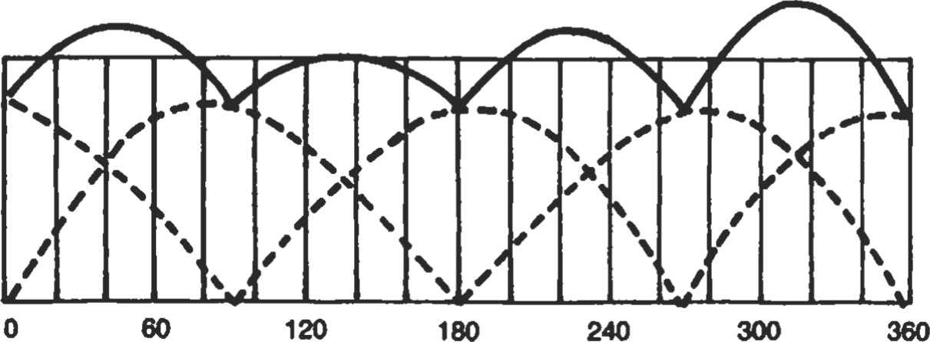100%

DUPLEX DOUBLE-ACTING

Average Flow — 100%

Maximum Flow — 100% + 24%

Minimum Flow — 100% - 22% Total Flow Var. — 46%

0%

Crankshaft Angle (Degree)

100%

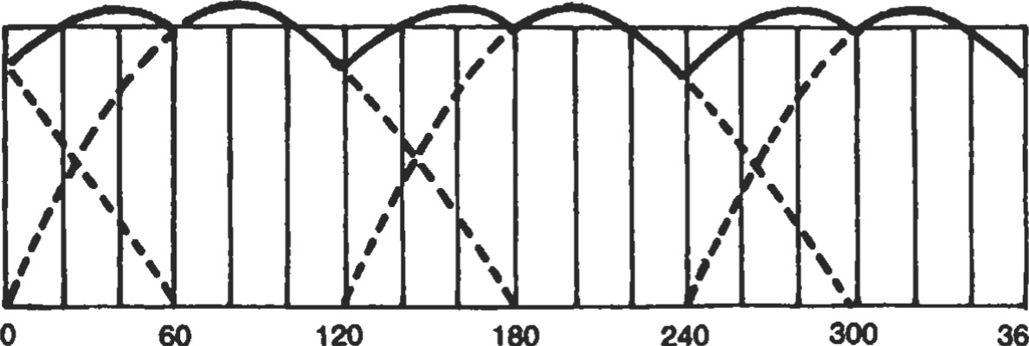

360

TRIPLEX SINGLE-ACTING

Average Flow — 100%

Maximum Flow — 100% + 6% Minimum Flow — 100% - 17% Total Flow Var. — 23%

0%

Crankshaft Angle (Degree)

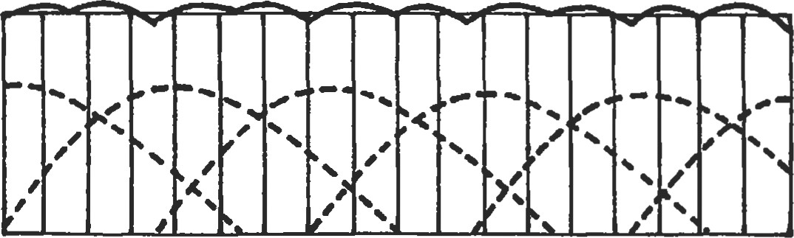100%

QUINTUPLEX SINGLE-ACTING

Average Flow — 100%

Maximum Flow — 100% + 2% Minimum Flow — 100% - 5%

Total Ftow Var

0%

O 60 120 180 240

Crankshaft Angle (Degree)

100%

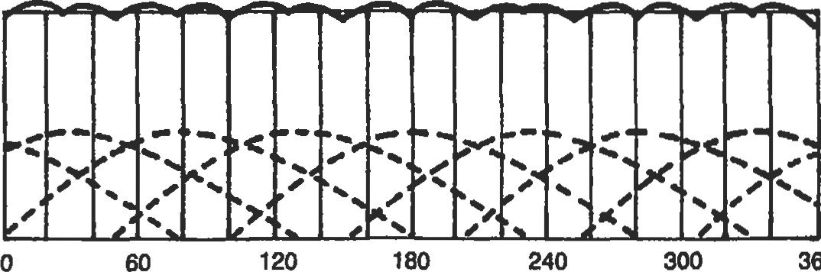

360

0%

Crankshaft Angle (Degree)

100%

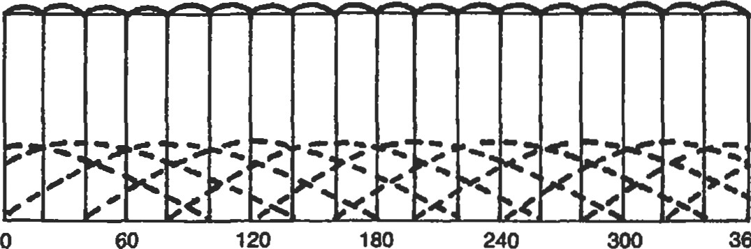

360

0%

Crankshaft Angle (Degree)

REQUIRED FORMULAE AND DEFINITIONS

Acceleration Head

|  |  |
| --- | --- |
| ha - LVNC | GPM |
| Kg | (2.45) (D) |

Where

ha Acceleration head (in feet) L = Length of liquid supply line (in line)

V — Average velocity in liquid supply line (in fps)

N — Pump speed (revolutions per minute) C — Constant depending on the type of pump

C — 0.200 for simplex double-acting

— 0.200 for duplex single-acting

— 0.115 for duplex double-acting

= 0.066 for triplex single or double-acting

= 0.040 for quintuplex single or double-acting

— 0.028 for septuplex, single or double-acting

= 0.022 for nonuplex, single or double-acting

K — Liquid compressibility factor

K — 2.5 For relatively compressible liquids (ethane, hot oil)

K — 2.0 For most other hydrocarbons

K — 1.5 For amine, glycol and water

K — 1.4 For liquids with almost no compressibility (hot water) g — Gravitational constant — 32.2 ft/sec2 d = Inside diameter of pipe (inches)

Stroke

One complete uni-directional motion of piston or plunger.

300 360

SEPTUPLEX SINGLE-ACTING

Average Flow — 100%

Maximum Flow — 100% + 1.2%

Minimum Flow — 100% - 2.6%

Total Flow Var. — 3.8%

NONUPLEX SINGLE-ACTING

Average Flow — 100%

Maximum Flow — 100% + 0.6% Minimum Flow — 100% - $1.5%

Total Flow Var. —

Pump Capacity (Q)

The capacity of a reciprocating pump is the total volume through-put per unit of time at suction conditions. It includes both liquid and any dissolved or entrained gases at the stated operating conditions. The standard unit of pump capacity is the U.S. gallon per minute.

Pump Displacement (D)

The displacement of a reciprocating pump is the volume swept by all pistons or plungers per unit time. Deduction for piston rod volume is made on double acting piston type pumps when calculating displacement. The standard unit of pump displacement is the U.S. gallon per minute.

For single-acting pumps: D = Asnm

231

For double-acting piston pumps:

D — (2A — a) snm

231

Where

A — Plunger or piston area, square inch a = Piston rod cross-sectional area, square inch

(double-acting pumps) s = Stroke length, inch n — RPM of crankshaft

Stroke length is expressed in inches. Number of pistons or plungers

Plunger or Piston Speed (v)

The plunger or piston speed is the average speed of the plunger of piston. It is expressed in feet per minute.

v = ns

6

Pressures

The standard unit of pressure is the pound force per square inch.

Discharge Pressure (Pd)—The liquid pressure at the centerline of the pump discharge port.

Suction Pressure (Ps)—The liquid pressure at the centeriine of the suction port.

Differential pressure (Ptd)—The difference between the Iiquid discharge pressure and suction pressure.

Net Positive Suction Head Required (NPSHR)—The amount of suction pressure, over vapor pressure, required by the pump to obtain satisfactory volumetric efficiency and prevent excessive cavitation.

The pump manufacturer determines (by test) the net positive suction head required by the pump at the specified operating conditions.

NPSHR is related to losses in the suction valves of the pump and frictional losses in the pump suction manifold and pumping chambers. Required NPSHR does not include system acceleration head, which is a system-related factor.

##### Slip (S)

Slip of a reciprocating pump is the loss of capacity, expressed as a fraction or percent of displacement, due to leaks past the valves (including the back-flow through the valves caused by delayed closing) and past double-acting pistons. Slip does not include fluid compressibility or leaks from the liquid end.

Power (P)

Pump Power Input (Pi)—The mechanical power delivered to a pump input shaft, at the specified operating conditions. Input horsepower may be calculated as follows:

Pi Q x Ptd

1714 x np

Pump Power Output (Po)—The hydraulic power imparted to the liquid by the pump, at the specified operating conditions. Output horsepower may be calculated as follows:

Po = Q x Ptd

The standard unit for power is the horsepower.

Efficiencies (n)

Pump Efficiency (also called pump mechanical efficiency)-—The ratio of the pump power output to the pump power input.

Volumetric Efficiency ratio of the pump capacity to displacement.

##### nV - Q

Plunger Load (Single-Acting Pump)

The computed axial hydraulic load, acting upon one plunger during the discharge portion of the stroke is the plunger load. it is the product of plunger area and the guage discharge presssure. It is expressed in pounds force.

Piston Rod Load (Double-Acting Pump)

The computed axial hydraulic load, acting upon one piston rod during the forward stroke (toward head end) is the piston rod load.

It is the product of piston area and discharge pressure, less the product of net piston area (rod area deducted) and suction pressure. It is expressed in pounds force.

Liquid pressure ( pounds ) or(psi) = square inch

Cylinder area (square inches) =

(3.1416) x (Radius(inches))2 =

###### (3.1416) x (diameters(inches))2

4

Cylinder force (pounds)—pressure (psi) x area (square inches)

Cyllnder speed or average liquld velocity through

Ing (feet/second) = flow rate (gpm) 2.448 x

(inside diameter (inch))2

Reciprocating pump displacement (gpm) rpm x displacement (cubic in/revolution)

231

Pump Input horsepower—see horsepower calculations

Shaft torque (foot-pounds) = horsepower x 5252 shaft speed (rpm)

Electric motor speed (rpm) — 120 x frequency (Hz) number of poles

Three phase motor horsepower (output) =

1.73 x ampers x volts x efficiency x power factor 746

Static head of liquid (feet) =

2.31 x static pressure (psig)



specific gravity

|  |  |
| --- | --- |
| Velocity head of liquid (feet) = | Absolute pressure (psia) = |
| liquid velocity2 | Local atmospheric pressure + gauge pressure (psig) |

|  |  |
| --- | --- |
| g = 32.2 ft1sec2 | Gallon per revolution = |
| Absolute viscosity (centipoise) = | Area of plunger (sq in) x length of |
| specific gravity x Kinematic viscosity (centistrokes) | stroke(in) x number of plungers |
| Kinematic viscosity (centistrokes) =  0.22 x saybolt viscosity (ssu) — 180 | 231 |

 Saybolt viscosity (ssu) Barrels per day = gal/rev x pump speed (rpm) x 34.3

TABLE 5 Water Compressibility

Compressibility Factor ßt x in Unit Volume Per Psi Pressure

Compressibility from 14.7 Psia, 32 F to 212 F and from Saturation Pressure Above 212 F

###### TEMPERATURE

|  |  |  |  |  |  |  |  |  |  |  |  |  |  |  |  |  |  |  |  |
| --- | --- | --- | --- | --- | --- | --- | --- | --- | --- | --- | --- | --- | --- | --- | --- | --- | --- | --- | --- |
| Pressure Psia | oc  32 F | 20 c 40 C 60 C 80 Cloo C120 CuO C160 C180 C200 C220 C240 C260 C280 C300 C320 C340 C360 C  63 F 104 F 140 F 176 F 212 F 248 F 284 F 320 F 356 F 392 F 428 F 464 F 500 F 536 F 572 F 608 F 644 F 680 F | | | | | | | | | | | | | | | | | |
| 200  400  600  800  1000 | 3.12  3.11  3.10  3.10  3.09 | 3.06  3.05  3.05  3.04  3.03 | 3.06  3.05  3.05  3.04  3.03 | 3.12  3.11  3.10  3.09  3.09 | 3.23  3.22  321  3.21  3.20 | 3.40  3.39  3.39  3.38  3.37 | 3.66  3.64  3.63  3.62  3.61 | 4.00  3.99  3.97  3.96  3.95 | 4.47  4.45  4.44  4.42  4.40 | 5.11  5.09  5.07  5.04  5.02 | 6.00  5.97  5.93  5.90  5.87 | 7.27  7.21  7.15  7.10  7.05 | 8.95  8.85  8.76 | 11.6  11.4 | 16.0 |  |  |  |  |
| 1200  1400  1600  1800  2000 | 3,08  3.07  3.06  3.05  3.04 | 3.02  3.01  3.00  2.99  2.99 | 3.02  3.01  3.00  3.00  2.99 | 3.08  3.07  3.06  3.05  3.04 | 3.19  3.18  3.17  3.16  3.15 | 3.36  3.35  3.34  3.33  3.32 | 3.60  3.59  3.58  3.57  3.56 | 3.94  3.92  3.91  3.90  3.88 | 4.39  4.37  4.35  4.34  4.32 | 5.00  4.98  4.96  4.94  4.91 | 5.84  5.81  5.78  5.75  5.72 | 7.00  6.95  6.91  6.87  6.83 | 8.68  8.61  8.53  8.47  8.40 | 11.2  11.1  10.9  10.8  10.7 | 15.4  15.1  14.8  14.6  14.3 | 23.0  21.9  21.2  20.7 | 36.9  34.7 |  |  |
| 2200  2400  2600  2800  3000 | 3.03  3.02  3.01  3.00  3.00 | 2.98  2.97  2.96  2.95  2.94 | 2.98  2.97  2.96  2.96  2.95 | 3.04  3.03  3.02  3.01  3.00 | 3.14  3.14  3.13  3.12  3.11 | 3.31  3.30  3.29  3.28  3.28 | 3.55  3.54  3.53  3.52  3.51 | 3.87  3.85  3.85  3.83  3.82 | 4.31  4.29  4.28  4.26  4.25 | 4.89  4.87  4.85  4.83  4.81 | 5.69  5.66  5.63  5.61  5.58 | 6.78  6.74  6.70  6.66  6.62 | 8.33  8.26  8.20  8.14  8.08 | 10.6  10.5  10.4  10.3  10.2 | 14.1  13.9  13.7  13.5  13.4 | 20.2  19.8  19.4  19.0  18.6 | 32.9  31.6  30.5  29.6  28.7 | 86.4  69.1  61.7  572  53.8 | 238.2  193.4 |
| 3200  3400  3600  3800  4000 | 2.99  2.98  2.97  2.96  2.95 | 2.94  2.93  2.92  2.91  2.90 | 2.94  2.93  2.93  2.92  2.91 | 3.00  2.99  2.98  2.97  2.97 | 3.10  3.09  3.09  3.08  3.07 | 3.27  3.26  3.25  3.24  3.23 | 3.50  3.49  3.48  3.47  3.46 | 3.81  3.80  3.79  3.78  3.76 | 4.23  4.22  4.20  4.19  4.17 | 4.79  4.78  4.76  4.74  4.72 | 5.55  5.53  5.50  5.47  5.45 | 6.58  6.54  6.51  6.47  6.43 | 8.02  7.96  7.90  7.84  7.78 | 10.1  9.98  9.89  9.79  9.70 | 13.2  13.0  12.9  12.7  12.5 | 18.3  17.9  17.6  17.3  17.1 | 27.9  27.1  26.4  25.8  25.2 | 51.0  48.6  45.4  44.5  42.8 | 161.0  138.1  122.4  110.8  101.5 |
| 4200  4400  4600  4800  5000 | 2.95  2.94  2.93  2.92  2.91 | 2.90  2.89  2.83  2.87  2.87 | 2.90  2.90  2.89  2.88  2.87 | 2.96  2.95  2.94  2.94  2.93 | 3.06  3.05  3.05  3.04  3.03 | 3.22  3.21  3.20  3.20  3.10 | 3.45  3.44  3.43  3.42  3.41 | 3.75  3.74  3.73  3.72  3.71 | 4.16  4.14  4.13  4.12  4.10 | 4.70  4.68  4.66  4.64  4.63 | 5.42  5.40  5.37  5.35  5.32 | 6.40  6.36  6.32  6.29  6.25 | 7.73  7.68  7.62  7.57  7.52 | 9.62  9.53  9.44  9.36  9.28 | 12.4  12.2  12.1  12.0  11.8 | 16.8  16.5  16.3  16.0  15.8 | 24.6  24.1  23.6  23.2  22.7 | 41.3  40.0  38.8  37.6  36.6 | 93.9  87.6  82.3  77.7  73.9 |

5200 2.90 2.85 2.87 2.92 3.02 3.18 3.40 3.69 4.09 4.61 5.30 6.22 7.47 9.19 11.7 15.6 22.3 35.6 70.3

5400 2.90 2.85 2.86 291 3.01 3.17 3.39 3.68 4.07 4.59 5.27 6.19 7.41 9.12 11.6 15.3 21.9 34,6 66.9

EXAMPLE: Find the volumetric efficiency of a reciprocating pump with the following conditions: vol. Eff. -

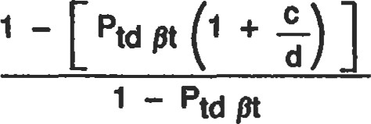Type of pump 3 in diam plunger x

5 in stroke triplex

Liquid pumped Water

Suction pressure Zero psig

|  |  |  |
| --- | --- | --- |
|  | .00000305) | 127.42  1 +  35.343 |

|  |  |
| --- | --- |
| d 35.343 cu in  s .02 |  |
| Find pt from Table of Water Compressibility (Table 5 ). | -.96026 |
| pt = .00000305 at 140 F and 1800 psia Calculate volumetric efficiency: | —96 per cent |

Discharge pressure 1785 psig Pumping temperature 140 F c 127.42 cu in- .02

Specific gravity (at 60 09 — 141.5

131.5 + API gravity (degree)

Bolt clamp load (1b) =

0.75 x proof strength (psi) x tensile stress area (in2)

Bott torque (ft-lb) =

0.2 (or 0.15) x nominat diameter in inches x bolt clamp

12 load (1b)

0.2 for dry

0.15 for lubricated, plating, and hardened washers

Calculating Volumetric Efficiency for Water

The volumetric efficiency of a reciprocating pump, based on capacity at suction conditions, using table of water compressibility, shall be calculated as follows:

vol. Eff. =

Ptd pt + E_

d -s

I - Ptd Pt

Where

= Compressibility factor at temperature t (degrees

Fahrenheit or centigrade). (See Tables 5 and 6). c = Liquid chamber volume in the passages of chamber between valves when plunger is at the end of discharge stroke in cubic inches

dVolume displacement per plunger in cubic inches Ptd  Discharge pressure minus suction pressure in psi s  Slip, expressed in decimal value

Calculating Volumetric Efficiency For Hydrocarbons

The volumetric efficiency of a reciprocating pump based on capacity at suction conditions, using compressibility factors for hydrocarbons, shall be calculated as follows:

vol. Eff 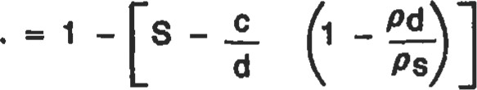pd

Where

c — Fluid chamber volume in the passages of chamber between valves, when plunger is at the end of discharge strike, in cubic inches d = Volume displacement per plunger, in cubic inches p = Pressure in psia (Ps —suction pressure in psia;

Pd —discharge pressure in psia)

Pc = Critical pressure of liquid in psia

 — Reduced pressure

Actual pressure in psia P

Critical pressure in psia Pc

 Reduced suction pressure = pc

p pre Reduced discharge pressure = pc

TABLE 6 Water Compressibility

Compressibility Factor pt x  in Unit Volume Per Psi Pressure

Compressibility from 14.7 Psia at 68 F and 212 F and from Saturation Pressure at 392 F

Temperature Temperature

|  |  |  |  |  |  |  |  |
| --- | --- | --- | --- | --- | --- | --- | --- |
| Pressure Psla | 20 c  68 F | 100 c  212 F | 200 c  392 F | Pressure Psia | 20 c | 100 c  212 F | 200 c  392 F |
| 6000 | 2.84 | 3.14 | 5.20 | 22000 | 2.61 | 2.42 | 3.75 |
| 7000 | 2.82 | 3.10 | 5.09 | 23000 | 2.59 | 2.38 | 3.68 |
| 8000 | 2.80 | 3.05 | 4.97 | 24000 | 2.58 | 2.33 | 3.61 |
| 9000 | 2.78 | 3.01 | 4.87 | 25000 | 2.57 | 2.29 | 3.55 |
| 10000 | 2.76 | 2.96 | 4.76 | 26000 | 2.56 | 2.24 | 3.49 |
| 11000 | 2.75 | 2.92 | 4.66 | 27000 | 2.55 | 2.20 | 3.43 |
| 12000 | 2.73 | 2.87 | 4.57 | 28000 | 2.55 | 2.15 | 3.37 |
| 13000 | 2.71 | 2.83 | 4.47 | 29000 | 2.54 | 2.11 | 3.31 |
| 14000 | 2.70 | 2.78 |  | 30000 | 2.53 | 2.06 | 3.26 |
| 15000 | 2.69 | 2.74 | 4.29 | 31000 | 2.52 | 2.02 | 3.21 |
| 16000 | 2.67 | 2.69 | 4.21 | 32000 | 2.51 | 1.97 | 3.16 |
| 17000 | 2.66 | 2.65 | 4.13 | 33000 | 2.50 | 1.93 | 3.11 |
| 18000 | 2.65 | 2.60 | 4.05 | 34000 | 2.49 | 1.88 | 3.07 |
| 19000 | 2.64 | 2.56 | 3.97 | 35000 | 2.49 | 1.84 | 3.03 |
| 20000 | 2.63 | 2.51 | 3.89 | 36000 | 2.48 | 1.79 | 2.99 |

21000 2.62 2.47 3.82

s = Slip expressed in decimal value  Reduced discharge temperature t  in degrees Rankine

 Degrees F+ 460 (ts suction temperature in degrees Rankine; td discharge temperature in degrees Rankine) Vol. Eff. —Volumetric efficiency expressed in decimal T = Critical temperature of liquid, in degrees Rankine value.

(See Table 7)

|  |  |  |
| --- | --- | --- |
| Reduced temperature |  | — ---— x x 62.4 —density of liquid in 1b 1 |
| actual temp. in degrees Rankine |  | per cu ft |
| critical temp. in degrees Rankine | S | Density in 1b per cu ft at suction pressure  Density in 1b per cu ft at discharge pressure |
| (See Fig. 7) |  | — Expansion factor of liquid |

|  |  |  |
| --- | --- | --- |
| rs |  | grams  1 which is established by  timeter for any one liquid density measurements and the corresponding values of (See Table 7).  TABLE 7 |
| Carbon |  | Degrees Lb Per Grams |
| Atoms | Name | Rankine Sq In Per cc |

 = Reduced suction temperature —— Characteristic constant in per cubic cen-

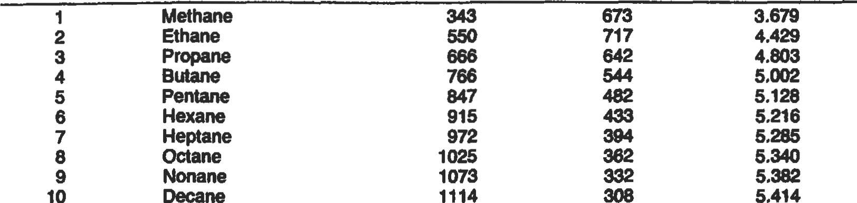

5.459

5.483

1185

1248

3.679

4.429

10

12 Dodecane 272

14 Tetradecane

|  |  |
| --- | --- |
| Example: Find volumetric efficiency of the previous reciprocating | Find density at discharge pressure: |
| pump example with the following new conditions:  Type of Pump 3 inch dia plunger x 5 inch | t 460 + 80  d _ .81 |
| stroke triplex  Liquid pumped Propane | P 1926  prd = d _ — -3.0 |
| Suction temperature 70 F Discharge temperature 80 F | pc 642 |
| Suction pressure 242 psig | .1089 (From Fig. 7) |
| Dischar* pressure 1911 psig | PI  Pd = xwx 62.4 |
| Find density at suction pressure: | - 4.803 x .1089 x æ.4 |
| ts 460+70  -.795 | — 32.641b per cu ft |
| p | Therefore |

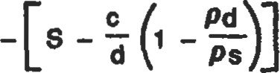s 257

pts pc 642 Vol. Eff. 1

PI

= 4.803 (From Table 7, propane)

###### 01

127.42 32.64

- .02 -

t.J= .1048 (From Fig. 7) 35.343 31.4

PI

Ps = —xo.)" 62.4

01 = .8376

- 4.803 x .1048 x 62.4

31.4 1b per cu fi = 83.76 per cent



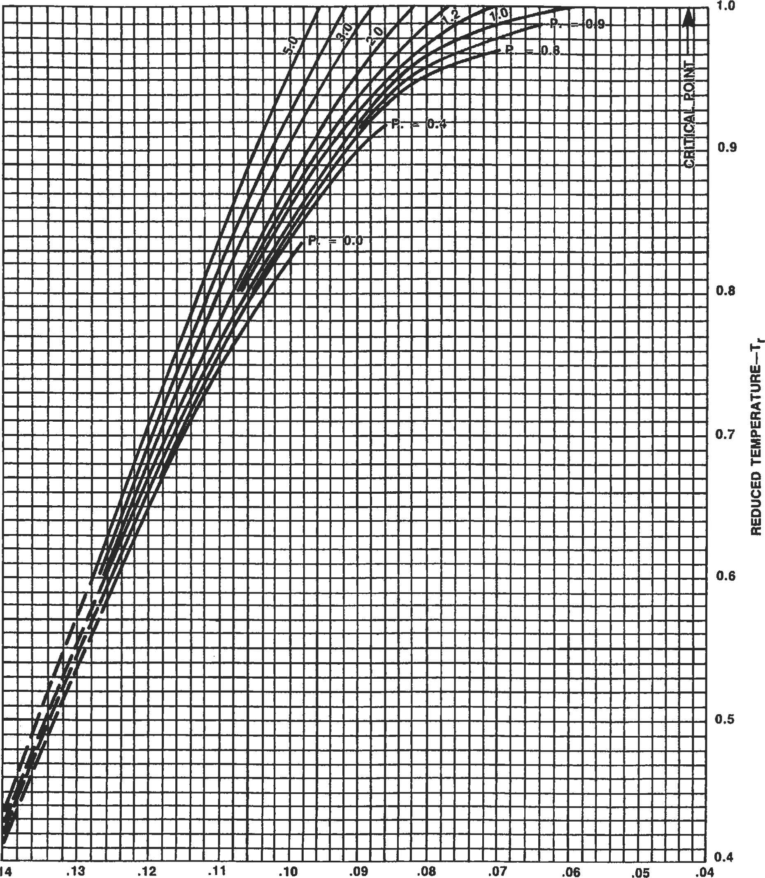

.14

EXPANSION FACTOR—

Figure 7. Thermal Expansion and Compressibility of Liquids. (Reprinted with permission—Goulds Pumps.)

Source (Reciprocating Pumps)

McAllister, E. W. (Ed.), Pipe Line Rules ofThumb Handbook, 3rd Ed. Houston: Gulf Publishing co., 1993.

###### COMPRESSORS*

The following data are for use in the approximation of horsepower needed for compæOn of gas.

Definltlons

The "N value" of gas is the ratio of the specific heat at constant presure (Cp) to the specific heat at constant volume (Cv).

If the of gas is known, the value of N for a gas mixture may be determined from the molal heat capacides of the componenb. If only the gavity of gas is hown an approximate N value may be obtained by using the chart in Figure 1.

Pisu»n Displacement of a compressor cylinder is the volume swept by the piston with the proper deduction for the piston rod. The displacement is usually explessed in cubic ft per minute.

Clearance is the volume remaining in one end of a cylinder with the piston positioned at the end of the delivery stroke for this end. The clearance volume is as a percentage of the volume swept by the piston in making

|  |  |  |  |  |  |  |  |  |  |  |  |  |
| --- | --- | --- | --- | --- | --- | --- | --- | --- | --- | --- | --- | --- |
| onaooooooooa | | | | | | | | | | | | |
|  |  |  |  |  |  |  |  |  |  |  |  | |
|  |  |  |  |  |  |  |  |  |  |  |  | |
|  |  |  |  |  |  | APPROXIMATE SPECFC HEAT RATIO  NTA OF HYDROCARBON GAB PLOTTED  AGAINST THEIR MOLECULAR WEIGHTS | | | | | |  |
| oooooooooaaa oaoosaoaoaoa OOOOONOOOOOO ooooaasoaaoo | | | | | | | | | | | | |
|  |  |  |  |  |  |  |  |  |  |  |  | |
|  |  |  |  |  |  |  |  |  |  |  |  | |
|  |  |  |  |  |  |  |  |  |  |  |  | |

70 241

65 2.24

60 2.06

55 1.89

50 1.72

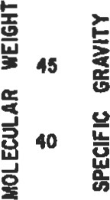1.55

1.38

35 1.2

30 JDS

25 aes

20 aes

15



full delivery s&oke for the end of the cylinder being ered.

Rado of  is the ratio of the absolute discharge pressure to the absolute inlet presure.

Actual capacity is the quantity of gas compresed and delivered, in cubic ft per minute, at the intake presure and temperature.

Volurnetric efficiency is the ratio of actual capacity, in cubic ft per minute, to the piston displacement, in cubic ft per minute, in percent.

Adiabaüc horsepower is the theoretical horsepowæ required to compres gas in a cycle in which there is no bansfer of heat to or from the gas during compreOn or Qansion.

IsotlErmal horsepower is the theoretical horsepower required to compress gas in a cycle in which there is no change in gas temperatuxe during compression or expansion.

Indicated horsepower is the actual horsepower required to compr• gas, taking account losses within the compresor but not taking into account any loss in frame, gear or power transmision equipment.

1,20 1.50

*Reprinted from Pipe Line Rules

Figure 1. Ratio of specific heat (n-value).

Thwnb Handbook, 3rd Ed., E. W. McAllister (Ed.), Gulf Publishing Company, Houston, Texas, 1993.

Compresion efficiency is the ratio of the theoredcal horsepower to the actual indicatd horsepower, required to a definite amount of gas. The  expræsed in percent, should be in regard to the base at which the theor&al power was calculated, whether adiabatic or isothermal.

Mechmiical efficiency is the ratio of the indicated hore power of the cylinder to the brake horsepower delivered to the shaft in the case of a power driven machine. It is in percent.

Overall effiden%' is ffle product, exproed in percent, of the comprasion efficiency and the mechanical efficiency. It must be defined according to the base, adiabatic isother-

mal, which was used in Btabl.ishing the  efficiency.

Piston rod load is the varying, and usually reversing, load imposed on the piston rod and during the by different gas presuræ existing on the faces of the compresor piston.

|  |
| --- |
| Performance Calculations for Reciprocating Compressors |

The maximum piston rod gas load is determined for each compressor by the manufacturer, to limit the in the frame members and the bearing loads in accordance with mechanical daign. The maximum allowed piston rod gas load is affected by the ratio of compression and also by the desigl; i.e., whether it is single or double acting.

Piston Dlsplacement

Single compressor:

|  |  |
| --- | --- |
| Pd = [St X N X 3.1416 X D2V[4 X 1,728]  Double acting compressor without a tail rod:  Pd = [St X N X 3.1416 X (02 - X 1,728] | (1)  (2) |

Double acting compresor with a tail rod:

[St x N x 3.1416 x 2 x - x 1,728] (3)

Single acting compressor comprssing on frame end only:

Pd - [St X N X 3.1416 X - X 1,728] (4)

where Pd = displacement, cu ft/min St = Stroke length, in.

N =  speed, number of comprasion strokß/min D Cylinder diameter, in.

d = Piston rod diameter, in.

VolumeMc Emcienw

Ev=O.97 - - -L (5) where Ev = Volumeüic emciency f = ratio of discharge compressibility to suction compressibility Z2Z1 rp = pressure raüo k = isenü•opic exponent C = percent clearance

L = gas slippage factor

Let L = 0.3 for lubricated

I-at L = 0M for non lubricated

These values are approximations and the exact value may vary by as much as an additional 0.02 to 0.03.

Note: A value of 0.97 is used in the volumetric efficiency equation rather than 1.0 since even with O clearance, the cylinder will not fill perfectly.

Cylinder inlet capacity

 (7)

Piston Speed

PS [2 x st x N]/12

Discharge Temperature

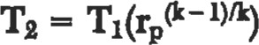

where = Absolute discharge temperature O R

Tl Absolute sucåon temperature OR

Note: Even though this is an adiabaHc relationship, cylinder cooling will generally offset the effect of efficiency.

Power

wcyl - [144 PIQi/33,OOO x [k/(k - 1)]

X [r k-l/k — l] (10)

where ncyl — efficiency ww1 — Cylinder horsepower

See Figure 2 "Reciprocating compressor efficiencies" for curve of efficiency vs pressure ratio. This curve includes a 95% mechanical efficiency and a valve velocity of 3,000 ft. per minute. Tables I and 2 pennit a correction to be made to the compressor horsepower for specific gravity and low inlet pressure. While it is recognized that the efficiency is not necessarily the element affected, the desire is to modify the power required per the criteria in these figures. The efficiency correction accom-

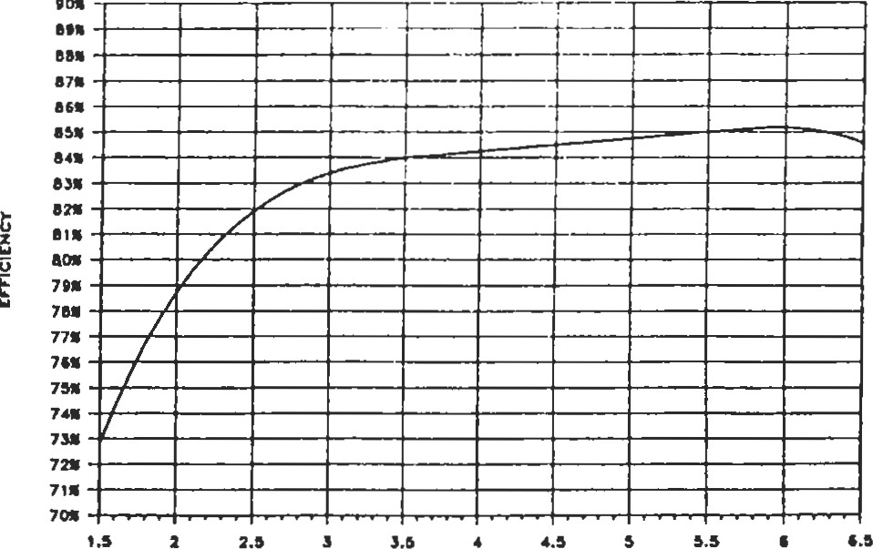

PRESSURE RATIO

Reciprocating compressor efficiencies plotted against pressure ratio with a valve velocity of 3,000 fpm and a mechanical efficiency of 95 percent.

Figure 2. Reciprocating compressor efficiencies.

|  |  |  |  |  |  |  |  |  |  |  |
| --- | --- | --- | --- | --- | --- | --- | --- | --- | --- | --- |
|  | OOOOOOOOOD oaaaooaozo | | | | | | | | | |
|  |  |  |  |  |  |  |  |  |  |  |
|  | aooooaøooa | | | | | | | | |
|  |  |  |  |  |  |  |  |  |  |  |
|  |  |  |  |  |  |  |  |  |  |  |
|  |  |  |  |  |  |  |  |  |  |  |
|  | aoodaaaoo | | | | | | | | |  |
|  |
|  |  |  |  |  |  |  |  |  |  |  |
|  |  |  |  |  |  |  |  | |  |  |

12

 10

7





Figure 3. Volume bottle sizing.

plishes this. These corrections become more significant at the lower pressure ratios.

Inlet Valve Velocity

V = 288 x PWA (11)

where V = Inlet valve velocity

A = Product of actual lift and the valve opening periphery and is the total for inlet valves in a cylinder expressed in square in. (This is a compressor vendor furnished number.) Example. Calculate the following:

Suction capacity

Horsepower

Discharge temperature Piston speed

Given:

Bore = 6 in.

Stroke = 12 in.

Speed = 300 rpm

Rod diameter = 2.5 in.

Clearance = 12%

Gas = C02

Inlet pressure = 1,720 psia

Discharge pressure = 3,440 psia

Inlet temperature = 115 0 F

Calculate piston displacement using Equation 2.

Pd = 12 X 300 X 3.1416 X

107.6 cfm

Calculate volumetric efficiency using Equation 5. It will first be necessary to calculate f, which is the ratio of discharge compressibility to suction compressibility.

Tl = 115 + 460 = 575 0 R



* 575/548

= 1.05

where Tr = Reduced temperature

 = Critical temperature = 548 0 for C02

T = Inlet temperature

Pr = P/Pc

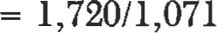

= 1.61

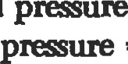whae Pr = Reduced

Pc = Critical = 1,071 psia for C02

P = SucHon presure

From the generalized compressibility chart (Figure 4):

* 0.312

Determine discharge comproibility. Calculate discharge temperature by using Equation 9.

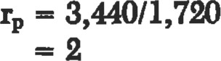

k — cp/cv = 1.3 for C02

= 575 x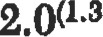

 674.70R

= 674.7 - 460 - 214 0 F

Tr - 674.7/548 = 1.23

Pr =  - 3.21

From the generalizd chart (Figure 4) :

z.2 0.575

f - 0.575/1.61 = 1.843

Ev = 0.97 - [(1/1.843) X 2.01/1 .3 - 1] X 0.12 - 0.05

- 0.929

-93%

Note: A value of 0.05 was used for L because of the high diffeæntial presure.

Calculate suction capacity.

QI =EvxPd

- 0.93 x 107.6

= 100.1 cfm

Calculate piston speed.

PS [2 x st x N]/12

= [2 x 12 x 300]/12 = 600 ft/min

Täble 1

|  |  |  |  |  |  |  |  |  |
| --- | --- | --- | --- | --- | --- | --- | --- | --- |
|  |  |  |  | Psia |  |  |  |  |
| r, | 10 | 14.7 |  | 40 | eo | 80 | 100 | ISO |
|  | .990 | 1.00 | 1.00 | 1.00 | 1.00 | 1.00 | 1.00 | 1.00 |
| 2.5 | .980 | .985 | ,990 | $95 | 1,00 | 1.00 | 1.00 | 1.00 |
| 2.0 | .960 |  | .970 | .980 | .990 | 1.00 | 1.00 | 1.00 |
| 1.5 |  | ,900 | .020 |  |  | .980 | .990 | 1.00 |

*clency Multiplier for Low Pressure

Source: Modlfled courtesy o' the G" Processors SuppU•ro Auoclatloa cod Ingersoll-Rand.

###### able 2

Efflclency Multlpller for Speclflc Gravity

|  |  |  |  |  |  |
| --- | --- | --- | --- | --- | --- |
|  |  |  | SG |  |  |
|  | 1.5 |  |  |  |  |
|  | 0.99 |  | 1.0 | 1.0 | 1.01 |
|  |  |  |  | 101 | 1.02 |
| l.s | o." | 0M |  |  | 1.04 |

Source Modified courtesy oe te Gas hocessots S.ptien Assæi•tJon.

|  |
| --- |
| =  LOO  00 reduced pressure, Pr  Figure 4. Compressibility chart for low to high values of reduced pressure. Reproduced by permission of Chemical Engineering, McGraw Hill Publications Company, July 1954.  Estimating suction and discharge volume bottle sizes for pulsation control for reciprocating compressors |

Pressure surges are created as a result of the cessation of flow at the end of the compressor's discharge and suction stroke. As long as the compressor speed is constant, the pressure pulses will also be constant. A low pressure compressor will likely require little if any treatment for pulsation control; however, the same machine with increased gas density, pressure, or other operational changes may develop a problem with pressure pulses. Dealing with pulsation becomes more complex when multiple cylinders are connected to one header or when multiple stages are used.

API Standard 618 should be reviewed in detail when planning a compressor installation. The pulsation level at the outlet side of any pulsation control device, regardless of type, should be no more than 2% peak-to-peak of the line pressure of the value given by the following equation, whichever is less.

 (12)

Where a detailed pulsation analysis is required, several approaches may be followed. An analog analysis may be performed on the Southern Cas Associaåon dynamic comsimulator, or the analysis may be made a part of the compressor purchase conbact. Regardles of who makæ the analysis, a detailed drawing of the piping in the compræsor area will be needed.

The following equations are intanded as an aid in mating bottle sizes or for checking sizes proposed by a vendor for simple installations—i.e., single cylinder connected to a header without the interaction of multiple cylinders. The bottle type is the dmple unbaffled type.

Determine the approximate üe of suction and discharge volume bottles for a single-stage, single-acting, lubricated compressor in natural gas service.

Cylinder bore — 9 in.

Cylinder s&oke = 5 in. Rod diameter = 2.25 in. Sucdon temp = 800F

Discharge temp = 141 OF

Suction = 514 psia

Discharge = 831 psia

Isentropic exponent, k — 1.28

Specific gravity = 0.6

Percent clearance = 25.7%

Step 1. Determine suction and discharge volumetric efficienciæ using Equations 5 and 13.

 (13)

rp - 831/514

- 1.617

Zl = 0.93 (from Figure 5) zo = 0.93 (from Figure 5)

f = 0.93/0.93

= 1.0

Calculate suction volumebic efficiency using Equation 5:

Ev - 0.97 - [(1/1) X 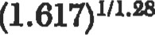 - 1] X 0.257 - 0.03

- 0.823

Calculate discharge volumetric efficiency using EquaHon 13:



= 0.565

Calculate volume displaced per revolution u.Mng EquaHon 1:

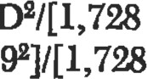Pd/N - st X 3.1416 X X 4] = [5 x 3.1416 x x 4] = 0.184 cu ft or 318 cu in.

Refer to Figure 3, volume bottle sizing, using emciencies previously calculated, and determine the multipliers.

Suction mulåplier = 13.5

Discharge multiplier = 10.4

Discharge volume = 318 x 13.5

= 3,308 cu in.

Suction volume = 318 x 10.4

= 4,294 cu in.

Calculate bottle dimensions. For elliptical heads, use Equation 14.

Bottle diameter db — 0.86 x volume1/3 (14)

Volume = sucüon or discharge volurne

Suction bottle diameter — 0.86 x 4,2941/3 - 13.98 in.

Discharge bottle diameter = 0.86 X 3,308113 = 12.81 in.

Bottle length = Lb = 2 X db (15)

SucHon bottle length = 2 x 13.98 = 27.96 in.

Discharge bottle length = 2 x 12.81 = 25.62 in.

Source

Brown, R. N., Comprasors—Selection & Sizing, Houston: Gulf PublN1ing Company, 1986.

s 000 10.000 15000 20.000 25.000 30.000 33.000 40.000 4 3.000



PRESSURE- PSIA

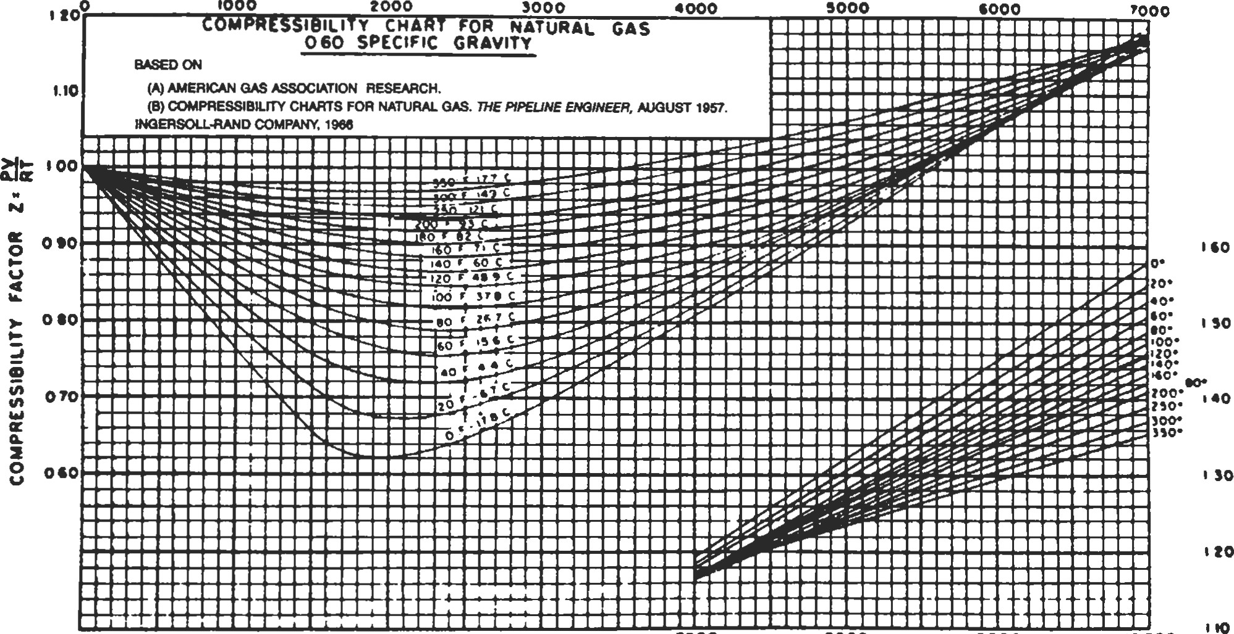

PRESSURE - PSIA 2000 '000 '000 •0 000

 KILO PASCALS

Figure 5. Compressibility chart for natural gas. Reprinted by permission and courtesy of Ingersoll Rand.

Compression horsepower determination

The method outlined below permits determination of approximate horsepower requirements for compression of gas.

l. From Figure 6, determine the atmospheric pressure in psia for the altitude above sea level at which the compressor is to operate,

1. Determine intake pressure (Ps) and discharge pressure (Pd) by adding the atmospheric pressure to the corresponding gage pressure for the conditions of compres-

sion.

1. Determine total compression ratio R = Pd/Ps. If ratio R is more than 5 to l, two or more compressor stages will be required. Allow for a pressure loss of approximately 5 psi between stages. Use the same ratio for each stage. The ratio per stage, so that each stage has the same ratio, can be approximated by finding the nth root of the total ratio, when n = number of stages. The exact ratio can be found by trial and error, accounting for the 5 psi interstage pressure losses.
2. Determine the N value of gas from Figure 7, ratio of specific heat.

5.

6.

7.

Figure 8 gives horsepower requirements for compression of one million cu ft per day for the compression ratios and N values commonly encountered in oil producing operations.

If the suction temperature is not 60 0 F, correct the curve horsepower figure in proportion to absolute temperature. This is done as follows:

460 0 + Ts hp (corrected for suction

460 0 + 60 0 F

temperature)

where Ts is suction temperature in O F.

Add together the horsepower loads determined for each stage to secure the total compression horsepower load. For altitudes greater than 1,500 ft above sea level apply a multiplier derived from the following table to determine the nominal sea level horsepower rating of the internal combustion engine driver.

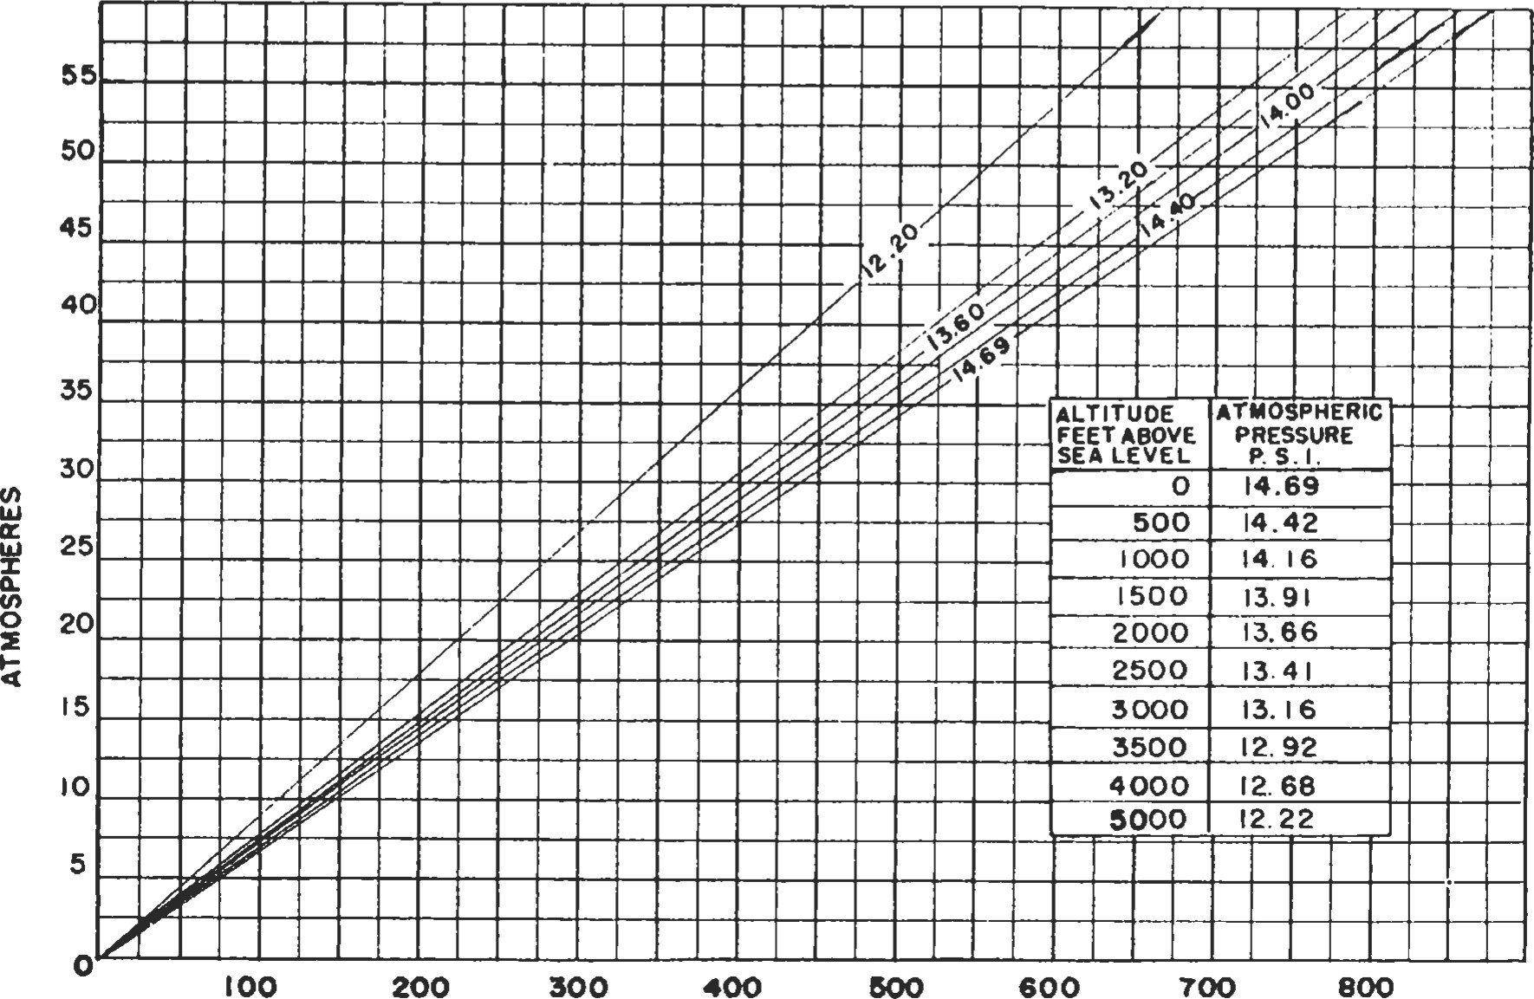

PRESSJRE (PSI.)

Figure 6. Atmospheres at various atmospheric pressures. From Modern Gas Lift Practices and Principles, Merla Tool Corp.

|  |  |  |  |  |
| --- | --- | --- | --- | --- |
| OF SPECIFIC HEATS cp/Cv | 1.10 |  | 120 | 1.30 |
| SUCTION PRESSURE IN PS.I.A. POs DISCHARGE PRESSURE IN es.l.A. |  | Altitude —Multiplier |  | Altitude—Multiplier |
| Rs COMPRESSION RATIO Pd/Ps |  | 1,500 ft 1.000 |  | 4,000 ft 1.12 |

Figure 7. Ratio of specific heat (n-value).

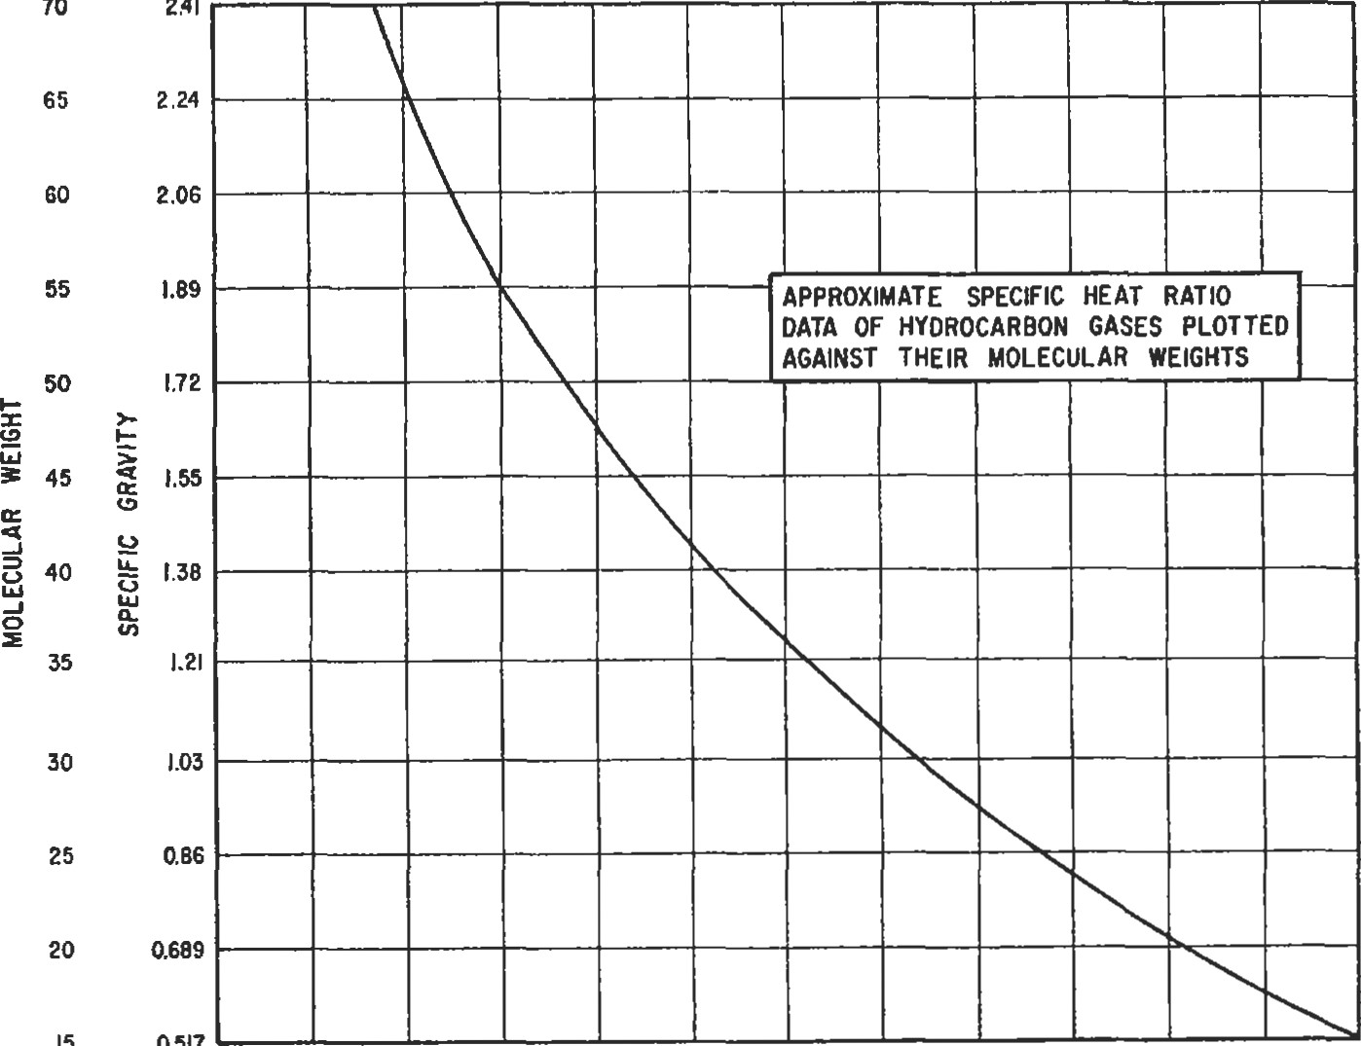

15

0.517

25 0.86

20 0.689

1302,000 ft 1.03 4,500 ft 1.14

|  |  |  |  |  |  |  |  |  |  |  |  |
| --- | --- | --- | --- | --- | --- | --- | --- | --- | --- | --- | --- |
|  |  |  |  |  |  |  |  |  |  |  | N".40 |
|  |  |  |  |  |  |  |  |  |  |  |  |
|  |  |  |  |  |  |  |  |  |  |  | Nat.t6 |
|  |  |  |  |  |  |  |  |  |  |  |  |
|  |  |  |  |  |  |  |  |  |  |  |  |
|  |  |  |  |  |  |  |  |  |  |  |  |
|  |  |  |  |  |  |  |  |  |  |  |  |
|  |  |  |  |  |  |  |  |  |  |  |  |
|  |  |  |  |  |  |  |  |  |  |  |  |
|  |  |  |  |  | aomoooaoooao |  |  |  |  |  |  |
|  | | | |
|  |  |  |  |  |  |  |  |  |  |  |  |
|  |  |  |  |  |  |  |  |  |  |  |  |

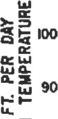 1202,500 ft 1.05 5,000 ft 1.17

3,000 ft 1.07 5,500 ft 1.20

1103,500 ft 1.10 6,000 ft 1.22

8. For a portable unit with a fan cooler and pump driven from the compressor unit, increase the horseS e 80power figure by 7 1/2 % .

70The resulting figure is sufficiently accurate for all pur60poses. The nearest commercially available size of compressor is then selected.

50"Ihe method does not take into consideration the supercompressibility of gas and is applicable for pressures up to 401,000 psi. In the region of high pressures, neglecting the de-

30viation of behavior of gas from that of the perfect gas may lead to substantial errors in calculating the compression 20horsepower requirements. The enthalpy-entropy charts

10may be used conveniently in such cases. The procedures are given in sources 1 and 2.

2 3 4 5



NOTE : COMPRESSION RATIOExample. What is the nominal size of a portable com-

FOR 'R' GREATER THAN 4.5 TO 5 USE

MULTI- STAGE COMPRESSION, ALLOWING pressor unit required for compressing 1,600,000 standard FOR USUALLY PRESSURE 5 RS.I.. DROP MAKE BETWEEN CORRECTIONSTAGES. cubic ft of gas per 24 hours at a temperature of 85 0 F from

FOR INTERSTAGE SUCTION TEMPERATURE.

40 psig pressure to 600 psig pressure? The alåtude above Figure 8. Brake horsepower required for compressing natural sea level is 2,500 ft. The N value of gas is 1.28. The suction gas. temperature of stages, other than the first stage, is 130 0 F.

Solution.

Ps = 53.41 psia

Pd = 613.41 psia

Re = 11.5 - (3.4)2 - (2.26)3 fry soluåon using 3.44 rado and 2 stages.

1st stage: 53.41 psia x 3.44 — 183.5 psia discharge

2nd stage: 178.5 psia x 3.44 — 614 pü discharge

Horsepower from curve, Figure 8 — 77 hp for 3.44 ratio

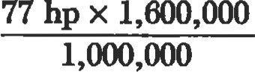— 123.1 (for 600F sucMon temp.)

460 + 85 0

1st stage: 123.1 hp x 0 — 129.1 hp

460 + 60

460 + 130 0

2nd stage: 123.1 hp x 0 - 139.7 hp

460 + 60

1.05 (129.1 hp + 139.7 hp) = 282 hp

1.075 x 282 hp - 303 hp

Nearst nominal size is 300 hp.

Centrifugal compressors

The cenfrifugal compressors are inherently high volume machina. They have extenAve application in gas bansmissystems. Their use in producing operations is very ited.

Sources

1. Engineering Data Book, Natural Gasoline Supply Men's Association, 1957.

|  |
| --- |
| Generalized compressibility factor |

1. Dr. George Granger Brown: "A Seriæ of Enthalpy-enbopy Charts for Natural Gas," Petroleum Doelcpment and Technology, Petoleum Division AIME, 1945.

The nomogam (Figure 9) is based on a genaalized comchart. l It is based on data for 26 gass, excluding helium, hydrogen, water, and ammonia. The accuracy is about one percent for gases other than those mentioned. use the nomog•am, the values of the reduced temperature (T/To) and reduced pressure (P/PJ must be calculated first.

where T = temperature in consistent units

Tc = critical temperature in consistent unib P = pressure in consistent units

Pc = critical pressure in consistent uni6

Example. Pr = 0.078, Tr = 0.84, what is the ibility factor, z? Connect Pr with Tr and read z — 0.948.

Source

Davis, D. S., Petroleum Refiner, 37, No. n, (1961).

Reference

1. Nelson, L. C., and Obert, E. R, Chem. Eng., (1954).

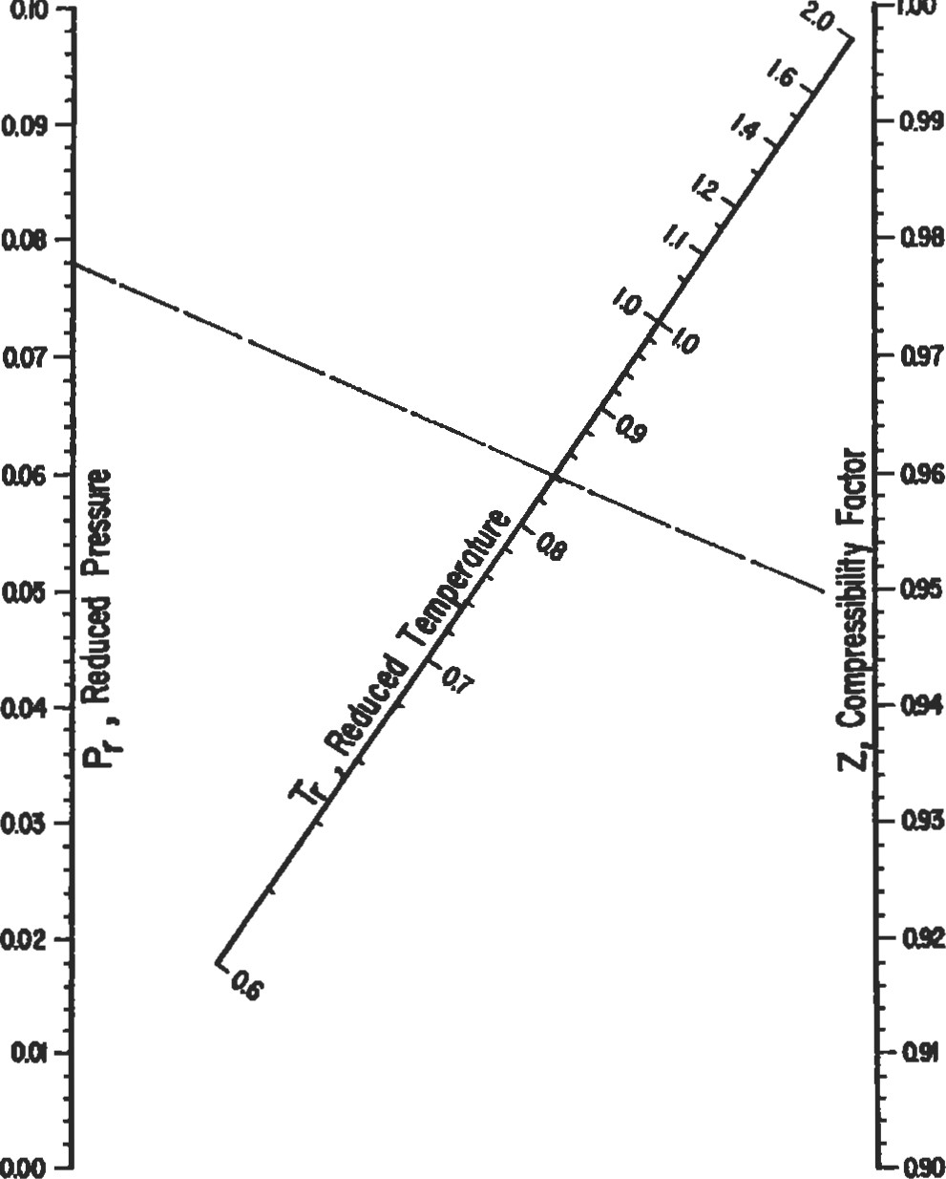

IDO

ato

Flgure 9. Generallzed compressibility factor. (Reproduced by permission Refine; Vol. 37, No. 11, copyright 1961 , Gulf Publishing Co„ Houston.)

|  |
| --- |
| Centrifugal Compressor Performance Calculations |

Centrifugal compressors are versatile, compact, and generally used in the range of 1,000 to 100,000 inlet cubic ft per minute (ICFM) for process and pipe line compression applications.

Centrifugal compressors can use either a horizontal or a vertical split case. The type of case used will depend on the pressure rating with vertical split casings generally being used for the higher pressure applications. Flow arrangements include straight through, double flow, and side flow configurations.

Centrifugal compressors may be evaluated using either the adiabatic or polytropic process method. An adiabatic process is one in which no heat transfer occurs. This doesn't imply a constant temperature, only that no heat is transferred into or out of the procß,s system. Adiabatic is normally intended to mean adiabatic isentropic. A polytropic process is a variable-entropy process in which heat transfer can take place.

When the compressor is installed in the field, the power required from the driver will be the same whether the process is called adiabatic or polytropic during design. Therefore, the work input will be the same value for either process. It will be to use corresponding values when making the calculations. When using adiabatic head, use adiabatic efficiency and when using polytropic head, use polytropic efficiency. Polytropic calculations are easier to make even though the adiabatic approach appears to be simpler and quicker.

The polytropic approach offers two advantages over the adiabatic approach. The polytropic approach is independent of the thermodynamic state of the gas being compressed, whereas the adiabatic efficiency is a function of the pressure ratio and therefore is dependent upon the thermodynamic state of the gas.

If the design considers all processes to be polytropic, an impeller may be designed, its efficiency curve determined, and it can be applied without correction of pressure, temperature, or molecular weight of the gas being compressed. Another advantage of the polytropic approach is that the sum of the polytropic heads for each stage of compression equals the total polytropic head required to get from state point 1 to state point 2. This is not true for adiabatic heads.

Sample Performance Calculations

Determine the compressor frame size, number of stages, rotational speed, power requirement, and discharge temperature required to compress 5,000 lbm/min of gas from 30 psia at 600F to 100 psia. The gas mixture molar composition is as follows:

Ethane 5% Propane n-Butane 15%

The properties of this mixture are as follows:

MW = 45.5

Pc = 611 psia

Tc = 6760R

17.76 kl = 1 126

 = 0.955

Before proceeding with the compressor calculations, let's review the merits of using average values of Z and k in calculating the polytropic head.

The inlet compressibility must be used to determine the actual volume entering the compressor to approximate the size of the compressor and to communicate with the vendor via the data sheets. The maximum value of 9 is of interest and will be at its maximum at the inlet to the comprßsor where the inlet compresibility occurs (although using the average compressibility will result in a conservative estimate of 0).

Compressibility will decrease as the gas is compressed. This would imply that using the inlet compressibility would be conservative since as the compressibility decreases, the head requirement also decreases. If the variation in compressibility is drastic, the polytropic head requirement calculated by using the inlet would be practically Compr—or manufacturers calculate the performance for each stage and use the inlet compr«sibility for each stage. An accurate approximation may be substituted for the stage-by-stage calculadon by calculating the polytropic head for the overall secåon using the average Esulb in overatimating the first half of the impellers and underesåmating the half of the impellers, thereby calculating a polytropic head very near that calculated by the stage-bystage technique.

Detæ•mine the flow volume, Q:



where m = mas flow

Zl = inlet compresibility factor

R = gas constant = 1,545/MW

Tl = inlet temperature O R

PI = inlet pressure



= 19,517 ICFM

to 'mble 3 and select a mmpressor frame that will handle a flow rate of 19,517 ICFM. A Frame C will handle a range of 13,000 to 31,000 ICFM and would have the following nominal data:

Hpoom = 10,000 ft-lb/lbm (nominal polytropic head)

np — 77% (polybopic 

N — 5,900 rpm

Determine ele pressure ratio, rp.

rp = 100/30 = 3.33

Determine the approximate discharge temperature, TR.

n/n — I = [Wk — l]np

- [1.126/(1.126 -

6.88

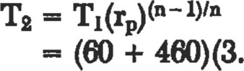

= 6190R = 1590F where Tl = inlet temp

Determine the average compressibility, Za.

Zl = 0.955 (from gas properties calculation)

where Zl = inlet compresibility

(Pr)2

= 100/611

= 0.164

(Tr)2 = T2/Tc

= 619/676

= 0.916

Täble 3

Typical Centifugal Compressor Frame Data'

Nominal Nominal

Nominal Nominal

Nominal Inlet Volume Row Polytroplc Head Rotational Impeller Diameter

Polytroplc 

English Metric Efflciency Speed English Matric coincidental.

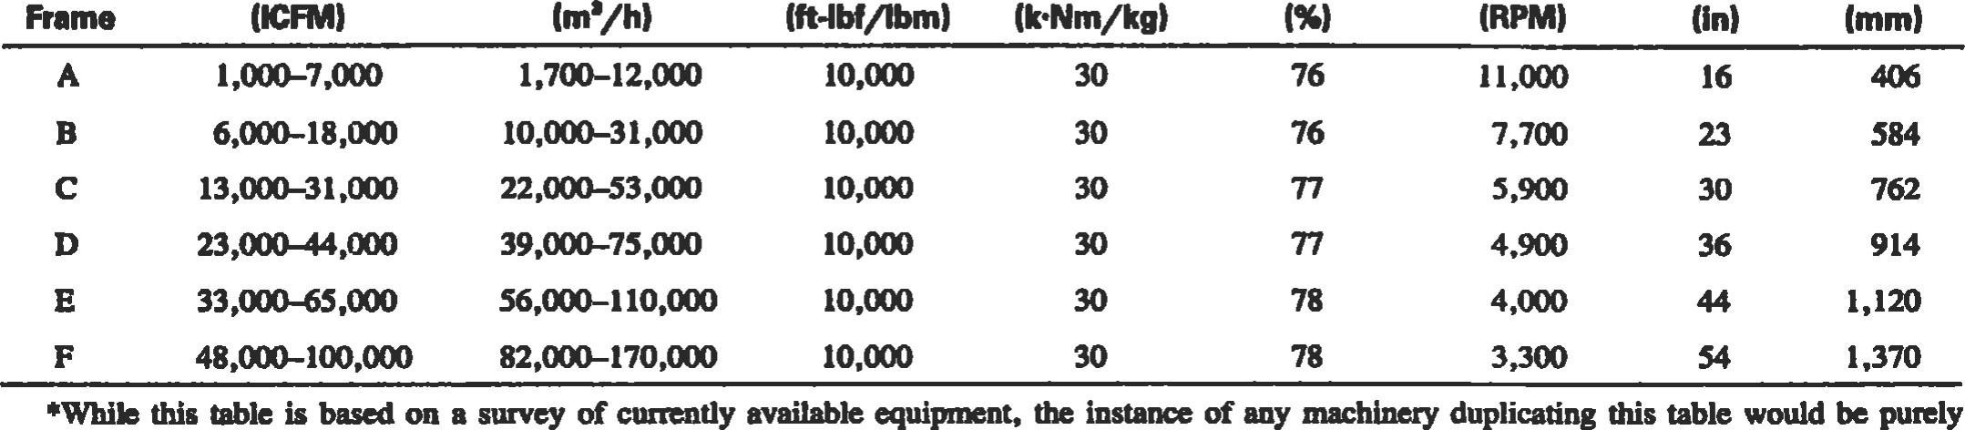

English

MeMc

|  |  |  |  |  |  |  |  |  |  |  |  |  |  |  |  |
| --- | --- | --- | --- | --- | --- | --- | --- | --- | --- | --- | --- | --- | --- | --- | --- |
|  |  |  |  |  |  |  |  |  |  |  |  |  |  |  |  |
|  |  |  |  |  |  |  |  |  |  |  |  |  |  |  |
|  |  |  |  |  |  |  |  |  |  | 26.1 MW k,ztT, |  |  |  |  |  |
|  | limit for limited yield | | | |  |  |  |  |  |  |  |
|  | stress impellers | | | |  |  |  |  |  |  |  |
|  |  |  |  |  |  |  |  |  |  |  |  |  |  |  |  |
|  |  |  |  |  |  |  |  |  |  |  |  |  |  |  |  |
|  |  |  |  |  |  |  |  |  |  |  |  |  |  |  |  |
|  |  |  |  |  |  |  |  |  |  |  |  |  |  |  |  |
|  |  |  |  |  |  |  |  |  |  |  |  |  |  |  |  |
|  |  |  |  |  |  |  |  |  |  |  |  |  |  |  |

12,000

11,000

10,000

9.000

8,000

7,000

6,000

5,000

4,000

3.000

1.0 1.1 1.2 1.3 1.4 1.5 1.6 1.7 1.8 1.9 2.0 2.1 2.2 2.3 2.4 2.5

Figure 10. Maximum polytropic head per stage—-EngIish system.

Refer to Figure 5 to find Z2, discharge compressibility.

 = 0.925

za = (ZI + Z2)/2

= 0.94

Determine average k-value. For simplicity, the inlet value of k will be used for this calculation. The polytropic head equation is insensitive to k-value (and therefore nvalue) within the limits that k normally varies during compression. This is because any errors in the n/(n — 1) multiplier in the polytropic head equation tend to balance corresponding errors in the (n — l)/n exponent. Discharge temperature is very sensitive to k-value. Since the k-value normally decreases during compression, a discharge temperature calculated by using the inlet k-value will be conservative and the actual temperature may be several degrees higher—possibly as much as 25—50 0 F. Calculating the average k-value can be time-consuming, especially for mixtures containing several gases, since not only must the mol-weighted % of the mixture be determined at the inlet temperature but also at the estimated discharge temperature.

The suggested approach is as follows:

1. If the k-value is felt to be highly variable, one pass should be made at estimating discharge temperature based on the inlet k-value; the average k-value should then be calculated using the estimated discharge temperature.
2. If the k-value is felt to be fairly constant, the inlet kvalue can be used in the calculations.
3. If the k-value is felt to be highly variable, but sufficient time to calculate the average value is not available, the inlet k-value can be used (but be aware of the potential discrepancy in the calculated discharge temperature).

kl = ka = 1.126

|  |
| --- |
| Table 4  Approximate Mechanical Losses as a Percentage of Gas Power  3  Requirement•  2.5 2  *There is no way to estimate mechanical losses from gas power requirements. This table will, however, ensure that mechanical losses are considered and yield useful values for estimating purposes. |

Determine average n/(n — l) value from the average kvalue. For the same reasons discussed above, use n/ (n - 1) = 6.88.

Determine polytropic head, Hp:

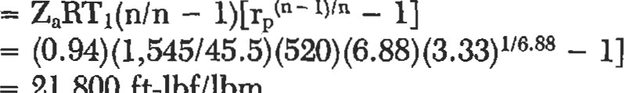

—

HP

21,800

ft-lbf/lbm

Determine the required number of compressor stages,

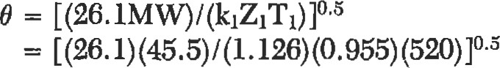

- 1.46

max Hp/stage from Figure 10 using 9 = 1.46

Number of stages = Hp/max. Hp/stage



= 2.25

= 3 stages

Determine the required rotational speed:

N = N nom [H p pnom x no. stages]05

— 5,030 rpm

Determine the required shaft power:

PWRg = mHp/33,OOOnp



— 4,290 hp

Mechanical losses (Lm) = 2.5% (from Table 4)



= 107 hp

PWRs - PWRg + 

4,290 + 107

- 4,397 hp

Determine the actual discharge temperature:

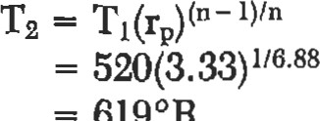6190R

= 1590F

The discharge temperature calculated in the last step is the same as that calculated earlier only because of the decision to use the inlet k-value instead of the average k-value. Had the average k-value been used, the actual discharge temperature would have been lower.

Source

Lapina, R. P., Estimating Centrifugal Compressor

|  |
| --- |
| Estimate hp required to compress natural gas |

Performance, Houston: Gulf Publishing Company, 1982.

To estimate the horsepower to compress a million cubic ft of gas per day, use the following formula:

R 5.16 + 124 Log R

BHP/MMcfd 

R + RJ 0.97 - 0.03 R

where R = compression ratio. Absolute discharge pressure divided by absolute suction pressure

J = supercompressibility factor— assumed 0.022 per 100 psia suction pressure

Example. How much horsepower should be installed to raise the pressure of 10 million cubic ft of gas per day from 185.3 psi to 985.3 psi?

This gives absolute pressures of 200 and 1,000.

= 1,000 = 5.0 then R

200

Substituting in the formula:

5.0 5.16 + 124 x .699

BHP/MMcfd  x 

5.0 + 5 x 0.044 .97 - .03 x 5

|  |  |  |  |  |  |  |  |  |  |  |  |  |  |  |  |  |  |  |  |
| --- | --- | --- | --- | --- | --- | --- | --- | --- | --- | --- | --- | --- | --- | --- | --- | --- | --- | --- | --- |
|  |  |  |  |  |  |  |  |  |  |  |  |  |  |  |  |  |  |  |  |
| Suction Pressure-400 PSiA | | | | | | | | | |  |  |  |  |  |  |  |  |  |  |
|  |  |  |  |  |  |  |  |  |  |  |  |  |  |  |  |  |  |  |  |
|  |  |  |  |  |  |  |  |  |  |  |  |  |  |  |  |  |  |  |  |
|  |  |  |  |  |  |  |  |  |  |  |  |  |  |  |  |  |  |  |  |
|  |  |  |  |  |  |  |  |  |  |  |  |  |  |  |  |  |  |  |  |
|  |  |  |  |  |  |  |  |  |  |  |  |  |  |  |  |  |  |  |  |
|  |  |  |  |  |  |  |  |  |  |  |  |  |  |  |  |  |  |  |  |
|  |  |  |  |  |  |  |  |  |  |  |  |  |  |  |  |  |  |  |  |
|  |  |  |  |  |  |  |  |  |  |  |  |  |  |  |  |  |  |  |  |
|  |  |  |  |  |  |  |  |  |  |  |  |  |  |  |  |  |  |  |  |
|  |  |  |  |  |  |  |  |  |  |  |  |  |  |  |  |  |  |  |  |

 120

e 100

8  eo

(9

O

40

20

2 3 4 5 6

Compression Ratio

= 106.5 hp - BHP for 10 MMcfd = 1,065 hp

Where the suction pressure is about 400 psia, the brake horsepower per MMcfd can be read from the chart.

The above formula may be used to calculate horsepower requirements for various suction pressures and gas physical

properties to plot a family of curves.

|  |  |  |  |  |  |  |  |  |  |  |  |  |  |  |  |  |  |  |  |  |  |  |  |  |  |  |  |  |  |  |  |  |  |  |  |  |  |  |  |  |  |  |  |  |  |  |
| --- | --- | --- | --- | --- | --- | --- | --- | --- | --- | --- | --- | --- | --- | --- | --- | --- | --- | --- | --- | --- | --- | --- | --- | --- | --- | --- | --- | --- | --- | --- | --- | --- | --- | --- | --- | --- | --- | --- | --- | --- | --- | --- | --- | --- | --- | --- |
| Estimate engine cooling water requirements   |  |  |  |  | | --- | --- | --- | --- | | This equation can be used for calculating engine jacket | | BHP = Brake Horsepower Hour | | | water requirements as well as lube oil cooling water re- | | At = Temperature differential across engine. | | | quirements:  H x BHP | | Usually manufacturers recommend this not exceed 15 0F; IOOF is preferable.  Example. Find the jacket water requirements for a | | | GPM = | 500At | | where | H = Heat dissipation in Btu's per BHP/hr. This | 2,000 hp gas engine which has no water jacket around the | | |  | will vary for different engines; where they are available, the manufacturers' values | exhaust manifold. |  | |  | should be used. Otherwise, you will be safe in substituting the following values in the | Solution. |  | |  | formula: For engines with water-cooled ex- | 1,500 x 2,000 |  | |  | haust manifolds: Engine jacket water = 2,200 Btu's per BHP/hr. Lube oil cooling water = 600 Btu's per BHP/hr. | CPM =  500 x 10 |  | |  | For engines with dry type manifolds (so far as cooling water is concerned) use 1,500 Btu's/BHP/hr for the engine jackets and 650 | CPM =— 600 gallons per min  5,000 |  | |  | Btu's/BHP/hr for lube oil cooling water re- | The lube oil cooling water | could be calcu- | |  | quirements. | lated in like manner. |  |   Estimate fuel requirements for internal combustion engines |

When installing an internal combustion at a gathering station, a quick approximation of fuel consumptions could aid in selecting the type fuel used.

Using Natural Gas: Multiply the brake hp at drive by 11.5 to get cubic ft of gas per hour.

Example. Internal combustion engine rated at 50 bhp—3 types of fuel available.

Using Butane: Multiply the brake hp at drive by 0.107 to get gallons of butane per hour.

Using Gasoline: Multiply the brake hp at drive by O. 112 to get gallons of gasoline per hour.

These approximations will give reasonably accurate figures under full load conditions.

|  |
| --- |
| Gasoline: 50 x 0.112 = 5.60 gallons of gasoline per hour  Natural Gas: 50 x 11.5 = 575 cubic ft of gas per hour  REFERENCES |

Butane: 50 X 0.107 = 5.35 gallons of butane per hour

1. Brown, R. N., Compressors: Selection and Sizing, 2nd Ed. Houston: Gulf Publishing Co., 1997.
2. McAllister, E. W. (Ed.), Pipe Line Rules ofThumb Handbook, 3rd Ed. Houston: Gulf Publishing co., 1993.
3. Lapina, R. P., Estimating Centrifugal Compressor Performance, Vol. 1. Houston: Gulf Publishing Co., 1982.
4. Warring, R. H. , Pumping Manual, 7th Ed. Houston: Gulf Publishing co., 1984.
5. Warring, R. H. (Ed.), Pumps: Selection, Systems, and Applications,2nd Ed. Houston: Gulf Publishing Co., 1984.
6. Cheremisinoff, N. P., Fluid Flow Pocket Handbook. Houston: Gulf Publishing Co., 1984.
7. Streeter, V. L. and Wylie, E. B., Fluid Mechanics. New York: McGraw-Hill, 1979.



# Drivers

Carl R. Branan, Engineer, El Paso, Texas*

|  |  |  |  |
| --- | --- | --- | --- |
| Motors: Efficiency |  | 126 Steam Turbines: Steam Rate | 129 |
| Motors: Starter Sizes |  | 127 Steam nn•bines: Efficiency | 129 |
| Motors: Service Factor |  | 127 Gas Turbines: Fuel Rates | 130 |
| Motors: Useful Equations |  | 128 Gas Engines: Fuel Rates | 132 |
| Motors: Relative Costs |  | 128 Gas Expanders: Available Energy | 132 |
| Motors: Overloading |  | 129 |  |

*Reprinted from Rules of Thumb for Chemical Engineers, Carl R. Branan (Ed.), Gulf Publishing Company, Houston, Texas, 1994.

### 125

### Motors: Efficiency

Table 1 from the GPSA Engineering Data Book [1] compares standard and high efficiency motors. Table 2 from GPSA compares synchronous and induction motors. Table 3 from Evans [2] shows the effect of a large range of speeds on efficiency.

Table 1

Energy Evaluation Chart

NEMA Frame Size Motors, Induction

Amperes Based Efficiency in Percentage on 460V at Full Load

Approx.

Full

Load Standard High Standard High

RPM Efficiency Efficiency Efficiency Efficiency

1. 1 ,800 1.9 1.5 72.0 84.0
   1. ,200 2.0 2.0 68.0 78.5

1% 1 ,800 2.5 2.2 75.5 84.0

1 ,200 2.8 2.6 72.0 84.0

1. 1 ,800 2.9 3.0 75.5 84.0
   1. ,200 3.5 3.2 75.5 84.0
2. 1 ,800 4.7 3.9 75.5 87.5
   1. ,200 5.1 4.8 75.5 86.5

5 1 ,800 7.1 6.3 78.5 89.5

1 ,200 7.6 7.4 78.5 87.5

7% 1 ,800 9.7 9.4 84.0 90.2

1 ,200 10.5 9.9 81.5 89.5

10 1 ,800 12.7 12.4 86.5 91.0

1 ,200 13.4 13.9 84.0 89.5

15 1 ,800 18.8 18.6 86.5 91.0

1 ,200 19.7 19.0 84.0 89.5

20 1 ,80025.0 86.5 91.0

1 ,200 25.0 24.9 86.5 90.2

25 1 ,800 31.2 29.5 88.5 91.7

1 ,200 29.2 29.1 88.5 91.0

30 1 ,800 36.2 35.9 88.5 93.0

1 ,200 34.8 34.5 88.5 91.0

40 1 ,800 48.9 47.8 88.5 93.0

1 ,200 46.0 46.2 90.2 92.4

50 1 ,800 59.3 57.7 90.2 93.6

1 ,200 58.1 58.0 90.2 91.7

60 1 ,800 71.6 68.8 90.2 93.6

1 ,200 68.5 69.6 90.2 93.0

75 1 ,800 92.5 85.3 90.2 93.6

1 ,200 86.0 86.5 90.2 93.0

100 1 ,800 112.0 109.0 91.7 94.5

1 ,200 114.0 115.0 91.7 93.6

125 1 ,800 139.0 136.0 91.7 94.1

1 ,200 142.0 144.0 91.7 93.6

150 1 ,800 167.0 164.0 91.7 95.0

1 ,200 168.0 174.0 91.7 94.1

200 1 ,800 217.0 214.0 93.0 94.1

1 ,200 222.0 214.0 93.0 95.0

Table 2

Synchronous vs. Induction 3 Phase, 60 Hertz, 2,300 or 4,000 Volts

|  |  |  |  |  |  |  |  |  |  |  |  |
| --- | --- | --- | --- | --- | --- | --- | --- | --- | --- | --- | --- |
|  | Speed RPM | | Synch. Motor  Efficiency  Full Load  1.0 PF | | | | Induction Motor  Efficiency Power  Full Load Factor | | | | |
| 3,000 | 1 ,800 | | | 96.6 | | 95.4 | | | 89.0 | |
|  | 1 ,200 | | | 96.7 | | 95.2 | | | 87.0 | |
| 3,500 | 1 ,800 | | | 96.6 | | 95.5 | | | 89.0 | |
|  | 1 ,200 | | | 96.8 | | 95.4 | | | 88,0 | |
|  | 1 ,800 | | | 96.7 | | 95.5 | | | 90.0 | |
|  | 1 ,200 | | | 96.8 | | 95.4 | | | 88.0 | |
| 4,500 | 1 ,800 | | | 96.8 | | 95.5 | | | 89,0 | |
|  | 1 ,200 | | | 97.0 | | 95.4 | | | 88.0 | |
| 5,000 | 1 ,800 | | | 96.8 | | 95.6 | | | 89.0 | |
|  | 1 ,200 | | | 97.0 | | 95.4 | | | 88.0 | |
| 5,500 | 1 ,800 | | | 96.8 | | 95.6 | | | 89.0 | |
|  | 1 ,200 | | | 97.0 | | 95.5 | | | 89.0 | |
| 6,000 | 1 ,800 | | | 96.9 | | 95.6 | | | 89.0 | |
|  | 1 ,200 | | | 97.1 | | 95.5 | | | 87.0 | |
| 7,000 | 1 ,800 | | | 96.9 | | 95.6 | | | 89.0 | |
|  | 1 ,200 | | | 97.2 | | 95.6 | | | 88.0 | |
| 8,000 | 1 ,800 | | | 97.0 | | 95.7 | | | 89.0 | |
|  | 1 ,200 | | | 97.3 | | 95.6 | | | 89.0 | |
| 9,000 | 1 ,800 | | | 97.0 | | 95.7 | | | 89.0 | |
|  | 1 ,200 | | | 97.3 | | 95.8 | | | 88.0 | |
|  | | Table 3  Full Load Efficiencies | | | | | |  | |  | |
| hp | | 3,600 rpm | | | 1 ,200 rpm | | | 600 rpm | | 300 rpm | |

5 80.0 82.5

20 86.0 86.5

82.7*

100 91.0 91.0 93.0

9190.3*

250 91.5 92.0 91.0

93.9* 93.4* 92.8*

1 ,ooo 94.2 93.7 93.5 92.3

95.5* 95.5* 95.5*

5,000 96.0 95.2

97.2* 97.3*



*Synchronous motors, 1.0 PF

Sources

1. GPSA Engineering Data Book, Gas Processors Suppliers Association, Vol. I, 10th Ed.
2. Evans, F. L., Equipment Design Handbookfor Refineries and Chemical Plants, Vol. 1, 2nd Ed. Houston: Gulf

Publishing Co., 1979.

Drivers 127

Motors: Starter Sizes

Here are motor starter (controller) sizes. Single Phase Motors

Maximum Horsepower

Full Voltage Starting

Polyphase Motors (Two Pole Contactor)

NEMA 115

|  |  |  |
| --- | --- | --- |
| NEMA  Size | Maximum Horsepower  Full Voltage Starting  230 460-575  Volts Volts | |
| 00  1  2  3  4  5  6  7 | 1.5  3  7.5  15  30  50  100  200  300 | 2  5  10  25  50  100  200  400  600 |

 Size Volts Volts

1 2

* 1. 2 3
  2. 3 7.5
  3. 7.5 15

Source

McAllister, E. W., Pipe Line Rules of Thumb Handbook, 3rd Ed. Houston: Gulf Publishing Co., 1993.

### Motors: Service Factor

Over the years, oldtimers came to expect a 10—15% service factor for motors. Things are changing, as shown in the following section from Evans.

For many years it was common practice to give standard open motors a 1 15% service factor rating; that is, the motor would operate at a safe temperature at 15% overload. This has changed for large motors, which are closely tailored to specific applications. Large motors, as used here, include synchronous motors and all induction motors with 16 poles or more (450 rpm at 60 Hz).

New catalogs for large induction motors are based on standard motors with Class B insulation of 800C rise by resistance, 1.0 service factor. Previously, they were 600C rise by thermometer, 1.15 service factor.

Service factor is mentioned nowhere in the NEMA standards for large machines; there is no definition of it. There is no standard for temperature rise or other characteristics at the service factor overload. In fact, the standards are being changed to state that the temperature rise tables are for motors with 1.0 service factors. Neither standard synchronous nor enclosed induction motors have included service factor for several years.

Today, almost all large motors are designed specifically for a particular application and for a specific driven machine. In sizing the motor for the load, the hp is usually selected so that additional overload capacity is not required. Customers should not have to pay for capability they do not need. With the elimination of service factor, standard motor base prices have been reduced 4—5% to reflect the savings. Users should specify standard hp ratings, without service factor for these reasons:

I . All of the larger standard hp are within or close to 15% steps.

1. As stated in NEMA, using the next larger hp avoids exceeding standard temperature rise.
2. The larger hp ratings provide increased pull-out torque, starting torque, and pull-up torque.
3. The practice of using 1.0 service factor induction motors would be consistent with that generally followed in selecting hp requirements of synchronous motors.
4. For loads requiring an occasional overload, such as startup of pumps with cold water followed by continuous operation with hot water at lower hp loads, using a motor with a short time overload rating will probably be appropriate.

Induction motors with a 15% service factor are still available. Large open motors (except splash-prooD are available for an addition of 5% to the base price, with a specified temperature rise of 900 C for Class B insulation by resistance at the overload horsepower. ms means the net price will be approximately the same. At nameplate hp the service factor rated motor will usually have less than 800 C rise by resistance.

|  |  |
| --- | --- |
| Motors: Useful Equations |  |
| The following equations are useful in determining the current, voltage, horsepower, torque, and power factor for AC motors:  Full Load 1 =  E (eff.) PF  (three phase)  = (eff.) PF]  (single phase) kVA input =IE  (three phase) = IE/I,OOO (single phase) kW input =kVA input (PF) hp output = kW input (eff.)/0.746 = Torque (rpm)/5,250  Full Load Torque = hp (5,250 lb.-ft.)/rpm  Power Factor = kW input/kVA input | where  E = Volts (line-to-line)  I = Current (amps)  PF = Power factor (per unit = percent PF/IOO) eff = Efficiency (per unit = percent eff./100) hp = Horsepower kW = Kilowatts kVA Kilovoltamperes  Source  Evans, F. L., Equipment Design Handbook for Refineries and Chemical Plants, Vol. 1, 2nd Ed. Houston: Gulf Publishing co., 1979. |
| Motors: Relative Costs |  |

Motors with a higher service factor rating such as 125% are also still available, but not normally justifiable. Most smaller open induction motors (i.e., 200 hp and below, 514 rpm and above) still have the 115% service factor rating. Motors in this size range with 115% service factor are standard, general purpose, continuous-rated, 60 Hz, design A or B, drip-proof machines. Motors in this size range which normally have a 100% service factor are totally enclosed motors, intermittent rated motors, high slip design D motors, most multispeed motors, encapsulated motors, and motors other than 60 Hz.

Source

Evans, F. L., Equipment Design Handbookfor Refineries and Chemical Plants, Vol. 1, 2nd Ed. Houston: Gulf Publishing co., 1979.

Evans gives handy relative cost tables for motors based on voltages (Table 1), speeds (Table 2), and enclosures (Table 3).

Table 1

Relative Cost at Three Voltage Levels of Drip-Proof 1 ,200-rpm Motors

|  |  |  |  |
| --- | --- | --- | --- |
|  | 2,300Volts | 4,160Volts | 13,200Volts |
| 1 ,500-hp  3,000-hp  5,000-hp  7,000-hp  9,000-hp  10,OOO-hp | 100%  100  100  100  100  100 | 114%  108  104  100  100  100 | 174%  155  145  133  129  129 |

Table 2 Relative Cost at Three Speeds of Drip-Proof 2,300-VoIt Motors

3,600 1 ,800- 1,200Rpm Rpm Rpm

|  |  |  |  |
| --- | --- | --- | --- |
| 1 ,500-hp | 124% | 94% | 100% |
| 3,000-hp | 132 | 100 | 100 |
| 5,000-hp | 134 | 107 | 100 |
| 7,000-hp | 136 | 113 | 100 |
| 9,000-hp | 136 | 117 | 100 |
| 10,000-hp | 136 | 120 | 100 |

Table 3

Relative Cost of ntree Enclosure

Wpes 2,300-vott, 1 ,200-rvm Motors

|  |  |  |  |
| --- | --- | --- | --- |
|  | Dipproof | Force  Ventilated* | Totally-  Enclosed Inen Gas or Alr |
| 3,000-hp  5,000-hp  7,000-hp  9,000-hp  10,000-hp | 100%  100  100  100  100  100 | 115%  113  112  111  111  110 | 183%  152  136  134  132  125 |

not Include blower and duct for air suppy.

double tube gas to water heat exchatwr. Cooling water wihin manufacturer's standard condiüons of temperature and pressure.

Divers 129

Source

|  |
| --- |
| Motors: Overloading |

Evans, F. L., Equipment Design Handbookfor Refineries and Chemical Plants, Vol. 1, 2nd Ed. Houston: Gulf Publishing Co., 1979.

|  |  |
| --- | --- |
| Steam Mines: Steam Rate |  |

When a pump has a motor drive, the process engineer must verify that the motor will not overload from exü•eme process changes. The horsepower for a centrifugal pump increases with flow. If the control valve in the discha•ge line fully opens or an operator opens the valve bypass, the pump will tend to "run out on its curve," giving more flow and requiring more horsepower. The motor must have the capacity to handle this.

Source

Branan, C. R., The Process Engineer 's Pocket Hmdbook, vol. 2. Houston: GulfPub1ishing co., 1978.

The theoretical steam rate (sometimes referred to as the water rate) for steam turbines can be determined from Keenan and Keyes [1] or Mollier charts following a conStant entropy path. The theoretical steam ratel is given as lb/hr/kw which is easily converted to lb/hr/hp. One word of caution—in using Keenan and Keyes, steam pressures are given in PSIG. Sea level is the basis. For low steam pressures at high altitudes appropriate corrections must be made. See the section on Pressure Drop Air-Cooled Air Side Heat Exchangers, in this handbook, for the equation to correct atmospheric pressure for

The theoretical steam rate must then be divided by the efficiency to obtain the actual steam rate. See the section on Steam Turbines: Effciency.

Sources

1. Keenan, J. H., and Keyes, F. G., "Theoretical Steam Rate Tables," Trans. A.S.M.E. (1938).

|  |
| --- |
| Steam Turbines: Efficiency  Evans [1] provides the following graph of steam turbine Smaller turbines can vary widely in efficiency dependefficiencies. ing greatly on speed, horsepower, and pressure conditions. |

1. Branan, C. R., The Pmcess Engineer 's Pocket Handbook, vol. 1. Houston: GulfPub1ishing co., 1976.

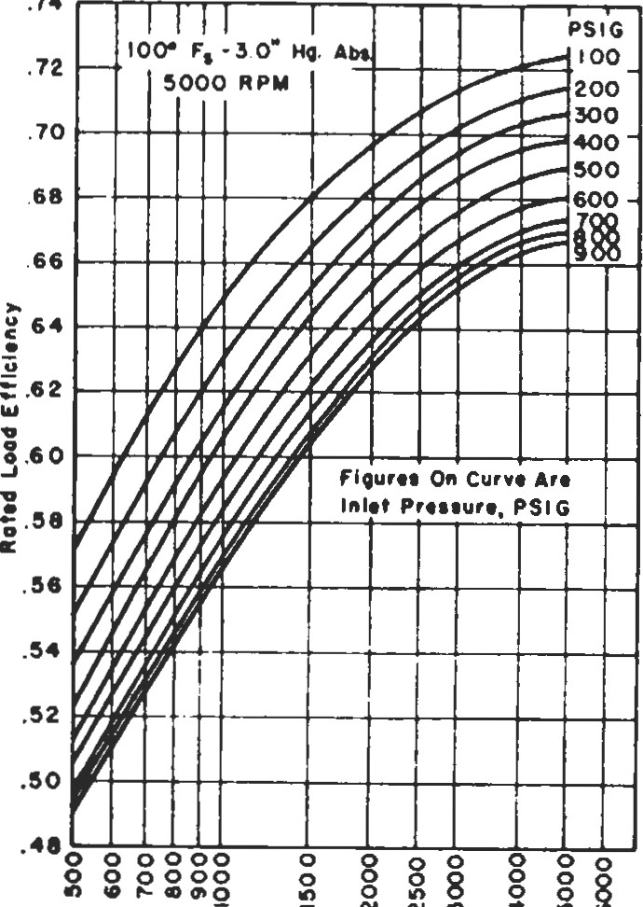

.74

Rating

tn

Horsepo—r

Figure 1. Typical efficiencies for mechanical drive turbines.

Some designers limit the speed of the cheaper small steam turbines to 3,600 rpm.

Sources

I. Evans, F. L., Equipment Design Handbookfor Refineries and Chemical Plants, Vol. 1, 2nd Ed. Houston: Gulf Publishing co., 1979.

|  |
| --- |
| Very rough efficiencies to use for initial planning below 500 horsepower at 3,500 rpm are  Horsepower Efficiency, %  1-10 15  10-50 20  50-300 25  300-350 30  350-500 40  Gas Turbines: Fuel Rates |

2. Branan, C. R., The Process Engineer's Pocket Handbook, vol. 1. Houston: Gulf Publishing co., 1976.

Gas turbine fuel rates (heat rates) vary considerably; however, Evans [l] provides the following fuel rate graph for initial estimating. It is based on gaseous fuels.

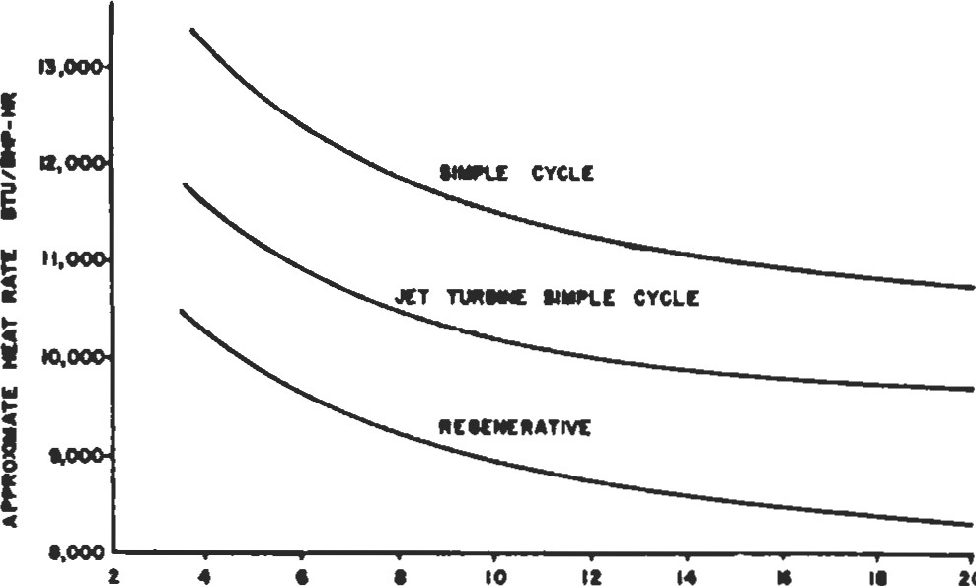

20



Figure 1. Approximate gas turbine fuel rates.

The GPSA Engineering Data Book [2] provides the following four graphs (Figures 2—5) showing the effect of altitude, inlet pressure loss, exhaust pressure loss, and ambient temperature on power and heat rate.

GPSA [21 also provides a table showing 1982 Performance Specifications for a worldwide list of gas turbines, in their Section 15.

Sources

l. Evans, F. L., Equipment Design Handbookfor Refineries and Chemical Plants, Vol. 1, 2nd Ed. Houston: Gulf Publishing Co., 1979.

2. GPSA Engineering Data Book, Gas Processors Suppliers Association, Vol. I, 10th Ed.

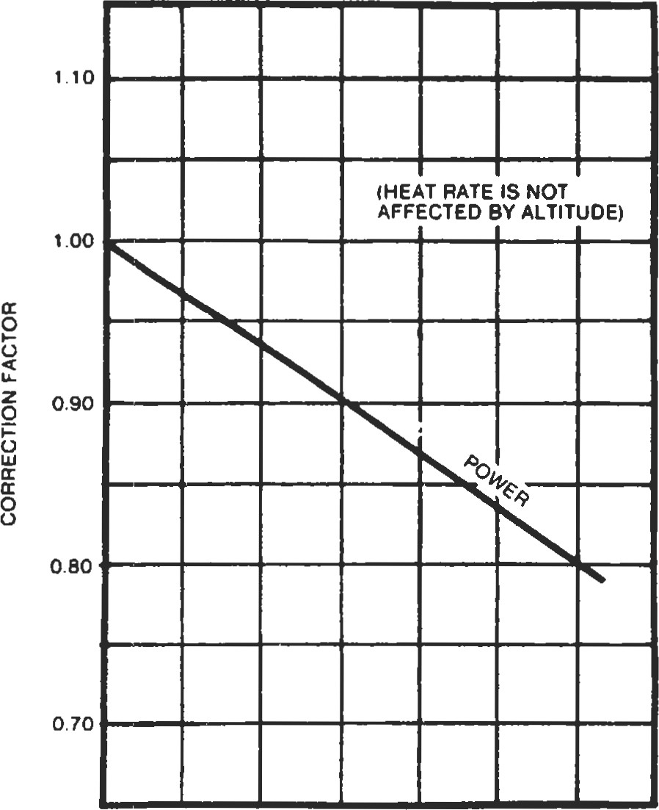Altitude Correction Factor

0.0 2000 4000 6000

ALTtTUOE. FT

Figure 2. Altitude Correction Factor.

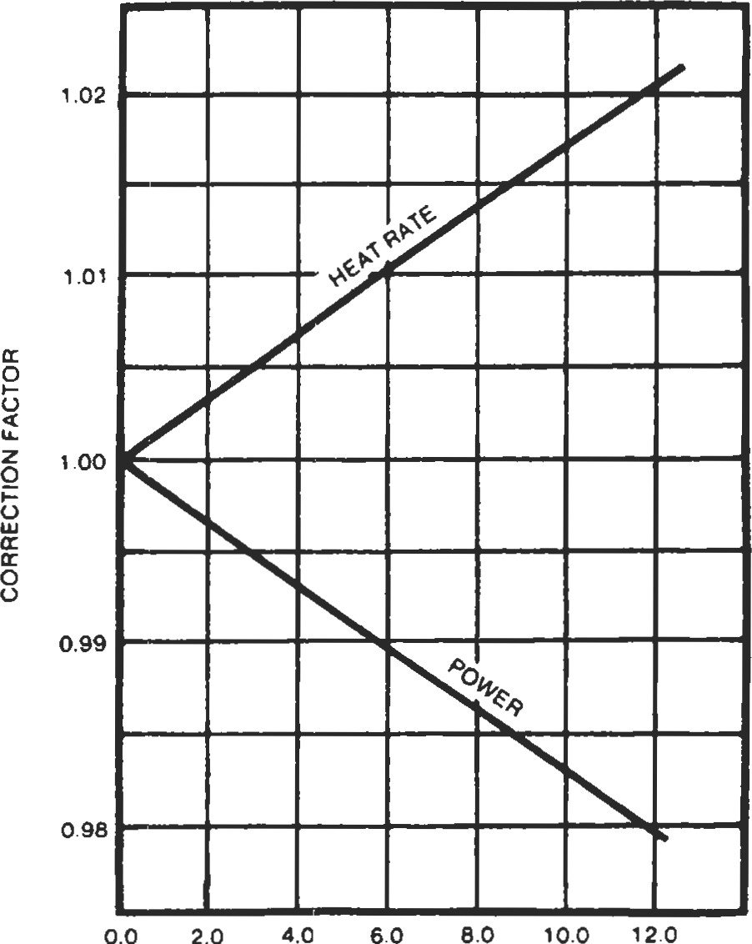Exhaust Loss Correction Factor

EXHAUST PRESSURE LOSS. IN. OF WATER

Figure 4. Exhaust Loss Correction Factor.

#### Inlet Loss Correction Factor

o

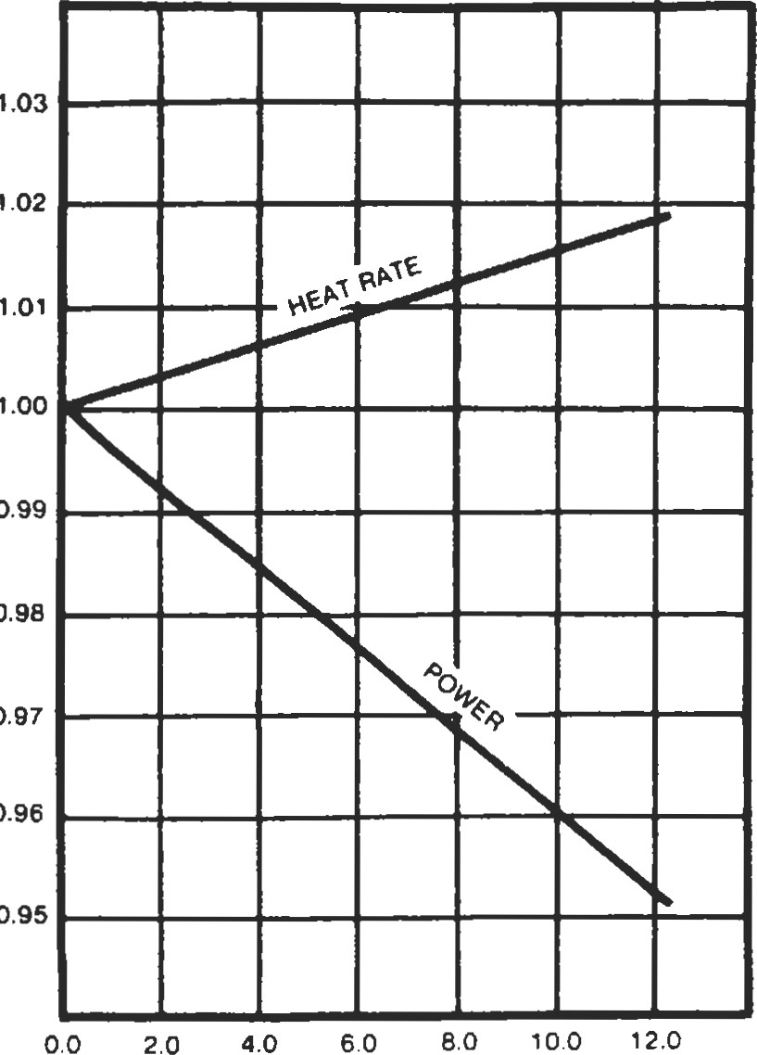

0.99

0.98

0.97

0.96

0.95

z

INLET PRESSURE LOSS. 'N. OF WATER

Figure 3. Inlet Loss Correction Factor.

Temperature Correction Factor z

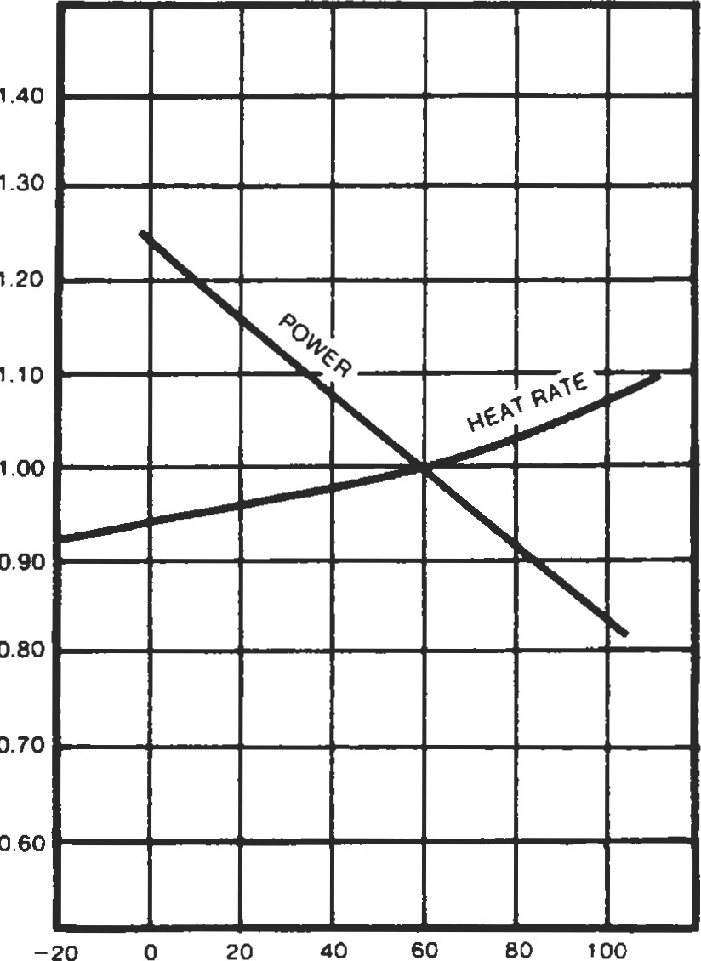

0.80

o.

TEMPERATURE. F

Figure 5. Temperature Correction Factor.

## Gas Engines: Fuel Rates

Here are heat rates, for initial estimating, for gas engines. Source

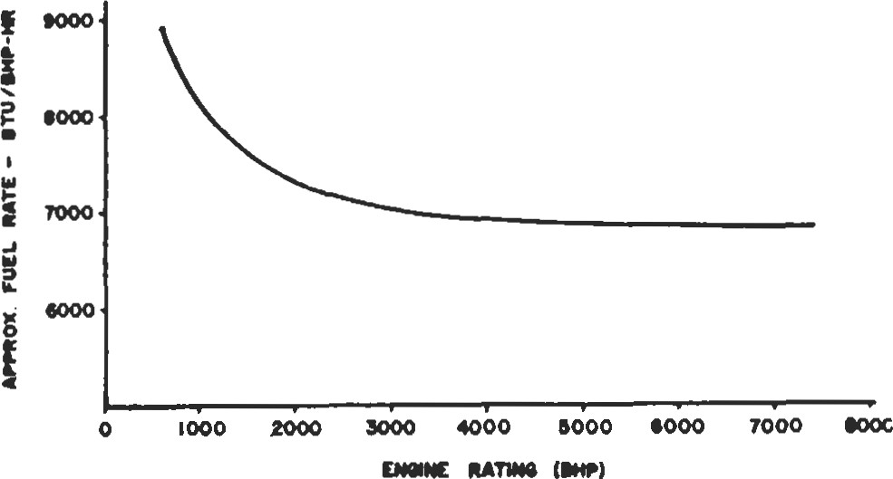Evans, F. L. Equipment Design Handbookfor Refineries and Chemical Plants, Vol. 1, 2nd Ed. Houston: Gulf Publishing co., 1979.

Figure 1. Approximate gas engine fuel rates.

## Gas Expanders: Available Energy

|  |  |
| --- | --- |
| With high energy costs, expanders will be used more than ever. A quickie rough estimate of actual expander available energy is  (K-I)/K  AH=CpTl 1- — 0.5 (1) | For large expanders, Equation I may be conservative. A full rating using vendor data is required for accurate results. Equation I can be used to see if a more accurate rating is worthwhile.  For comparison, the outlet temperature for gas at critical flow across an orifice is given by |

where T2 =Tl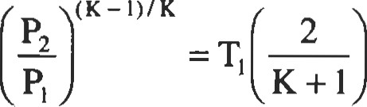 (3)

|  |  |
| --- | --- |
| AH = Actual available energy, BtuJlb |  |
| Cp = Heat capacity (constant pressure), Btu/lb OF | The proposed expander may cool the working fluid |
| Tl = Inlet temperature, OR  Inlet, outlet pressures, psia | below the dew point. Be sure to check for this. |
| K = cp/C  To get lb/hr-hp divide as follows: | Source  Branan, C. R. , The Process Engineer's Pocket Handbook, |
| 2545 | Vol. 1. Houston: Gulf Publishing Co., 1976. |

A rough outlet temperature can be estimated by

(K-I)/K

T2 =Tl (2) c

### Gears

Leonard L. Haas, Manager, Lift Fan Design, Allison Advanced Development Company

Ratios and Nomenclature134 Materials142

Spur and Helical Gear Design134 Summary of Gear Types143 Bevel Gear Design139 Buying Gears and Gear Drives144 Cylindrical Worm Gear Design141 References144

133

#### 1M

|  |  |  |  |  |  |  |  |  |  |  |  |  |  |  |  |  |  |  |  |  |  |  |  |  |  |  |  |  |  |  |  |  |  |  |  |  |  |  |  |  |  |  |  |  |
| --- | --- | --- | --- | --- | --- | --- | --- | --- | --- | --- | --- | --- | --- | --- | --- | --- | --- | --- | --- | --- | --- | --- | --- | --- | --- | --- | --- | --- | --- | --- | --- | --- | --- | --- | --- | --- | --- | --- | --- | --- | --- | --- | --- | --- |
| Ratios and Nomenclature  Consider the most common gear application of Educing ically pracücal for different types of gears and arrangements,   |  |  | | --- | --- | | motor speed to machine speed. The necessary gear ratio is the ratio of the motor speed to the machine speed. The magnitude of the required ratio may affect the type of gear or gear arrangement. See Table I for the range of ratios typ- | and see also the section on gear types later in the chapter. Nomenclature is given in Table 2.  Table 2  Nomenclature |  |  |  |  |  |  |  |  | | --- | --- | --- | --- | --- | --- | --- | |  |  |  | P | Allowable based on conuct |  | Alowable K factor | |  |  |  | n | Speed of pinion | F | Contacting face width | | Type of Geerset | Min. Ratio | Max. Ratio | P | Transmitted power |  | Face-to-diameter ratio | |  |  |  | J | Tooth fom geometry factor | sat | Allowable bending stress | | External spur gear | 1 :1 |  |  | Chordat addendum for | Pd | Transverse diametral pltch | | tntemal spur gear | 1.5:1 |  |  | caliper measurement | Cd | Combined derating factor |   Table 1  mg  Gear  Wpical Gear Raios  External helical gear 1:1 10:1 t kc tooth thickness Dynamic factor  Intemal helical gear 1.5:1 10:1 Applicaüon factor Nonmal chordal tiickness  Cylindrical wom 100:1 Cm Mounting factor Pitch line velocity  Normal diametral pitch  Straight bevel gear 1:1Bevel gear diameter dba Bevel pinion diameter Pitch angle  Spiral bevel gear 1:1 NT Total number of Number of gear teefr  Epicyclic planetary 12:1 Number of pinion teeth  Epicyclic star11:1  me smaller diameter gear in a pair is called the plnion.  Epicyclic solar 1.2:1 1.7:1 a one-bone ratio, Vie definltjon is meaningless.  In  Spur and Helical Gear Design |

This chapter is intended as a brief guide for the engineer who has an occasional need to consider gear design. The methods presented are for estimating only, and full analysis should be done in accordance with the standards of the American Gear Manufacturers Association (AGMA) or the International Standards Organization (ISO). The engineer should also reference the many good books covering the complete subject of gear design.

The most common arrangement is to use spur or helical gears on parallel shafts. If the required ratio is greater than the recommended ratio for a single set, then a number of sets in series are used with the total ratio being the product of the individual gear set ratios.

Consider a case in which the required ratio is in the practical range for a single gear set. If the only considerafion were to fit gears of the desired ratio on parallel shafts separated by some desired distance, the diameter of the gears could be calculated by Equations 1 and 2.

2xc

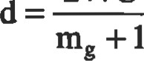 (1)

#### D=2xC-d (2)

The normal requirement is to make the gears large enough to transmit a certain power. The power capacity depends on the diameter, the face width, the size of the teeth (diamefral pitch), and the material. Each gear member must have a safe stress margin relative to both contact stress and bending sü•ess. Both stress levels depend on the diameter, the face width, and the material, while the bending stress also depends on the size and form of the teeth. To esümate the size of gear set needed to transmit a required power at a given speed, first determine the size required for a safe level of contact sffess, using Equation 3a:

|  |  |
| --- | --- |
| 126000 X Pac | x |
| Kall xnxFxCd | m |

The stress calculation equation can be rearranged to calculate the allowable power that can be resulting in equation 3b:

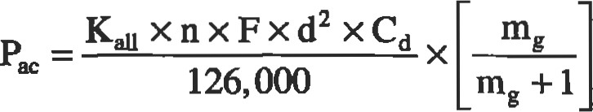 (3b) Note: Gear power equations always use the rpm and diameter of the pinion even when the power rating of the gear is being calculated.

The power, speed, and ratio are known values, but Kali and Cd are unknown, and F and d are the size of the desired pinion. The allowable K factor (Kali) depends on the material to be used for the gears. In general, the harder the material, the higher the allowable K, but there is usually more manufacturing cost. For estimating the size of a gear set, allowable values can be taken from Table 3. The allowable K must be selected for the gear member with the lower value; the capacity of the pair is based on the lesser material. If the materials are through-hardened alloy steel, there should be a hmdness differential between the pinion and the gear as shown in the pinion and gear columns in Table 3.

Table 3

Allowable Material Factors

|  |  |  |  |
| --- | --- | --- | --- |
| BHN of Pinion | BHN of Gear | Kali Factor | Sat |
| 225  350  575  58 Rc | 180  300  575  58 Rc | 110  350-450  500-800  600 | 31 ,ooo-41 ,ooo |

The derating factor Cd is used to allow for the manufactured quality, operating conditions, and installation of the gear set. Actual gears have tolerance and are not manufactured perfectly. They are mounted in support sü•uctures that are not in perfect alignment, and the shafts, bearings, and supports deflect when the gear reaction loads are applied. Derating factors can be included in the power-to-stess equaüon to allow for these conditions. There are several significant conditions that should be considered in the derating factor, and many minor  The major considerations are speed, gear accuracy, type of load, reliability requirements, and flexibility of gear mounting (rigidity of shafts, bearings, and gear case). The design and operating conditions should be considered when selecting a value for Cd. Cd is defined from a combination of factors as shown in Equation 4.

Cd = ca + X cm (4)

The application factor Ca is selected to compensate for the nature of the driving and driven machines. If both machines are smooth, such as a gas turbine and a centrifugal blower, the factor can be 1.00. If a machine runs with dynamic load pulses, as in a reciprocating engine, or shock loads, as in a crusher drive, then a larger value of Ca must be used to allow for the dynamic loads that are above the nominal design load. The application factor is also adjusted for use and life requirements. If the gears are needed only for a short life and the use is intermittent, smaller gears at higher load levels can be used and designed with the "short life" factors. Conversely, to achieve long life with high reliability, the gears should be designed to a lower load level, and the "extra life" factors should be used.

Based on the driving/driven machines and the life required, choose a Ca factor from Table 4. "Smooth" machines include:

* gas turbines
* steam turbines
* electric motors
* centrifugal blowers

"Rough" machines include:

* reciprocating engines and compressors
* crushers
* pulverizers
* rolling mills

Table 4

Applicaüon Factor, Ce

|  |  |  |  |
| --- | --- | --- | --- |
| Load Type |  | Required Life |  |
| Shod  200 hrs | Normal  1,000 hrs | Exb•a  10 000 hrs |
| SmooWSmooth  SmooWRough Rough/Rough | 0.50  0.63  0.75 | 1.00  1.25  1.50 | 1.25  1.56  1.88 |

The dynamic factor cv allows for the increased load caused by inaccuracies in the gear teeth that result in nonuniform transmission of load from the driving gear to the driven gear. The dynamic load tends to increase with speed, as defined by the pitch line velocity (v, see Equation 5). It will be necessary to assume a diameter, or velocity, to choose the cv factor and to recalculate later if necessary. The dynamic load is also very dependent on the precision of the gear tooth form manufactured. Select from the columns of Table 5 as follows:

##### v = .262 x d x n (5)

|  |  |  |  |  |
| --- | --- | --- | --- | --- |
| PW |  | Quality | |  |
| Low  Quality | Standard  Commercial | Precision | Extra  Precision |
| 0-2,000    > 10,000 | 1.35  1.53 | 1.18  1.26  1.33 | 1.10  1.14  1.20  1.25 | 1.05  1.05  1.05  1.05 |

|  |
| --- |
| Table 5  Dynamic Factor, cv  (7) |

*Better precision quality Is required for these higher speeds.

Gears manufactured by cutting only, with the main priority of low cost, normally fall in the first column—low quality. Most gears that are surface hardened without finishing after hardening also fit into the first column.

Normal commercial-cut-only gears usually fit into the second column.

Finish grinding, or shaving of through-hardened gears, is usually required to qualify for the precision column.

Extra-precision gears require careful finish grinding of the gear teeth as well as precision control of gear blank dimensions and accurate mounüngs.

The mounting factor Cm allows for the deflection of the shafts, bearings, and housing that will cause the misalignment of the pinion teeth relative to the gear teeth. Misalignment also results from inaccuracy of manufacture of the gear teeth and deviation from theoretical helix angle. The Cm factor should be selected from Table 6 based on the precision of manufacture of the gears and housing as well as the support design of the drive.

When the derating factor has been selected, the pinion diameter and the face width are both unknown. For estimating these, the proportion of face width to diameter Fd can be assumed. There is a wide range of acceptable values, but 0.75 to 1.25 is a good starüng value. Equaüon 2 can be rearranged to calculate the pinion diameter required.

d

With the pinion diameter estimated, the face and the gear diameter can be established by Equations 8 and 9.

F=dxFd (8)

##### D=dxmg or (9)

When the diameters have been established, it is time to determine the number of teeth to put on the gears. The size of gear teeth is defined in terms of diametral pitch. Diameffal pitch is defined as the number of teeth per inch of pitch diameter. For a helical gear, the size of teeth can be measured in the plane of rotation, called transverse diametral pitch (PO, or in the normal plane, called normal diametral pitch (PO. For a spur gear, the normal plane is the plane of rotation. When gear teeth are cut, the tool works in the normal plane. For most gears, standard cutting tools are used; therefore, it is best to use standard whole number values for the normal diametral pitch. The normal and pitches are related by the helix angle as shown in Equation 10. Obviously, the number of teeth on the gears must be a whole number, so slight adjusünents to pitch diameter may be necessary. For helical gears, the diameter is a function of normal diametral pitch and helix angle, so slight changes in helix angle can be used to get a whole number of teeth on a given pitch diameter. The size of the gear teeth, and therefore the number, must be selected to provide a satisfactory bending stress. The required diameffal pitch can be estimated using Equation 11.

|  |  |  |
| --- | --- | --- |
|  | X COS (V) | (10) |
|  | nxdxFxJxSat | (11) |

|  |  |  |  |  |  |  |
| --- | --- | --- | --- | --- | --- | --- |
| |  |  | | --- | --- | | Table 6  Mounting Factor, Cm | for the gears. The geometry factor J is calculated for the number of teeth, the pressure angle, the tooth proportions, and the fillet radius. For approximation, the values in Table 7 can be used. When the Pd value is esümated from Equa- |   126,OOOxPxCd mg +1  x  (6) Sat can be selected from Table 3 for the material to be used   |  |  | | --- | --- | | Mounting |  | | Rigid  Normal  Overhung | 1.10  1.30  1.60 |   tion 11, it should be rounded down to the nearest whole number to use standard cutters. Because of the different number of teeth and the possible different materials, the pitch requirement should be calculated for both the pinion and the gear, and the smaller value used. |

252,000 x P x Cd

The actual number of teeth can be calculated from Equations 12 and 13. The result will probably be a fractional number. The center distance, or the helix angle, must be adjusted to get a whole number. An alternative is to use Equation 14. Adjust the center distance or helix angle to oly

Table 7

J Factors

Number of Teeål

Spur 16 20 25 30 50 or more

|  |  |  |  |  |  |
| --- | --- | --- | --- | --- | --- |
| I to 1  3t01  5 tol | 299 P  .299 G  .315 P  .407 G  .319 P  .434 G | .333 P  .351 P  .428 G  .357 P  .451 G | .359 P  .359 G  .379 P  .44-4 G  .385 P  .464 G | .388 P  .388 G  .409 P  .462 G  .415 P  .479 G | .442 p  .442 G  .463 P  .495 G  .507 G |
| Helical  (12-degree) | |  |  |  |  |
| I to 1  3 tol  5t01 | .422 P  .422 G  .455 p  .549 G  .465 P  .581 G | .465 P  .465 G  .496 P  .574 G  .506 P  .602 G | .496 P  .496 G  .526 p  .593 G  .534 P  .617G | .530 P  .530 G  .588 P  .613G  .565 P  .633 G | .589 P  .589 G  .611 P  .648 G  .56 P  .662 G |

tain an even number for the total (NT), and then divide the total to pinion and gear to give the ratio closest to the original desired ratio. Equation 15 can be used.

|  |  |
| --- | --- |
| Np=d x Pn x cos (v) or Np=dxPd | (12) |
| or N =DxPd | (13) |

14)

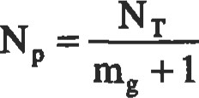 (15)

The final number of teeth should be a reasonable value. The choice of number of teeth can be a function of speed. The best measure of speed is pitch line velocity, which is calculated per Equation 5.

The number of teeth should not be less than 16 unless more detailed analysis is done to determine the opümum tooth form. Above 4,000 ft/min pitch line velocity, at least 20 teeth should be used, and at least 26 teeth above 10,000 ft/min. If the estimating procedure gives a number of pinion teeth less than recommendation, then a larger diametral pitch should be used, and the sn•ength requirement saffsfied by using a higher-strength material or an increase in diameter or face width.

Gear Set Sizing

Example. Estimate the size of gear set required for a 500-hp high-speed electric motor running 3,500 rpm to drive a reciprocaång compresser at 700 rpm. Assume that there are no dimensional requirements (any center distance will work). Because of the output torque, this will be a relatively large gear set. Therefore, a single helical, throughhardened gear set will be selected. For single helical gears, a good starting point would be to choose a helix angle of 12 degrees; for double helical gears, 28 degrees would be a better choice.

Start with the gear ratio: 3,500/700 = 5.0 to l.

From Table 3, assume through-hardened alloy steel, 350 BEN for the pinion and 300 BHN for the gear; therefore, = 400.

From Table 4, select Ca for a motor driving a compresser to give a long-life gear set: Ca = 1.56.

To select a value for Cv, an estimate of pitch line velocity is needed. Assume that the pinion will be approximately 10 inches in diameter and use Equation 5 to calculate the velocity:

v = .262 x 10.0 x 3,500 = 7,336 ft/min

From Table 5, the value for cv can be selected as 1.33, and Cm as 1.3.

From Equation 4:

1.56 x 1.33 X 1.30 = 2.70

Assume Fd = 1.0, and then Equation 6 can be used to determine the pinion diameter:

###### 5.0+1

= 5.26 in.

5.0

At this point, the pitch line velocity must be checked to determine if the estimate used to select the dynamic factor cv was valid.

v = .262 x 5.26 x 3,500 = 4,823 ft/min

This is lower than the estimated velocity and would give a cv factor of 1.26 from Table 5. However, this would only reduce the diameter of the pinion by 2%, so there is no need to recalculate.

###### numb

Per Equations 8 and 9:

F = 1.0 x 5.26 = 5.26 in.

D = 5.26 x 5.0 = 26.32 in.

5.26 + 26.32

= 15.79 in.

2

Next, the size and number of teeth for the pinion and gear must be determined. From Table 3, the allowable bending stress Sat is selected: 45,000 psi for the pinion and 40,000 psi for the gear. The remaining factors needed are the J factors for the gears. If we assume that the number of teeth on the pinion will be approximately 25, then the J factors can be taken from Table 7 : Jp =.534 and .617.

Now, Equation I I can be used to solve for the size of the gear teeth, the diameffa.l pitch Pd. Because the J factors and allowable bending stresses are different for the pinion and the gear, it will be necessary to calculate both and use the smaller value, which is the larger size gear teeth (the smaller the diametral pitch Pd, the larger the teeth).

3,500 x 5.26 x 5.26 x .534 x 45,000

= 6.84 252,000 x 500 x 2.70

3,500 x 5.26 x 5.26 x .617x 40,000

= 7.03 252,000 x 500 x 2.70

Conünue to determine the actual size and number of teeth based on the smaller Pd, 6.84:

Pn = 6.84 X COS (12) = 6.69

As stated above, the Pd should be a nominal integer if it is desired to use standard tools. Therefore, the Pn will change to 6.0. Now the number of teeth can be calculated using Equations 12 and 13.

= 5.26 X 6.0 X COS (12) = 30.87

Because the number of teeth must be a whole integer number, use 31 teeth for the pinion:

= 155

In this case, the desired gear ratio has been achieved exactly, but the rounding of the normal diameü•al pitch requires recalculation of the pitch diameters and the center distance. Equations 12 and 13 can be reorganized to calculate the diameters based on the nominal diamefral pitch:

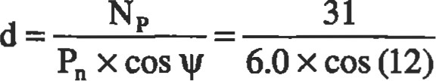= 5.28

D = mg x d = 5.0 x 5.28 = 26.41

and

d+D 5.28+2641

• =15.85

2 2

A more accurate raüng of this gear set by the current AGMA standards gives a capacity of 537 hp, limited by pitting resistance with a bending fatigue capacity of 900 hp. The bending capacity should normally be 1.5 to 2.0 times the pitting capacity because it is much more desirable to have the gears suffer surface deterioration than to have tooth breakage.

Drawing Data

When the pinion and gear are designed, it is necessary to put adequate information on manufacturing drawings for the parts to be produced. The drawings must have the normal graphic representation of the patt configuraüon, the dimensions that define the size, and the normal material and specification notes. In addition, there are dimensions required to produce the gear teeth that are usually shown on the drawing in table form. Table 8 shows an example of the the data required. To determine some of the manufacturing dimensions, it is necessary to select a value for backlash, or running clearance. For normal conditions, the backlash

Table 8

Typical Gear Drawing Data Table

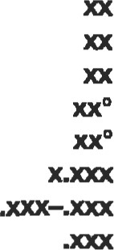Number of teefi

Normal diametral pitch

Transverse diametral pitch

Normal pressuæ angle

Transverse pressure angle

Pitch diameter

Normal cireular thickness

Normal chordal addendum

|  |  |
| --- | --- |
| Normal chordal thickness  Whole depth  Helix angle left (or right) hand | .xxx—.xxx |
| Lead | x.xxx |

is a function of diametral pitch and can be selected from Table 9. For very high speeds or unusual temperature ranges, more detailed study is required to determine the proper backlash.

In addition to the physical size and data used in the design, dimensions are required to allow machining the teeth with the precision required for smooth operation. The basic method of measuring the teeth is to use a tooth caliper.

are two calipers, one to measure the tooth thickness and one

Table 9

|  |  |  |  |
| --- | --- | --- | --- |
| Diametral Pitch | Backlash (B) | Diame&al Pitch | Backlash (B) |
| 1%  2  2%  3  4 | .025-.040  .01 B-.027  .014—.020  „011-.016  .007-.011 | 5  6  7  10—13 | .006-.009  .005-.008  .004-.007  .004-.006  .003-.005  .002-.004 |

Backlash

to confrol the depth point where the measurement is made. The thickless is called the normal chordal thickness, and it is measured at the normal chordal addendum. Equations 16 and 17 can be used to calculate the thickness and addendum.

|  |  |  |
| --- | --- | --- |
| 180 x t | | (16) |
| ac =a+— I—cos |  |
| 2 | It x d |  |
| 180 X t t c = d x sin  It x d  It x d B |  | (17) |

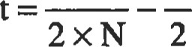 (18)

The dimensions are calculated for both the pinion and the gear by using the appropriate number of teeth (NP or NG) n Equations 16 and 17. Machining tolerance is provided by calculating with both the minimum and the maximum values of backlash in Equation 18.

Bevel Gear Design

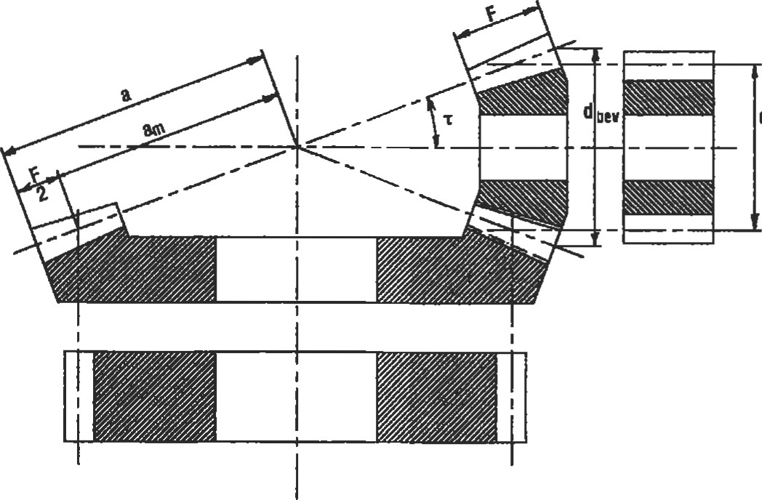Bevel gear sizes can be esümated with the same methods used for spur and helical gears. First, a few differences in normal pracüce between bevel gears and parallel shaft gears must be considered. The pitch diameters and tooth size (di-d ametral pitch) for bevel gears are defined at the large end of the gear. To determine load capacity, the load can be considered to be applied at the mid-face where the diameter is called the mean diameter. 'Ihe face width is very consistently sized as one-th.ird of the outer cone distance, based on good design and machine capabilities (see Figure 1).

|  |  |
| --- | --- |
| Equation 6 with the constant adjusted for bevel gears (Equation 21). The face and bevel pinion diameter can then be determined from Equations 22 through 24. | Figure 1. Spur gear equivalent for bevel gears. |

To estimate size by Equation 6, the face factor Fd must be calculated from Equations 19 and 20. The mean diameter can then be estimated from an equation similar to

Pitch diameter d can now be estimated by modifying

1

r=tan l(19) Equation 6:

IOO,OOOxPxCd mg +1

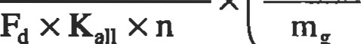

x

0.2(21)

(20)

sin r

 (22)

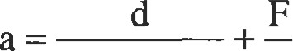 (23)

|  |  |
| --- | --- |
| 2.Oxsinr 2 |  |
| = 2.0 x a x sin r | (24) |

The size of bevel gear teeth is calculated the same as with spur and helical gears except a size factor is included. When an average value of size factor is included in Equation I l, the result is Equation 25. Equation 25 can be used to estimate the tooth size. The tapered tooth of the bevel gear changes in size across the face width. The diametral pitch calculated from Equation 25 is the size at the mid-face (mean diameter). The standard nomenclature for bevel gears defines the diametral pitch at the large end. Due to the different methods of manufacturing, it is not necessary to round the calculated pitch value to a whole number, but only to adjust the value to the size at the large end of the gear, per Equation 26.

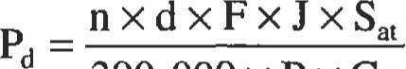 (25)

390, 000 X P X Cd

d

(26)

dbev

Pbev dbev (27)

The number of teeth must be adjusted to a whole number, and then the pitch Pdbev must be adjusted so the number of teeth will fit the diameter.

 (28)

After rounding the number of gear teeth to a whole number, the gear diameter can be calculated:

D bev Gbev (29)

dbev

Bevel Gear Sizing

Example. Estimate the size of bevel gearing for a steam turbine running 4,200 rpm to drive a centrifugal pump requiring 350 hp and running at 2,000 rpm. Most spiral bevel gears are carburized and hardened—this is best for the higher rpm in this application. For normal practice the pressure angle will be 20 degrees and the spiral angle 30 degrees.

Start with the gear ratio: 4,200/2,000 = 2.1 to 1. From Table 3, for gears surface-hardened to 58 Rc, the = 600.

From Table 4, select Ca. Based on smooth driving and driven machines and extra life, choose Ca = 1.25.

For an initial value of Cv, assume a diameter d of 4.0 inches. Per Equation 5 calculate the pitch line velocity:

v = .262 x 4.0 x 4,200 = 4,402 ft/min

Use standard commercial practice, which would be to cut the gears, then carburize and harden, and then finish by lapping. From Table 5, use cv = 1.26, and from Table 6, use cm = 1.30.

Therefore, from Equation 4:

Cd = 1.25 X 1.26 X 1.30 = 2.05

Now use Equations 19 and 20 to determine the face-todiameter factor Fd based on the gear ratio of the bevels:

1 r = tan-l — = 25.46

2.1

0.2

= 0.47 sin 25.46

Now the equivalent mean diameter d can be calculated

using Equation 21.

100,000 x 50 x 2.05 2.1+1

= 4.485

.47 x 600 x 4, 200 2.1

From Equation 20:

F = 4.485 x 0.47 = 2.11

The cone distance a is calculated per Equation 23:

4.485 2.109

= 6.271

2 x sin 25.46 2

The actual pitch diameter of the bevel pinion is calculated from Equation 24:

 = 2.0 X 6.271 X sin 25.46 = 5.392

Use Equation 5 to calculate the actual pitch line velocity: v = .262 x 5.392 x 4,200 = 5,933 ft/min

This is close enough to 5,000 ft/min to validate the original cv factor of 1.26. Proceed to Equation 25 to estimate the tooth size at the mean diameter. From Table 3, the value of Sat can be selected as 65,000 psi. Assume 22 teeth on the pinion and select J factors from the helical section since this gear set is spiral bevel, the equivalent of helical in a parallel shaft gear set.

J 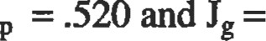 .560

Because the material strengths of the pinion and the gear are the same, the pinion with the smaller J factor will dictate the tooth size.

4,200 x 4.485 x 2.109 x .520 x 65,000

= 4.799 390, x 350 x 2.05

From Equation 26 the actual diametral pitch at the large end of the pinion is:

4.485 x 4.799 dbev ¯ = 3.991

5.392 From Equation 27:

= 5.392 X 3.99 = 21.52

Obviously, the number of teeth must be an integer number, so use NPbev = 22. Working Equation 26 backwards, define the final diametral pitch:

22

Pdbev = — = 4.08

5.392

From Equation 28:

N = 22 x 2.1 =46.2

Use 46 teeth. From Equation 29:

46



4.08

|  |
| --- |
| Cylindrical Worm Gear Design |

Thus, the size of the bevel pinion and gear and the numbers of teeth on the gears are estimated. When this gear set is rated by AGNIA standards, the resulß show 423 capacity which shows that the esåmate is reasonable and conservative.

Worm gears have a number of unique characteristics besides the arrangement of perpendicular shafts offset by the center distance. The input worm is basically a screw thread which makes one revolution to advance the gear wheel one tooth. This makes it possible to have very high gear ratios, especially since the worn can be made with mulüple start threads. Due to the sliding nature of the tooth contact, the efficiency can be poor, with typical values being 90% to 50% with the lower values in the high-ratio designs. This characteristic can be used to make a self-locking drive in which the output gear cannot drive the input worm. This is generally the case when the lead angle is 5 degrees or less. Caution must be exercised if this characteristic is desired, because the difference between dynamic and static coemcient of friction can cause a self-locking drive to unlock due to vibration or any slight initiation from the input. Since the efficiency can be low, it is best to think in terms of two different power ratings: the output power to drive the load and the input power which also includes the friction loss load.

Input Power Rating. The raüng equation has two parts: the first is the transmitted power and the second is the friction power loss in the mesh.

|  |  |
| --- | --- |
| 126,000 mg 33,000  The maximum tooth load is: | (30) |
| wt = 900 X FcKrKv | (31) |

wtDn vWf

This is based on a hardened and ground worm running with a centrifugal-cast bronze wheel with a physical face width of 6 inches or less. A wider face, up to 12 inches, would be derated up to 20%. For a chill-cast bronze wheel, derate by 20%, and by 30% for a sand-cast bronze wheel.

FC is the effective face width, which is the actual face width but not exceeding % of the mean diameter of the worm. Kr is the ratio correction factor taken from Figure 2. The velocity factor, Kv, is a function of sliding velocity and can be read from Figure 3. The sliding velocity is:

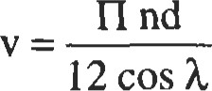 (32)

Velocity Functions

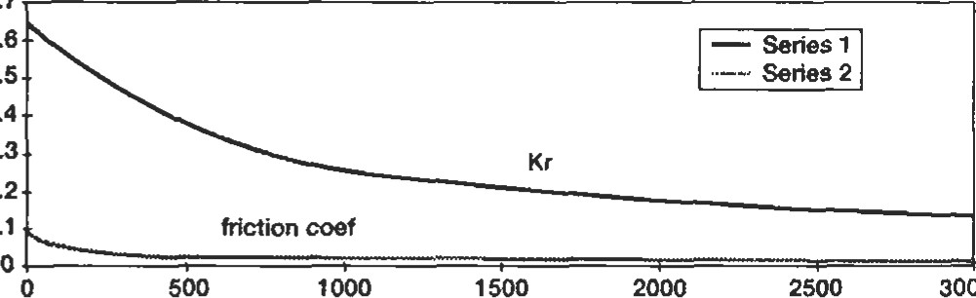

0.7

0.6

0.5

0.4

0.3

0.2

0.1

3000

Sliding Velocity

|  |
| --- |
| where y = lead angle of the worm thread at the mean diameter  Ratio Correction Factor With the tooth load calculated, the friction force can be calculated:  0.9  0.8  0.7gwt  0.6(33)  0.5  0.4  0.3  0.2The design of the finished gear drive must allow for cool-  0.1  ing the heat from the friction part of the input power. Worm 20 40 60 80 100 drives frequently have cooling fans on the high-speed input  Ratio shafts and cooling fins cast onto the housing. It should also be noted that surface finish is critical on the tooth Figure 2. Ratio correction factor. surfaces, and lubricating oil properties are very important. |

Figure 3. Velocity functions.

Most gears are made of alloy steel. The main criteria for selecting material is the fact that the load capacity of the gear set is proportional to the hardness of the material. There are two major material categories: surface-hardened and throughhardened. Through-hardened alloy steel is normally limited to the range of 38 Rc maximum. One characteristic of through-hardened gear sets that might not be expected is the hardness relationship between the pinion and the gear. For best life and durability, the pinion should be at least 2 Rc points harder than the gear. When both members are the same size—one-to-one ratio—equal hardness works satisfactorily.

Surface hardening can increase the surface to as much as 60 Rc while the softer core maintains a ductility and toughness. Of the various methods that can be used to surface-harden gears, three are most common. Carburizing is the most common method used to achieve the maximum hardness and gear load capacity. The greatest drawback with carburizing is the significant geometric distortion introduced during the quenching operation. This requires a finishing operation to restore the dimensional accuracy in almost all designs. As an alternative, nitriding can achieve surface hardness in the range of 50 to 60 Rc depending on the steel alloy used. The distortion is usually very low so that finishing is not generally required. The nitriding operation requires a long furnace time—40 to 120 hours in proportion to the case depth and therefore is normally limited to smaller case depth used for smaller-size teeth and may be impractical for gears with large-size teeth. Induction hardening takes a number of forms and can be used with a wide range of case depths. Distortion is usually low. This process requires careful development and, sometimes, tool development to assure consistent quality. Without proper development, the result may give good surface and core hardness but may have problems with ductility and fatigue life.

|  |
| --- |
| Summary of Gear Types |

With so many types and arrangements of gearing available, a summary is provided below.

Parallel Shaft

This is the most common type of gear and, as the label implies, this type of gear set operates with the axes of rotation parallel to each other. The most common use of parallel shaft gears is to change the speed, and torque, of the driven shaft relafr.'e to the driving shaft. The driven shaft also rotates in the opposite direction (unless one of the gears is an internal gear). Unless the two gears are equal in diameter, the smaller diameter member is called a pinion.

Spur. Spur gears are the most basic type of gear. The gear teeth are parallel to the axis of the shaft.

Helical. As the name implies, the teeth on a helical gear have a lead angle relative to the axis of rotation and follow the curve of a helix across the face width of the gear. The tooth load is shared by more pairs of teeth and can be transferred from tooth to tooth more smoothly than the more simple spur gear. Therefore, when all other parameters are equal, a helical gear set can carry more load and run quieter with less vibration than a spur gear set. While the basic cost to manufacture a helical gear is usually no greater than a spur, there is a penalty in the form of a thrust component to the gear reaction loads that must be supported by the shaft and bearings.

Double Helical (Herringbone). A way to counter the thrust loads of the helical gear is the double helical gear. This is accomplished by dividing the face width of the gear into two halves and using the opposite hand of helix for each half. In order to use conventional manufacturing machines, a cutter runout space must be provided between the two halves; this adds to the overall width of the gear and makes it bigger than the equivalent helical gear. With special cutting machines, the space between the two halves can be eliminated, and this type of gear is called herringbone. Some of the finishing methods used to improve the capacity and precision of gears cannot be used with herringbone gears. Since nothing in this world is perfect, the gear tooth circle is never perfectly concentric with the shaft axis of rotation, and this eccentricity contributes to vibration and dynamic load. This is of particular importance in the case of double helical gears because the two halves of the face each have specific runouts and combine to cleate an additional axial runout. While this is not generally a problem, it can require additional manufacturing effort. It is also imperaüve that the gear shaft bearing and coupling designs allow the two halves of the gear face to share the tooth load equally, as any external thrust loads that react through the gears will cause an overload in one half.

Bevel

Bevel gears have the teeth formed on a cone in place of a cylinder, and the axes of rotation intersect rather than being parallel lines. The most common arrangement has the axes intersecüng at 90 degrees; however, other angles can be used, such as seen in Vee drives for boat transmissions.

Straight Tooth. The straight tooth bevel is the spur gear of the bevel family. Being on a cone, the teeth are tapered in from the inner end of the face to the outer end.

Spiel Bevel. The spiral bevel gear is the equivalent of the helical gear on a cone. While the teeth on a straight bevel follow a ray line along the cone from one end of the face to the other, the spiral bevel tooth is modified in two ways. The tooth is set at a spiral angle, similar to the helix angle of the helical gear, and it is curved with the radius of the cutter head used to hold the blades that cut the teeth.

Zerol. The zerol is a special form of the spiral bevel that has the teeth curved with the cutter radius, but with a spiral angle of zero degrees. The curved tooth form gives some of the smoother-action characteristics of the spiral bevel; but with no spiral angle, the thrust reaction is not transmitted to the bearings.

Hypoid. The hypoid gear set is very similar to the spiral bevel set except the input pinion axis is offset so that the axes no longer intersect. More sliding is introduced in the tooth contact which results in a slight reduction in efficiency, but some geometric shaft arrangement problems can be solved.

Worm

|  |
| --- |
| Buying Gears and Gear Drives |

Worm gear sets have their input and output axes perpendicular and offset by the center distance. While this arrangement may be an advantage for some applications, the worm gear type is more frequently chosen for other characteristics. Very high gear ratios can be achieved in a single gear stage. However, efficiency goes down as raüo goes up. This is sometimes used to advantage since highratio worm sets are the only gears normally designed to be self-locking. A self-locking set acts as a brake, and üle gears lock if the output shaft tries to drive the input.

One of the most important considerations in purchasing gears is to work with a reliable and experienced vendor. A good source of information on suppliers is the American Gear Manufacturers Association (see References). It is also important to inform the vendor of all possible data about the requirements, application, and use planned for the gears or drive. Keep the specification of detailed gear data to a minimum and allow the vendor to apply his experience to help you get the best possible product. However, the most detailed possible design information should be required to be submiüed with the vendor's quotaüon. The idea is to give the vendor freedom to offer the most appropriate product but to require detailed data with the quotation for evaluation in selecting the best offering. Many frnes, a second quotation will be in order.

#### REFERENCES

1. American Gear Manufacturers Association, AGMA and 3. Drago, Raymond J., Fundamentals of Gear Design. ISO Standards, 1500 King St., Suite 201, Alexandria, VA Stoneham, MA: Butterworth Publishers, 1988.

22314. 4. Townsand, Dennis P., Dudley's Gear Handbook New

1. Dudley, Darle W., Practical Gear Design. New York: York: McGraw-Hill, Inc., 1991. McGraw-Hill, Inc., 1984.



#### Bearings

C. Richard Lenglade, Jr., Development Engineer, Allison Engine Company

|  |  |  |  |  |  |  |  |
| --- | --- | --- | --- | --- | --- | --- | --- |
| Types of Bearings |  | | 146 | Lubrication | |  | 160 |
| Ball Bearings... ..... .. |  | | 146 | General............. | |  | 160 |
| Roller Bearings |  | | 147 | Oils | |  |  |
| Standardization |  | | 149 | Greases | |  | 161 |
| Materials . |  | | 151 | Lubricant Selection | |  | 162 |
| Rating and Life |  | | 152 | Lubricating Methods ..... .. | |  | 163 |
| ABMA Definitions |  | | 152 | Relubrication | |  |  |
| Fatigue Life |  | | 153 | Cleaning, Preservation, and Storage .. | | | 165 |
| Life Adjustment Factors .... .... .... . . | | | 154 | Mounting |  | | 166 |
| Load and Speed Analysis | | | 156 | Shafting .. |  | | 166 |
| Equivalent Loads | |  | 156 | Housings |  | | 169 |
| Contact Stresses | |  | 157 | Bearing Clearance |  | | 172 |
| Preloading .................... | |  | 157 | Seals |  | | 174 |
| Special Loads | |  | 158 | Sleeve Bearings |  | | 175 |
| Effects of Speed | |  | 159 | References |  | | 177 |

145

##### TYPES OF BEARINGS

There are two general categories of bearings: rolling element bearings and journal bearings. Most of this chapter is devoted to•rolling element bearings because, for most industrial equipment, these are the most common bearings in usage. On the other hand, journal bearings have their place on some types of equipment, and are covered briefly at the end of the chapter.

Rolling element bearings consist of four basic components: the inner ring, the outer ring, the cage or separator or retainer, and the rolling elements, either balls or rollers. The inner ring is mounted on the shaft with the rolling elements between it and the outer ring, which goes in the housing.

|  |
| --- |
| Ball Bearings |

Rolling element bearings can be grouped into two basic types: ball bearings and roller bearings. Each type has its advantages and disadvantages which are described below in the discussion for each type of bearing.

Ball bearings have a number of advantages over roller bearings, but they also have some disadvantages. Advantages are:

* Low friction
* Low heat generation
* Higher speeds
* Low cost
* Take both radial and thrust loads
* Less sensitive to mounting errors

Disadvantages are:

* Lower life
* Lower load capacity

There are many different types of ball bearings, each designed for a particular type of application. The most common type of ball bearing is the Conrad or deep groove type (Figure l). It is suitable for radial loads, thrust loads in both

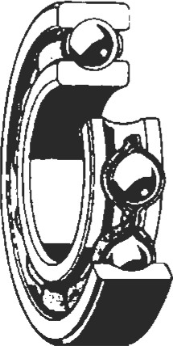

Figure 1. Deep groove (Conrad) ball bearing. (Courtesy

SKF USA, Inc.)

directions, or a combination of both. This bearing uses either a two-piece riveted cage or a snap-on polymeric cage. This feature of the bearing tends to limit its top end speed where a one-piece cage is needed, but it is suitable for most industrial machine speeds.

Another common type of ball bearing is the angular contact ball bearing (Figure 2). This bearing is designed primarily for thrust loads but can take limited radial loads if sufficient thrust loads are also present. The thrust load must be in one direction only on single bearings. This bearing has the advantage of higher capacity and longer life than a deep groove bearing because one of the rings is counterbored, allowing more balls to be assembled in the bearing. Another advantage for very high speeds is that a one piece cage can be used, if necessary. Angular contact bearings are available in several different contact angles, depending on how much thrust will be present relative to the radial load.

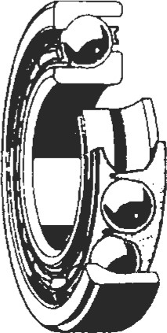

Figure 2. Angular contact ball bearing. (Courtesy SKF

USA, Inc.)

Because single angular contact bearings can take thrust in only one direction, they are often used in pairs. This is sometimes called a duplex bearing, or a duplex set (Figure 3). The two single bearings are mounted with their counterbores in •opposite directions, allowing thrust in both directions. Duplex bearings can also be conveniently preloaded as a set to provide very rigid and accurate shaft position control and stiffness.

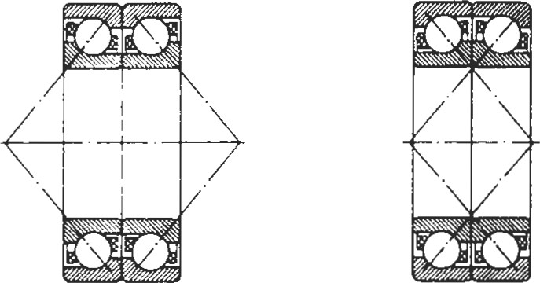

Back-to-back Face-to-face arrangement arrangement

Figure 3. Duplex sets of angular contact ball bearings. (Courtesy SKF USA, Inc.)

A variation of the angular contact bearing is the split inner ring bearing (Figure 4). This is a ball bearing with the inner ring split circumferentially, allowing a single row bearing to take thrust in either direction. These bearings are used mostly in the aircraft industry due to their cost.

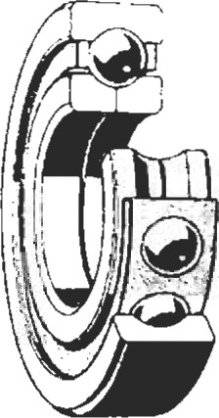

Figure 4. Split inner ring ball bearing. (Courtesy SKF

USA, Inc.)

Self-aligning, double-row ball bearings are a somewhat specialized two-row bearing (Figure 5). The outer ring raceway is a portion of a curve with only the inner ring having grooves for the balls to ride in. This allows the bearing to be internally self-aligning, and can compensate for considerable mounting or even dynamic misalignment in the shaft/housing system. Its major disadvantage is that because of the flat outer raceway, the load capacity is not very high.

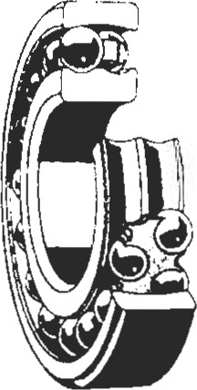

Figure 5. Self-aligning ball bearing. (Courtesy SKF USA, Inc.)

Finally, thrust-type ball bearings are bearings with a 900 contact angle (Figure 6). They cannot take any radial load, but can take considerable thrust load and high speeds. They are somewhat of a specialty bearing due to the special mounting systems required.

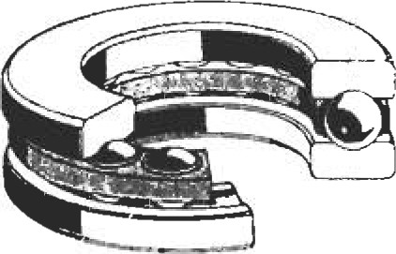

|  |
| --- |
| Roller Bearings |

Figure 6. Thrust ball bearing. (Courtesy SKF USA, Inc.)

Roller bearings are usually used for applications requiring greater load carrying capacity than a ball bearing. Roller bearings are generally much stiffer structurally and provide greater fatigue life than do ball bearings of a comparable size. Their advantages and disadvantages tend to be the opposite of ball bearings. Advantages are:

* Greater load capacity
* Greater fatigue life
* Some types take both radial and thrust loads
* Some types less sensitive to mounting errors

Disadvantages are:

* Higher friction
* Higher heat generation
* Moderate speeds
* Higher cost

There are three basic types of roller bearings: cylindrical or straight roller bearings, spherical roller bearings, and tapered roller bearings. As with the ball bearings, each has its strengths and weaknesses.

Cylindrical Roller Bearings

Cylindrical roller bearings have the lowest frictional characteristics of all other roller bearings, which makes them more suitable for high speed operation. They also have the highest radial load carrying capacity. They are not designed for carrying axial loads, although some configurations can handle very small axial loads, such as shaft positioning, when there is no external thrust load. Cylindrical roller bearings are also very sensitive to misalignment. Often, their rollers have a partial or even a full crown to help this situation.

Cylindrical roller bearings are available in a variety of rib configurations (Figure 7). These are illustrated below. In general, there must be at least two ribs on one of the rings. One or two ribs on the other ring allow the bearing to locate the shaft as long as there is no external thrust load. This feature is used in gear trains by using two cylindrical bearings to support the spur gear shaft with no ball bearing. The typical cylindrical roller bearing is free to float axially. It has two roller guiding ribs on one ring and none on the other. Then a ball bearing or other thrust type bearing is used on the other end of the shaft to locate it.

Spherical Roller Bearings

Spherical roller bearings (Figure 8) are so named because the cross-section of one of the raceways, usually the outer raceway, makes up a portion of a sphere. The rollers of this type of bearing are barrel shaped and usually symmetrical but sometimes off-center or asymmetrical. The bearings are available in both single- or double-row configurations, but the double-row design is by far the most common. Spherical roller bearings are capable of carrying high radial loads or, in the double-row versions, a combination of radial and axial loads. The single-row design cannot take any thrust loading.

|  |  |  |  |  |  |  |  |  |  |  |  |  |  |  |  |  |  |  |  |  |  |  |  |  |  |  |  |  |  |  |  |  |  |  |  |  |  |  |  |  |  |  |
| --- | --- | --- | --- | --- | --- | --- | --- | --- | --- | --- | --- | --- | --- | --- | --- | --- | --- | --- | --- | --- | --- | --- | --- | --- | --- | --- | --- | --- | --- | --- | --- | --- | --- | --- | --- | --- | --- | --- | --- | --- | --- | --- |
| |  |  |  |  |  |  |  |  |  | | --- | --- | --- | --- | --- | --- | --- | --- | --- | |  | Roller Bearing Types | | | | | | | | | Bearing Type |  |  | | |  |  |  | |  |  |  |  | |  | | --- | | 7/7/4 | |  | |  |  | | Inner  Ring  Flanges | Both  Sides | Both  Sides | | | None | One  Fixed  One  Separable | One  Side | | Outer  Ring  Flanges | None | One  Side | | | Both  Sides | Both  Sides | Both  Sides |   Figure 7. Cylindrical roller bearing rib configurations [16]. (Courtesy SKF USA, Inc.) |

The great advantage of the spherical roller bearing over the ball bearing or cylindrical roller bearing is its ability to take considerable amounts of misalignment without reduction of capacity. The misalignment can be either static or dynamic, and as much as 3 to 5 degrees depending on the internal geometry of the bearing. It can also take much more thrust load than a ball bearing of the same size. Its biggest disadvantage is that it is the most difficult bearing type to manufacture. It costs several times as much as a

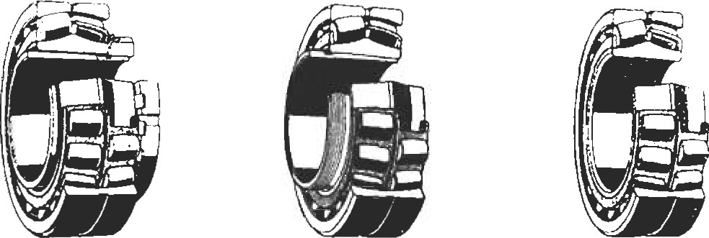

Bearing on Bearing on Bearing with adapter sleeve withdrawal sleeve cylindrical bore figure 8. Sphe6ca} roller bearings. (Courtesy SKF USA, Inc.)

cylindrical roller bearing with the same load capacity. The other significant disadvantage is that it has more friction and heat generation than any other type of bearing.

Tapered Roller Bearings

Tapered roller bearings (Figure 9) are similar to cylindrical roller bearings except that the roller is tapered from one end to the other and the raceways are angled to match the roller taper. Unlike cylindrical roller bearings, they can take large thrust loads or a combination of radial and thrust loads. Tapered roller bearings can be mounted on the shaft in pairs, taking thrust in both directions and completely controlling the shaft location. They also have more load capacity than a spherical roller bearing of the same size and are much less difficult to manufacture, providing a significant cost advantage.

The biggest disadvantage of the tapered roller bearing is its tapered design. In operation, the raceway forces push the roller to one end of the bearing so that there must be a guide flange present to keep the roller in the bearing. This sliding contact causes friction and heat generation and makes the bearing generally unsuitable for high speeds. The other disadvantage of this bearing is that it is sensitive to misalignment, just like a cylindrical roller bearing. In general, tapered roller bearings have the same .001 " per inch requirement for full load capacity.

Because the tapered roller bearing has evolved a little differently than other types of roller bearings, its part terminology is different. Inner rings are frequently called cones and outer rings are called cups.

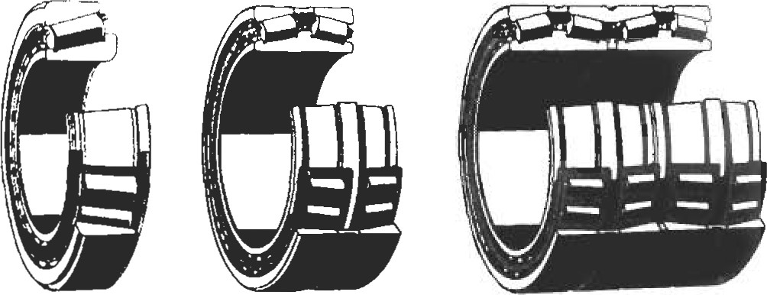

|  |
| --- |
| Standardization |

Figure 9. Tapered roller bearings. (Courtesy SKF USA, Inc.)

Bearings are one of the earlier manufactured items to have become standardized. Today, almost all bearings are made to a strict standard, for many features, that is the same around the world in many aspects, especially in the areas of boundary plan and tolerances. A standardized set of definitions has been developed by the American Bearing Manufacturers Association (ABMA) for the various bearing components and some of their key dimensions and tolerances. To better understand the discussions that follow and to better communicate with bearing suppliers, some of these definitions as given in ANSI/AFBMA Standard l 1990 [4] are included here.

Inner ring: A bearing ring incorporating the raceway(s) on its outside surface.

Cone: An inner ring of a tapered roller bearing.

Outer ring: A bearing ring incorporating the raceway(s) on its inside surface.

Cup: An outer ring of a tapered roller bearing.

Cage: A bearing part which partly surrounds all or several of the rolling elements and moves with them. Its purpose is to space the rolling elements and generally also to guide and/or retain them in the bearing.

Separator: Another word for cage.

Retainer: Another word for cage.

Rolling element: A ball or roller which rolls between raceways.

Raceway: A surface of a load supporting part of a rolling bearing, suitably prepared as a rolling track for the rolling elements.

Bearing bore diameter (bore): The bore or I.D. of the inner ring of a rolling bearing.

Bearing outside diameter (O.D.): The outside surface of the outer ring of a rolling bearing.

Bearing width (width): The axial distance between the two ring faces designated to bound the width of a radial bearing. For a single row tapered roller bearing this is the axial distance between the back face of the cup and the opposite face of the cone.

In the United States, this standardization is conü•olled by the American National Standards Institute (ANSI) together with the American Bearing Manufacturers Association (ABMA), formerly the Anti-Friction Bearing Manufacturers Association (AFBMA). The ABMA has published a large number of standards on bearings, including boundary plans, tolerances, life calculations and load ratings, gauging practices, ball specifications, mounting practices, and packaging. It also works together with the International Standards Organizaüon (ISO) in the development of international standards. The three engineering committees of the ABMA develop these standards for the United States and consist of the Annular Bearing Engineering Committee (ABEC—for ball bearings), the Roller Bearing Engineers Committee (RBEC—for roller bearings), and the Ball Manufacturers Engineers Committee (BMEC—for bearing balls only).

The basic boundary dimension plan consists of the inner ring bore or I.D., the outer ring O.D., and the bearing width. It is important to realize that bearing boundary dimension plans are so standardized that they need to be factored into every machine design. The shaft and housing should be sized to correspond to one of the standard bearing boundary plans. Only the gas turbine aircraft engine indusüy, due to its special designs and extremely low volume usage, can violate the standard boundary plans, and even then it is usually cost-effective to take them into account. The good news is that there are a u•emendous number of dimensional variations in the standards, many of which are commonly produced.

Boundary plans are done in terms of millimeters. This is due both around the world and in the United States.

Some manufacturers make a variety of bearings with the ring bore dimension in even fractional inch sizes, but even these bearings are merely variations of a metric boundary plan with an undersized or oversized bore to the nearest fracüonal inch. The entire range of boundary plan variations is given in the ANSI/ABNIA Standard 19-1974 [91 for tapered roller bearings and ANSI/ABMA Standard 20-1987 [10] for ball bearings and cylindrical and spherical roller bearings, and are too extensive to list here. However, Table I lists the boundary plans for the most commonly available ball and roller bearings.

The exception to the above comments and the table on boundary plan standardization are the tapered roller bearings. ABMA also publishes standards for tapered roller bearings, but they do not follow the same boundary plan rules as other bearings. Some tapered roller bearings have metric boundary plans, but many more have inch dimension boundary plans. The sizes that are available in general come from the standardization plan developed by The Timken Co., and are not as easily categorized as the other types of bearings. Their standards have effectively been adopted by the rest of the world.

Another important area of standardization by ANSI/ABMA is tolerances. Certain dimensional features of bearings have had the allowable tolerances in manufacture standardized. These features are: bore and O.D. variation (roundness), width variation, bore and O.D. diameter variation (taper), side face runout with bore, raceway radial runout, and raceway axial runout. In general, these tolerances control the running accuracy of a bearing. The tolerances have been grouped into classes and numbered—the higher the number, the higher the bearing precision. For ball bearings they are ABEC-I, -3, -5, -7, and -9, and for roller bearings they are RBEC -1, -3, and -5. In both cases, Class 1 bearings are standard commercial bearings, and Class 5 are standard high precision, or aircraft precision, bearings. A complete listing of bearing tolerances can be found in ANSI/ABMA Standard 4. Some precision bearing manufacturers list some of these tolerances in their catalogs.

|  |  |  |  |  |  |  |  |  |  |  |  |  |  |  |  |  |  |  |  |  |  |  |  |  |  |  |  |  |  |  |  |  |  |  |  |  |  |  |
| --- | --- | --- | --- | --- | --- | --- | --- | --- | --- | --- | --- | --- | --- | --- | --- | --- | --- | --- | --- | --- | --- | --- | --- | --- | --- | --- | --- | --- | --- | --- | --- | --- | --- | --- | --- | --- | --- | --- |
| Table 1  Common Boundaw Dimension Plans  Dimensions in m   |  |  |  |  |  |  |  |  |  |  |  |  |  | | --- | --- | --- | --- | --- | --- | --- | --- | --- | --- | --- | --- | --- | | Bore  Size |  | |  | Dimensions Series | | | | |  |  |  |  | | 1 8  o.D. Width | | O.D. | Width | O.D. Width | | 0 2  O.D. Width | | O.D. | Width | O.D. | Width | | 12  15  20  22  28  30  32  35  40  50  55  65  70  75  80  85  90  100  105  110  120  130  140  150 | 21  24  26  32  34  40  42  52  72  85  90  100  110  115  120  125  130  140  150  165  175  190 | 10  10  10  10  10  13  13  13  13  16  18  20 | 24  28  37  39  55  62  80  100  105  110  120  125  130  140  145  150  165  180  190  210 | 12  12  13  13  13  16  18  18  20  20  22  24  28 | 28  32  42  44  55  62  68  80  90  100  110  115  125  130  140  145  150  160  170  180  200  210  225 | 12  12  12  13  15  18  18  20  22  22  24  24  26  28  33  35 | 32  35  50  62  80  90  100  110  120  125  130  140  150  160  170  180  190  200  215  230  250  270 | 10  11  14  14  16  16  17  18  20  21  23  24  28  34  40  40  45 | 37  42  52  56  68  72  80  90  100  110  120  130  140  150  160  170  180  190  200  215  225  240  260  280  300  320 | 11  12  13  15  16  19  21  23  29  33  35  41    55  58  62  65 | 42  52  62  80  90  100  110  120  130  140  150  160  180  190  200  210  225  240  250  260  280  310  340  360  380 | 12  13  15  19  23  25  27  31  33  37  42  48  52  58  60  72  78  82  85 |   Source: ANSI/AFBMA.  Materials |

The types of steel used in bearing inner rings, outer rings, balls, and rollers are made especially for bearings. The material properties are extremely important to the life of any bearing. The requirements for bearing steels are high strength, wear resistance, excellent fatigue resistance, and dimensional stability. In addition, they must be capable of being hardened to a high level, producing a very fine and uniform microsü-ucture, having a high level of cleanliness, and having the proper chemistry.

Table 2 lists most of the steels used in bearings. It also gives their useful, continuous temperature limit. The problem is that for off-the-shelf industrial bearings, there is usually not a choice as to the material. If special requirements are needed, a specific bearing manufacturer Table 2

Common Bearing Steels and Their Temperature Limits

|  |  |  |
| --- | --- | --- |
| ThN-hardening Steels | Case-hardening Steels | Temperature Limit |
| TBS-9  STROLOY 503-A 52100 | 4118  5120  8620  4620  4720  4320 | 3000F |
| 52100 TYPE 1 52100 TYPE 2  440C | 4820  9310  3310 | 3500F |
| M50  T-1 (18-4-1) | M50NiL | 5500F |

should be consulted. Some bearing materials are available in increasing levels of cleanliness, which will increase the life of any bearing; but again, these are only available on special order.

Bearing cages are also available in a variety of materials. The commonly used materials are shown in Table 3 along with the useful, continuous temperature limit for each. Again, common industrial bearings are usually only available in one cage material, selected by the manufacturer for general use. Other cage materials can often be obtained in the high precision bearings of some manufacturers.

Table 3

Common Bearing Cage Materials and Their Temperature Limits

|  |
| --- |
| RATING AND LIFE  ABMA Definitions |

Material Temperawre, OF



Numinum

|  |  |
| --- | --- |
| Alloy steel wiWsilver plate | 600 |
| Nylon 6/6 Phenolic | 250--300 |
| Polyethersulfone | 400 |
| Polyetheretherketone | 500 |



Polyamide

To provide a means of evaluating similar bearings from different manufacmrers, the ABMA developed standards for the way in which bearing capacity and life are calculated. The ABMA standard on ratings was adopted as ANSI

B3.11. The load rating standards have been published as ANSI/ABMA Standard 9-1990 [7] for ball bearings and Standard 11-1990[8] for tapered roller bearings, spherical roller bearings, and cylindrical roller bearings. As with the dimensions, there are a number of special terms associated with bearing life, and these are also defined in ANSI/ABMA Standard 1, Terminology. Several of the more important ones are given below.

Basic rating life or LIO life: The predicted value of life, based on a basic dynamic radial load rating, associated with 90% reliability.

Basic dynamic radial load rating (capacity): That constant stationary radial load which a rolling bearing can theoretically endure for a basic radng life of one million revolutions. Often referred to as the "basic load rating." Basic static radial load rating (Co): Static radial load which corresponds to a calculated contact at the center of the most heavily loaded rolling element/raceway contact of 580,000 psi. (NOTE: For this contact stress, a total permanent deformaüon of rolling element and raceway occurs which is approximately .0001 of the rolling diameter.)

Fatigue life (ofan individual bearing): The number of revwhich one of the bearing rings makes in relation to the other ring before the first evidence of fatigue develops in the material of one of the rings or one of the rolling elements. Life may also be expressed in number of hours of at a given constant speed of rotation.

The basic dynamic radial load rating is the one used for calculating the life of a bearing and is more useful than the static load radng. When someone talks about the capacity of a bearing, the basic load rating is what he is refen•ing to. The capacity or basic load rating is the best way to compare various bearings of the same type. The formula for bearing capacity is as follows:

For roller bearings:



For ball bearings:

1. = fc (i Z2]3 (for balls larger than 1", use D l •4)

where: C = basic load rating, in pounds fc = a factor which depends on bearing geometry i = number of rows of rolling elements leff = effective length of contact between the roller and raceway a = bearing contact angle Z = number of rolling elements per row

1. = maximum rolling element diameter

These formulas are not complicated, but they do require the knowledge of bearing geometry not usually disclosed by the bearing manufacturers. Because most manufacturers' catalogs contain listings of the capacities of their bearings based on the ABMA standards, it is preferable to use these values to compare one bearing to another and for calculations. These formulas are given here so that the effect of each variable can be judged by the engineer. For instance, judging by the exponents, it can be seen that roller diameter has a greater effect on capacity than either the number of rollers or the roller length.

|  |
| --- |
| Fatigue Life |

According to the ABMA standard, the static load rating is that load which will produce a raceway maximum Hertzian contact sfress of 580,000 psi. However, this will not usually produce permanent measurable deformation of the bearing raceways and is not directly related to the calculated fatigue life. This is why static load rating is seldom used except as a guideline for the maximum load that a bearing can take. The nature of the load should also be considered when dealing with static loading. Impact or shock loads will have a more severe effect as will a repetitive cycle. Stiffness of the support sü-ucture must also be considered.

There are many misconceptions about bearing life. Bearings operating in the field can fail from a variety of causes. Among these are lack of lubrication, corrosion, dirt, wear, and fatigue, to name just a few. It is possible to keep records of operational bearing life and use these as a predictor for future bearings. However, when it comes to new or redesigned applications, the only life that can be calculated is the fatigue life. While it is known that fatigue life failures represent a small percentage of the actual bearing failures in the field, it is still a good yardstick for predicting the reliability of a bearing application.

Bearing fatigue life is generally discussed in terms of calculated LIO life. This is also referred to as rating life and also BIO life. This LIO life or basic rating life is the one that is calculated from the basic dynamic radial load rating or capacity. This life is a statistical value based on high cycle fatigue of the material and is not an absolute value. It is associated with 90% reliability. This means that for any statistically large group of bearings with the same calculated LIO life, 10% of them will fail before they reach the calculated life.

There are a number of assumptions included in the calculaüon of the LIO life. It is assumed frat the bearing is pror erly lubricated and the internal geometry is correct. It is assumed that there is no dirt or water present in the bearing. It is also assumed that the loading applied to the bearing is within the bearing's capability and that there is no misalignment. The steel used to make the bearing is assumed to be clean within acceptable bearing standards.

With all of these assumptions, it is easy to see why bearings do not always last as long as their calculated life. In addition, the LIO life is a statistical value that does not guarantee the life of any particular bearing, and in fact predicts that some of them (10%) will fail before the calculated life is reached.

The formula for calculating bearing LIO fatigue life is relatively simple and based on empirical data. All that is needed is the bearing capacity or basic dynamic load rat-

ing from the manufacturer's catalog and the equivalent radial load (discussed in the next section). The formula is as follows:

###### LIO life = (CIP)n in cycles

where: C = basic dynamic load rating P = equivalent radial load n = 3 for ball bearings, 10/3 for roller bearings

To convert this fonnula to hours, the bearing speed must be factored in. The complete formula for bearing LIO fadgue life in hours is as follows:

(C/P) n (1, 000, 000)

LIO life = in hours

###### N (60)

|  |
| --- |
| Life Adjustment Factors |

where: N =shaft speed (or housing speed, for outer ring rotation)

The LIO fadgue life formula and the ones for calculating the basic dynamic load ratings are based on empirical data generated in the 1940s and 1950s in the laboratory where all of the conditions could be controlled, resulting in only fatigue-related failures. Because some applications vary, the ABMA has created three life adjustment factors that are intended to be combined with the LIO life to obtain an adjusted life, as shown below. Care must be taken in the use of these factors to be sure that the conditions that justify them exist.



where: ar = life adjustment factor for reliability a2 = life adjustment factor for material a3 = life adjustment factor for application conditions

There are dines when a level of reliability greater than the 90% calculated by LIO life is desired. In these cases al can be used as given in the Table 4 (from ANSI/AFBMA Std. 9-1990 [7]).

the years, bearing materials and their procesülg have improved considerably. This means that the empirical data that created the life and capacity formulas are conservaüve,

Table 4

ABMA Life Adjustment Factor for Reliability

Adjusted rating life, Ln Reliability, per cent Life factor, al

From ABMA Standards (1990)

|  |  |  |
| --- | --- | --- |
| LIO  1-4 | 90  95  96  98  99 | 1.00  0.62  0.53  0.44  0.33  0.21 |

since they are based on material cleanliness at the time. In addition, special processing for some steels used in the precision and aircraft bearing industies have improved their cleanliness even further. A few of the materials/processes are listed in Table 5, with a suggested material factor. The problem with using these factors is that these materials are not available in standard, off-the-shelf bearings.

Table 5

Life Adjustment Factor for Material

|  |  |
| --- | --- |
| Material/Process | Life Adjustment Factor |
| SAE 521  SAE M-50NlM-VAR 9310/CEVM  8620/CEVM  M50 NiLNlM-VAR | 5  6  8  8  12 |

The life adjustment factor for application conditions is most commonly used for adjustments due to lubrication, load disüibution, clearance, and misalignment. In many cases, there is not enough information available to accurately use these factors. The operating condiüons for which a3 can be assumed to be 1.0 are given in Table 6.

The most comrnon use for the a3 life adjustment factor is for lubrication effects. This factor can be either greater or less than 1.0, depending on the of the lubricant film thickness to the bearing raceway surface roughness, A. (See the lubricaüon secüon for a discussion of A.) A chart from which the life adjustment factor for lubrication can be calculated is shown in Figure 10.

The bearing load zone refers to the number of rolling elements that are carrying the load for a given condition. The standard life assumes a load zone of 1800, which

Table 6

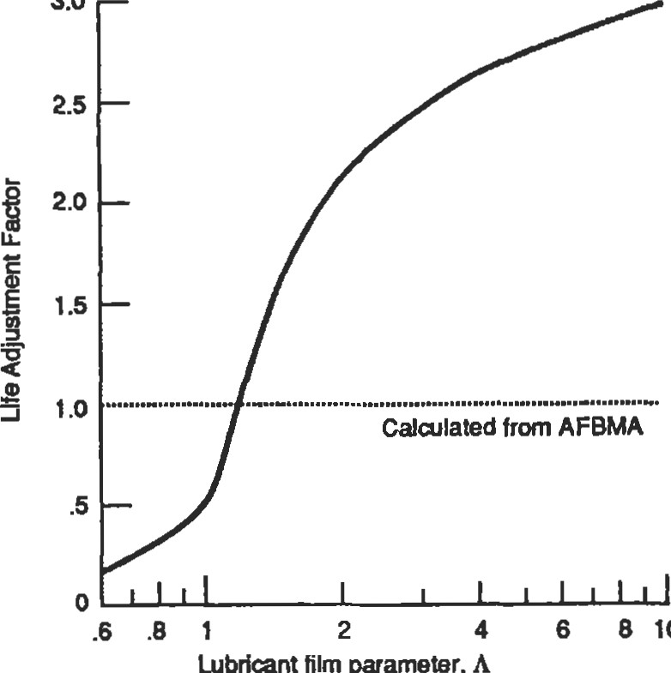

3.0

10

Lubricant

film

paameter,

Standard Conditions for Valid Life Calculation

Load From 1% to 30% of C

Speed Witlin the manufacturers catalog rating

Temperature -400F to +2500F

Lubrication 011 viscosity giving 1.1 1.3 (where A is defined in the text)

Ring Support Housing and shaft support must keep ring defections small when compared to the rolling element contact deflections

Misalignment Between inner and outer rings as follows:

Ball bearings .0030 inlin

Cylindrical roller bearings *0005 innn Spherical roller bearings .0087 inlin

|  |  |
| --- | --- |
| implies an operating internal clearance of zero. Because this is not a normally recommended situation, the a3 factor for load zone is almost always less than 1.0. ms type of calculation is usually done in a computer progam and combined with all the other applicaüon factors. For hand calculations, it is best to ignore this portion of the factor as it is often balanced out by other factors also not used in hand calculaüons. To a certain extent, this factor has been accounted for in the life equation since it was partly derived from empirical data involving bearings running with some clearance.  Misalignment in excess of the above limits will always result in an a3 factor less than 1.0. This is also a factor best | Figure 10. Life adjustment factor as function of lubricant film parameter [12]. (Reprinted Wiffl permission ofASME.)  left to computer programs. However, Figure 11 for ball bearings under radial load illustrates the importance of maintaining good alignment in all situations.  It must be emphasized that care be taken in the use of the three life adjustment factors. A considerable amount of information must be kiown to use them properly, and often some of the needed information is not available. It is also improper to use one of the adjustment factors to compensate for something like contamination. |

Tapered roller bearings .0010 inlin

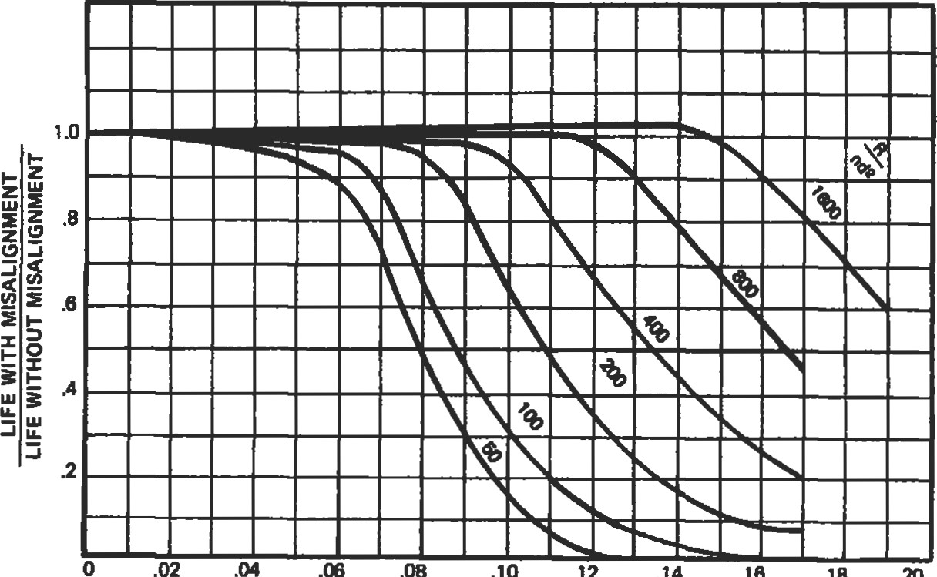

.14

.16

18

.20

MISALIGNMENT - DEGREES where: R - RADIAL LOAD - LBS. n = NUMBER OF BALLS d = DIA. OF BALLS

Figure 11. Effect of misalignment on ball bearing fatigue life.

###### LOAD AND SPEED ANALYSIS

Equivalent Loads

To calculate the LIO life of a bearing, the bearing capacity and loading must be known. The previous section discussed the bearing capacity. The loading on a given bearing may be simple or complex, but all of the loads must be converted into a single equivalent load that can be used with the basic dynamic rating discussed above. For radial bearings, the equivalent load is defined by the ABMA:

Equivalent Load: That constant stationary radial load under the influence of which a rolling bearing would have the same life as it will attain under the actual load conditions.

The general formula for the equivalent load is:

P = XFr + YFa

where: P = equivalent load

Fr radial load

Fa = axial or thrust load

1. = radial factor, taken from bearing manufacturer's catalog
2. = thrust factor, taken from bearing manufacturer's catalog

For most bearings, the X and Y factors are variable according to the ratio of the thrust to radial load. Table 7a illustrates how the factors are determined for radial deep groove ball bearings, and Table 7b shows how to calculate the factors for radial roller bearings. In both tables, comparing the thrust to radial load ratio to "e" tells which column to use. In Table 7a, the proper row to use is determined by calculating the ratio of thrust load to iZD2 (where i is the number of rows of balls, Z is the number of balls per row, and D is the ball diameter) and matching the ratio with the values in the table. In Table 7b, the 'a' refers to the bearing contact angle (a = 0 for cylindrical roller bearings). These tables are taken from ANSI/AFBMA Standard 9-1990[7] and Standard 11-1990[8]. A more comprehensive table for ball bearings, including thrust bearings and angular contact bearings, can be found in ANSI/AFBMA Standard 9-1990 [7]. Some of these tables are also given in several of the references to varying degrees (10, 12, 13, 15, 16).

Table 7a

Inch Values of X and Y for Radial Ball Bearings3

Single row bearings Double row bearings



Bearing Relative axial load

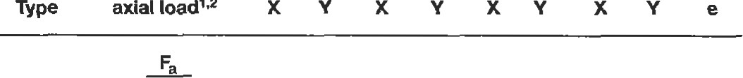

i

2

iZD2

|  |  |  |  |  |
| --- | --- | --- | --- | --- |
| 24.92 |  | 2.30 | 2.30 | 0.19 |
| 50.03 |  | 1.99 | 1.99 | 0.22 |
| 99.91 |  | 1.71 | 1.71 | 0.26 |
| Radial contact 149.35 |  | 1.55 | 1.55 | 0.28 |
| groove ball 200.10 | 1 o 0.56 | 1.45 | 1 o 0.56 1.45 | 0.30 |
| bearings 300.15 |  | 1.31 | 1.31 | 0.34 |
| 500.25 |  | 1.15 | 1.15 | 0.38 |

749.65 1.04 1.04 0.42

999.05 1.00 1.00 0.44

'Permissible maximum value depends on bearing design (intemal clearance and raceway groove depth). use first or second column depending on available information.

2VaIues ofX. Y, and e for intermediate "relative axial loads" and/or contact angles or obtained by linear interpolation.

Use to obtain P in pounds when D is given in inches.

Source: ANSIfAFBMA Std. 9.

Table 7b

Values of X and Y for Radial Roller Bearings

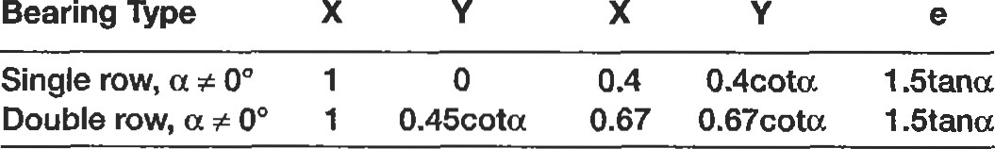

x

x

Source: ANSI/AFBMA Std. 11.

Cylindrical roller bearings that have opposed integral ribs on inner and outer rings can support limited thrust loads, but these loads do not affect fatigue life. Heavier thrust loads will reduce life due to overturning moments exerted on the rollers, but this effect is difficult to estimate at best.

Due to the design of tapered roller bearings, a radial load will induce a thrust reaction load within the bearing which must be opposed by another bearing somewhere on the shaft, usually another tapered roller bearing mounted in opposition. When only a radial load is applied to a tapered roller bearing, the induced bearing thrust is:

Fa = (.47Fr)/K where: K = K factor from bearing manufacturer's catalog

There are many variations of mounting arrangements for tapered roller bearings which pmduce a variety of equaüons for calculating the total thrust load, including the induced thrust. These are too numerous and rigorous to reproduce here, but the Bearing Selection Handbook published by The Timken Company [14] has a complete description.

Loading in the case of a duty cycle can be calculated by means of the formula shown below. When using fis formula, the question of what speed to use in the life equation once the load is determined can usually be answered by using the average speed. If the speeds vary widely, the life will not be completely accurate but should be a good estimate.

+P2 N2t2 +...+

+N2t2 +...+Nntn

where: Pn = equivalent load for condition n

Nn = speed for condition n % = of time at condition n b = 3 for ball bearings; 10/3 for roller bearings

To obtain the most accurate life estimate for a duty cycle, or for a system of bearings, where the life is known for each duty cycle condition or for each bearing, Minor's Rule can be used. The formula for this is as follows:

1

LIO(weighted) =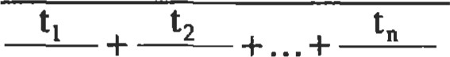

(LIDI (LIO)2 (LIO)n

|  |  |  |  |  |  |  |  |  |  |  |  |  |  |  |
| --- | --- | --- | --- | --- | --- | --- | --- | --- | --- | --- | --- | --- | --- | --- |
| Contact Stresses  Compared to most mechanical components, bearings op- Table 8 erate under high stresses. Even a lightly loaded bearing Maximum Recommended S&ess Level might have as much as 100,000 psi rolling element/race contact stress. Bearings are designed to take this su•ess for (All values in ksi) millions of revolutions. Some may only need a Continuous load toad Static load   |  |  |  |  |  | | --- | --- | --- | --- | --- | | vay short fatigue life, and the temptation is to use a very small bearing because the life calculations indicate diat there is PIQ ty of life. This is often the case when the shaft speed is very low. In this case, the bearing should be designed to a maximum stress level as well as to a life criteria. The maximum su•ess level for continuous is given in Table 8. | Ball bearing  Roller bearing | 300  320 | 375  400 | 610  580 | |  |  |  |  | | Preloading |  |  |  |  | |

where: (LIO)n —— calculated LIO life of condition for bearing n

One of the basic jobs of a bearing is to the location of the shaft that it is on. Somefrnes this has to be very precise, as in the case of machine tool spindles. The deviation from rotation about the theoretical shaft centerline is called runout. There are many factors related to the shaft, housing, and bearings that can affect üle mnout of the shaft. One of the common ways to control this runout is by preloading the bearings. Preloading also has several other advantages which are listed below:

* eliminate all radial and axial play
* reduce nonrepeütive runout
* increase rigidity of the shaft system
* impart a known yield to a system
* limit change in contact angle between inner and outer rings at high speed
* prevent undesirable ball dynamics under high acceleration or speed

One of the problems with using preloaded bearings is that they generate more heat when preloaded than when clearance is left in the bearing. If the preload is not carefully designed, bearing operating temperatures can be excessive or even out of control. If the preloaded bearings are not mounted close to each other, they are susceptible to damage due to differenüal expansion of the shaft or housing system. In addition, the amount of preload adds to the bearing operaüng load and reduces life.

There are four basic methods of preloading bearings:

1. spring preloading
2. axial adjustment
3. use of duplexed bearings

Spring preloading is a method accomplished by the user. One of the two bearings is mounted with a sping pushing on the outer ring, creating an artificial axial load or preload. The outer ring is able to move axially in the housing so as to maintain a constant spring force. Axial adjustment is done through control of the axial stack dimensions between the two bearings, creating a preload when the complete shaft/housing system is put together. Duplexed bearings are a pair of angular contact ball bearings, or sometimes tapered roller bearings, that are mounted opposed to each other. Their inner rings or outer rings are specially ground to eliminate all axial play in the bearings when they are mounted on the shaft and in the housing.

|  |  |
| --- | --- |
| 4. controlled elimination of radial clearance | not recommended for cylindrical roller bearings. |
| Special Loads |  |

It is also possible to preload double-row spherical roller bearings not axially, but radially, by very carefully eliminaüng all of the bearing clearance. This must be done under very closely controlled conditions to avoid overheating of the bearing, and is usually restricted to low or moderate speeds. Controlled clearance bearings are only available from the manufacturer, who should be consulted for application advice. The controlled clegrance bearing is

A shaft is considered indeterminate when it is supported by three or more bearings. The extra bearings will affect the load on the other bearings, inducing leverage forces caused by deflections of the shaft. More than two bearings on a shaft should be avoided, if possible; otherwise, great care must be taken to accurately align the shaft.

Unbalanced loads come in two varieües: ones that are designed to be there, such as a vibratory feeder, and ones that occur during operation, such as dirty fan blades on an air handler. In the second case, if the condition is known to be common, it should be designed for by adding some unbalanced load to the regular operating load and making the bearing selection based on the sum.

Equipment that is designed to have unbalanced load must be analyzed carefully. Although the unbalanced load can be calculated accurately, this type load puts an extra strain on a bearing and is one of the most severe applications for the cage. One way to compensate for this is to multiply the calculated load by an application factor of at least 1.5. It is also suggested that the manufacturer be consulted to determine if the bearing cage is suitable for unbalanced load operation.

Applications involving oscillating motion impose conditions that make bearing selection difficult. Life calculations do not have the same meaning because there are no revolutions. Loading is resfricted to only a small portion of the total bearing raceway and on only a few rolling elements. Usually, oscillating motion is so slow that there is no lubricant film built up. The normal mode of failure of this type of application is wear, not fatigue. Therefore, the choice of lubricant is important. Keeping the bearing cavity full of a soft grease with an EP additive or, even better, an EP oil has been found effective in minimizing this wear.

Bearings are often subjected to inertial loading caused by a variety of conditions. Some of the most common are:

* reciprocating motion
* rotary mechanism subject to fluctuating loads
* accelerations
* cyclic or random torsional variations

If any of these are included in the applicaüon, whether by design or not, it is important to include them in the load and

|  |  |  |  |
| --- | --- | --- | --- |
| life calculations. Often, these conditions add to stresses and forces on bearing cages and mounting systems.  There are a number of bearing selection criteria that depend on the bearing loading. Bearing loading is generally expressed in terms of a percentage of the basic dynamic rating or capacity, "C." Table 9 gives the typical groupings for such selections as shaft and housing fits and lubricaüon | Bearings 159  Table 9  Load Ranges for Rolling Element Bearings | | |
| Descripion | Ball | Roller |
| Very light  Light  Normal  Heavy 15%  Very heavy | C | 8% to 18% C  18% to C |

practices. where: C = bearing basic (dynamic) capacity

###### Effects of Speed

There are a number of consideraüons for bearing selection associated with speed. Because most applications have the shaft and bearing inner ring turning, shaft speed and bearing speed are often interchanged. Speed is a relative term. Obviously, any given speed will have a greater effect on a larger bearing than on a small one. The most common way of comparing speeds of bearings is by using the term DN. This is calculated by multiplying the bearing bore diameter, in millimeters, by the shaft speed, in rpm. (A 50mm bore bearing running at 2,000 rpm has a DN level of 100,000.) This factor can be used for all types of bearings, although different types of bearings have different DN levels that are critical.

Most bearing manufacturers specify speed limits for their products in their catalogs. These serve as useful guides for the majority of normal bearing applications. They are based on good lubrication, moderate load, and a reasonable thermal environment. In addition to affecting the life calculation, speed causes heat generation in a bearing. The speed beyond which bearing temperatures exceed a critical value is often the limiting factor. At the other end of the spectrum, die speed may be so low that a good lubricant film is never developed, reducing the life as discussed in the lubrication section. Generally, however, it is the upper limit of speed that is of most concern. Capability of the lubricant, seal requirements, thermal requirements, and even bearing design will affect this limit.

In general. bearings can operate in oil lubricaüon at higher speeds than in grease. Clearance-type seals can operate at higher speeds than lip seals. One-piece bearing cage designs can operate higher than riveted or assembled cages. Some special bearing steels have higher temperature limits than standard materials, allowing higher speed operation where high speed heat generaüon would affect the material properties.

Table 10 contains general guidelines for limiting speeds of the different types of bearings. Because lubricant interaction is so important, two conditions are given. To illusthat these recommendations are not hard and fast, the highest speed attained in each type of bearing is also given. These speeds were usually obtained with very special bearing designs and test machine set-ups and in no way indicate typical performance.

There are several effects of high speed operation that should be considered in bearing selection. Most of these effects do not occur at normal indusffial equipment speeds. Gas turbine engines and high speed machine tools are examples of where they can be a problem. These are:

* skidding
* spin-to-roll ratio
* ball excursions

' centrifugal loading

Skidding is a condition in which the bearing loading is so light that it cannot create enough traction for the rolling

Table 10

Bearing Speed Limits

|  |  |  |  |
| --- | --- | --- | --- |
| Bearing Type | Approximate Normal  Speed Limits, DN  Grease or Circulatng  Oil Bath Oil | | Highest Speeds Attained |
| Radial or angular contact baw bearings  Cylindrical roller bearings  Tapered roller bearings  Spherical roller bearings | 300,000  300,000  150,000  200,000 | 500,000  500,000  300,000  300,000 |  |

elements to roll at the given speed, so they tend to slide along. This can be reduced by increasing the rolling element load by reducing the number of balls or rollers, by reducing the lubricant factor A, thereby increasing the fraction, and in the case of cylindrical roller bearings, by using a purposely out-of-round outer ring to pinch the rollers and increase the roller load.

Spin-to-roll ratio is a measure of the amount of spinning that a ball does compared to its rolling around the raceway. High spin-to-roll ratio in high speed ball bearings can cause excessive wear. Ball excursions is another ball bearing effect that causes cage wear at high speed when the thrust-to-radial load ratio is too low. Both of these effects are difficult design problems that should be referred to a bea.ring manufacturer for analysis.

|  |
| --- |
| LUBRICATION  General |

Cendifugal loading is the effect of increased loading of the roller/outer raceway contact due to high speed. This will affect any type of bearing, reducing the life from the stancalculation because of die increased stresses on the raceway. This cannot be eliminated but must be considered in the selection of high speed bearings. One situation created by this effect is that, according to the capacity (see above), capacity goes up as rolling element diameter increases. At high speeds, a point is reached where a larger rolling element will cause the life to be lower due to centrifugal loading. These situaüons are best analyzed by special computer programs used by the bearing manufacturers.

Adequate lubricaüon of rolling bearings is required for achieving the life calculated for any bearing. In a correctly operating rolling element bearing, a thin film of lubricant separates the rolling elements from the raceways. This film should be of suffcient thiclmess to actually prevent the rolling element surfaces from touching the inner and outer ring raceways. Contact of the raceway surfaces will result in wear, scoring, and possible seizure. Providing this film is the primary of the lubricant to four types of intemal bearing contact:

• uue rolling contact of the rolling element/raceways

• sliding contact between the cage and other bearing components

• partial sliding/rolling contact in some bearing types

* sliding contact between the rollers and guide ribs in roller bearings

In addition, the lubricant has several important secondary functions:

* protection from corrosion
* dissipation of heat
* exclusion of contaminants
* flushing away of wear products and debris

The requirements of a lubricant for rolling element bearings are often more severe than realized. In a rolling element bearing, there are conditions of both rolling and sliding with extremely high contact pressures. The lubricant must withstand high rates of shear and mechanical working not generally prevalent in other mechanical components. For these reasons, proper attention to lubrication is vital for successful bearing operation.

|  |
| --- |
| Oils |

Oil is a liquid lubricant which can be pumped, circulated, atomized, filtered, cleaned, heated, and cooled, making it more versatile than grease. It is suitable for many severe applications involving extreme speeds and high temperatures. On the other hand, it is more difficult to seal or retain in bearings and housings and, in general, involves a more complicated system than grease.

Viscosity, the measure of an oil's thickness, is the most important property of lubricating oil. The of proper viscosity is and is based primarily on expected operating temperatures of bearings. Excessive oil viscosity may cause skidding of rolling elements and high friction. Insufficient oil viscosity may result in metal-toed by the extreme environmental demands of military and aerospace applications. There is a wide range of synthetic types with varying temperature limits. The maximum temperature limits for the common types are given in Table 11. The major disadvantage of synthetics is diat they do not have the same load-carrying capacity as do mineral oils at typical indusfrial equipment operaüng temperatures. Also, syntheücs are rarely compatible with mineral oils, so care must be taken when both types are being used in proximity.

Table 11

|  |  |  |
| --- | --- | --- |
| |  |  | | --- | --- | | Petroleum or mineral Superrefined petroleum  Synthetic hydrocarbon  Synthetic esters  Silicones  Polyphenolether  Perfluonnated compounds | 300  350  400  400  500  500  600 |   metal contact of the rolling surfaces.  There are two general categories for liquid lubricants: petroleum or mineral oils, and synthetic oils. Mineral oils are lower in cost and have excellent lubricating properties. Synthetic lubricants have been developed to satisfy the need for a wider operating temperature range than is posSible with mineral oils. This development has been prompt-  Greases |

Approximate Temperature Limits for Oils, OF

Grease is a combination of mineral oil or a synthetic fluid and a suitable thickener (often called soap). The percentage of the oil in grease is usually about 80%, but can range from 70% to 97%. Grease consistency or stiffness is determined primarily by the thickener and base oil viscosity. Greases of a given consistency may be formulated from various combinations of thickener and base oil viscosity so that greases of equal stiffness are not necessarily equal in performance.

Greases considered satisfactory lubricants for rolling element bearings are combinations of soap or nonsoap agents, mineral oil, and additives. Soaps such as sodium, calcium, barium, aluminum, lithium, complexes of these soaps, and nonsoaps such as silica and special clays are generally used. Rust and oxidation inhibitors and extreme pressure agents are often added. Lithium and lithium-complex thickeners seem to give the best all-purpose performance, but each type has its advantages.

Performance of a grease depends on several different factors. The lubricating capability of the grease is mainly dependent on the  of the base oil used. The corrosion protection of the yease is determined by the thickener.

While the temperature limit of grease can be restricted by the base oil also, it is usually restricted by the thickener. Table 12 shows the maximum temperature limits for the most common thickener types.

Be careful to avoid mixing greases of different soap bases. The combination will usually be worse than eifrer one by itself, and worthless. Care should be taken when mixing greases with the same soap bases from different manufacturers, although this is usually not a problem. However, it is not always obvious what the soap base is unless the manufacturer's sheet is consulted. In no case should mineral oil greases be mixed with greases using a synthetic oil.

Table 12

Approximate Temperawre Limits for Grease Thickeners, OF

|  |  |
| --- | --- |
| Calcium  Aluminum  Barium  Sodium Lithium  Synthetics | 170  180  225  <500 |

|  |
| --- |
| Lubricant Selection |

The major criteria for selection of a lubricant is the viscosity. The selection of the proper viscosity oil is especially important for bearings operating in the high load, speed, or temperature ranges. As mentioned in the section on life adjustment factors, it is necessary to have A between 1.1 and 1.3. The A factor is a measure of the ratio of the oil film thickness to the surface roughness of the raceways in contact. In other words, the oil film needs to be thicker than the raceway roughness so that there is never metal-to-metal contact.

The viscosity of most oils changes dramatically with a change in temperature. When determining the operating temperature, it is the oil temperature that is important. Generally, the oil temperature is 50 to 200F greater than that of the bearing housing.

|  |
| --- |
| SUS  mm2/s  (cSt)  Pitch Diameter (mm) dmmm  bore + bearing 0.0.) + 2 v, —required lubricant viscosity for adequate lubrication at the operating temperature  Figure 12. Minimum required lubricant viscosity [151. (Courtesy SKF USA, Inc.) |

The oil film thickness is calculated through the theory of elastohydrodynamic lubrication. This involves the elastic deformaüons of the raceway contacts, and the pressure-viscosity effects and hydrodynamics of the lubricant. This theory is very complex and best left to computer programs. However, a simplified method for determining if the oil film thickness is sufficient involves using Figures 12 and 13. From Figure 12, find the oil viscosity needed based on the

bearing size and the operating speed. Then, using Figure 13, combine that viscosity with the operating temperature of the oil to determine what grade of oil is needed. This should give a ballpark estimate of which oil to use: It assumes the use of a mineral oil with a viscosity index of 95. If a much different oil is to be used (like a synthetic, for example), it is best to consult with a bearing manufacturer or oil supplier to make a more detailed calculation.

|  |
| --- |
| Approximate Temperature Conversions Degrees Fahrenheit  50 90 120 140 160 175 190 210  20000  10000  5000  3000  2000  1000  500  400  300  200  E 150  IOO  75 o 50 c 40 o 30  20  15  5  10  8  6  5  4  -20 -10 o 10 20 30 40 50 60 70 80 90 100 120 150  Temperature, Degree Celsius  NOTE VI•scosity classification numbers are according to international Standard ISO 3448 — 1975 for oils having a viscosity index of 95. Approximate equivalent SAE viscosity grades are shown in parentheses.  Figure 13. Viscosity-temperature chart [15]. (Courtesy ofSKF USA, Inc.)  Lubricatlng Methods |

If the A factor is less than 1.1, the bearing life will be reduced. If A is greater than 1.3, the bearing life will be increased. This implies that the highest viscosity possible should be used. However, as the viscosity goes up, so does the operating temperature. As temperature goes up, the oil viscosity goes down and maintenance activity goes up. This all means that there is a practical limit to the life improvement from higher oil viscosity.

There are a variety of methods to apply the proper amount of oil to a bearing. The most common are as follows:

* Oil bath
* Circulating systems
* Jet lubrication
* Mist lubrication
* Wick feed

The simple oil bath method is satisfactory for low and moderate speeds. The oil level in the housing should not be less than the lip of the outer ring, nor higher than the center of the lowest rolling element. The oil level should only be checked when the bearing is not rotating.

Circulating oil is an excellent way to lubricate a bearing, especially on large machines, and can reduce maintenance and prolong the life of the oil in severe operating conditions.

IN

It can be used with either a wet or dry sump, with the oil usually introduced on one side of the bearing and drained on the other. A system shutoff with loss of pressure is a desired feature. This system is good for all speeds and loads. The main drawback of such a system is the cost.

Jet lubricaüon is a special type of circulating oil system used on very high speed bearings such as in a gas turbine engine. Most of the oil in this method is used for cooling of the bearing. This method can be used at speed levels up to 1.5 million DN with proper design. The jet should be aimed at the largest space between the cage and the ring lands.

Mist lubrication is of two types, which are distinguished by the method of generating the mist. In some applications, the mist is generated by a flinger that dips into the oil and throws it into the air in the vicinity of the bearing. Sometimes gears substitute for the flinger. Another way to generate the mist is to spray a jet of oil against the side on the inside of the machinery. This method can be very effective for bearings where cooling is not needed.

The second type of oil mist lubrication is when the mist is produced by a special mist generator. The oil mist is formed in an atomizer and supplied to the bearing housing under suitable pressure. This method of lubrication has proven very effective in reducing the operating temperature, not so much by air cooling as by the flow of air, preventing excess oil from accumulaüng in the bearing. Since the air pressurizes the housing and escapes through the seals, the enu•ance of moisture and grit is retarded. No drain is needed, as the quantity of oil supplied is very small. The problems with mist oil generators is that the immediate area may be coated with oil and if the oil generator shuts off, the bearings cannot survive long because of the small amount of oil supplied. Also, if there are air pressures created by other parts of the mechanical system, they should be checked to make sure they are not restricting the flow of the air mist under all operating condiüons.

Wick feed is also suitable for high speeds because, again, a small amount of oil is delivered to the bearing. Careful maintenance is needed to make sure the cup never runs dry and that the wick is always in contact with the source.

Grease systems are not as numerous as those for oil. Many bearings come from the manufacturer with a supply of grease already in them. Grease can be added to other bearings by hand, filling the internal volume of the bearing one-third to one-half full. A grease gun with a grease fitüng on the housing can be used, but care should be exercised not to overfill the housing and cause overheating of the bearing. One method of gauging the amount of grease to ackl is to add grease slowly while the bearing is running unfil some yease is just visible coming out either seal. The grease fitting should then be removed briefly to allow any yease backpressure to relieve itself, and then be reinstalled.

|  |
| --- |
| Relubrlcatlon |

There are automatic grease systems on the market that can relieve a lot of maintenance activity when a number of bearings can be grouped into a system. The bearings and/or their housings need to be packed with grease before the system is operated. The disadvantages of these systems is their initial cost and all bearings on any one system must be able to use the same grease. Bearings with special needs would need a separate system.

The proper relubrication of bearings is often of equal or greater importance than the iniüal selection of lubricant. The establishment of proper relubrication procedures is also one of the most difficult aspects of lubrication. This is because bearing requirements vary so much depending on the load, speed, temperature, and environmental conditions of operaüon. The basic concept is to replace the lubricant at a rate that will compensate for deterioration from all causes. Although recommendations can be made, often the best guide can only be established by experience.

The frequency at which the oil must be changed is mainly dependent on the temperature and quantity of oil used. A temperature rise of the oil of 150 to 200F can double the rate of oxidaüon. In an oil bath system, the frequency of oil change can vmy from once a year if the oil temperature does not exceed 1200F to four times a year for oil temperatures of 2200F. This assumes that there is no contamination of the oil and that no oil is lost through the seals. These same rules would hold ü-ue for a circulaüng system, modified slightly by how often the total oil quantity is circulated. There is no relubrication necessary for mist or wick feed lubrication, as all of the oil is lost Of course, it is imperaüve that the reservoirs or feed cups are kept supplied with oil.

Relubrication with gease is more complicated than with oil. The major variables to be considered are bearing size and type, speed, operaüng temperature, and the type of grease used.

Some bearings are lubricated for life and not only do not require relubrication but usually have no provision for it. This typically applies to small bearings, and the life referred to is the life of the lubricant—not necessa.rily the life of the bearing. For other bearings, when new grease is added to an operating bearing, the used grease condition and the amount of grease added to start purging of the grease can be used as a relubrication guide. As a general guideline, Figure 14 can be used and then modified by experience. The

c

|  |
| --- |
| 10000  a Radial ball bearings b Cylindrical roller bearings, c Spherical roller bearings, taper roller bearings, thru8t ball barlngs d Bearing bore diameter  Figure 14. Relubrication interval [15]. (Courtesy of SKF USA, Inc.)  Cleaning, Preservation, and Storage |

chart is valid for stationary machines where loading conditions are normal. The use of a good quality grease is assumed, and the temperature should not exceed 1600F. The relubrication intervals should be halved for every 30 0F increase in temperature above 1600F, but the temperan.l.re limit of the grease must not be exceeded. When contamination is known to be a concern, relubrication intervals should be reduced accordingly. The best protection for the bearings is a good maintenance program.

Bearings come from the manufacturer in a very clean condition. They are usually coated with a preservative oil and wrapped in special corrosion-resistant paper. Bemings should not be cleaned by the user before assembling them on a machine unless something has happened to them after the box has been opened. Cleanliness in bearings is very important. Tests have been done showing decreasing bearing life with increasing oil contarnination. New bearings should always be stored in their original packaging whenever possible.

If bearings need to be cleaned, the chemicals used should be consistent with the bearing materials, especially the cage. Many solvents can harm nylon or other types of nonmetal cages. For general cleaning, mineral spirits is recommended. Other solvents will work well on the rn&l parts, but many have environmental drawbacks. After cleaning, bearings are exü•emely vulnerable to corrosion and handling damage. They should be dried and coated with oil or preservative fluid as soon as possible. If compressed air is used to dry the bearing, DO NOT allow the bearing to spin under the force of the air. This is not only dangerous, but serious damage to the bearing can result. After preserving, the bearings should be wrapped in a neutral grease-proof paper, foil, or plastic film. For a more detailed procedure on cleaning unshielded bearings, recommendations by ABEC have been reproduced in the SKF Bearing Installation and Maintenance Guide [15].

|  |
| --- |
| MOUNTING |

When machinery with rolling element bearings is to be idle for a long period of time, some extra measures should be taken. Bearings should be relubricated before shutdown. No rolling bearing lubricant has been developed which will completely protect a bearing against moisture, but some oils and greases are better than others. Compounded oils and lithium base greases are more water-repellent than others. In severe cases of bearings exposed to the elements for a long storage period, one method of protecting them is to completely fill the housing and bearing with a good water-resistant grease. The only problem with this is that when it comes üme to start the machine back up, the excess grease must be removed first, or else some means of allowing the housing and bearing to self-purge without overheating the bearing must be used.

|  |  |  |  |  |  |  |  |  |  |  |  |  |  |  |  |  |  |  |  |  |  |  |  |
| --- | --- | --- | --- | --- | --- | --- | --- | --- | --- | --- | --- | --- | --- | --- | --- | --- | --- | --- | --- | --- | --- | --- | --- |
| |  |  |  |  | | --- | --- | --- | --- | | Shafting |  |  | | | There are several different types of mounting methods available for commercial bearings. These include collar mounting, adapter sleeve, and direct press fit, both straight and tapered bearing seat. Table 13 lists the advantages and disadvantages of each kind.  The aspects of shaft quality that affect bearings are geometric and dimensional accuracy, surface finish deflections, material, and hardness. The geomeuic accuracy includes not only the bearing seats but the shoulders. Because the inner and outer rings of rolling element bearings are relatively elastic, imperfections in the shafting and the housing can be translated directly to distortion of the bearing raceways. This is especially frue of shaft out-of-roundness, taper, and shoulder squareness. A shaft that is not straight can cause dynamic misalignment that severely increases the bearing loading.  Although one of the advantages of using collar-mounted bearings is the use of commercial shafting, some care should be taken. On more critical applications, it is recommended that turned, ground, and polished shafting be used. |  | Table 13  Mounting Methods | | | Mounting Type | Advantages | Disadvantages | | Eccentric locking collar | Quick and easy. | Least reliable, cat come loose. | | Set screw locking collar | Can use commercial shafting. | Set scßW slightly better. | | Adapter sleeve | Can use commercial shaföng.  Positive mounting. | Bearing must have tapered bore.  Not all bearings available with a upered bore. Additional hardware is needed.  No accurate axial location. | | Press fit—tapered bore | Ease of mounting.  Ease of dismounting.  Positive mounting. | Requires machined tapered shaft beaing seat.  Bearing must have tapered bore.  Not all bearings available wtth a tapered bore. |   Other commewial shafting is often quite a bit undersize and Precision machined can cause the collar to eventually come loose. It is best for shaft seat. the shaft to be no more than .001" undersize. The best |

Rolling element bearings have exfremely accurate component dimensions. The inner ring bore and outer ring O.D. are manufactured to very close tolerances to fit their supporüng members—the shaft and housing. It follows that the shaft and housing must also be machined to close tolerances. Even with collar-mounted bearings, the quality of the shafting will affect the performance of the bearing.

mounting for poor quality shafting is adapter sleeve mounted bearings. For this type of mounting, the shaft can be up to .003" to .004" undersize and still give a secure fit.

The surface roughness of the shaft may cause loss of press fits and excessive wear and fretting of the bearing seat (if it is too rough). A maximum limit for roughness on the bearing seat of 63 Ra is recommended. If integral seals will also contact the shaft surface, a finish between 10 and 20 Ra is the maximum recommended.

Sometimes a shaft surface itself is used as the inner raceway of the bearing. This is mainly true of cylindrical roller bearings, although occasionally of other types. The most common usage of this concept is for gearbox or transmission applications in which there is a gear on the shaft between two bearings. The advantage is that there is no need to press fit an inner ring on the shaft, and the loclmut and lock washer usually associated with keeping the inner ring on the shaft is not needed. The disadvantage is that the shaft raceway surface has to have the same tolerances and finishes that an actual inner raceway would have. This makes the shaft difficult to make and costly, and can cause a maintenance problem if the inner raceway fails on one end but the gear and other raceway are still good. For this type of application, the shaft raceways should have a surface hardness of Rockwell HRC 59 minimum, a maximum surface roughness of 15 Ra, and freedom from objectionable lobing and waviness. Some manufacturers' catalogs list the raceway diameters needed for different size bearings.

|  |  |  |  |  |  |  |  |  |  |  |  |  |  |  |  |  |  |  |  |  |  |  |  |  |  |  |  |  |  |  |  |  |  |  |  |  |  |  |  |  |  |  |  |  |  |  |  |  |  |  |  |  |  |  |  |  |  |  |  |  |  |  |  |  |  |  |  |  |  |  |  |  |  |  |  |  |  |  |  |  |  |  |  |  |  |  |  |  |  |  |  |  |  |  |  |  |  |  |  |  |  |
| --- | --- | --- | --- | --- | --- | --- | --- | --- | --- | --- | --- | --- | --- | --- | --- | --- | --- | --- | --- | --- | --- | --- | --- | --- | --- | --- | --- | --- | --- | --- | --- | --- | --- | --- | --- | --- | --- | --- | --- | --- | --- | --- | --- | --- | --- | --- | --- | --- | --- | --- | --- | --- | --- | --- | --- | --- | --- | --- | --- | --- | --- | --- | --- | --- | --- | --- | --- | --- | --- | --- | --- | --- | --- | --- | --- | --- | --- | --- | --- | --- | --- | --- | --- | --- | --- | --- | --- | --- | --- | --- | --- | --- | --- | --- | --- | --- | --- | --- | --- | --- | --- |
| Table 14  Selection of Shaft Tolerance Classifications for Metric  Radial Ball and Roller Bearings of Tolerance Classes ABEC-I, RBEC-I  Dimensions in inches   |  |  |  |  |  |  |  |  |  |  |  |  | | --- | --- | --- | --- | --- | --- | --- | --- | --- | --- | --- | --- | | DESIGN & OPERATING CONDITIONS | | | BALL BEARINGS | | | CYLINDRICAL  ROLLER BEARINGS | | | SPHERICAL  ROLLER BEARINGS | | | | Rotational  Conditions | Inner Ring  Mal  Displaceability | Radial  Loading | d | | Tolerance  Classification  (1) | d | | Tolerance  Classification | d | | Tolerance  Classification  (1) | | Over | Incl. | Over | Incl. | Over | Incl. | | Inner Rinq Bgt2Ugg in relation to Load Direction  or  Load Direction is  Indeterminate |  | Light | o  0.71 | 0.71  All | h5 | o  1.57  5.51  12.6  19.7 | 1.57  5.51  12.6  19.7  All | m6(2) n6 | 0  1.57  3.94  12.6  19.7 | 1.57  3.94  12.6  19.7  All | m6(2) n6 p6 | | Normal | o  0.71 | 0.71  All |  | o  1.57  3.94  5.51  12.6  19.7 | 1.57  3.94  5.51  12.6  19.7 | m5 m6  n6 p6 r6 | o  4.72  2.56  3.94  5.51  11 .0  19.7 | 1.57  2.56  3.94  5.51  11 .0  19.7  Ali | k5 m5 m6 n6 p6 r6 | |  |  |  |  |  |  |  |  |  |  | | Inner Rinq Stationary in Relation to Load  Direction | Inner Ring must be easily axially displaceable | Light | Ali Sizes | | g6 | All Sizes | | g6 | All Sizes | |  | | Normal | | Heavy | | Inner Ring need not be easily axialty displaceable | Light | All Sizes | |  | All Sizes | |  | Ali Sizes | |  | | Normal | |  | | PuÆ Thrust (Axial) Load | | | Al' Sizes | | 16 | Consult Bearing Manufacturer | | |  | | |  1. Tolerance Classificaticns shown are for solid steel shaft. Numerical values are listed in Table 15. For hollow or nonferrous shafts, tighter fits may be needed. 2. If greater accuracy is needed, substitute 15, k5 and m5 for 16, k6, and m6 respectively.   Source: ANSI/AFBMA Std. 7-1988. |

The majority of bearings are mounted on a shaft with a very close or interference fit. The contact pressure and movement of the rollers on the inner or outer ring during operation causes them to fret and even creep around the shaft or housing. The amount of press or interference fit needed varies considerably depending on the application. The factors that must be considered are speed, load magnitude and direction, stiffness of the supporting structure, and the temperature range of the system. Shaft fits recommended for various types of applications are listed in Table 14. In

general, the higher the load, the heavier the press fit needed. This same trend is true of speed. An interference fit is generally recommended for the ring, which rotates relative to the major load. A loose or slip fit is recommended for the stationary. ring. If the shaft is hollow, a heavier press fit is usually needed. The fits in the table are valid for an operating temperature range between 32 0 and 2500F and when the speed level is less than 600,000 DN.

The fit classes recommended in Table 14 refer to the bearing/shaft diameter fits given in Table 15. This table gives the bearing bore and tolerance for commercial grade (ABEC I and RBEC l) bearings and the corresponding shaft diameter tolerance from the nominal bearing bore for a range of bearing sizes and fit classes. A complete listing can be found in ANSI/ABMA Standard 7-1996 [6], but many bearing companies reprint portions of the listings in their catalogs.

For unusual applications, it is necessary to calculate the correct fit. These calculations are based on thin wall ring theory. In general, some level of fit pressure must be maintained while at the same time the inner ring hoop stress is within allowable limits. These limits are about 25 ksi for rings made of through hardened material, and 35 ksi for rings made from a carburizing or case-hardened steel.

Table 15

Shaft Fitting Practice for Metric Radial Ball and Roller Bearings of Tolerance Classes ABEC-I, RBEC-I

Dimensions 'n inches

PartDeviations and Hts in .0001 mches



|  |  |  |  |  |  |  |  |  |  |  |  |  |  |  |  |  |  |  |  |  |  |  |  |  |  |  |  |  |  |
| --- | --- | --- | --- | --- | --- | --- | --- | --- | --- | --- | --- | --- | --- | --- | --- | --- | --- | --- | --- | --- | --- | --- | --- | --- | --- | --- | --- | --- | --- |
|  | |  |  |  | |  |  |  |  | |  |  | TOLERANCE CUSSIFICATIONS | | | | |  |  | |  |  | |  |  | | | | |
|  |  |  |  |  |  | j5 | |  |  |  |  | |  | |  |  |  |  | 06 | |  |  |  | |  | |
|  |  |  |  |  |  |  |  |  |  |  |  |  |  |  |  |  |  |  |  |  |  |  |  |  |  |  |  |  |  |
|  | 0.7087 | -3 |  |  |  | 37 | -3 | 37 | -1 |  | 5T | -1 | 61 |  |  |  |  | +3 |  |  |  |  |  |  |  |  |  |  |  |
| 0.7087 | 1.1811 | o  —4 | -3  -8 | IT | -5 |  |  |  | -2 |  |  | -2 |  |  |  |  |  |  | 31  11T |  |  |  |  |  |  |  |  |  |  |
|  | 1.9685 | 4.5 | -10 | O,5T | -6 | 4.5T |  |  | -2 |  | 6.51 | -2 | 8.5T | +1 | 9.51 | +1 | 11.51 | +4 | 12.51 | +10  +4 | 14,5T |  |  |  |  |  |  |  |  |
|  | 3.14% | -6 | -11 | 21 | -7 |  |  |  | —3 |  |  | -3 | 11T |  | 12T |  | 14T | +4 | 15T |  | 18T | +8 | 211 |  |  |  |  |  |  |
|  | 4.7244 | -8 | -13 |  | -9 |  |  |  | -4 |  | 41  IOT |  | 41  13T | +1 |  | +10 | 18T | +11  +5 | 19T | + 14 | 221 | + 18  +9 | 26T | + 23  + 15 | 311 |  |  |  |
|  | 7. | -10 | -15 | 4T | - 10 | IOT |  |  | -4 |  | 13T | -4 | 41  16T | +8 | 18T | +11 | IT 211 | +13  +6 | 231 | +16  +6 | 26T | + 20 | 11T  30T | +27  + 17 | 17T  37T | +35  +26 | 26T |  |  |
|  | 7.8740 | -12 | -17 |  | -11 | 12T |  |  | -5 |  | 15T | -5 |  | +9  +2 | 21  21T |  |  | +15  +7 |  | + 18  +7 | 30T | +24  +12 | 12T  36T | +31  + 20 | 431 | +30 | 30T  54T |  |  |
| 7.8740 | 8.8583 | 0  -12 | -6  -17 | 17L | o  -11 | 111  12T |  |  | -5 |  | 51  15T | +6  -5 | 51  18T | +9  +2 | 21  211 |  |  | +15 | 27 | + 18  +7 | 30T | + 24  +12 | 12T  36T | +31  + 20 | 20T  43T | +43  +31 | 311 | + 50  +31 |  |
|  | 9.8425 | -12 | -17 |  | -11 | 12T |  |  | +3  -5 |  | 51  15T | +6  -5 | 18T | +9  +2 | 211 |  |  | +15  +7 | 27T | + 18  +7 | 30T | +24  + 12 | 12T | +31  + 20 | 20T  43T | + 44  +33 | 33T | + 33 | 33T  631 |
|  | 11.0236 | -14 |  |  | o | 131 |  |  | -6 |  | 61  17T | +6  -6 | 61 | +11  +2 | 21  25T |  |  | +17 |  | +20  +8 | 34T | + 26  +13 | 40T | +35  +22 | 22T  49T | +50  37 | 64T | , 37 | 37T |
|  | 12.4016 | -14 | -19 |  | -13 | 14T |  |  | -6 |  | 17T | -6 | 20T | +2 | 25T |  |  | + 17  +8 | 311 | + 20  +8 | 34 T | +26  +13 | 13T  40T | +35  + 22 | 221  49T | + 5}  + 39 | 39T  65T | _+ 59  4-39 |  |

Housings

The housing should provide a rigid support for the bearing. Housings may be separate components fastened to a machine frame or foundation, or they may be an integral part of the machine. In addition to supporting the load, the housing protects the bearing and often provides other features such as a lubricant reservoir, a lubricant flow system, cooling, and seals.

There are so many things that affect the selection of a housing that it is difficult to make any specific recommendations. Table 16 lists many of the factors that may affect the housing design or selection.

Bea.ring outside diameters (O.D.) are held to tolerances almost as close as the bores. A system of fits has been developed by the ABMA to provide flexibility in selecting housing fits. Housing fits recommended for various types of applications are listed in Table 17 (from ANSI/AFBMA Standard 7-1996[61). The class of fit is determined by the nature of loading, axial movement requirements, temperature conditions, housing materials, and design. In most cases, the outer lings are subjected to stationary loads that permit a loose housing fit when matched with a tight shaft fit. Fits must also account for differenüal thermal expansion between the bearing and housing so that the bearing O.D. is always able to move axially. However, a loose fit should never be greater than necessary. Excessive looseness results in less accurate shaft centering and additional outer ring deformation under load.

The classes of fits referred to in Table 17 are given in Table 18 for a limited range of bearing sizes. ANSI/ABMA Standard 7-1996 [6] presents a wider range of bearing sizes as well as additional fit classes. The bearing O.D. tolerances shown in the table are for standard commercial (ABEC 1 or RBEC 1) bearings. Precision-class bearings have tighter O.D. tolerances, and therefore, different fit ranges. These are also given in the ABMA standards.

Table 16

Housing Design Considerations

|  |  |
| --- | --- |
| Loading | Accuracy |
| Magnitude of load: variable or  Direction of load: variable or  Shock  Vibration | Axial contol of shaft  Radial control of shaft  Bearing/housing fit  Squanness and concenticity |
| Enfronment | Servicing and Maintenance |
| Corrosion resistance  Radiaüon resistance  Heat and cold resistance  Magnetic penneability | Installation problems  Removal: frequent, or only at failure  Relubdcation: regreasing or changing oil |

Styling, Appearance, and Cost Accessories and Auxiliaries

|  |  |
| --- | --- |
| Housing: solid or two-piece design  Consbuction: casting or fabricaton  Weight: massive or light | Lubrication: grease or oil  Lube method: circulating, bath, mist  Sea.ls and sealing  Controls: themocouples, switches, |

Source: Link-Belt Bearing Tæhnical Joumal [11].

Again, many bearing companies include portions of these tables in their catalogs.

In most bearing/shaft/housing systems, it is necessary to have one fixed bearing to locate the shaft, and one expansion bearing. The purpose of the expansion bearing is to prevent preloading of the two bearings against each other. This is often accomplished through housing design. For ball bearings and spherical roller bearings, this is done by using a loose fit of the bearing, in its housing or on the shaft.

Table 17

Selection of Housing Tolerance Classifications for Metric Radial Ball and Roller Bearings of

Tolerance Classes ABEC-I, RBEC-I

|  |  |  |  |  |
| --- | --- | --- | --- | --- |
|  | DESIGN AND OPERATING CONDITIONS | | | TOLERANCE  CLASSIFICATION  (1) |
| Rotational  Conditions | Loading | Other  Conditions | Outer Ring Axial  Displaceability |
| Outer Ring Stationary in relation to load direction | Light  Normal or  Heavy | Heat input through shaft | Outer ring easily axially displaceable | G7 (3) |
| Housing split axially |  |
| Housing not axially | 1-16 (2) |
| Shock with temporary complete unloading | Transitional range (4) |  |
| Load  Direction indeterminate | Light |
| Normal or Heavy | Split housing not recommended |  |
| Heavy shock |  |
| Outer Ring  Rotating in relation to toad direction | Light |
| Normal or Heavy | Outer ring not easily axially displaceable |  |
| Heavy | Thin wall housing not split |  |

1. For cast iron or steel housings. Numerical values are listed in Table 18. For housings of non-ferrous attoys tighter fits may be needed.
2. Where wider tolerances are permissible, use tolerance classifications H8, H7, J7, K7, M7, N7 and P7 in place of H7, H6, J6, K6, M6, N6 and P6 respectively.
3. For large bearings and temperature differences between outer ring and housings greater than 10 degrees C, F7 may be used instead of G7.
4. The tolerance zones are such that outer ring may be either tight or loose in the housing. Source: ANSI/AFBMA Std. 7-1988.

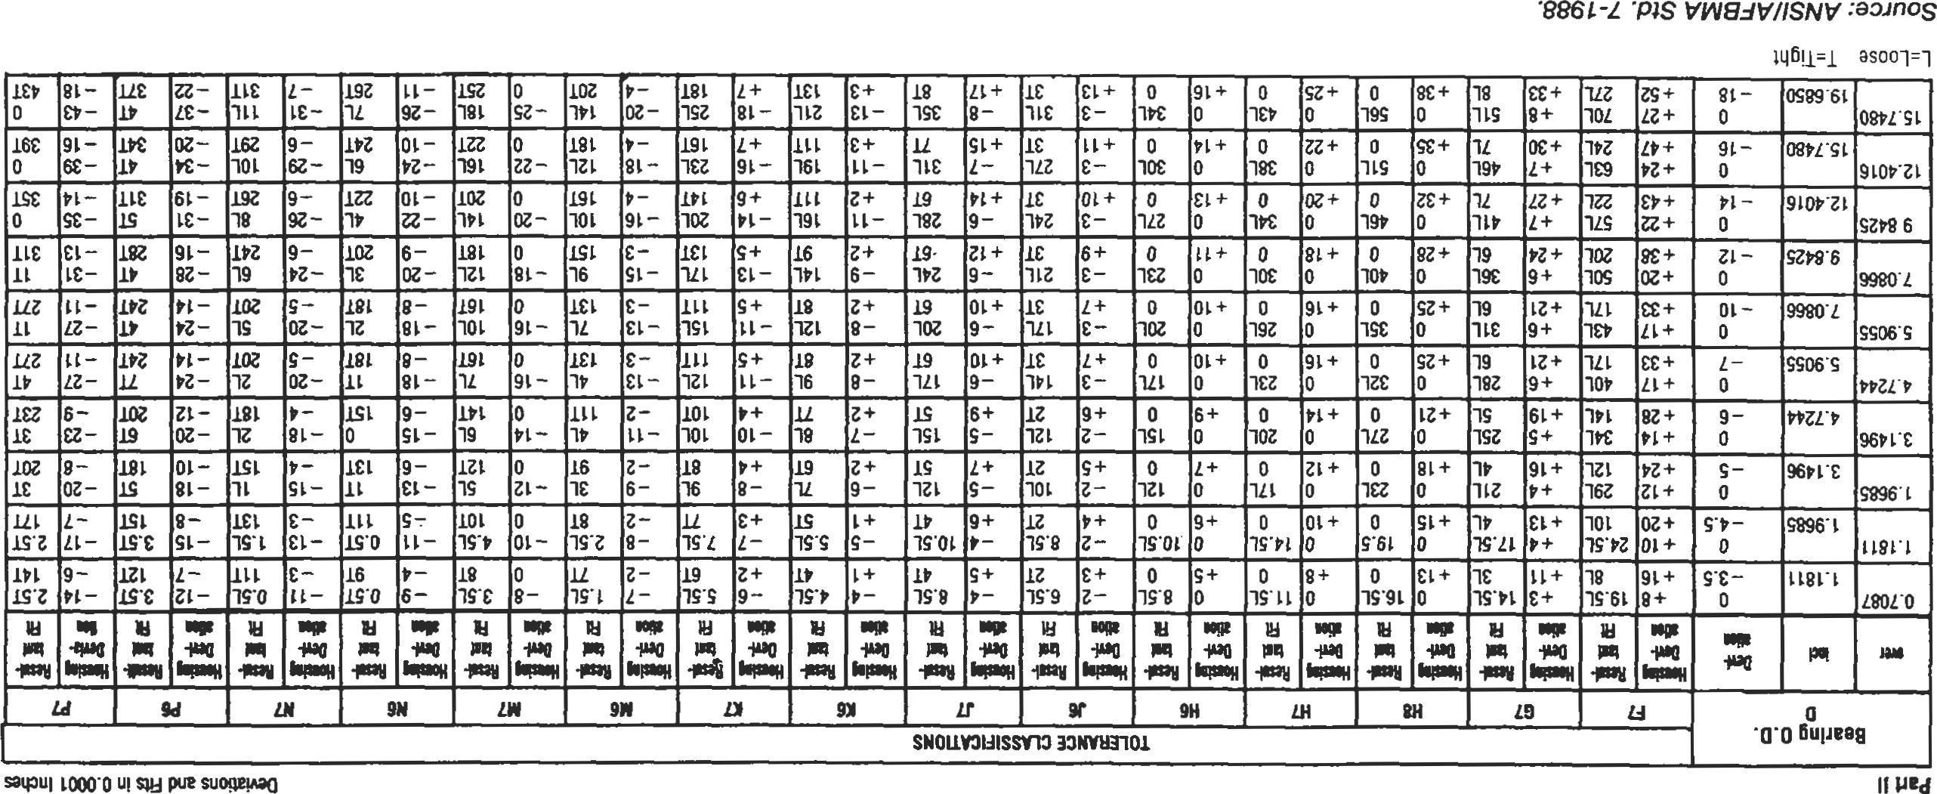



 「ー0 88 ー0山9くsesseto・ou 型0トちs6uに2・8」型一0 でue=28一2も 0一43W」0←・0一ち2」d6u 6u一のコ0工

Bearings

8 ト

Bearing Clearance

The establishment of correct bearing clearance is essential for reliable performance of rolling element bearings. Excessive bearing clearance will result in poor load distribution within the bearing, decreased fatigue life, and possible excessive dynamic excursions of the rotating system. Insuffcient bearing clearance may result in excessive operating temperature or possible thermal lockup and catfailure.

Most bearings are manufactured with an initial radial intemal clearance. This clearance is expressed over the diameter. It is called radial clearance to distinguish it from axial clearance or end play. The terms radial clearance and clearance are used interchangeably in the rolling bearing indusüy. The radial internal clearance is defined by the outer ring raceway contact diarneter minus the inner ring raceway contact diameter minus twice the rolling element diameter. This initial unmounted clearance is changed by the shaft and housing fits, shaft speed, and by the thermal gradients exisång in the system and created by operation of the bearing. After all of these factors have been considered, the bearing "operating clearance" should usually be positive. The exception to this occurs with preloaded bearings where the clearance has been carefully selected to provide shaft control. Clearances of only .0001" or .0002" are acceptable, but very small changes in thermal gradients can eliminate such a clearance and cause problems.

Generally, higher speed bearings will need higher operating clearance to allow a margin for unknown thermal gradients. Lower speed bearings, especially those with heavy loads, will perform best with smaller operating clearance. If the housing will remain much cooler than the bearing dur-

Table 19

Radial Internal Clearance Classificaüons

|  |  |
| --- | --- |
| ANSVABMA  IdenMcatIon Code | Internal Fit |
| 2  3  4 | Tight  Standard  Loose  Extra loose |

ing operaüon, extra clearance is often needed to account for the fact that the shaft and inner ring will expand, while the housing and outer ring will not. In general, ball bearings need less operating clearance than do roller bearings. A rule of thumb for minimum operating clearance of a cylindrical roller bearing is .0003" to .0005". Ball bearings can be slightly less, and spherical roller bearings should be slightly more. The above considerations must be used to go from an operating clearance to the unmounted internal radial clearance that must be obtained in the bearing.

After both the shaft and housing fits have been selected, it is absolutely necessary to go back and review the internal radial clearance of the bearings. If a relaüvely üght fit has been selected, a bearing with more than standard clearance is usually needed. Interference fits always reduce the internal clearance of the bearing. For bearings mounted on solid shafts, the reduction in clearance will be about 80%—90% of the interference fit. For housings, this factor is about 90% of the interference fit. These factors can change significantly for hollow shafts and thin section housings. Again, this can be calculated by using thin ring theory.

The clearance manufactured into the unmounted bearing has been standardized by ANSI/ABMA in Standard 20-1987 [10] for ball and roller bearings (except tapers). For some types of bearings a similar format is used, but the actual values of clearance are selected by the manufacturer. Table 19 gives the radial intemal clearance classifications. The internal fit refers to the relative amount of clearance inside the bearing.

Tables 20 and 21 illustrate the radial intemal clearance values for ball and roller bearings, respectively, established by ANSVABMA. A complete version of these tables can be found in ANSI/AFBMA Standard 20-1987 [10]. Commercial and precision bearings can normally be obtained off the shelf with tkE clearances listed, although tight and extra loose bearings are not always stocked in all sizes. For special applications, clearances other than those listed can be obtained on special order. Special clearances are not necessarily more costly to make except that the would be low and delivery much longer. However, if the combination of fits and special circumstances of operation require more clearance than available in the standards, there is no alternative to getting a nonstandard clearance bearing.

Table 20

Radial Internal Clearance Values for Radial Contact Ball Bearings

Clearance values in 0.0001 inch

|  |  |  |  |  |  |  |  |  |  |  |  |
| --- | --- | --- | --- | --- | --- | --- | --- | --- | --- | --- | --- |
| mm | | SYMBOL 2* | | SYMBOL  (Normal) | | SYMBOL | | SYMBOL | | SYMBOL | |
| over | incl. | min. | max. | min. | max. | min. | max. | min. | max. | mln. | max. |
| 10  24  65  80  100  140  160  180 | 18  24  30  40  50  65 80  IOO  200 | 0.5  0.5 | 3.5  10  12 | 10 | 11  12  28 | 10  12  14  16  18  21  25 | 10  11  11  13  14  17  20  23  26  32  36  40  46 | 11  12  15  18  21  32  36  42 | 11  13  14  16  18  24  28  58 | 10  11  12  16  22  26  30  35  41  47  53  59 | 15  18  19  21  25  29  41  47  55  63  71  79  91 |

* These symbols relate to the Identification Code.

Source: ANSI/AFBMA Std. 20-7987.

Table 21

Radial Internal Clearance Values for Cylindrical Roller Bearings

Clearance values in 0.0001 inches

|  |  |  |  |  |  |  |  |  |  |
| --- | --- | --- | --- | --- | --- | --- | --- | --- | --- |
| mm | | Tight | | Normal | | Loose | | Extra Loose | |
| Over | Incl. | low | high | low |  | low | high | low | high |
| 10  18  24  30  50  65  100  120  160 IBO  200  225  250  280  315 | 18  24  30  40  50  65  100  120  140  160  180  200  225  250  280  315  355 | 10  10  12  14  14  16  18  20  22  24  26 | 10  10  12  14  16  18  30  32  35  39  43  47  53 | 10  10  12  14  16  18  24  26  30  32 | 14  16  18  20  24  28  32  35  39  43  47 | 14  14  16  18  20  22  28  32  37  45  49  55 | 18  18  18  20  22  30  35  41  47  53  59  65  71 | 18  20  22  26  30  41  59  65  71 | 22  22  22  24  28  32  35  49  57  63  71  79  87 |

*These symbols relate to the Identification Code.

Source: ANSI/AFBMA Std. 20-1987.

Seals

Bearing seals have two basic funcüons: to keep contaminants out of the bearing and to keep the lubricant in the bearing. The design of the seal depends heavily on exactly what the seal is supposed to do. The nature of the contaminant, shaft speed, temperature, allowable leakage, and type of lubricant must be considered. Sealing can be an important consideration since in field use more bearings fail from contaminafion than from fatigue. There are two major categories of seals: contact seals and clearance seals. Each has its advantages and disadvantages for different applications. Contact seals vary widely from a simple felt strip to precision face seals made flat to millionths of an inch. In all cases, there is contact between moving and nonmoving surfaces. which provides a barrier to contaminants and loss of lubricant. There is a fremendous variety of materials and configurations used for contact seals.

The main limitation of contact seals is the sliding friction between the seal and shaft or rubbing surface. Seals for commercial bearing application can use felt seals up to 500 to 1,000 feet per minute surface velocity. Lip seals, probably the most common contact seal, can be used up to 2,000 to 3,000 feet per minute with common materials, and up to 5,000 feet per minute with special materials. Special carbon circumferential seals and face seals can be used at very high speeds, but these types of seals are very special and not suitable for the average indusfrial application.

Lip seals are excellent for sealing solids, liquids, and gases at reasonable pressures. The most common lip seal material is Buna-N, a synthetic rubber compound. This is the material usually used for bonded lip seals where a thin rubber lip is attached to a metal holder and attached directly to the bearing. It is also used in commercial carüidge-type lip seals where the rubber is held by a metal case and a spring is used to conü•ol lip pressure against the shaft. This type of seal can have high torque and heat generation and requires lubrication. For the effective application of lip seals, the rubbing surface roughness should be 10 to 20 Ra. Smoother than this can result in leakage while rougher can cause leakage and premature wear. Bearings with builtin lip seals already have this type surface ground on the bearing. Housing seals usually rub on the shaft itself, which must have a smooth surface with no spiraling.

Labyrinth seals, often called clearance seals, do not have rubbing contact between the seal and rotating member. It is this feature that gives them their principle advantage: no fricüonal drag or heat generation. Because of this, they are the most commonly used seal for high speeds. Their disadvantage is that they cannot be used to seal against pressure, and they are less effective against liquid and should not be used when even partially submerged. Seal effectiveness often depends on the availability of regular maintenance to keep the area around them clean and to lubricate them where necessary. Grease combined with a labyrinth seal can form a very effective barrier when properly maintained. Seal clearance must be carefully analyzed to keep the seal gap as small as possible but still maintain some gap at all operafing points. To retain oil, labyrinth seals may need to be vented and usually must provide an oil return drain within the seal.

For extreme sealing conditions, special seal designs must be created. There is no exact formula for the design of special sealing systems because the conditions are so varied. Engineering experience is the biggest factor, and consulting with one of the bearing manufacturers that offers sealed bearings or with a seal company is recommended. One of the most common considerations is to use a combination of two or more seals at a given location. A good example is the Link-Belt D8 grease-flushable auxiliary seal shown in Figure 15.

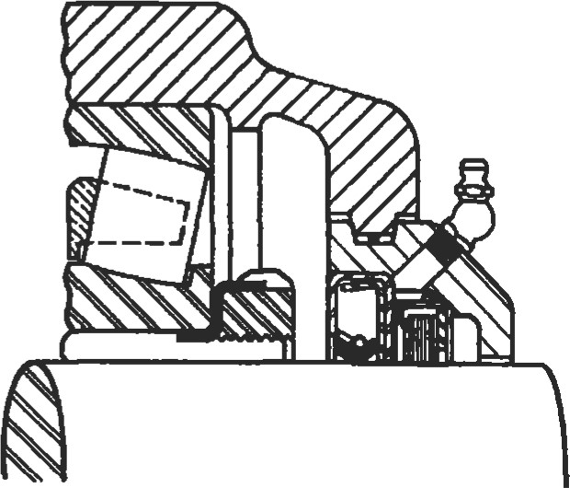

Figure 15. DB Independently Flushable Seal [11]. (Courtesy Link-Belt Bearing Div., Rexnord Corp.)

|  |
| --- |
| 175  SLEEVE BEARINGS |

A sleeve bearing (also called a journal bearing) is a simple device for providing support and radial positioning while permitting rotation of a shaft. It is the oldest bearing device known to man. In the broad category of sleeve bearings can be included a great variety of materials, shapes, and sizes. Materials used include an infinite number of metallic alloys, sintered metals, plastics, wood, rubber, ceramic, solid lubricants, and composites. Types range from a simple hole in a cast-iron machine frame to some exceedingly complex gas-lubricated high-speed rotor bearings.

Sleeve bearings do have a number of advantages over rolling element bearings, as well some disadvantages. Advantages are:

1. Inherently quiet operation because there are no moving parts.
2. If properly selected and maintained, they do not fail suddenly.
3. Wear is gradual, allowing scheduling of replacement. 4. Well suited to oscillating movement of the shaft.

5, With proper material selection, excessive moisture and submersion can be tolerated.

6. With proper material selection, extreme temperatures can be accommodated.

Disadvantages are:

1. High coefficient of friction.
2. For the same boundary plan, much less load capacity. 3. Life is not predictable except through experience.

In the application of sleeve bearings, the most important factor is the selection of the actual bearing material. The three most common indusuial materials are babbitt, bronze, and cast iron. After these, there is an amazing variety of different bearing materials, often specialized for a particular application. In most cases, the details of selection are unique and assistance should be obtained from the manufacturer of the sleeve material.

Plain bearings made from babbitt are universally accepted as providing reasonable capacity and dependable service, often under adverse conditions. Babbitt is a relatively soft bearing material, which minimizes the danger of scoring or damage to shafts or rotors. It often can be repaired quickly on the spot by, for example, rescraping or pouring of new metal. Ambient temperatures should not exceed 1300F, and the actual bearing operating temperature must not exceed 2000F. Babbitt bearings are usually restricted to applications involving light to moderate loads and mild shock.

Bronze bearings are more suitable than babbitt for heavier loads bearings (75% to 200% higher), depending on specific conditions of load and speed. Bronze withstands higher shock loads and permits somewhat higher speed operation. It is usually restricted to 3000F ambient temperatures if properly lubricated. Bronze is a harder material than babbitt and has a greater tendency to score or damage shafts in the event of malfunction such as lack of relubrication. Field repair of bronze bearings generally requires removing shims and scraping or replacement of bushings. Bronze bushings commonly are available in both cast and sintered forms.

Cast-iron bearings are generally low in cost and suitable for many slow-moving shafts and oscillaüng or reciprocating arms supporting relatively light loads. The lubricating characteristics of cast iron are attributed to the free graphite flakes present in the material. With the use of cast-inn bearings, higher shaft clearance is usually utilized. Thus, any large wear particles or debris will not join or seize the bearing. This material has been used to temperatures as high as 10000F (where ordinary lubricants are ineffective), under light loads and slow speed intermittent operaüons.

Lubrication is just as important in sleeve bearings as it is in rolling element bearings. There are three basic conditions of lubrication for sleeve bearings: full film or hydrodynamic, boundary, and extreme boundary lubricaüon. In full film lubrication, the mating surfaces of the shaft and bearing material are completely separated by a relatively thick film of lubricant. Boundary lubrication occurs when the separating film becomes very thin. Extreme boundary occurs when mating surfaces are in direct contact at various high points. The first two categories give long bearing life, while the third results in wear and shorter life.

In a full film bearing, the coefficient of friction is from .001 to .020, depending on the mating surfaces, clearances, lubricant type and viscosity, and speed. For a boundary lubricated bronze bearing, it is .08 to .14. Friction in a bearing design is important because temperature and wear are directly related to it. The lower the coefficient of friction, the longer the life of the bearing.

Either oil or grease can be used for lubrication as long as the temperature limitations for the grease or oil are not exceeded. Oil viscosity should be chosen between 100 and 200 SUS at the estimated operating temperature. Grease is the most common lubricant used for sleeve bearings, mainly due to lubricant retention. Grease lubricated bearings usually operate with a boundary film. Many sleeve bearings use grooving to improve lubrication on long sleeves. If the sleeve length-to-diameter ratio is greater than 1.5:1, a groove should be used.

Under certain operating conditions, dry lubrication can be used successfully with sleeve bearings. Graphited castbronze bearings are commonly used at elevated temperatures, in low speed or high load applications, or where the bearings are inaccessible for relubricaüon. Typical operating conditions for graphited bearings are 50 psi load with speeds to 30 sfm or a maximum PV factor of 1,500.

There are a number of factors that combine to determine the type of lubrication a bearing will have. Any of the following changes in the application would result in improved lubrication and longer life:

* A greater supply of lubricant available at the bearing
* Increased shaft speed, which gives increased oil film thiclmess
* Reducing the load, which will increase the oil film thickness
* Better alignment
* Smoother surface finishes

' Use of a higher-viscosity lubricant

The load carrying ability of a sleeve bearing is usually expressed in pounds per square inch (psi). This is calculated by dividing the applied load in pounds by the projected bearing area in square inches. Projected bearing area is found by multiplying the bearing bore diameter by the effective length of the sleeve. Few industrial bearings are loaded over 3,000 psi, and most are carrying loads under 400 psi. With cast-bronze sleeve bearings, 1,000 psi is acceptable. A usable figure for flat thrust washers is 100 psi. Figure 16 shows the maximum loads for various materials.

Another way of evaluating load capacity is through its maximum PV factor. The PV factor is the bearing load pres-

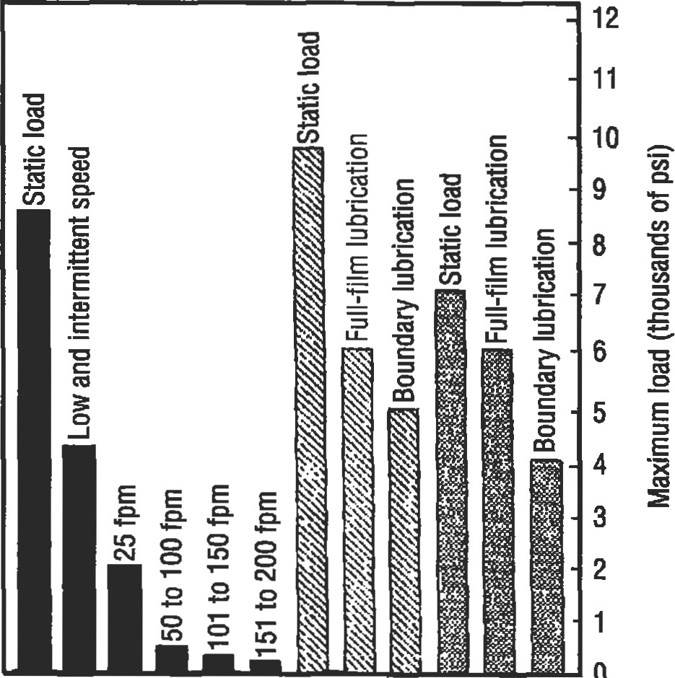

Sintered

Aluminum

Leaded-tin

bronze

bronze

bronze

Figure 16. Load rating of three common bronzes. Temperatures should not exceed 3000F with most lubricants. (From 1996 Power Tansmission Design Handbook [180.

sure times the surface velocity of the shaft in feet per minute (sfm). For speeds above 200 sfm, use a PV factor of 20,000 for bronze sleeves and 10,000 for babbitt sleeves. Of course, there are maximum load limits and maximum and minimum speed limits that must also be kept in mind when using the PV factors. PV factors for other materials should be obtained from the sleeve manufacturers.

Very careful shaft alignment is necessary during installation. Shaft journals must turn freely without binding in the bearing, otherwise, excessive heat and seizure can result. Sharp edges on the shaft or the bearing surface can act as scrapers to destroy lubricant films. Do not extend shaft keyways into bearing bores. Shafting should be of the proper size and finish. Shaft diameters for rigid sleeve bearing units are usually held to the regular commercial tolerances as shown in Table 22. shaft surface roughness of 32 Ra is acceptable for most applications. Graphited sleeves should have shaft roughness reduced to 12 Ra. When picking the housing style, consider the direction of loading. Avoid loading cast-iron housings in tension, whether one- or two-piece styles. If this cannot be avoided, Ey to obtain cast-steel housings.

|  |  |  |  |  |
| --- | --- | --- | --- | --- |
| 177  Table 22  Recommended Shaft Tolerances for Joumal Bearings   |  |  | | --- | --- | | Shaft Diameters | Recommended Tolerance | | Through Z'  2% through 4" through 6" through 13" | Nominal to —.003"  Nominal to —.004  Nominal to —.005  Nominal to |   From Link-Belt Technical Joumal [111.  REFERENCES |

1. Lundberg, G. and Palmgren A., "Dynamic Capacity of Rolling Bearings," Acta Polytechnica, Mechanical Engineering Series, Vol. 1, No. 3, Royal Swedish Academy of Engineering Sciences, Stockholm, 1947.
2. LundtErg, G. and Palmgren A., "Dynamic Capacity of Roller Bearings," Acta Polytechnica, Mechanical Engineering Series, Vol. 2, No. 4, Royal Swedish Academy of Engineering Sciences, Stockholm, 1947.
3. Anderson, W. J., "Bearing Fatigue Life Predicüon," National Bureau of Standards, No. 43NANB716211, 1987.
4. American National Standard (ANSI/AFBMA) Std 11990, "Terminology for Anti-friction Ball and Roller Bearings and Parts."
5. American Naüonal Standard (ANSI/ABMA) Std 41984, "Tolerance Definitions and Gaging Pracüces for Ball and Roller Bearings."
6. American National Standard (ANSI/ABMA) Std. 71996, "Shafting and Housing Fits for Meuic Radial Ball and Roller Bearings (Except Tapered Roller Bearings) Conforming to Basic Boundary Plans."
7. American National Standard (ANSI/AFBMA) Std

9-1990, "Load Ratings and Fatigue Life for Ball Bearings."

1. American National Standard (ANSI/AFBMA) Std 11-1990, "Load Ratings and Fatigue Life for Roller

Bearings."

1. American National Standard (ANSI/AFBMA) Std 19-

1974, '"Tapered Roller Bearings, Radial, Inch Design."

1. American National Standard (ANSI/AFBMA) Std 201987, "Radial Bearings of Ball, Cylindrical Roller, and Spherical Roller Types, Metric Design."
2. Bearing Technical Journal, Link-Belt Bearing Div., Rexnord Corporation, 1982.
3. Bamberger, E. N., et al., Life Adjusment Factorsfor Ball and Roller Bearings—An Engineering Design Guide,ASME, New York, 1967.
4. Harris, T. A., Rolling Bearing Analysis. New York: John Wiley & Sons, Inc., 1966.
5. Bearing Selection Handbook Revised—1986, The Timken co., 1986.
6. Bearing Installation and Maintenance Guide, SKF USA, Inc., 1988.
7. MRC Aerospace Ball and Roller Bearings, Engineering Data Catalog, SKF USA, Inc., 1993.
8. Zaretsky, Erwin V. (Editor), STLE Life Factors for Rolling Bearings. Society of Tribologists and Lubrication Engineers, 1992.
9. 1996 Power Transmission Design Handbook, Penton Publishing, Inc., copyrighted Dec. 1995.

9

Piping and Pressure Vessels

R. R. Lee, Vice President—International Sales, Lee's Materials Services, Inc., Houston, Texasl

E. W. McAllister, P.E., Houston, Texas2

|  |  |  |
| --- | --- | --- |
| Process Plant Pipe | 179 | Pressure Vessels206 |
| Definitions and Sizing | 179 | Stress Analysis. 206 |
| Pipe Specifications | 187 | Failures in Pressure Vessels 207 |
| Storing Pipe | 188 | Loadings 208 |
| Calculations to Use | 189 | Stress 209 |
| Transportation Pipe Lines | 190 | Procedure 1: General Vessel Formulas 213 |
| Steel Pipe Design. | 190 | Procedure 2: Stresses in Heads Due to Internal Pressure 215 |
| Gas Pipe Lines | 190 | Joint Efficiencies (ASME Code) 217 |
| Liquid Pipe Lines | 192 | Properties of Heads 218 |
| Pipe Line Condition Monitoring | 195 | Volumes and Surface Areas of Vessel Sections............... 220 |
| Pig-based Monitoring Systems........................................ 195 | | Maximum Length of Unstiffened Shells  221 |
| Coupons .... . 196 | | Useful Formulas for Vessels... 222 |
| Manual Investigation. 196 | | Material Selection Guide 224 |
| Cathodic Protection 197 | | References 225 |

Jesse W. Cotherman, former Chief Engineer, Miller Pipeline Corp., Indianapolis, Ind.3 Dennis R. Moss, Supervisor of Vessel Engineering, Fluor Daniel, Inc., Irvine, Calif.4

(Process Plant Pipe

2Transportation Pipe Lines

2'3Pipe Line Condition Monitoring

4Pressure Vessels

178

179

##### PROCESS PLANT PIPE

|  |
| --- |
| Definitions and Sizing |

Standard pipe is widely used in the process industries and is manufactured to ASTM standards (ANSI B36.10). Pipe charts, such as the one in Table l, and careful attention to purchase order descriptions when shipping or receiving pipe help achieve accurate results. A description of piping, definitions, and how various types are manufactured follows.

Pipe Size

In pipe of any given size, the variations in wall thickness do not affect the outside diameter (OD), just the inside diameter (ID). For example, 12-in. nominal pipe has the same OD whether the wall thickness is 0.375 in. or 0.500 in. (Refer to Table 1 for wall thickness of pipe).

Pipe Length

Pipe is supplied and referred to as single random, double random, longer than double random, and cut lengths.

Single random pipe length is usually 18—22 ft threaded and coupled (T&C), and 18—25 ft plain end (PE).

Double random pipe lengths average 38—40 feet.

Cut lengths are made to order within Some pipe is available in about 80-ft lengths.

The major manufacturers of pipe offer brochures on their process of manufacturing pipe. The following descriptions are based upon vendor literature and specifications.

Seamless Pipe

This type of pipe is made by heating billets and advancing them over a piercer point. The pipe then passes through a series of rolls where it is formed to a true round and sized to exact requirements.

Electric Weld

Coils or rolls of flat steel are fed to a forming section that transforms the flat strip of steel into a round pipe section.

A high-frequency welder heats the edges of the strip to 2,6000F at the fusion point. Pressure rollers then squeeze the heated edges together to form a fusion weld.

Double Submerged Arc Weld

Flat plate is used to make large-diameter pipe (20-in. to 44-in.) in double random lengths. The plate is rolled and pressed into an "O" shape, then welded at the edges both inside and outside. The pipe is then expanded to the final diameter.

Continuous Weld

Coiled skelp (skelp is semi-finished coils of steel plate used specifically for making pipe), is fed into a flattener, and welded to the trailing end of a preceding coil, thus forming a conünuous strip of skelp. The skelp travels through a furnace where it is heated to 2,6000F and then bent into an oval by form rollers. It then proceeds through a welding stand where the heat in the skelp and pressure exerted by the rolls forms the weld. The pipe is stretched to a desired OD and D, and cut to lengths. (Couplings, if ordered for any size pipe, will be hand tight only.)

Source

Lee, R. R., Pocket Guide to Flanges, Fittings, and Piping Data, 2nd Ed. Houston: Gulf Publishing Co., 1992.

Table 1

Pipe Chart

|  |  |  |
| --- | --- | --- |
| NO M INAL  PIPE OUTSIDE |  |  |
| SIZE DIAMETER INCHES INCHES | WALL DIAMETER  SCHEDULE INCHES INCHES POU N DS | |
| ,405 .049 .307 .1863  40 40S Std. .068 .269 2447  80 80S Ex. I-ivy. .095 .21 5 .3145 | | |
| .540 .065 .410 .3297  40 40S Std. .088 .364 .4248  80 80S Ex. I-ivy. .119 .302 .5351 | | |
| .675 IOS .065 .545 .4235  40 40S Std. .091 .493 .5676  80 80S Ex. Hvy. .126 .423 .7388 | | |
| h 840 .065 .710 .5383 1 os .083 .674 .6710  40 40S Std. .109 .622 .8510  80 80S Ex. I-ivy. .147 .546 1.088 160 .188 .466 1.309 XX Hvy. .294 .252 1.71 4 | | |
| 1.050 .065 .920 .6838 IOS .083 .884 .8572  40 40S Std. .1 13 1824 1.131  80 80S Ex. Hvy. .154 .742 1.474  160 .219 .614 1.944 XX I-ivy. .308 .434 2.441 | | |
| 1 1.315 .065 1.185 .8678  .109 1.097 1 .404  40 40S Std .133 1.049 1.679  80 80S Ex. Hvy. .179 .957 2.1 72 160 250 .815 2.844 XX Hvy. .358 .599 3.659 | | |

181

Pipe Chart

|  |  |  |  |  |  |  |  |
| --- | --- | --- | --- | --- | --- | --- | --- |
| NOM INAL  PIPE | OUTSIDE |  |  |  | INSIDE |  |  |
| SIZE  INCHES  1 1/4 | DIAMETER INCHES  I .660 | I P S  40  80  160 | SCHEDULE  1 os  40S Std.  80S Ex. Hvy.  XX I-ivy | WALL  INCHES  .065  .109  .140  .191  .250  .382 | DIAMETER INCHES  1.530  1.442  1.380 I .278  1.160  .896 | POUN DS  1.107  1.806  2.273  2.997  3.765  5.214 | |
| 11/2 | 1.900 | 40  80  160 | 40S Std.  80S Ex. I-ivy.  XX Hvy. | .065  .109  .145  .200  .281  .400 | 1.682  1.610  1.500  1.338  1.100 | I .274  2.085  2.718  3.631  4.859  6.408 | |
| 2 | 2.375 | 40  80  160 | 40S Std.  80S Ex. Hvy.  XX Hvy. | .065  .109  .154  .218  .344  .436 | 2.245  2.157  2.067  1.939  1.689  1.503 | 1.604  2.638  3.653  5.022  7.462  9.029 | |
| 21/2 | 2.875 | 40  80  160 | 1 os  40S Std.  80S Ex. I-ivy.  XX Hvy. | .083  .120  .203  276  .375  .552 | 2.709  2.635  2.469  2.323  2.125  I .771 | 2.475  3.531  5.793  7.661  10.01  13.69 | |
| 3 | 3.500 | 40  80  160 | 40S Std.  80S Ex.Hvy.  XX Hvy. | -083  .120  216  -300  .438  .600 | 3.334  3.260  3.068  2.900  2.624  2.300 | 3.029  4.332  7.576  10.25  14.32  18.58 | |

Pipe Chart

|  |  |  |  |  |  |
| --- | --- | --- | --- | --- | --- |
| NOMINAL  PIPE  SIZE  INCHES | OUTSIDE  DIAMETER INCHES | I P S | SCHEDULE | INSIDE  WALL DIAMETER  INCHES INCHES | WT/FT  POUNDS |
| 31/2 | 4.000 | 5  10  40  80 | 40S Std  80s EX. Hvy. XX Hvy. | .083 3.834  .120 3.760  226 3.548  .318 3.364  .636 2.728 | 3.472  4.973  9.109  12.50  22.85 |
| 4 | 4.500 | 40  80  120  160 | IOS  40S Std  80s EX. Hvy.  XX Hvy. | .083 4.334  -120 4.260  .237 4.026  .337 3.826  .438 3.624  .531 3.438  .674 3.152 | 3.915  5.613  10.79  14.98  19.00  22.51  27.54 |
| 41/2 | 5.00 |  | 40 Std.  80 Ex. Hvy.  XX Hvy. | .247 4.506  .355 4.290  .710 3.580 | 12.53  17.61  32.43 |
| 5 | 5.563 | 40  80  120  160 | IOS  40S Std  80s EX. Hvy.  XX Hvy. | .109 5.345  .134 5.295  .258 5.047  .375 4.813  .500 4.563  .625 4.31 3  .750 4.063 | 6.349  7.770  14.62  20.78  27.04  32.96  38.55 |
| 6 | 6.625 | 40  80  120  160 | 1 os  40S Std.  80S Ex. Hvy.  XX Hvy. | .109 6.407  .134 6.357  .280 6.065  .432 5.761  .562 5.491  .719 5.189  .864 4.897 | 7.585  9289  18.97  28.57  36.39  45.35  53.16 |

183

Pipe Chart

|  |
| --- |
| NOM INAL  PIPE OUTSIDE INSfOE |
| 7  7.625  40  Std.  .301  7.023  23.57  80  Ex.  Hvy.  .500  6.625  38.05  XX Hvy. .875 5.875 63.08 |
|
| 8 8.625 .109 8.407 9.914  IOS .148 8.329 13.40  20 .250 8.125 22.36  30 .277 8.071 24.70  40 40S Std .322 7.981 28.55  60 .406 7.813 35.64  80 80s EX. Hvy. .500 7.625 43.39  100 .594 7.439 50.95  120 .719 7.189 60.71 140 .812 7.001 67.76  I-ivy. .875 6.875 72.42  160 .906 6.813 74.69 |
| 9 9.625 40 Std. .342 8.941 33.90 80 Ex. Hvy. .500 8.625 48.72 XX I-ivy. .875 7.875 81.77 |
| 10 10.750 .134 10.482 15.19  1 os .165 10.420 18.70  20 .250 10.250 28.04  30 .307 10.136 34.24  40 40S Std. .365 10.020 40.48  60 80S Ex. Hvy. .500 9.750 54.74  80 -594 9.564 64.43  100 .719 9.314 77.03  120 .844 9.064 89.29  140 1.000 8.750 104.13  160 1.125 8.500 1 15.64 |
| 11 11.750 40 Std. .375 11.000 45.55 80 Ex. Hvy. soo 10.750 60.07 XX Hvy. .875 10.000 101.63 |

Pipe Chart

|  |  |
| --- | --- |
| NOMINAL  PIPE OUTSIDE  SIZE DIAMETER  INCHES INCHES |  |
| 12 12.750 .165 12.420 22.18  IOS .180 12.390 24.20 20 250 12.250 33.38  30 .330 12.090 43.77  40S Std. .375 12.000 49.56  40 .406 11.938 53.52  80S Ex. Hvy. .500 11.750 65.42  60 .562 11.626 73.15  80 .688 11.376 88.63  100 .844 11.064 107.32  120 1.000 10.750 125.49  1.125 10.500 139.67  160 1.312 10.126 160.27 | |
| 14 14.000 10 250 13.500 36.71  20 .312 13.376 45.61  30 Std. .375 13.250 54.57  40 .438 13.124 63.44  Ex. Hvy. .500 13.000 72.09  60 .594 12.814 85.05  80 .750 12.500 106.13  100 -938 12.126 130.85  120 1.094 11.814 150.9  140 1.250 11.500 170.21  160 1.406 11.188 189.1 | |
| 16 16.000 10 .250 15.500 42.05  20 .312 15.376 52.27  30 Std. .375 15.250 62.58  40 Ex. Hvy .500 15.000 82.77  60 .656 14.688 107.5  80 .844 14.314 136.61  100 1.031 13.938 164.82  120 1.219 13.564 192.43  140 1.438 13.124 223.64  160 1.594 12.814 245.25 | |

185

Pipe Chart

|  |
| --- |
|  |
| 18 18.000 10 .250 17.500 47.39  20 .312 17.376 58.94  Std. .375 17.250 70.59  30 .438 17.124 82.15  Ex. Hvy. .500 17.000 93.45  40 .562 16.876 104.67  60 750 16.500 138.17  80 .938 16.126 170.92 IOO 1.156 15.688 207.96 120 1.375 15.250 244.14  140 I .562 14.876 274.22  160 1.781 14.438 308.5 |
| 20 20.000 10 .250 19.500 52.73  20 Std. .375 19.250 78.60  30 Ex. Hvy. .500 19.000 104.13  40 .594 18.814 123.11  60 .812 18.376 166.4  80 1.031 17.938 208.87  100 1.281 17.438 256.1  120 1.500 17.000 296.37  140 1.750 16.500 341.09  160 1.969 16.064 379.17 |
| 22 22.000 10 .250 21.500 58.07  20 Std. .375 21.250 86.61  30 X Hvy. .500 21 .ooo 114.81  60 .875 20.250 197.41  80 1.125 19.750 250.81  100 1.375 19.250 302.88  120 1.625 18.750 353.61  140 1.875 18.250 403.0  160 2.125 17.750 451.06 |
| 24 24.000 10 .250 23.500 63.41 20 Std. -375 23.250 94.62 Ex. Hvy. .500 23.000 125.49 |

Table 1 (Continued) Pipe Chart

|  |  |
| --- | --- |
| NOMINAL  PIPE OUTSIDE |  |
| DIAMETER |
| INCHES INCHES | SCHEDULE INCHES INCHES POUNDS |
| 30 .562 22.876 140.68  .688 22.626 171.29  60 .969 22.064 238.35 80 1.219 21.564 296.58 IOO 1.531 20.938 367.39  120 1.812 20.376 429.39  140 2062 19.876 483.1  160 2.344 19.314 542.13 | |
| 26 26.000 10 -312 25.376 85.60  Std. .375 25.250 102.63 20 X Hvy. .500 25.000 136.17 | |
| 28 28.000 10 .312 27.376 92.26  Std. .375 27.250 1 10.64  20 .500 27.000 146.85  30 .625 26.750 182.73 | |
| 30 30.000 10 .312 29.376 98.93  Std. .375 29.250 118.65  20 Ex. Hvy. .500 29.000 157.53  30 625 28.750 196.08 | |
| 32 32.000 10 -312 31.376 105.59  Std. .375 31.250 126.66  20 .500 31 .ooo 168.21  30 .625 30.750 209.43  40 .688 30.624 230.08 | |
| 34 34.000 10 .312 33.376 112.25  Std. .375 33.250 134.67  20 .500 33.000 178.89  30 .625 32.750 222.78  40 .688 32.624 244.77 | |
| 36 36.000 10 .312 35.375 118.92  Std. .375 35.250 142.68  EX. Hvy. .500 35.000 189.57 | |

Table 1 (Continued) Pipe Chart

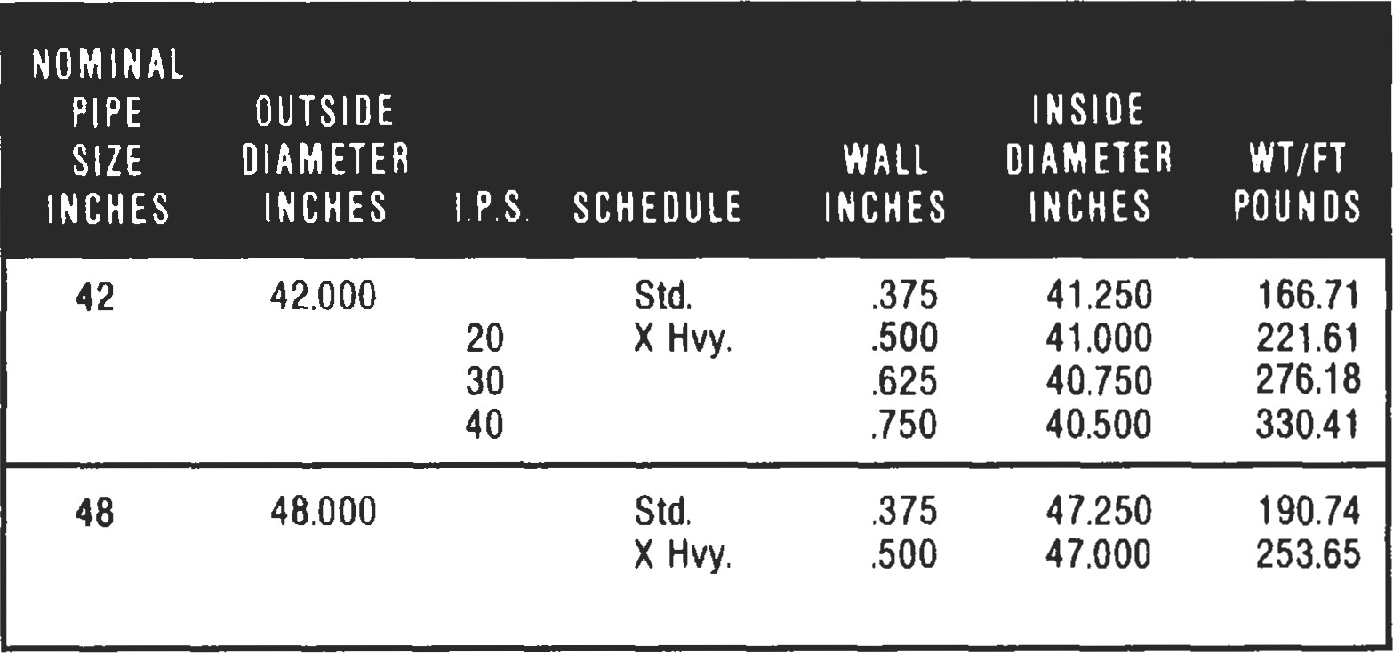

Data in Table 7 courtesy of 770ga Pipe Supply Company.

###### Pipe Specifications

ASTM A-120

Sizes h-in. to 16-in. standard weight, extra strong, and double extra strong (Std. Wt., XS, XXS). The specification covers black and hot-dipped galvanized welded and seamless average wall pipe for use in steam, gas, and air lines.

Markings. Rolled, stamped or stenciled on each length of pipe: the brand name, ASTM A-120, and the length of the pipe. In case of bundled pipe, markings will appear on a tag attached to each bundle. Table 2 shows a bundling schedule.

ASTM A-53

Sizes %-in. to 26-in., standard weight, extra strong, and double extra strong, ANSI schedules 10 through 160 (see Table 1 for ANSI pipe schedules). The specification covers seamless and welded black and hot-dipped galvanized Table 2

Bundling Schedule

Nominal Number Standard *ight Pipe Extra Stmng Pipe

|  |  |  |  |  |  |
| --- | --- | --- | --- | --- | --- |
| Size (in.) | Pieces per Bundle | Total Length | Total  (lbs) | Mal Length | TOW *ight  (lbs) |
| 1  1 1/4  1 112 | 30  24  18  12  7  5  3  3 | 630  504  378  252  147  105  63  63 | 151  212  215  214  166  176  144  172 | 630  504  378  252  147  105  63  63 | 195  272  280  275  216  228  189  229 |

average wall pipe for conveying oil, water, gas, and petroleum products.

Markings. Rolled, stamped or stenciled with brand name, kind, schedule, length of pipe, and type of steel used. In case of bundles, markings will appear on a bundle tag.

ASTM A-106

Sizes h to 26-in., ANSI schedules to 160. The specification covers seamless carbon steel average wall pipe for high-temperature service.

Markings. Rolled, stamped or stenciled with brand name, type such as ASTM A-106A, A-106B, A-106C (the A, B, C, indicate tensile strengths and yield point designations), the test pressure, and length of pipe. In case of bundles, the markings will appear on a bundle tag.

API-5L

Sizes K-in. to 48-in., standard weight through double strong. The specification covers welded and seamless pipe suitable for use in conveying oil, water, and gas.

Markings. Paint stenciled with brand name, the API monogram, size, grade, steel process, type of steel, length, and weight per foot on pipe 4-in. and larger. In case of bundles, the markings will be on the bundle tag. Couplings, if ordered, will be hand tight.

Source

|  |  |  |  |  |  |  |
| --- | --- | --- | --- | --- | --- | --- |
| Storing Pipe  Step I—Pipe Racks  Figure 1 shows a pipe rack made by using 12 x 12-in. timbers. The rack has been assigned a number for materials accounting purposes. Do not store pipe directly on the ground. If rack materials are not available, then use the pipe itself by preparing a rack from the pipe with a few boards under each end.  Step 2—Layers   |  |  |  | | --- | --- | --- | | 24•.376• WT  API 61-XO | 106 FT. | e Q co-seol | | 24' 376' wr  5LX.B | 8 JVS.  taeFT. | P. O. 0-301 |   Form the first layer of pipe with one end straight, and other joints straight across the rack. Secure the stack by nailing wooden blocks to the sills, against the side of the pipe on the inside edges (see Figure 1).  Step 3—Measure  Tally each joint of pipe in the layer. Use a paint stick or suitable marker to mark each joint according to length, size, Figure 1. Schematic of rack for storing pipe. schedule, and purchase order item number. |

Lee, R. R., Pocket Guide to Flanges, Fittings, and Piping Data, 2nd Ed. Houston: Gulf Publishing co., 1992.

Total the footage on the layer of pipe, and then mark the total footage and number of joints on the outside pipe for future inventory purposes. Apply color codes to pipe at this üme if applicable.

Step 4---Dunnage

Apply sumcient dunnage of the same thickness across the pipe with wooden blocks to one side. Stack the next layer of pipe directly over the first layer with the straight ends in line with each other. Then follow steps 2, 3, and 4.

Continue to follow the steps until the rack is considered full by the supervisor.

Rules for Storing Pipe

1. Do not mix pipe sizes and schedules on the same
2. Keep the pipe storage area clean to prevent accidents.
3. Do not crowd the storage areas. Leave room for large ducks and cranes.
4. Make a physical count of the pipe on a weekly or monthly basis to verify your materials accounting records as correct.
5. Always measure pipe within tenths of an inch. Meastre the entire length of pipes, including couplings and threads.

Source

|  |  |
| --- | --- |
| pipe rack. | Data, 2nd Ed. Houston: Gulf Publishing Co., 1992. |
| Calculations to Use |  |

Lee, R. R., Pocket Guide to Flanges, Fittings, and Piping

If the outside diameter (OD) and the wall thickness of a pipe (t) are known, then you may calculate the weight per foot with the following equation:

Weight per foot = 10.68 x (OD — t) x t

Example: What is the weight per foot of a 3-in. pipe with a .216-in. wall thickness and an OD of 3.500 in.? Using the equation,

weight per foot = 10.68 x (3.500 - .216) x .216

= 7.58 lbs/ft

Another method to determine weight per foot of pipe where the outside diameter and wall thickness are known is called the Baiamonte plate method. It is based on a square foot of plate 1 inch thick weighing 40.833 lbs, and uses the following equation:

##### OD-t

Weight per foot = 40.833 x

###### 12

Example: What is the weight per foot of an 8-in. pipe with a wall thickness of .322 in.? Table 1 shows that an 8-in. pipe has an OD of 8.625 ins. So, using the equation,

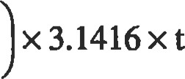8.625 -.322

Weight per foot = 40.833 x

###### 12

= 28.58 lbs/ft

Source

Lee, R. R., Pocket Guide to Flanges, Fittings, and Piping Data, 2nd Ed. Houston: Gulf Publishing Co., 1992.

|  |
| --- |
| TRANSPORTATION PIPE LINES*  Steel Pipe Design |

The maximum allowable design pressure stress will depend upon the intended service for the pipe line.

Pipe lines to be used for transporting liquid petroleum are covered by ANSI/ASME Petroleum 'fransportation Piping Systems." Pipe lines used for transporting gas are covered by ANSI/ASME TYansmission and Distribution Systems."

Pipe lines which must be operated in compliance with the Federal Pipeline Safety Regulations will also need to comply with the applicable parts of these regulations: Part 192 for gas transportation systems, and Part 195 for liquid transportation systems.

Gas Pipe Lines—ANSI/ASME B31.8

The maximum allowable pressure is calculated by the following equation:

P = (2St/D) x F x E x T

where P = Design pressure, lb/in. 2

1. Specified minimum yield strength, lb/in. 2 (see Table 1) t = Nominal wall thickness, in.

D = Nominal outside diameter, in.

F = Design factor (see Table 2)

E = Longitudinal joint factor (see Table 3)

1. = Temperature derating factor (see Table 4)

Class location definitions may be obtained from p. 192.111 of Part 192 of the Federal Pipeline Safety Regulations. A typical calculation is as follows:

Pipe: 16" OD x 0.250" wt API 5LX X52 ERW

Location: Class 1, therefore F = 0.72 (see Table 2)

Temperature: 90 0 F, Temp. factor T = I (see Table 4)

Joint Factor: E = 1.0 (see Table 3)

P = (2 x 52,000 x 0.250/16.0) x 0.72 x 1 x 1

P = 1,170 lb/in. 2 gauge

Table 1

Specified Minimum Yield Strength for Steel and Iron Pipe Commonly

Used in Piping Systems

|  |  |  |  |
| --- | --- | --- | --- |
| Specification | Grade | Typei | SMYS, psi |
| API SL |  | . BW,ERW,S | 25,000 |

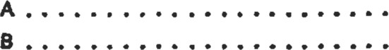API SL. ERW, FW,s, OSA 30,000 API SL. ERW, FW,s, DSA 35,000

|  |  |  |  |  |  |
| --- | --- | --- | --- | --- | --- |
| API SuS (Note (2)J |  | | . ERW, OSA |  | 30,000 |
| APt 5LS |  | | . ERW, OSA |  | 35,000 |
| API 51-S | X42 |  | . ERW, DSA |  | 42,000 |
| API 5LS | X46 |  | . ERW, DSA |  | 46,000 |
| API 5 LS | XS2 |  | . ERW, DSA |  | 52,000 |
| API 5 LS | XS6 |  | . ERW, DSA |  | 56,000 |
| API S LS | X60 |  | . ERW, DSA |  | 60,000 |
| API SLS | X65 |  | . ERW, OSA |  | 65,000 |
| API 5 LS | X70 |  | . ERW, DSA |  | 70,000 |
| API s LX (Note | X42 |  | . | DSA | 42,000 |
| API SLX | X46 |  | . ERW, FW,s, OSA | | 46,000 |
| SLX | XS2 |  | . ERW, FW,s, DSA | | 52,000 |
| API 5 LX |  | | . ERW, DSA | | 56,000 |
| API 5LX | X60 | | . ERW, DSA | | 60,000 |
| API SLX | X65 | | . ERW, OSA | | 65 ,ooo |
|  | X70 | | . ERW, FW,s, DSA | | 70,000 |
| ASTM AS3 | Open Hrth. Bas, Oxy„ Elec. Furn | | . BW | | 25,000 |

ASTM AS3 Bessemer . BW 30,000



Reproduced from ANSI/ASME Code B31-8-1982, Appendix D. Reprintedcourtesy of The American Society of Mechanical Engineers.

*This section reprinted from Pipe Line Rules of Thwnb Handbook, 3rd Ed., E. W. McAllister (Ed.), Gulf Publishing Company, Houston, Texas, 1993.

Table 1 (Continued)

Specified Minimum Yield Strength for Steel and Iron Pipe Commonly Used in Piping Systems

Specification Grade Type: SMYS, psi

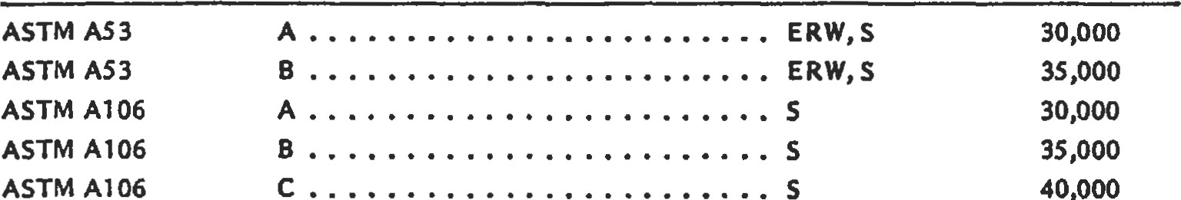ASTM AS3

ASTM A53

ASTM A106

ASTM A106

ASTM Al 06

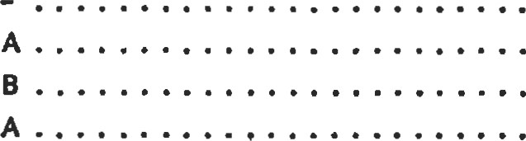 ASTM A134. EFW [Note (3))

ASTM Al 35. ERW 30,000 ASTM Al 35ERW 35 ,ooo

ASTM Al 39. ERW 30,000

|  |  |  |
| --- | --- | --- |
| ASTM Al 39 | B           . ERW | 35,000 |
| ASTM A333 | . S, ERW | 30,000 |
| ASTM A333 | 3      . S, ERW | 35 ,ooo |
| ASTM A333 | 4 | 35 ,ooo |
| ASTM A333 | 6          . S, ERW | 35 ,ooo |
| ASTM A333 | 7           . S, ERW | 35,000 |

ASTM A333 8 . S, ERW 75,000



Reproduced from ANSI/ASME Code 831-8-1982,Appendix D. Reprinted courtesy of The American Society

of Mechanical Engineers.

Table 2

Values of Design Factor F

Construction Type

(see 841.151) Design Factor F

Type A 0.72

Type B 0.60

Type C 0.50

Type D 0.40

Reproduced from ANSI/ASME Code B31-8-1982, Table 841.IA. Reprinted courtesy of The American Society of Mechanical Engineers

Table 4

Temperature Derating Factor T For Steel Pipe

|  |  |
| --- | --- |
| Temperature, 0 F | Tempenture Derating Factor T |
| 250 or less  300  350  450 | 1.000  0.967  0.933  0.900  0.867 |

NOTE: For Intermediate temperatures, interpolate for derating factor.

Reproduced from ANSI/ASME Code B31-8-1982, Table 841.1C. Reprinted courtesy of The American Society of Mechanical Engineers.

Table 3

Longitudinal Joint Factor E

|  |  |  |
| --- | --- | --- |
| Spec. Number | Pipe Class | E Factor |
| ASTM A53  ASTM A106  ASTM A134 ASTM A135  ASTM Al 39 ASTM A211  ASTM A381 ASTM A671 ASTM A672  API 51-  API 5LX  API 51S | Seamless  Electric Resistance Welded  Furnace Welded  Seamless  Electric Fusion Arc Welded  Electric Resistance Welded  Electric Fusion Welded  Spiral Welded Steel Pipe  Double Submerged-Arc•Welded  Etectric Fusion Welded Electric Fusion Welded  Seamless  Electric Resistance Welded  Electric Flzh Welded  Submerged Arc Welded Furnace Butt Welded  Seamless  Electric Resistance Welded  Electric Flash Welded  Submerged Arc Welded  Electric Resistance Welded  Submerged Welded | 1.00  1.00  0.60  1.00  0.80  1.00  0.80  0.80  1.00  1.00*  1.00*  1.00  1.00  1.00  1.00  0.60  1.00  1.00  1.00  1.00  1.00  1.00 |

NOTE: Definitions for the various classes of welded pipe are given in 804.243

*Includes Classes 12, 22, 32, 42, and 52 only.

Reproduced from ANSI/ASME Code 831-8-1982, Table 841.1B. Reprinted courtesy of The American Society of Mechanical Engineers.

|  |  |
| --- | --- |
| Liquid Pipe Lines—ANSI/ASME 831.4  The internal design pressure is determined by using the following formula:  P = (2St/D) x E x F  where P = Internal design pressure, lb/in. 2 gauge  Specified minimum yield strength, lb/in. 2 (see  Table 5) t — Nominal wall thickness, in.   1. — Nominal outside diameter of the pipe, in. 2. = Weld joint factor (see Table 6) 3. = Design factor of 0.72 | Note: Refer to p. 195.106 of Part 195 Federal Pipeline Safety Regulations for design factors to be used on offshore risers and platform piping and cold worked pipe.  A typical calculation of the internal design pressure is as follows:  Pipe: 26" OD x 0.3125" wt API 5LX X52 ERW  Weld joint factor E = 1.0 (see Table 6)  Design factor F — 0.72  P - (2 x 52,000 x 0.3125/26) x 1 x 0.72  P = 900 lb/in. 2 gauge |

Table 5

Tabulation of Examples of Allowable Stresses for Reference Use in Piping Systems

Allowable stress values (S) shown in this Table are equal to 0.72 X E (weld joint factor) X spccificd minimum yield strength of the pipe.

Allowable stress values shown are for new pipe of known spccification. Allowable stress values for new pipc of unknown specification, ASTM A 120 spccification or used (reclaimed) pipe shall be detcrmined in accordance with 402.3.1.

For some Code computations, particularly with regard to branch connections [see 404.3.1 (d) (3)) and expansion, flexibility, structural attachments, supports, and restraints (Chapter Il, Part 5), the weld joint factor E need not be considered.

For specified minimum yield strength of other grades in approved specifications, refer to that particular spccification.

Allowable stress value for cold worked pipe subsequently heated to 600 F (300 C) or higher (welding excepted) shall be

75 percent of value listed in Table.

Definitions for the various types of pipe are given in 400.2.

(Metric Stress Levels are given in MPa [l Megapascal = I million pascalsl)

|  |  |  |  |  |  |
| --- | --- | --- | --- | --- | --- |
|  |  | Specified |  |  |  |
|  |  | Min Yield |  | (E) | Allowable Stress Value |
|  |  | Strength |  | Weld Joint | -20 F to 250 F (-30 C to 120 C) |
| Specification | Grade | psi (MPa) | Notes | Factor | psi (MPa) |



|  |  |  |  |  |  |
| --- | --- | --- | --- | --- | --- |
| Seamless |  |  |  |  |  |
| API SL | A25 | 25,000 (172) | (1) | 1.00 | 18,000 (124) |

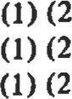API 5L, ASTM A53, ASTM A106 A 30,000 (207)1.00 21,600 (149) API 5L, ASTM A53, ASTM A106 B 35,000 (241)1.00 25,200 (174)

ASTM A106 c 40,000 (278)1.00 28,800 (199)

|  |  |  |  |  |  |
| --- | --- | --- | --- | --- | --- |
| ASTM A524 | 1 | 35,000 (241) | (1) | 1.00 | 25,200 (174) |
| ASTM A524 | 11 | 30,000 (207) | (1) | 1.00 | 21,600 (149) |

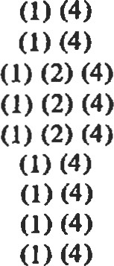API 5LU U80 80,000 (551)1.00 57,600 (397) API SLU100,000 (689) 1.00 72,000 (496)

API 5LX X42 42,000 (289)1.00 30,250 (208)

API 5LX X46 46,000 (317)1.00 33,100 (228)

API 5LX X52 52,000 (358)1.00 37,450 (258)

API 5LX X56 56,000 (386)1.00 40,300 (278)

API 5LX X60 60,000 (413)1.00 43,200 (298)

API 5LX X65 65,000 (448)1.00 46,800 (323)

API 5LX X70 70,000 (482)1.00 50,400 (347)

Furnace Welded-Butt Welded

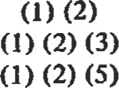ASTM A53 25,000 (172)0.60 10,800 (74)

API 5L Class 1 & Class 11 A25 25,000 (172)0.60 10,800 (74) API 5L (Bessemer), ASTM A53 (Bessemer) 30,000 (207)0.60 12,950 (89)

Specified

Min Yield Allowable Stress Value

Strength Weld Joint —20F to 250 F (-30 C to 120 0

Specification Grade psi (MPa) Notes Eactor pd (MPa)



Furnace Welded-Lap Welded

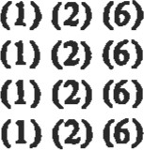 API 5L Class 25,000 (172)0.80 14,400 (99)

API 51., Clac 11 28,000 (193)0.80 16,150 (111)

API 5L (Bessemer) 30,000 (207)0.80 17,300 a 19) API SL Electric Furnace 25,000 (172)0.80 14,400 (99)

|  |  |  |  |  |
| --- | --- | --- | --- | --- |
| Electric Resistance Welded end Electric Flash Welded |  |  |  |  |
| API 5L A25 | 25,000 (172) |  | 1.00 | 18,000 a 24) |
| API 51.4, ASTM A53. ASTM A135 A | 30,000 (207) | (2) | 0.85 | 18,360 (127) |
| API 51, API 5LS, ASTM A53, ASTM A135 A | 30,000 (207) |  | 1.00 | 21,600 (149) |
| API 5L, ASTM A53, ASTM A135 B | 35,000 (241) | (2) | 0.85 | 21,420 (148) |
| API 5L, Am 5LS, ASTM A53, ASTM A135 B | 35,000 (241) | (1) | 1.00 | 25,200 (174) |

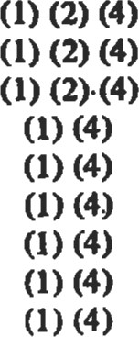API 51.S, API 5LX X42 42,000 (289)1.00 30,250 (208) API 51.S, API 5LX X46 46,000 (317)1.00 33,100 (228) API 5LS, API 5LX  52,000 (358) 1.00 37,450 (258) API SIS, API 5LX X56 56,000 (386)1.00 40,300 (279) API 51-S, API SLX X60 60,000 (413)1.00 43,200 (297) API 5LS, API 5LX X65 65,000 (448)1.00 46,800 (323) API 51.S, API 5LX X70 70,000 (482)1.00 50,400 (347) API 5LU U80 80,000 (551)1.00 57,600 (397) API SLU UIOO 100.000 (689)1.00 72,000 (496)

|  |  |
| --- | --- |
| Electric Fusion Welded |  |
| ASTM A 134 | 0.80 |

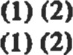ASTM A 139 A 30,000 (207)0.80 17,300 (119) ASTM A 139 B 35,000 (241)0.80 20,150 (139)

|  |  |  |  |  |  |
| --- | --- | --- | --- | --- | --- |
| ASTM A 155  ASTM A 155  Submerqed Arc Welded |  |  |  | 0.90  1.00 |  |
| API 5L, API ST Q | A | 30,000 (207) | (1) | 1.00 | 21,600 (149) |
| API API 5LS | B | 35,000 (241) | (1) |  | 25,200 (174) |

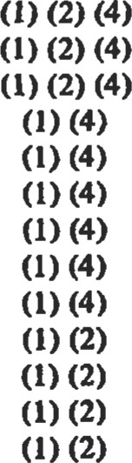API 5LS, API 5LX X42 42,000 (289)1.00 30,250 (208) API 51.S, API 5LX X46 46,000 (317)t .00 33,100 (228) API 5LS, API 5LX  52,000 (358) 1.00 37,450 (258) API 5LS, API SLX X56 56,000 (386)1.00 40,300 (278) API 51.S, API60,000 (413) 1.00 43,200 (298) API 51.S, API 5LX X65 65,000 (448)1.00 46,800 (323) Am SIS, API 5LX X70 70,000 (482)1.00 50,400 (347) API SLU U80 80,000 (551)1.00 57,600 (397) API 5LU UIOO 100,000 (689)1.00 72,000 (496)

ASTM A 381 Y3S 35,000 (241)1.00 25,200 a 74)

ASTM A 381 Y42 42,000 (290)1.00 30,250 (209)

ASTM A 381 Y46 46,000 (317)1.00 33,100 (228)

ASTM A 381 Y48 48,000 (331)1.00 34,550 (238)

|  |  |  |  |  |  |
| --- | --- | --- | --- | --- | --- |
| ASTM A 381 | Y50 | 50,000 (345) | (1) | 1.00 | 36,000 (248) |
| ASTM A 381 | YS2 | 52,000 (358) | (1) | 1.00 | 37,450 (258) |
| ASTM A 381 | Y60 | 60,000 (413) | (1) | 1.00 | 43,200 (298) |
| ASTM A 381 | Y6S | 65,000 (448) | (1) | 1.00 | 46,800 (323) |

NOTES (1) Weld joint factor E (see Table 402.4.3) and allowable strew value are applicable to pipe manufactured after 1958.

1. Weld joint factor E (see Table 402.4.3) and allowable stress value are applicable to pipe manufactured before 1959.
2. Class Il produced under API SL 23rd Edition, 1968, or earlier has a specified minimum yield strength of 28,000 psi (193 MPa).
3. Other grades provided for in API SLS, API 5LU, and API 5LX not precluded.
4. Manufacture wu discontinued and process deleted from API SL in 1969. (6) Manufacture was discontinued und process deleted from API 5L in 1962.
5. A25 is not produced in electric flash weld.
6. See applicable plate specification for yield point and refer to 402.3.1 for calculation of (S).

Reproduced from ANSVÆME Code B3141gn, Tabb Reprinted courtesy of The American Society of Mechanbal Engineers.

Table 6

Weld Joint Factor

Weld Joint Factor E

Specification

Number Pipe Type (l)



ASTM AS3 Seamless

Electric-Resistance-Welded

Furnace Lap-Welded

Furnace Butt-welded

ASTM Al 06 Seamles

ASTM A134 Electric-Fusion (Arc)-Welded single or double pass

ASTM A135 Electric-Resistance-Welded

ASTM A139 Electric-Fusion-Welded single or double pass

ASTM A15S Electric-Fusion-Welded

ASTM A381 Electric-Fusion-WeIded, Double Submerged Arc-Welded

API SL Seamless

Electric-Resistance-Welded

Electric-Flash-Welded

Electric-Induction-Welded

Submerged Arc-Weldcd

Furnace Lap-Welded

Furnace Butt-Welded

API SIS Electric-Resistance-Welded

Submerged Arc-Welded

API 5LX Scamless

Electric-Resistance-Welded

Electric-Nash-Weldcd

Electric-induction-Welded

Submerged Arc-Welded

API SLU Seamles

Electric-Resistance-Welded

Electric-Hash-welded

Electric-induction-Welded

Submerged Arc-Welded

Known Known

Unknown Seamless

Unknown Electric-Resistance or Flash-Welded

Unknown Electric-Fusion-Welded

Unknown Furnace Lap-Welded or over NPS 4

Unknown Furnace Butt-Welded or NPS 4 and smaller

NOTES: (1) Definitions for the various pipe types (weld joints) are given in 400.2.

Pipe Mfrd. Pipe Mfrd. Before 1959 After 1958

|  |  |
| --- | --- |
| i .00 | 1.00 |
| 0.85 (2) | 1.00 |
| 0.80 | 0.80 |
| 0.60 | oso |
| 1.00 | 1.00 |
| 0.80 | 0.80 |
| 0.85 (2) | 1.00 |
| 0.80 | 0.80 |
| 0.90 | 1.00  1.00 |
| 1.00 | 1.00 |
| 0.85 (2) | 1.00 |
| 0.85 (2) | 1.00  1.00  1.00 |
| 0.80 | 0.80 (3) |
| 0.60 | 0.60  1.00  1.00 |
| 1.00 | 1.00 |
| 1.00 | 1.00 |
| 1.00 | 1.00  1.00 |
| 1.00 | 1.00  1.00  1.00  1.00  1.00  1.00 |
| (4) | (5) |
| 1.00 (6) | 1.00 (6) |
| 0.85 (6) | 1.00 (6) |
| 0.80 (6) | 0.80 (6) |
| 0.80 (7) | 0.80 (7) |
| 0.60 (8) | 0.60 (8) |

1. A weld joint factor of 1.0 may be used for electric-resistance-welded or electric-flash-welded pipe manufactured prior to 1959 where (a) pipe furnished under this classification has been subjected to supplemental tests and/or heat treatments as agreed to by the supplier and the purchaser, and such supplemental tests and/or heat treatment demonstrate the strength characteristics of the weld to be equal to the minimum tensile strength specified for the pipe, or (b) pipe hug been tested as required for o new pipeline in with 437.4. I.
2. Manufacture was discontinued and process deleted from API SL in 1962.
3. Factors shown above for pipe manufactured before 1959 apply for new or used (reclaimed) pipe if pipe specification and pipe type are known and it is known that pipe was manufactured before 1959 or not known whether manufactured after 1958.

(S) Factors shown above for pipe manufactured after 1958 apply for new or used (reclaimed) pipe if pipe specification and pipe type are known and it is known that pipe was manufactured after 1958.

1. Factor applies for new or used pipe of unknown specification and ASTM Al 20 if type of weld joint is known.
2. Factor applies for new or used pipe of unknown specification and ASTM Al 20 if type of weld joint is known to be furnace lap-welded, or for pipe over NPS 4 if type of joint is unknown.
3. Factor applies for new or used pipe of unknown specification and ASTM Al 20 if type of weld joint is known to be furnace butt-welded, or for pipe NPS 4 and smaller if type of joint is unknown.

Reproduced from ANSVÆME Code B3141979, Table 402.4.3. Reprinted courtesy of The American Society of Mechanical Engineen.

PIPE LINE CONDITION MONITORING

###### Pig-based Monitoring Systems

Pipe line pigs are frequently used for pipe line commissioning, cleaning, filling, dewaxing, batching, and more recently pipe line monitoring. This last type of pig can be designed to carry a wide range of surveillance and monitoring equipment and can be used at regular intervals to check internal conditions rather than continuously monitoring the line. Data, however, can be built up over a period of time to provide a history of the line. This information can be used to predict or estimate when maintenance, line cleaning, or repairs are required. If a leak is detected, for example, by flow meter imbalance, the location can be found by using a pig with acoustic equipment on board. This will alarm when the detection equipment output reaches a maximum and the precise location of the pig can be confirmed by radio transmitters also mounted on board.

Pigs require tracking because they may become stuck, at a point of debris build-up, for example. Pigging should be carried out at a steady speed, but occasionally the pig may stop and start, particularly in smaller lines. Information on when and where the pig stops is therefore important in interpreting the inspection records. Pig tracking is not new and many such proprietary systems exist. In the best systems, however, a picture of the line is often programmed in so that outputs from junctions, valves, cross-overs, and other geometries act as an aid to location. Pig tracking can make use of the acoustic methods discussed earlier. When the sealing cups at the front of the pig encounter a weld, vibrational or acoustic signals are generated. Each pipe line therefore has its characteristic sound pattern. When a crack occurs this pattern changes from the no-leak case and the location can be found from direct comparison. The technology has become so advanced that information on dents, buckles, ovality, weld penetration, expansion, and pipe line footage can be generated.

The equipment is often simple, consisting of sensor, conditioning, and amplifier circuits and suitable output and recording devices. Such a device developed by British Gas is shown in Figure l. The range of detection is dependent on the pipe line diameter and the type of pig. Operational data have shown that light pigs in a 200 mm line can be detected at a range of 8 km, increasing to 80 km for a heavy pig in a 900 mm line. As the signals travel at acoustic velocity this means a signal from a pig at 80 km range will take 190 seconds to be picked up. Such technology is now becoming routine in both offshore gas and onshore liquid lines.

Source

McAllister, E. W. (Ed.), Pipe Line Rules of Thumb Handbook, 3rd Ed. Houston: Gulf Publishing Co., 1993.

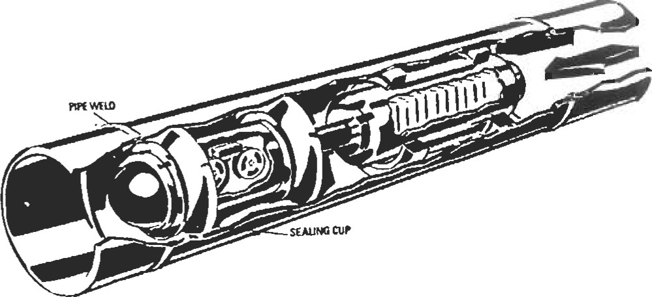

Figure 1. "Intelligent" pipe line monitoring pig. (Courtesy

British Gas)

Manual investigaüon of the pipe from inside is the most definitive way to check line condition. Visual indications can immediately be followed up with ultrasonic wall thickness measurements, magnetic field measurement of possible cracks, x-ray inspection, and possibly even fluorescent penetrant inspection. Pipe joints can be leak-checked with equipment that süaddles the joint.

Manual investigation is not, however, without disadvantages. Perhaps the biggest disadvantages is that the line must be shut down. This means that the customer must either be able to do without the services ofthe line or be supplied by other means while the line is down.

|  |  |  |
| --- | --- | --- |
| Coupons |  | |
| Coupon samples give an excellent indication of pipe condition, at least at the point at which the coupon is taken. With the application of current techniques, sampling can be a relatively easy procedure on certain types of lines. Coupon sampling involves taking a small section out of the wall of a pipe to check the condition of the line. This is done with a section-reüieving hole saw. The hole saw can be incorporated into a pipeline-attachable pressure box if line pressures and local ordinances prohibit a blowing hole. Once | the secüon is taken, a plug or screw can be driven hole to act as a stop. The pressure box, if it was can then be removed and the plug sealed with applied to small leaks, such as thermoset two-part  Source  Jesse W. Coülerman, Chief Corp., Indianapolis, N. | into the required, techniques plasücs.  Pipeline |
| Manual Investigation |  |  |

If this obstacle can be overcome, the next hurdle is the human technician. This may seem a little unbelievable to someone with but a definite mental makeup is required for underground work. The kiowledge that one is a long way undergound, even if the spæe is not confining, can be a disconcerting experience. If the technician is mentally suited for underground work, physical access comes next.

Physical access can be a constraint on both small and large pipes. On the small side, a 16-inch diameter line is about the smallest size pipe a small adult technician can get into and still do any kind of functional work. At the opposite extreme, special scaffolding may be required to reach the top and sides of larger pipes.

Source

Jesse W. Cotherman, former Chief Engineer, Miller Pipeline Corp., Indianapolis, m.

###### Cathodic protection for pipe lines

|  |  |
| --- | --- |
| Esdmate the rectifier Oe required for an infinite line. Refer to Figure l. If coaüng conductance tes6 have not been performed, pick a value from 'Ihble l.  Typical Wues of Coating Conductance | UE a value of — 0.3 volts for AEx. Ibis is usually enough to raise the potential of coated steel to about — 0.85 volb.  Use a value of 1.5 volb for AE at the drain point. HW values may be used in some ci.rcumstances; however, there may be a risk of some coating disbondment at higher voltagæ.  Calculate I at the drain point. |

|  |  |
| --- | --- |
| Mlcromhos/eq ft | Coating Condåtlon |
| 1-10  10-50  50-100  100-250 500-1,000 | Excellent coating—high resistivity soil  Good coating—high resistivity soil  Excellent coating—low resistivity soil  Good coating—low resistMty soil  Average coating—m resistivtty soil Poor coating—bw resistivity soil |

 - amp./in. x AEx/O.3 x D where D — pipe OD, in.

Example. 30-in. OD line with coating conductivity = 100 micmmhos/sq ft. What is the current change at

Based on 0.25-jnch wall pipe and steel resistivity of 18.8 microhm•cm

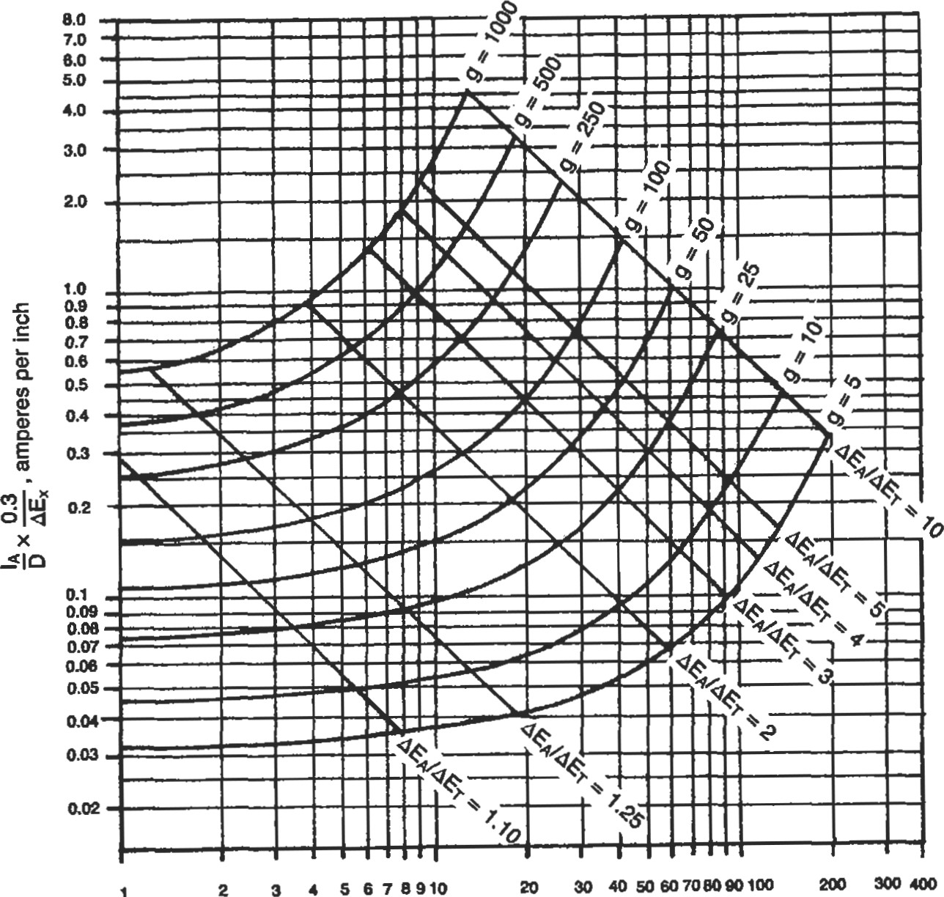

Thousands of Feet, x

Figure 1. Drainage current vs. distance for a coated infinite line.

Based on 0.25-inch wall pipe and steel resistivity of 18.8 microhm-cm

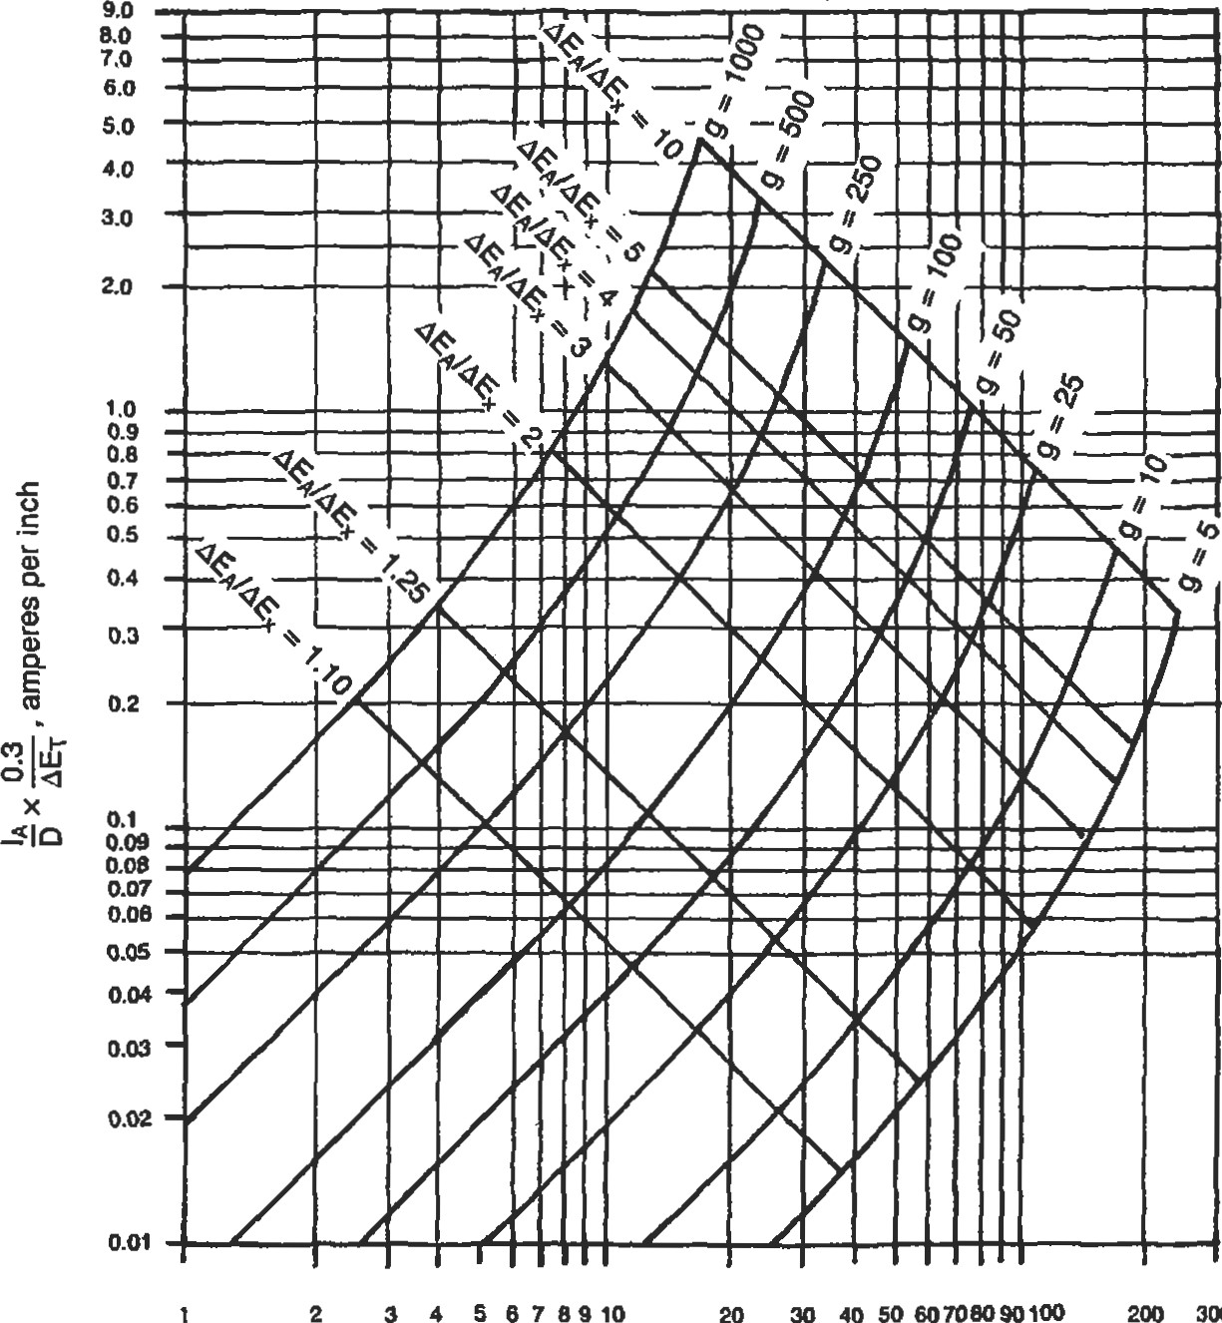

5678910

30

300

Thousands of Feet, L

Figure 2. Drainage current vs. distance for a coated finite line.

the drain point, and how far will this current protect an infinitely long pipe line?

AEA = 1.5

AEx = 0.3

AEA/AEx = 5.0

Refer to Figure 1 and read

L = 30,000 ft

AIA/D x 0.3/AEx - 0.7 (from Figure 1)

AIA = 0.7 x 30 = 21 amp.

21 amps will protect the line for 30,000 ft in either direction from the drain point.

Estimate rectifier size for a finite line. Refer to Figure 2. A 3 1/2-in. OD line 20,000 ft long is protected by insulating flanges at both ends and has a coating conductivity of 500 micromhos/sq ft. What is AEA/ET and what AIA is required? Assume that

ET = 0.3

From Figure 2 read

AEA/ET = 5.8

AEA = 1.74

AIA/D x 0.3/ET = 1.8 amp./in.

AIA = 1.8 x 3.5 — 6.3 amp.

Estimate ground bed resistance for a rectifier installation.

Example. A ground bed for a rectifier is to be installed in 1,000 ohm-cm soil. Seven 3-in. >< 60-in. vertical graphite anodes with backfill and a spacing of 10 ft will be used. What is the resistance of the ground bed?

 3 4 5 6 7 8 910 20 30

Number of Anodes

Figure 4. Anode bed resistance vs. number of anodes. 2-1n. x 60-in. vertical bare anodes.

to Figure 3. The resistance is 0.56 ohms.

Figure 3 is based on a soil resistivity of 1,000 ohms-cm. If the soil resistivity is different, use a ratio of the actual soil 1Mistivity divided by 1 ,OOO and multiply this by the reading obtained from Figure 3.



Figure 3. Anode bed resistance vs. number of anodes. 3-in. x 60-in. vertical graphite anodes in backfill.

40 60

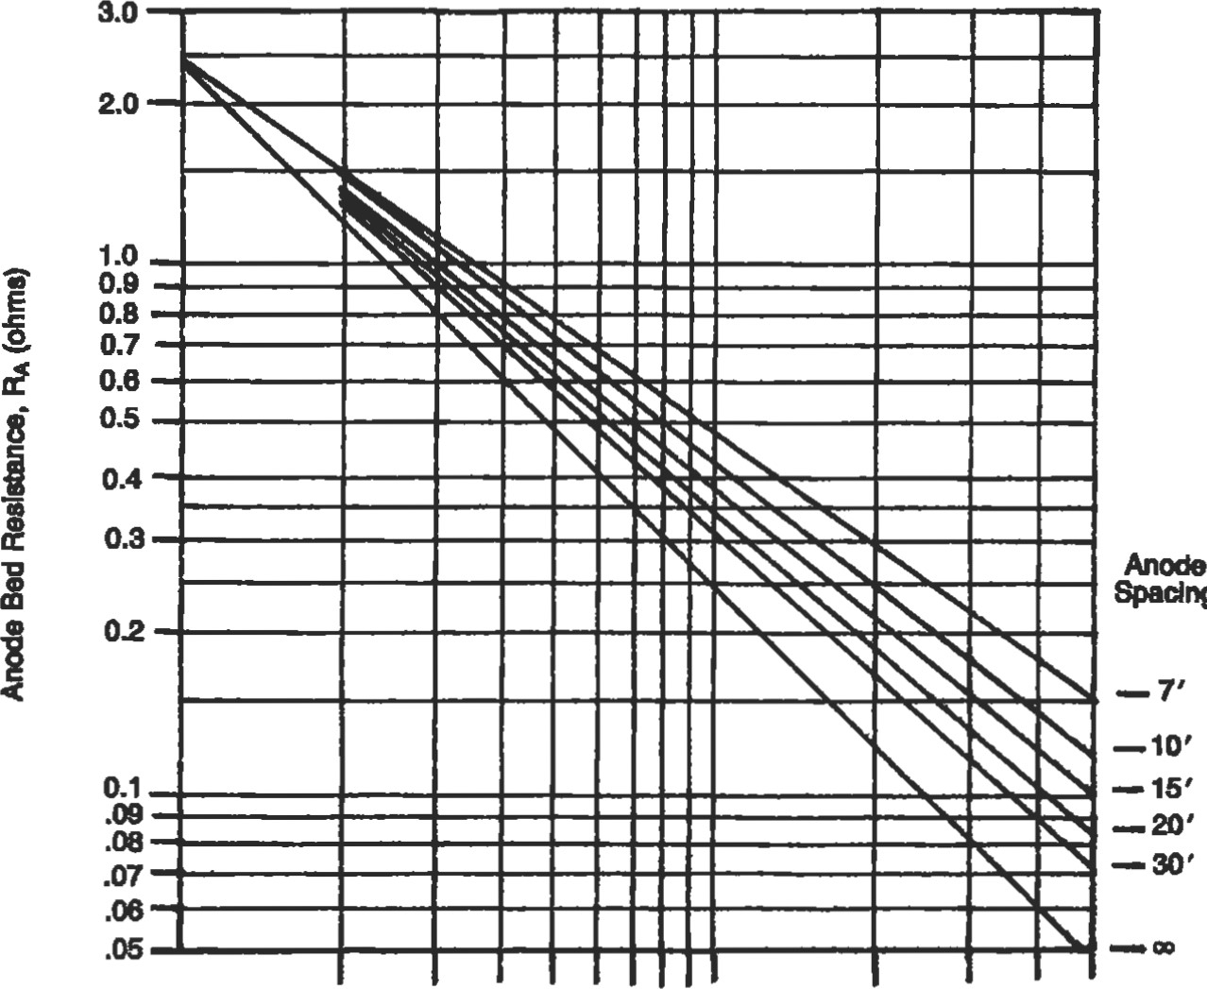

Spadng

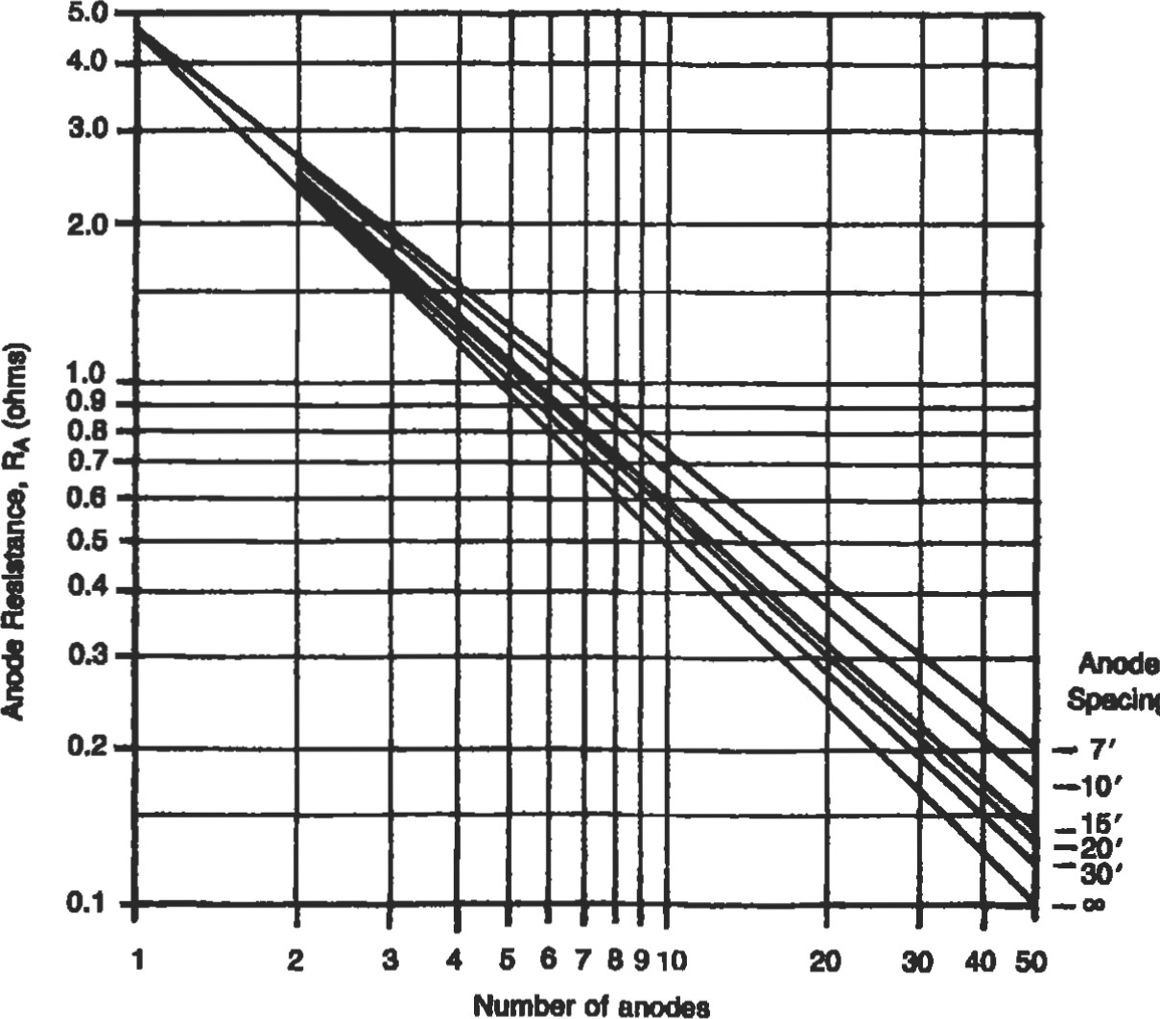

Speclng

A recHfier g•ound is to be composed of 10 — 2 x 60in. bare "Duriron" silicon anods spaced 20 ft apart. The M)il rsistivity is 3,000 ohms-cm. What is the ground bed resistance? Refer to Figure 4. The resisdvity from the chart is OS ohms. Since the chart is based on soil redstivity of 1,000 ohms-cm, the ground bed resistivity is 3,000/ 1,000 x 0.55 or 1.65 ohms.

The resistance of multiple anodes installed vertically and connected in parallel may be calculated with the following equation:

R = 0.00521P/NL x (2.3Log 8L/d - 1

+ 2L/SLog 0.656N) (1)

where R = ground bed resistance, ohms

P = soil resistivity, ohm-cm N = number of anodes d = diameter of anode, ft

L = length of anode, ft anode spacing, ft

If the anode is installed with backfill such as coke breeze, use the diameter and length of the hole in which the anode is installed. If the anode is installed bare, use the actual dimensions of the anode.

Figure 5 is based on Equation I and does not include the internal resistivity of the anode. The resistivity of a single vertical anode may be calculated with Equation 2.

R = 0.00521P/L x (2.3Log 8L/d - 1) (2)

If the anode is installed with backfill, calculate the resistivity using the length and diameter of the hole in which the anode is installed. Calculate the resistivity using the actual anode dimensions. The difference between these two values is the internal resistance of the anode. Use the value of P, typically about 50 ohm-cm, for the backfill medium. Figure 5 is based on 1,000 ohm-cm soil and a 7-ft x 8-in. hole with a 2-in. x 60-in. anode.

Example. Determine the resistivity of 20 anodes installed vertically in 1,500 ohm-cm soil with a spacing of 20 ft.

Read the ground bed resistivity from Figure 5.

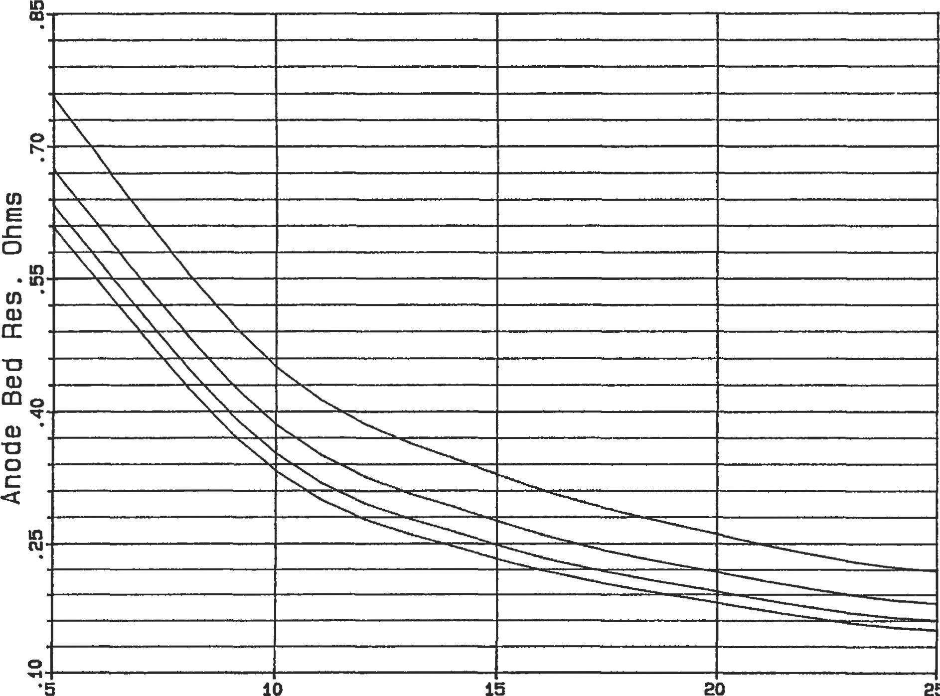

25

*acing to-ft.

|  |
| --- |
| Number of Anodes  Figure 5. Anode bed resistance. |

as-ft. eo-ft. a-ft.

R - 0.202 ohm

Since the anodes are to be installed in 1,500 ohm-cm soil and Figure 5 is based on 1,000 ohm-cm soil, multiply R by the ratio of the actual soil resistivity to 1,000 ohm-cm.

R = 0.202 x

R = 0.303 ohm

The internal resistivity for a single 2-in. x 60-in. verdcal anode installed in 50 ohm-cm backfill (7 ft x 8-in. hole) is 0.106 ohm.

Since 20 anodes will be installed in parallel, divide the resitivity for one anode by the number of anodes to obtain the internal resistivity of the anode bank.

0.106/20 = 0.005 ohm

ne total resistivity of the 20 anodes installed vertically will therefore be 0.308 ohm (0.303 + 0.005).

Galvanic Anodes

Zinc and magnesium are the most commonly used mat+ rials for galvanic anodes. Magnßium is available either in

4

201

standard alloy or high purity alloy. Galvanic anodes are usually pre-packaged with backfill to facilitate their installation. They may also be ordered bare if desired. Galvanic anodes offer the advantage of more uniformly distributing the cathodic protection current along the pipe line and it may be possible to protect the pipe line with a smaller amount of current than would be required with an impressed current system but not necessarily at a lower cost. Another advantage is that interference with other structures is minimized when galvanic anodes are used.

Galvanic anodes are not an economical source of cathodic protection current in areas of high soil resistivity. Their use is generally limited to soils of 3,000 ohm-cm except where small amounts of current are needed.

Magnesium is the most-used material for galvanic anodes for pipe line protection. Magnesium offers a higher solution potential than zinc and may therefore be used in areas of higher soil resistivity. A smaller amount of magnesium will generally be required for a comparable amount of current. Refer to Figure 6 for typical magnesium anode performance data. These curves are based on driving potentials of —0.70 volb for H-1 alloy and — 0.90 volts for Galvomag working against a structure potential of — 0.85 volb referenced to copper sulfate.

The driving potential with respect to steel for zinc is less than for magnesium. The efficiency of zinc at low current levels does not decrease as rapidly as the efficiency for magnesium. 'lhe solution potential for zinc referenced to a cop-

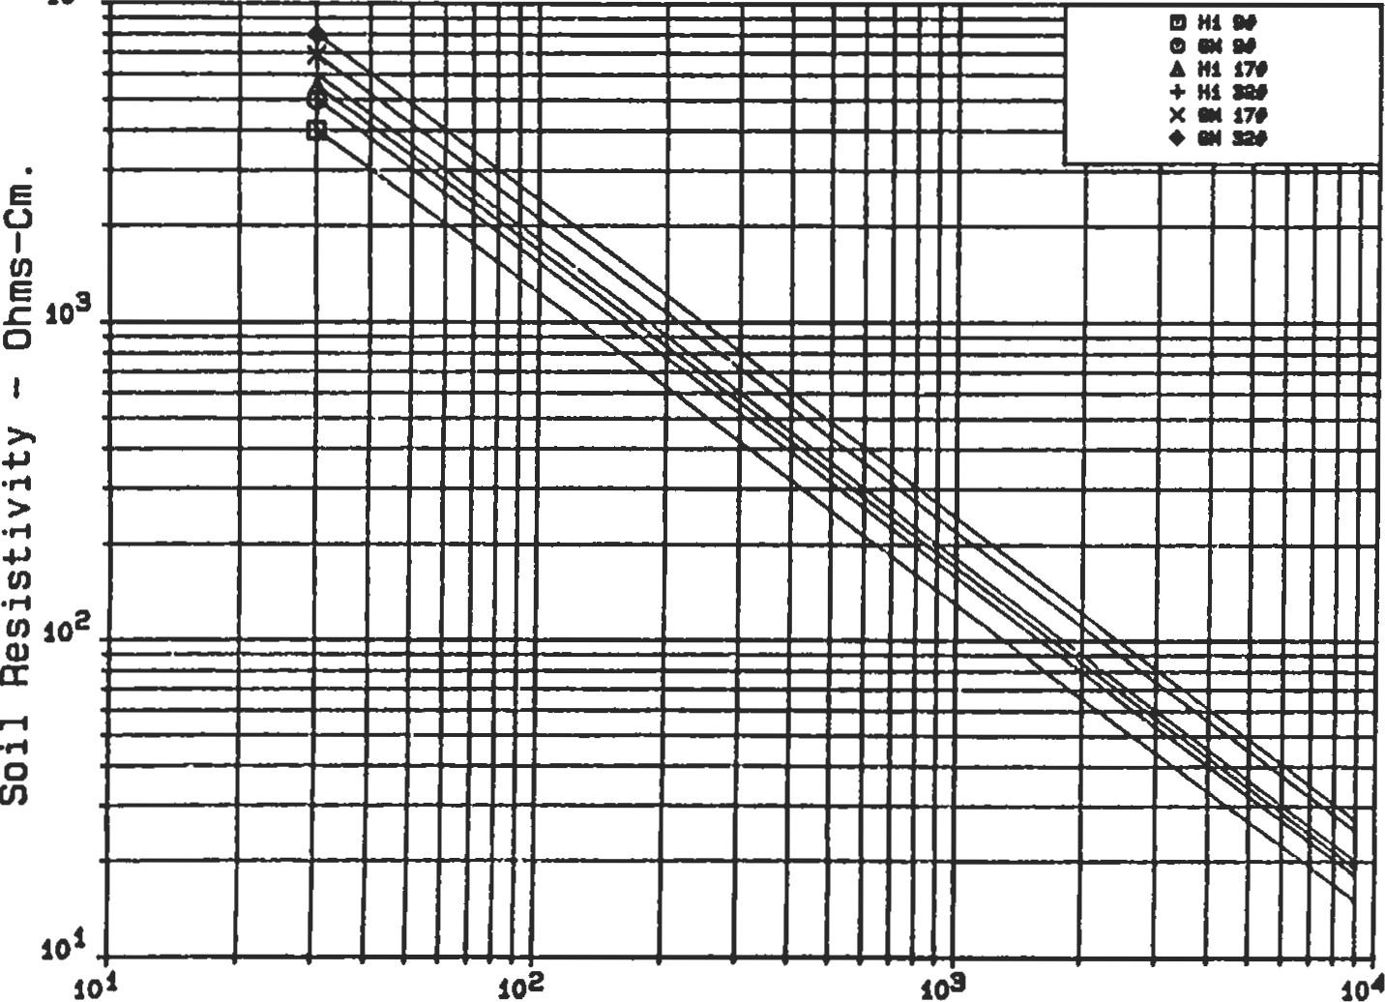10

###### Anode Current — Milliamperes

Figure 6. Magnesium anode current.

Of fo「

|  |  |  |  |  |  |  |  |  |  |  |  |  |  |  |  |  |
| --- | --- | --- | --- | --- | --- | --- | --- | --- | --- | --- | --- | --- | --- | --- | --- | --- |
| 1 | |  |  |  |  | ミ |  |  |  |  | ま | |  | 一0関  o鹵・  4 0・・  o・ | | |
|  |  |  |  | - |  |  |  |  |  | |  |
|  | 当ー |  |  |  |  | 目 |  |  |  |  | -- | |
|  |  |  |  |  |  |  |  |  | 0 | |  |  |  |  |
|  |  |  |  |  | ロ |  |  |  |  | ロ | |  |  |  |  |
| 日 |  |  |  |  | ロ |  |  |  |  | ロ | |  |  |  |  |
| ロ |  |  |  |  | ロ  ~ |  |  |  |  | ロ | |  |  |  |  |
| 一ま |  |  |  |  |  |  |  |  |  | ま | |  |  |  |  |
| - |  |  |  |  | ミ |  |  |  |  |  | |  |  |  |  |
| 当目 |  |  |  |  |  | |  |  |  | -- | |  |  |  |  |
|  |  |  |  | ー | |  |  |  | ロ | |  |  |  |  |
| ロ |  |  |  |  | ■ | |  |  |  |  | ロ |  |  |  |  |
|  | ■ |  |  |  |  | ー | |  |  |  |  | ■ |  |  |  |  |
|  | oー |  |  |  |  | ー | |  |  |  |  | ー |  |  |  |
|  |  |  | |  |  | | |  |  |  |  |  |  |  |  |  |

(JO—S(L(40

> 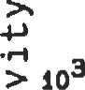!4

の

の

ad

S000地0 5 ′と. tVOS33・

れ4ーn講4 . By 5 Fセ. Long

Current Output Milliamperes

Figure 7a. Current output zinc anodes.

|  |  |  |  |  |  |  |  |  |  |  |  |  |  |  |  |  |  |
| --- | --- | --- | --- | --- | --- | --- | --- | --- | --- | --- | --- | --- | --- | --- | --- | --- | --- |
|  | 一一 | |  |  |  |  |  |  | |  |  |  | |  |  |  | |
|  | 一ま | |  |  |  |  |  | -- | |  |  | = | |  |  | oま0・・ △ま4・十03・ X懸0・ー◆期・・ | |
|  |  |  |  |  | -  ・ | |  |  | 一 | |  |  |
| 当呂■ | | |  |  |  |  | ・ | |  |  |  |  |  |  |
| ロロ0 | | |  |  |  |  |  | |  |  |  |  |  | ト | |  |
|  |  | 00 | |  |  |  |  |  | ー | |  |
| 日ロロ | | |  |  |  |  | ロ | |  |  | ロ | |  | 靍 | |  |
|  | ロ  =  一 | ミ0----  - | |  |  |  |  | ー | |  |  | ロ | |  | Ⅱ | |
|  |  |  |  | & | |  |  | = | |  | -・ | |  |
|  |  |  |  | 1- | |  |  |  | | | ・ | |  |
| ■ | | | |  |  |  | ■ | |  | を | | |  | |
| 目目 | | | |  |  |  | | |  |  | | |  | |  |
| ロ00 | | | |  |  |  |  |  | |  |  | | |  | 0000 |  |
|  | ロロロ | | | |  |  |  |  | 0000 | |  | 、 | | |  |  |  |
|  | ロロ0 | | | |  |  |  |  |  | |  | ロ | | |  | ! |  |
|  |  | | | |  |  |  |  |  | |  |  | | |  |  |  |

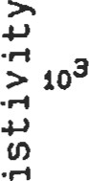UIO—SI.UUO

Sp・0 0ミ5代,

ÜOS33・

4-】れ.Xl.4-ーれ.

By S—ft . Long

Current Output Milliamperes

Figure 7b. Current output zinc anodes.

104

Spacing 15 ft.

1.4-1n.x1.4-1n. By 5—ft. Long

|  |  |  |  |  |  |  |  |  |  |  |  |  |  |  |  |  |  |  |
| --- | --- | --- | --- | --- | --- | --- | --- | --- | --- | --- | --- | --- | --- | --- | --- | --- | --- | --- |
|  |  |  |  |  |  |  |  |  |  |  |  |  |  |  |  |  | | |
|  |  |  |  |  |  |  |  |  |  |  |  |  |  |  |  |  | | |
|  |  |  |  |  |  |  |  |  |  |  |  |  |  |  |  |
|  |  |  |  |  |  | 11 |  |  |  |  |  |  |  |  |  |
|  |  |  |  |  |  |  |  |  |  |  |  |  |  |  |  |  |
|  |  |  |  |  |  |  |  |  |  |  |  |  |  |  |  |  |  |  |
|  |  |  |  |  |  |  |  |  |  |  |  |  |  |  |  |  |  |
|  |  |  |  |  |  |  |  |  |  |  |  |  |  |  |  |  |  |
|  |  |  |  |  |  |  |  |  |  |  |  |  |  |  |  |  |  |  |
|  |  |  |  |  |  |  |  |  |  |  |  |  |  |  |  |  |  |  |
|  |  |  |  |  |  |  |  |  |  |  |  |  |  |  |  |  |  |  |
|  |  |  |  |  |  |  |  |  |  |  |  |  |  |  |  |  |  |
|  |  |  |  |  |  |  |  |  |  |  |  |  |  |  |  |  |  |
|  |  |  |  |  |  |  |  |  |  |  |  |  |  |  |  |  |  |  |
|  |  |  |  |  |  |  |  |  |  |  |  |  |  |  |  |  |  |  |
|  |  |  |  |  |  |  |  |  |  |  |  |  |  |  |  |  |  |  |

102

102

### Current Output Milliamperes

Figure ea. Current output zinc anodes.

104

|  |  |  |  |  |  |  |  |  |  |  |  |  |  |  |  |  |  |  |
| --- | --- | --- | --- | --- | --- | --- | --- | --- | --- | --- | --- | --- | --- | --- | --- | --- | --- | --- |
|  |  |  |  |  |  |  |  |  |  |  |  |  |  |  |  | Anod•c 14 Anode  16 modes  20 Modoc | | |
|  |  |  |  |  |  |  |  |  |  |  |  |  |  |  |  |
|  |  |  |  |  |  |  |  |  |  |  |  |  |  |  |  |
|  |  |  |  |  |  |  |  |  |  |  |  |  |  |  |  |  |  |  |
|  |  |  |  |  |  |  |  |  |  |  |  |  |  |  |  |  |  |  |
|  |  |  |  |  |  |  |  |  |  |  |  |  |  |  |  |  |  |  |
|  |  |  |  |  |  |  |  |  |  |  |  |  |  |  |  |  |  |  |
|  |  |  |  |  |  |  |  |  |  |  |  |  |  |  |  |  |  |  |
|  |  |  |  |  |  |  |  |  |  |  |  |  |  |  |  |  |  |  |
|  |  |  |  |  |  |  |  |  |  |  |  |  |  |  |  |  |  |  |
|  |  |  |  |  |  |  |  |  |  |  |  |  |  |  |  |  |  |
|  |  | I ll | |  |  |  |  |  |  |  |  |  |  |  | h |
|  | no | |  |  |  |  |  |  |  |  |  |  |  |  |
|  |  |  |  |  |  |  |  |  |  |  |  |  |  |  |  |  |  |
|  |  |  |  |  |  |  |  |  |  |  |  |  |  |  |  |  |  |  |

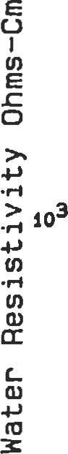 Spacing 15 ft.

1.4-1n.xf.4-1n. By 6-ft. Lone

101 102 103 104

### Current Output Milliamperes

Figure 8b. Current output zinc anodes.

per sulfate cell is — 1.1 volts; standard magnesium has a solution potential of — 1.55 volts; and high purity magnesium has a solution potential of — 1.8 volts.

If, for example, a pipe line is protected with zinc anodes at a polarization potential of — 0.9 volts, the driving potential will be - 1.1 - (—0.9) or —0.2 volts. If standard magnesium is used, the driving potential will be — 1.55 — 0.9) or — 0.65 volts. The circuit resistance for magnesium will be approximately three times as great as for zinc. This would be handled by using fewer magnesium anodes, smaller anodes, or using series resistors.

If the current demands for the system are increased due to coating deterioration, contact with foreign structures, or by oxygen reaching the pipe and causing depolarization, the potential drop will be less for zinc than for magnBium anodes. With zinc anodes, the current needs could increase by as much as 50% and the pipe polarization potential would still be about 0.8 volts. The polarization potential would drop to about 0.8 volts with only a 15% increase in current needs if magnesium were used.

The current efficiency for zinc is 90% and this value holds over a wide range of current densities. Magnesium anodes have an efficiency of 50% at normal current densities, Magnesium anodes may be consumed by self corrosion if operated at very low current densities. Refer to Figures 7a, 7b, 8a, and 8b for zinc anode performance data. The data in 7a and 7b are based on the anodes being installed in a gypsum-clay backfill and having a driving potential of — 0.2 volts. Figures 8a and 8b are based on the anodes being installed in water and having a driving potential of —0.2 volts. [from data prepared for the American Zinc Institute].

Example. Estimate the number of packaged anodes required to protect a pipe line.

What is the anode resistance of a packaged magnesium anode installation consisting of nine 32 1b anodes spaced 7 ft apart in 2,000 ohm-cm soil?

Refer to Figure 9. This chart is based on 17} packaged anodes in 1,000 ohm-cm soil. For nine 321b anodes, the resistivity will be

1 X  x 0.9 1.8 ohm

See Figure 10 for a table of multiplying factors for other size anodes.

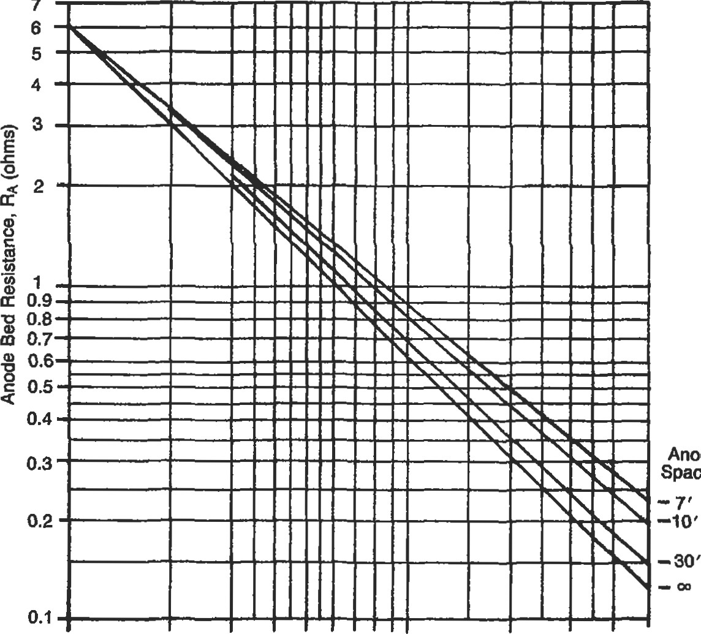

7

Anode

Spacing

1 2 3 4 5 6 7 8 910 20 30 40 50

Number of Anodes

Figure 9. Anode bed resistance vs. number of anodes. 17# packaged magnesium anodes.

Chart based on 17-1b. magnesium anodes installed in 1000 ohm-cm soil in groups of 10 spaced on 10-ft. centers.

For other conditions multiply number of anodes by the following multiplying factors:

For soil resistivity: MF = For 9-1b. anodes: MF = 1.25 1000

For conventional magnesium: MF 1.3 For 32-1b. anodes: MF = 0.9

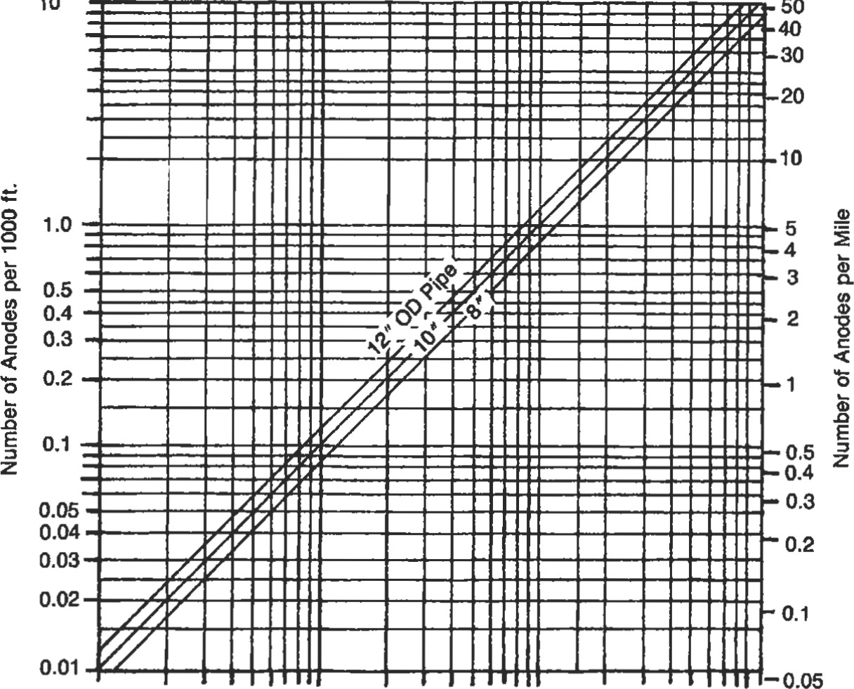

10

50

1 2 3 4 s 10 20 304050 100 200300400 1000

Coating Conductivity (micromhos/sq ft)

Figure 10. Number of anodes required for coated line protection.

Example. A coated pipe line has a coating conductivity of 100 micromhos/sq ft and is 10,000 ft long, and the diameter is 103/4-in. How many 171b magnesium anodes will be required to protect 1,000 ft? Refer to Figure 7 and read 2 anodes per 1,000 ft. A total of twenty 17} anodes will be required for the entire line.

Sources

l. Parker, M. E. and Peattie, E. G., Pipe Line Corrosion and Cathodic Protection, 3rd Ed. Houston: Gulf Publishing co., 1984.

2. McAllister, E. W. (Ed.), Pipe Line Rules of Thumb Handbook 3rd Ed. Houston: Gulf Publishing co., 1993.

|  |
| --- |
| PRESSURE VESSELS  Stress Analysis |

Stress analysis is the determination of the relationship between external forces applied to a vessel and the corresponding stress. The emphasis of this discussion is not how to do stress analysis in particular, but rather how to analyze vessels and their component parts in an effort to m-rive at an economical and safe design—the difference being that we analyze su•esses where necessary to determine thickness of material and sizes of members. We are not so concemed with building mathematical models as with providing a stepby-step approach to the design of ASÄ.'E Code vessels. It is not necessary to find every stress but rather to know the governing stresses and how they relate to the vessel or its respective parts, attachments, and supports.

The starting place for stress analysis is to determine all the design conditions for a given problem and then determine all the related external forces. We must then relate these external forces to the vessel parts which must resist them to find the corresponding stresses. By isolating the causes (loadings), the effects (stress) can be more accurately determined.

The designer must also be keenly aware of the types of loads and how they relate to the vessel as a whole. Are the effects long or short term? Do they apply to a localized portion of the vessel or are they uniform throughout?

How these stresses are interpreted and combined, what significance they have to the overall safety of the vessel, and what allowable stresses are applied will be determined by three things:

1. The strength/failure theory utilized.
2. The types and categories of loadings.
3. The hazard the stress represents to the vessel.

Membrane S&ess Analysis

Pressure vessels commonly have the form of spheres, cylinders, cones, ellipsoids, tori, or composites of these. When the thickness is small in comparison with other dimensions (Rm/t > 10), vessels are referred to as membranes and the associated stresses resulting from the contained pressure are called membrane stresses. These membrane stresses are average tension or compression stresses. They are assumed to be uniform across the vessel wall and act tangentially to its surface. The membrane or wall is assumed to offer no resistance to bending. When the wall offers resistance to bending, bending stresses occur in addition to membrane stresses.

In a vessel of complicated shape subjected to internal pressure, the simple membrane-sffess concepts do not suffice to give an adequate idea of the ffue sfress situaüon. The types of heads closing the vessel, effects of supports, variaüon in thickness and cross section, nozzles, external attachments, and overall bending due to weight, wind, and seismic all cause varying disfributions in the vessel. Deviations from a true membrane shape set up bending in the vessel wall and cause the direct loading to vary from point to point. The direct loading is diverted from the more flexible to the more rigid portions of the vessel. This effect is called "süess redistribution."

In any pressure vessel subjected to internal or external pressure, sü•esses are set up in the shell wall. The state of sffess is friaxial and the three principal sffesses are:

Ox = longitudinal/meridional stress

= circumferential/latitudinal stress or = radial sfress

In addition, there may be bending and shear stresses. The radial su•ess is a direct süess, which is a result ofthe pressure acting directly on the wall, and causes a compressive stress equal to the pressure. In thin-walled vessels this stress is so small compared to the other stesses that it is generally ignored. Thus we assume for purposes of analysis that the state of stress is biaxial. This greatly simplifies the method of combining süesses in comparison to üiaxial stress states. For thick-walled vessels (Rm/t < 10), the radial sü•ess cannot be ignored and formulas are quite different from those used in finding '%nembrane st-esses" in thin shells.

Since ASME Code, Section VIII, Division 1, is basically for design by rules, a higher factor of safety is used to allow for the "unknown" stresses in the vessel. This higher safety factor, which allows for these unknown stresses, can impose a penalty on design but requires much less analysis. The design techniques outlined in this text are a compromise between finding all stresses and utilizing minimum code formulas. This addiüonal knowledge of stresses warrants the use of higher allowable stresses in some cases, while meeting the requirements that all loadings be considered.

|  |
| --- |
| Failures in Pressure Vessels |

In conclusion, "membrane sü•ess analysis" is not completely accurate but allows certain simplifying assumptions to be made while maintaining a fair degree of accuracy. The main simplifying assumptions are that the stress is biaxial and that the stresses are uniform across the shell wall. For thin-walled vessels these assumpüons have proven themselves to be reliable. No vessel meets the criteria of being a true membrane, but we can use this tool within a reasonable degree of accuracy.

Vessel failures can be grouped into four major categories, which describe why a vessel failure occurs. Failures can also be grouped into types of failures, which describe how the failure occurs, Each failure has a why and how to its history. It may have failed through corrosion fatigue because the wrong material was selected! The designer must be as familiar with categories and types of failure as with categories and types of stress and loadings. Ultimately they are all related.

Categories of Failures

l. Material—Improper selection of material; defects in material.

1. Design—lncorrect design data; inaccurate or incorrect design methods; inadequate shop testing.
2. Fabricaüon—Poor quality control; improper or insufficient fabrication procedures including welding; heat or forming methods.
3. Service—Change of service condition by the user; inexperienced operations or maintenance personnel; upset conditions. Some types of service which require special attention both for selection of material, design details, and fabrication methods are as follows:
   1. Lethal
   2. Fatigue (cyclic)
   3. Brittle (low temperature)
   4. High temperature
   5. High shock or vibration
   6. Vessel contents
   * Hydrogen
   * Ammonia

' Compressed air

Caustic

* + Chlorides

Types of Failures

1. Elastic deformation—Elastic instability or elastic buckling, vessel geometry, and stiffness as well as properties of materials are protection against buckling.
2. Brittle fracture—Can occur at low or intermediate temperatures. Brittle fractures have occurred in vessels made of low carbon steel in the 400—500F range during hydrotest where minor flaws exist.
3. Excessive plastic deformation—The primary and secondary stress limits as outlined in ASME Section VIII, Division 2, are intended to prwent excessive plastic deformation and incremental collapse.
4. Stress rupture—Creep deformation as a result of fatigue or cyclic loading, i.e., progressive fracture. Creep is a time-dependent phenomenon, whereas fatigue is a cycle-dependent phenomenon.
5. Plastic instability—lncremental collapse; incremental collapse is cyclic strain accumulation or cumulative cyclic deformation. Cumulative damage leads to instability of vessel by plastic deformation.
6. High strain—Low cycle fatigue is and occurs mainly in materials.
7. Stress corrosion—It is well known that chlorides cause stress corrosion cracking in stainless steels, likewise caustic service can cause stress corrosion cracking in carbon steels. Material selection is critical in these services.
8. Corrosion fadgue—Occurs when corrosive and fatigue effects occur simultaneously. Corrosion can reduce fatigue life by pitting the surface and propagating cracks. Material selection and fatigue properties are the major considerations.

In dealing with these various modes of failure, the designer must have at his disposal a picture of the state of sü•ess

|  |
| --- |
| Loadings |

in the various parts. It is against these failure modes that the designer must compare and interpret stress values. But setting allowable stresses is not enough! For elastic instability one must consider geometry, stiffness, and the properties of the material. Material selection is a major consideration when related to the type of service. Design details and fabrication methods are as important as "alIowable stress" in design of vessels for cyclic service. The designer and all those persons who ultimately affect the design must have a clear picture of the conditions under which the vessel will operate.

Loadings or forces are the "causes" of stresses in pressure vessels. These forces and moments must be isolated both to determine where they apply to the vessel and when they apply to a vessel. Categories of loadings define where these forces are applied. Loadings may be applied over a large portion (general area) of the vessel or over a local area of the vessel. Remember both general and local loads can produce membrane and bending stresses. These stresses are additive and define the overall state of stress in the vessel or component. from local loads must be added to from general loadings. These combined stresses are then compared to an allowable stress.

Consider a pressurized, vertical vessel bending due to wind, which has an inward radial force applied locally. The effects of the pressure loading ate longitudinal and circumferenüal tension. The effects of the wind loading are longitudinal tension on the windward side and longitudinal compression on the leeward side. The effect of the local inward radial load is some local membrane sü•esses and local bending stresses. The local would be both circumferential and longitudinal, tension on the inside surface of the vessel, and compressive on the outside. Of course the steel at any given point only sees a certain level of sffess or the combined effect. It is the designer's job to combine the sü•esses from the various loadings to arrive at the worst prob able combination of stresses, combine them using some failure theory, and compare the results to an acceptable s&ess level to obtain an economical and safe design.

This hypothetical problem serves to illustrate how categories and types of loadings are related to the stresses they produce. The stresses applied more or less continuously and uniformly across an entire section of the vessel are primary stresses.

The stresses due to pressure and wind are primary membrane stresses. These stresses should be limited to the Code allowable. These stresses would cause the bursting or collapse of the vessel if allowed to reach an unacceptably high level.

On the other hand, the su•esses from the inward radial load could be either a primary local stress or secondary stress. It is a primary local stress if it is produced from an unrelenting load or a secondary stress if produced by a relenting load. Either stress may cause local deformation but will not in and of itself cause the vessel to fail. If it is a primary stress, the sü•ess will be redistributed; if it is a secondary sü•ess, the load will relax once slight defonnation occurs.

Also be aware that this is only true for ductile materials. In brittle materials, there would be no difference between primary and secondary stresses. If the material cannot yield to reduce the load, then the definition of secondary stress does not apply! Fortunately current pressure vessel codes require the use of materials.

This should make it obvious that the type and category of loading will determine the type and category of sü•ess. This will be expanded upon later, but basically each combination of sffesses (stress categories) will have different allowables, i.e.:

* Primary stress: Pm < SE
* Primary membrane local (PL):

1.5 SE

 < 1.5 SE

* Primary membrane + secondary (Q):



But what if the loading was of relatively short ålrafion? This describes the "type" of loading. Whether a loading is steady, more or less continuous, or nonsteady, variable, or temporary will also have an effect on what level of stress will be acceptable. If in our hypothetical problem the loading had been pressure + seismic + local load, we would have a different case. Due to the relatively short duration of seismic loading, a higher 'temporary" allowable sfress would be acceptable. The vessel doesn't have to operate in an earthquake all the time. On the other hand, it also shouldn't fall down in the event of an earthquake! Structural designs allow a one-third increase in allowable sffess for seismic loadings for this reason.

For steady loads, the vessel must support these loads more or less continuously during its useful life. As a result, the stresses produced from these loads must be maintained to an acceptable level.

For nonsteady loads, the vessel may experience some or all of these loadings at various times but not all at once and not more or less continuously. Therefore a temporarily higher stress is acceptable.

For general loads that apply more or less uniformly across an entire section, the corresponding must be lower, since the entire vessel must support that loading.

For local loads, the corresponding stresses are confined to a small portion of the vessel and normally fall off rapidly in distance from the applied load. As discussed previously, pressurizing a vessel causes bending in certain components. But it doesn't cause the entire vessel to bend. The results are not as significant (except in cyclic service) as those caused by general loadings. Therefore a slightly higher allowable staess would be in order. Loadings can be outHned as follows:

A. Categories of loadings

1. General loads—Applied more or less continuously across a vessel section.

1. Pressure loads—Internal or external pressure (design, operating, hydrotest, and hydrostatic head of liquid).
2. Moment loads—Due to wind, seismic, erecdon, transportation.
3. Compressive/tensile loads—Due to dead weight, installed equipment, ladders, platforms, piping, and vessel contents.
4. Thermal loads—Hot box design of skirt-head attachment.

2. Local loads—Due to reactions from supports, internals, attached piping, attached equipment, i.e., platforms, mixers, etc.

1. Radial load—inward or outward.
2. Shear load—Longitudinal or circumferential.
3. Torsional load.
4. Tangential load.
5. Moment load—Longitudinal or circumferential.
6. Thermal loads. B. Types of loadings
7. Steady loads—Long-term duration, continuous.
   1. Internal/extemal pressure.
   2. Dead weight.
   3. Vessel contents.
   4. Loadings due to attached piping and equipment.
   5. Loadings to and from vessel supports.
   6. Thermal loads.
   7. Wind loads.
8. Nonsteady loads—Short-term duration; variable.
   1. Shop and field hydrotests.
   2. Earthquake.
   3. Erection.
   4. Transportation.
   5. Upset, emergency.
   6. Thermal loads.

|  |
| --- |
| Stress |

* 1. Start up, shut down.

ASME Code, Section VIN, Division 1 w. Division 2

ASNfE Code, Secüon VIII, Division 1 does not explicitly consider the effects of combined stress. Neither does it give detailed methods on how stresses are combined. ASME Code, VIII, Division 2, on the other hand, provides specific guidelines for süesses, how they are combined, and allowable sü•esses for categories of combined sü•esses. Division 2 is design by analysis whereas Division 1 is designed by rules. Although stress analysis as udlized by Division 2 is beyond fre scope of this discussion, the use of suess categories, definitions of stress, and allowable sü•esses is applicable.

Division 2 stress analysis considers all st-esses in a ü•iaxial state combined in accordance with the maximum shear stress theory. Division I and the procedures outlined in this section consider a biaxial state of su-ess combined in accordance with the maximum sffess theory. Just as you would not design a nuclear reactor to the rules of Division 1, you would not design an air receiver by the techniques of Division 2. Each has its place and applications. The following discussion on categories of stress and allowables will utilize information from Division 2, which can be applied in general to all vessels.

|  |
| --- |
| 210 |

Types, Classes, and Categories of Stress

The shell thickless as computed by Code formulas for internal or external pressure alone is often not sufficient to withstand the combined effects of all other loadings. Detailed calculations consider the effects of each loading separately and then must be combined to give the total state of stress in that part. The stresses that are present in pressure vessels are separated into various classes in accordance with the types of loads that produced them, and the hazard they represent to the vessel. Each class of stress must be maintained at an acceptable level and the combined total stress must be kept at another acceptable level. The combined stresses due to a combination of loads acting simultaneously are called stress categories. Please note that this terminology differs from that given in Division 2, but is clearer for the purposes intended here.

Classes of stress, categories of stress, and allowable sfresses are based on the type of loading that produced them and on the hazard they represent to the suucture. Unrelenting loads produce primary sffesses. Relenting loads (self limiting) produce secondary stresses. General loadings produce primary membrane and bending s&esses. Local loads produce local membrane and bending stresses. Primary st-esses must be kept lower than secondary stresses. Primary plus secondary stresses are allowed to be higher and so on. Before considering the combination of stresses (categories), we must fn•st define the various types and classes of sffess.

Types of Stres

There are many names to describe types of sfress. Enough in fact to provide a confusing picture even to the experienced designer. As these sffesses apply to pressure vessels, we group all types of sfress into three major classes of stress, and subdivision of each of the groups is arranged according to their effect on the vessel. The following list of sü•esses describes types of sffess without regard to their effect on the vessel or component. They define a direction of stress or relate to the application of the load.

|  |  |
| --- | --- |
| 1. Tensile | 10. Thermal |
| 2. Compressive | 11. Tangential |
| 3. Shear | 12. Load induced |
| 4. Bending | 13. Strain induced |
| 5. Bearing | 14. Circumferential |
| 6. Anal | 15. Longitudinal |
| 7. Discontinuity | 16. Radial |
| 1. Membrane 2. Principal | 17. Normal |

Classes of Stres

The foregoing list provides examples of types of suess. It is, however, too general to provide a basis with which to combine süesses or apply allowable stresses. For dis purpose, new groupings called classes of sfress must be used. Classes of group sfresses according to the type of loading which produced them and the hazard they represent to the vessel.

1. Primary stress

1. General:
   * Primary general membrane Pm
   * Primary general bending stress, Pb
2. Primary local stress, PL
3. Secondary st-ess
   1. Secondary membrane sffess, Qm
   2. Secondary bending stress, Qb
4. Peak F

Definitions and examples of these stresses are as follows:

Primary general stress. These stresses act over a full cross-section of the vessel. They are produced by mechanical loads (load induced) and are the most hazardous of all types of stress. The basic characteristic of a primary su•ess is that it is not self limiting. Primary sffesses are generally due to internal or external pressure or produced by sustained external forces and moments. Thermal stresses are never classified as primary sffesses.

Primary general sfresses are divided into membrane and bending stresses. The need for dividing primary general sü•ess into membrane and bending is that the calculated value of a primary bending stress may be allowed to go higher than that of a primary membrane sffess. Primary stresses that exceed the yield strulgth of the material can cause failure or gross distortion. Typical  of primary stress are:

PR F MC TC

, and —



Primary general membrane stress, Pm. This stress occurs across the entire cross section of the vessel. It is remote from discontinuities such as head-shell intersections, cone-cylinder intersections, nozzles, and supports. Examples are:

1. Circumferential and longitudinal su•ess due to pressure.
2. Compressive and tensile axial sfresses due to wind.
3. Longitudinal stress due to the bending of the horizontal vessel over the saddles.
4. Membrane stress in the center of the flat head.
5. Membrane stress in the nozzle wall within the area of reinforcement due to pressure or external loads.
6. Axial compression due to weight.

Primary general bending stress, Pb. Primary bending stresses are due to sustained loads and are capable of causing collapse of the vessel. There are relatively few areas where primary bending occurs:

1. Bending stress in the center of a flat head or crown of a dished head.
2. Bending stress in a shallow conical head.
3. Bending stress in the ligaments of closely spaced openings.

Local Prinzry Membrane S&ess, PL. Local primary membrane st-ess is not technically a classification of su•ess but a stress category, since it is a combination of two stresses. The combination it represents is primary membrane stress, Pm, plus secondary membrane süess produced from sustained loads. These have been grouped together in order to limit the allowable for this particular combination to a level lower than allowed for other primary and secondary su•ess applications. It was felt that local süess from sustained (unrelenting) loads presented a great enough hazard for the combination to be "classified" as a primary stress.

A local primary stress is produced either by design pressure alone or by other mechanical loads. Local primary have some self-limiting characteristics like secondary stresses. Since they are localized, once the yield strength of the material is reached, the load is redistributed to stiffer portions of the vessel. However, since any deformation associated with yielding would be unacceptable, an allowable stress lower than secondary is assigned. The basic difference between a primary local and a secondary stress is that a primary local is produced by a load that is unrelenüng; the stress is just redistributed. In a secondary stress, yielding relaxes the load and is truly self limiting. The ability of primary local stresses to redistribute themselves after the yield sffength is attained locally provides a safety-valve effect. Thus, the higher alIowable stress applies only to a local area.

Primary local membrane stresses are a combination of membrane stresses only. Thus only the "membrane" sü•esses from a local load are combined with primary general membrane stresses, not the bending stresses. The bending stresses associated with a local loading are secondary sü•esses. Therefore, the membrane stresses from a WRC107-type analysis must be broken out separately and combined with primary general stresses. The same is ü•ue for discontinuity membrane st-esses at head-shell junctures, cone-cylinder junctures, and nozzle-shell junctures. The bending stresses would be secondary stresses.

Therefore, PL = Pm + Qm where Qm is a local stress from a sustained or unrelenting load. Examples of primary local membrane sü•esses are:

Pm + membrane stresses at local discontinuities:

1. Head-shell juncture
2. Cone-cylinder juncture
3. Nozzle-shell juncture
4. Shell-flange juncture
5. Head-skirt juncture
6. Shell-stiffening ring juncture

Pm + membrane stresses from local sustained loads:

1. Support lugs
2. Nozzle loads
3. Beam supports
4. Major attachments

Secondary stess. The basic characteristic of a secondary sü•ess is that it is self limiüng. As defined earlier, means that local yielding and minor distortions can satisfy the conditions which caused the stress to occur. Application of a secondary stress cannot cause structural failure due to the resu•aints offered by the body to which the part is attached. Secondary mean sffesses are developed at the junctions of major components of a pressure vessel. Secondary mean are also produced by sustained loads other than internal or external pressure. Radial loads on nozzles produce secondary mean in the shell at the junction of the nozzle. Secondary stresses are s&ain-induced sfresses.

Discontinuity stresses are only considered as secondary stresses if their extent along the length of the shell is limited. Division 2 imposes the restriction that the length over which the sü•ess is secondary Beyond this distance, the stresses are considered as primary mean stresses. In a cylindrical vessel, the length v"kmt represents the length over which the shell behaves as a ring.

A further resüiction on secondmy suesses is that they may not be closer to another gross structural discontinuity than a distance of 2.5 vQmt. This restriction is to eliminate the additive effects of edge moments and forces.

212

Secondary sü•esses are divided into two ad(htional groups, membrane and bending. Examples of each are as follows: Secondary membrane stress, Qm.

1. Axial stress at the juncture of a flange and the hub of the flange.
2. Thermal stresses.
3. Membrane sfress in the knuckle area of the head.
4. Membrane stress due to local relenting loads.

Secondary bending stress, Qb.

1. Bending stress at a gross suuctural disconünuity: nozzles, lugs, etc. (relenting loadings only).
2. The nonuniform portion of the stress distribuüon in a thick-walled vessel due to internal pressure.
3. The sfress variation of the radial sffess due to internal pressure in thick-walled vessels.
4. Discontinuity at stiffening or support rings.

Note: For b and c it is necessary to subtract out the average stress which is the primary su•ess. Only the part of the sfress distribution is a seondary s&ess.

Peak stress, F. Peak stresses are the additional su•esses due to st-ess intensification in highly localized areas. They apply to both sustained loads and self-limiting loads. There are no significant distortions associated with peak stresses. Peak stresses are additive to primary and secondary sffesses present at the point of the stress concenü•aüon. Peak stresses are only significant in faügue conditions or brittle materials. Peak stresses are sources of fatigue cracks and apply to membrane, bending, and shear stresses. Examples are:

1. Stress at the comer of a discontinuity.
2. Thermal stresses in a wall caused by a sudden change in the surface temperature.
3. Thermal stresses in cladding or weld overlay.
4. Stress due to notch effect (sü•ess

Categories of Stress

Once the various stresses of a component are calculated, they must be combined and this final result compared to an allowable sfress (see Table 1). The combined classes of sü•ess due to a combination of loads acüng at the same time are stress categories. Each category has assigned limits of sffess based on the hazard it represents to the vessel. The following is derived basically from ASNfE Code, Secvm, Division 2, simplified for application to Division 1 vessels and allowable It should be used as a guideline only because Division 1 recogn.izes only two categories of stress—primary membrane and primary bending stress. Since the calculations of most secondary (thermal and disconünuities) and peak su•esses are not included in this text, these categories can be considered for reference only. In addition, Division 2 uülizes a factor K mulüplied by the allowable stress for increase due to short term loads due to seismic or upset conditions. It also sets allowable limits of combined sfress for fatigue loading where secondary and peak su•esses are major considQtions. Table 1 sets allowable sü•esses for both st-ess classifications and sfress categories.

Table 1

Allowable S&esses for Stess Classifications and

Categories



S&ess ClassmcaUon or Category Allowable %ess



Generat primary membrane, Pm SE

General primary bending, Pb 1.5 SE < .9 F

Local primary membrane, PL

Pm+Pb+Qm*+Qb PL+Pb+Qm*+Qb

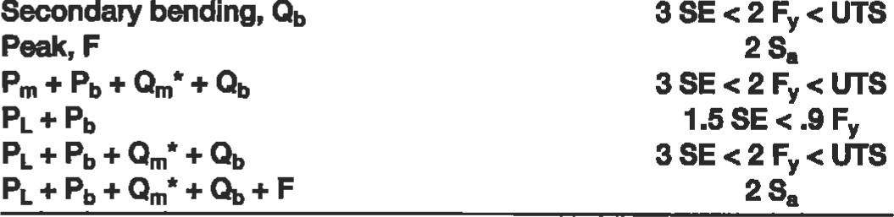

Secondary

membrane,

Qm

1.5

SE

<

.9

F

(PL=Pm+QmJ

1.5

SE

<

.9

F

Notes:

Qms = membrane stre#es from loads membrane from relenäng, self limmng loads

S = allowable sfress per ASME Code, Section WII, Division 1, at de%n tempæ•aå/re

Fy = minimum specified yidd strengü at design temperature

U.T.S. — minimum specified tensile strengü

Sa — allowable stress for any given number of cycles from sign faygue curves.

Be aware that at certain temperawres for certain materials, 1.5 SE is greater than .9 Fr

|  |
| --- |
| Procedure 1  General Vessel Fomulas [1 , 31 |

Noütion

P = internal pressure, psi

Di, Do = inside/outside diameter, in. S = allowable or calculated stress, PSI E = joint efficiency

L = crown radius, in.

Ri, Ro = inside/outside radius, in.

K, M = coeffcients ox = longitudinal stress, psi

= circumferenüal stress, psi Rm = mean radius of shell, in.

t = or thickness required of shell, head, or cone, in.

r = knuckle radius, in.

Notes

l. Formulas are valid for:

1. Pressures < 3,000 psi.
2. Cylindrical shells where t .5Ri or P .385 SE. For thicker shells see Reference 1, Para. 1-2.
3. Spherical shells and hemispherical heads where t S .356 Ri or P .665 SE. For thicker shells see Reference 1, Para. 1-3.

2. All ellipsoidal and torispherical heads having a minünum specified tensile strength greater than 80,000 psi shall be designed using S = 20,000 psi at ambient temperature and reduced by the ratio of the allowable stresses at design temperature and ambient temperature where required. 3. Formulas for factors:

D 2

#### K=.167 2+

M = .25 3 + r

Ellipsoidal or torispherical head

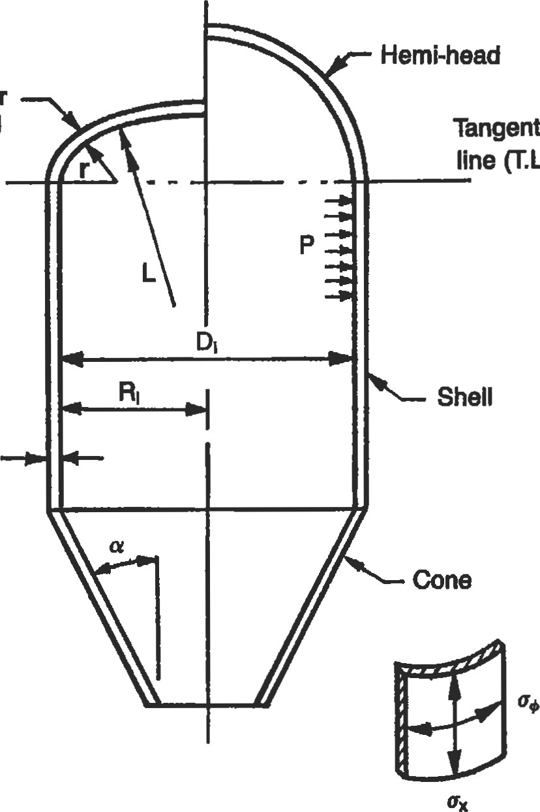

(T.L.)

t

1. General configuration and dimensional data for vessel shells and heads.

Table 1

General Vessel Formulas

Stress Thickness, t Pressure, P Stress, S

Part Formula

##### Shell o

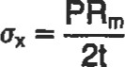LongitudinalPRI PRO 2SEt 2SEt P(Ri — .4t) P(Ro — 1 .4t)

[Section2SE + .4P 2SE + 1.4P Ro- 1.4t 2Et 2Et

Circumferential PRm PRI PRO SEt SEt P(Ri + .6t) P(Ro — .4t)

[Section UG-27(c)(1); 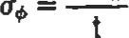 SE - .6P

Section 1-1

##### Heads

Hemisphere PRm2SEt 2SEt P(Ri + .2t) P(Ro — .80 m

[Section I-I(a)(2); 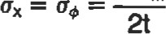 2SE - .2P 2SE + .8P Ri + .2t 2Et 2Et

Section

Ellipsoidal See PROCEDURE PDiK PDOK 2SEt 2SEt See PROCEDURE 2



[Section2 2SE - .2P 2SE + 2P(K - .1) KDi + .2t KDO - 2t(K - .1)

|  |  |  |  |  |
| --- | --- | --- | --- | --- |
| [Section UG-32dl* | 2SE - .2P | 2SE + 1.8P |  | DO - 1.8t |
| 100%—6% Torispherical | .885PLi | .885PL0 | SEt | SEt |

|  |  |  |  |  |
| --- | --- | --- | --- | --- |
| [Section UG-32(e)l* | SE — . IP | SE + .8P | .885Li + .1t | .885L0 - .8t |
| Torispherical | Pi-iM | PLOM | 2SEt | 2SEt |

|  |  |  |  |  |  |  |
| --- | --- | --- | --- | --- | --- | --- |
| % < 16.66  [Section  Cone | 2SE - .2P | 2SE + | - .2) | LIM + .2t | 1-0M - | - .2) |

 PDi PDo 2SEt 2SEt

|  |
| --- |
| 2.8tcos |

Longitudinal PRm PDo 4SEt 4SEt cos oc P(Di — .8tcos o,) P(Do —



2t cos oc 4COS oc(SE + . 4cos + 1.4P) Di — .8tcos oc Do — 2.8tcos oc 4Et cos oc 4Et cos oc

|  |
| --- |
| P(Di + 1.2tcos |

Circumferential PRm 2SEt cos ocP(DO — .8tcos oc)



PDi

PDO

2SEt

[Section 1-4(e); tcosoc äE-a•tSÉZGFj 2cos oc(SE + .4P) Di + 1.2tcos oc Do — .8tcos oc 2Et cos o, 2Etcos

Section

*ASME Boiler and Pressure Vessel Code, Section Vlll, Division 1, 1983 Edition, American Society of Mechanical Engineers.

##### Procedure 2 Stresses in Heads Due to Internal Pressure [3, 41

Notation

L = crown radius, in.

r = knuckle radius, in. h = depth of head, in.

RL = latitudinal radius of curvature, in.

Rm = meridional radius of curvature, in.

= latitudinal stress, psi ox = meridional stress, psi

P = internal pressure, psi

Fomulas

Lengths of RL and Rm for ellipsoidal heads:

* At equator:

RL=R e At center of head:

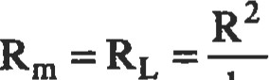

h

* At any point X:

|  |
| --- |
| 1-— 112 |

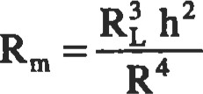

Notes

1. Latitudinal (hoop) stresses in the knuckle become compressive when the R/h exceeds 1.42. These heads will fail by either elastic or plastic buckling, depending on the Wt ratio.
2. Head types fall into one of three general categories: hemispherical, torispherical, and ellipsoidal. Hemispherical heads are analyzed as spheres and were covered in the previous secüon. Torispherical (also known as flanged and dished heads) and ellipsoidal head formulas for sffess are outlined in the following form.

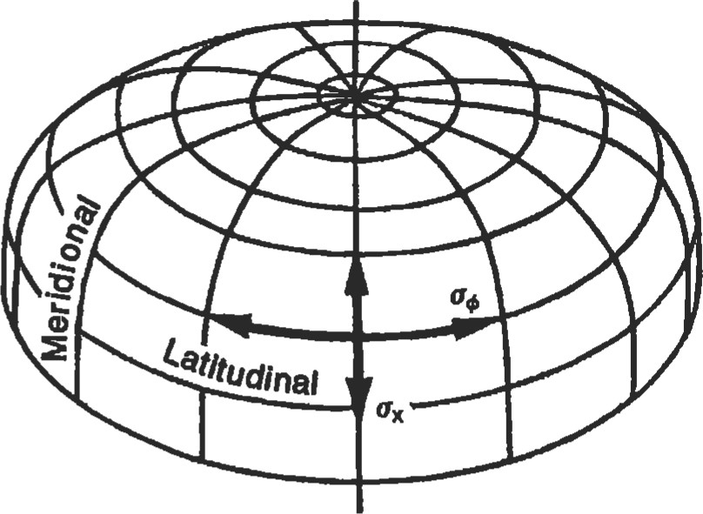

Flgure 1. Direction of stresses in a vessel head.

x

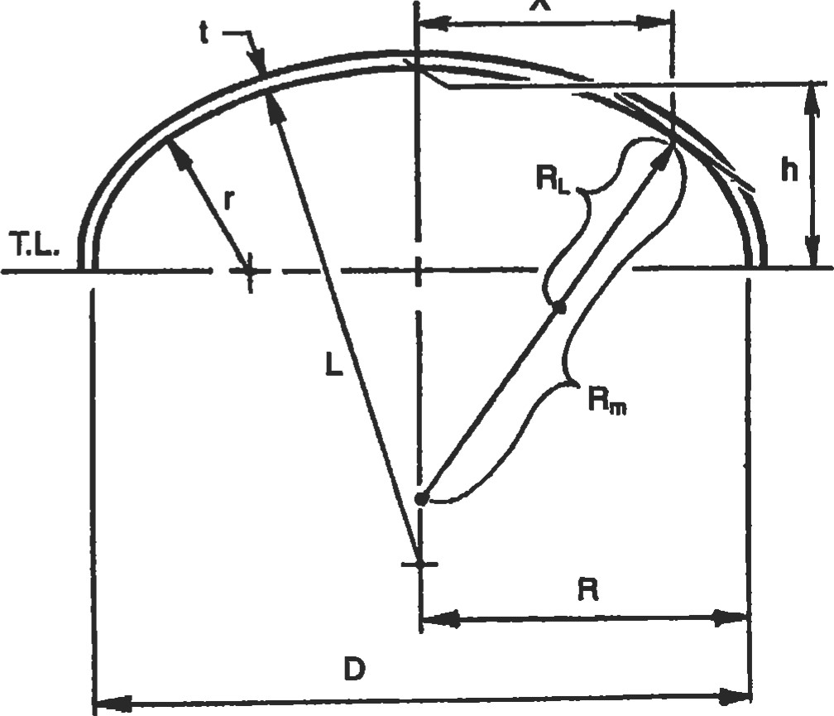

Figure 2. Dimensional data for a vessel head.

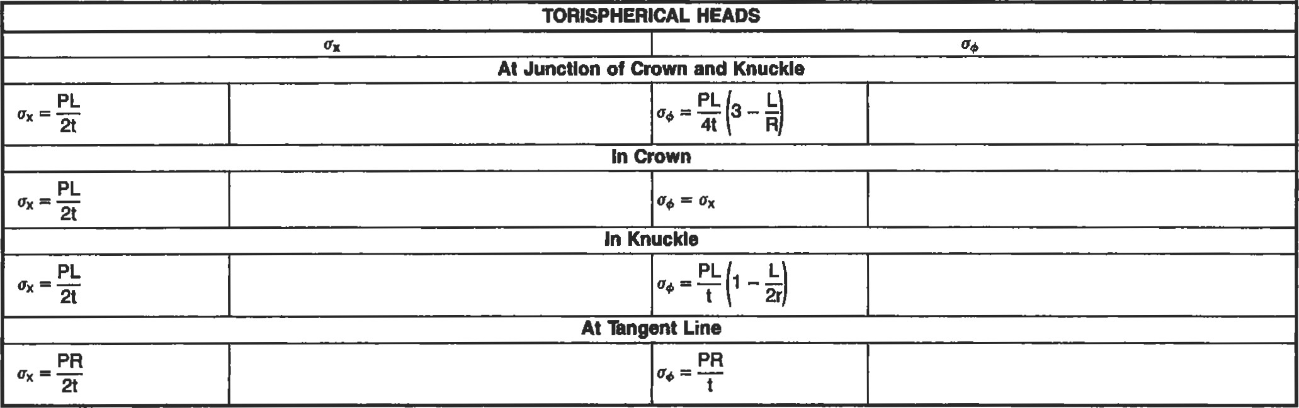

|  |  |  |  |
| --- | --- | --- | --- |
| ELLIPSOIDAL HEADS | | | |
|  | |  | |
| At Any hint X | | | |
|  |  | |  |  |  |  | | --- | --- | --- | --- | |  | |  | | --- | |  | | 2Rm | | |  |
| At Center of Heed | | | |
| PR2  2th |  |  |  |
| At Llne | | | |
|  |  |  |  |

Joint Efficiencies (ASME Code) [51

Miter

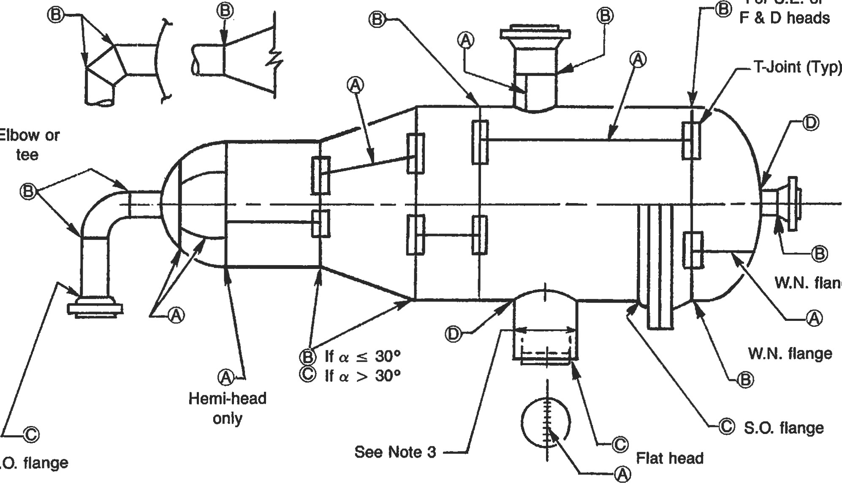

For

S.E.

or

Elbow

flange

S.O.

Figure 1 u Categories of welded joints in a pressure vessel.

Table 1

Values of Joint Efficiency, E, and Allowable Stress, S*

|  |  |  |  |  |  |  |  |  |  |  |  |  |  |  |  |  |  |  |  |
| --- | --- | --- | --- | --- | --- | --- | --- | --- | --- | --- | --- | --- | --- | --- | --- | --- | --- | --- | --- |
| Extent of  Radiography | Case 1 | | | | Case 2 | | | | | | Case 3 | | | | | | Case 4 | | |
| Seamless  Head  E s | Seamless  Shell  E s | Seamless  Head  E s | | | Welded  Shell  E s E | | | Welded  Head s | | | Seamless  Shell  E s E | | | Welded  Head s | | | Welded  Shell  E s | |
| Full (RT-I) spot (RT-3) Combinationt None | 1.0 100%  1.0 85%  1.0 100%  1.0 80% | 1.0 100%  1.0 85%  1.0 100%  1.0 | 1.0  1.0  1.0  1.0 | 100%  85%  100%  80% | | 1.0  .85  .85  .7 | 100%  100%  100%  100% | 1.0  .85  1.0  .7 | | 100%  100%  100%  100% | | 1.0  1.0  1.0  1.0 | 100%  85%  100%  80% | 1.0  .85  1.0  .7 | | 100%  100%  100%  100% | | 1.0  .85  .85  .7 | 100%  100%  100% 100% |

*See Note 1.

*See Note 2.

Table 2

Joint Efficiencies

x-Ray

Types of Joints Full Spot None

|  |  |  |  |  |  |  |  |  |  |
| --- | --- | --- | --- | --- | --- | --- | --- | --- | --- |
|  | |  |  |  |  | | --- | --- | --- | --- | | Single butt |  |  |  | | joint without backing |  |  | .6 | |

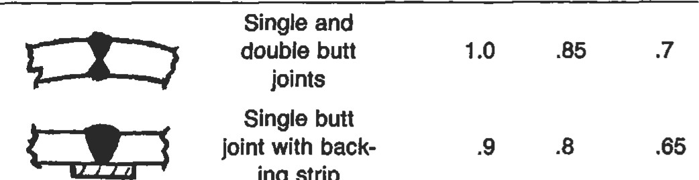joint with back- .9 .8 .65 ing strip

strip

Double full 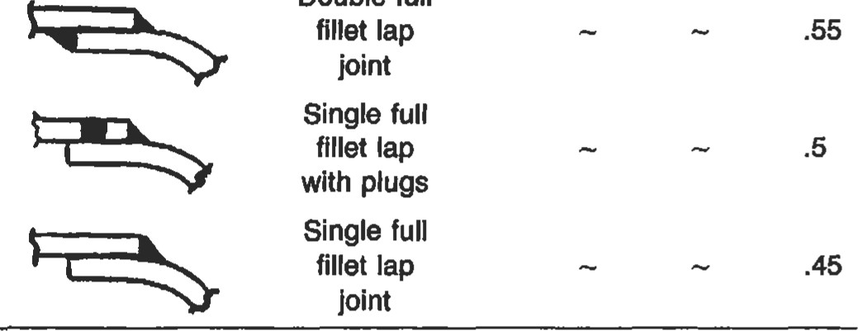fillet lap

Notes

1. In Table I joint efficiencies and allowable stresses for shells are for longitudinal seams only! All joints are assumed as Type 1 only! Where combination radiography is shown it is assumed that all requirements for full radiography have been met for head, and shell is spot R. T.
2. Combination radiography: Applies to vessels not fully radiographed where the designer wishes to apply a joint efficiency of 1.0 per ASME code, Table UW-12, for only a specific part of a vessel. Specifically for any part to meet this requirement, you must perform the following:
   * (ASME Code, Section UW-11(5)): Fully x-ray any

Cat. A or D butt welds

* + (ASME code, Section  spot x-ray any Category B or C butt welds attaching the part
  + (ASME code, Section UW-I I All butt joints must be Type I

1. Any Category B or C butt weld in a nozzle or communicating chamber of a vessel or vessel part which is to have a joint efficiency of 1.0 and exceeds either 10 in. nominal pipe size or 1K in. in wall thickness shall be fully radiographed. See ASME Code, Section UW11

##### Properties of Heads

d

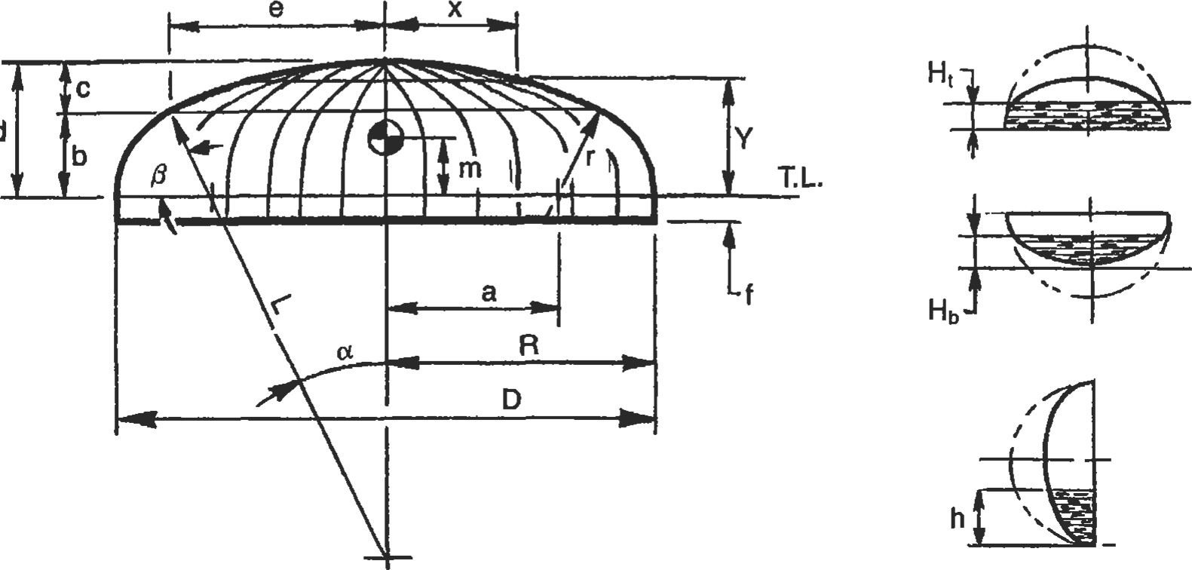

x

Figure 1. Dimensions of heads.

|  |  |
| --- | --- |
| Formulas | Volume |
| D-2r  2 | VI = (frustum) = .333b Tt(e2 + ea + a2) |

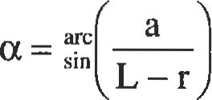 V2 = (spherical segment) = Itc 2 (L — c/3)

|  |  |
| --- | --- |
| p = 90 -a b = cos r | V3 = (solid of revolution) |
| c = L — cos oc L | 120r 3 Tt sin cos + aOTt2 r 2 |
| e = sin L | 90 |
| 2 | Total volume: VI + V2 + V3 |

Table 1

Partial Volumes

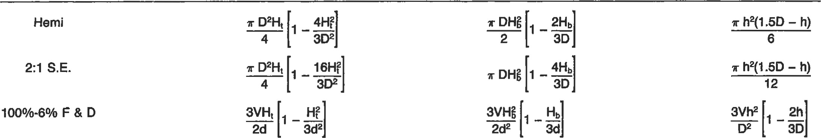

Type

Volume

to

Ht

Volume

to

Hb

Volume

to

h

|  |  |  |  |  |  |
| --- | --- | --- | --- | --- | --- |
| D is in ft. |  |  | Table 2  General Data |  |  |
| Type | Surface Area | Volume | C.G. — m  Empty Full | Depth of Head, d | Points on Heads |

Hemi  D212 T 03112 .2878D ,375D .5D





1. is in tt.

Notes 2. For 2:1 S.E. heads the crown and knuckle radius may be approximated as follows: I. Developed length of flat plate (diameter)

L = .9045 D

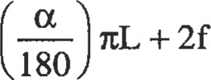 D.L. = 2 7tr + 2r = .1727D

180

3. Conversion factors 4. Depth of head



* + Multiply ft3 x 7.48 to get gallons R—r
  + Multiply ft3 x 62.39 to get lb-water
  + Multiply gallons x 8.33 to get lb-water 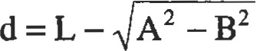

##### Volumes and Surface Areas of Vessel Sections

Notation

I = height of cone, depth of head, or length of cylinder a = one-half apex angle of cone

D = large diameter of cone, diameter of head or cylinder

R = radius r = knuckle radius of F & D head L = crown radius of F & D head h = partial depth of horizontal cylinder

K, C = coefficients d = small diameter of truncated cone

V = volume

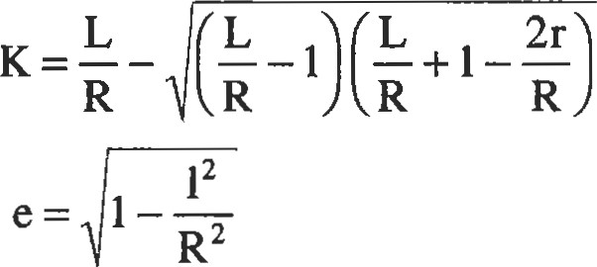

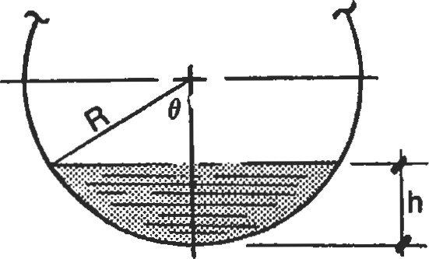

###### arc cos

V = R2 e — sin e cos 9 180

###### or

TR2 ec

Figure 1. Formulas for partial volumes of a horizontal cylinder.

Table 1

Volumes and Surface Areas of Vessel Sections

Section Volume Surface Area

100-6% .08467 D3

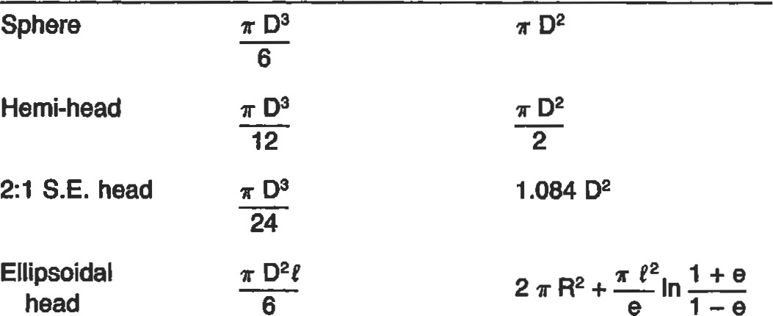

.9286

D

2

F & D head

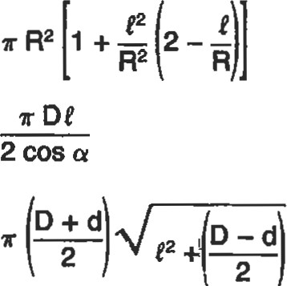F&Dhead 2 R3K

3

Cone  D2e

12

Tuncated r t(D2 + Dd + d2) cone 12

|  |  |  |
| --- | --- | --- |
| 300 Tuncated | .227(D3 - d3) | 1.57 (D2 - d2) |

cone

Table 2

|  |  |
| --- | --- |
| .1 | .0524 |
| .15 | .0941 |
| .2 | .1424 |
| .25 | .1955 |
| .3 | .2523 |
| .35 | .3119 |
| .4 | .3735 |
| .45 | .4364 |
| .5 | .5 |
| .55 | .5636 |
| .6 | .6265 |
| .65 | .6881  7477 |
| .75 | .8045 |
| .8 | .8576 |
| .85 | .9059 |
| .9 | .9480 |

Values of c for Partial Volumes of a Horizontal Cylinder

.95 .9813

##### Maximum Length of Unstiffened Shells

Thickness

Diameter 1/4 5116  7/16718 15116 13/16

(in.)

204 36

|  |
| --- |
| 1. All values are in in. 2. Values are for temperatures up to 5000 F. 3. Top value is for full vacuum, lower value is half vacuum. 4. Values are for carbon or low alloy steel (Fy > 30,000 psi) based on Figure UCS 28.2 of ASME Code, Section VI", Div.   1. |

168 280

42

313 

142 235 358

48

264 437 

122 203 306 437

54

228 377 00

104 178 268 381

60

200 330 499 

91 157 238 336 458

66

174 293 442 626 

79 138 213 302 408 537

72

152 263 396 561 00

70 124 193 273 369 483 616

78

136 237 359 508 686 

63 110 175 249 336 438 559

84

123 212 327 462 625 816 00

57 99 157 228 308 402 510 637

90

112 190 300 424 573 748 00

52 90 143 210 284 370 470 585 715

96

103 173 274 391 528 689 875 00

48 82 130 190 263 343 435 540 661 795

102

94 160 249 363 490 639 810 1 ,005 oo

44 76 118 176 245 320 405 502 613 738 875

108

87 148 228 337 456 594 754 935 00

42 70 109 162 223 299 379 469 571 687 816

114

79 138 211 311 426 555 705 874 1 ,064 00

39 65 101 149 209 280 355 440 536 642 762 894

120

74 128 197 287 400 521 660 819 997 00

37 61 95 138 195 263 334 414 504 603 715 839 974

126

69 120 184 266 374 490 621 770 938 1,124 00

35 57 88 129 181 242 315 391 475 569 673 789 916 1 ,053

132

65 113 173 248 348 462 586 727  1, 1,253 oo

|  |  |  |  |  |  |  |  |  |  |  |  |  |  |  |  |  |
| --- | --- | --- | --- | --- | --- | --- | --- | --- | --- | --- | --- | --- | --- | --- | --- | --- |
| 138  144  150  156  162 | 33  62  31  59 | 54  106  51  98  49  92  46  87  44  83 | 83  163  78  154  74  146  70  138  67  131 | 121  234  114  221  107  209  101  199  96  189 | 169  325  158  304  148  286  140  271  133  258 | 228  437  214  411  201  385  189  363  178  342 | 297  555  275  526  261  499  248  475  233  448 | 369  687  350  652  332  619  309  590  294  562 | 449  836  426  793  405  753  385  717  367  684 | 538  1 ,002  510  950  485  902  462  859  440  819 | 636  1,185  603  1,123  573  1 ,066  546  1,015  520  968 | 744  oo  705  1,312  669  1 ,246  637  1,186  608  1,131 | 864  817  00  774  1 ,442  737  1,373  703  1 ,309 | 994  940  891  846  00  806  1 ,509 | 1 ,073  1,017  966  919 | 1,152  1 ,095  1 ,042 |
|  |  |  |  | 7116 |  | 9/16 |  |  |  |  | 71B | 15/16 | 1 |  |  |  |

##### Useful Formulas for Vessels [2, 61

l. Properties of a circle. (See Figure 1.)

* C. G. of area

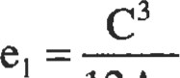

12Al

120C e2 = oat 38.197 (R3 — r3 )sin (9/2



* Chord, C.

C = 2R sin 0/2

2bR-b2

Rise, b.



b=R-.5 4R2 -e

 Angle, 0.

c

0 = 2 arc sin — • Area of sections

OltR2 -180C(R

360

###### TR2a

360

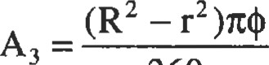

360

1. Properties of a cylinder.
   * Cross-sectional metal area, A

A = 27tRmt

* + Section modulus, Z.

Z = flR2mt

TtD2mt

4

n(D 4 -

32d

Circular

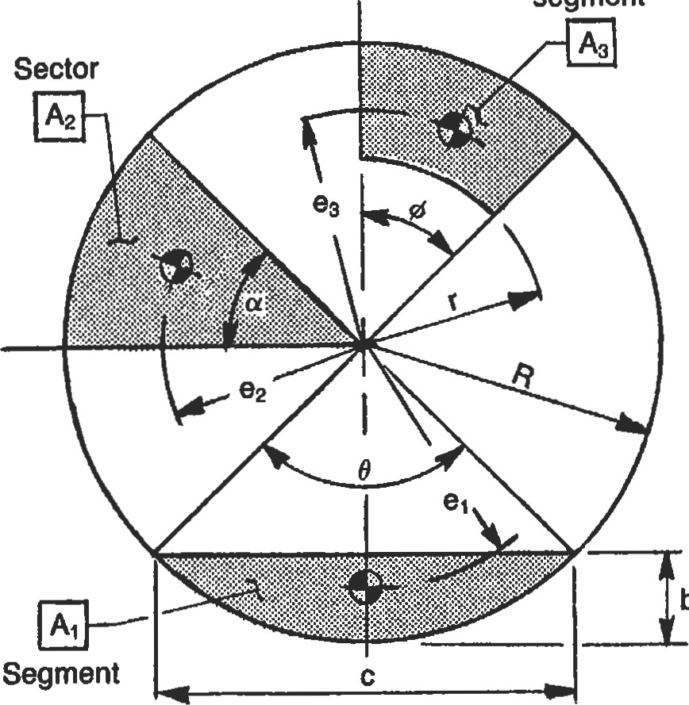

b

segment

ring

Figure 1. Dimensions and areas of circular sections.

* + Moment of inertia, I.

1 = TtR3mt

TtD3mt

8 it(D4 -d 4 )

64

1. Radial displacements due to internal pressure.
   * Cylinder.

PR2

= — (1 — .5v)

* + Cone.

PR2

(1 — .5v)

Et cos a

' Sphere/hemisphere.

PR2

##### 2Et

• Torispherical/ellipsoidal.

— vox)

where P =internal pressure, psi R = inside radius, in. t = thickness, in.

v = Poisson's ratio (.3 for steel) E = modulus of elasticity, psi a = h apex angle of cone, degrees

= circumferenüal stress, psi

 = meridional stress, psi

1. Longitudinal sffess in a cylinder due to longitudinal bending moment, ML.
   * Tension.

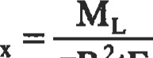

ltR2tE

* + Compression.

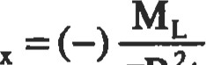

TtR2t

where E = joint efficiency

R = inside radius, in.

ML = bending moment, in.-lb t = thickness, in.

1. 'Ihickness required for heads due to external pressure.

|  |  |
| --- | --- |
|  |  |
| 16Pe |

where L = crown radius, in.

Pe = extemal pressure, psi

E = modulus of elasticity, psi

1. Equivalent pressure of flanged connection under external loads.

16M 4F ltG3 ltG2

where P = internal pressure, psi

F = radial load, 1b

M = bending moment, in.-lb

G = gasket reaction diameter, in.

1. Bending ratio of formed plates.

where finished radius, in.

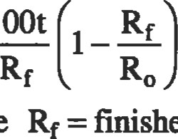

100t

Ro = starting radius, in. (00 for flat plates) t = thickness, in.

1. in nozzle neck subjected to external loads.

PR F MRm

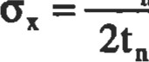

where Rm = nozzle mean radius, in. tn = nozzle neck thickness, in.

A = metal cross-sectional area, in.2

I = moment of in.4

F = radial load, 1b

M = moment, in.-lb

P = internal pressure, psi

1. Circumferential bending stress for out of round shells [21.



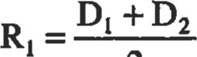

2

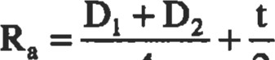

4 2

1.5PRlt(Dl t3 +3 — RIR2a

where DI = maximum inside diameter, in.

D2 = minimum inside diameter, in.

P = internal pressure, psi

E = modulus of elasticity, psi t = thickness, in.

Baffle

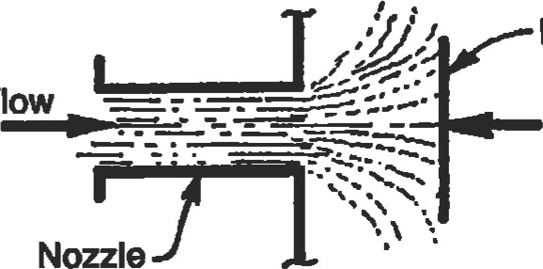

Flow

Nozzle

F

##### Figure 2. Typical nonle with intemal

10. Equivalent static forve from dynamic flow.

###### v2Ad

where F = equivalent force, 1b

V = velocity, ft/sec

A = cross-secüonal area of nozzle, ft2 d = density, lb/ft3 g = acceleration due to gravity, 32.2 ft/sec2

11. Allowable compressive s&ess in cylinders [1].

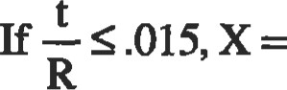 106t 200t

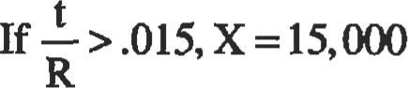

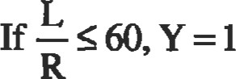

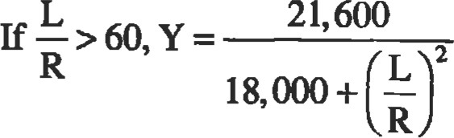

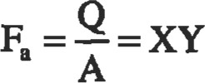

where t = thickness, in.

R = outside radius, in.

L = length of column, in.

Q = allowable load, 1b

A = metal cross-sectional area, in.2

Fa = allowable compressive stress, psi

Material Selection Guido

|  |  |  |  |  |  |  |  |
| --- | --- | --- | --- | --- | --- | --- | --- |
| Temperature, OF | | Matedal |  | Pipe | hrglngs | Fitlngs | Bolting |
|  | -425 to -321 | Stainless steel | 304, 304L, 347,  316, 316L | SA-312304, 347,  316, 316L | smu304.304L, 347,  316, 316L | SA403  304, 304', 347,  316, 316L | SA-3oB8 with SM94-8 |
| -320to -151 | 9 nickel |  |  |  | SA420-WPL8 |
|  | -78 | 31k nickel | SM03-D | SA-333-3 | SA-350-LF63 | SA420-WPL3 | SA-320-L7  SM94-4 |
| -75to -51 | 21k nlckel | SM03-A |
| -50to -21 | Carbon steel | SA.616-55, eo to SA-20 |  | SA-350-LF2 | SA4&WPL6 |
| -20b4 | SA.516-All | SA-333-1 or 6 | SM93-B7 with SA-194-2H |
| 5toæ | SA-285C | SA-53-B  SA-106-B | SA-105  SA-181-60,70 | SA-B4-WPB |
|  | 33 t060  81 to 775 | S*r5te-All  SA-51Mll SA455-ll |
|  | 776 to 875 | c-1%40 | SA-204-B | SA-335-P1 | SA-182-F1 | SA.234-WP1 |
| 878 to 1000 | ICr-1kMo | M-387-12-1 | SA-335-P12 | SA-182-F12 | SA-B4-WP12 |
| 11/4Cr-lkMo | M-387-11-2 | SA-33+P11 | smæ-F11 | SA-2WWP11 |
| 1001 to 1100 | 21kCr-1 Mo | SA-387-2A1 |  | SA-182-F2 | 34-234-wpæ | with SA-193-B5  *194-3 |
| 1101 to 1500 | Stainless steel | SA-240..347H | SA-312-347H | SM82-347H | SA403-347H | SA-193-B8 with SA-194-8 |
| Incoby |  |  |  | SB-366 |
| Above  1500 | Inconel |  | SB444 |  | SB-366 |

From Bedner, H. H., Regure Van Nostrand Reinhold 1981.

##### References

1. Boiler and Pressure Vessel code, vm, Division l, 1983 Edition, American Society of Mechanical Engineers.
2. ASN,E Boiler and Pressure Vessel code, Section Vlll, Division 2, 1983 Edition, American Society of Mechanical Engineers
3. Harvey, J. F., Theory and Design ofModem Pressuæ Vessels, 2nd Ed. New York: Van Reinhold Co., 1974.
4. Bednar, H. H., Pressure Vessel Design Handbook New York: Van Reinhold Co., 1981.
5. National Board Bulletin, vol. 32, No. 4, April 1975.
6. Roark, R. J., Fomulasfor Stress and Strain, Ed. New York: McGraw-Hill, 1975.

Source

Moss, Dennis R., Pressuæ Vessel Design Manual, 2nd Ed. Houston: Gulf Publishing co., 1997.



### •n•ibology

|  |  |  |  |  |
| --- | --- | --- | --- | --- |
| Introduction | 227 | Friction |  | 235 |
| Contact Mechanics | 227 | Wear |  | 235 |
| Two-dimensional (Line) Hertz Contact of Cylinders .... | 227 | Lubrication |  | 236 |
| Three-dimensional (Point) Hertz Contact  Effect of Friction on Contact Stress  Yield and Shakedown Criteria for Contacts  Topography of Engineering Surfaces  Definition of Surface Roughness  Contact of Rough Surfaces  Life Factors | 229  232  232  233  233  234  234 | References |  | 237 |

Thomas N. Farris, Ph.D., Professor of Aeronautics and Astronautics, Purdue University

226

Tibology

#### INTRODUCTION

Tribology is the science and technology of interacting surfaces in relative motion and the practices related thereto. The word was officially coined and defined by Jost [11]. It is derived fmm the Greek root tribos which means rubbing. Tribology includes friction, wear, and lubrication.

Tribology has several consequences in mechanical components and modern-day life. Most consequences of friction and wear are considered negative, such as power consumption and the cause of mechanical failure. However, there are also some positive benefits of friction and wear.

It is estimated that 20% of the power consumed in automobiles is used in overcoming friction, while friction acThis chapter begins with a description of contact mechanics and surface topography in sumcient detail to discuss friction, wear, and lubrication in the latter secüons.

gy is a rich subject that cannot be given jusüce in the space permitted, and the interested reader is encouraged to pursue the subject in greater depth in any of the following books: Bow&n and Tabor [3], Rabinowicz [13], Halling [7], Suh [14], Bhushan and Gupta [1], and Hutchings [9]. In addition, an enormous array of material properües is available in uibology handbooks such as Peterson and Winer [12] and Blau [2].

|  |  |  |  |  |  |  |  |  |  |  |  |  |  |  |  |  |  |  |  |  |  |  |  |  |  |  |  |  |  |  |  |  |  |  |  |  |  |  |  |
| --- | --- | --- | --- | --- | --- | --- | --- | --- | --- | --- | --- | --- | --- | --- | --- | --- | --- | --- | --- | --- | --- | --- | --- | --- | --- | --- | --- | --- | --- | --- | --- | --- | --- | --- | --- | --- | --- | --- | --- |
| |  |  |  | | --- | --- | --- | | counts for 10% of the power consumption in airplane pis- | a | contact half-width or radius | | ton engines and 1.5—2% in modern turbojets: Friction also | c | approximate radius of elliptical contacts | | leads to heat build-up which can cause the deterioration of | E H | modulus of elasticity hardness | | components due to thermo-mechanical fatigue. Under- | h | surface separation | | standing friction is the first step towards reducing friction | k | wear coefficient | | through clever design, the use of low-friction materials, and | P | load or load per length | | the proper use of lubricating oils and greases. | p po | contact pressure maximum pressure | | Friction has many benefits, such as the interaction be- | q | shear tracion | | tween the and the road and the shoe and the floor withwhich we would not travel. Friction serves |  | roughness surface radius |  |  |  |  | | --- | --- | --- | | bolt assembly. some | 2 | = x + iz iM-f | | such as the interaction between the fiber and in |  | coeffcient of Mcdon | | composites and damping which may reduce deleterious |  | RMS roughness | | effects due to resonance. | 01, T | stress components |   out be able to position as the inherent connecting mechanism in knots, nails, anddisplacements the nut and It has secondary benefits,Westergaard functions  CONTACT MECHANICS |

NomenclaWre

The solution of contact problems can be reduced to the solution of integral equaüons in which die known right-hand sides Elate to surface geomery and die unknown unda•neath the integral sign relates to the unknown pressure distribution. Details of the derivation and solution of these equaüons that highlight the necessary assumptions can be found in Johnson (1985).

##### Two-dimensional (Line) Herb Contact of Cylinders

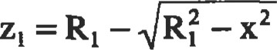In this section, the contact distribution for the frictionless contact of two long cylinders along a line parallel to their axes is derived (Figure 1). This is a special case of the contact of two ellipsoidal bodies first solved by Hertz in 1881.

The origin is placed at the point where the cylinders

first come into contact. At first contact the of the 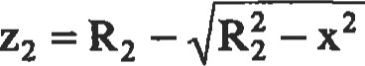 (1) cylinders is:

Thumb

x

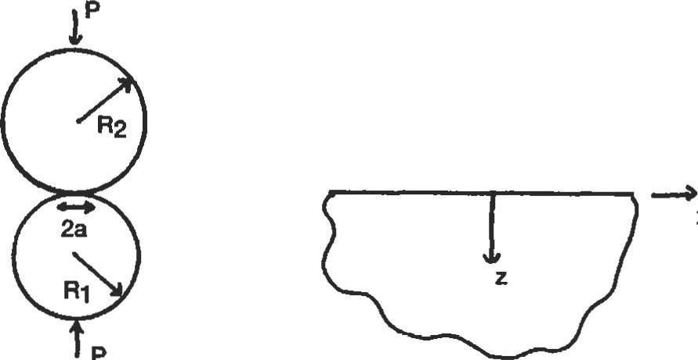

p

Figure 1. Long cylinders brought into contact by a load per unit length P.

If the contact length is small compared to the size of the cylinders, a R, then Equation 1 can be approximated as:

2

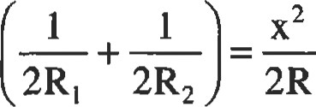

2

where I/R = I/RI + l/R2. The loads cause the cylinders to approach each other a distance ö = + 82. The cylinders must deform to cancel the interpenetration. This is written in equation form as:



or

2 x

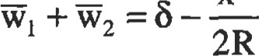

Differentiating gives:

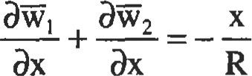

Using the equations of elasticity, the previous equation can be written as:

p(s)ds 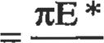x



where I/E* = (1 — + (l — V2)/E2

This equation can be inverted for p(x) and the constant of integration is used to assure that the stress is continuous at the edge of contact resulting in:

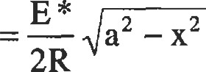

The remaining unknown is the contact length (a) which is used to ensure global equilibrium so that:

p(x)dx = P 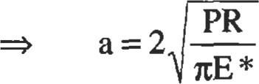

and the maximum contact pressure is:

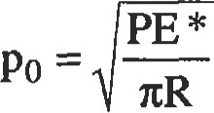 (2)

It is interesting to note that the maximum pressure varies as the square root of the load rather than linearly with the load. This is because the contact length increases with the applied load, resulting in an increased area that bears the load. From this perspective, hertzian contacts are very forgiving in the sense that overloads of a factor of two only increase the resulting contact pressure and subsurface stresses by a factor of VI.

Ductile materials will be subject to plastic deformation once the maximum shear stress in the material reaches the shear stress at yield in a tensile test. The symmetry of the problem requires that initial yielding occurs along the z-axis, which is a line of symmetry. Because = O along the zaxis, the stresses ox and are principal stresses and the maximum shear stress is one-half of their difference. These stresses along x = O are [10]:

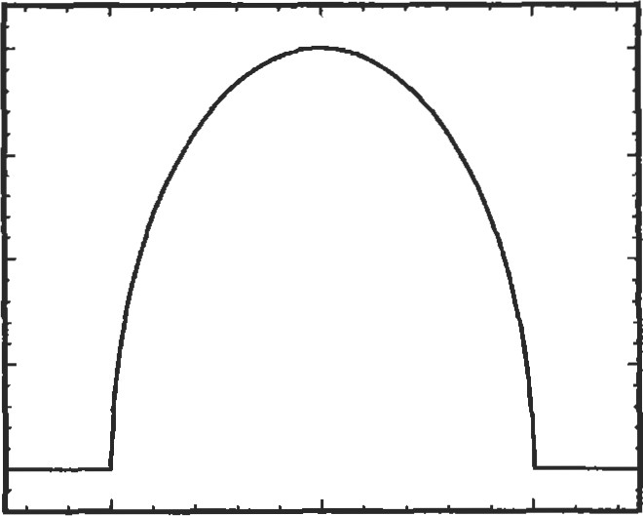1.00

€0.75

ä 0.50

0.25

-0.00

-1.0 0.0 1.0

Position (x/a)

Figure 2. Hertz line contact pressure distribution.

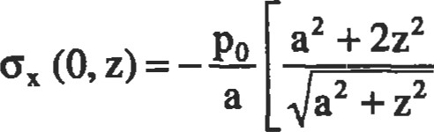— 2z

Poa

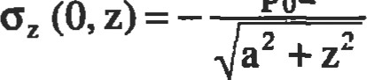

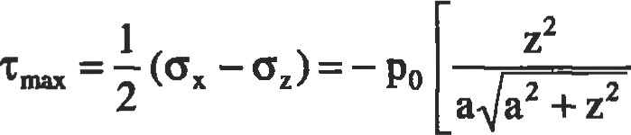 — z (3)

The maximum shear stress occurs below the surface at a depth of z 0.78a and has a value of = 0.3m. These stress distribuüons are shown in Figure 3.

.%ess (CIP)

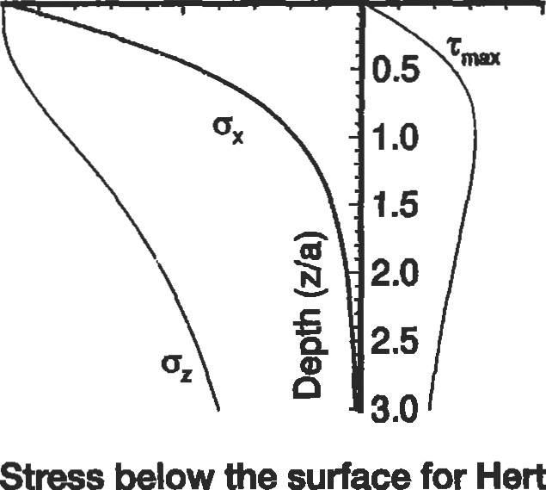

surface

for

Herü

contact.

-1.0

-0.5

0.0

0.5

Figure

3.

Stress

below

The Westergaard stress funcüons [17] can be used in conjunction with a simple FORTRAN program to evaluate the subsurface stress field induced by Heü contact. For fricfribology

tionless Hertz contact, the appropriate Westergaard stress function is

A) (4)

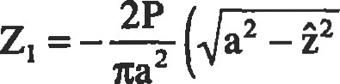

+iz

where P is the contact force per unit length, a is the half contact length, and 2 = x + iz with i = IF—I. This sü•ess function satisfies all of the ü-action boundary condiüons along z = 0. The branch cut on the radical in Equation 4 is chosen so that Zl -4 0 as 2 O. Contours of the in-plane maximum shear

|  |  |
| --- | --- |
| 2 | 2 |

(5)

are shown in Figure 4. The maximum in-plane shear stress is about 0.3 PO, where po is the maximum contact pressure, and it occurs on the z-axis at a depth of about z 0.78a.

Position (x/a)

0.0 0.5 1.0 1.5 2.0

0.0

|  |  |
| --- | --- |
|  | e 7  5  4  2  1 |
|
|

on

##### one

-0.50.231m

0.1%5 0.10812 oogtlß on—sn one

|  |
| --- |
| Three-dimensional (Point) Hertz Conect |

Figure 4. Stress contours of Ipo for contact.

In this section, the equations for three-dimensional or point contacts derived. The approach taken is very similar to that used in two-dimensional problems where the point force is superposed to yield the distributed load solutions. The point load solution is derived using Love's axisymmeüic s&ess function, and more details can be found in Chapter 12 of Timoshenko and Goodier [16] and Chapters 3 and 4 of Johnson [10].

Contact of Spheres

For an ellipsoidal pressure disuibution applied to a circle of radius, a, such that p(r) = po

üz  I—v2 po (2a2 —r2 ), r < a (6)

I-v2 — PO [(2a2 — r2 ) sin-I (a/r)

###### +r2 (a/r) (I—a2 / r ) ], r>a

Consider the spheres being brought into contact in Figure 5. The load is P, the total approach is 6, and the radius of contact is a. Geometric considerations very similar to those for the cylinders reveal that the sum of the displacements for the two spheres should satisfy:

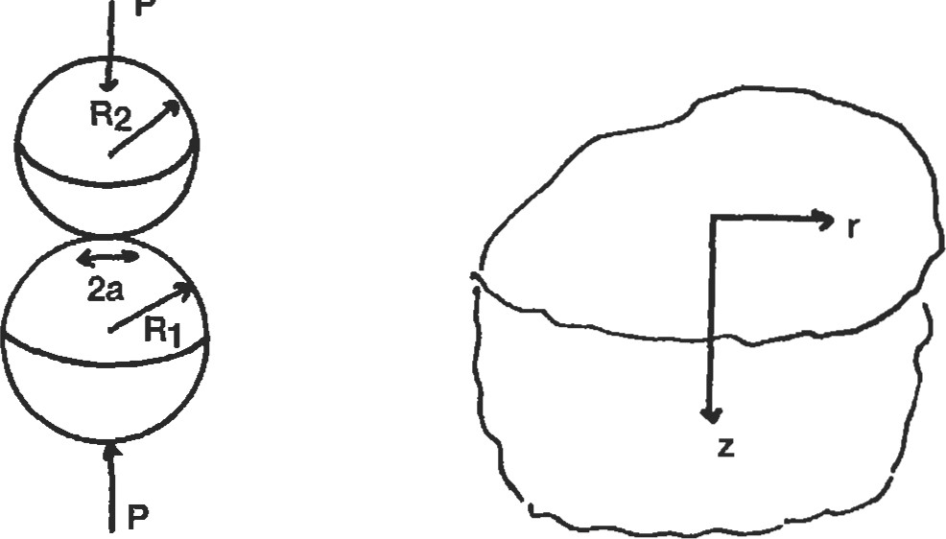

|  |
| --- |
| Thumb  p |

Figure 5. Hertz contact of spheres.

1 2

üzl + =ö (7)

where I/R = IRI + 1/R2. That is, a pressure distribution which gives a constant plus r2 term is needed to cancel the potential interpenetration of the spheres. Comparing Equations 6 and 7 reveals that the contacting spheres induce an ellipsoidal pressure distribution and

It PO 1 2

 (2a2 r ) ö——r

4 aE*

This equation must be valid for any r < a requiring:

It POR

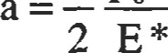

and

It apo

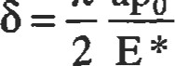

Global equilibrium requires:

|  |  |
| --- | --- |
| P = Jo  Finally: | 2  = — polta |

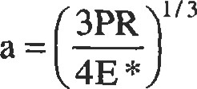 (8)

1/3

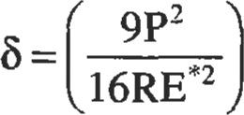 (9)

1/3

6PE*2

(10)

Tt3R2

These equations describe Hertz contact for spheres. Notice that these results are nonlinear and that the maximum pressure increases as the load is raised to the h power.

The corresponding surface stresses can be calculated as:

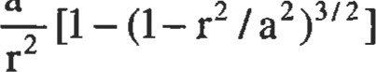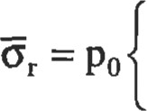I—2v a 2



—(1—r2 /a )(11)

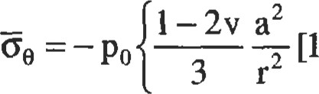2 2 3/2

|  |  |
| --- | --- |
| +2v(1- r2 /a ) | (12) |
| 2 2 1/2 | (13) |

 —(1—r / a ) 

inside the contact patch (r < a) and

 (1 — 2v)a 2

= PO (14) 3r2

outside the contact patch (r > a). These stresses are shown in Figure 6. Notice that the radial stress is tensile outside the circle and that it reaches its maximum value at r = a. This is the maximum tensile stress in the whole body.

0.50

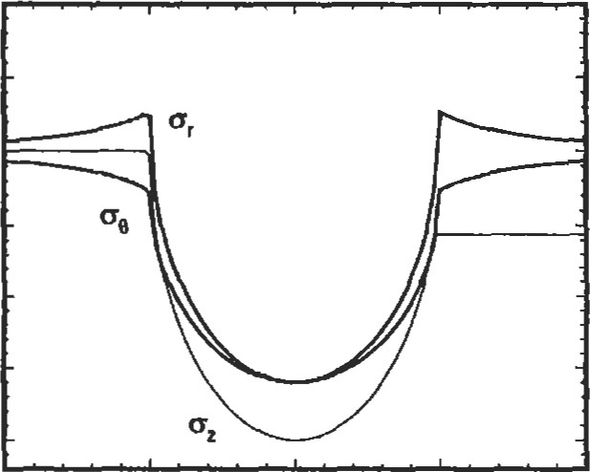0.25

0-0.00

5-0.25

a) ö -0.50

-0.75

-1.00

-2.0 -1.0 0.0 1.0 2.0

Position (r/a)

Figure 6. Surface stresses induced by circular point contact (v = 0.3).

The stresses along the z-axis (r = O) can be calculated by first evaluating the stress due to a ring of point force along r = r and integrating from r = O to r = a. For example:

3poz rar a — r2 dr a Jo (z2 + r 2 )5/2

Making the subsütution a2 — r2 = u2 and using leads to:

2 a

 (O, z) = — PO 2 (15)

I — Z tan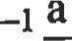

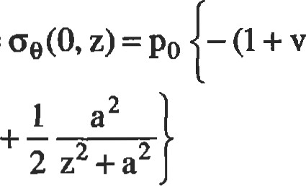

Gr

(O,

z)

=

a z

(16)

Symmetry dictates that the maximum shear stress in the body occurs along r = 0. Manipulaüon of the above equaüons leads to:

1

'tmax = — (oz(0, Z) — or (0, Z)) 2

= PO (1 + v) 1—— 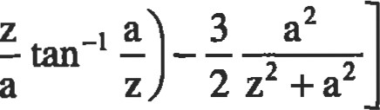tan

For v = 0.3, the maximum shear stress is about 0.3 Ipo and occurs at a depth of approximately z 0.48a. The sfresses are plotted for v = 0.3 in Figure 7.

Stress (o/po)

-1.0 -0.5 0.0 0.5

|  |  |
| --- | --- |
|  | .0 |

Figure 7. Subsurface stresses induced by ciæular point contact (v = 0.3).

Elliptical Contact

When solids having unequal curvatures in two directions are brought into contact, the contours of constant separation are ellipses. When the principal curvatures of the two bodies are aligned, the axes of die ellipse correspond to these directions. Placing the x and y axes in the directions of principal curvature, the equation comparable to Equation 7 is:

1 1

uzl + uz2 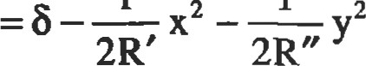 (17)

where

1 1 1

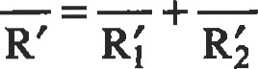

1 1 1

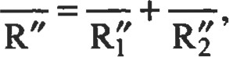

and Ri' are the curvatures in the x direction and Rf' are the curvatures in the y direction.

The contact area is an ellipse, and the resulting pressure disü•ibution is semi-ellipsoidal given by:

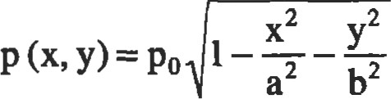

The actual calculation of a and b is cumbersome. However, for mildly elliptical contacts (Greenwood [5]), the contact can be approximated as circular with:

c = ab 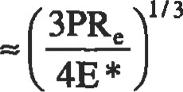

 (18)

with ö and po given by Equations 9 and 10.

Note that for contact of crossed cylinders of radii RI and R2, respecüvely, the effective radii are given by:

##### 1 1 1

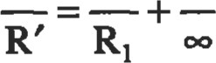

###### 1 1 1

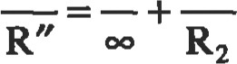

so that if RI = R2, the contact patch is circular and the equations of the previous section ("Contact of Spheres") hold.

|  |
| --- |
| numb  Effect of Friction on Contact Stress |

If contacting cylinders are loaded tangentially as well as normally and caused to slide over each other, then a shear stress will exist at the surface. This shear is equal in magnitude to the coefficient of friction multiplied by the normal contact pressure. 'I'he shear stress acts to oppose the tangential motion of each cylinder. Thus, if the top cylinder moves from the left to the right relative to the bottom cylinder, then the tangential traction on the bottom cylinder is given by:

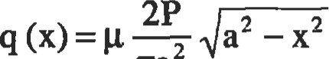 (19)

Ita

The Westergaard sfress funcüon that yields these surface tractions is:

(20)

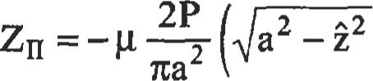

+iz

as can be verified using the equations of Westergaard [17].

Contours of the in-plane maximum shear sffess for the combined shear and normal ffactions are shown in Figures 8 and 9 for p = O. I and g = 0.4, respectively. The indenter is sliding over the surface from left to right. Notice that increasing the coefficient of friction increases the maximum shear stress while changing its location to be nearer the surface and off the z-axis towards the leading edge of contact. For the higher value of g, occurs on the surface.

Tangentially loading spheres so that they slide with respect to each other has similar effects. The subsurface maximum shear stress is increased and moved closer to the surface toward the leading edge of contact. In addition, the surface tensile sü•ess is decreased at the leading edge of con-

Position (Wa)

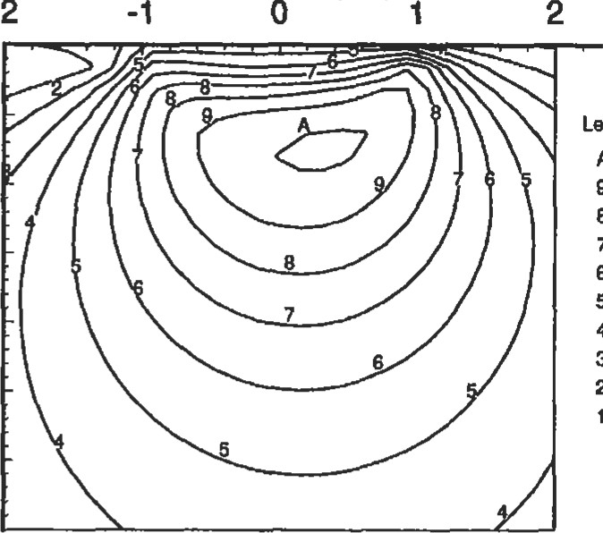

A

B

7

-2

2

0.0

0.5

@1.0

E

1.5

2.0

2.5

3.0

3.5

Level

tuna

0.3

0.27

024

021

0.1B

0.15

0.12

0.09

o.oe

0.03

Figure 8. Stress contours of max /po for frictional Hertz contact with g = 0.1. The load is sliding from left to right.

Position (x/a)

-21 2

0.0tauma

|  |  |
| --- | --- |
|  | Level  9 e 7  6  5  4  3  2 |

0.50.360.32

028

0.24

0.2

E 1.50.16

0.12

0.08

2.00.04

2.5

3.0

3.5

|  |  |  |
| --- | --- | --- |
| tact and increased at the trailing edge of contact. | contact with | = 0.4. The load is sliding from left to right. |
| Yield and Shakedown Criteria for Contacts |  |  |

Figure 9. Stress contours of tmax /po for frictional Hertz

The maximum shear stress values above can be used as initial yield criteria for contacts. However, rolling contacts that are loaded above the elastic limit can sometimes develop residual sü•esses in such a way that the body reaches a state of elastic shakedown. Elasüc shakedown implies that there is no repeated plastic deformation and the resulting deleterious fadgue effects. Shakedown occurs when the sum of the residual stresses and the live stresses do not violate yield anywhere.

Whenever the loads are such that it is possible for such a residual s&ess state to be developed, then the body does shakedown. This idea makes it possible for shakedown limits to be calculated. As an example, for two-dimensional contacts without friction, the maximum shear stress

|  |  |
| --- | --- |
| is about = 0.3 PO, implying that initial yield occurs when 0.3po = k or po = 3.3k where k is the yield stress in shear. However, it can be shown that for po < 4k, elastic shakedown is reached so that subsurface plastic deformaüon does not continue throughout life. Recalling that the max- | imum contact pressure with the square root of load makes this shakedown effect very important. More details on the concept of residual stress-induced shakedown and additional effects that can lead to shakedown such as hardening can be found in Johnson [10]. |

##### TOPOGRAPHY OF ENGINEERING SURFACES

|  |  |
| --- | --- |
| The discussion of surface roughness and the techniques used to quantify it are discussed here. Some general work in this area includes Thomas [15] and Greenwood [6].  'Ihe length scale of interest is smaller than that consid- | mechanical properties also different near the surface than they are in the bulk of the material.  Table 1  Surface Roughness for Various Flnishing Processes |

|  |  |
| --- | --- |
| Process | RMS Roughness (Microns) |
| Grinding  "ne grinding  Polishing  Super finishing | 0.8 0.4  0.25  0.1  0.025 0.01 |

ered in the Hertz contact calculations in which contact suesses are calculated to discover what is happening inside the body such as the locadon of first yield or cracking. Now we are going to focus on fre surface of the bodies. One convenient manner of characterizing this surface is to measure its surface roughness. However, it is important to note that

###### Definition of Surface Roughness

Consi&t a surface profile whose height is given as a func- The root-mean-square roughness or standard deviation don of position z(x). The datum is chosen so that: is defined by:

fo z(x)dx = O 02 = —f z 2dx

'Ihe average roughness Ra is defined as: The RMS roughness is always greater than the average roughness so that:

JOLIzldx

6>Ra die absolute value implies that peaks and valleys have the same contribution. and Thumb

1.2Ra

for most surfaces. Typical RMS values for finishing processes are given in Table 1.

Of course, widely different surfaces could give the same Ra and RMS values. The type of statistical quantity needed will depend on the application. One quantity that is used in practice is the bearing area curve which is a plot of the surface area of the surface as a function of height. If the surface does not deform during contact, then the bearing area curve is the relationship between actual area of contact and approach of the two surfaces. This concept leads to discussion of con- along surface (mm)

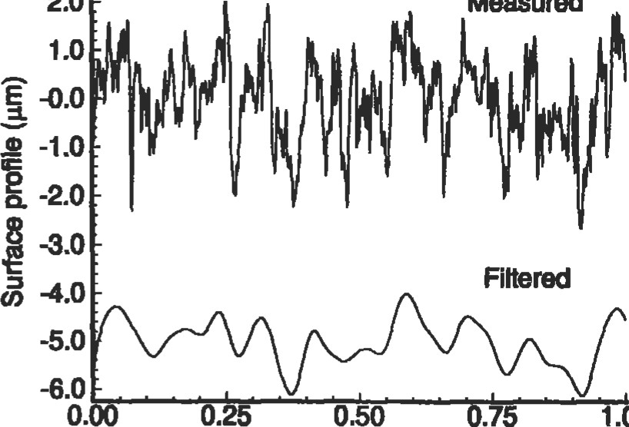

2.0

Measured

0.25

0.50

.75

1.00

Diü1ce

|  |  |
| --- | --- |
| tact of actual rough surface contacts. (See also Figure 10.) | Figure 10. A typical rough surface. |
| Contact of Rough Surfaces |  |

Much can be gleaned from consideration of the contact of rough surfaces in which it is found that the real area of contact is much less than the apparent area of contact as illustrated by the contact pressure disfributions shown in Figure 11. The smooth solid line is the contact pressure for contact with an equivalent smooth surface, while the line showing pressure peaks is the contact pressure for contact with a model periodic rough surface. The dashed line is the moving average of the rough surface contact pressure, and it is very similar to that of the Hertz contact with the smooth surface. Thus, the subsurface stresses are similar for 1.5

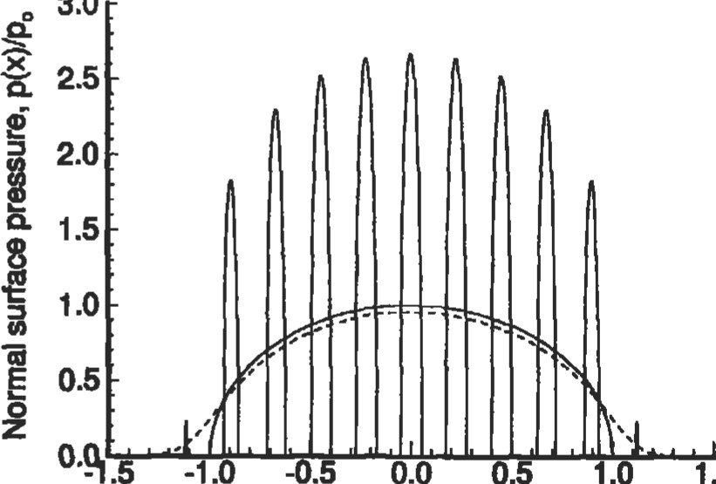

3.0

-1.0

.5

0.0

0.5

1.0

|  |  |
| --- | --- |
| the smooth and rough surface contacts, and yield and plastic flow beneath the surface is not strongly dependent on the surface roughness. ms conclusion is the reason that many hertzian contact designs are based on calculated smooth surface pressure disüibuüons with an accompanying call-out on surface roughness. | Posidon along surface, Wa  figure 11. Line contact pressure distibuöon for periodic rough surface. |

###### Life Factors

The fact that some of the informaüon contained in the rough surface st-ess field can be inferred from the corresponding Hertz sffesses and the surface profile has lead to the development of life factors for rolling element bearings. In these life factor equations, there are terms that account for near-surface metallurgy, surface roughness, lubrication, as well as addiüonal effects. These life factors were summarized recently by longtime in the bearing design field. This summary can be found in Zaretsky [18] and is written in a format that can be applied easily by the practicing engineer.

|  |
| --- |
| FRICTION |

Consider a block of weight W resting on an inclined plane. As the plane is €1ted to an angle with the horizontal e, the weight can be resolved into force components perpendicular to the plane N and parallel to the plane F. If 9 is less than a certain value, say, es, the block does not move. It is inferred that the plane resists the motion of the block that is driven by the component of the weight parallel to the plane. The force resisting the motion is due tofriction between the plane and block. As e is increased past Os the block begins to move because the tangential force due to the weight F overcomes the frictional force. It can be shown experimenmlly that es is approximately independent of the size, shape, and weight of the block. The ratio of F to N at sliding is tan g, which is called the coeficient offriction. The frictional resistance to modon is equal to the coemcient of friction ümes the compressive normal force between two bodies. The coefficient of friction depends on the two materials and, in general, 0.05 < < 00.

The idea that the resistance to motion caused by friction is F = g.N is called the Amontons-Coulomb Law of sliding friction. This law is not like Newton's Laws such as F = ma. The more we study the friction law, the more complex it becomes. In fact, we cannot fully explain the friction law as evidenced by the fact that it is difficult or even impossible to estimate g for two materials without performing an experiment. As a point of reference, g is tabulated for severAssuming that the real area of contact is equal to the applied load divided by the hardness of the softer material, and that the shear stress required to break the junctions is the yield stress in shear of the weaker material, leads to:

where g is the coefficient of friction, ty is the yield stress in shear, and H is the hardness. For most materials, the hardness is about three drnes the yield stress in tension and the Tresca yield conditions assume that the yield stress in shear is about half of the yield st-ess in tension. Substituting leads to g 1/6.

The simple adhesive law of friction is amctive in that it is independent of the shape of the bodies and leads to the force acting opposite the direction of motion, resulting in energy dissipation. Its weakness is that it incorrectly predicts that g is always equal to 1/6. This can be explained in part by the effect of large localized contact pressure on material properties and the conüibution of plowing and thermal effects.

Table 2

|  |
| --- |
| al everyday circumstances in Table 2.  As noted in the rough surface contact section, the real area of contact is invariably dian the apparent area of contact. The most common model of friction is based on assuming that the patches of real contact area form juncüons in which the two bodies adhere to each other. The resistance to sliding, or friction, is due to these juncüons. Source: Bowden [31  WEAR |

|  |  |
| --- | --- |
| Physical Situation |  |
| Rubber on cardboard (try it)  Brake material on brake drum  Dry tire on dry road  Wet tire on wet mad  Copper on steel, dry Ice on wood | 0.5-0.8  1.2  1  0.2  0.7  0.05 |

Typical Coefficients of Friction

The rubbing together of two bodies can cause material removal or weight loss from one or both of the bodies. This phenomenon is called wear. Wear is a very complex process. It is much more complex even than friction. The complexity of wear is exemplified in Table 3 where wear rate is shown with for several material combinations. Radical differences in wear rate occur over relatively small ranges of the coefficient of fricüon. Note that wear is calculated from wear rate by mulüplying by the distance traveled.

There are several standard wear configurations that can be used to obtain wear coefficients and compare material choices for a particular design. A primary source for this information is the Wear Confiol Handbook by Peterson and Winer [12].

Thumb

Table 3

Fricüon and Wear from Pin on Ring Tests

|  |  |  |
| --- | --- | --- |
| Matedals | g | 3 cm  Wear rate x 10-12 |
| 1. Mild steel on mild steel 2. 60/40 leaded brass 3. PTFE (Teflon) 4. Stelltte 5. Fenitic stainless steel 6. Polyethylene 7. Tungsten carbide on itself | 0.62  0.24  0.18  0.60  0.53  0.65  0.35 | 157,000  24,000  2,000  270  30  2 |

Rings are hardened tool steel in tests 1 and 7 (Hdllng PI). me load Is 400 g and Vie speed is 180 cm/sec.

As in friction, the most pmminent wear mechanism is due to adhesion. Assuming that some of the real contact area junctions fail just below the surface leading to a wear particle results in:

###### V=k-—

|  |
| --- |
| LUBRICATION |

where V is the volume of material removed, W is the normal load, s is the horizontal distance Eaveled, H is the hardness of the softer material, and k is the dimensionless wear coemcient representing the probability that a junction will form a wear particle. In this form, wear coeffcients vm•y from — 10-8 to — 10-2. There is a wealth of on wear coefficients published biannually in the proceedings of the International Conference on Wear of Materials, which is sponsored by the American Society of Mechanical Engineers.

Lubrication is the effect of a third body on the contacting bodies. Ihe body may be a lubricating oil or a ically formed layer from one or both of the contacting bodies (oxides). In general, the coemcient of fricü)n in the presence of lubrication is reduced so that 0.001 < g < 0.1. is understood to fall into three regimes dependent on the component configuration, load, and speed. Under relatively modest loads in conformal contacts such as a journal bearings, moderate pressures exist and the deformation of the solid components does not have a large effect on the lubricant pressure distribution. The bodies are far apart and wear is insignificant. This regime is known as hydrodynamic lubrication.

As loads are increased and the geometry is nonconforming, such as in roller bearings, the lubricant pressure greatly increases and the elastic deformation of the solid components plays a role in lubricant pressure. This regime is known as elastohydrodynamic lubricaüon, provided the lubrication film thickness is geater than about three ümes the surface roughness. Once the film thickness gets smaller than this, the solid bodies touch at isolated patches in a mechanism known as boundary lubrication. Here, the intense pressures and temperatures make the chemisüy of the lubricant surface interaction important.

The lubricant film thickness is su•ongly dependent on lubricant viscosity at both high and low temperatures. Nondimensional formulas are available for designers to use in distinguishing the regimes of lubrication. Once the regime of lubrication is determined, additional formulas can be used to esümate the maximum contact pressure as well as the milk imum film thickness. The maximum contact pressure can then be used in the life factors of Zaretsky [18], and the miry imum film thickness can be used in the consideration of lubricant film breakdown. While these formulas are too numerous to summarize here, a primary source is Hamrock [8] in which all of the requisite formulas are defined.

|  |
| --- |
| REFERENCES |

1. Bhushan, B. and Gupta, B. K., Handbook of Tribology: Materials, Coatings, and Surface Treatments. New York: McGraw-Hill, 1991.
2. Blau, P. J. (Ed.), Friction, Lubrication, and Wear Technology. ASM Handbook, vol. 18, ASM, 1992.
3. Bowden, F. P. and Tabor, D., The Friction and Lubrication ofSolids: Part I. Oxford: Clarendon Press, 1958.
4. Bowden, F. P. and Tabor, D., Friction: An Introduction to Tribology. Melbourne, FL: Krieger, 1982.
5. Greenwood, J. A., "A Unified Theory of Surface Roughness," Proceedings of the Royal Society, A393, 1984, pp. 133-157.
6. Greenwood, J. A., "Formulas for Moderately Elliptical Hertzian Contact," Joumal of Tribology, 107(4), 1985, pp. 501-504.
7. Halling, J. (Ed.), Principles of Tribology. MacMillan Press, Ltd., 1983.
8. Hamrock, B. J., Fundamentals ofFluid Film Lubrication. New York: McGraw-Hill, 1994.
9. Hutchings, I. M., THbology: Friction and Wear ofEngineering Materials. Boca Raton: CRC Press, 1992.
10. Johnson, K. L., Contact Mechanics. Cambridge: Cambridge, 1985.

ll. Jost, P., "Lubrication (Tribology) Education and Research," Technical report, H.M.S.O., 1966.

1. Peterson, M. B. and Winer, W. O. (Eds.), Wear Control Handbook ASME, 1980.
2. Rabinowicz, E., Friction and Wear ofMaterials. New York: Wiley, 1965.
3. Suh, N. R, Tribophysics. Englewood Cliffs: PrenticeHall, 1986.
4. Thomas, T. R. (Ed.), Rough Surfaces. London: Longman, 1982.
5. Timoshenko, S. P. and Goodier, J. N., Theory of Elasticity, 3rd Ed. New York: McGraw-Hill, 1970.
6. Westergaard, H. M., "Bearing Pressures and Cracks," Journal ofApplied Mechanics, 6(2), A49-A53, 1939.
7. Zaretsky, E. V. (Ed.), SILE Life Factors for Roller Bearings. Society of Tribologists and Lubrication Engi.neers, 1992.

### Vibration

Lawrence D. Norris, Senior Technical Marketing Engineer—Large Commercial Engines, Allison Engine Company,

Rolls-Royce Aerospace Group

Vibration Definitions, Terminology, and Symbols 239 Solving the One Degree of Freedom System243 Solving Multiple Degree of Freedom Systems245

Vibration Measurements and Instrumentation ..... 246

Table A: Spring Stiffness250

Table B: Natural Frequencies of Simple Systems.. 251 Table C: Longitudinal and Torsional Vibration of

Uniform Beams 252

Table D: Bending (Transverse) Vibration of

Uniform Beams 253 Table E: Natural Frequencies of Multiple DOF

Systems 254

Table F: Planetary Gear Mesh Frequencies 255

Table G: Rolling Element Bearing Frequencies and Bearing Defect Frequencies 256

Table H: General Vibration Diagnostic

Frequencies 257

|  |
| --- |
| 238 |

References 258

|  |
| --- |
| Vibration Definitions, Terminology, and Symbols |

This chapter presents a brief discussion of mechanical and its associated terminology. Its main emphasis is to provide practical "rules of thumb" to help calculate, measure, and analyze vibration frequencies of mechanical systems. Tables are provided with useful formulas for computing the vibration frequencies of common mechanical systems. Additional tables are provided for use with vibraüon measurements and instrumentation. A number of well-known references are also listed at the end of the chapter, and can be referred to when additional information is required.

Beating: A vibraüon (and acoustic) phenomenon that occurs when two harmonic motions (Xl and x2) of the same amplitude (X), but of slightly different frequencies are applied to a mechanical system:

 = X COS ot

= X cos (o + Ao) t

The resultant motion of the mechanical system will be the superposition of the two input vibrations and x2, which simplifies to:

Ao x = 2X cos t co 0+—— t

2

This vibration is called the beating phenomenon, and is illusüated in Figure l. The frequency and period of the beats will be, respectively:

#### Ao

f cycles/ sec

27t

T = — sec

Ao

A common example of beating vibration occurs in a twin engine aircraft. Whenever the speed of one engine varies slightly from the other, a person can easily feel the beating in the aircraft's s&ucture, and hear the vibration acoustically.

Critical speeds: A term used to describe resonance points (speeds) for rotating shafts, rotors, or disks. For example, the critical speed of a turbine rotor occurs when the rotational speed coincides with one of the rotor's natural frequencies.

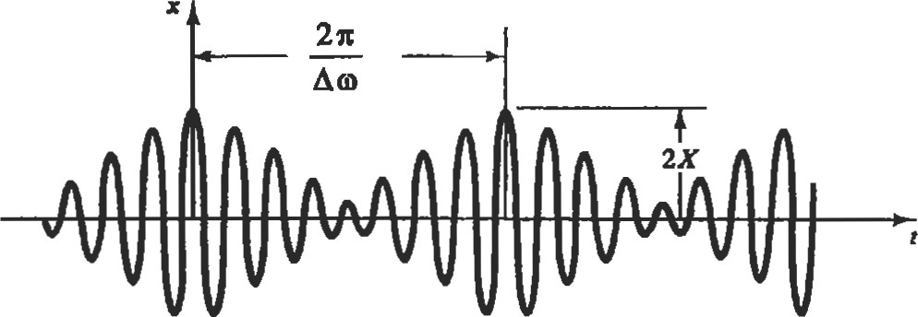

Figue 1. Beating phenomenon.

Damped natural frequency (Od or G): The inherent frequency of a mechanical system with viscous damping (friction) under free, unforced vibration. Damping decreases the system's natural frequency and causes vibratory motion to decay over time. A system's damped and undamped natural frequencies are related by:

Od 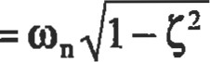

Damping (c): Damping dissipates energy and thereby "damps" the response of a mechanical system, causing vibratory to decay over time. Damping can result from fluid or air resistance to a system's moüon, or from friction between sliding surfaces. Damping force is usually proportional to the velocity of the system: F = ci, where c is the damping coeficient, and typically has units of lb-sec/in or N-sec/m.

r

Da.ing rado ( # lhe damped namral frequency is related to a system's undamped natural frequency by the following formula:

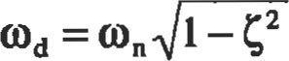

|  |
| --- |
| Thumb |

'Ihe damping ratio (C) determines the rate of decay in the vibration of the mechanical system. No vibratory oscillation will exist in a system that is overdamped (G > I .0) or critically damped (G = I .0). The length of time required for vibratory oscillaüons to die out in the underdamped system (G <1.0) increases as the damping raüo decreases. As decreases to O, (Dd equals on, and vibratory oscillations will continue indefinitely due to the absence of friction.

Degrees of freedom (DOF): The minimum number of independent coordinates required to describe a system's motion. A single "lumped mass" which is to move in only one linear direction (or angular plane) is said to be a "single DOF" system, and has only one discrete natural fiequency. Conversely, continuous media (such as beams, bars, plates, shells, etc.) have their mass evenly distributed and cannot be modeled as "lumped" mass systems. Continuous media have an infinite number of small masses, and therefore have an infinite number of DOF and natural frequencies. Figure 2 shows examples of one- and Ogro-DOF systems.

Equation of motion: A differential equation which describes a mechanical system's motion as a function of time. The number of equations of motion for each mechanical system is equal to its DOF. For example, a system with two-DOF will also have two equations of moüon. The two natural frcquencies of this system can be determined by finding a solution to these equations of motion.

Forced vibration: When a continuous external force is applied to a mechanical system, the system will vibrate at the frequency of the input force, and initially at its own natur-

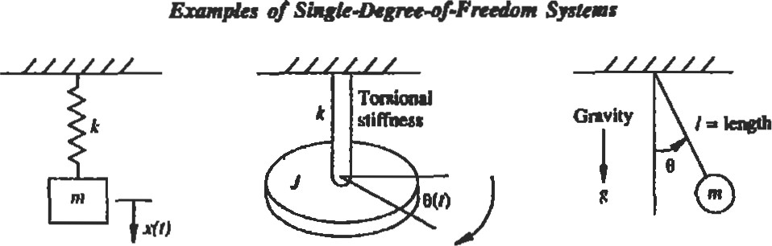

Spring—m.sx Shaft and ask Simple paidulum n? + kr=O

—a ofneo-D«eg

|  |  |  |  |  |  |  |  |  |  |  |  |
| --- | --- | --- | --- | --- | --- | --- | --- | --- | --- | --- | --- |
| |  |  |  |  |  | | --- | --- | --- | --- | --- | |  |  | | |  | |  | | k2 |  | | |  |

Figure 2. One and two degree of freedom mechanical systems (Reprinted by permission of Prentice-Han, Inc., Upper Saddle River, NJ.)

al frequency. However, if damping is present, the vibration at Od will eventually die out so that only vibraüon at åe forcing frequency remains. This is called the steady state response of the system to the input force. (See Figure 3.)

Free vibration: When a system is displaced from its equilibrium position, released, and then allowed to vibrate without any further input force, it will vibrate at its natural frequency (wn or Wd). Free vibration, with and without damping, is illustrated in Figure 3.

Frequency (o or 0: The rate of vibration, which can be expressed either as a circular frequency (o) with units of radians per second, or as the frequency (D of the periodic motion in cycles per second (Hz). The periodic frequency (f) is the reciprocal of the period (f = I'D. Since there are 27t radians per cycle, o = 21tf.

|  |  |  |
| --- | --- | --- |
| x |  | |
|  |  | t |

Free Vibration (with damping)

|  |  |  |  |  |  |  |
| --- | --- | --- | --- | --- | --- | --- |
| x |  |  |  |  |  |  |
|  | t | | | | | |

Forced Vibration (at steady state response)

Free Vibration (without damping)

Figure 3. Free vibration, with and without damping.

Harmonic/spectral analßis (Fourier series): Any complex periodic motion or random vibraüon signal can be represented by a series (called a Fourier series) of individual sine and cosine functions which are related harmonically. The summaüon of these individual sine and cosine waveforms equal the original, complex waveform of the periodic modon in question. When the Fourier spectrum of a vibration signal is plotted (vibration amplitude vs. frequency), one can see which discrete vibration frequencies over the entire frequency specuum contribute the most to the overall vibraüon signal. Thus, spectral analysis is very useful for troubleshooting vibration problems in mechanical systems. Spectral analysis allows one to pinpoint, via its operational frequency, which component of the system is causing a vibration problem. Modem vibration analyzers with digital microprocessors use an algorithm kiown as Fast Fourier Transform (FFI) which can perforrn spectral analysis of vibration signals of even the highest frequency.

Ibrmmic frequencies: Integer multiples of the natural frequency of a mechanical system. Complex systems frequently vibrate not only at their natural frequency, but also at harmonics of this frequency. The richness and fullness of the sound of a piano or guitar string is the result of harmonics. When a frequency varies by a 2: 1 ratio relative to another, the frequencies are said to differ by one octave.

Mode shapes: Multiple DOF systems have multiple natural frequencies and the physical response of the system at each natural frequency is called its mode shape. The actual physical deflecüon of the mechanical system under viis different at each mode, as by the cantilevered beam in Figure 4.

Natural frequency (on or fn): The inherent frequency of a mechanical system without damping under free, unforced vibradon. For a simple mechanical system with mass m and stiffness k, the natural frequency of the system is:

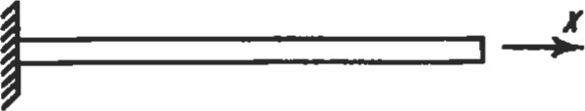

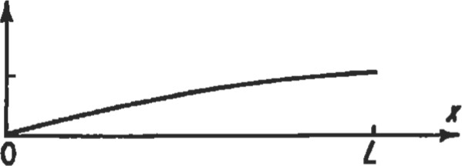1st mode shape

(O nodes)

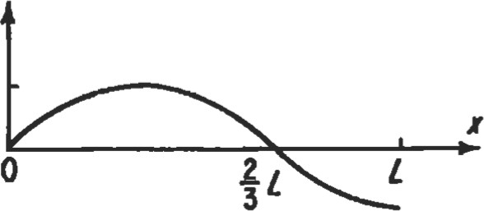2nd mode shape

(1 node)

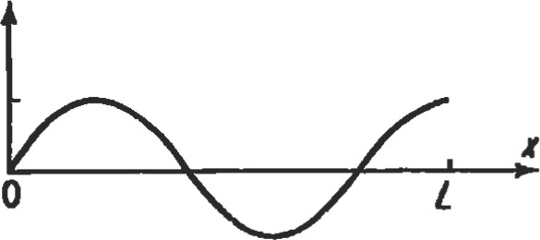3rd mode shape (2 nodes)

Figure 4. Mode shapes and nodes of tie cantilever beam. k on —

Node point: Node points are points on a mechanical system where no vibration exists, and hence no deflection from the equilibrium position occurs. Node points occur with multiple DOF systems. Figure 4 illustrates the node points for the 2nd and 3rd modes of vibraüon of a cantilever beam. Antinodes, conversely, are the positions where the vibratory displacement is the greatest.

Phase angle (4)): Since vibration is repetitive, its periodic motion can be defined using a sine function and phase angle. The displacement as a function of time for a single DOF system in SHM can be described by the function:

x(t) = A sin (ot + Q)

where A is the amplitude of the vibration, o is the vibration frequency, and is the phase angle. The phase angle sets the initial value of the sine function. Its units can either be radians or degrees. Phase angle can also be used to describe the time lag between a forcing function applied to a system and the system's response to the force. The phase relationship between the displacement, velocity, and acceleraüon of a mechanical system in steady state vibration is illusü•ated in Figtu•e 5. Since acceleration is die first derivative of velocity and second daivative of displæement, its phase angle velocity by 90 degrees and displacement by 180 degrees.

|  |  |
| --- | --- |
|  |  |
| 900 | 2700 4500 |
|  | 7200 |
| 9 00 | 2700 4500 6300 |

displacement

v velocity

a acceleration

Figure 5. Interrelationship between the phase angle of displacement, velocity, and acceleration (Reprinted by of the Insituüon of Diagnosäc Engineers.)

Thumb

Resonance: When the frequency of the excitation force (forcing ftlncüon) is equal to or very close to the natural fiequency of a mechanical system, the system is excited into resonance. During resonance, vibration amplitude increases dramatically, and is limited only by the amount of inherent damping in the system. Excessive vibration during resonance can result in serious damage to a mechanical system. Thus, when designing mechanical systems, it is extremely important to be able to calculate the system's natural frequencies, and then ensure that the system only operate at speed ranges outside of these frequencies, to ensure that problems due to resonance are avoided. Figure 6 ilhow much vibration can increase at resonance for various amounts of damping.

Rotting unbalance: When the center of gravity of a rotating part does not coincide with the axis of unbalance and its coresponding vibration will result. The unbalance force can be expressed as:

F = med

where m is an equivalent eccentric mass at a distance e from the center of rotation, rotating at an angular speed of 0.

Simple harmonic motion (SHM): The simplest form of undamped periodic moüon. When plotted against üme, the displacement of a system in BSI-ma is a pure sine curve. In SEM, the acceleration of the system is inversely proporü)nal ( 180 degrees out of phase) with the linear (or angular) displacement from the origin. Examples of SHM are simple one-DOF systems such as the pendulum or a single massspring combination.

Spring rate or stiffness (k): The elasticity of the mechanical system, which enables the system to store and release kinetic energy, thereby resulting in vibraüon. The input force (F) required to displace the system by an amount (x) is proportionate to this spring rate: F = The spring rate will typically have units of lb/in. or N/m.

Vibration: A periodic motion of a mechanical system which occurs repetitively with a time period (cycle time) of T seconds.

Vibration transmissibility: An important goal in the installation of machinery is frequently to isolate the vibration and motion of a machine from its foundation, or vice versa. Vibration isolators (sometimes called elastomers) are used to achieve this goal and reduce vibration ü•ansmitted through them via their damping properties. Transmissibility (TR) is a measure of the extent of isolaüon achieved, and is the amplitude ratio of the force being &ansmitted across the vibration isolator (FD to the imposing force (Fo). If the frequency of the imposing force is o, and the natural frequency of the system (composed of the machinery mounted on its vibraüon isolators) is on, the transmissibility is calculated by:

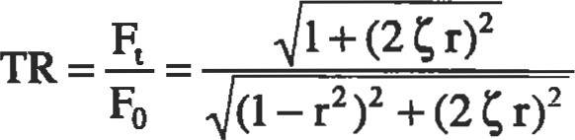

where = damping ratio r = frequency ratio = 

Figure 6 shows that for a given input force with frequency (o), flexible mounting (low on, high r) with very light damping provides the best isolation.

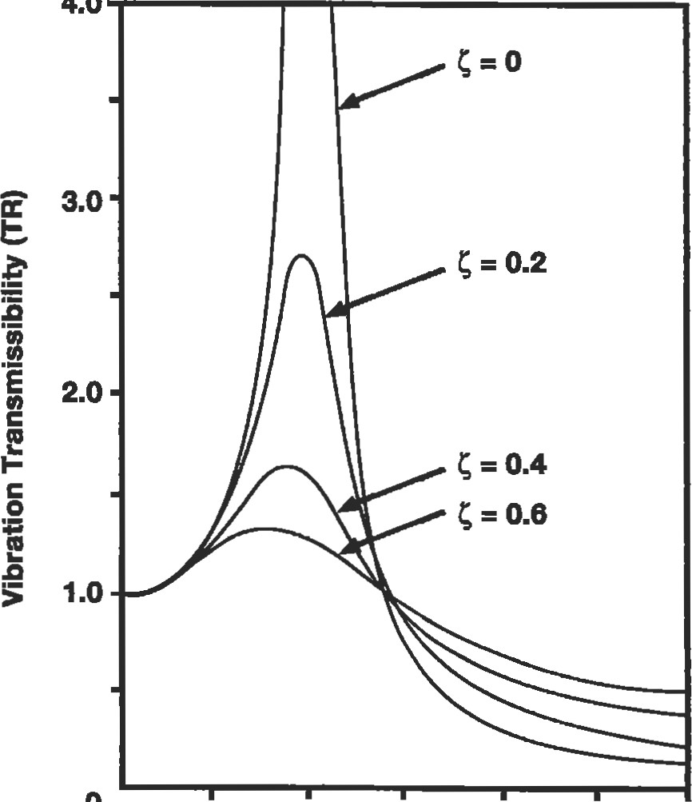

4.0

O 1.0 2.0 3.0

Frequency Ratio

Figure 6. Vibration transmissibility vs. frequency ratio.

|  |
| --- |
| Solving the One Degree of Freedom System |

A simple, one degree of freedom mechanical system with damped, linear motion can be modeled as a mass, spring, and damper (dashpot), which represent the inertia, elasticity, and the friction of the system, respectively. A drawing of this system is shown in Figure 7, along with a free body diagram of the forces acting upon this mass when it is displaced from its equilibrium position. The equation ofmotion for the system can be obtained by summing the forces acting upon the mass. From Newton's laws of motion, the sum of the forces acting upon the body equals its mass times acceleration:

EF = ma = mi = F — kx — c*

where F = F(t) x = x(t) Simplifying the equation:

mi + ci + kx = F

This equation of describes the displacement (x) of the system as a function of time, and can be solved to determine the system's naturalfrequency. Since damping is present, this frequency is the system's damped natural frequency. The equation of motion is a second order differential equation, and can be solved for a given set of initial condiüons. Initial conditions describe any force that is being applied to the system, as well as any initial displacement, velocity, or acceleration of the system at time zero. Soludons to this equation of motion are now presented for two different cases of free (unforced) vibration, and forced harmonic vibration.

|  |  |  |  |  |  |  |  |  |  |  |  |  |  |
| --- | --- | --- | --- | --- | --- | --- | --- | --- | --- | --- | --- | --- | --- |
|  | |  |  |  |  | | --- | --- | --- | --- | |  | |  | | | m | | | | |  |  | |  | |

Figure 7. Single degree of freedom system and free body diagram.

Solutlon for Free Vibration

For the case of free vibration, the mass is put into motion following an initial displacement and/or initial velocity. No external force is applied to the mass other than that force required to produce the initial displacement. The mass is released from its initial displacement at üme t = O and allowed to vibrate freely. The equation of motion, initial conditions, and solution are:

mi + c* + kx = O

Initial conditons (at time t = 0):

F = 0 (no force applied) xo = initial displacement = initial velocity

Solution to the Equation of Motion:

XO COS Odt+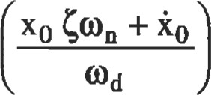sin Odt

k

where : on —

= undamped natural frequency (rad/sec .)

Od = on 1 — G2 = damped natural frequency

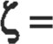—- = damping factor ccr ccr = 2G = critical damping

The response of the system under free vibration is ilin Figure 8 for the three separate cases of underdamped, overdamped, and critically damped motion. The damping factor (C) and damping coefficient (c) for the underdamped system may be determined experimentally, if they are not already known, using the logarithmic decrement (G) method. The logarithmic decrement is the natural logarithm of the ratio of any two consecutive amplitudes (x) of free vibration, and is related to the damping factor by the following equation:

x2 Itc

Ö=ln xn+l

#### numb

Given the magnitude of two successive amplitudes of vibration, this equation can be solved for and then the damping coeffcient (c) can be calculated with the equations listed previously. When is small, as in most mechanical systems, the log-decrement can be approximated by:

Dispbement (mm)

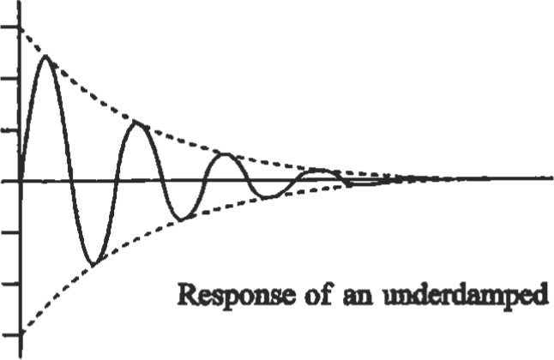

lime

(s)

<

1

systen• > 1

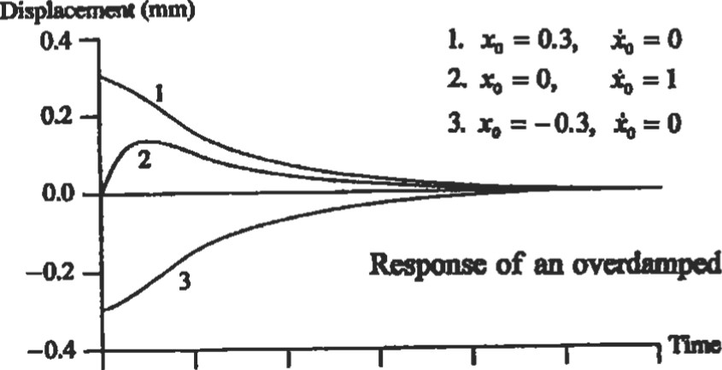

Time

(8)

o 1 2 3 4 S 6

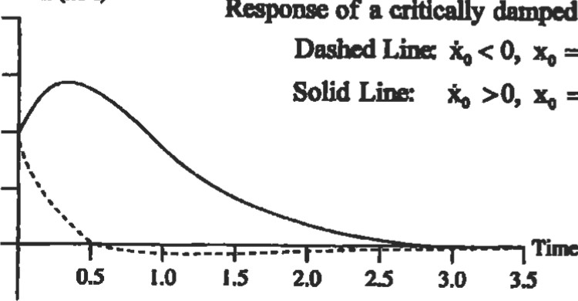

Time

(s)

Di»luanent

(mm)

0.8

=

1

0.6

—0.2

=

0.4mm

=

0.4

mm

Figure 8. Response of underdamped, overdamped, and critically damped systems to free vibration [1]. (Reprinted by pennjssion of Prentice-Hall, Inc., Upper Saddle River, NJ.)

Solution for Forced Harmonic

We now consider the case where the single degree of freedom system has a constant harmonic force (F = Fo sin ojt) acting upon it. The equation of motion for this system will be:

mi + + kx = Fo sin o t

The solution to this equation consists of two parts: free vibration and forced vibradon. The solution for the free vibration component is the same solution in the preceding paragraph for the free vibraüon problem. ms free vibration will dampen out at a rate proportional to the system's damping ratio (G), after which only the steady state response to the forced vibraüon will remain. This steady state response, illustated previously in Figure 3, is a harmonic vibraüon at the same frequency (o) as the forcing function (F). Therefore, the steady state solution to the equation of motion will be of the form:

x = X sin (ot + Q)

X is the amplitude of the vibration, o is its frequency, and is the phase angle of the displacement (x) of the system relative to the input force. When this expression is substituted into the equation of motion, the equation of modon may then be solved to give the following expressions for amplitude and phase:

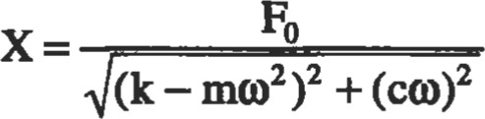

CO

#### 4=tan 2

k — m0

These equations may be further reåuced by subsftudng with the following known quantities:

k

o = — = undamped natural frequency

##### ccr = 2A/G = criücal damping

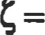— = damping factor

Following this substitution, the amplitude and phase of the steady state response are now expressed in the following nondimensional form:

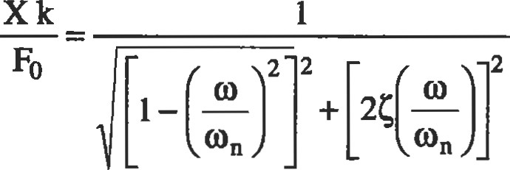

tan $ =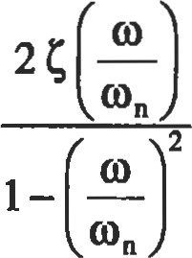

These equations are now functions of only the frequency ratio (don) and the damping factor (G). Figure 9 plots this nondimensional amplitude and phase angle versus the frequency ratio. As illustrated by this figure, the system goes into resonance as the input frequency (o) approaches the system's natural frequency, and the vibration amplitude at resonance is consü•ained only by the amount of damping (G) in the system. In the theoretical case with no damping, the vibration amplitude reaches infinity. A phase shift of 180 degrees also occurs above and below the resonance point, and rate that this phase shift occurs (relative to a change in frequency) is inversely proportional to the amount of damping in the system. This phase shift occurs instantaneously at o = on for the theoretical case with no damping. Note also that the vibration amplitude is very low when the forcing frequency is well above the resonance point. If sumcient damping is designed into a mechanical system, it is possible to accelerate the system quickly through its resonance point, and then operate with low vibradon in speed ranges above tffs frequency. In rot±g machinery, this is commonly referred to as "operating above the critical speed" of the rotor/shaft/disk.

|  |  |  |  |  |  |  |  |  |  |  |
| --- | --- | --- | --- | --- | --- | --- | --- | --- | --- | --- |
|  |  |  |  |  |  |  |  |  |  |  |
|  |  |  |  |  |  |  |  |  |  |  |
|  |  |  |  |  |  |  |  |  |  |  |
|  |  |  | |  |  |  |  |  |  |  |
|  |  |  | |  |  |  |  |  |  |  |
|  |  |  | |  | # | 1.0 |  |  |  |  |
|  |  |  | |  |  |  |  |  |  |  |

3.0

2.0

1.0

|  |  |  |
| --- | --- | --- |
| o | 2.0 3.0  Frequency Ratio | 5.0 |

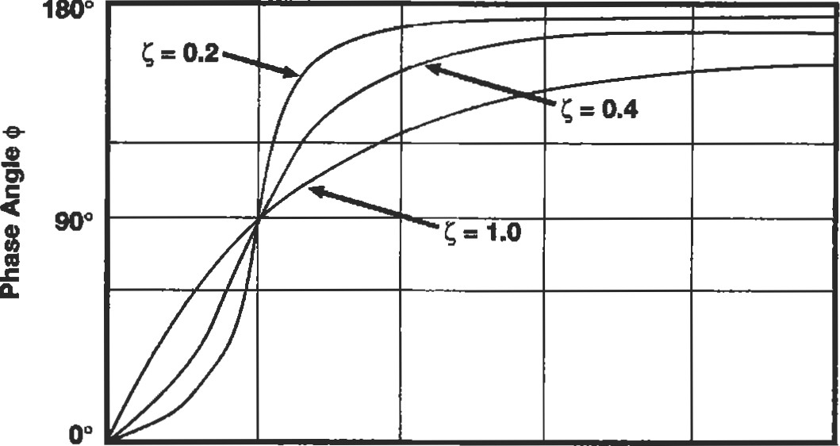

o 1.0 2.0 3.0 4.0 5.0

Frequency Ratio

|  |
| --- |
| Solving Multiple Degree of Freedom Systems |

Figure 9. Vibration amplitude and phase of the steady state response of the damped 1 DOF system to a harmonic input force at various frequencies.

There are a number of different methods used to derive and solve the equations of motion for multiple degree of freedom systems. However, the length of this chapter allows only a brief description of a few of these techniques. Any of the books referenced by this chapter, or any engineering vibration textbook, can be referenced if more information is required about these techniques. Tables at the end of this chapter have listed equations, derived via these techniques, to calculate the natural frequencies of various mechanical systems.

Energy meüods: For complex mechanical systems, an energy approach is often easier than tying to determine, analyze, and sum all the forces and torques acting upon a system. The principle of conservation of energy states that the total energy of a mechanical system remains the same over time, and therefore the following equations are ffue:

Kineüc Energy (KE) + Potential Energy (PE) = constant d dt

KEmax =

Writing expressions for KE and PE (as functions of displacement) and substituting them into the first equation yields the equation of motion for a system. The natural fiequency of the system can also be obtained by equaü.ng expressions for the maximum energy with the maximum potential energy.

equaüom: Lagrange's equations mee another energy method which will yield a number of equations of motion equal to the number of degrees of freedom in a mechanical system. These equations can then be solved to determine the natural frequencies and motion of the system. Lagrange's equations are written in terms of independent, generalized coordinates (q):

d OKE DKE DPE DDE dt

where: DE = dissipative energy of the system

###### Q = generalized applied external force

When the principle of conservation of energy applies, this equation reduces to:

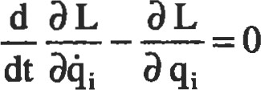

where: L = KE - PE

"L" is called the Lagrangian.

Principle of ottogonality: Principal (normal) modes of vibration for mechanical systems with more than one DOF occur along mutually perpendicular sffaight lines. This orthogonality principle can be very useful for the calculation of a system's natural frequencies. For a two-DOF system, this principle may be written as:

where Al, A2, Bl, and B2 are the vibration amplitudes of the two coordinates for the first and second modes.

transform: The Laplace Transform method u•ansforms (via integration) a differential equation of motion into a function of an alternative (complex) variable. This funcüon can then be manipulated algebraically to determine the Laplace Transform of the system's response. Laplace Transform pairs have been tabulated in many textbooks, so one can look up in these tables the solution to the response of many complex mechanical systems.

|  |  |
| --- | --- |
| ml Al B2=o | with specialized FEM software on personal computers. |
| Vibration Measurements and Instrumentation |  |

Finite element metod (FEM): A powerful method of modeling and solving (via d.i$tal computer) complex suuctures by approximating the sü•ucture and dividing it into a number of small, simple, symmetrical parts. These parts are calledfinite elements, and each element has its own equation of motion, which can be easily solved. Each element also has boundary points (nodes) which connect it to adjacent elements. A finite element grid (model) is the complete collection of all elements and nodes for the entire stucture. The solutions to the equations of motion for the individual elements are made compaüble with the to their adjacent elements at their common node points (boundary conditions). The solutions to all of the elements are then assembled by the computer into global mass and stiffness matrices, which in turn describe the vibration response and motion of the entire structure. Thus, a finite element model is really a miniature lumped mass approximation of an entire süucture. As the number of elements (lumped masses) in the model is increased towards infinity, the response predicted by the F.E. model approaches the exact response of the complex structure. Up until recent years, large F.E. models required mainframe computers to be able to solve simultaneously the enormous number of equations of a large F.E. model. However, increases in processing power of digital computers have now made it possible to solve all but the most complex EE. models

Analytical methods are not always adequate to predict or solve every vibration problem during the design and operation of mechanical systems. Therefore, it is often necessary to experimentally measure and analyze both the vibration frequencies and physical motion of mechanical systems. Sensors can be used to measure and are called transducers because they change the mechanical motion of a system into a signal (usually electrical voltage) that can be measured, recorded, and processed. A number of different types of transducers for vibration measurements are available. Some transducers directly measure the displacement, velocity, or acceleration of the vibrating system, while other tansducers measure vibration indirectly by sensing the mechanical strain induced in another object, such as a beam. Examples of modem sping-mass and strain gage accelerometers, along with schematics of their internal components, are shown in Figure 10. The following paragraphs describe how several of the most widely used vibration transducers work, as well as their advantages and disadvantages.

###### Spring-Mass Accelerometer Mounted on a Structure

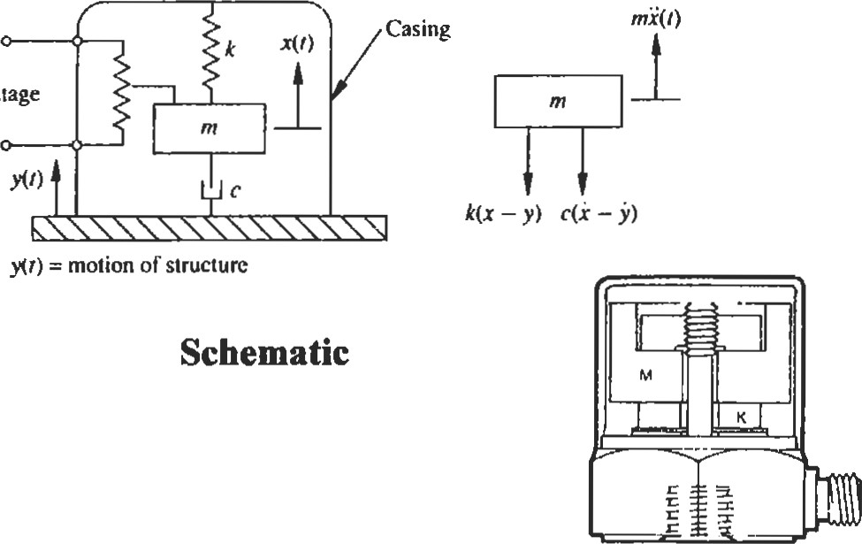

Voltage

Cutaway

Strain Gage Accelerometer Made of a Small Beam

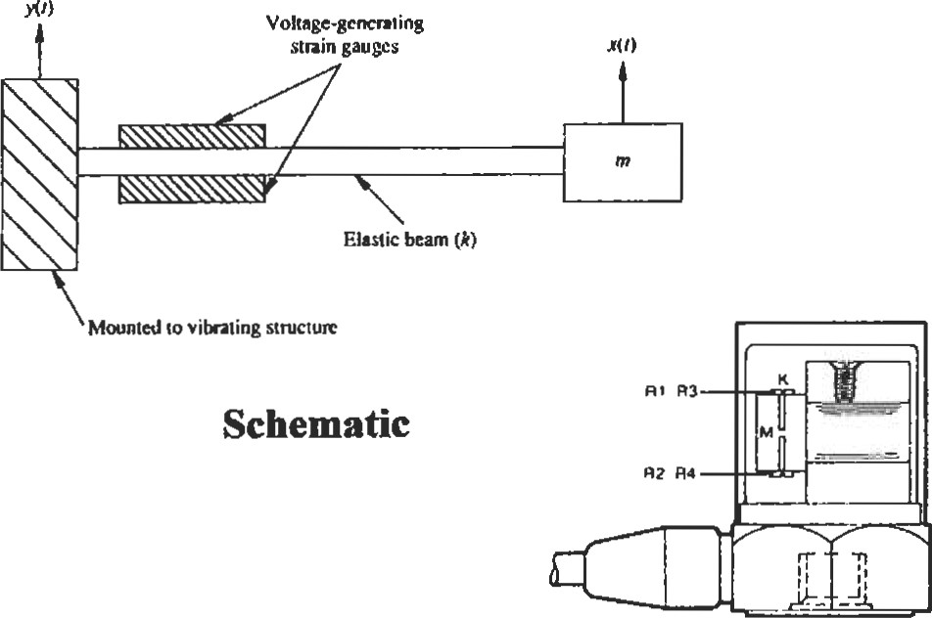

Cutaway

Figure 10. Schematics and cutaway drawings of modern spring-mass and strain gage accelerometers. (Schematics from Inman [11, reprinted by permission of Prentice-Hall, Inc., Upper Saddle River, NJ. Cutaways courtesy of Endevco Corp.)

Accelerometers

Accelerometers, as their name implies, measure the acceleration of a mechanical system. Accelerometers are contact transducers; they are physically mounted to the surface of the mechanism being measured. Most modem accelerometers are piezoelectric accelerometers, and contain a spring-mass combination which generates a force proportional to the amplitude and frequency of the mechanical system the accelerometer is mounted upon. This force is applied to an internal piezoelectric crystal, which produces a proportional charge at the accelerometer's terminals. Piezoelectric accelerometers are rated in terms of their charge sensitivity, usually expressed as pico-coulombs (electrical charge) per "g" of acceleraüon. Piezoelecüic accelerometers are self-generating and do not require an external power source. However, an external charge amplifier is used to convert the electrical charge from the fransducer to a voltage signal. Therefore, piezoelecffic accelerometers are also rated in terms of their voltage sensitivity (usually mV/g) for a given external capacitance supplied by a amplifier. The charge produced by the ü•ansducer is converted into a voltage by die chmge amplifier by electronically dividing the charge by the capacitance in the accelerometer/cable/charge-amplifier system:

c

Accelerometers are calibrated by the manufacturer and a copy of their frequency response curve is included with the ü•ansducer. Frequency response is ve07 flat (usually less than ±5%) up to approximately 20% of the resonant (natural) frequency of the accelerometer. The response becomes increasingly nonlinear above this level. The accelerometer should not be used to measure frequencies exceeding 20% on unless the manufacturer's specifications state otherwise.

Advantages:

* Available in numerous designs (such as compression, shear, and stain gage), sizes, weights, and arrangements (such as center, stud, screw mounted, and glue-on). Ease of installation is also an advantage.
* Accelerometers are available for high-temperature environments (up to 1,2000F).
* Wide band frequency and amplitude response.
* Accelemmeters ue available for high and low frequency (down to DC) measuring capabilities.
* Durable, robust construction and long-term reliability.

Disadvantages:

* Require contact with (mounting upon) the object being measured. Therefore, the mass of the accelerometer must be small relative to this object (generally should be less than 5% of mass of vibrating component being measured).
* Sensitive to mounting (must be mounted securely).

Sensitive to cable noise and "whip" (change in cable capacitance caused by dynamic bending of the cable). e Results are not particularly reliable when displacement is calculated by double integrating (electronically) the acceleraüon signal.

Displacement Sensors and Proximity Probes

are a number of &fferent types of displacement sensors. The linear variable (voltage) differential transducer (LVDT) is a contact transducer which uses a magnet and coil system to produce a voltage proportional to displacement. One end of the LVDT is mounted to the vibrating object while the other is attached to a fixed reference. In conüast, capacitance, inductance, and proximity sensors are all noncontact displacement transducers which do not physically contact the vibrating object. These sensors measure the change in capacitance or magneüc field currents caused by the displacement and vibraüon of the object being measured. Of all the various noncontact displacement dansducers available, the eddy current proximity sensor is the most widely used.

The eddy current proximity sensor is supplied with a high-frequency carrier signal to a coil in the of ff.is sensor, which generates an eddy current field to any conducting surface within the measurement range of the sensor. Any reduction in the gap between the sensor tip and the object being measured, whedler by displacement or vibraüon of this object, reduces the output voltage of the proximity sensor. The proximity sensor measures only the gap between it and the object in question. Therefore, this sensor is not useful for balancing rotors, since it can only measure the "high" point of the rotor (smallest gap) rather than the "heavy spot" of the rotor. However, proximity probes are very useful when accurate displacement monitoring is quired. The orbital motion of shafts is one example where two proximity sensors set at right angles to each other can produce a useful X-Y plot of the orbital motion of a shaft. Orbital motion provides an effective basis for malfunction monitoring of rotating machinery and for dynamic evaluation of relative clearances between bearings and shafts.

Advantages:

* No contact with the object being measured (except for LVDT).
* Small sensor size and weight.
* Can be mounted to a fixed reference surface to give absolute displacement of an object, or to a moving reference surface to give relative displacement of an object.
* Wide frequency response from DC (O Hz) to over 5,000 Hz.
* Measures displacement directly (no need to integrate velocity and acceleraüon signals).
* Displacement measurements are extremely useful for analyses such as shaft orbits and run-outs.

Dbadvantagæ:

* LVDT has limited frequency response due to its inertia. It also is a contact transducer, and therefore must be attached to the object being measured.
* Proximity probes are accurate only for a limited measurement range ("gap").
* Not self-generating (requires external power source). ' Limited temperature environment range.

' Proximity sensors are susceptible to induced voltage from other conductors, such as nearby 50 or 60 Hz alternating current power sources.

Useful Relationships Between Dynamic Measurement Values and Units

Dynamic measurements, like vibration, can be expressed in any number of units and values. For example, the viof a rotating shaft could be expressed in terms of its displacement (inches), velocity (in/sec), or acceleration (in/sec2 or "g"). Additionally, since vibration is a periodic, sinusoidal moüon, these displacement, velocity, and acceleration units can be expressed in a number of different values (peak, peak-to-peak, nns, or average values). Figue 11 gives a visual illustration of the difference between these values for a pure sine wave, and provides the conversion constants needed to convert one value to another. Figure 12 gives the relationships for sinusoidal motion between displacement, velocity, and acceleration. These relationships can also be plotted graphically on a nomograph, as illusü•ated in Figure 13. The nomograph provides a quick graphical method to convert any vibration measurement, for a given frequency, between displacement, velocity, and acceleration units.

b 0 2

|  |  |  |  |
| --- | --- | --- | --- |
| d v a一  vo vo | where:  8 2 Tft do 2 Tf 2 Tft do ( 2 2Tft acceleration  6 ·28 3· 14 f D  6L42 —--in./s Pk  L560一/ pk  9·780一inches Pk  0·2484一me pk | do D  G  T q  G  G  T | peak displacement pk-pk displacement acceleration g units frequency Hz period in seconds 9 ·806 65 m/s2  386 ·09 in./s2  32· ! 74 ft/s2  0.05u f2D  (where: D - inches peak-to-peak)  2 ·013 D  (where: D meters peak-to-peak) 一seconds |

|  |
| --- |
| 8 v01 e 0·707 x peak va 0 value 1 · 11 x avera 0 value peak value 1.4】4 x ms value peak value 1.57 x average value average value - 0 · 637 x peak value erage value 0.90 x rms value peak-to-peak 2 x peak v01 e peak value  crestfactor (applies to any rms v01u0 varying quantity) |

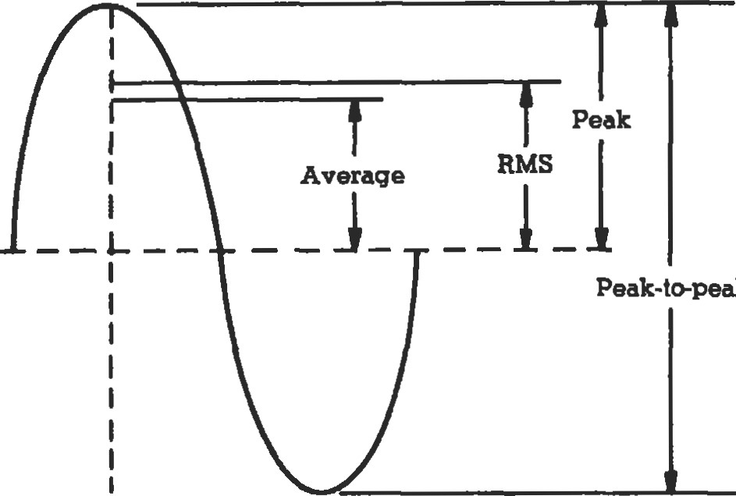F 212. Displacement, velocity, and acceleration relationships for sinusoidal motion. (Courtesy ofEndevco

Figure 11. Dynamic meæuæment value relationships for sinusoidal motion. (Courtesy Of Endevco CO p·》

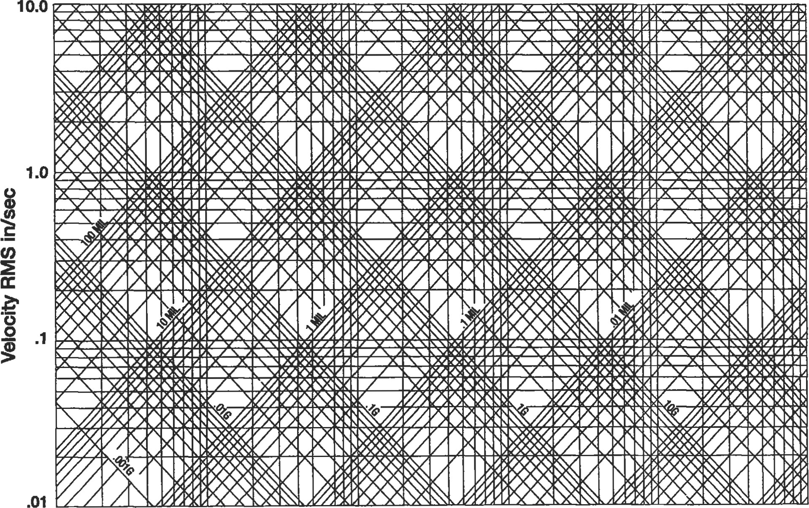

1 Hz 10 Hz 18 Hz 1 kHz 10 kHz Frequency—Hertz

Figure 13 ·  nomograph.

##### A: Sprlng Stiffness

Description Sketch Sti.ffness Equation

|  |  |  |
| --- | --- | --- |
| Springs in parallel |  | 2 |
| Springs in s«ies |  | 1 l/ k I + l/k2 |
| Torsional spring |  | E l  I = momem of for cross-section L = length of spring |
| Rod in torsion |  | J = torsion constant for cross-section  L = length of nod |
| Rod in tasion (or compression) |  | A = cross-sectional area L — total lengül ofrod |
|
| Sdffess of coiled wire spring |  | 8 n D3  = mnnber of coils; d = wire ff.ickness;  D = O.D. ofcoil |
| Candlevered beun load at end |  | 3 El  I = moment of inertia frr cross-section L = total length of beam |
| Beun with boå ends fixed, load in middle of beam |  | 192E1  I = momem of inerda for  L = total length of beam |
| Beam bot1 ends pinned, load in middle of beam | .......-.>l  142 | 48 El  I = moment of inertia for cross-section L — total length of beam |
| Beam with boå ends pinned, widi offceer load |  | 3EIL  I — moment of inertia for  L — length of beam = a + b |
| witl one end fixed, one pinned, load in middle of beam | 142  — | 768 E 1  I — momem of inerüa for cross-section L — total length |

Vlbraüon

###### Table B: Natural Frequencies of Slmple Systems

##### End mags M; spring mag m, spring stiffness k

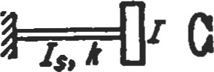 End inertia l; shaft inertia 

10, shaft stiffness 

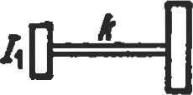12 Two disks on a shaft

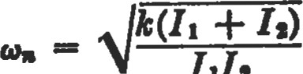

1112

|  |
| --- |
|  |
| M + 0.237. |

Cantilever; end mass M;

4.—.4æ.-.nM beam mag m

|  |
| --- |
|  |
| M + 0.5m |

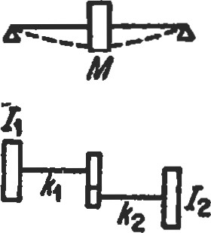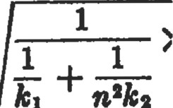Simply supported beam ; centrol mass M; beam mus

Massless gears, speed of 12 n times aa large as speed of 11

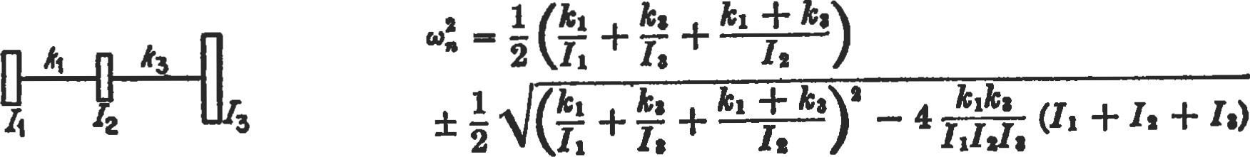

Note: Torsional Shaft Stiffness (k) above is frequently referred to as torsional shaft rigidity (t):

where: G = modulus of rigidity of the shaft

J = polar second monEnt of area of the L = shan lengh

For a solid, circular shaft:

4

2

Source: from Den Hartog [2], with perrnission of Dover Publications, Inc.

###### C: Longitudinal and Torslonal Vibratlon of Unlfom Beams

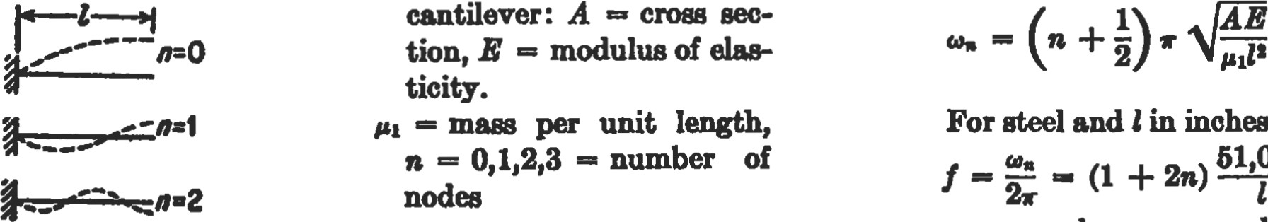

Inngitudinsl

vibration

of

inches

this

bec

51,000

cycles per second

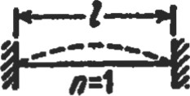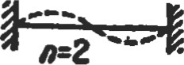Longitudinal vibration of beam clamped (or free) at both ends

For steel, in inchæ

Torsional vibration of beams

Organ pipe open at one end, closed 8t the other

Water column in rigid pipe closed at one end (l in inchæ)

Organ pipe closed (or open)  at both ends (air Lt 600F.)

Wat« column in rigid pipe closed (or open) 8t both endg



Dover

Publications,

For water columne in nonrigid pipes

— n -1 2 3

 102,000

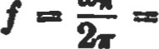 cy&/gec.

In åe previous e#on, replace Bional stiffness AB by tors stiffness C ( — Glpfor circular section) ; replace by the mo of inertia per unit length i •

For sir at 600F., in inches:

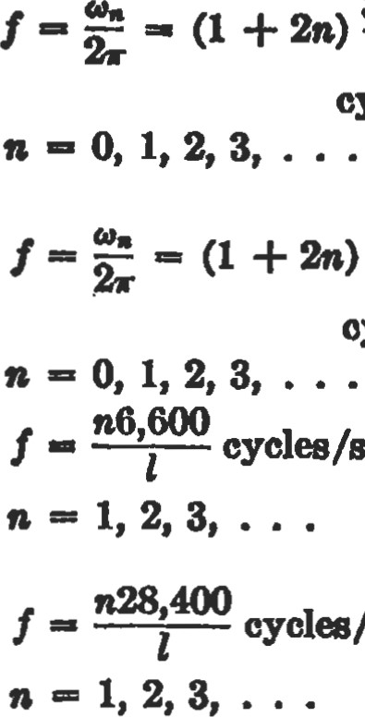

cycles/sec.

cycla/sec.

3,300

cyclæ/gec.

14,200

oyclæ/sec.

LA—rigid 1

|  |  |
| --- | --- |
|  | 300,OOOD |

##### = e188Cic modulus of lb./in.'

D, C — pipe and thiokne, same u

|  |
| --- |
| Vibraüon  Table D: Bending (Transverse) Vibration of Uniform Beams  The same general formula holds for all the following cuæ,    where El is the bending Btiffnæs of the section, is the length of the beam, iB the mass per unit length — W/d, and is a numerical constant, different for each case |

and listed below

 Cantilever or "clamped-free" beam





Simply supported or "hinged-hinged beam







"Free-free" beam or floating ship

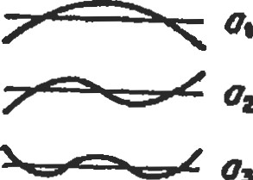

03

" Clamped-clamped beam has same frequenci08 as " free-free"

02 as

" Clamped-hinged" beam may be considered  as half "clamped-clamped" beam for even a-numbers



Hinged-free" beam or wing of autogyro  may be considered BS half a "free-free"

 02 beam for even a-numbers



##### at =

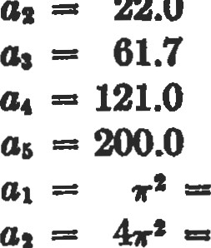

3.52

22

0

9.87 - 39.5

 = 16ra - 158. 05 = 247, al — 22.0  - 61.7  - 121.0 a, = 200.0 a, = 298.2 - 22.0 61.7 a, = 121.0



a, = 298.2 at = 15.4 02 50.0 104. = 178.

an =

= 15.4

50.0 = 104.

 178.

Source: from Den Hnrtog [21, with permission of Dover Publications, Inc.

 nuamb

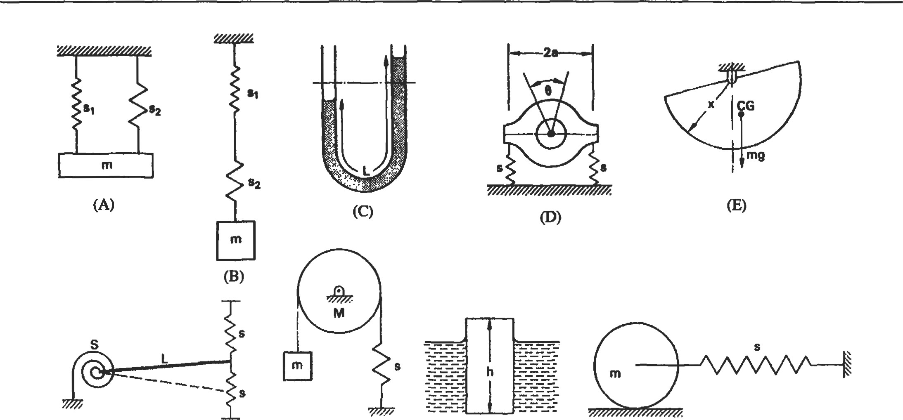

E:

Natural

Frequencies

of

Multiple

DOF

Systens

(F)

(G)

(H)

(1)

System Frequenqr (HL) Reference in Dwg.

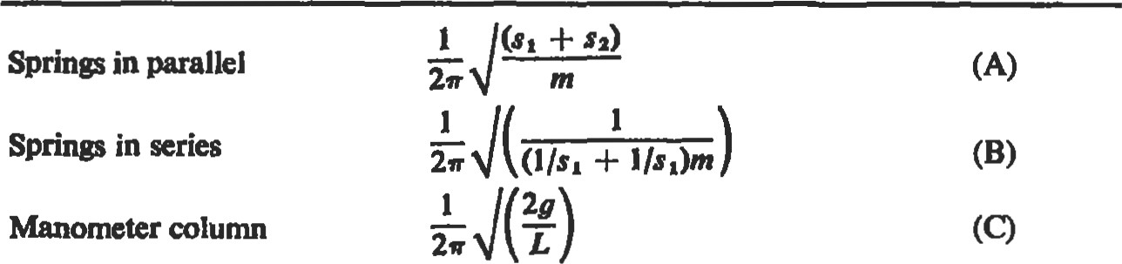

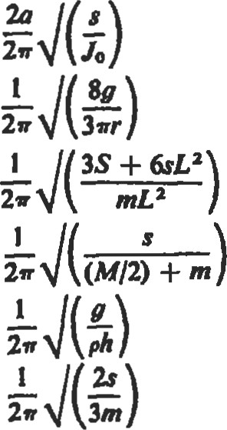Torsion of flexibly supported machine(D)

Pivoted semicircular disc(E)

Linear and torsional spring restraint(F)

Spring—mass pulley(G)

Floating body(H)

Rolling disc with spring restraint(1)

where g = gravitational acceleration h — height of floating body

 = mass moment of inertia of machine about axis of owillation L — length of fluid in manometer or length of uniform rigid rod r radius of pivoted semicircular disc

= spring stiffness S = torsion spring stiffness p — &nsity of floating body

Sourve.• fmm [91, Institution



###### Table F: Planetary Gear Mesh Frequencles

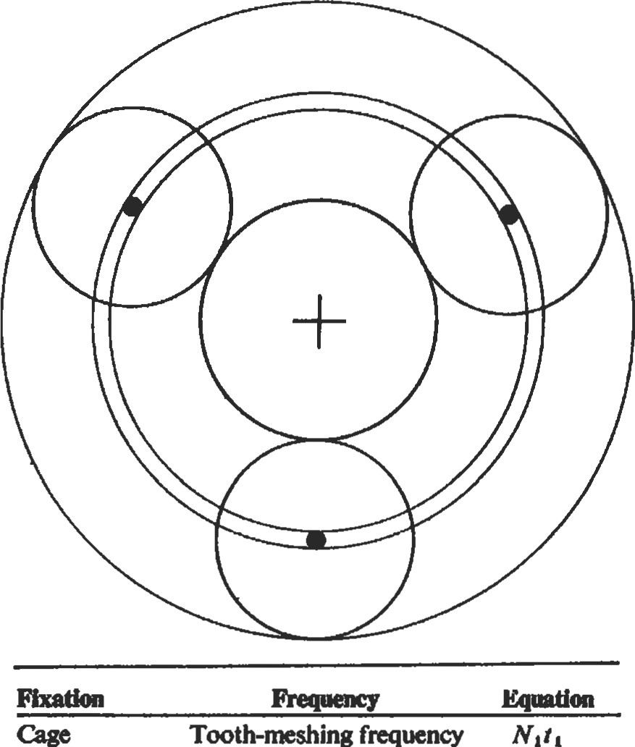Tooth-nrshing frequency

|  |  |  |
| --- | --- | --- |
|  | High spot on sun | nNi |
|  | High spot on planet | 2N2 |
|  | High spot on annulus | nN3 |
| Sun | Tooth-me&g frequency | N4ta |
|  | High spot on sun | nN4 |
|  | High spot on planet | 211 |
|  | High spot on annulus | ntl t3 |
| Annulus | Tooth-meshing frequency | N4t3 |

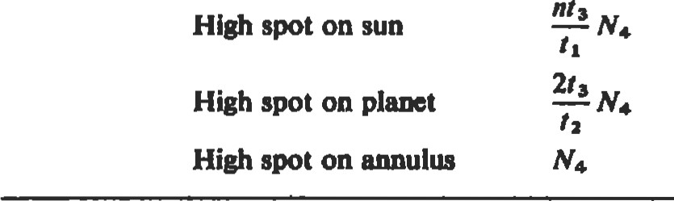High spot on sun

whee: n = mmgbr planet gers ti = number of teeth(sgm t2 = number gers) t, = mmber teeth(amulw) N = gear red (rpm or Hz.)

NI = sun gec

N2 = ger

N, = avndus sped

N4 = c. sped



###### G: Rolling Element Bearing Frequencies and Bearing Defect Frequencies

Rolling Element Bearing Frequencies

Rotational/pass

Component frequ»ncy

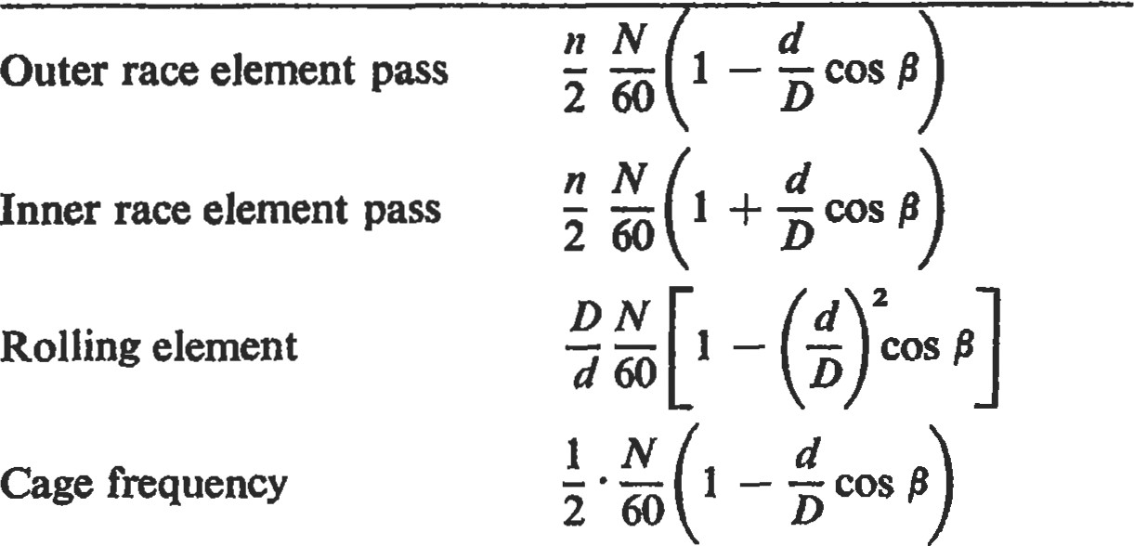

where d = rolling-element diameter D = bearing pitch diameter ß = contact angle n = number of rolling elements

N = shaft speed

Rolling Element Bearing Defect Frequencies

Frequency Significance



Component

the

cage

|  |  |  |
| --- | --- | --- |
| Rolling element | 2 x rolling element spin | Irregularity strikes the |
| defect | 2  d | inner and outer cases |
|  | cos ß | alternately |
| Inner race defect | Inner race pass frequency  I + — • cos ß |  |
| Outer race | Outer race pass frequency | Likely to arise if there is a |
| defect | d | variation in stiffness |
|  | 1 — — • cos ß | around bearing hous- |

ing

Source: from [91, Instituü)n

Mbration

###### Table H: General Vibration Diagnostic Frequencies

Defect cause Frequency

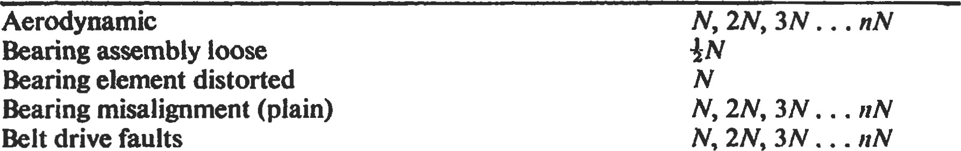Aerodynamic

Combustion faulty, diesel engines (four-stroke) Coupling misalignment

##### Electrical

Electrical machines, DC (armature slots/commutator segments)

Electrical machines, induction (magnetic field)

###### Electrical machines, induction (rotor slots)

Electrical machines, synchronous (magnetic field)

Fan blades

###### Forces, reciprocating Journals, eccentric

Mechanical looseness Oil whirl

Pump impellers.

Rotor, bent

Shaft, bent Unbalance

Whirl, friction-induced

##### Whirl, oil

{N

N, 2N, 3N nN NSFor 2SF, 3N, 6N

###### eithersNorsN ± 2Fs

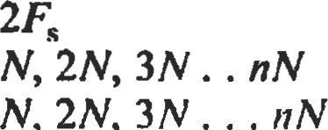

N,

2N,

O•45N

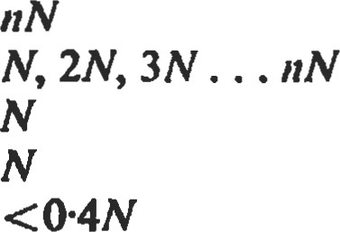

O•45N

where: N = shaft rotation frequency

SF = synchronous frequency FS = sunly frequency s = number of slots or segments

Source: from Collacoü [9], with permission of Institution of Diagnostic

References

Vibration Theory and Fundamentals

1. Inman, Daniel J., Engineering Vibration. Upper Saddle River, NJ: Prentice-Hall, 1994.
2. Den Hartog, J. P., Mechanical Wrations. New York: Dover Publications, Inc., 1985.
3. Dimarogonas, A. D. and Haddad, S., Vibrationfor Engineers. Upper Saddle River, NJ: Prentice-Hall, 1992.
4. Thomson, W. T., Theory of Vibration with Applications. Upper Saddle River, NJ: Prentice-Hali, 1972.
5. 'Ihomson, W. T., "Vlbraüon" in Standard Handbookfor Mechanical Engineers, T. Baumeister and L.S. Marks (Editors). New York: McGraw-Hill, 1967.
6. Meirovich, L., Analytical Methods in Vibration. New York: The Macmillan co., 1967.

Solution Methods to Numerous Practical Vibration Problems

1. Seto, W. W., Theory and Problems of Mechanical Vibrations (Schaum's Outline Series). New York: McGraw-Hi11, 1964.

Vibration Measurement and

Analysis Techniques

1. Jackson, C., The Practical Vibration Primer. Houston: Gulf Publishing Co., 1979.
2. Collacott, R. A., Vibration Monitoring and Diagnosis. London: George Godwin Ltd. (Institution of Diagnostic Engineers), 1979.
3. Endevco Dynanic Test Hmdbook, Rancho Viejo Road, San Juan Capistrano, CA.



### Materials

|  |  |  |  |  |  |  |
| --- | --- | --- | --- | --- | --- | --- |
| Classes of Materials |  | 260 | Polymers |  | | 281 |
| Definitions |  | 260 | Ceramics |  | | 284 |
| Metals |  | 262 | Mechanical Testing |  | | 284 |
| Steels |  | 262 | Tensile Testing |  | | 284 |
| Tool Steels . |  | 264 | Fatigue Testing |  | | .. 285 |
| Cast Iron |  | 265 | Hardness Testing |  | | .. 286 |
| Stainless Steels |  | 266 | Creep and Stress Rupture Testing | | | .. 287 |
| Superalloys .. |  | 268 | Forming | |  | 288 |
| Aluminum Alloys |  | 269 | Casting | |  | 289 |
| Joining |  | 270 | Case Studies | |  | 290 |
| Coatings ... |  | 273 | Failure Analysis | |  | 290 |
| Corrosion ... |  | 276 | Corrosion | |  | 291 |
| Powder Metallurgy |  | 279 | References | |  | 292 |

Paul S. Korinko, Ph.D., Senior Experimental Metallurgist, Allison Engine Company

|  |
| --- |
| CLASSES OF MATERIALS |

In this chapter, material properties, a few definitions, and some typical applications will be presented as guidelines for material selection. The most important rule for material selecüon is that the operating conditions must be well defined. These include temperamre, environment, impurities, stress, su•ain, cost, and any limitations for life cycle, such as creep or fatigue.

Materials can be broken down into three major classes, each having specific characteristics. Metals, ceramics, and polymers consütute these classes, and some typical properües and applications will be described. In addition, fabrication methods for the materials will be described.

Metals are characterized by metallic bonding in which the electrons are shared in a veritable sea of

Each nucleus is surrounded by elecffons, but the electrons mae not specifically attached to any particular nucleus. Metals are further characterized by their surface appearance and generally have a "metallic" sheen and can be polished to a mirror finish. Metals also capable of sustaining large loads, they are ductile, and they have reversible elastic properties to a point. They can be alloyed to alter their physical and chemical properties.

Metals and alloys are defined by the major alloying element present. Common engineering alloys consist of iron, nickel, cobalt, aluminum, magnesium, titanium, and copper. These alloys will be discussed in some detail after some definitions are presented.

Polymers are long chains of carbon and hydrogen arranged in specific bonding orientations. The bonds are generally covalent bonds. Noncrystalline or amorphous polymers have a random arrangement of polymer chains. Crystalline polymers have specific polymer chain arrangements. The unit cells (smallest repeating arrangement of atoms to make the full sü•ucture) are large (10 nm) relative to metal unit cells (0.3 nm). Polymer properties can be elastic, viscous, or viscoelastic. The actual behavior depends on the temperature, composiüon, orientation, and degree of crystallinity.

|  |
| --- |
| DEFINITIONS |

Ceramics are characterized by either ionic bonding in which electrons are lost and there is an electronic force that holds the ions together, or covalent bonding in which the elecü•ons are shated. Because of the electronic nature of die bonding, the net charge on the material must be zero. This requirement makes deformation difficult when like charged atoms must pass closely together. Ceramics can sustain large compressive loads but are very surface defect sensitive for tensile loads. They tend to behave elasücally to failure with little or no plastic deformation prior to fracture.

Grain size is a microstructural property of a material that indicates how large the crystals constituting the süucture are. The grain size is important for a number of mechanical and physical properties. For example, room temperature sü•ength is increased by having a small grain size. The correlaüon between grain size and strength is as the Hall-Petch relationship and is shown in Equation 1 : 0=00+kyd (1)

where is the sffength of a single crystal in MPa or ksi and ky is the slope of the line with units of MPA*mm1/2 or ksi*in 1/2. High-temperature, long-term properties, such as creep, are improved by a large grain size, thus, a balance between the required properties is necessary. A number of methods are used to measure the grain size, with the most common being ASTM El 12. In this method, the number of grains per square inch is measured. The larger the number, the finer the grain size, and vice versa.

Alloying is the intenüonal addition of one or more ments to a parent metal. Most of the metals that are used are alloys; alloys typically have higher su•ength and other more desirable properties than pure metals. The chemical resistance and oxidation resistance of some alloys is better than the pure elements—nickel alloyed with chromium and aluminum, for example. Alloys can be one of three types: interstiüal alloys, in which the added element is much smaller than the parent element and the atoms reside at normally

unoccupied positions in the lattice, i.e., interstiüal sites; substitutional alloys, in which the addition displaces an atom of the parent metal; or precipitation alloys, in which a cluster of atoms forms a second phase in the parent metal.

Precipitation hamening is a strengthening mechanism for alloys that have specific chemical interacüons which can be seen in a type of phase diagam. The solid solubility increases with increasing temperature, and only a certain range of alloying additions will work. The second phase should be stronger than the parent metal, is generally brittle, and can interact with the crystal defects (dislocations) that the deformation of the alloys, Most alloys are sü•engthened by a combinafion of the three methods mentioned.

Composites are formed by the addition of discrete particles or fibers to a metal matrix. The st•ength increase depends on the strength and modulus of both the matrix and the reinforcement addition. For a composite that is strengthened due to isostress, the composite strength is given by Equation 2:

(1 —VD 6m + VfGf (2)

where Vf is the volume fraction of the reinforcing phase, and Of and Gm are the reinforcing phase and maüix strengths.

The modulus of a fiber-reinforced composite tested perpendicular to the fiber axis is given by Equation 3. lhe symbols are the same as those used above, with E used for the modulus:

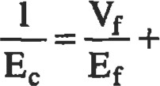(I-Vf)

(3)

m

The following definiüons regarding mechanical properties are usually based on a tensile test—a mechanical test in which a standard specimen is pulled uniaxially unül ure. The displacement and load are recorded. These data are then converted into stress and strain. In engineering and strain, the is load divided by the original cross-sectional area; the strain is the change in length divided by the original length. These terms are different than the due stress and st-ain which are generally ignored in practice but are defined as the load divided by the instantaneous area and increase in length divided by the instantaneous length. The difference does not amount to much in practical applications, but it does change the nature of the stress-sffa.in diagram.

Yield strength refers to the su•ess at which a certain permanent strain, typically 0.02% or 0.2%, has occurred. Figure 1 shows a typical stress-sEain curve with the yield determined as in the inset.

Tensile strength is the maximum sü•ess that the specimen withstands, and occurs when the strain is no longer uniform and has become centralized at a band called a "neck." It is often referred to as the onset of necking.

Failuæ strength is the point at which the specimen separates into two This stress is not of any practical value.

Elastic modulus, also referred to as Young's modulus, occurs in the linear portion of the curve. It is a measure of a material's süffness, much like a spring constant The modulus is loosely correlated with the melting point of a material and increases as the melting point increases. Table 1 lists some melting points of metals and their respecüve elastic modulus. Figure 2 more clearly shows the general dend of increased modulus with increased melting point.

100

|  |
| --- |
| Failu•e sterv&i  UTS |

 60

40

20

0.00 0.10 020 0.30 0.40 050

Strain (in/in)

Figure 1. IYpicaI tensile curve showing yield, tensile, and ultimate strengths and elastic and plastic strains.

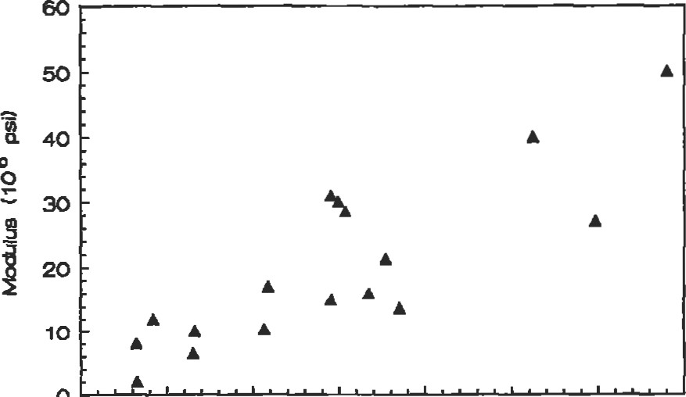

o

* 500 1000 1500 2000 2500 3000 3500
* (00

Figure 2. Elastic modulus as a function of melting point

(Data from Table 1 .)

Table 1

Modulus and Melting Temperatures of Important Engineering Elemene

Element Melting Modulus

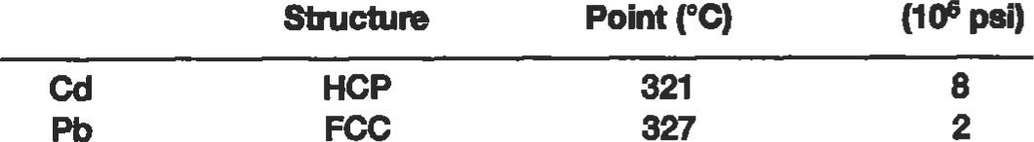

Crystal

Point

HCP 321

FCC 327

|  |  |  |  |  |  |  |  |  |  |  |  |  |  |  |  |  |  |  |  |  |  |  |  |  |  |  |  |  |  |  |  |  |
| --- | --- | --- | --- | --- | --- | --- | --- | --- | --- | --- | --- | --- | --- | --- | --- | --- | --- | --- | --- | --- | --- | --- | --- | --- | --- | --- | --- | --- | --- | --- | --- | --- |
| |  |  |  |  | | --- | --- | --- | --- | | Zn | HCP | 419 | 12 | | Mg | HCP | 650 | 6.4 | |  | FCC |  | 10 | | Au | FCC | 1 ,062 | 10.8 | | cu | FCC | 1,084 | 17 |   FCC 1,453 31  BCC 1,453 15  HCP 1,495 30  BCC 1,536 28.5   |  |  |  |  | | --- | --- | --- | --- | | pt | FCC | 1,770 | 21.3 | | Zr | HCP | 1,852 | 13.7 | | Cr | BCC | 1,860 | 36 |   HCP 1,670 16  BCC 2,620 40  2,980  3,400  Adapted from the CRC Handbook of Tables for Applied Engineering Science, 2nd Ed. CRC Press, 1984, with pemlssion.  METALS  Steels |

Strain tofailure provides an indicaüon of the amount of energy required to break a specimen. It is measured as indicated in Figure 1. The total strain is increased by the elastic component of the strain.

Steels are one of the most commonly used consüuction materials. Steels are typically termed plain carbon or low alloy, depending on the type of additions made to the iron base; a new class of steels is the low alloy, high strength variety. A plain carbon steel consists of iron and an alloying addition of carbon. The iron and carbon combine to form a compound phase, known as iron carbide (or which has the composition of F%C. Iron undergoes an allotropic transformation (a change in crystal sü•ucture) of body centered cubic (BCC), also known as alpha iron, to face centered cubic (FCC), also known as gamma iron, at 8850C, and another  of FCC to BCC, also known as delta iron, at 1,395 0C. The first of these transformations can be either useful or defrimental.

The composition of a steel is indicated by its SAE number. The SAE number has four to five digits. The first two digits indicate the alloying additions, and the last two indicate the carbon content; for instance, a 1020 steel is a plain carbon steel with nominally 0.2% carbon, and a 4340 steel has nickel and chromium with 0.4% carbon. Table 2 lists a number of common steels and their SAE numbers. Typical applications and yield strengths are listed in Table 3. In some cases, the composition is not specified, rather, several key properties such as hardness, strength, and ductility are specified and the supplier is free, within reason, to adjust the chemisüy to have it meet the mechanical or physical properties. Further, it is apparent that even with the same composition, a number of properties can be developed.

|  |  |  |  |  |  |  |  |  |  |  |  |  |  |  |  |  |  |  |
| --- | --- | --- | --- | --- | --- | --- | --- | --- | --- | --- | --- | --- | --- | --- | --- | --- | --- | --- |
| 2  Typical Compositions of Steels   |  |  |  |  |  |  |  |  |  | | --- | --- | --- | --- | --- | --- | --- | --- | --- | | ASI-SAE | c | Mn |  | s | Si | Cr |  |  | | 1018  1040  1095  4023  4037  4118  4140  4161  4340  5120  5140  51100  8620  8640  9310* | 0.14 0.20  0.36—0.44  0.90-1.04  0.20-0.25  0.35-0.40  0.18--0.23  0.38-0.43  0.56-0.64  0.38-0.43  0.17-0.22  0.38-0.43  0.98-1.10  0.18-0.23  0.38-0.43  0.56-0.64  0.08-0.13 | 0.60-0.90  0.60-0.90  0.30-0.50  0.70--0.90  0.70-0.90  0.70-0.90  0.75-1.00  0.75-1.10  0.60-0.80  0.70-0.90  0.70-0.90  0.25-0.45  0.70-0.90  0.75-1.00  0.75-1.00  0.45-0.65 | 0.035  0.035  0.035  0.035  0.035  0.035  0.035  0.035  0.025  0.035  0.035  0.035  0.035 | 0.040  0.040  0.040  0.040  0.040  0.040  0.040  0.040  0.025  0.040  0.040  0.040  0.040 | 0.15--0.30  0.15-0.30  0.15-0.30  0.15-0.30  0.15-0.30  0.15-0.30  0.15-0.30  0.15-0.30  0.15-0.30  0.15-0.30  0.15-0.30  0.15-0.30  0.15-0.30 | 0.40-0.60  0.80-.1.10  0.80-1.10  0.70-0.90  0.70-0.90  0.70-0.90  0.40-0.60  0.40-0.60  0.40-0.60  0.40--0.60  1.00-1-40 | 1.65-2.oo  0.40--0.70  0.40.-0.70  0.40-0.70  3.00-3.50 | 0.20-0.30  o.2c-o.30 0.08-0.15  0.15-0.25  0.15-0.25  0.20-0.30  0.15-0.25  0.15-0.25  0.15-0.25  0.08-0.15 |   * Also contains O. 10-0.15 V.  Wpical compositions for steels. Actual compositions depend on class and grade specified. |

Adapted from ASM Metals Handbook, Vol. 1, Ed. [21.

Table 3

Wpical Mechanical Property Ranges and Applications for Oil Quenched and Plain Carbon and Alloy Steels

Mechanical Pmperty Range

Type Tensile Strength Yield Strength DuctliW Appllcaüono acsi) (%e'ongaöon in Z')

|  |  |  |  |
| --- | --- | --- | --- |
| 1040  1080  1095  4063  4340 | 88-113  116-190  110-186  114-345  142-284  118-315 | Plain carbon steels 62-85 33-19  70-142 24-13  74-120 26-10  Alloy •tee's  103-257 24-4 130-228 21-11  108-270 | Cranbchafts, bolts  Chisels, hammers  Knives, haclgaw blades  Springs, handtools  Bushings, aircraft tublng pistons, gears |

Souæe: WIst«Pl. RepHnted bypemWm of Ehn Mby & %'8, Inc.

Steels can be selectively hardened through an appropriate thennal treatment. Surface hardness can be increased by locally increasing the carbon content. Shafts are particularly useful if surface or case hardened. In a case hardened steel, the surface contains a substantially higher carbon content than the core. ms provides better wear resistance at die surface for applications such as gems, where there is potentially significant wear at the surface but some impact loading of the core. The surface is hard and somewhat brittle but wear resistant, and the core is tough and more ductile. A nitride layer can also be introduced to increase the surface hardness. Ammonia gas is dissociated, and aluminum in the steel reacts to form aluminum nitrides which impart wearresistant surfaces to the steel.

Various methods can be used to strengthen steels. The first is to heat üeat In the process ofheat treating, a steel is first heated to the single phase region (fre) shown in Figure 3 (austeniüe). It can then be rapidly cooled (quenched) to form martensite. The martensitic steel is subsequently toughened by tempering. This step occurs at a slightly elevated temperature, but not one too high to prevent overt.empering and losing the martensiüc structure; Table 4 shows the effect of increasing tempering temperature on 4140 and 4340 steels. It is clear that the strength decreases and the ducülity increases with increasing tempering temperature.

A second heat treatment is to austeniüze and fumace cool (normalize). This produces a structure that consists of fairly coarse pearlite and either ferrite or cementite depending on the alloy composition, which will have low strength and high ductility.

Yet another treatment is to austenitize and air cool. This cooling rate typically results in finer pearlite and ferrite or cementite structure, properties between quenched and norma.lized.

Other treatments include heating to below the euctoid temperature to intentionally coarsen the pearlite (spheroidizing). There are other treatments such as ausforming and ausquenching. For a more detailed description of these

#### numb

Weight Percent Carbon

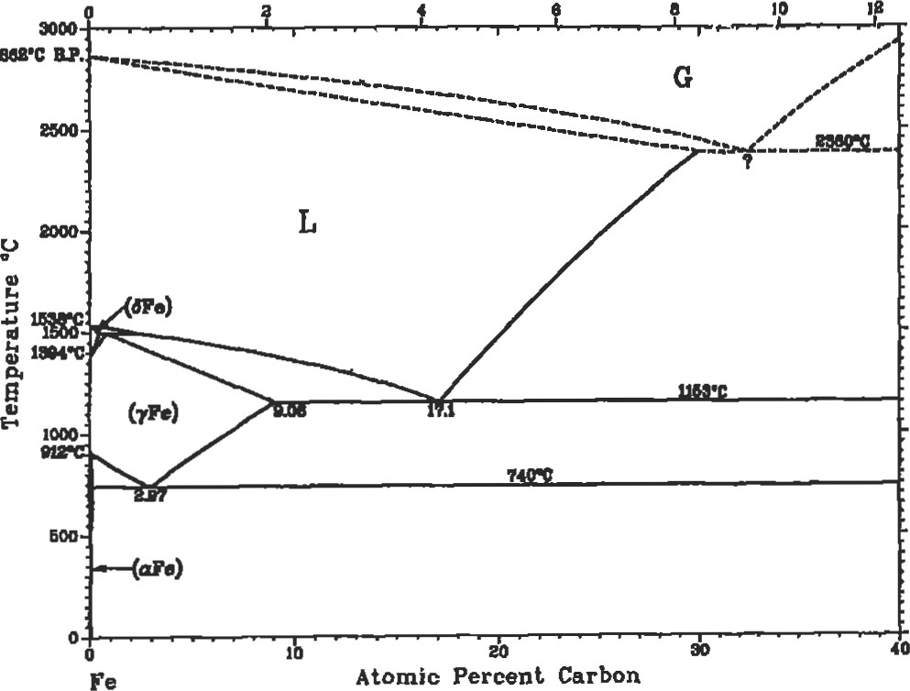

au•c

Atomic Percent Carbon

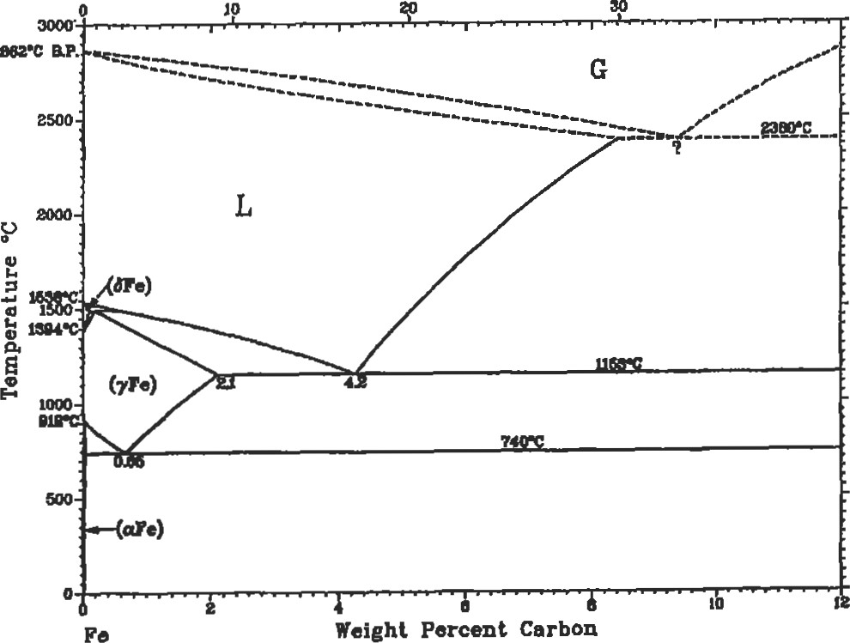

na•c

Figure 3. Iron-carbon phase diagram [231. (With permission, ASM International.)

Table 4

Wplcal Mechanical Pmperties of Heat-Teated 4140 and

4340 Steels Oil Quenched from 1,5500F

Tempedng Tensile Yield Elongadon Reducüon Temperanare Strength



in

in

Ana

4140 Steel

 252 11.0578

500 270 240 11.0

600 250 228 11.5495

700 231  12.5

800  195 15.0 429

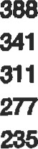  16.0 52

167 152 17.5

1,100 148 132 19.0 58

1 ,20021.0

1 ,3008.0

4340 Steel

400 287 270 11 39 520

600 255  12 44 490

800 217 198 14

1 ,ooo 180 168 17 360

1 ,200 148 125 20 60 1,300 125 108

thermal treaünents, almost any introducüon to materials science course [6, 7] will be adequate.

|  |
| --- |
| Tool Steels |

The mechanical properties vary significantly for these treatments. The highest yield and tensile strengths will be obtained for the martensitic structure, and the weakest for the spheroidized. The fine pearlite will be stronger than the coarse pearlite.

Tool steels are characterized by higher carbon contents than conventional steels, and quench and temper heat treatments. They are used as cutting tools, dies, and in other applications where a combination of high strength, hardness, toughness, and high temperature capability are important.

Some typical compositions are shown in Table 5. 'IYpical properties are listed in Table 6. Tool steels can be machined in the annealed condition and then hardened, although distortion from heat treatment can occur.

5

Nominal Composition of Classes of Tool Steels



AISI USN c Si Cr w v



Air-hardening medium

|  |  |  |  |  |  |  |  |
| --- | --- | --- | --- | --- | --- | --- | --- |
| alloy cold work steels |  |  |  |  |  |  |  |
| A3 T30103 1.20-1.30  Shock resistant steels | 0.40-0.60 | 0.50 max | 4.75-5.50 | 0.30 max | 0.90-1.40 |  | 0.80-1.40 |
| T41901 0.40--0.55 | 0.10--0.40 | 0.15-1.20 | 1.00-1.80 | 0.30 max | 0.50 max | 1.50-3.00 | 0.15-0.30 |
| T41905 0.50--0.65  Low alloy special purpose tool steels | 0.60-1.00 | 1.75-2.25 | 0.35 max |  | 0.50 max |  | 0.35 max |
| L2 T61202 0.45—1.00 | 0.10-0.90 | 0.50 max | 0.70-1.20 |  | 0.25 |  | 0.10-0.30 |
| L6 T61206 0.65-0.75 | 0.25-0.80 | 0.50 max | 0.60-1.20 | 1.25-2.oo | 0.50 |  | 0.20-0.30 |

Adapted from ASM Metals Handbook, Vol. 1, Ed. 121.

Table 6

|  |  |
| --- | --- |
| Cast iron is a higher carbon containing iron-based alloy. Cast irons contain more than 2.1 % C by weight. 'Ihey can be cast with a number of different microsüuctures. The most common is gray cast iron which has graphite flakes in a continuous three-dimensional structure which looks rather like potato chips. This structure promotes acoustic damping and low wear rates because of the graphite. | A second süucwre involves heat-treadng the gray cast iron to form spherodized cast iron. In this strucmre, the damping capacity is lost but the corrosion resistance is improved.  White iron is very brittle and is formed during cool-down from the melt. It can be used as a wear-resistant surface if the rest of the casting can be ductilized by perhaps forming gray cast iron. |

Typical Properties of Tool Steels After Indicated Heat Teatment



|  |  |  |  |  |
| --- | --- | --- | --- | --- |
| L2 hneated 103  Oil quenched from 1 ,5750F and single tempered at | 74 | 25 | 50 | 96 HRB |
| 4000F 290 |  | 5 | 15 | 54 |
| 6000F 260 | 240 | 10 | 30 | 52 |
| L6 Annealed 95  Oil quenched from 1 ,5500F and single tempered at | 55 | 25 | 55 | 93 HRB |
| 6000F | 260 | 4 | 9 | 54 |
| 8000 F | 200 | 8 | 20 | 46 |
| Sl Annealed 100  Oil quenched from 1,7000F single tempered at | 60 | 24 | 52 | 96 BRB |
| 4000F 300 | 275 |  |  | 57.5 |
| 294 | 270 | 44 | 12 | 54 |
| S5 Annealed 105  011 quenched from 1 ,6000F and single tempered at | 64 | 25 | 50 | 96 HRB |
| 4000F 340 |  | 5 | 20 | 58 |
| 6000F 325 | 270 | 7 | 24 | 58 |



#### Cast Iron

##### Stainless steels

A special class of iron-based alloys have been developed for resistance to tarnishing and are known as stainless steels. These alloys may be martensitic (body centered tetragonal), austenitic (FCC), orferritic (BCC) depending on the alloying additions that have been made to the iron.

Use of stainless steels should be considered carefully. The use of some classes should be limited to oxidizing environments in which the alloy has the chance to form a protective oxide scale. Use of alloys requiring the oxide scale for protection in reducing environments, such as carbon monoxide which can electrochemically or thermodynamically convert oxides to metals, can be disastrous. Tables 7 and 8 contain a partial list of common stainless steel compositions and acceptable use environments.

A thin oxide scale forms on the stainless steel and protects it from further oxidation and corrosion. Chromium is typically the element responsible for stainless steel's "stainless" appearance.

Ferritic stainless steels have typically up to 30% Cr and 0.12% C and are moderately strong, solid solution and sfrain hardened, and low cost. The strengths can be increased by increasing the Cr and C; unformnately, these actions result in carbide precipitation and subsequent embrittlement. Excessive Cr addiüons can also promote the precipitation of a brittle second phase known as sigma phase.

Martensitic stainless steels contain up to 17% Cr and from 0.1—1.0% C. These alloys are strengthened by the formation of martensite on cooling from a single-phase austenite field. With the range of carbon contents available, martensite of varying hardness can be produced. Martensitic stainless steels have good hardness, strength, and corrosion resistance. Typical uses are in knives, ball bearings, and valves. They soften at temperatures above 5000C.

Austenidc stainless steels have high chromium and high nickel content. The generic term is 18-8 stainless, which refers to 18% Cr and 8% Ni. The nickel is required to stabilize the gamma or face centered cubic (FCC) phase of the iron, and the Cr imparts the corrosion resistance. These alloys can be used to 1,0000C. Above this temperature, the chromium oxide that forms can vaporize and will not protect the so rapid oxidation can occur.

Table 7

Composition of Standard Stainless Steels

Composition (%)



UNS

Type Number C Si Cr P s OUwr



Austenitic types

|  |  |  |  |  |  |  |  |  |
| --- | --- | --- | --- | --- | --- | --- | --- | --- |
| 201 S20100 | 0.15 | 5.5-7.5 | 1.00 | 16.0-18.0 | 3.5-5.5 | 0.06 | 0.03 | 0.25 N |
| 304 S30400 | 0.08 | 2.00 | 1.00 | 18.0-20.0 | 8.0-10.5 | 0.045 | 0.03 |  |
| 304L S30403 | 0.03 | 2.00 | 1.00 | 18.0-20.0 | 8.0-12.0 | 0.045 | 0.03 |  |
| 310 | 0.25 | 2.00 | 1.50 | 24.0-26.0 | 19.0-22.0 | 0.045 | 0.03 |  |
| 316 S31600 | 0.08 | 2.00 | 1.00 | 16.0-18.0 | 10.0-14.0 | 0.045 | 0.03 | 2.0-3.0 Mo |
| 347 S34700  Fenitic types | 0.08 | 2.00 | 1.00 | 17.0-19.0 | 9.0-13.0 | 0.045 | 0.03 | min Nb+Ta |
| 450 S40500 | 0.045 | 1.00 | 1.00 | 11.5-14.5 |  | 0.04 | 0.03 | 0.1-0.3 Al |
| 430 S43000  Martensitic types | 0.12 | 1.25 | 1.00 | 16.0-18.0 |  | 0.04 | 0.03 |  |
| 410 S41000 | 0.15 | 1.00 | 1.00 | 11.5-13.0 |  | 0.04 | 0.03 |  |
| 420 S42000 | 0.15 | 1.00 | 1.00 | 12.0-14.0 |  | 0.04 | 0.03 |  |
| 431 S431 oo  Precipitationhardening types | 0.20 | 1.00 | 1.00 | 15.0-17.0 | 1.25-2.50 | 0.04 | 0.03 |  |
| 17-4PH S17400 | 0.07 | 1.00 | 1.00 | 15.5-17.5 | 3.0-5.0 | 0.04 | 0.03 | 3.0-5.0 cu;  0.15-0.45 (Nb+Ta) |
| 17-7PH S17700 | 0.09 | 1.00 | 1.00 | 16.0-18.0 | 6.5-7.75 | 0.04 | 0.03 | 0.75-1.5Al |



Adapted from ASM Metals Handbook, Vol. 3, Ed. [401.

8

Resistance of Standard Wpes of Steel to Various Classes of Environments

|  |  |  |  |  |  |  |  |  |
| --- | --- | --- | --- | --- | --- | --- | --- | --- |
| Type | Mild Atmospheric end Fresh Water | | Atmospheric  Industial Marine | | Satt water | Mild | Chemical O)ddizing | Reducing |
| Austenitic stainless steels 201  304  310  316  347  Femtic stainless steels 405  430  Martensitic stainless steels 410  420  431  Precipitation hardening stainless steels  17-7PH | | x x x x x  x x  x  x x  x x | x x x x x  x  x  x x | x x x x  x  x  x x | x | x x x  x x  x x  x  x  x  x | x x x x x  x  x x | x |

An Ux" notation indicates that the specific type is to the corrosive environment.

Adapted from ASM MeEls Handbook, Vol. 3, 9th Ed. [401.

Since austenitic stainless steels are FCC, they tend not to be magnetic. Thus an easy test to separate austenitic stainless steel from ferritic or manensitic alloys is to use a magnet.

Austenitic stainless steels are not as strong as martensitic stainless steels, but can be cold worked to higher strengths than ferritic stainless steels since they are strengthened via solid soluüon hardening in addition to the cold work. They are more formable and weldable than the other two types of stainless steel. They are also more expensive due to the high nickel content.

The amount of carbon in an austenitic stainless steel is impottant; if it exceeds 0.03% C, the Cr can form chromium carbides which locally decrease the Cr content of the stainless steel and can sensiüze it. A sensitized alloy forms when slowly cooled from below about 8700C to about 5000C. It is prone to corrosion along the grain boundaries where the local Cr content drops below 12%. Figure 4 shows a schematic of a sensitized alloy. A rapid quench through this temperature range should prevent the formaüon of the chrome carbides. Elements such as or Nb, which are st-ong carbide formers, can be added to the alloy to form carbides and stabilize the alloy, for exarnple, types 347 and 321.

Austenitic stainless steels also have good low temperature properties. Since they are FCC, they do not undergo a ductile to brittle transition like body centered cubic metals (BCC). Austenitic stainless steels can be used at cryogenic temperatures.

The precipitation hardening alloys are strengthened by the formation of martensite and precipitates of copperniobium-tantalum.

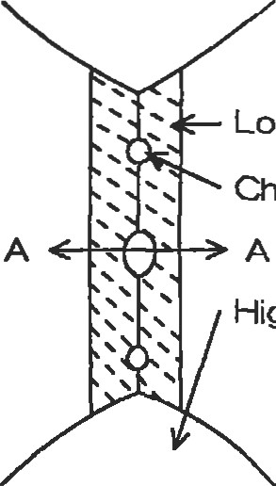Low Chromium Austenite

Crromiurn Carbide

High Chromium Austenite

Cr

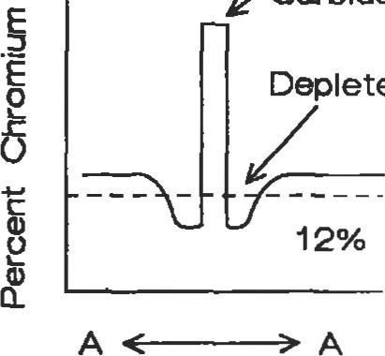

Depleted

V

Carbide

Zone

Figure 4. Sensitized stainless steel. Cr content near grain boundary is too low for corrosion protection.

|  |
| --- |
| Superalloys |

Iron-based superalloys have high nickel contents to stabilize the austenite, chromium for corrosion protection, and niobium, titanium, and aluminum for precipitation hardening. Refractory elements are introduced for solid lution hardening. They also confer some creep resistance. Creep resistance is further enhanced by the presence of small coherent precipitates. Unfortunately, the fine precipitates that improve the creep strength the most are also the most likely to dissolve or coalesce and grow.

Nickel- and cobalt-based superalloys have higher temperature capabiliües than iron-based superalloys. The strengthening mechanisms for nickel-based alloys are similar to those for iron-based alloys. The nickel maüix is precipitation hardened with coherent preciptitates of niobium, aluminum, and titanium. Carbides and borides are used as grain boundary strengtheners, and refractory elements are added as solid suengtheners. The gamma prime (Ni3Al,1i) is a very potent strengthener that is a coherent precipitate. These precipitates are present up to 70% in modem, advanced nickel-based alloys. They permit the use of nickelbased alloys to approximately ().75 times the melting point. Nickel-based alloys are also cast as single crystals which vide significant strength and creep improvements over polyalloys of the same composition. Some Wpical compositions and applications are listed in Tables 9 and 10.

Table 9

Nominal Compositions of Typically Used Iron-, Nickel-, and Cobalt-based Superalloys



Alloy co w Cu Other



|  |  |  |  |  |  |  |  |  |  |  |  |
| --- | --- | --- | --- | --- | --- | --- | --- | --- | --- | --- | --- |
| Wmught Alloys  HASTELLOYO C-4• | | Bal |  | 16 |  |  | 16 |  |  |  |  |
| HASTELLOYØ c-22Na | | Bal | 3 | 22 |  |  | 13 | 3 |  |  |  |
| HASTELLOYØ c-276A | | Bal | 5 | 16 |  |  | 18 | 4 |  |  |  |
| HASTELLOYØ D-205TM* | | Bal  Bal  Bal | 6  6 | 20  16  5 |  |  | 2.5  15  24 |  |  | 20 | La |
| HASTELLOYO so  HASTELLOY€ W• |  |
| HASTELLOYØ r | 1.5 | Bal | 18 | 22 |  |  | 9 | 0.6 |  |  |  |
| HAYNES 18B'  HAYNES 214TM. HAYNES 230TM*  Alloy 625' | Bal | 22  Bal  Bal  Bal | 3 | 22  16  21 | 4.5 |  | 2  9 | 14  14 |  |  | L.a  L.a |
| Alloy 718* |  | Bel | 19 | 18 |  | 1 |  |  | 5 |  |  |
| Waepeloy• | 14 | Bal |  | 19 | 1.5 | 3 | 4 |  |  |  |  |
| INCONELO 754t INCONELOMA 956t |  |  | 1  Bal | 20  20 | 0.3  4.5 | 0.5  0.5 |  |  |  |  | Y203 |



|  |  |  |  |  |  |  |  |  |
| --- | --- | --- | --- | --- | --- | --- | --- | --- |
| Alloy 713 |  | Bal | 12.5 | 6.1 |  |  |  |  |
| IN-IOO | 15 | Bal | 10 | 5.5 | 4.7 | 3 |  |  |
| IN-7U | 8.5 | Bal | 18 | 3.4 | 3.4 | 1.7 | 2.6 | 0.9 |
| Mar M 247 | 10 | Bal | 8.3 |  | 1 | 0.7 | 10 |  |

 Bal 10 23.5 7

Bal 10 25.5 7.5 0.7

Cobalt alloys are not strengthened by a phase like Ni3Al, rather, they are solid solution hardened and carbide s&engthened. Cobalt alloys have higher melting points and flatter sffess rupture curves which often allow these alloys to used at higher absolute temperatures than nickel- or ironbased alloys. Iheir use includes vanes, combustor lina•s, and other applications which require high temperature strength and corrosion resistance. Most cobalt-based superalloys have better hot corrosion resistance than nickel-based superalloys. They also have better fabricability, weldability, and thermal fatigue resistance than nickel-based alloys.

Table 10

Common Application of Iron-, Nickel-, and

Cobalt-based Superalloys

|  |  |
| --- | --- |
| Wrought Alloys |  |
| HASTELLOYØ C-4* | High temperature stability to 1 ,9000 F. Excellent corrosion resistance. |
| HASTELLOYØ c-22TM* | Universal filler metal Tor corrosionosistant welds. Resistance to localized   stress corrosion cracking, and oxidizing and reducing chemicals. |
| HASTELLO%,•• C-276* | Excellent resistance to oxidiing and reducing corrosives, mixed acids, and chlorine beating hydrocarbons. |
| HASTELLOY€ D-205TM* | Superior performance in sulfuric acid of various concentrations. |
| HASTELLOY€ | Low stress gas turbine parts. Excellent dissimilar filler metal. |
| HASTELLOYØ | Arcrafi engine repair and maintenance. |
| HASTELLOYØ r | Arcraft, marine, and industrial gas turbine engine combustors and fabricated parts. |
| HAYNES@ 188* | Sutfidation resistant. MiliEry and civilian aircraft engine combustors.  Honeycomb seals demanding Industrial heating applications. |
| HAYNES@ 230TM• | Gas turbine combustors and other   members, industrial heating, and chemica.l processing. |
| IN-625* | Aerospace, industrial heating, and chemical processing.  Extensive use in gas turbines. |
| Waspaloy* | Gas turbine components. |
| INCONEL@ MA 754t | Mechanically alloyed for improved alloy st±ility.  Gas tuÖIne vanes. |
| INCONEL' MA 956t  Alloys | Mechanically alloyed for imprwed dloy subility.  Gas turbine combust0ß. |
| Alloy 713 | üJrbine blades. |
| IN-IOO | blades. |
| IN-738 | Turbine blades. |
| Mar-M 247 | Turbine blades and vanes. |
| Mar-M 509 | Turbine vanes. |
| x-40 | Turbine vanes. |

*From H"nes Intemayona', Product H-1%4D, IW3. tFrom "temünal, hodtEt Handbook, 1%8.

Intemünal, Product Bulbün tlnco Alloys Intemaüonal, Product Handbook, 1%8.

HASTE-LOY Md MYNES trademarks of HM1es Intü'ünal, Inc. C-2, D-u, 214 and 230 are of Hayn% Intemaüotkl, Inc. IWONEL and IWOLOY trademae*s of tie Inco group of companies.

Inco Albr

"From gms, et [261 by of bhn Mley & Inc.

Aluminum Alloys

Aluminum alloys do not possess the high strength and temperature capability of iron-, nickel- or cobalt-based alloys. They are very useful where low density and moderate strength capability are required. Because of their relatively low melting point (less than 660 0C), they can be readily worked by a number of different processes that metals with higher melting points cannot. Aluminum alloys are designated by their major alloying consituent. The common classes of alloying additions are listed in Table 11. Since alloy additions affect the melting range and strengthening mechanisms, a number of classes of alloys are generated can have varying responses to heat treament. Some alloys are solution heat treated and naturally aged (at room temperature), while some are solution treated and artificially aged (at elevated temperature). Table 12 lists several posSible treaments for wrought aluminum alloys, and Table 13 lists typical applications.

Table 11

Major Alloying Elements for Aluminum Alloys and Compositions for Some Commonly Used Alloys

|  |  |  |  |  |  |  |  |  |
| --- | --- | --- | --- | --- | --- | --- | --- | --- |
| Series | Alloying element | | | |  |  |  |  |
| Ixxx  2xxx  3xxx  4xxx  5xxx  6xxx  8xxx  AA | None 99.00% or greater Al  Copper  Manganese  Silicon  Magnesium  Magnesium and silicon  Zinc  Other element  Unused series  Si cu | | | | Mg | Cr | Zn | Otter |
| 1050  1100  2014  2024  4032  4043  5052  6063  7075 | 99.50  99.00  93.5  93.5  85.0  94.8  97.2  98.9  90.0 | 0.8  12.2  5.2  0.4 | 0.12  4.4  4.4  0.9  1.6 | 0.8  0.6 | 0.5  1.5  1.0  2.5  0.7  2.5 | 0.25  0.23 | 5.6 | O.9Ni |

Adapted from ASM Metals Handbook, vol. 2, % Ed.

Table 12

Common AJ Alloy Temper Designations

|  |  |
| --- | --- |
| O | Annealed. |
| F | As fabricated. |
| Tl | Cooled from an elevated temperature shaping process and naturally aged to a substantially stable condition. |
| T2 | Cooled from an elevated temperature shaping process, cold worked, and naturally aged to a substantially stable condition. |
| T3 | Solution heat treated, cold worked, and naturally aged to a substantially stable condition. |
| T4 | Solution heat treated and naturally aged to a substanially stable condition. |
| T5 | Cooled from an elevated temperature shaping process and artifically aged. |
| T6 | Solution treated and artificially aged. |
| T7 | Solution treated and stabilized.  Solution treated, cold worked, and aröficially aged. |
| T9 | Solution treated, cold worked, and arificially aged. |
| TIO | Cooled from an elevated temperature shaping process, cold worked, and artificially aged. |

From ASM Metals Handbook, vol. 2, Ed. [221.

Table 13

Typical Applications and Mechanical Properties of

Aluminum Alloys

1050 Chemical equipment, railroad



cars

1100 Sheet metal work, spun hollow ware. fin stock

2014 Hevy duty forgings, plates and extrusions for aircraft fittings, wheels, truck frames

2024 Truck wheels, screw machine products, aircraft structures

4032 Pistons

4043 Welding electrode

5052 Sheet metal wort, hydraulic tube, appliances 6063 Pipe railing, fumiture, architectural extrusions

7075 Aircraft and other structures

Tensile Yield Elongation Hardness

Strength Soength in 50 mm

|  |  |  |  |  |  |
| --- | --- | --- | --- | --- | --- |
| 1050 | O | 11 | 4 |  |  |
| 1100 | o | 13 | 5 | 35 (a) | 23 |
| 2014 | O | 27 | 14 | 18(b) | 45 |
|  |  | 70 | 60 | 13(b) | 135 |
| 2024 | o | 27 | 11 | 20 (a) | 47 |
|  |  | 70 | 50 | 18(b) | 120 |
| 4032 |  | 56 | 46 |  | 120 |
| 4043 | o | 21 | 10 | 22 (b) |  |
| 5052 | O | 28 | 13 | 25 (b) | 36 |
| 6063 | o | 13 | 7 |  | 25 |

Alloy Temper (ksi) (ksi) (%) (500 kg/10 mm ball)

 22 13 20 (b) 42

35 31 12 (b) 73

7075 o 38 15 17 (b) 60  83 73 11 (b) 150

Adapted from ASM Mems Handbook, Vol. 2, 9th Ed. pa.

|  |
| --- |
| Joining |

Joining materials can be accomplished either mechanically, e.g., riveting, bolüng, or metallurgically, e.g., brazing, soldering, welding. This section includes a brief discussion of metallurgical bonding.

Soldering

Solders are the lowest temperature metallurgical bonds that can be made. Typical materials that are soldered are wires and pipes. In a solder joint, the component pieces are not melted, only the solder filler metal. Soldering occurs at a temperature below 4500C (84000. The metallurgical, physical, and chemical interaction of the elements, as well as the underlying thermodynamic and fluid dynamics of the solder, determine the properties of the solder joint.

A clean surface is required; the surface should be precleaned to remove any oil, pencil markings, wax, tarnish, and atmospheric dirt which can interfere with the soldering process. The surface may be cleaned with a flux which removes any adherent oxides and may further clean the surface. Fluxes may also serve to activate the surface. The type of flux used depends on the substrate and solder alloy. Most fluxes are proprietary, so experimentaüon is necessary to determine tie effectiveness for the application. Removal of the oxide motes wetting of the substrate with the solder alloy.

The joint strengths obtained by soldering depend on a number of factors, including the material, solder composition, and joint geomeüy. Some typical joint geomefries are depicted in Figure 5. Typically lead-tin solders are

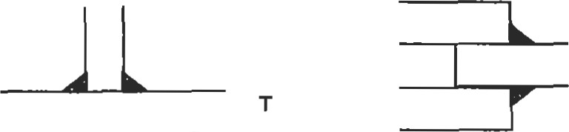Double



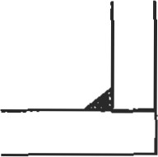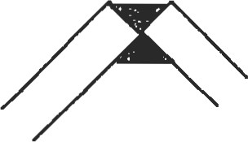Corn%

Comer

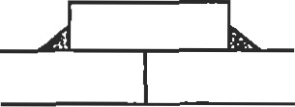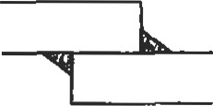 Strap Butt

Figure 5. Typical solder joint geometries [36]. (With permission, ASM International.)

used. Table 14 lists a variety of Pb-Sn solders and their applications. Many of the solders have wide freezing ranges. This feature makes them useful for filling and wiping. An 80/20 Pb-Sn solder has a melting range of 1700F. This wide melting range allows one to work with it for an extended period of time. It can be used to fill dents in auto bodies.

The heat source for soldering is typically an iron, although torches, furnaces, induction coils, resistance, ulffasound, or hot dipping can be used to heat the joint.

Brazing

Brazing is related to soldering in that the subsfrate materials are not melted. The braze joint geometries are similar to soldering also. A metallurgical bond is formed between the two substrates via liquid enhanced diffusion. Intermetallic compounds may form between the braze and

Brazing may occur in several atmospheres including air, vacuum, and inert gas. The atmosphere used depends on the heat source and alloy. Heat sources can be torches, induction coils. furnaces, resistance heaters, etc.

Table 14

Composition and Applicaüons of Lead Tin Solders



Composün Temperaüne (F)

Melting lln L*ad Solldus Llquidus Range Uses

2 98 518 76 Side seams for can

5 95 518 594 76 CoMing and joining metals.

10 90 514 570 56

15 85 440 550 110

20 80 361 531 170 Coating and joining meWs, or filling dents and seams in automobile bodles.

25 75 361 511 150 Machine and t0FGh soldering.

30 70 361 491 130

35 65 361 477 116 Genetal purpose and wiping solder.

40 60 361 460 99 Wiping solder for Joining bad pipes and cable sheaths. For automobile radiator cores and heating units.

45 55 361 441 80 Automotive radlator cores and roofing seams.

50 50 361 421 60 General purpose.

40 361 374 13 Primarily used in soldering where low soldering temperatures ere required.

63 37 361 361 O Lowest melting (eutectic) solder for electmnic appllcations.



From MEI Metallurgy for the Non-Metalurgist, Lesson 9, ASM Intemaümal, 187.

Small steel assemblies can be furnace brazed. For furnace brazing of assemblies to be successful, the design of the parts must be such that the braze can be preplaced on the joint and remain in position during the braze cycle. A copper-based braze alloy is used because of the high strength ofjoint developed. The high brazing temperature (1,093 0 to 1,1490C or 2,000 to 2, IOOOF) necessary to melt the copper braze proves beneficial when the assembly needs to be heat treated after brazing. The operations entailed in furnace brazing are cleaning, brazing, and cooling.

Small steel assemblies, less than 5 pounds, are most efficiently brazed. Larger assemblies can be fabricated, but these may require specially designed and built furnaces.

Cleaning is typically accomplished by solvent cleaning, alkaline cleaning, or vQor degeasing. All alkaline compounds must be removed prior to placing assemblies in the brazing fumace. Adherent parücles may be removed through mechanical means, such as wire brushing or light grinding.

Brazing of the components requires that they first be assembled and the braze applied. For multiple small articles, the components should be fitted, either through swaging or press fitting, such that no fixturing is required.

The articles are placed in the brazing furnace under an appropriate atmosphere to prevent oxidation and decarburizaüon. When the assemblies reach a temperature higher than the melting range of the braze, the braze melts and flows into the joint via capillary action. Some diffusion occurs between the molten braze and the substrates, and the joint is formed. The heating cycle time is approximately 10—15 minutes, although longer times can be used to promote some diffusion and homogenization of the bond joint. Inadequate furnace heating can result in the braze melting but not flowing into the joint. This occurs because the assembly has not reached or exceeded the melting point of the braze. Increased superheat (temperature above the melting point) improves braze flow but may cause erosion.

Cooling of the assembly must be done under a protective atmosphere to prevent surface oxidation. The parts should be cooled to a temperature below about 1500C (3000D. The cooling typically occurs in a section of the furnace chamber that is not heated.

The furnaces used may be either batch or continuous. A batch type furnace requires an operator to place a tray of assemblies in the hot zone and move them to the cooling zone after the requisite braze cycle. In a continuous braze furnace, assemblies are placed on a chain link and the furnace pulls the assemblies through the hot zone and into the cooling zone of the furnace.

The atmosphere used can be either inert. protective, reducing, or carburizing. The selection of the gas atmosphere depends on the requirements of the parts and joint. If the atmosphere is incorrect, it can alter the surface chemistry of the parts and lead to rejected hardware, poor strength, or premature failure in service.

Steel assemblies can be torch brazed or induction brazed. In torch brazing, surface cleanliness is required, but because the protective atmosphere surrounding the flame is not always adequate, a flux may be necessary. Torch brazing can be fully manual, partially automated, or fully automated. rme gases used are acetylene, natural gas, propane, and prietary gas mixtures. Oxygen is principally used as a combustion agent because of its high heating rate. Lower grades of compressed oxygen, compressed air, or a blower can also be used to reduce costs.

Filler metals used in torch brazing are silver- or copper zincbased. Silver alloys are used for steel-to-steel joints and most other metals except aluminum and magnesium. Copper zinc alloys can be used to join steels, and even nickel and cobalt alloys where corrosion resistance is not necessary. High temperature alloys like cobalt- and nickel-based superalloys can be brazed with Ni- or Co-based alloys also. The braze alloy selected is usually based on the base metal being brazed. The service temperature of the brazed assembly will generally be lower than the braze temperature. Diffusion heat üeatments can be used to reduce the of low meldng point elements near the braze joint, which increases the braze remelt temperature, and possibly the service temperature.

The strength of a lap joint can be calculated using Equaüon 4:

ySw

(4)

where x is the length of the lap, y is the factor of safety, S is the tensile strength of the weaker member, w is the thickness of the weaker member, and L is the shear sü•ength of the braze filler metal.

headng with or without atmosphere can be used to make braze joints. The heat flux generated by an induction coil depends on the number of coils, distance between the coil and work piece, and geometry of the work piece.

Welding

Welding produces metallurgical bonds between the work pieces by melting them The joints can be heterogenous if a filler metal is inüoduced or autogenous if none is introduced.

The need for filler metal is determined by the process that is used. There are several methods to inu•oduce heat into the work pieces. Each process has its individual total heat input and concentraüon of heat input. Further, each process uses various methods to protect the molten metal and surrounding area from oxidation.

Joint geometry plays an important role in the ease of welding fabrication, generation of residual stress, and application. The typical joint geometries and weld types are shown in Figure 6. Joint preparation should include cleaning to remove any oils and cutting residue. Entrapped moisture can lead to hydrogen embrittlement also. The geometry of the joint should be designed so that there is easy access to the joint. The effect of residual stresses should be minimized. A poorly designed joint is shown in Figure 7.

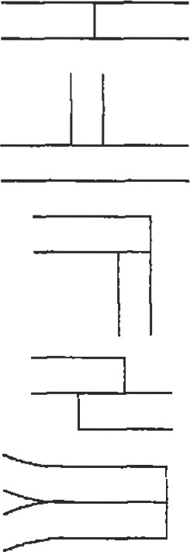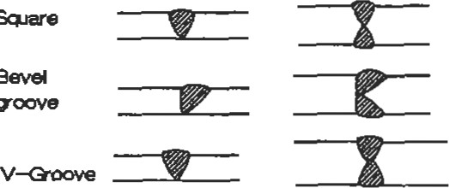 Slrvle Da.ble

Fillet

Figure 6. Typical joint geometries and weld types [36]. (With permission, ASM International.)

Camot lay in last weld at acceptable arOe (450 )

|  |  |  |
| --- | --- | --- |
| /y |  | 22, |

Double T, Double fillet weldment

Figure 7. A poorly designed weld joint.

This joint design is poor because it does not allow welding of the second plate in an unobsüucted manner or an ar propriate angle.

The Elationship of groove angle and root opening is shown in Figure 8. It is important to note that the root opening decreases with increasing bevel angle. The change in width is required for elecffode access into the base of the joint. The selection forjoint design depends on the base plate thickless and the amount of filler required to manufacture the joint.

600 450

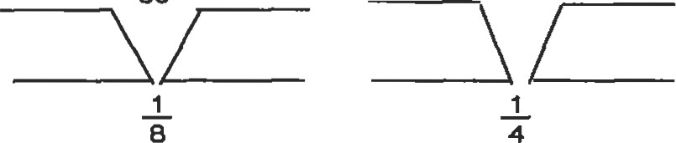

300 200



3 1

8 2

Figure 8. The relationship between nove angle and root opening for butt welds [36]. (With permission, ASM lntemational.)

A number of processes are available for welding. The method selected depends on the joint requirements, material, and costs. Table 15 lists acronyms of the American Welding Society and uses for common engineering alloy classes.

Table 15

Common Welding Names and Applications

|  |  |  |  |  |  |  |
| --- | --- | --- | --- | --- | --- | --- |
| Carbon Low-alloy Stainless Cast Nickel Alumlnum  Steel Steel Steel Iron Allop All%8 | | | | |  | Copper Alloys |
| SMAW All  GTAW <1/4'  GMAW  EBW All  I-BW &'4" | All | All  All | All All  1/8-3/4 All  All | All  <314" | All |  |

Process not from ASM Mews Vol. 6, 9th 1961.

A brief description of the type of weldments made with the more common methods follows. Shielded metal arc welding (SMAW) is a poruble and flexible welding method. It works well in all positions and can be done outside or inside. It is typically a manual process and is not continuous, as it relies on consumable electrodes that are from 12 to 18 inches long. The elecü•odes have a surface layer of flux on them which melts as the elecü•ode is consumed and forms a slag over the weld. "Ihe slag protects the joint from oxidaüon and contamination while it solidifies and cools.

Gas metal arc welding (GMAW), also referred to as metal inert gas welding (MIG), is a continuous process that relies on filler wire fed through the torch. It can be used on aluminum, magnesium, steel, and stainless steel. A shielding gas, either argon, helium, or even carbon dioxide mixed with an inert gas, is used to protect the joint and heat-affected zone (HAZ) during the welding process.

Flux cored arc welding (FCAW) uses a continuous wire which has flux inside the wire. The electrode melts, fills the gap, and a slag is generated on the surface of the weld to protect it from oxidation. It is usually used only on steels. For additional protection around the weld, an auxilary shielding gas can be used.

Gas tungsten arc welding (GTAW), also referred to as mgsten inert gas (TIG), is a process that can be automated. It can be eitlEr mtogenous md heterogenous, depending on whether filler wire is introduced; the tungsten electrode does not melt to fill the joint. An inert gas, typically argon, helium, or, more recently, carbon dioxide, is used to protect thejoint from oxidation during welding. The filler wire selected for the joint should match the base metals of the joint materials. In some cases, the joint metal may be a different composition. In stainless steels, type 308 filler wire is used for 304 and 316 joints. A large number of metal alloys can be welded with GTAW, including carbon and alloy steels, stainless steels, heat-resistant alloys, refractory metals, dtanium alloys, copper alloys, and nickel alloys. The nominal thickness that is easily welded is between 0.005 and 0.25 inch.

GMAW, SMAW, FCAW, and GTAW are all moderate rate of heat input techniques. This means that there is about a one-to-one ratio of weld penetration to weld width.

Figure 9 shows a typical weld depth to width of one, in addiüon to multiple passes which can be made on thick plates for weld metal build-up.

LASER (LBW) welding uses a concentrated coherent light source as a power supply. It provides unique characteristics of weld joints and can be used to weld foil (0.001 inch) as well as thick sections (l inch). It is a high rate of input with deep penetration and narrow welds, shown schematically in Figure 9.

Another high rate of heat input is electron beam welding (EBW). It has a broad range of applicability and can weld tyin foil, 0.001 inch thick, as well as plates, up to 9 inches thick. It has drawbacks in that it requires a high vacuum for the electron beam heat source, but these can be overcome for continuous welding uses. The beam will melt and vaporize the work piece. Metal is deposited aft of the beam, and a full penetration weld is made.

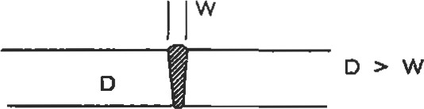

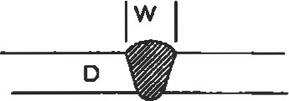

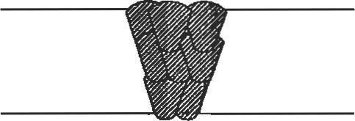

|  |
| --- |
| Coatings |

Hgure 9. Weld depth to width greater than 1, typical of L.ASER or EBW (top). Weld depth to width approximately equal to 1 , typical of SMAW, GTAW (middle). Multiple passes made on tick plde, Wpical of mutüpass GTAW (bottom).

Coatings can be used for decoration or to impart preferential surface characteristics to the substrates. Coatings can be an effective and emcient method to neat the surface of a component to provide surface protection, while die subprovides the mechanical and physical properties.

High temperature coatings can be applied by a number of methods. The approach used depends on the type of coating and the application. Ihere are basically two types of coatings: overlay and diffusion. Overlay coatings are generally applied to the surface of the part and increase the overall dimension of the part by the coating thickness. Methods to apply overlay coatings include chemical vapor deposition (CVD), physical vapor deposition (PVD), thermal spray deposition (TS), plasma spray deposition (PS), and high velocity oxygen fuel deposition (HVOF). Of the above listed methods, only CVD can coat in a non-line of sight. The others require that the coating area be visible. This limitation can pose problems for parts of complex geometry. Diffusion coatings may or may not be line of sight limited. There are several methods to apply diffusion coatings, the most common being the pack method although the use of CVD is growing. Table 16 compares diffusion and overlay coatings.

Table 16

Comparison Between Diffusion and Overlay Coatings

|  |  |
| --- | --- |
| Diffusion Coatings | Overlay Coatings |
| Metallurgically reacts with base metal.  May detrimentally affect propaties, especially fatigue.  Approximately 50% of thickness is added.  Intemal coatngs possible by some methods.  Limits on compositions. | Thin metallurgical interaction.  All thickness is added.  Little effect on mechanical properies, although they increase cross-secion without increasing load capabilities.  Line of sight limitations make complex geometries difficult to coat.  Internal coatings not possible. Compositions by PVD, TS, Pa, HVOF neady unlimited. |

Adapted from Aurrecoechea [351, Used with permission, Solar Trbines, Inc.

The compositions that can be applied by thermal spray processes and PVD are very wide. The chemisuy depends on the application. CSO coating chemistries are lin•üted by the type of precursor and the required chemical reaction to form the coating composition.

MCrAlY coatings are one family of coügs that can be used for hot corrosion and high temperature oxidation protection. The "M" stands for Fe, Ni, Co, or a combination of Ni and Co. Each element in the coafrlg is present for a specific purpose. Typical coatings contain 6%—12% Al, 1670-25% cr, and Y, balance Ni, co, Fe, or Ni and Co. Table 17 lists the specific elements and the influence on the coating.

Aluminum provides high temperature oxidation resistance. It needs to be present in a sufficiently high concenfration to be able to diffuse to the surface and react with the inward migrating oxygen. The activity and diffusivity of the Al is proporüonal to the of Al. The overall oxrate and life is affected by the Al concentration. Excessive Al content can cause coating embrittleness which can lead to cracking and spalling of the coating.

Chromium is added to impart corrosion resistance; it also increases the activity of Al. This allows continuous aluminum oxide scales to form at lower Al concentrations than normally expected. The protection of the coating thus relies on the synergistic effect of Al and Cr additions.

Table 17

Overlay Coating and the Effect of Individual Elements on Coating Behavior

Coating

|  |  |  |
| --- | --- | --- |
| Element Amount Effect | | |
| Balance Fe—Best oxidation and hot corrosion | | |
| co, Ni |  | resistance, low temperature limitations Ni—Excellent high temperature oxidation resistance  Co-—Best hot corrosion resistance, not as good in high temperatRE oxidation  Ni + Co-—-Best balance between oxidaton and hot corrosion, mixed environments |
| Cr | 16-25 | Mainly hot corrosion resistance, synergistc effect with for oxidation |
| Al | 6—12 | Oxidation although excess additions cause embrittlement |
|  | 0.3-1.0 | Improved oxide adhesion by tying up S in alloy Hot corrosion |
| T4 Pt,Pd |  | Oxidation |

Adapted from Amdry Product Bulleän 961, 970, 995[14].

Yttrium is added to improve the oxide adherence. Generally, oxides spall on coatings without reactive element additions. The method of improved adhesion is not fully understood, but experimentation has shown that the majority of the benefit is derived by tying up the sulfur inherendy present in the alloys. Sulfur acts to poison the bond between the oxide scale and the coating. Yttrium or other reactive elements, Zr or Hf, also may promote the formaüon of oxide pegs which help mechanically key the oxide layer to the coating.

More advanced may contain Hf and Si which act like Y to improve adherence. Hafnium, which acts chemical-ly similar to yurium, may be used in place of Y. Additions of Si can be used to improve the hot corrosion resistance of the coatings. Tantalum is sometimes added to improve both oxidation and corrosion resistance. Noble metals like platinum and palladium can be used similarly to chromium to improve both oxidaüon and corrosion resistance.

The major alloy element(s) affect the coaüngs in different ways. Iron (Fe) based MCrAlY coatings have superior oxidation resistance to the other types of coatings. They also tend to interact with the base metal and diffuse inward. Thus, they are limited in temperature to approximately

FeCrAlY coatings are suitable for high sulfur applications.

Cobalt-based alloys have superior hot corrosion resistance to NiCrAlY coatings due to the presence of cobalt which helps modify the thermochemisfry of molten Na2S04. This modification alters the oxygen and sulfur activities and lowers the rate of attack. CoCrAlY's do not have as good of oxidation resistance as NiCrAlY's, and have a temperature limit of

Nickel-based alloys are used for high temperature oxidation applications, such as aircraft coaüngs. They have outstanding oxidation and diffusional stability and can be used to temperatures of 1,8000F.

A mixture of both Ni and Co can be used for applications requiring a balance between hot corrosion and oxidation properties. These alloys are called NiCoCrAlY or CoNiCrAlY, the designation depending on which element is more prevalent.

Overlay coatings can be very thick, up to 0.1 inch, and can be used to refurbish mismachined pms. Further, ceramic coatings can be applied to provide reduced heat transfer and ultimately lower metal temperatures. Elecffon beam physical vapor deposition can be used to form vertically cracked thermal barrier coatings. The vertical cracks provide increased strain tolerance, as shown in Figure 10. ms type of süucture is possible to create with other methods, such as plasma spray, by careful confrol of the processing parameters.

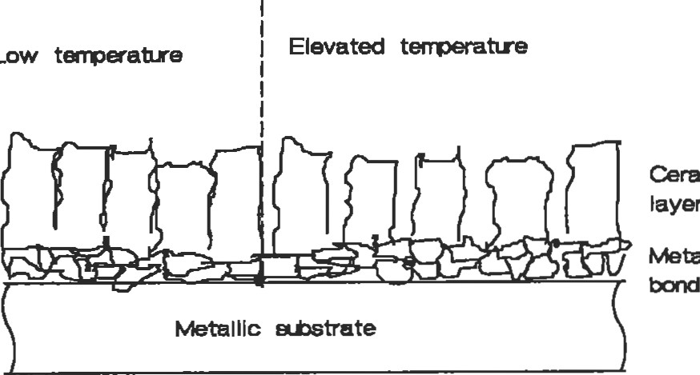

Low

Ceramic

M&llic

coat

Figure 10. Schematic of a vertically cracked ceramic showing improved strain tolerance.

Diffusion coatings are less complex in terms of initial chemisüy. Aluminum or chromium is diffused into a nickel- or cobalt-based alloy. This u•eatment results in an aluminum- or chromium-rich surface layer that adds some ülickness to the part and also diffuses inward. The aluminum or chromium is applied to the surface either through some gas phase process or solid state diffusion process. A typical aluminide coating on a nickel substrate is shown schematically in Figure 11. The coaüng contains all of the elements present in the substrate. There is typically a "fin-

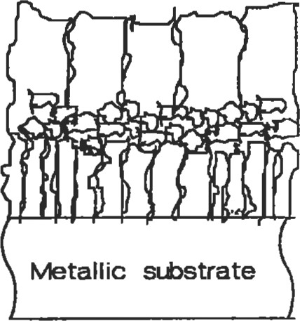Al—rich zone

Transition zone

Interdiffusion zone

Figure 11. Schematic of a typical aluminide coating on a nickel substrate

ger" diffusion zone between the aluminum-rich surface and the substrate. The process requires a fairly high temperature which is generally determined by the heat ü•eatment required for the base metal. Diffusion coatings are significantly less ductile than overlay coatings but provide excellent oxidation and moderate hot corrosion resistance depending on the coating composition. As is the case for overlay coatings, the amount of protection afforded to the substrate is determined by the aluminum and/or chromium content. The thickness of diffusion coatings is on the order of 0.001—0.003 inch.

Low temperature coatings consist of a number of possible metallic, inorganic, or organic compounds. Some possible metallic coatings are zinc plate, either galvanic or hot dipped, aluminum cladding, either by roll bonding or thermal spray, cadmium plating, or nickel plate. Zinc, aluminum, and cadmium coatings are useful for aqueous corrosion protection where moisture is in contact with the parts. Nickel plate can be used as a moderate temperature oxidation-resistant coating.

The coating selected needs to fulfill the application requirements. These include many of the same considerations as the substrate, e.g., temperature, active species, effect of failure, etc. An important consideration these days is the effect of coating-related processing on the environment. Plating processes which rely heavily on hazardous solutions are being phased out. Alternative methods of applying the decorative plate to materials are being sought. Thermal spray processing is one possible coating method. This has its own environmental hazards such as dust collection and cleaning solutions.

Organic coatings include substances like epoxies and paints. These can be used to protect materials from cormsion problems and as decoration for low temperature applications.

|  |
| --- |
| Corrosion |

Corrosion is a material degradation problem that can cause immediate and long-term failures of otherwise properly designed components. Corrosion occurs because of oxidaüon and reduction of species in contact with one another. In an aqueous solution, the common reactants are hydrogen, oxygen, hydroxyl ions, a metal, and the metal's ions.

There are at least eight forms of corrosion attack. These are erosion-corrosion, corrosion, uniform, galvanic, crevice, pitting, intergranular attack, and selective leaching. Many of these types are based on the appearance of failed components.

Two electrochemical series can be used to determine the likelihood of corrosion. One is the electromotive force series (EMF) and the other is the galvanic series. The Eh11F series is based on a reversible equilibrium half-cell reaction from which the Gibb's Free Energy for reactions can be determined, while the galvanic series establishes the tendency for nonequilibrium reacüons to occur in various solutions. Different galvanic series may be determined for seawater, fresh water, and indusüial atmospheres (See Table 18).

The galvanic series indicates the tendency for corrosion to occur on two metals that are joined together either metallurgically (soldered, brazed, or welded) or mechanically (bolted, riveted, or adjacent) and is material combination and solution specific. In either case—EMF or galvanic—the tendency for corrosion is greater the wider the separation between the two materials. For instance, if one were to connect titanium and Inconel alloy 625, there would be little driving force for the reaction to occur. On the other hand, if one were to connect titanium and an aluminum alloy, there would be a large driving for the reaction to occur. The EMF and galvanic series only address the likelihood of and do not indicate the rate at which corrosion may proceed.

Erosion-Corrosion occurs when a corrosive medium is present that is in relative motion. It can cause rapid failure of a materials combination that had excellent life in laboratory testing but was tested under static condiüons. Many metals rely on the formaüon of a protective film to decrease the corrosion rate. However, when the metals are placed in a solution diat has relative motion—such as a pump impeller or pipe—the protective film may be removed by the fluid and accelerated corrosion can occur. Both the environment and the fluid velocity affect the corrosion rate, and

Table 18

Galvanic Series in Seawater at 770F

Protected end (cathodic, or noble)

Platinum

Gold

Graphite

Titanium

Silver

HASTELLOYØ alloy C

INCONELO alloy 625

INCONEL@ alloy 825

Type 316 stainless steel (passive)

Type 304 stainless steel (passive)

IYpe 410 stainless steel (passive)

Monel alloy 400

INCONELØ aJloy 600 (passive)

Nickel 200 (passive)

Copper alloy C71500 (Cu Ni)

Copper alloy C23000 (red brass 85% Cu)

Copper alloy C27000 (yellow brass 65% Cu)

HASTELLOY@ alloy B

INCONEL@ alloy 600 (active)

Nickel 200 (active)

Copper alloys C46400, C46500, C46600, C46700 (naval brass) Tin

IYpe 316 stainless steel (acive)

IYpe 304 stainless steel (active) 50-50 lead in solder

Type 410 stainless steel (active)

Cast inn

Wrought iron

Low carbon steel

Aluminum alloys 2117, 2017, and 2024 in order

Cadmium

Aluminum alloys 5052, 3004, 3003, 1100, 6053 in order

Galvanized steel

Zinc

Magnesium alloys

Magnesium

Adapted fmm ASM Metals Handbook, Vol. 13, % Ed. [411.

there may be more than one minimum corrosion rate for a material combinaüon. The following are general guidelines:

1. Any solution or addiüve that removes the protective scale increases erosion corrosion.
2. Increasing velocity generally increases corrosion rate.
3. High impingement angles increase erosion-corrosion (especially important at pipe elbows).
4. Soft metals are more susceptible to erosion corrosion since they are less resistant to mechanical wear.

Stress-Corrosion is a complicated interaction of both a specific corrosive environment and a tensile stress. The stresses may be external (due to applied loads) or residual (for example, differential cooling after welding). Unstressed materials may be relatively inert (non-reactive) in the specific environment but may crack catastrophically when a critical load is applied. The material combination is very important; for instance, brasses tend to crack in ammoniacontaining solutions but not in chloride solutions. On the other hand, stainless steels tend to crack in chloride solutions but not in ammonia or many acids (nitric, sulfuric, acetic, or water). There is no one, particular crack morphology that occurs, although the crack is usually perpendicular to the stress axis. Cracks can be intergranular (between the grains), transgranular (across the grains), or single- or multi-branched.

The stress corrosion cracking phenomenon depends on the solution chemistry, temperature, metal composition and microstructure, and stress. In a given environment, the stress required to cause cracking may be as low as 10% of the yield strength or as high as 70%. Above the critical load for cracking, increasing the stress decreases the time required for cracking. Increasing the temperature decreases the time to cracking for 316 and 347 type stainless steels in sodium chloride (salt) solutions.

High strength, low alloy steels are more likely to exhibit stress corrosion cracking than low or medium strength steels. The presence of cold work increases the likelihood of stress corrosion cracking. The following stainless steels are ranked in increasing order of resistance to stress corrosion cracking: Type 3()4, types 316 and 347, and types 310 and 314 [101.

Tables describing the materials resistance to stress corrosion cracking can be found in Fontana [10].

Uniform corrosion occurs all over a surface or structure. A common example is unpainted steel, which turns rusty over the entire exposed surfaces. There are several methods to prevent uniform corrosion, including proper materials selection for the structure and, if necessary, coatings, addition of inhibitors (ionic species which preferentially oxidize; chromates in antifreeze) to the solution to reduce the corrosion rate, and cathodic protection.

Galvanic corrosion occurs when two or more dissimilar metals are coupled in a corrosive media. A potential difference is generated, the magnitude of which depends on the separation between the two metals on the galvanic series, shown in Table 18, or electromotive series. The larger the potential difference between the two metals, the higher the driving force for the reaction to occur; but the overall rate is determined by local kinetics. Based on the separation argument, it would be acceptable to join Monel 400 and Nickel 200 (passive) in a salt water environment.

On the other hand, it likely would be detrimental to join Monel 400 and low carbon steel, since they are widely separated.

The relative position of the two metals on the series dictates which metal will be oxidized (corroded) and which will be reduced. The lower the metal in the series, the more active and the more likely it will be oxidized (anode). The higher the position, the more noble and the more likely it will be reduced (cathode).

The galvanic cell can become polarized, having a lower concentration of ions being reduced, at the cathode. Polarization will decrease the corrosion rate of the anode since the overall solution must remain charge balanced.

It is difficult to predict whether or not galvanic corrosion will be a problem, so it is best to test the metal combinations in situations that simulate service. The following are general guidelines for preventing galvanic corrosion

Design systems that are susceptible to galvanic corrosion have a large anode and small cathode area ratio. Figure 12 shows favorable and unfavorable designs for dissimilar metals that are galvanically coupled. This design reduces the current density and limits the penetration. Fully isolate the materials using insulation appropriate for the solution and temperature. Apply coatings, but use with caution. If painting or coating is necessary, paint the cathode. In the event of a coating rupture, the favorable cathode-to-anode ratio is maintained. If a coating rupture occurs on a painted anode (component likely to corrode), then there is a large cathode and very small anode. This situation will lead to rapid attack of the anode, which can lead to penetration and subsequent failure. Avoid threaded fasteners for metals

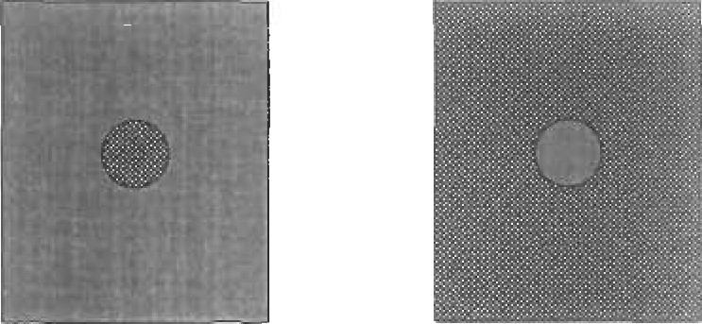

Good design Poor design

Alumirum Copper

Figure 12. Favorable and unfavorable designs for dissimilar metals that are galvanically coupled.

which are far apart on the galvanic series, braze with a more noble alloy, or weld with the same metal. Design to replace anodic material. Introduce a third alloy that is more anodic than either of the component alloys as a replaceable anode for protection (sacrificial anode). Impress a current on the system so that no metal dissolution occurs.

Crevice corrosion is a caused by stagnant solutions in surface defects such as scratches, holes, gasket materials, lap joints, surface deposits, and beneath rivet and bolt heads. A crack or gap wide enough to alloy liquid penetration and stagnation (a few thousandths) but not provide for complete solution change creates an ideal environment for crevice corrosion. Fibmus gaskets promote wick and stagnant solutions and, therefore, crevice corrosion. Stainless steels are very susceptible to crevice corrosion.

Crevice corrosion can be prevented by avoiding bolted construction in new designs. It is better to weld or braze so that no cracks are formed in the system. Welded construction should have full penetration welds and no porosity. The system should also be designed so that there are no stagnation points and the system can be fully drained. For existing systems, close the gaps using welds, brazes, or caulks. Inspect systems often to ensure that there are no deposits, and if there are, remove them. Remove any wet packing material. Use solid gaskets (such as teflon) rather than porous ones.

Pitting corrosion operates in a mechanism that is similar to crevice corrosion, but this insidious form of attack promotes the formation of its own crevice. It may also be influenced by gravity. It is diffcult to inspect because corrosion products may form over the pits and make them difficult to detect. Further, the pits may not go straight through the wall; they may have a "worm hole" appearance.

Pitting corrosion can be prevented by appropriate selection of materials. In increasing order of pitting resistance, there 304 SS; 316 SS; HASTELLOY@F alloy, Duramet 20; HASTELLOY@ C, Chloromet 3; and titanium. Proper heat u-eating can be used as a preventative measure since sensitized stainless steel is more suscepüble to pitting than nonsensitized. Quenching, rapidly cooling, austenitic steels from above 1,8000F will help prevent sensitizaüon. Polishing the surfaces of the parts makes them less likely to iniüate pits, although once initiated, the pits tend to grow faster.

Intergranular corrosion is a preferential attack at the grain boundaries. It occurs for a number of reasons; for instance, grain boundaries are more active, grain boundaries can be enriched with either impurities or alloying additions, or grain boundaries can be depleted in corrosion-resistant alloying addiüons.

Intergranular corrosion can be a problem in austenitic stainless steels with high carbon content (0.06%-0.08% C). Chromium is required at a minimum of 12% to ensure corrosion resistance; however, chromium carbides may form if the cooling rate through the sensitization range is not sumciently rapid. A schemaüc of a sensitized austenitic stainless steel is shown in Figure 4. The Cr content around the grain boundaries is below the required minimum, and this variation leads to attack along the grain boundaries.

A related phenomenon is weld decay, which is accelerated corrosion at a distance away from the weld. It occurs because carbides precipitate in die heat-affected zone (since this area is heated to the susceptibility range). If welding is necessary, a moderate to high rate of heat input process should be selected.

Susceptibility of intergranular attack can be controlled by solutioning and water quenching parts through the susceptibility range. Stabilizers such as niobium or titanium can be used in the alloys (types 347 and 321 SS). These promote the formaüon of more stable carbides than chromium carbide. Ultra low carbon alloys can be used (<0.03% C). Castings should be poured into low carbon molds.

Welded stabilized alloys may exhibit a failure mode similar to weld decay. The rate of cooling may be too rapid at the weld/work piece interface for the high melting point

Melting point

|  |
| --- |
| Columbium carbide dissolves Chromium carbide dissolves |
| Columbium carbide precipitates Chromium carbide dissolves |
| Chomiurn carbide precipitates |
| No reactions |

2250

1450

950

70

Figure 13. Schematic of the thermal cycle that occurs for a welded stabilized stainless steel [10]. (Reprinted by permission of McGraw Hill, Inc.)

carbides to reform on cooling, and only chromium carbides can precipitate. Figure 13 shows a schematic of what occurs as a stabilized alloy is welded. As the Cr and Cr-carbides are solutioned, it is possible for localized areas near the weld joint to fall below the critical Cr content required for corrosion resistance.

High strength aluminum alloys can suffer from a form of intergranular attack. Typically they are strengthened with copper. A potential difference (voltage) is established between the CL12Al precipitates and the surrounding alloy. A localized galvanic reacüon occurs which results in what appears to be intergranular attack.

Selective leaching is a generic term that describes the removal of one constituent of the alloy by a corrosive process. A process termed dezincification is the most commonly observd Dezincificaüon occurs when brass, an alloy of zinc and copper, is dissolved and copper is plated back on the remaining smicture. Dezincification results in a change in color of the parts and is visible to the naked eye.

Dezincification can be prevented by reducing the severity of the environment, reducing the zinc content of the alloy, or changing from brass to a cupronickel (coppernickel) alloy.

|  |
| --- |
| Powder Metallurgy |

Gray cast iron is also susceptible to selective leaching. In fis case, the iron surmundng the graphite flakes is dissolved, leaving a spongy mass of rusted iron. The part appears to be surface rusted, but all of the metal may actually be dissolved, leaving a süucture without integrity. This process occurs over a long period of and can be prevented by using nodular (ductile) cast iron rather than gray cast iron.

Powder metallurgy is a material shaping process that starts with finely divided metal (ceramic powders can also be processed by typical powder metallurgical techniques), uses a compacü)n step to shape the powder, and applies heat to make a süong fmished product. Nearly all types of metal alloys can be formed by powder metallurgy. In some instances, tungsten for example, it is the only method to produce a useful shape. This is because it is difficult if not impossible to melt and contain tungsten. If powder metallurgy is to be used, features of the final part must be incorporated early in the design stages to produce the parts at the lowest possible cost.

Undercuts and negative drafts cannot be pressed into a part using uniaxial compression. Feather edges should be avoided by incorporating a small step at the edge of the bevel. Cenü•al cut-outs should be rounded. Some of the salient features of designing powder metallurgy parts are illustrated in Figure 14.

There are basically three steps to producing powder metallurgy parts. Elemental or prealloyed powders are mixed with die lubricants or other addiüves. Blending is also performed when powders of the same composition from different lots or vendors are combined.

The mixed powders are then compacted into a green (unsintered) form. The compaction pressure can be applied uniaxially, the most common for simple two-dimensional shapes, or isostatically, a common method to produce complex shaped parts. The pressures used are as low as 10 tons per square inch or as high as 60 tons per square inch.

The pressing cycle includes a die filling, compaction, and ejection. The cycle is performed repeatedly until the number of parts required are processed.

Sintering is the final step. This process takes the green compacts and fires them at a high temperature to promote diffusion (atomic migraüon). The atoms in the powders move from one particle to another and form a metallurgical bond. The parts are generally not heated above the melüng point of the powders, although some alloys are liquid phase sintered, like tungsten carbide cobalt for tool inserts. The liquid phase promotes densification and full density.

Powder metallurgy parts can be used after sintering, but sometimes additional steps such as coining, repressing, impregnating, machining, tumbling, plating, or heat treating are used to produce a completed part.

Feather Edges

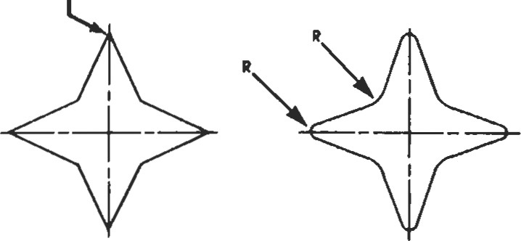

Feather edges on the part should be avoided.

Original Design Preferred Design

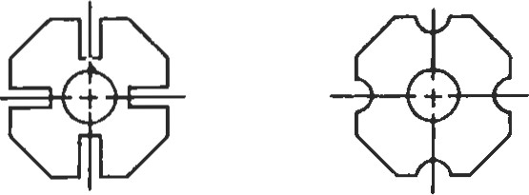

Avoid narrow, deep spines on the part.

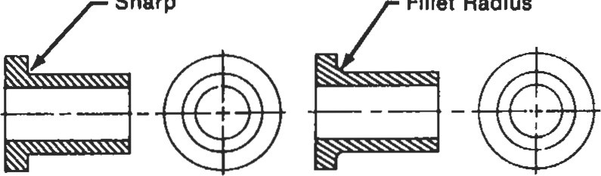

Sharp

Fillet

Radius

A rounded corner gives better powder flow In die and gives part increased strength and eliminates stress risers in tools and parts.

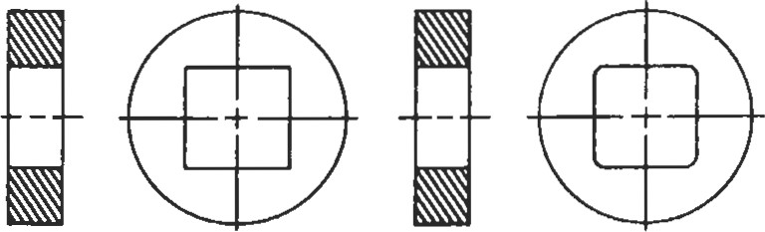

Rounded corners permit uniform powder flow in the die.

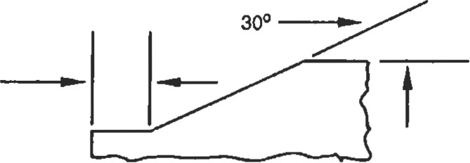0.015'

0.005

Chamfers are Preferred on Part Edges

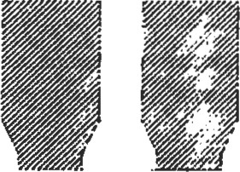

Chamfers in Clearance

Figure 14. Powder metallurgy design considerations for successful implementation [13]. (Reprinted by permission of Metal Powder Industries Federation.)

#### POLYMERS

Use of polymers (plastics) has grown tremendously in recent years. To properly use these materials to replace metallic structures or to use them in new applications requires that certain information be considered prior to designing parts for the application.

To properly design and implement polymer parts use, the required properties that are of engineering importance must be defined. Often a list, such as that in Table 19, is generated and the material selection proceeds by process of elimination. Many polymeric materials can be eliminated from the list simply because they do not meet key/critical property requirements.

The material selection process must include specific recommendations, and one cannot simply request polypropylene or polyvinyl chloride as these terms are as nonspecific as requesting steel or an aluminum alloy. Var-

Table 19

Factors That Influence the Selection of Polymers for Engineering Applications

Mechanical Service stress—type and magnitude

Loading pattern—frequency and duration

Fatigue resistance

Strain limitations

Impact resistance

Environmental Temperature—range, maximum and minimum limits

Corrosiveness—solvent, vapor, acid, & base attack

Oxidation

Exposure to sunlight

|  |  |
| --- | --- |
| Electrical | Resistivity  Antistatic properties Dielectric loss |
| Hazards | Toxicity—additives or degradation products Flammability |
| Appearance | Color |

Surface finish

Long-tem appearance

General weight Space limitation Tolerances Life expectancy Pemeability

Manufacturing Process of choice

Method of assembly

Finishing requirements

Quality control and inspection

Economics Material cost

Process cost—maintenance and fuel

Capital costs-qnolds and equipment

Adapted from McCrum, et al. [111.

ious additives are made to the melt or powdered mixture to alter the key property requirements, such as flammability, plasticity, impact resistance, and toughness.

Fundamentally, there are two types of polymers: thermoplastics and thermosets. Thermoplastic polymers soften when they are heated and can be formed in this semiliquid state. Further, the process is reversible and it can be repeated a number of times. Thermoset polymers cross-link and change structure when heated. This process is a chemical reaction that is not reversible and results in a polymer that is permanently set once cooled.

Polymers can be either crystalline or amorphous. The mechanical properties resulting from either structure are different. Polymers need not be fully crystalline or amorphous. They can be fractionally crystalline. The polymer composition and process determines the degree of crystallinity. The degree of crystallinity can be determined using standard thermal techniques such as differential scanning calorimetry and x-ray diffraction.

Polymers are made of long organic molecules that can be combined to produce other polymers with mixed properties. Figure 15 shows how two polymers, A and B, can be combined to give properties that are mixed between homopolymer A and homopolymer B.

The mechanical response of polymers is viscoelastic; they can behave elastically or viscously or have a mix of both.

When a polymer behaves elastically it responds like a spring; it extends, instantaneously, as far as the load requires and then stops. The strain is recovered when the load is removed. The behavior is as indicated by Equation 5.

(5)

where is the elastic shear strain, is the applied shear stress, and G is the elastic shear modulus.

If it is responding viscously, in a time dependent manner, then it elongates to failure. It can be modeled after a dashpot and responds as indicated in Equation 6. The süains inü•oduced are not recoverable when the load is removed.

(6)

where is the viscous shear stain, t is time, and is viscosity.

|  |  |  |  |  |  |  |  |  |  |  |  |  |  |  |  |  |  |  |  |  |  |  |  |  |  |  |  |  |  |  |  |  |  |  |
| --- | --- | --- | --- | --- | --- | --- | --- | --- | --- | --- | --- | --- | --- | --- | --- | --- | --- | --- | --- | --- | --- | --- | --- | --- | --- | --- | --- | --- | --- | --- | --- | --- | --- | --- |
| |  |  |  |  |  |  | | --- | --- | --- | --- | --- | --- | |  |  |  |  | |  | | CtassOf  Pctymg |  | RandM" | Bhck | Graft | Homopolymer | | Naaw |  | (A-co-B) |  | Pory (A-frB) |  | | Chunlcal Structuce |  |  |  |  |  | | Exarng*ø  Variation or  Log A with temp«atue | -'DO O +100 rcc) | -100 0 +100  TfCi   |  | | --- | | Phase  -100 |   .4 | |  | | --- | | Two  -100 | | |  | | --- | | Two muse |   req | |  | | --- | | mgse |   -too o +100 | |   Figure 15. Effect of mixing (alloying) two homopolymers on thennal and mechanical properties [1 ll. (Reprinted by permission of Oxford University Press.)  If it has a combinaüon of bcm properties, then it may be like a spring and dashpot in series, described by Equation 7. Sys- |

tems like these will immediately recover the elasüc porü)n of the deformation but will not recover the viscous porüon.

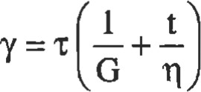 (7)

A more complex situation occurs if the viscous and elastic elements act in melastic behavior. When fis situaüon arises, tie elongation behavior is time&pendent but relaxaüon is reversible. A of behavior is shown in Figure 16 and mathematically in Equation 8.

Y = — (l — e¯t/Yv ) (8)

If it is viscoelastic, then all three elements can be incorporated. This type of behavior is illustrated in Figure 17 and Equaüon 9, which is the summation of the shears indicated in the equations above.

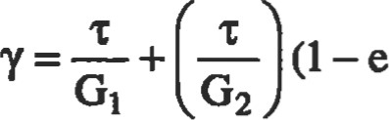-tG2102 ) + — (9)

Typical polymer names and applications are listed in Table 20.

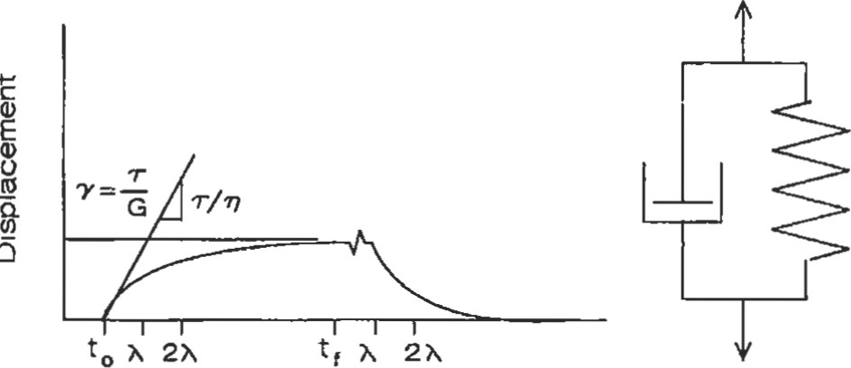

Time

Figure 16. Behavior of a polymer with time-dependent elongation. This model element is also known as the Voight model.

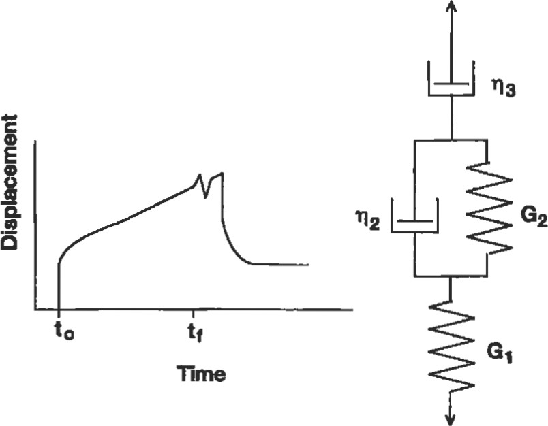

Figure 17. Vlscoelastlc material response that contains instantaneous, nonrecoverable time-dependent, and recoverable time-dependent elongation behaviors.

Table 20

Names and Applications of Polymers

Type Name Typical applications

Thermoset

Phenolics "Bakelite"a Electrical equipment

Polyurethane Sheet, tubing, foam, elastomers, fibers

Amino resins Dishes (urea formaldehyde)

|  |  |
| --- | --- |
| Polyesters | Fiberglass composites, coatings |
| Epoxies  Elastomers | Adhesives, fiberglass composites, coatings |
| Butadiene/styrene | Tires, moldings |
| Isoprene  (natural rubber) | Tires, bearings, gaskets |
| Chloroprene | Structural bearings, fire resistant foam, |
| (Neoprene) | power transmission belts |
| Isobutene/lsoprene | Tires |
| Silicones | Gaskets, adhesives |
| Vinytidene fluoride/ | Seals, O-rings, gloves |

hexafluoropropylene (Vitonb)

|  |  |
| --- | --- |
| Thermoplastics |  |
| Polyethylene | Clear sheet, bottles |
| Polyvinyl chloride | Floors, fabrics, films |
| Polypropylene | Sheet, pipe, coverings |
| Polystyrene | Containers, foam |
| ABSC | Luggage, telephones |
| Acrylicsd (Luciteb) | Windows |
| Cellulosics  Polyester, thermoplastic type | Fibers, films, coatings, explosives |
| (Dacronb, Mylarb) | Magnetic tape, fibers, films |
| Nylons | Fabrics, rope, gears, machine parts |
| Polycarbonates (Lexane) | Machine parts, propellers |
| Acetals | Hardware, gears |

Fluoroplastics (Teflonb) Chemical ware, seals, bearings, gaskets

a rrade name of Union Carbide. b Trade name of Du Pont. CAcrylonitrile-Butadiene-Styrene.

d

Example: polymethyl methacrylate.

made name of General Electric.

Adapted from Harper [37], by permission of McGraw-Hill, Inc.

#### CERAMICS

|  |  |
| --- | --- |
| Ceramics are generally brittle materials that have excellent compressive sü•ength. The tensile strength is dictated by the presence of surface flaws (griffith cracks). The surface flaws are generated by the fabricaüon methods and sequent machining operations.  There are two major types of ceramics: traditional and advanced. Traditional ceramics include refractory bricks, tableware, earthenware, whiteware, and common glass products. The advanced ceramics consist of both oxides and nonoxides. These ceramics may be used as structural ceramics and other technically advanced products. Some advanced ceramics and applications are listed in Table 21.  Ceramics can be formed by slip casting and powder metallurgical processes. Complex parts, like automotive turbochargers, can be formed by injection molding. Other methods include hot pressing and simple press and sinter operations. Often, the densification of the part is enhanced by adding lower melting compounds to the mixture prior to forming it. Yttrium oxide is a common addition to silicon nitride and silicon carbide to enhance the diffusivity.  Ceramics and glasses can be joined to metals, each other, and glasses. The joining technologies are just emerging for the most advanced materials. There are many physical | Table 21  Common Advanced Ceramics and Applications  Silicon nitride and silicon Structural applications, high carbide temperature strength,   resistance, autonwtive turbochargers  Boron carbide Cutting and grinding wheels when cornposited with a metal  Complex oxides Depends on the electronic pmpetties required, also advanced high temperature superconducting oxides.  Glass ceramics Forming seals between glasses and metals, cookware  Alumina Refractory plates, labwate  Mullite Furnace tubes  From Materials Handbook, Volume 41151.  properties that must be accounted for in selecting a joint combination. The two most significant are chemical compatibility and thermal expansion compatibility.  Ceramics can also be joined in the green state. This can greatly simplify the materials required to form the s&ucture. |

#### MECHANICAL TESTING

##### Tensile Testing

The tensile test is one of the simplest tests to perform. The gage length (uniformly reduced section) of the sample depends on the design requirements. Standard sizes are 0.5, 1, and 2 inches. The gage secüon length has the highest stress (load/area) because it is the smallest diameter. Tests can be performed at almost any temperature in almost any environment provided a suitable chamber is designed and built for testing. It is common to test at both room temperature and elevated temperature. Air is the most common environment to test in, although vacuum, argon, other inert gases, hydrogen, or gas mixtures are all possible. In addition, one can test cathodically charged samples to ascertain the effect of hydrogen charging on the ductility.

The cross-section can have nearly any shape, although circular and rectangular are the most common. The cross-secüonal area has some influence on die strength properties, with thinner samples having higher indicated properties. The shape is often dictated by the form of the material; flat plate will generally be tested as flats or sheeG while bar stock may be tested in the mund. Further, plate stock may be tested parallel to the rolling direction, long transverse, or short transverse. The properties will vary greatly with the orientation of the stress axis with respect to the rolling direction. Forgings are also gain orientation dependent, and more dian one direcüon is tested to characterize the properties.

|  |
| --- |
| Fatigue Testing |

St-ain is a normalized parameter which defmes the unit length extension per length (inlin). There are two types of strain: elastic and plastic. Elastic strain is recoverable when the load (force, stress) is removed. Plastic strain is nonrecoverable. A typical stress-strain curve is shown in Figure 2. This figure also shows other important material characteristics.

Faügue testing is done to evaluate a materials response to cyclic loading. When a load less than the yield sÜength of the material is cycled, a sample is undergoing high-cycle fatigue or load-controlled fatigue. If a sample is plastically yielding, then the testing is termed low-cycle faügue. Figure 18 shows areas that can be delineated for fatigue testing.

The limit between high-cycle and low-cycle fatigue can also be drawn based on the number of cycles sustained prior to failure—typically fewer than 104 cycles. The number of cycles to failure can be plotted against the applied maximum stress, mean sü•ess, or range. A brief description of several test methods will enlighten the reader as to the significance of these terms. Fatigue tests are performed by applying a maximum and minimum stress, and o The omin is defined as the algebraically lowest stress and G asthe stress. Either of these suesses can be positive or negative. They can also be different magnitudes. The periodic loads can be fully reversed loading omin = foramean stress + omax]/2) of zero (O), o • ando both positive, and omin < 0 and but not equal. The loading does not have to be sinusoidal, it can be random, saw tooth, or alrnost any wave shape that can be created on waveform generator. The simplest waveforms to test are sinusoidal and sawtooth.

Fatigue failures are characterized by a flat, nearly featureless surface with 'beachmarks" where the crack periodically stopped. A zone between the fatigue region and fast fracture region is apparent. The fast fracture region is more tortuous and may show signs of either ducüle (cup and cone features) or brittle (cleavage or intergranular) fracmre. Figure 18 shows a schematic of a fatigue failure. A more detailed discussion of fatigue is presented in a separate chapter.

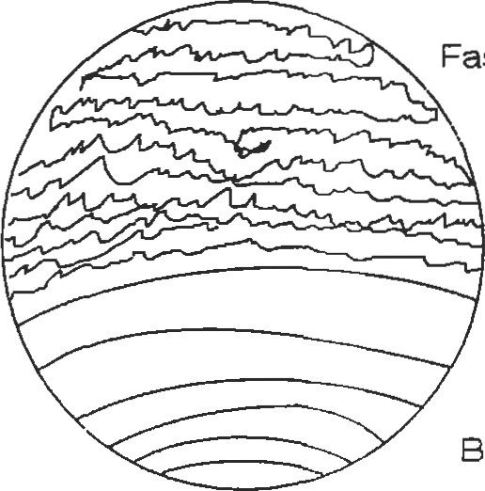The fatigue life of ferrous and nonferrous alloys is different. Ferrous alloys exhibit a fatigue limit below which failure does not occur). Nonferrous alloys will fail at nearly any applied load, although the number of cycles Fast Fracture

Beachmarks

Figure 18. The beachmaüs show major places where the crack was stopped. Finer details can be observed using high power optical or electmn optical microscopy.

to failure can be very large. A limit of 108 cycles is used as a stopping point for most testing. This number of cycles is called the endurance limit of a material. Figure 19 shows a schematic of a sfress-number of cycles to failure (S-N curve) plot of data for ferrous and nonferrous alloys. The

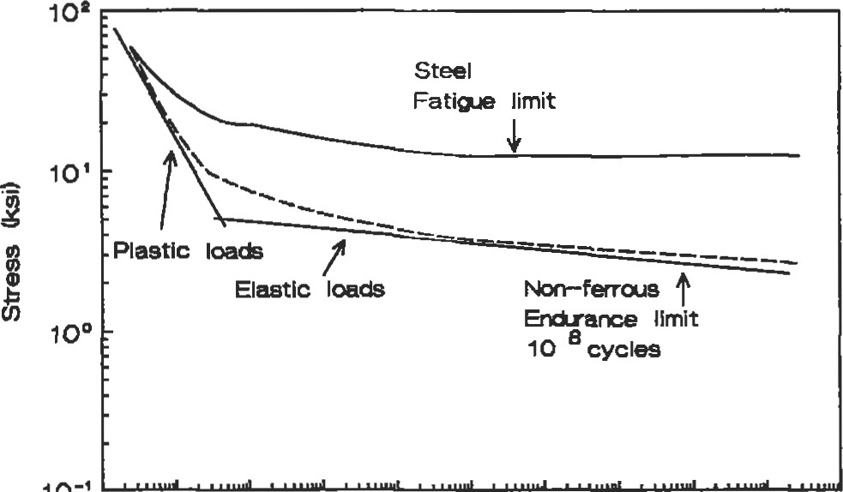

10-1

100 10' 102 103 104 106 10' 10' 10' log 10 10

Cycles to Failure

Figure 19. Fatigue terms for ferrous and nonferrous metals.

fatigue ratio (fatigue limit or fatigue for 108 cycles divided by the tensile strength) for most steels is 0.5. The fatigue ratio for nonferrous metals, such as nickel, copper, and magnesium, is about 0.35. These ratios are for smooth bars tested under zero mean stress. For notched samples, the ferrous fatigue ratio drops to 0.3-0.4 [4].

The fatigue life is directly affected by the surface preparation of both test samples and machine elements. Smooth surfaces increase the fatigue life. Surface freatments, such as carburizing and nitriding steels, increase life. üon of compressive surface stresses by shot peening increases life, especially if followed by light polishing to reduce surface roughness. Uneven peening can reduce life by introducing stress risers. Tensile stresses, which can be introduced by grinding and quenching, reduce fatigue life. Elecü•oplating reduces fatigue life since the electroplate may have porosity, may introduce residual stresses, or may change the surface hardness. Residual have the greatest influence on tests and materials that are loaded near the fatigue limit. Their influence is minimal at high loads.

There are many metallurgical factors that influence the fatigue resistance. The effect of solid solution alloying elements on fatigue has a parallel effect on the tensile suength of iron and aluminum alloys. Elements that promote wavy slip result in higher lives than elements that promote planar slip. Grain size can also affect the fatigue life, depending on whether initiation or propagation are the lifelimiting features. In alpha brasses, which have low stacking fault energies, grain size influences the fatigue life; in other Al and Cu alloys, which have high stacking fault energies, there is no such influence. In steels, a quenched and tempered martensitic suucture has the optimum fatigue resistance, although ausformed steels (bainitic microsü•ucture) with hardnesses in excess of HRC 40 are better than the same alloy in the quenched and tempered



Suggested Reading

References for designing against fatigue failure which have extensive design examples include:

Ruiz, C. and Koenigsberger, F., Designfor Strength and Pmduction. New York: Gordon and Breach Science Publishers, Inc., 1970.

Juvinall, R. C., Engineering Considerations of Stress, Strain, and Strength. New York: McGraw-Hill Book co., 1967.

Graham, J. A. (ed.), Fatigue Design Handbook. New York: Society of Automotive Engineers, 1968.

Osgood, C. C., Fatigue Design, 2nd Ed. New York: Permagon Press, 1982.

|  |
| --- |
| Hardness Testing |

Boyer, H. E. (ed.), Atlas of Fatigue Curves. Metals Park, OH: American Society for Metals, 1985.

Hardness testing is a fairly simple method of conforming to quality control standards. It is also used to develop materials. A small sample is loaded by an indentor. The geometry of the indentor and the magnitude of the load is determined by the type of test that is performed and the material that is being tested.

A hardness test provides insight into several material properües. These are: strain hardening, since the test causes plastic deformation; plastic flow curve; and ultimate tensile sü•ength. For carbon and medium alloy steels, there is a direct correlaüon between the Brinell hardness test and the tensile strength. It is given in 10: UTS (V) = 500BHN (10) where UTS (V) is the ultimate tensile strength and BHN is the Brinell hardness number.

The test can be conducted on either a macro or a micro scale. There are three indentor geometries: a ball, a brale, and a diamond pyramid. Table 22 lists a number of common hardness tests and the materials most likely to be tested. There are limits to the size of the samples that can be tested. Some general rules are that the hardness indentations be spaced at least 4 diameters apart, and the thickness of the material be 6 ümes the depth of the peneü•ator. ASTM EIO provides complete guidelines regarding the hardness test for Brinell tesü.ng [31], E18 for Rockwell testing [30], and E92 for Vickers hardness testing [32].



Table 22

Common Types of Hardness Tests, Indentors, and Applicaüons

|  |  |  |  |
| --- | --- | --- | --- |
| Test | Indentor | Load | Material |
| Brinell  Brinell  Rockwell A Rockwell B  Rockwell C  Rockwell N Rockwell Y  Vickers  Knoop | 10 mm ball  10 mm ball  Brale  Brale  W ball  Diamond pyramid  Diamond pyramid | 3,000 Kg  500 Kg  100 Kg  150 Kg  1&-45 Kg  15-45 Kg  50g-1 Kg  500 g | Cast iron and steel  Nonferrous alloys  Very hard materials  Brasses and low strength steels  High strength steels  Hard coaings, superficial hardness Soft coatings, superficial hardness  All materials  All materials |

Creep and Stress Rupture Testing

Elevated temperature properties are measured using either creep or rupture tests. The tests measure different material properties. A creep test measures a material's resistance to elongaüon, while a stress rupture test measures the time for a sample to break into two separate pieces. Creep tests are run for long times and have small but finite elongations, typically 0.1, 0.2, 0.5, 1.0, 2.0, and 5.0. Further, they are run for long periods of time. Sfress rupture tests are run for shorter times and high total strains, up to 50%. Both elongaüon and rupture time can be determined by a creep rupture test.

Creep tests are run at either constant sfress or, more commonly, constant load. The main stages of creep and the differences between these two types of loading are shown in Figure 20. An iniüal strain is present due to elastic response of the material, (e.g., e = O/E). Primary creep is characterized by viscous flow of the material. Further, the creep rate decreases with increased time. Second-stage creep involves steady-state creep with the minimum creep rate. During this time period, the processes of hardening and recovery are occurring simultaneously at nearly the same rate. Tertiary creep is actually a geometric effect. It results because of localized necking of the sample which effectively increases the stress.

Creep rate increases with increasing at constant temperature and with increasing temperature at constant

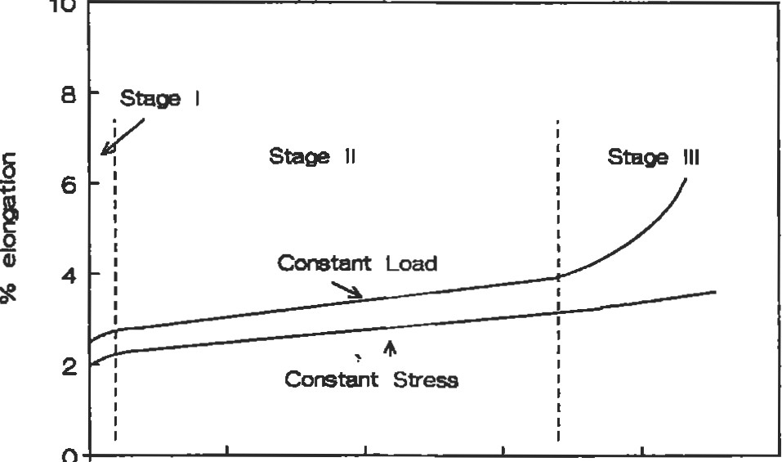

10

o

o 200 400 600 BOO 1000

Tin-e

Figure 20. creep curve for consum bad Z1d conStant stress. Also shown are the three stages of creep.

stress. Figure 21 shows the effect of increasing süess at constant temperature. Some typical creep limits for material applications are 1% in 10,000 hours (or a creep rate of 0.0001% per hour) for aircraft turbine parts and 1% in 100,000 hours (or a creep rate of 0.00001% per hour) for steam turbines and other similar equipment.

Su•ess rupture are typically conducted under constant load conditions and are terminated after samples break.

ntumb

1000

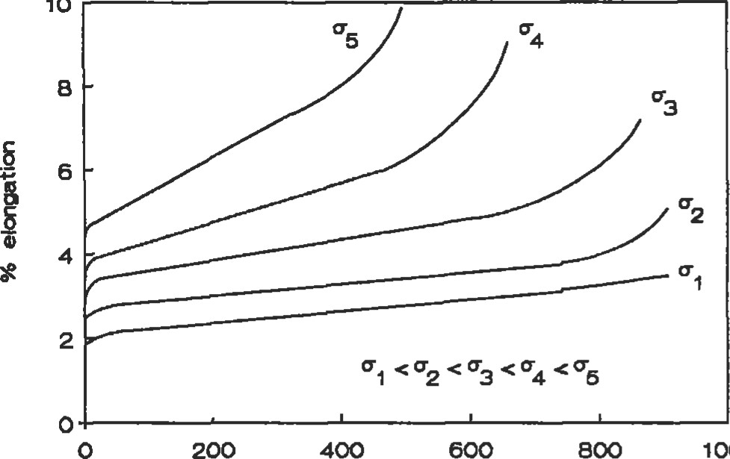

10

200

600

Time

"gure 21. Effect of increasing stress on creep response at constant temperature.

They generally last less than 1,000 hours. They are inexpensive and require less complex instrumentation than creep tests. Stress rupture tests make it easy to characterize an alloy that is under development. The effect of temperature on the stress rupture life is shown schematically in Figure 22.

It is not always practical to test for the long at lower for design applications. Many nEthods have been devised that allow one to trade up in temperature for design

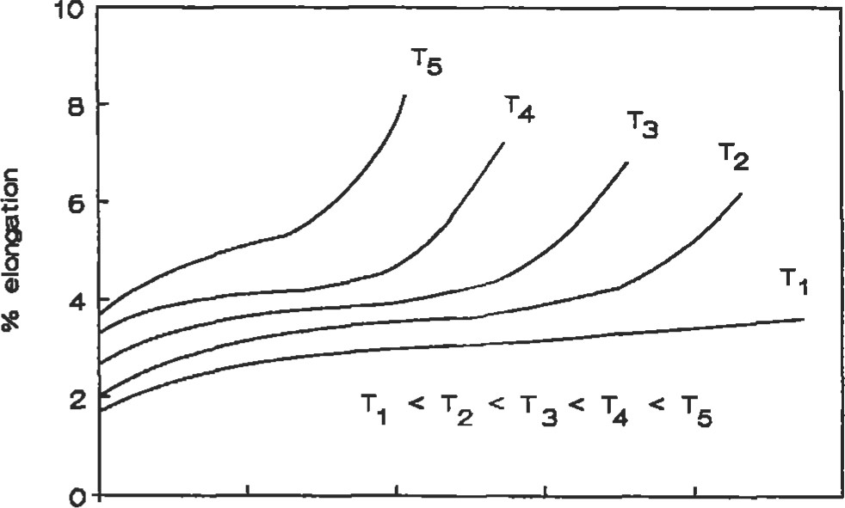

1. 200 400 600 800 1000

Time

Flgure 22. Effect of increasing temperature at constant load on stress rupture life.

data One ofthe more common empirical equaüons is the Ixson Miller parameter. It is provided in Equation 11.

1. = (T + 460) * (log [t] + A) (11)

|  |  |  |  |  |
| --- | --- | --- | --- | --- |
| FORMING  Metals can be shaped by a number of processes which include machining and plastic deformadon. This secdon will briefly address metal shaping by plastic deformaüon. Plastic deformaüon is the application of force to change the shape of a material. Some of the more common types of   |  |  |  |  | | --- | --- | --- | --- | | plastic deformation are shown in Figure 23. Most of these methods can be used either hot or cold; exü•usion is done hot. When used cold, these forming processes can increase | Forging | Rolling | Drawing |   strength with a resultant in as shown schematically in Figure 24. When used hot, these processes can close off porosity from the casting stage. |

The t can be either the time to reach a creep or the üme to rupture, depending on whether one is model-ing strain or stress rupture. The A in the equation can be either experimentally determined or is assumed to be 20. T is the temperature in OF.

In some cases the forming methods used can be primary, to rough a piece to near net shape, or secondary, to produce a finished part. Forging can produce simple pancakes

Extruding Deep &awing

Figure 23. Five common metal forming methods [4].

(RepHnted by permission of McGraw-Hill, Inc.)

|  |
| --- |
| or complex parts. It may require several intermediate dies and heat ü•eatments to produce very complex pa.rts. Rolling is used to produce flat plate, strip, and foil. Wire drawing, as the name implies, is used for wires. Tubes can also be drawn by including a plug in the die set-up. Exü•usions are made of low melting point alloys, aluminum, copper, and lead because of the high forces needed to push the metal through the die and the high temperatures required to decrease the material strength. Deep drawing is used to form thin sections like doorknobs and beverage cans.  20  40  60  Reduction in Area (%)  Figure 24. Influence of cold work on the ductility and strength of a metal.  CASTING |

The Forming section pertained to methods of getting metal into a usable form using solid-state techniques. Another option to obtain components is by solidifying metal in the desired shape. Casting technologies are varied for the many melting point materials that are used. The simplest use of casting is to form ingots that a-re subsequently shaped by forming processes. These castings can be very large, on the order of tons. Continuous is used in steel mills to form large, thick, flat slabs which are subsequently rolled into plate, sheet, and other simple shapes. These casting methodologies do not produce a final shape for use, rather, they produce raw material for other processing.

Some methods of producing final shapes through casting are sand molding, die casting, and investment casting. In sand molding, a carefully prepared molding sand containing a binder, which may be clay, is mixed with water. ms mixture generates a material that has some su•ength to be molded. The sand is then either sculpted or molded into the desired shape. If it is molded, then a pattem must be fabricated. The pattern may be made of plastic, wood, or metal, depending on the number of pieces that will be cast. The pattern must have some draft or taper to allow it to be removed from the sand. Sprues, downspouts for the incoming metal, runners, channels to contain the molten metal, and gates to lead it into the die cavity must be cut into the sand or can be included in the mold. Internal passages can be formed by the use of cores.

Molten metal is poured into the cavity and allowed to scy lidify. The final product of a sand mold will have a coarse surface finish that depends on the size and texture of the sand used for molding. Often, castings will have pores and other defects that may make them unusable as is. They can be either repaired (welded) or scrapped.

Die casting (or pressure die casting) uses a permanent mold of tool steel or other high melting point alloy and injects molten metal into the cavity. The die may have water cooling to prevent its melting. The surface finish of a die cast is better than a sand cast part. Since the cooling rate is faster, a finer sffucture is produced.

Die casting is useful for making zinc, aluminum, and copper parts. The difficulty in producing quality parts increases with increased melting point, and metals with higher melting points than copper cannot be die cast. Many of the parts that are die cast can be produced more cheaply out of plastic and are being replaced by plastics.

Invesünent casting uses a sacrificial wax or plastic pattem that has all of the features of the finished part. The gates and sprue may be directly molded or aüached by wax "welding." The mold, for a shell type casting, is made by assembling all of the components and then dipping die wax or plastic pattern in slurry of fine silica. Two or three slurry coats are applied, then several layers of a coarse slurry are used to give the shell The wax is then melted out, die shell fired to eliminate all of the traces of the pattern and to strengthen Thumb

the mold, and the molten metal poured into the mold. The metal solidifies and the shell is broken off.

Internal passages and other product features can be incorporated into the casting using cores. Excellent surface finish and dimensional control can be obtained. Complex turbine blades can be manufactured with this method. It is more expensive than other casting technologies.

A specialized form of investment casting is used to make single crystal and directionally solidified pieces. With these technologies, which are very important for materials that require long stress rupture and creep properties, the heat is preferentially extracted in a single direction. This promotes the growth of a single grain or a single grain orientation. The grain orientation selected depends on the crystal anisotropy and the property most important for the application.

|  |
| --- |
| CASE STUDIES  Failure Analysis |

Information about the castability of the various alloys can be found in Principles ofMetal Casting [27] and the ASM Metals Handbook, Vol. 15, 9th Ed.

Failure analysis entails the systematic investigation of why or how a component fails. Despite the best design, an improper material selection or a processing sequence can lead to a premature failure of said component. A detailed history is generally established. Temperature, expected environment, stresses, and strains are all important variables for the failure analyst to know. As one investigates various failures, documentation of the salient features is required. The methods used include photography, notetaking, videography, and the like. The examination of the fracture surfaces optically and electron optically are useful in determining the type of failure, e.g., brittle or ductile fracture, high or low cycle fatigue, environmentally assisted fracture, or wear.

TWO operational failures and fixes will be discussed. Wear is one of the most important causes of failure, although many factors are usually involved. Piston rings, gears, and bearings are a few of the many parts where resistance to wear is required. Wear is probably the most easily recognized failure mode, as shown in Figure 25. Although wear may not be prevented, steps can be taken to reduce the rate and yield a long service life by the proper application of materials, lubrication, and design.

Often, improper application of steels, load distribution, heat treatment, and inadequate or faulty lubrication result in excessive wear and poor service life. High loads and speeds are capable of producing very high temperatures under which metal surfaces may actually melt. Friction is

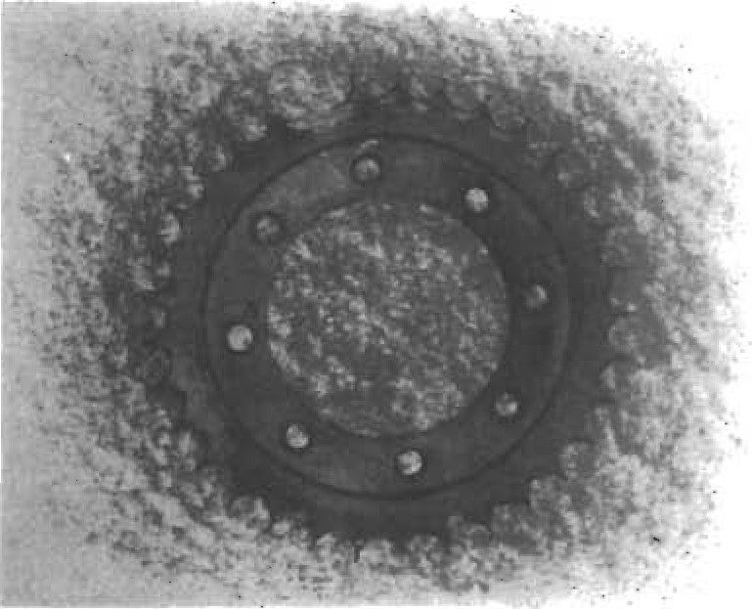

##### Figure 25. Excessive wear of gear teeth. (Reprinted by permission of Republic Steel.)

an important factor in producing temperatures that may cause the breakdown of hardened surfaces, such as those produced by carburizing. Therefore, special lubricants for specific applications involving very high unit pressures may be required.

The gear wear shown in Figure 25 was corrected by selecting a new material that was significantly harder than the 1020 rimmed steel with a Brinell hardness of 1 16. The worn teeth were driven by rollers in a chain link with a Brinell hardness of 401. An alloy steel with higher hardness was substituted, and the new sprocket was still in service after seven years [331.

|  |
| --- |
| Corrosion |

The diagram in Figure 26 is a schematic of the lower end of a tube-and-shell heat exhanger made from mild steel. The unit was designed to heat oil in a chemical process plant. The oil was passed through the small tubes and the heat was supplied from steam which was injected into the shell. The unit had been in operation for only 2.5 years when one of the tubes perforated. When the tubes were extracted from the shell, it was found that they all had corroded on the outside over a distance of about 160 mm from the lower tube plate. On the worst-affected areas, attack had occurred to a depth of about 1.5 mm over regions measuring typically 10 mm by 20 . The corroded areas were light brown in color.

The heat exchanger was operated on a cyclic basis as follows. First, saturated steam was admitted to the shell at 1800C to heat a new batch of oil. The steam condensed on the surfaces of the tubes and the condensed water trickled down to the bottom of the shell, where it was drawn off via the condensate drain. When the oil was up to temperature, the steam supply was cut off and the pressure in the shell

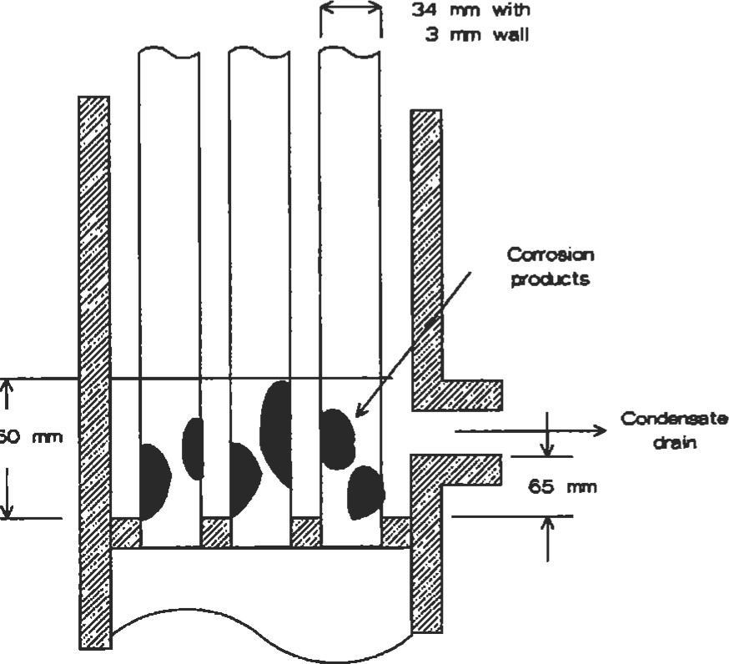

160

Figure 26. Schematic view of the lower end of a tubeand-shell heat exchanger made from mild steel.

was dropped to amospheric. The cycle was repeated when it was time to heat up a new batch of oil.

Based on the above observations and operating cycle, it is apparent diat fre corroü)n product is red rust, i.e., hydrated Fe203. Of the three forms of iron oxide (FeO, F%04), and Fe203), the latter has the highest ratio of oxygen to iron. It is the favored oxide in an oxygen-rich environment. When the oxygen concenü•ation is low, the corrosion product consists ofhydrated F%04 (magnetite), which is black But there was no evidence that this was present as a corrosion product. There is evidence, however, of oxygen in the condensate which presumably came from air dissolved in the make-up feed water to the boiler. This would have provided the oxygen needed for the cathodic reaction.

The design of the unit allows condensate to build up to the level of the drain. It is interesüng that corrosion has only occurred in, orjust above, the pool of condensate; it has not taken place farther up the tubes even though they would have been dripping widl condensed steam. A likely scenario is that when the shell was let down to atmosphere, the water at the bottom of the shell was boiled off by the residual heat in the tube plate. This would have left either a concenü•ated soluüon or a solid residue containing most of the impurities that were originally dissolved in the condensate pool. With each cycle of operation, the concenü•ation of impuriües in the pool would have increased. A prime suspect is the carbonic acid, derived from carbon dioxide dissolved in the feed water. This would have made the liquid in the pool very acidic and given it a high ionic conducüvity, both of which would have resulted in rapid attack. It can be seen from the electrochemical equilibrium diagram for iron [39], iron does not form a surface film in acid waters. Finally, the temperature is elevated so the rates of thermally activated corrosion processes should be high as well.

A simple desiB1 modification of moving the condensate drain from the side to the lowest point of the shell would prevent water from accumulating in the bottom of the shell [34].

|  |
| --- |
| Thumb  REFERENCES |

1. Bob, R. E. and Tuve, G. L. (Eds.), Handbook ofTab1es forApplied Engineering Science, 2nd Ed. Boca Raton: CRC Press, 1984.
2. ASM Metals Handbook: Properties and Selection— Irons and Steels, Vol. 1, 9th Ed., ASM Intemational, Materials Park, OH, 1978.
3. Callister, W. D., Jr., Materials Science and Engineering, An Introduction. New York: John Wiley & Sons, Inc., 1985.
4. Dieter, G. E., Mechanical Metallurgy. New York: McGraw-Hi11, 1986.
5. Hertzberg, R. W., Deformation and Fracture Mechanics ofEngineering Materials, 2nd Ed. New York: John Wiley & sons, 1983.
6. Schackelford, J. F., Introduction to Materials Science for Engineers, 2nd Ed. New York: Macmillan Publishing, 1988.
7. Askeland, D. R., The Science and Engineering ofMaterials. Belmont, CA: Wadsworth, 1984.
8. Van Vlack, L. H., Materials Science for Engineers. Redding, MA: Addison Wesley, 1970.
9. Uhlig, H. H. and Revie, R. W., Corrosion and Corrosion Control and Intmduction to Corrosion Science and Engineering, 3rd Ed. New York: John Wiley & sons, Inc., 1985.
10. Fontana, M. G., Cormsion Engineering. New York: McGraw-Hi11, 1986.

ll. McCrum, N. G., Buckley, C. P., and Bucknall, C. B., Principles of Polymer Engineering. New York: Oxford University Press, 1988.

1. Powder Metallurgy Design Solutions. Powder Industries Federation, Princeton, NJ, 1993.
2. German, R. M., Powder Metallurgy Science. Metal Powder Indusüies Federation, Princeton, NJ, 1984.
3. "Amdry MCrAlY Thermal Spray Powders Specially Formulated and Customized Alloys Provide Oxidaand Corrosion Resistance at Elevated Temperatures," Amdry Product 961, 970, 995, Alloy Metals, Inc., 1984.
4. Engineewd Materials Handbook, VOL 4: Ceramics and Glasses. S. J. Schneider, Jr., Volume Chairman, ASM International, Materials Park, OH, 1991.
5. Davis, J. R. (Ed.), ASM Materials Engineering Dictionary. ASM International, Metals Park, OH, 1992.
6. Craig, B. D. (Ed.), Handbook ofCorrosion Data. ASM International, Materials Park, OH, 1989.
7. McEvily, A. J. (Ed.), Atlas of Stress-Corrosion and Corrosion Fatigue Curves. ASM Intemational, MatePark, OH, 1990
8. Coburn, S. K. (Ed.), Corrosion soume Book ASM lntemational, Materials Park, OH, 1984.
9. Sedriks, A. J. (Ed.), Corrosion ofStainless Steels. New York: John Wiley & sons, Inc., 1979.
10. Uhlig, H. H., Corrosion Handbook New York: John Wiley & sons, Inc., 1948.
11. ASM Metals Handbook: Pmperties and Selection— Nonferrous Alloys and Pure Metals, Vol. 2, 9th Ed., ASM International, Materials Park, OH, 1979.
12. Massalski, T. B., Okamoto, H., Subramanian, P. R., and Kacprzak, L. (Eds.), Binary Alloy Phase Diagrams,

2nd Ed., ASM Intemational, Materials Park, OH, 1990. 24. Haynes International, Product Bulleün H-1064D, 1993. 25. Inco Alloys International, Product Handbook, 1988.

1. Sims, C. T., Stoloff, N. S., and Hagel, W. C. (Eds.), superalloys Il High Temperature Materials for Aerospace and Industrial Power. New York: John Wiley & Sons, Inc., 1987.
2. Heine, R. W., Loper, C. R., and Rosenthal, P. C., Principles of Metal Casting, 2nd Ed. St. Louis: McGrawHill, 1967.
3. Birks, N. and Meier, G. H., Introduction to High Temperature Oxidation of Metals. Great Britain: Edward Arnold, 1983.
4. ASTM E112, Standard Methodfor Average Grain Size ofMeta11ic Materials, Volume 03.01 , Metals-Mechanical Tesfrlg•, Elevated and Low Temperature Test; Metallography, ASTM, 1992.
5. ASTM E18, Standard Test Methodsfor Rockwell Hardness and Rockwell Superficial Haüess ofMetallic Materials, Volume 03.01, Metals-Mechanical Testing; Elevated and Low Temperature Test; Metallography, ASTM, 1992.
6. ASIM EIO, Standard Test Methodfor Brinell Hardness ofMetallic Materials, Volume 03.01, Metals-Mechanical Elevated and Low Temperatu.re Test; Metalloyaphy, ASTM, 1992.
7. ASTM E92, Standard Test Methodfor Vickers Hardness of Metallic Materials, Volume 03.01, Metals-Mechanical Testing; Elevated and Low Temperature Test; Metallography, ASTM, 1992.
8. "Analysis of Service Failures," Republic Alloy Steels Handbook Adv. 1099R, Republic Steel Corporation, 1974.
9. Jones, D. R. H., Engineering Materials 3, Materials Failuæ Analysis, Case Studies and Design Implications. New York: Pergamon Press, 1993.
10. Aurrecoechea, J. M., "Gas Turbine Hot Section Coating Technology," Solar Turbines Incorporated, 1995.
11. ASM Metals Handbook: Welding, Brazing, and Soldering, Vol. 6., 9th Ed. ASM Intemational, Materials Park, OH.
12. Harper, C. A. (Ed.), Handbook ofP1astics and mastomers. New York: McGraw-Hill, Inc., 1975.
13. ASM Metals Handbook vol. 15, 9th Ed., ASM International, Materials Park, OH, 1988.
14. Pourbaix, M., Atlas of Electrochemical Equilibria in Aqueous Solutions, National Association of Corrosion Engineers (NACE), Houston, TX, 1974.
15. ASM Metals Handbook: Properties and Selection— Stainless Steels, Tool Materials, and Special Purpose Metals, Vol. 3, 9th Ed., ASM Intemational, Materials Park, OH, 1980.
16. ASM Metals Handbook: Corrosion, Vol. 13, 9th Ed., ASM International, Materials Park, OH, 1987.

13

Stress and Strain

Marlin W. Reimer, Development Engineer, Structural Mechanics Dept., Allison Engine Company

|  |  |  |  |  |
| --- | --- | --- | --- | --- |
| Fundamentals of Stress and Strain | 295 | Rotating Equipment |  | 310 |
| Introduction | 295 | Rotating Disks |  | 310 |
| Definitions—Stress and Strain | 295 | Rotating Shafts |  | 313 |
| Equilibrium | 297 | Flange Analysis |  | 315 |
| Compatibility | 297 | mush Flanges ... . . |  | 315 |
| Saint-Venant's Principle | 297 | Undercut Flanges . |  |  |
| Superposition | 298 | Mechanical Fasteners |  | 316 |
| Plane Stress/Plane Strain | 298 | Threaded Fasteners | | 317 |
| Thermal Stresses | 298 | Pins | | 318 |
| Stress Concentrations | 299 | Rivets | | 318 |
| Determination of Stress Concentration Factors | 300 | Welded and Brazed Joints | | 319 |
| Design Criteria for Structural Analysis | 305 | Creep Rupture | | 320 |
| General Guidelines for Effective Criteria | 305 | Finite Element Analysis | | 320 |
| Strength Design Factors ..... .. | 305 | Overview......... | | 321 |
| Beam Analysis | 306 | The Elements | | 321 |
| Limitations of General Beam Bending Equations | 307 | Modeling Techniques | | 322 |
| Short Beams | 307 | Advantages and Limitations of FEM | | 323 |
| Plastic Bending . | 307 | Centroids and Moments of Inertia for Common | |  |
| Torsion | 308 | Shapes | | 324 |
| Pressure Vessels | 309 | Beams: Shear, Moment, and Deflection Formulas | | |
| Thin-walled Cylinders  Thick-walled Cylinders | 309  309 | for Common End Conditions 325 | | |
| Press Fits Between Cylinders | 310 | References 328 | | |

294

Strain

### FUNDAMENTALS OF STRESS AND STRAIN

Introduction

Stress is a defined quantity that cannot be directly observed or measured, but it is the cause of most failures in manufactured products. Stress is defined as the force per unit area (o) with English units of pounds per square inch (psi) or metric units of megapascals (mpa). The type of load, i.e., duration of load application, coupled with thermal conditions affects the ability of a structural component to resist failure at a particular magnitude of Gas turbine airfoils under sustained rotating loads at high temperature may fail in creep rupture. Components subjected to cyclic loading may fail in fatigue. High speed rotating disks allowed to overspeed will burst when the average stress exceeds the rupture strength which is a function of the ductility and the ultimate strength of the material.

|  |  |
| --- | --- |
| I. At elevated temperatures, the modulus will decrease for | Sources: Mil-Hdbk-5D [11, Aerospace Stuctural Metals Handbook 14 |
| Definitions---Stress and Strain |  |

Conversely, strain is a measurable quantity. the size or shape of a component is altered, the deformation in any dimension can be characterized by the deformation per unit length or strain (e). Strain is proportional to su•ess at or below the proportional limit of the material. Hooke's law in one dimension relates stress to sffain by the modulus of elasticity (E). Typical values for E at 700F are listed in Table the materials listed. Note that the ratio of modulus to density for the selected materials is relatively constant, i.e.,

FJ(p/g) 108:

#### o=Ee

where o = su•ess

E = modulus of elasticity e = strain

Table 1

Range of Elastic Modulus for Common Alloys

|  |  |
| --- | --- |
| Auminum alloys 10.0 - 11.2 x 106 | 0.10 |
| Cobalt alloys 32.6 - 35.0 x 106 | 0.33 |
| Magnesium alloys 6.4 - 6.5 x 106 | 0.065 |
| Nickel alloys 28.0 - 31.5 x 108 | 0.30 |
| and low alloy 30.7 — 31.0 x 106 | 0.28 |
| Steel-—stainless 28.5 - 31.8 x 106 | 0.28 |
| Titanium alloys 15.5-17.9 x 108 | 0.16 |

Material Modulus (E) psi Density (p/g) lb/in.2

The following basic sü•ess quantities are useful in the evaluation of many simple structures. They are depicted in Figures 1 through 4. Today, complex components with rapid changes in  multiple load paths, and stress concen&ations are analyzed using finite element models. However, the basic equations supplemented by handbook soluüons should be employed for preliminary calculaüons and to check finite element model results.

Basic Stress Quantities

##### Direct Stess: o = P/A

where P = load

A = area.

Bending Stress: = Mc/l

where M = moment I = area moment of inertia c = distance from neutral surface

Transverse Shear Stres: t = VQ/It

where V = shear force

Q = first moment of the area I = area moment of inertia t = thickness of cross-section

Torsional Shear Stres: = TUJ

where T = torque r' = distance from axis of shaft, J = polar moment of inertia

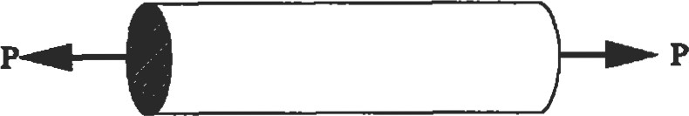

Figure 1. Direct stress.

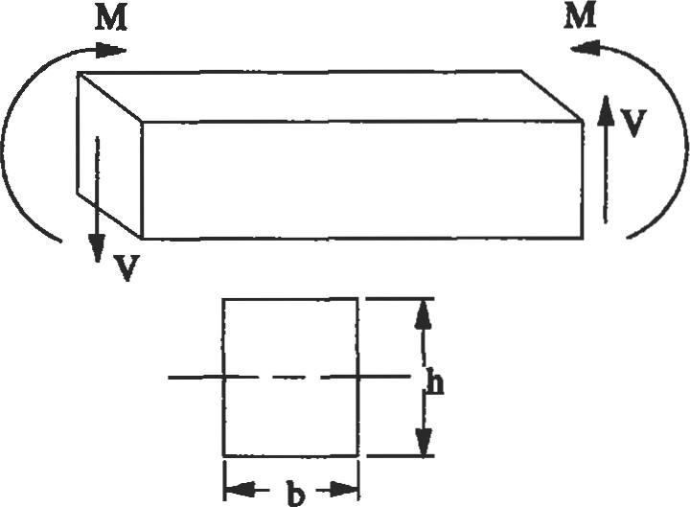

Figure 2. Bending stress.

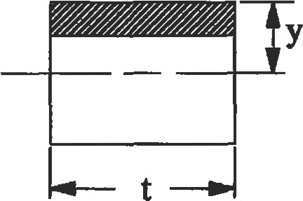

Figure 3. Tansverse shear sFess.

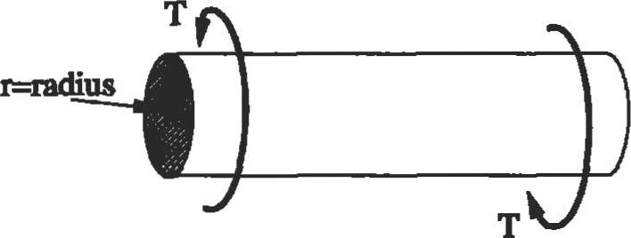

Flgure 4. Torsional shear stress

Law Equations

The proportionality of load to deflection in one dimension is written as:

= Ee (for normal stress o and e)

•t = Gy (for shearing stress and stain y)

Poisson's (v) is the constant for s&esses below the proportional limit that relates strain in one dimension to another. For an incompressible material, v = 0.5. Since actual materials are compressible, Poisson's must be less than 0.5—typically 0.25 v 0.30 for most metals.

Hooke's Law in free dimensions for normal stresses [3]:

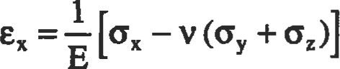

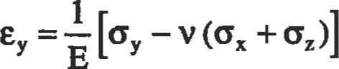

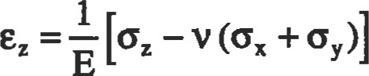

Hooke's Law for shear s&esses:

Gy = GYxy xyz = Gyyz txz = where G is the modulus of elasticity in shear.

The relationship between the shearing and tensile moduli of elasticity for an material:

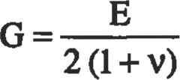

Von Mises Equivalent Stress

Most material strength data is based on uniaxial testing. However, structures are usually subjected to more than a uniaxial sü•ess field. The Von Mises equivalent stress is generally used to evaluate yielding in a multiaxial field, allowing the comparison of a multiaxial sü•ess state with the

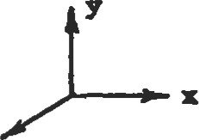 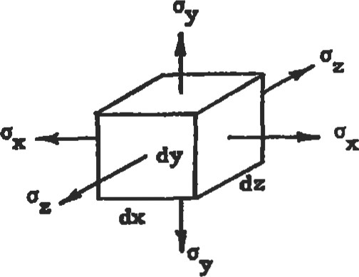 z

Figure 5. Three-dimensional nonnal stresses.

uniaxial material data. If the nominal equivalent sfress is less than the yield sffength, no gross yielding will occur.

Oequivalent ¯

[(6x —oy)2 + (oy — 62)2 + (oz —ox)2 +6 +t}z + * ) -0.5

2

Swain

|  |  |  |
| --- | --- | --- |
| Equilibrium  EF=O  EM=O Axisymmetic crossaecöon of the compressor case  Reaction  force  flange   |  |  | | --- | --- | | the separating force at axial splitline flanges between the engine cases to ensure the proper number of bolts and size the flange thicknesses. A free body diagram helps to isolate the various loads on the static structure connected to the case. The compressor case drawing in Figure 6 shows the axial vane and flange loads on the case. The pressure differential across the case wall would also contibute to the axial force balance if the case was conical in shape. | Axial gas loads on vanes  Figure 6. Free body diagram of a compressor case from a gas turbine engine. |   To successfully analyze a sfructural component, it is necessary to define the force balance on the part. A free body diagram of the part will assist in determining the path which various loads take through a snucture. For example, in a gas turbine engine it is necessary to determine  Compatibility  refers to the concept that sü-ains must be 1001b compatible within a i.e., the adjacent deformed elements must fit together (see Figure 7). Boundary equations, strain-displacement, and sü•ess equilibrium equations must be defined for the complete of a general stress problem.  Figure 7. Compatibility.  Saint-Venant's Principle |

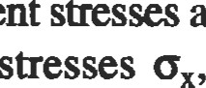Note that equivalent are always positive. If the sum of the principal o and is positive, the equivalent süess is considered tensile in nature. A negative sum denotes a compressive stress.

Saint-Venant's principle states that if the forces acüng on a local section of an elasüc body are replaced by a staücally equivalent system of forces on üle same se&n ofthe body, the effect upon the stresses in the body is negligible except in the immediate area affected by the applied forces. The stress field remains unchanged in areas of the body which are relaüvely distant from the surfaces upon which the forces are changed. "Statically equivalent systems" implies that the two distributions of fomes have the same resultant force and moment. Saint-Venant's principle allows simplification of boundary con(fiüon application to many problems as long as the system of applied forces is statically equivalent.

Often, for many problems of practical interest, it is possible to make simplifying assumptions with respect to the stress or strain distributions. For example, a spinning disk which is relatively thin (see Figure 8) is in a state of plane stress. The centrifugal body force is large with respect to gravity. No normal or tangential loads act on either the top or bottom of the disk. q, trz, and tez ate zero on these sufaces. Since the disk is thin, these stresses do not build up to significant values in the interior of the disk. Plane sfress assumptions valid for thin plates and disks that are loaded parallel to their long dimension. Thin plates containing holes, notches, and other stress concentrations, as well as deep beams subject to bending, can be analyzed as plane problems.

Another simplification can be made for long cylinders or pipes of any uniform cross-section which are loaded laterally by forces that do not vary appreciably in the longi-

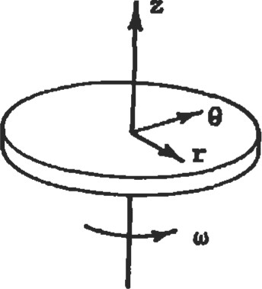

Figue 8. Thin spinning disk---an example of plane sfress.

|  |  |
| --- | --- |
| Superposition |  |
| The principle of superposition states that the stresses at a point in a body that are caused by different loads may be calculated independently and then added together, as long as the sum of the stresses remains below the proportional | limit and remains stable. Application of this principle allows the engineer to break a more complex problem down into a number of fundamental load the solutions of which can be found in many engineering handbooks. |
| Plane Stress/PIane Strain |  |

tudinal direction. If a long cylinder (see Figure 9) is subjected to a uniformly applied lateral load along its length and is consü•ained axially at both ends, the axial deflecüon (öz) at both ends is zero. By symmeüy, the axial deflection at the center of the cylinder is also zero and the approximate assumpüon that is zero along the entire length of the cylinder can be made. The deformation of a large portion of the body away from the ends is independent of the axial coordinate z. The lateral and vertical displacements are a function of the x and y coordinates only. The strain components % Yxz, and yyz are equal to zero and the cylinder is in a state of plane strain. A pipe carrying fluid under pressure is an example of plane strain.

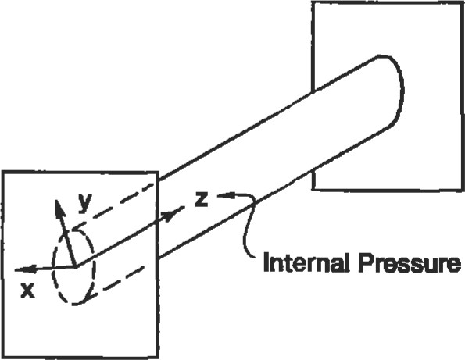

Pressure

P

|  |
| --- |
| Thermal Stresses |

Figure 9. Pipe line--—an example of plane strain.

Thermal stresses are induced in a body when it is subjected to heating or cooling and is resü-ained such that it cannot expand or contract. The body may be restrained by external forces, or different parts of the body may expand or conu•act in an incompatible fashion due to temperature gradients within the body. A straight bar of uniform cross-section, restrained at each end and subjected to a temperature change AT, will experience an axial compressive stress per unit length of Ea.AT. a is the coefficient of thermal expansion. A flat plate of uniform secüon that is resü•ained at the edges and subjected to a uniform temperature increase AT will develop a compressive st•ess equal to EaAT/(1 — v). Addiüonal miscellaneous cases for thermally induced sü-esses in plates, disks, and cylinders, are listed in Young [4] and Hsu [5]. Tyr ical values for the coeffcient of thermal expansion (a) for several common materials are listed in Table 2.

Design Hints

* If thermally induced sfresses in a member exceed the capability of the material, increasing the cross-sectional area of the member will generally not solve the problem. Additional cross-section will increase the stiffness, and the thermally induced loads will increase almost as rapidly as the section properties. Often, the flexibility of the structure must be increased such that the thermal deflections can be accommodated without building up large stresses.
* Thermal problems can be minimized by matching the thermal growths of mating components through appropriate material selection.

•In situations where transient thermal gradients cause peak stresses, changes in the mass of the component, changes in the conducüon path, addition of cooling flow, and shielding from the heat source may reduce the transient thermal gradients.

Table 2

Range of Coefficient of Thermal Expansion for Common Alloys

Max.

Recommended @ 1200*

Material Temp. (OF) (in.nn.PF) (in.nnrn



Aluminum alloys 300-600 13.0-14.2 x 10-6

Cobalt alloys 7.0-7.7 x 10-6 7.8-8.7 x 10-6

Magnesium alloys

Nickel alloys 63-8.0 x 10-4 73-8.8 x 104

|  |  |  |  |
| --- | --- | --- | --- |
| steel—carbon |  |  |  |
| and low alloy | 450-1,000 | 7.1-7.3 x 10-4 | 7.7-8.3 x 10--6 |
| Steel—stainless | 600—1 ,500 | 6.0-9.7 x 10-8 | 6.7-10.3 x |
| Ttanium alloys | 400-1 ,ooo | 5.0-5.4 x | 5.5-5.6 x 10-8 |

|  |
| --- |
| STRESS CONCENTRATIONS |

Sources: Mil-Hdbk-5D 01, Aerospace Structural Metals Handbook

'Ihe basic sü•ess quantiües used in design assume a conStant or gradual change in cross-section. The presence of holes, shoulder fillets, notches, grooves, keyways, splines, threads, and other discontinuities cause locally high sfresses in structural members. concentration factors associated with the aforementioned changes in geometry have been evaluated mathematically and experimentally with tools such as finite element models and photoelastic studies, respectively.

The ratio of üue maximum stress to the stress calculated by the basic formulas of mechanics, using the net section but ignoring the changed distribution of stress, is the factor of concentration (Kt). A concenü•ated stress is not significant for cases involving static loading (steady stress) of a ducüle material, as the material will yield inelastically in the local region of high sfress and redistribute. However, a concentrated stress is important in cases where the load is repeated, as it may lead to the fatigue failure of the component. Often components are subject to a combination of a steady stress (q) due to a constant load and an alternating stress (OD due to a fluctuating load such that the cycle up and down without passing through zero (see Figure 10). Note that the steady sffess and the mean sffess (0m) may not have the same value. The steady can have any value between the maximum and minimum sfress values. The damaging effect of a stress concentration is only associated with the alternating portion of the cycle. Hence, it is common practice to apply only any existing stress concenffation to the alternating sffess [6]. A good example of this situation is a shaft transmitting a steady state torque that is also subject to a vibratory torsional

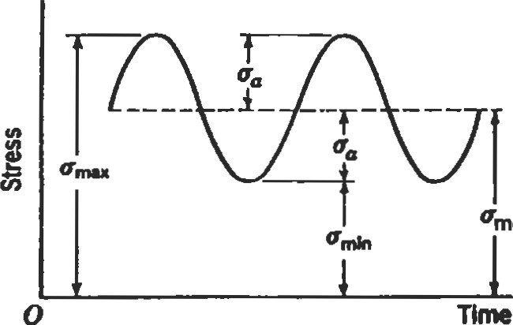mean

Figure 10. Fluctuating stress.

load which may be ±5% of the steady state torque. For stress concentration features such as shoulder fillets, the Kt would be applied to the vibratory or alternating stress.

Design Hint

* Eliminate unnecessary stress concenfrations. Avoid abrupt changes in secüon where concentrations cannot be relieved by a tolerable degee of local plastic deformation. All fillet radii should be made as generous as is practicable.
* When possible, keep hole locations away from areas of high nominal stress. For example, in high speed rotating disks such as turbine wheels (see Figure 11), holes near the bore will be in a region of high hoop stress. Peak sfresses at holes in the web of a rotating disk may also be affected by the radial stresses due to thermal gradients, rotational speed, and bending in the web due to eccentric loads on the rim of the disk. If web holes are unavoidable, fry to locate the holes in the most biaxial suess field in the web, i.e., where the tensile hoop stress and the tensile radial stress are nearly equal. It may also be necessary to increase the thickness of the section around the holes to compensate for the st-ess concentration.

' The use of corrosion-resistant materials helps prevent stress concentrations caused by the pitting that may accompany typical corrosive attack.

* In certain situations, the clever removal of material reduces the effect of stress concentrations such as flange bolt holes. Scalloping flanges as shown in Figure 12 cut the hoop stress path, thus decreasing the effect of the holes on the peak stress.

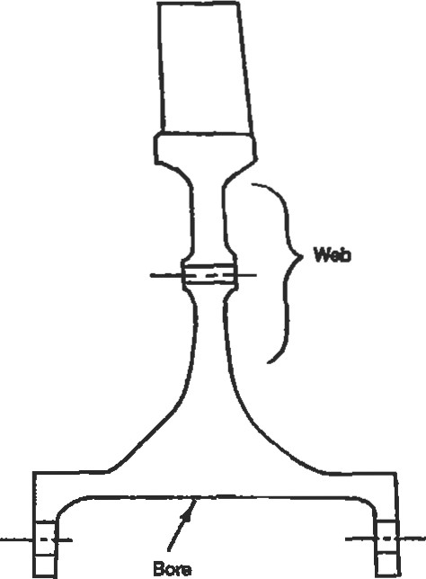

Figure 11. Axisymmetic cross-section of a turbine wheel.

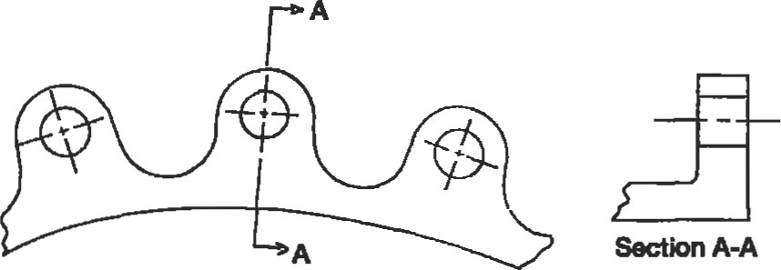

|  |
| --- |
| Determination of Stress Concentration Factors |

Figure 12. Scalloped flange.

A first approximation for the stress concentration due to a single small hole in a plate (Figure 13) subjected to a uniaxial sü-ess field is Kt = 3. In a biaxial stress field with equal stresses (60) of the same sign, the same hole (Figure 14) would cause a maximum su•ess equal to twice the nominal stress (Kt = 2). Conversely, for a biaxial stress field with equal sü•esses of opposite sign, Kt = 4. This latter would occur at a small hole in a thin cylinder subjected to pure torsion where omax equals four times the nominal torsional shear sü•ess (t). Stæss Concentration Factors by R. E. Peterson [7] is the best source of numerical values of Kc for grooves, notches, shoulder fillets, holes, and certain other miscellaneous design elements.

|  |  |  |  |  |  |  |  |  |  |  |  |  |  |  |  |  |  |  |  |  |  |  |  |  |
| --- | --- | --- | --- | --- | --- | --- | --- | --- | --- | --- | --- | --- | --- | --- | --- | --- | --- | --- | --- | --- | --- | --- | --- | --- |
| |  |  |  |  |  |  |  |  | | --- | --- | --- | --- | --- | --- | --- | --- | |  |  |  |  |  |  |  |  | | = 30 | | | | | | | | |  |  |  |  |  |  |  | |   thus from Figure 16:  Ksolid 1.41  From Figure 17:  Ksolid -1  = 0.77 Khollow - 1  thus Khollow = 1.53   * Determine the axial Kt from Figure 18:   rid = 0.07 Figure 13. Small hole in a plate subject to a uniaxial 2.14 stress field.  thus 2.22   * Determine the nonconcentrated axial and torsional shear stresses:   (.70  -  .45  4  )  -5000  A - (0.702 -0.45 2 ) = -11,072 psi  .70  1600— 2  = 28,650 psi  32  • Assuming full notch sensitivity, calculate the peak |

Figure 14. Small hole in a plate subject to a biaxial stress field.

Example: For the hollow shaft in Figure 15, determine the maximum equivalent sü•ess at the shoulder fillet. The shaft is subjected to an axial tensile load and torque.

T = 1,600 in. 1b r = 0.07 in. D = 1.50 in.  = 0.45 in.

d = 0.70 in.

P = -5,000 1b.

• Determine the torsional Kt from Figures 16 and 17:

r/d = 0.10 D/d=2.14 dl/d = 0.643 equivalent stress:

equivalent 

—0.5

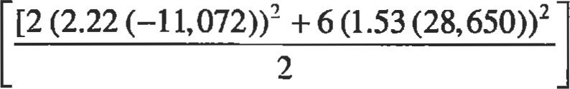

= 79,803 psi

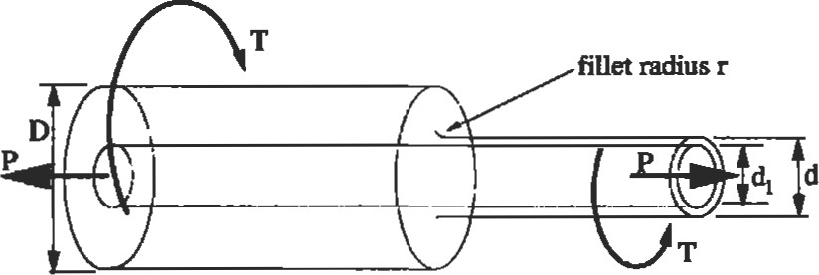

Figure 15. Hollow shaft subject to axial load and torque.

(text continued on page 305)

STÅESS CONCENiRATlON FACTOR, Kts, 2

FOR TORSION OF A

SHAFT WITH A SHOULDER FILLET

(Data from Matthews and Hooke)

1 .9

fillet radius r

1 .8 r/d = 0.02

#### Éid= 003

KtS =Xmax / Cnom

nom = 16T/1td 3

##### 1.6

rid = 0.05 ts

1.5

ace:

1 .3

rid = 0.20

##### 1 .2 rid = 0.30

1 .0

1 .0 2.5

###### Figuæ 16. Stress concentration factor for torsion of a shaft with a shoulder fillet. (From Stress Concentration Factors by R. E. Peterson [7]. Reprinted by permission of John Wiley & Sons, Inc.)

r/d = 0 05 r/d = 0 10

KtSO - 1 r/d = 0 25

= 1 .2

rid = 0.05: tso r/d 0. 1'($ :

0.25

-4

EFFECT OF AXIAL HOLE

ON

STRESS CONCENTRATION FACTOR

OF A

TORSION SHAFT

WITH A SHOULDER FILLET

(From data of Rushton)

:r. ;

fillet radius r

Kts, Hollow Shaft

Ktso, Solid Shaft

Iki Ktso=Omax / Onom nom = 16Td/Tt(d4-d14)

lfil

0.8 1 .0

Figure 17. Effect of axial hole on stress concentration factor of a torsion shaft with a shoulder fillet. (From Stress Concentration Factors by R. E. Peterson [7]. Reprinted by permission of John Wiley & Sons, Inc.)

5.0

STRESS CONCENTRATION FACTOR, Kt

FOR A

STEPPED ROUND TENSION BAR

WITH A SHOULDER FILLET

### .34

Kt Values are Approximate

#### 3.5

nom = 4Phtd2

Did = 3

D/d=2

#### 2.5

Did = 1.2

2 .0

1 .5

Did = 1.65

- D/d= 1.02

Did = 1.01

#### 1 .0

0.01 0.05 0.10 0. 1 5 0.20 0.25 0.30

r/d

Figure 18. Stress concentration factor for a stepped round tension bar with a shoulder fillet. (From Stress Concentraüon

Factors by R. E. Peterson Reprinted by permission of John Wiley & Sons, Inc.)

(text continuedfrom page 301)

#### DESIGN CRITERIA FOR STRUCTURAL ANALYSIS

Comprehensive desiY1 criteria should always be developed between the design functions and will conüibute to a situaearly in the design process to ensure that the component or tion in which the design goals become a moving target. system will meet the functional requirements. The lack of a This often leads to slipped schedules due to the redesign ef-

|  |  |  |
| --- | --- | --- |
| published design criteria leads to a lack of communication | forts needed to correct the | deficiencies. |
| General Guidelines for Effective Criteria |  |  |

An effective structural design criteria must address the ftncüonal requirements as they relate to cyclic, time dependent, and time independent load conditions.

In applications where cyclic loading is expected, the low cycle fatigue life (cræk initiation life) requirement must be specified. The requirement should not only define the total number of cycles but also the nature of the cycle or mission, i.e., the operating points within the mission. If significant vibratory loads are present, the high cycle fatigue life must be considered as well. The endurance strength, i.e., the alternating below which the cyclic life exceeds 107 cycles, is usually used to define a Goodman diagram. Depending upon the application, fatigue crack growth requirements may need to be included. These requirements would specify the minimum flaw or crack size that can be detecæd by the inspection technique employed and the inspection interval in terms of number of cycles and/or hours. Time dependent criteria generally include creep and rupture, although fatigue crack growth can have time dependence. Creep requirements should specify an allowed growth over the life of the component based on the dimensional tolerances between mating parts. Stress rupture is usually only a problem for high-temperature applications where temperatures exceed 50% of the melting temperature of the material. In such cases a combination of temperature and stress over a period of time will lead to failure.

Time independent load criteria include limit and ultimate loads. Limit loads are defined as the maximum expected operational loads. The average cross-sectional stresses imposed by limit loads are compared to the yield strength of the material. Under normal operating conditions, tffs protects the design from gross yielding. Local yielding in an area of stress concenü•ation is permissible. Ultimate loads are defined as any load conditions in which the structure should tolerate a single application without failure, i.e., the load path remains effective after one application, but the part will be inspected and probably replaced after such an event.

The average material properties are seldom used to define allowable sü•esses. Usually, the properties are degraded on a statistical basis to account for scatter. Aircraft applications usually degrade the creep, yield, and ultimate strengths by three standard deviations (-3 0). Assuming a normal distribution of properties, 'three standard deviations" is equivalent to saying that only I out of 741 parts could possess lower strength properties. Frequently, a more stringent requirement is placed on the low cycle fatigue properties, i.e., -3.726 or 1 out of 10,000.

In addition to scatter in material properties, it is sometimes prudent to factor in the scatter associated with dimensional tolerances if the fit between mating components has a large effect on the stress levels.

A factor of safety (F.S.) is defined as the allowable strength divided by the calculated or measured stress, whereas the margin ofs#ety (M.S.) equals the factor of safety minus one.

F.S. = Fallowableffcalculated

M.S. = (Fdlowable / Fcalculated ) ¯ I

|  |
| --- |
| BEAM ANALYSIS |

Required factors of safety may vary widely between industries and applications. For example, if weight is not a consideration and material cost is low, large factors of safety can be employed to reduce the risk of failure and avoid costly test programs. Factors of safety based on yield criteria range between I .5 and 4.0 depending upon the uncertainty associated with the materials and load conditions. Test rig hardware should be designed with larger factors of safety to reduce the risk of rig failure prior to failure of the tested components. However, overdesign of products is not a luxury permitted in indusffies where weight is minimized to provide improved energy and material costs, as in the automotive and aircraft industries.

A beam is commonly regarded as a structural member which is much longer than its cross-sectional dimensions and is subjected to loads applied transverse to its longitudinal axis. Beams are classified with respect to the type of support applied to the beam, as shown in Figure 19. Some examples include:

Simple beam with pinned ends—rotation of the ends is allowed but translation is restrained such that vertical and horizontal reactions are developed.

* Simple beam with rollers—rotation of ends is allowed and only verfical reacfions are developed.
* Simple beam with overhang—beam overhangs supports either at one or both ends.

Cantilever beam—one end is built into a wall preventing rotation and transverse motion such that a moment and reactions are developed.

* Continuous beam—a beam that has more than two simple supports.

Beams are said to be statically determinant when the reacüons at the supports can be determined by use of the equations of static equilibrium. If the number of reactions exceeds the number of equations of static equilibrium, the beam is statically indeterminate and additional equations based upon the deformations of the beam must be used to solve for the reactions.

In general, the maximum fiber stress occurs at the point farthest from the neutral axis at the beam section possessing the largest bending moment. The maximum shear st-ess is usually at the neuffal axis of the section subject to the greatest shear load. This may not be Hue if the width of the section at the neutral axis is wider than other points in the secüon. For a rectangular section the maximum shear s&ess is 1.5 dmes the average (VIA), while for a solid circular section it is 1.33 times the average.

Extensive tables for calculating shear forces, moments, reactions, slopes, and deflecüons for straight beams are found in Young [4] and Hsu [8]. A few of the most com-

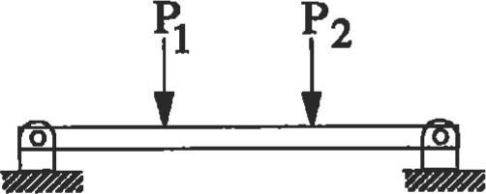mon beam end conditions are found in the section on Beams at the end of this chapter.

(a) simple beam: pinned ends

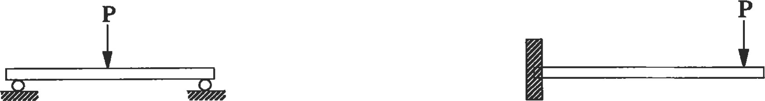

|  |  |  |
| --- | --- | --- |
| (b) simple beam: rollers | | (d) cantilever beam |
|  | | |  |  |  | | --- | --- | --- | |  | | | |  | o |  | |  | | | | |

(c) simple beam with overhang (e) continuous beam

Figure 19. Examples of beam classifications.

##### Limitations of General Beam Bending Equations

Often, practicing engineers neglect consideration of the assumptions associated with the flexural formula o = Mc/l and the transverse shearing stress equation = VQ/It and will use these equations indiscriminately. A review of the assumptions behind these equations is helpful.

* The beam is made of an isotropic and homogeneous material with same modulus of elasticity in tension and compression.

The beam is straight or has at least a radius of curvature that is more than 10 times the depth. Depending upon the beam a radius of curvature equal to 10 infroduces error in bending stress (Mc/l) calculaüons of roughly 5% to 12% [6]. The inside fiber will error on the low side while the outside fiber will error on the high side. Tables providing bending stress correction factors for curved beams are found in Young [4], and Seely and Smith [6].

* The beam has a uniform cross-section and an axis of symmetry in the plane of bending. If the beam crosssecdon changes gradually and is statically determinant, the flexural formula is adequate for approximate stress calculations. Abrupt changes in cross-section create stress concentrations with high local

Young [4] provides a table for reaction and deflection coefficients for tapered beams.

* All loads and reactions are perpendicular to the axis of the beam and lie in the same plane.
* The beam is long as compared to its depth:

length/depth > 8 for compact sections of metal beams [4] length/depth > 15 for beams with thin webs [4]

* The beam is not disproportionately wide. Since the formula VQ/It averages the shear stress across the thickness t, it is accurate only if the thickness is not too great as compared to its depth. For a rectangular beam where the depth is two times the thickness, the error is only 3%. For a square beam, the error climbs to 12%. For a beam with a thiclmess-to-depth rado of 4, the error is 100%
* The maximum stress does not exceed the proportional limit, i.e., Hooke's Law applies.
* The loads on the beam must be static loads, i.e., impact loads accelerate the beam. thus the stresses and sffains would not be predicted by the flexural formula.

|  |
| --- |
| Short Beams |

* The beam must be free of residual stresses due to thermal gradients, heat treatment, cold working, etc.

|  |  |
| --- | --- |
| Plastic Bending |  |

The deflection due to shearing sü•esses is neglected for a beam that is long compared to its depth. However, for a short, heavily loaded beam, the deflection due to shear loads can be significant. The shear stress conüibuüon to deflecüon is a function of the modulus of rigidity G. In short beams where the material has a small value of G as compared to E, such as wood, the shear contribuüon to deflection is much more significant. For metal beams, the deflection due to shear stress can still be neglected unless the length/depth (l/d) ratio is very small.

The sü-ess disüibution for short, deep beams is no longer linear. However, for a l/d ratio above 3, the flexural formula provides a reasonable approximation of the maximum bending stress [4].

For a beam made of a ductile material such as sü«uctural steel or wrought aluminum, the beam's resistance to failure under static ultimate loads is determined by calculating the fully plastic moment (MP). The moment necessary to produce yielding in the outermost fibers only is known as the elastic moment (Me). As additional moment is applied to the beam, more of the cross-section becomes inelastically strained. At the point where the entire crosssection is inelastically strained, the section is said to be fully plastic. The plastic moment is determined by multiplying the yield su•ength by the plastic section modulus. Young [4], provides a table with the plastic moduli for a number of cross-sections. For the rectangular section of Figure 20, the plastic moment is equal to oyield x (bh2/4), or 1.5 x Me.

|  |  |  |  |  |
| --- | --- | --- | --- | --- |
| |  |  | | --- | --- | | Cross-secüon | Plasüc Moment | | solid rectangle solid circle I-section diamond hourglass | 1.5xMe  1.698 X Me  1.15 xMe  2.0 X Me  1.333xM. |   Table 3  Plastic for Common Beam Cross-sections  Hwre m. Plasic moment for a recunwlar cross-secion.  Torsion |

The torsional stress and angular twist for a beam with a circular cross-section and length (L) are straighfforward applications of TUJ and TIJJG, respectively. For noncircular cross-sections, the torsional shear and twist cannot be obtained from a simple The maximum torsional shear stress for rectangular sections occurs at the center of each side. A rectangular cross-section where the length exceeds the thickness, has a maximum shear stress of 3T/bt2. As the dimensions b and t approach the same magnitude, the following expressions apply if end effects are small (see also Figure 21).

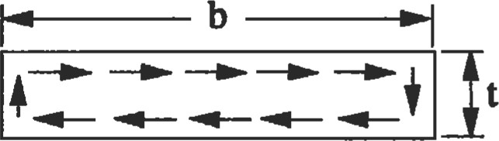

Figure 21. Rectangular cross-section under torsional load.

•t = T/abt2

= TWßbt3G where a and are obtained from Table 4.

läble 4

Constants for Tomlonal Shear Stress and Angular

Deaecüon Equations for Nonclrculer Cross-sections

DR 1.00 1.50 1.75 2.00 2.50 3.0 4.0 6.0 8.0 10.0  one 0.231 0.239 0.246 0.258 0.267 0.282 0.299 0.307 0.313 0.333

0.141 0.196 0.214 0229 0.249 0.263 0.281 0.299 0.307 0.313 0.333 Source: [101 R.rhted tun Arctan Strucwree by D. J. md J. J.

of%Graw-Hlä

If a cross-secüon is composed of several rectangular elements such as shown in Figure 22, the shear constant K = ßbt3 for each element can be calculated. The torque ar plied to the overall cross-section can then be disfributed over each rectangular element based on the ratio of Kl to Ktonl.

Kl = ßlblt13

Ktotal = ß1b1t13 + ß3b2t23 + ß3b3t33

The maximum shear s&ess for section 1 becomes



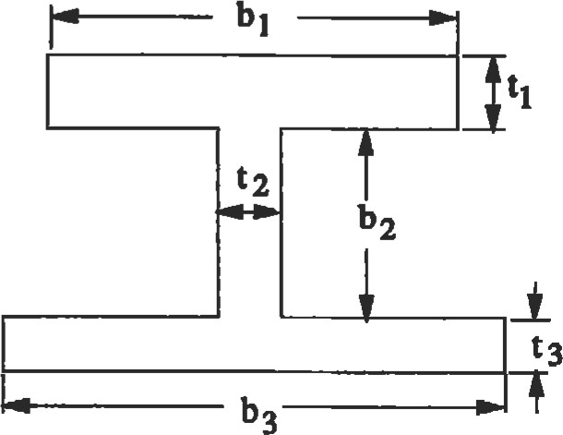

Figure 22. Cross-section consisting of multiple rectangular areas.

%ess S&aln

#### PRESSURE VESSELS

Cylindrical pressure vessels can be classified as either dius raüo of a cylinder is 1/10 or less, it is considered to be 'thin-walled" or 'thick-walled." If the wall thichless-to-ra- thin-walled.

##### Thin-walled Cyllnders

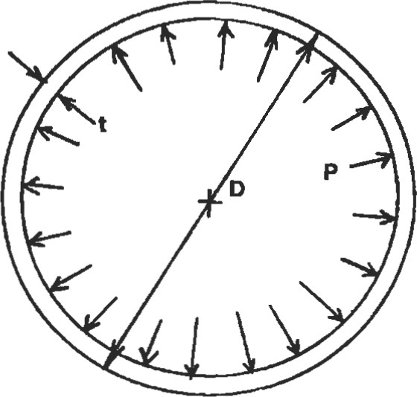For thin-walled cylinders (Figure 23), the tangential stress due to an internal pressure can be assumed to be uniformly disfributed across the wall thickness. The hoop equals pD/2t where p = internal pressure, D = d.i„ and t = wall thickness. For a closed cylinder, an axial stress oz = pD/4t will also be induced because of the pressure acting on the ends of the cylinder.

Figure 23. Thin-walled cylinder.

##### Thick-walled Cylinders

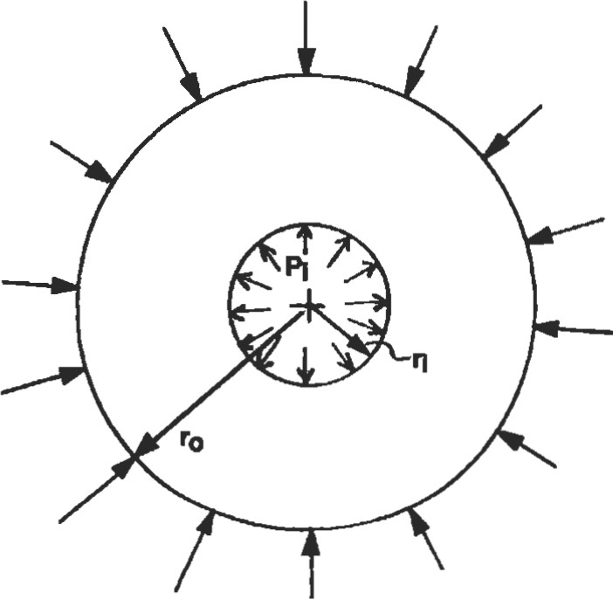For a thick-walled cylinder (Figure 24), the radial and tangenüal sü•esses are a function of the radius. The radial and hoop su•esses can be obtained from the equations listed in Table 5 for a disk of uniform thickness under internal and/or external pressures. The sum of ot and or at all points through the wall is constant.

##### or + ot = 2(Pi r? + po — r?)PO

For a closed cylinder the axial sü•ess equals:

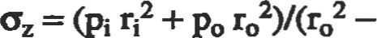r?) or = (or + ot)/2

The maximum tangential will occur at the inner diameter of the cylinder. Figure 24. Thick-walled cylinder.

—poro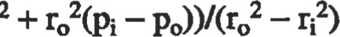

#### PRESS FITS BETWEEN CYLINDERS

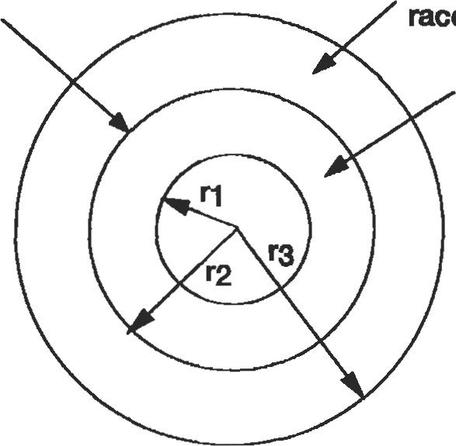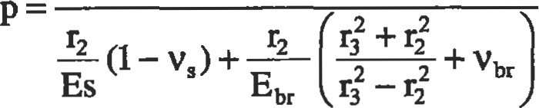If one cylinder is shrink-fit onto another, such as a bear- Ar = Shrink fit radial interference Bearing ing race on a shaft (Figure 25), the pressure force p devel- race oped between the two cylinders equals:

Shaft

Ar

which simplifies to the following if the bearing race and shaft are made of the same material and the shaft is solid.

Figure 25. Press fit between cylinders.

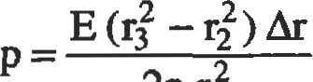

2r2%

ROTATING EQUIPMENT

|  |  |
| --- | --- |
| The design of rotating disks and shafts can present a design challenge, particularly when high rotaüonal speeds are coupled with significant transmitted torque, large number of start-stop cycles, desire for lightweight design, and elevated temperature operation. The mechanical stresses in the hoop and radial directions are a function of the square of the angular velocity (o). A 10% increase in the rotaüonal | speed will increase the su•ess level by 21%. Thermal gradients in turbine disks have a significant impact on the total   range experienced in the disk and will have a big effect on the low cycle life of the disk. Where interference fits known as radial pilots are required between shafting components, the intemal or external p:essure loads should be included in the calculation of peak sÜesses. |

##### Rotating Disks

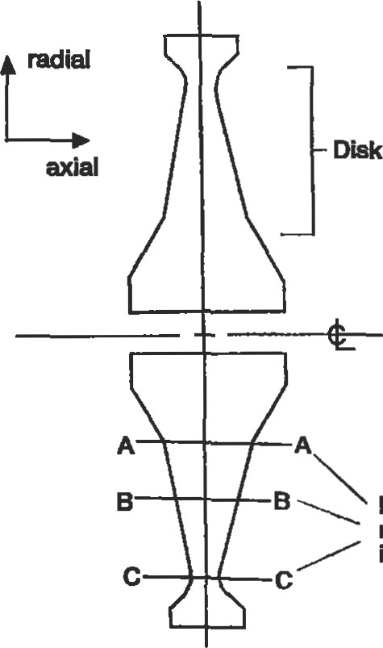In the detail design of high speed rotating disks, such as those found in the compressor and turbine sections of gas turbine engines for aircraft, finite element models are employed to analyze the sometimes rather complex shape of Disk web the disks. However, hand calculation of mechanical es is important for preliminary sizing and for checking the validity of a finite element model. The average hoop stress in the disk is evaluated against yield, creep, and ultimate (burst) strength requirements. The average radial stress through a section of the disk web (Figure 26) is evaluated against creep rupture (if higher temperatures are involved) and ultimate strength. The average equivalent sü•ess in theDetermine max web should meet yield strength requirements to avoid ex-in radial web.strew cessive deformation which could lead to contact between rotating and static components. Finally, the fatigue life associated with the peak equivalent sü•ess must be compared to the fatigue life requirements for the design. Figure 26. Rotating disk.

Mechanical Stresses

Table 5 presents the equations for calculating the radial and tangential s&esses and radial deflections for disks ofuniform thickless under internal/extemal pressure loads and rotation. If a disk is under a combination of these load conditions, the equations can be superimposed on one another. The following points are noted for the rotaüng rings and disks in Figure 27:

1. A relatively thin ring (thickness t is small compared to the mean radius r) with a mass density of p and rotaüng at o radians/second will have an average hoop stress of G = pr202.
2. For a rotating solid circular disk of uniform thickness, the maximum hoop and radial are equal and occur at the center of the disk:

Ormax Otmax = P02r02(3 + V)/8

1. For a rotating circular disk with a center hole of radius q, the maximum radial suess occurs at r = (ri ro)0 5 and the maximum tangential sü•ess occurs at the inner radius q.

Stress

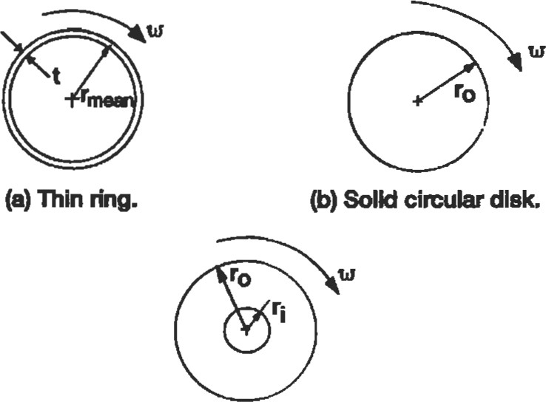

(c) Circular disk with center hole.

Figure 27. Rotating rings and disks.

= (3 + V) p02(ro 6tmax = "02[(3 + v)r02 + (l — V) ri2]/4 mermal Stresses In Disks

|  |  |  |  |  |  |  |  |  |  |  |  |  |  |  |  |  |  |  |  |  |  |  |  |  |  |  |  |  |  |  |  |  |  |  |  |  |  |  |  |  |  |  |  |  |  |  |  |  |  |  |  |  |  |  |  |  |  |  |  |  |  |  |  |  |  |  |  |  |  |  |  |  |  |
| --- | --- | --- | --- | --- | --- | --- | --- | --- | --- | --- | --- | --- | --- | --- | --- | --- | --- | --- | --- | --- | --- | --- | --- | --- | --- | --- | --- | --- | --- | --- | --- | --- | --- | --- | --- | --- | --- | --- | --- | --- | --- | --- | --- | --- | --- | --- | --- | --- | --- | --- | --- | --- | --- | --- | --- | --- | --- | --- | --- | --- | --- | --- | --- | --- | --- | --- | --- | --- | --- | --- | --- | --- | --- |
| Table 5  S&ess Equaüons for Disks of Unifom mc}mess   |  |  |  |  |  |  |  |  |  | | --- | --- | --- | --- | --- | --- | --- | --- | --- | | LOAD | RADIAL STRESS | | TANGENNAL STRESS | | AVnAGE    STRESS | RADIAL DEFIÆCTION | | | | SOLD DISK |  | |  | |  |  | | | | EX'IANA.L  PRESSURE (PO) +  ROTATION |  | | —PO | 1+3V po ro 2 | 3 | —por —+— v)r02 —(1+ v)r2 | | | | DISK WITH |  | |  |  |  |  | | | | DCI'ERNAL PRESSURE (PD | |  | | --- | | 2 | | 2 2 |   2 | 2  2  2 |  | |  | | --- | | 2 | | 2 2 |   2  12  2 2 | -Poro | 2 | 2  2 |  | | PRESSt.JRE (PO) | |  | | --- | |  | | 2 | | 2 |  |  |  |  |  |  | | ROTATION  ONLY | +02 | | |  |  |  |  | | --- | --- | --- | --- | | |  | | --- | | 2  p(3+ V) | |  | |  | | | 2 |  | | |   ro = outer radius, r, = inner radius, r = radius for calculation, p = mass o = romional v = Poison's raäo, |

Tensile and compressive hoop sü•esses are induced in disks with radial thermal gradients. If the outer diameter of the disk is hotter than the inner diameter, then the outer

fibers will be in compression while the inner fibers are in tension. A reverse gradient will have the opposite effect on the sign of the hoop in the disk The radial thermal gradient also increases the radial stresses in the web of the disk. In high temperature applications, the sient thermal gradients may be severe and affect the fatigue life of the component.

Yield Stress Criteria

A yield stress criteria for a rotating disk ensures that no gross deformaüon will occur under the limits of normal operation. Under the combined effects of rotation and thermal gradients, the disk average tangenüal stress and the maximum web average equivalent stress, i.e., averaged through the thickness of the disk web, must remain under the yield strength of the material. In aircraft engine süuctures, it is typical practice to use the -3 sigma yield strength of the material.

UltimateÆurst Stress Criteria

An ultimate stress criteria for a rotating disk prevents the disk from bursting below a predetermined rotaüonal velocity. A disk allowed to burst will cause tremendous damage to surrounding stucture and present a safety hazard for any nearby personnel. Usually, a burst disk will rupture into several large chunks and numerous small fragments. If tangential sfresses cause the burst, the disk will rupture through the bore or center of the disk (Figure 28a). A radial burst would leave the center of the disk intact and the disk would rupture circumferentially through the web of the disk (Figure 28b).

The rupture stress at which a disk bursts is a funcüon of the ultimate tensile sü•ength and the ducülity of the material. Ductility is measured by the percentage elongation present in the material specimen at fracture. A material with less

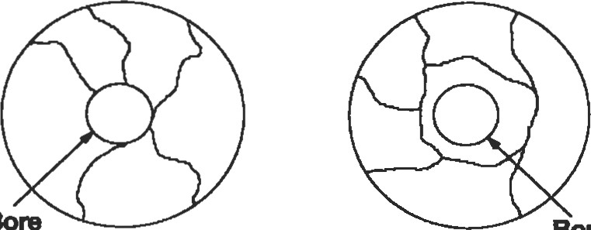

Bore

Bore (a) Disk tangential burst. (b) Disk radial burst.

Figure 28. Rotating disk burst failure modes.

than 5% elongation is usually designated as brittle, while a material with more than 5% elongaüon is ductile. Cast materials, as a rule, have much lower ductility than forged materials. As noted in the following procedure, ductile castings with greater than 5% elongation actually exhibit a higher percentage of uülizable ultimate sfrength than very forged materials as long as the peak tangential su•ess is not more than twice the average tangential of the disk However, a forged material has higher ulümate ffus providing higher rupture strength. The ultimate sü•ength used in the burst calculation should be degraded by the scater (three stand.ard deviaüons are often used for aircraft components) associated with the material data.

Tangential Burst Calculation:

1. Calculate average tangential suess for the disk.
2. Calculate maximum tangential sü•ess for the disk.
3. Determine average rupture strength, i.e., average s&ess at which disk burst occurs.
   * For a typical cast material:

Avg. Tangendal Stress/

Elongation Mot Tangenüal S&ess Rupture S&ength

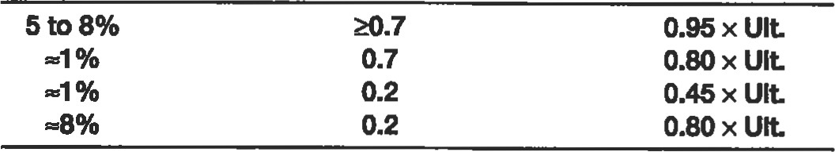

* + For high ducülity materials, such as forgings, the rupture is estimated to be 85% to 90% of the ulümate strength.

1. Tangential Burst Speed = (Rupture Strength/Avg. Tangential (100) (Rotational Speed).

The average tangential st-ess in a turbine disk does not change appreciably when thermal gradients are applied to the disk. Thus, even with thermal effects the average tangential stress is approximately proportional to the square of the speed.

Radial Bum Calculatlon:

1. Calculate the maximum average radial stress drough tie fickness of the disk web for rotaüon only (orotaion).
2. If thermal gradients present in the disk, calculate the maximum average radial stress through the thickness of the disk web due to temperature (oti*rmal).
3. Typically, a factor of .95 is applied to the ultimate su•ength regardless of ducülity for a radial burst cal-

Stress

culation. Since thermal do not ratio with speed, the allowable rupture su-ength is degraded by the magnitude of the radial stess due to temperature.

1. Radial Burst Speed = ([0.95 Ultimate Strength —

|  |
| --- |
| Rotating Shafts |

(100) (Rotational Speed).

Stresses Due to Torsion, Thrust, and Bending Loads

Rotating shafts may be subjected to a combination of torand axial thrust Since these loais are a combination of sntic and altemating loads, both and staüc su•ength criteria are considered in shafting design.

Select sections as illustrated in Figure 29 that include holes, shoulder fillets, splines, minimum secüon properües, and other sources of stress concentration for stress and life analysis. Calculate the maximum operating torque, bending moment, and axial load at each section.



where T = torque (in. 1b)

HP = horsepower

N = rpm

Spline teü Gear teeth

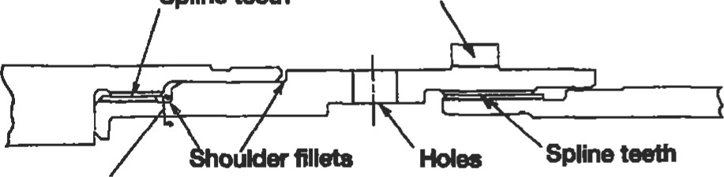

Minimum cross-secBon

Figure 29. Shafting features requiring stress analysis.

M011Ents may be imparted to the shaft by gear loads, rectilinear accelerations normal to the shaft or gyroscopic loads. Gyroscopic loads are always considered for aircraft applications of rotating shafting.



where I = polar moment of inertia of the shaft components (in. 1b sec2) o = angular velocity of shaft (radians/sec)

Q = precession speed (radians/sec) or angular velocity of the shaft spin axis about an axis normal to the spin axis

A gyroscopic moment will cause an alternating bending in the shaft. The torsional stress will remain steady. Experimental results [11] indicate that the bending fatigue is not sensitive to the torsional mean stress until it exceeds the torsional yield strength by as much as 50%.

Bearings should be located near the largest masses connected to the shafting to minimize the bending moments associated with rectilinear accelerations and gyroscopic effects. Nonconcenfrated loads should be limited to 85% of the yield strength.

Mechanical Couplings

Flanged. This type of coupling is used to dansmit torque through shear in the attaching bolts or by friction between the adjacent flanges.

• Figure 30 depicts two mating shaft flanges connected with 'body bound" bolts such that the torque is transmitted solely through the bolts. The bolts themselves pilot the radial position of the flange. With this type of assembly, it is necessary to ream the bolt holes on assembly or use the same fixture for both parts. The bolt shear stress is:

t = T/NAR

where T = torque (in. 1b)

N = number of bolts

A = bolt shear area (in.2)

R = bolt circle radius (in.)

• Figure 31 shows a rotating flanged joint where a circumferenüal flange pilot is used to control alignment and the torque is d•ansmitted by friction between the bolted flange surfaces. The bolt tensile sü•ess required to drive the torque by friction is:

oa=T/NARu

where = coefficient of friction (assume O. 1 for metal on metal contact)

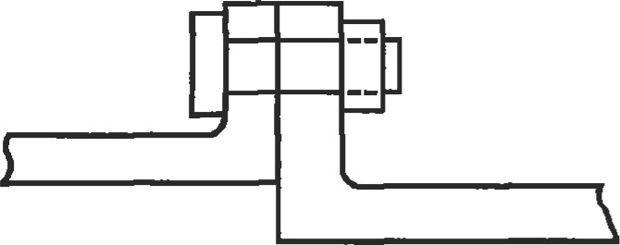

Figure 30. Bolts transmit torque.

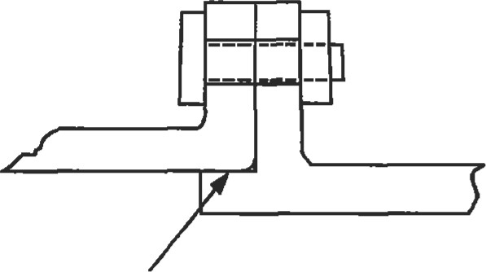

Circumference of maing flanges is radially piloted.

Figure 31. Fiction between mating surfaces transmits torque.

Splined. The splined coupling in Figure 32 is a torquecarrying connection with axial or helical teeth on the outer diameter and inner diameter of the male and female members, respectively. The involute spline profile is common and similar to gear teeth. Splines differ from gears in that there is no rolling action and all teeth may contact at the same time. When failure occurs, splines usually fail by fretting or fatigue. The two basic types of splines with respect to fit are fixed (nonworking) and flexible or floating (working) splines. Fixed splines do not allow relative moüon between the internal and external teeth. A radial press fit between the inand exernal teeth or on a radial pilot surface ofdle shaft adjacent to the spline prevents relative moüon. Flexible splines permit some degree of rocking modon and can accommodate axial movement between the mafrrg shafts. Case-hardened surfaces should be used with this spline type. Positive lubricafion is required at all ümes for flexible splines to minimize wear and fretüng. The rim or supporting ring of material beneath the spline teeth should have a minimum of 1.25 times the total tooth height.

Intemal spline

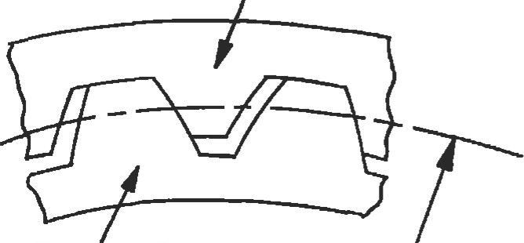

Extemal epline Pitch dlarneter Figure 32. Splined coupling.

Highly loaded aircraft splines will have spline lengths ranging from 50% to 100% of the pitch diameter. For flexible splines, a wide face width has limited value in extending the load-carrying capacity. Generally flexible splines are misaligned (since accommodation of misalignment is one of its main ftnctions), thus the contact load between the teeth tends to load the ends of the spline. Increased length does not relieve the intensity of the loading but will increase the dme required for the wear in the center of the spline to catch up with the wear at the ends. The number of spline teeth is governed by cost and manufacturing considerations because doubling the number of teeth does not have a large effect on the tooth stresses, i.e., the teeth become half as big when doubled, but there are twice as many teeth to carry the load—the two effects tend to cancel each other.

A complete evaluaüon of a splined coupling should include the tooth shear sü•ess, torsional shear stress, tangential or bursüng sÜess due to the radial load between the mating spline teeth and rpm, and the bearing or contact stresses between the teeth. Allowable spline stresses depend upon the material, severity of loading, number of torque cycles, and whether the spline is fixed or flexible. Fixed splines have a greater ability to ca.rry the contact stress because there is no relative moüon between the mating teeth.

Curvlc@. A fixed curvic@(a registered name by Gleason Works in Rochester, New York) is a face spline with teeth which are spaced circumferentially about the face and possess a characteristic curved shape when viewed in a plane perpendicular to the coupling axis (Figure 33). A curvic@

Convex member

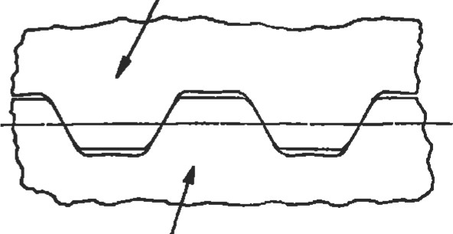

Concave member

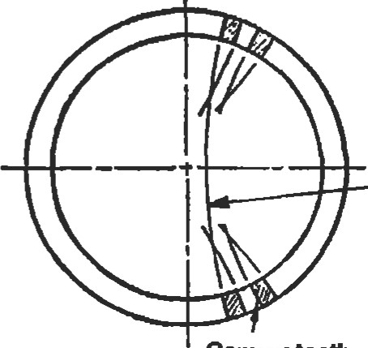Note curvature on teeth

Convex teefi

Figure 33. Curvic@ coupling.

coupling between shafting members must be bolted together with sufficient load to handle the axial separation loads due to shaft operating thrust loads, axial reaction from rotor torque, axial inertia loads, and bending loads due to lateral inertia loads, angular accelerations, and gyro-

#### %ess

|  |
| --- |
| FLANGE ANALYSIS |

scopic loads. The tooth shear and contact govern the required size of the curvic@ coupling. The design factors governing curvic design can be obtained from the Gleason Curvic Coupling Design Manual [12].

|  |
| --- |
| aliåDI II<BiBID  Forward Aft  case toad loadcaseload  Figure 34. Flush flange. Figure 35. Undercut flange. |

Mating cylindrical cases such as those found in aircraft engine applications may have axial as well as circumferential splitline flanges. These cases are subject to internal gas pressures. Under relatively low pressures, the flush type flange shown in Figure 34 is adequate. However, the undercut type flange joint of Figure 35 is recommended for those nongasketed high pressure applications where gas leakage must be minimized. A rigorous and deflection analysis of flanges can be somewhat complex depending upon the geomeüy, gradients, and load conditions. The following guidelines offer assistance in the preliminary sizing of typical splitline flanges.

* Design splitline joint such that the flanges do not separate (may leak) under proof test loading which is often specified as two times the maximum operating pressure load.

' Never exceed a five-bolt diameter separation between bolts to ensure that leakage is minimized.

* Account for the difference in thermal expansion coefficients for bolt and flange materials under operaüng conditions when calculating the required cold assembly bolt load.
* If the case moment at thejunction of the flange and case is not significant, then the minimum bolt load required to react the case load at operating conditions can be calculated using Figure 36. Assume the flanges open at point D during operation. The reaction per bolt at point A and the required operating bolt load FB can be calculated by summing moments about point A. F is the case load per bolt.

EMA=O



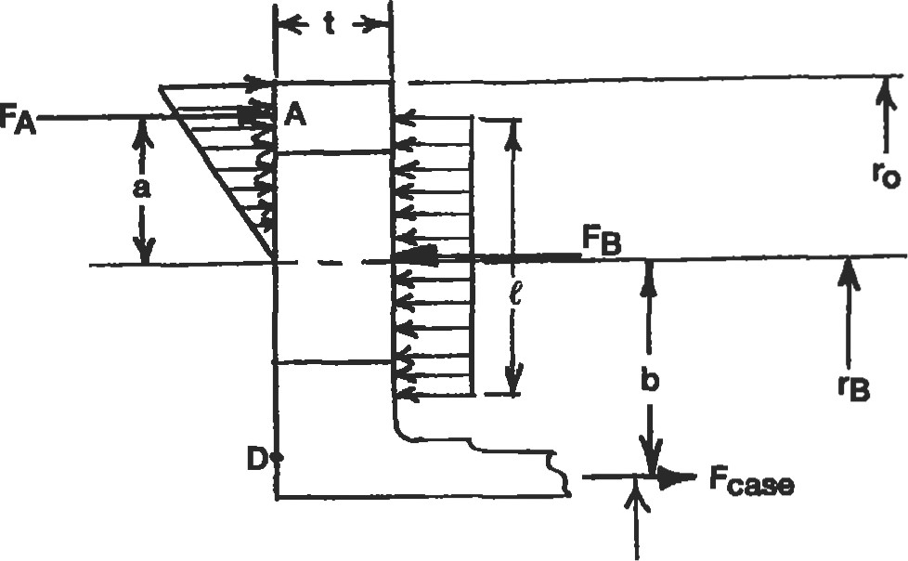

rc

Figure 36. Calculation of operating bolt load for flush flange.

where a = 2/3(ro — rB)

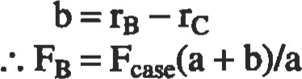

' The bending moment between bolts is calculated as follows:



8

Remember to use the maximum permissible bolt load to calculate the bending moment. The flange bending stress 0b per bolt equals:

|  |
| --- |
| Undercut Flanges |

= MC/I = 6M/ht2 where h is the distance between bolt holes.

* Undercut flanges minimize the clamping load requirements. The bolt clamping force is applied through two narrow contact lands between the mating flanges. The local stiffness of the flange is reduced by the undercut. During assembly, the reduced stiffness allows Then sum moments about the bolt circle point B to solve for FA.

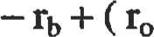EMB = O

slightly more deflecüon under bolt preload, hence it provides some margin for thermal mismatch between the flange and bolt materials.

' The flange thickness and bolt load must be designed such that the undercut area does not bottom out against the mating flange surface. This can be accomplished by limiting the bending stress in the flange to the yield strength of the flange material.

* 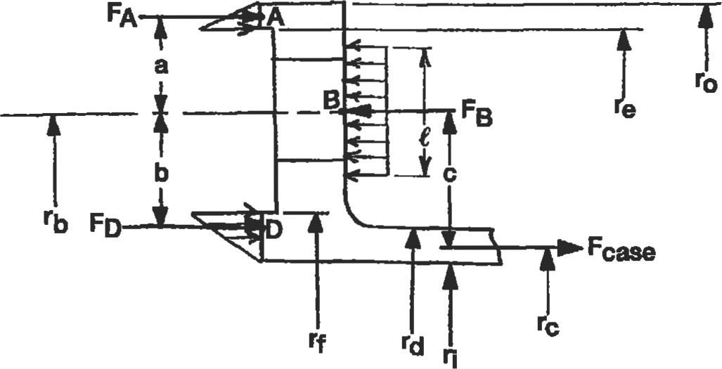The undercut width should be approximately 50% wider than the bolt diameter, and the outer contact land width equal to 20% of the bolt diameter.

where a re-re)/3

The minimum operaüng bolt load equals:

##### FB=FA+FD

|  |  |  |
| --- | --- | --- |
| ' If the case moment at the junction of the flange and the case is not significant, then the minimum bolt load at operaüng condiüons can be calculated using Figure 37. The mating flanges should remain in contact at points A and D. As long as the preload FD on the inner contact land D exceeds the case load (F ), the bending moment is dependent upon FD . First calculate the required preload FD to prevent separation at D.  FD = Fcase(c/b)   |  |  | | --- | --- | | where b = rb — rf + (rf — ri)/3  c | Hgure 37. CalculÜn of operaüng bolt load for undercut flange. |   MECHANICAL FASTENERS |

The bending moment and s&ess at the bolt circle are calculated in a manner identical to the flush flange.

The selection of appropriate mechanical fasteners is not an insignificant consideration in the design of certain products. 'IWo to three million fasteners are used in the consüuction of a single jumbo jet. Choice of the correct fasteners is a function of the parts being joined, space limitations, severe operating loads which include static, cyclic, and thermally induced loads, and the assembly and maintenance requirements. Fasteners are designated as to whether the application is predominately shear or tension.

Threaded Fasteners

Threaded fasteners include screws, bolts, and studs. Several fundamental quantities which apply to screw threads include the following:

pitch: the distance between adjacent thread forms.

pitch diameter: the diameter to an imaginary line drawn through the thread profile such that the width of the thread tooth and groove are equal.

major diameter: the largest diameter of the screw thread. minor diameter: the smallest diameter of the screw thread. thæad tensile area: the tensile area of a screw thread is based upon the experimental evidence that an unthreaded rod with a diameter equal to the mean of the pitch and minor diameters will have the same sÜength as the threaded rod. proof load: the maximum tensile load that a bolt can tolerate without incuning a permanent set.

Bolted Joints

Bolted joints which often resist a combination of external tensile and shear loads are the focus of this section. Bolt material should be strong and tough, whereas the nut material should be relatively soft, i.e., more ductile. A soft nut allows some plastic yielding which results in a more even load distribuüon between the engaged threads. Three full flireads are required to develop the full bolt strength, and good design practice dictates that the bolt extend two full threads beyond the outer end of the nut.

The bolts and the clamped joint members must possess similar thermal coeffcients of expansion to minimize load fluctuation in different thermal operating environments. A larger length-to-diameter (ID) will allow bolt flexibility to offset any difference in thermal expansion. In higher temperature environments, the bolt material must be selected for resistance to creep to prevent loss of preload.

A bolt should be relatively flexible as compared to the joint members being clamped together. Bolts with the largest possible I-JD ratio decrease the potential for vibration loosening of the bolt. A IJD > 8 would effectively prevent this occurrence [13]. Bolt stiffness is a function of the effective length of the bolt. For a large IJD rado, the thread engagement has a small effect upon the effective length. The effect is more significant for short bolts. Typically one-half the nut or hole threads are assumed to carry some load and conüibute to the length. The spring rate for a bolt equals AEJL, where A = area, E = modulus of elasticity, and L = effective bolt length. The clamped components act as compressive springs in series such that the total spring rate of the members is 1/Kt= 1/ Kl + 1/ K2 +. . . + 1/ Kn. The actual effective stiffness of each member is diffcult to obtain without experimentation or finite element modeling, as the bearing force between the clamped components spreads out in a nonuniform manner. For the sake of approximation, use a cylinder with an outer diameter of three times the bolt diameter and an inner diameter equal to the bolt diameter to represent the components clamped together by the bolt. If the bolt and clamped components have the same modulus E, fris assumption infers that the clamped components are eight times as stiff as the bolt.

Bolt Preload

In a bolted joint under tension, the bolt preload has two functions: keeping the clamped parts together and increasing the fatigue resistance of the joint The preload is proportional to the torque applied to the bolt head. This relationship between torque and preload is dependent on the actual coefficient of friction between the bolt and the mating components. The coefficients of friction for the bolt threads and bearing surfaces of the bolt head and nut range from 0.12 to 0.20 depending upon the material and lubrication. Approximately 50% of the assembly torque is used to overcome between the bearing face of the nut and mating clamped component. Another 40% is used to overcome thread and the balance produces bolt tension.

Depending upon the application, maximum bolt preload recommendations range from 75% to 100% of the proof load [14]. Using 100% of the proof strength reduces the number of bolts and generally reduces the alternadng load on the bolt, i.e., increases the fatigue life. However, for joints that experience substantial cyclic loading, a high preload may actually lower fatigue life because of the high mean stress. Applications which demand repeated assembly and disassembly are not good candidates for the 100% proof load specification, as the bolts will experience some yield in service and should not be reused. The 100% goal also requires more sophisticated assembly equipment to guarantee that the bolts are not overloaded.

The lower end of the range (75% to 80%) is much more widely used, as it provides an adequate margin of safety for traditional methods of assembly where a torque wrench is used to meet a specified torque. The combination of tensile and torsional stresses at the outer surface of a bolt often reach the yield strength at 80% of the proof load.

As pointed out in the previous section, the clamped joint components are generally several ümes more stiff than the bolts. An external static tensile load applied to the joint will extend the bolt and relieve the compression in the joint members. If the joint opens, the bolt will feel 100% of the external load. Assuming that the bolt andjoint members are in the elastic range and the joint does not separate, the degree of external load experienced by the bolt is proportional to the ratio of bolt to joint süffness. For example, if the joint members are eight fimes as stiff as the bolt, the bolt will feel approximately 11 % of the external load. A cyclic extemal load is split between the bolt and joint members in the same fashion. Thus, the bolt usually only experiences a fraction of the cyclic load applied to the joint. A higher bolt preload will lower the effect of the cyclic load on the total bolt load. As a rule, the cyclic load in the bolt should be less than 25% of its yield su-ength.

In general, joint fatigue can occur when the alternaüng sfress amplitude in the bolt exceeds the fatigue strength of the bolt or if the joint opens and the bolt experiences the fun external load.

Thread and fillet rolling after heat treatment will increase the sfrength of a bolt by creating a residual compressive stress.

Common Methods for Con&olling Bolt Preload

Torque. A specified range of torque is applied to the nut or bolt by some form of a calibrated torque wrench. In terms of application, this method is the simplest and is used where threads assemble into blind holes. Since the preload is a function of the coefficients of friction, the preload may vary by 25% [15].

Bolt elongation. This method can be used when the overall length of the bolt can be measured with a micrometer after assembly to achieve an accuracy of 3% to 5% for the preload [15]. The required bolt elongation (6) can be calculated using the bolt süffness:

5 = PL./AE where P is the required bolt preload.

Nut Romion. The nut rotaüon method requires a calcuof the fractional number of turns of the nut required to develop the desired preload. The nut rotaüon is measured from the snug or finger-tight condition. This method controls the preload to within 15% of desired levels [15].

Strain gages. Special fasteners with strain gages located inside the fastener or on its surface can be used to conü•ol the preload to within one percent [15]. Due to expense, this degree of cont-ol is usually used for design development.

A pin is a simple and inexpensive fastener for situations where the joint is primarily loaded in shear. The two broad classes of pins are semipermanent and quick release. The semipermanent class includes the standard machine pins which are grouped in four categories: dowel, taper, clevis, and cotter. In general, semipermanent pins should not be aligned such that the direction of vibration loads parallels the pin axis. Also, the shear plane of the pin should not lie more than one diameter from the end of the pin. Specific design data for each type of pin is available in vendor catalogs.

Rivets are permanent shear fasteners in which the rivet material is deformed to provide some clamping or retaining ability. Rivets should not be used as tension fasteners because the formed head is not capable of sustaining tensile loads of any magnitude. There are two families of rivets: tubular and blind. As the name suggests, the blind rivets require access to only one side of the components being

assembled.

In terms of design and analysis, riveted joints are ed exactly like bolted joints that are loaded in shear. These joints can fail by shear of the rivets, tensile failure of the joined members, crushing (bearing stress) failure of the rivet or joined members, or shear tear-out. For rivet shear sü•ess calculaüon, the nominal diameter (D) of the rivet is used for the area calculation. tensile stress in üEjoined members is based on the net area (mea with holes removed), with die suess concentration effects included for cyclic loads. The bearing stress between the rivets and joined members is calculated using the projected rivet area A = tD, where t is the thickness of the thinnest joined member. Shear tear-out is avoided by maintaining an edge distance greater than one and one-half diameters.

Additional design tips include:

1. Use washers to reinforce riveted joints in brittle material and thin sections.

|  |
| --- |
| WELDED AND BRAZED JOINTS |

1. When joining thick and thin members, position the rivet head against the thin section.

Welding is defined as a group of metal joining processes which allow parts to coalesce along their contacting surface by application of heat, pressure, or both. A filler metal with a melting point either approximately the same or below that of the base metals may be used. Welded joints should be designed such that the primary load fer produces shear load rather than a tension load in the weld. Sharp section changes, crevices, and other surface irregularities should be avoided at welded joints.

Fillet and butt welds are common weld forms found in machine components and pressure vessels. Fillet welds should be between 1.0 and 1.5 times the thickness of the thinnest material in the joint. For fillet and butt welds, the average shear stress is calculated using the weld throat area (see Figure 38). If the joint is subject to fatigue loads, the appropriate stress concentration factor is applied to the nominal cyclic stress. The reinforcement shown for the butt weld will cause a stress thus it is often necessary to grind this material off if the joint is subject to cyclic loads.

I>pending upon dre geomeüy and ty•pe of welding process, it may be difficult to guarantee full weld penetration. Often either larger factors of safety are used to compensate for this potential or die effecüve weld area is Educed Welding codes generally have conservadsm built into the allowable stresses. Both the of the weld metal and the joined parent materials in the welded condition must be determined.

Brazing is defined as a group of metal joining processes where the filler material is a nonferrous metal or an alloy whose melting point is lower than that of the metals to be joined. The brazing process spreads the filler material between closely fitted surfaces by capillary atü•action. The strength of the brazed joint depends upon the surface area of the joint and the clearance between the parts being joined. A lap of four the of the thinnest part being joined is typically specified for brazing.

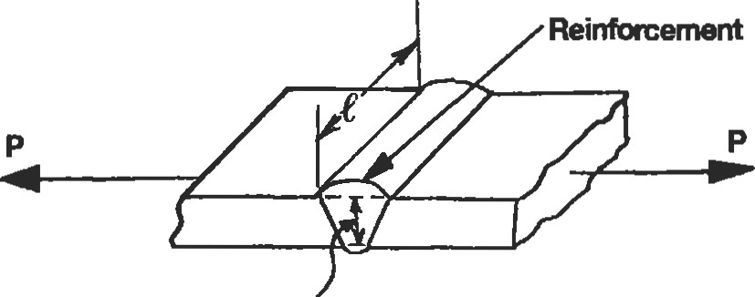

1. Weld ttroat for butt weld

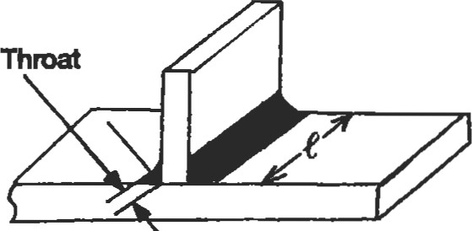

1. Fillet weld

Figure 38. Weld throat area.

mumb

##### CREEP RUPTURE

|  |  |
| --- | --- |
| Creep is plastic  which increases over üme under sustained loading at generally elevated temperatures. Stress rupture is the continuaüon of creep to the point where failure takes place. Metallic and nonmetallic materials vary in their susceptibility to creep, but most common structural materials exhibit creep at s&ess levels below the propor   limit at elevated temperatures which exceed onethird to one-half of the melting temperature. A few metals, such as lead and tin, will creep at ordinary temperatures.  The typical strain-time diagram in Figure 39 for a material subject to creep illusü•ates the three stages of creep behavior. After the iniüal elasüc deformation, the material exhibits a relatively short period of primary creep (stage 1), where the plastic sfrain rises rapidly at first. Then the strain versus time curve flattens out. The flatter portion of the curve is referred to as the secondary or steady state creep (stage 2). This is the stage of most importance to the en- | gineer in the design process. The final or tertia.ry creep stage (stage 3) is characterized by an acceleration of the creep rate, which leads to rupture in a relatively short period of time.  High sü•esses and high temperatures have comparable effects. Quantitatively, as a function of temperature, a logarithmic relationship exists between süess and the creep rate. A number of empirical procedures are available to correlate stress, temperature, and üme for creep in commercial alloys. The Larson-Miller parameter (KLM) is an example of one of these procedures. The general form of the Larson-Miller equaüon is:  = ct+20)  where  T = temperature in OF. t = time (hours) c = empirical parameter relating test specimens to design component |

|  |  |
| --- | --- |
| o Time | can halve the creep rupture life. Mark's Handbook [16] pro- |
| Figure 39. Three stages of creep behavior. | vides some creep rate information for steels. |

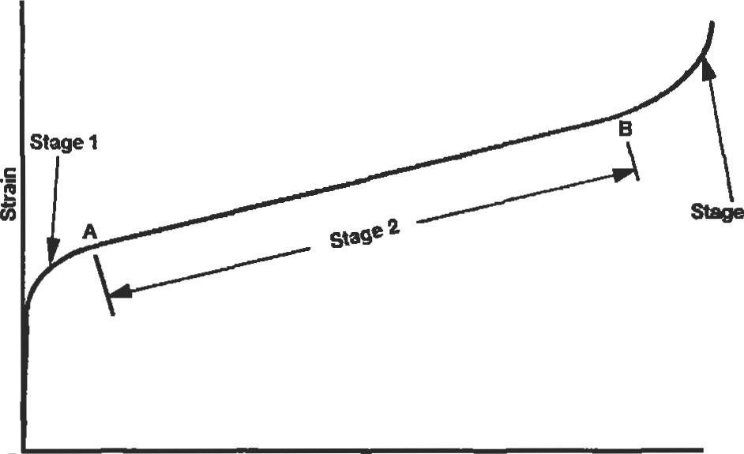Creep strength is specified as the sü•ess corresponding to a given amount of creep deformation over a defined period of time at a specified temperature, i.e., 0.5% creep in 10,000 hours at 1,2000F. The degree of creep that can be tolerated is a function of the application. In gas turbine en3 gines, the creep deformaüon of turbine rotating components must be limited such that contact with the static structure does not occur. In such high temperature applications, stress rupture can occur if the combination of temperature and stress is too high and leads to fracture. As little as a 200 to 300F increase in temperature or a 10% increase in stress

##### FINITE ELEMENT ANALYSIS

Over the last 25 years, the finite element method (FEM) has become a standard tool for structural analysis. Advances in computer technology and improvements in finite element analysis (FEA) softwa.re have made FEA both affordable and relatively easy to implement. Engineers have access to FEA codes on computers ranging from mainframes to personal computers. However, while FEA aids engineering judgment by providing a wealth of information, it is not a

|  |
| --- |
| Overview |

FEM has its origins in civil engineering, but the method first matured and reached a higher state of development in the aerospace industy. The basis of FEM is the representaüon of a by an assemblage of subdivisions, each of which has a standardized shape with a finite number of degees of freedom. 'Ihese subdivisions are finite elements. Thus the coüuum of the structure with an infinite number of degrees of freedom is approximated by a number of finite elements. The elements are connected at nodes, which are where the solutions to the problem are calculated. FEM proceeds to a soluüon through the use of sEess and sfrain equations to calculate the deflections in each element duced by the system of forves coming from adjacent elements through the nodal points. From the deflections of the nodal points, the strains and stresses are calculated. This procedure is complicated by the fact that the force at each node is dependent on the forces at every other node. The elements, like a system of springs, deflect until all the forces balance. The to the problem requires that a large number of simultaneous equations be solved, hence the need for matrix solutions and the computer.

|  |
| --- |
| The Elements |

Each FEA program has its own library of one-, two-, and three-dimensional elements. The elements selected for an analysis should be capable of simulating the deformations to which the actual suucture will be subjected, such as bending, shear, or torsion.

One-dimensional Elements

The term one-dimensional does not refer to the spatial location of the element, but rather indicates that the element will only respond in one dimension with respect to its local coordinate system. A ü•uss element is an example of a one-dimensional element which can only support axial loads. See Figure 40.

x

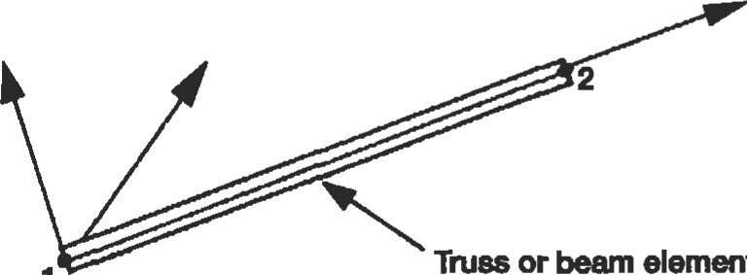

element

1

Figure 40. One-dimensional element.

Elements

A general two-dimensional element can also span threedimensional space, but displacements and forces are limited to two of the three dimensions in its local coordinate system. IWo dimensional elements are categorized as plane stress, plane strain, or axisymmeüic.

Plane stress problems assume a small dimension in the longitudinal direction such as a thin circular plate loaded in the radial direction. As a result the shear and normal stresses in the longitudinal direction are zero. Plane strain problems pertain to situations where the longitudinal dimension is long and displacements and loads are not a function of this dimension. The shear and normal s&ains in the longitudinal direction are equal to zero. Axisymmetric elements are used to model components which are symmetric about their central axes, i.e., a volume of revoluüon. Cylinders with uniform internal or external pressures and turbine disks are examples of axisymmetric problems. Symmeüy permits the assumption that there is no variafion in sü•ess or su•ain in the circumferential direction.

TWo-dimensional elements may be triangular or quadrilateral in shape. Lower order linear elements have only corner nodes while higher order isoparametric elements may have one or two midsides per edge. The additional edge nodes allow the element sides to conform to curved boundaries in addition to providing a more accurate higher order displacement function. See Figure 41.

Three-dimensional Elemenb

Three-dimensional solid elements are used to model süuctures where forces and deflections act in all three directions or when a component has a complex geometry that does not permit two-dimensional analysis. Three-dimensional elements may be shell, hexahedra (bricks), or teüahedra; and depending upon the order may have one or two midside nodes per edge. See Figure 42.

32 Thumb

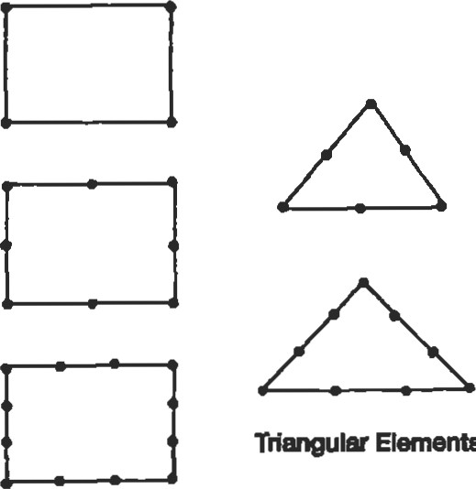

ElemenO

Quadrilateral Elementa

Figure 41. Two-dimensional 

The choice of elements, element mesh density, boundary conditions, and consffaints are critical to the ability of a model to provide an accurate representation of the physical part under operating

* Element mesh density is a compromise between making the mesh coarse enough to minimize the computation time and fine enough to provide for convergence of the numerical solution. Until a "feel" is developed for the number of elements necessary to adequately predict stresses, it is often necessary to modify the mesh density and make addiüonal runs solution convergence is achieved. Reduction of lution convergence error achieved by reducing element size without changing element order is known as h-convergence.
* Models intended for su•ess prediction require more elements than those used for thermal or dynamic analyses. Mesh density should be increased near areas of stress concentration, such as fillets and holes (Figure 43). Abrupt changes in element size should be avoided, as the mesh density transitions away from the stress concenü•ation feature.
* Compared to linear comer noded elements, fewer higher order isoparametric elements are required to model a structure. In general, lower order 2D &iangular elements and 3D tetrahedral solid elements are not adequate for stuctural analysis. Some finite element codes use an automated convergence analysis technique

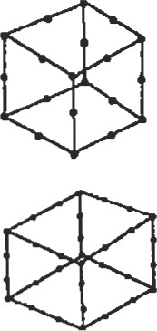

Tetrahedral elements

Hexahedraf elements

(bricks)

Figure 42.  elements.

Figure 43, Increase mesh density near stress concentrations.

known as the p-convergence method. This method maintains the same number of elements while increasing the order of the elements until soluüon convergence is achieved or the maximum available element order is reached.

* Convergence of the maximum principal stress is a much better indicator than the maximum Von Mises equivalent stress. The equivalent is a local measure and does not converge as smoothly as the maximum principal su•ess.
* Elements with large aspect ratios should be avoided. For two-dimensional elements, the aspect raüo is the of the larger dimension to the smaller dimension. While an aspect ratio of one would be ideal, the maximum allowable element aspect ratio is really a function of the stress field in the component. Larger aspect ratios with a value of 10 may be acceptable for models of components such as cylinders subjected only to an axial load. Gena•ally, the largest aspect ratio should be on the order of 5.
* Highly distorted elements should be avoided. Two-dimensional quadrilateral and three-dimensional brick elements should have comers which are approximately right angled and resemble rectangles and cubes respectively as much as possible, particularly in regions of high su•ess gradient. The angle between adjacent edges of an element should not exceed 1500 or be less than 300 . Many current finite element modeling codes have built-in options which permit identification of elements with sufficient distortion to affect the model's accuracy.
* Symmetry in a component's geometry and loading should be considered when constructing a model. Often, only the repeated portion of the component need be modeled. A section of a shaft contains three equally spaced holes. A solid model of the shaft containing one hole or even one-half of a hole Cigure 44), if the holes are loaded in a symmetric manner, must be modeled to perform the analysis. Appropriate constraints which define the hoop continuity of the shaft S&ain

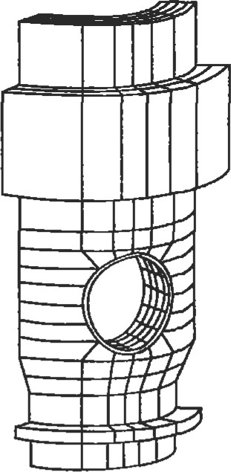

Figure 44. Sector model of a shaft cross-section containing three holes.

must be applied to the nodes on the circumferenüal boundaries of the model.

|  |
| --- |
| Advantages and Limibtlons of FEM |

* A number of FEA modeling codes have automated meshing features which, once the solid geometry is defined, will create a mesh at the punch of a button. This greatly speeds the production of a model, but it cannot be assumed that the model that is created will be free of distorted elements. Auto mesh programs are prone to creating an excessive number of elements in areas where the sfress field is fairly uniform and such mesh density is unwarranted. The analyst must use available mesh controls and diagnostic tools to minimize these potential problems.

Generally, the finer the element mesh, the more accurate the analysis. However, this also assumes that the model is loaded appropriately to mimic the load conditions to which the part is exposed. It is always advisable to ground the analysis with actual test results. Once an initial correlation between the model and test is established, then subsequent modifications can be implemented in the model with relative confidence. In many instances, the FEA results predict relative changes in deflection and stress between design iterations much better than they predict absolute deflections and su•esses.

324 Thumb

###### CENTROIDS AND MOMENTS OF INERTIA FOR COMMON SHAPES

Key to table notation: A = area (in. 2); Il = moment of inertia about axis 1-1 (in.4); Jo = polar moment of inertia (in.4); c—denotes centroid location; u and ß are measured in radians.

|  |  |  |  |
| --- | --- | --- | --- |
|  | bh3  12 | Trapezoid | +4))  3 |
| Circle |  | Circular Sector  Y2  Radius=R | A=aR  Il = —ta + sina cosa — 16sin2 a/9al  12   —sina cosal y, = Ril—2sina/3a} h = 2Rsina/3a |
| Semicircle | 12 -0.1098M | Solid Ellipse |  |
| Hollow Circle | ) | Hollow Ellipse | A = — biq )  -E-(ba 3 —blat) |
|  | bh  bh3 36 | Thin Annulus | A = 2ßRt  3 2sin 2 ß  Il = R1 + sinß cosß —  J  l(ß  —sin  cosß)  cos |

#### BEAMS: SHEAR, MOMENT, AND DEFLECTION FORMUS FOR COMMON END CONDITIONS

Key to table notation: P = concentrated load (lb.); W = uniform load (lb./in.); M = moment (in. lb.); V = shear (1b); R = reaction (lb.); y = deflection (in.); e = end slope (radians); E = modulus (psi); I = moment of inertia (in.4). Loads are positive upward. Moments which produce com-

pression in the upper surface of beam are positive.

1. Candlaer - End Load

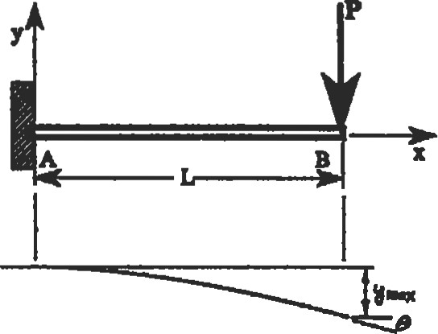

1. Cantilever - Intenediate Load

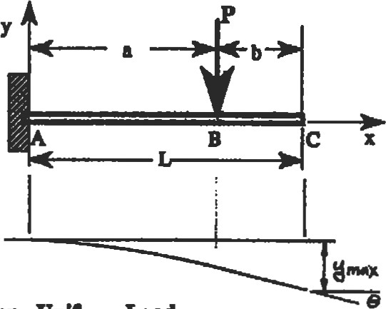V=-P,

V = O, (B toC)

1. Cantilwer - Unrom Inad

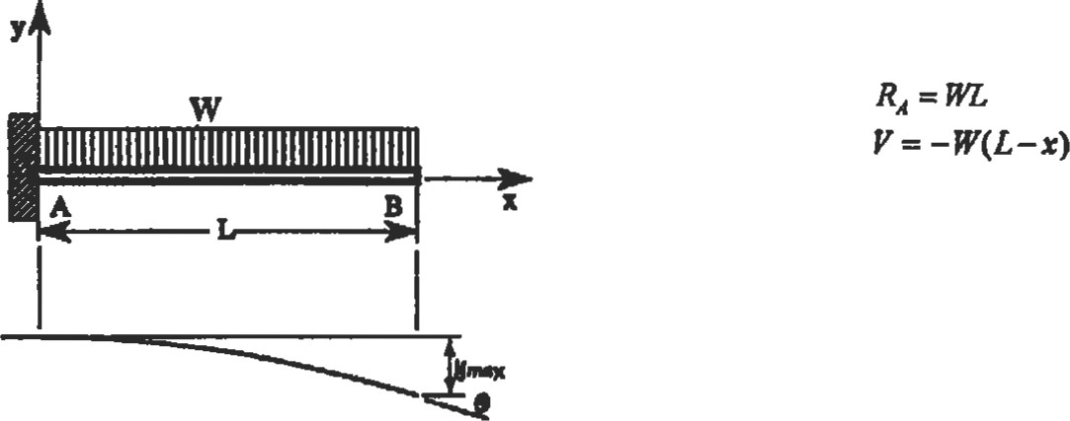

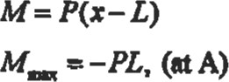

(AtoB)

M=o, (BtoC)

M =-Pa, (nA)

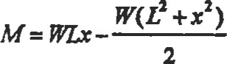

M— — (at A)

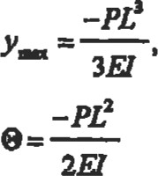(8tx—L)

— 3a2L-a3), (atB)

e--——, (Bt0C)

, (atB)

8E1

6FJ

1. Cantilever- End Moment

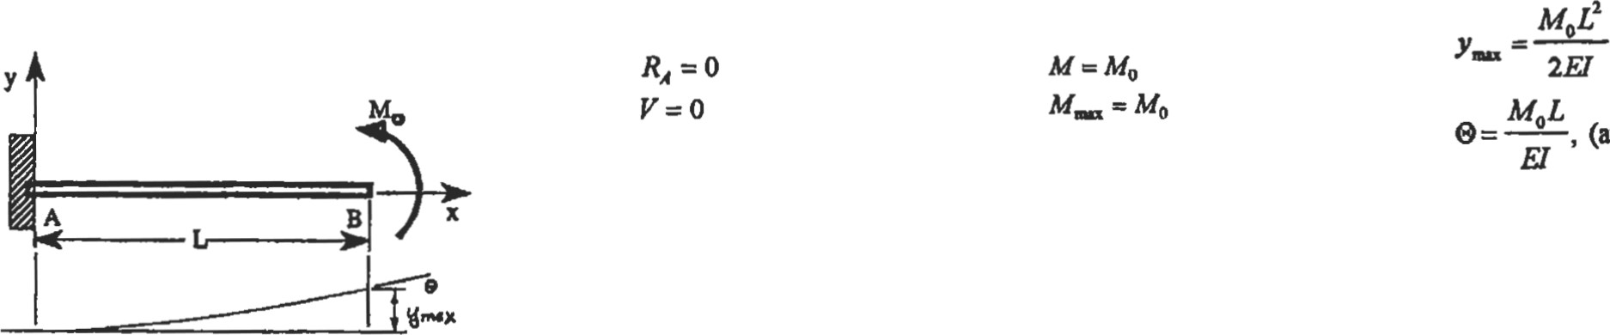, (atB)

1. End Supports - Intermediate Load

|  |
| --- |
| (L2-b2) |

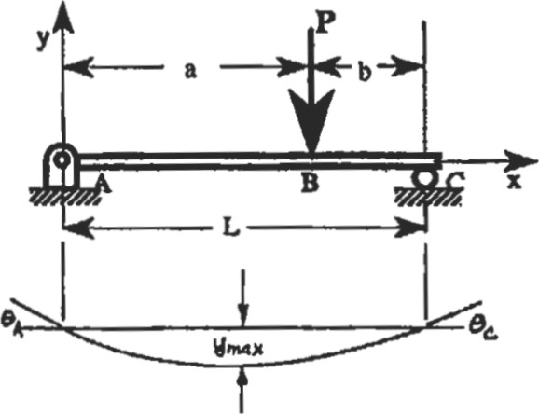-Pb(L2 -b2)Y2

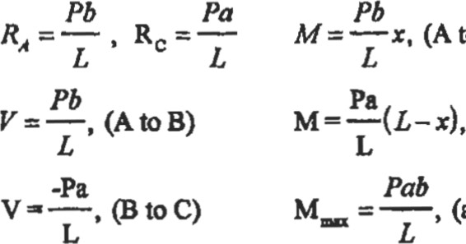

(atB)

* 1. toB) 96LFJ  at x =

-Pb(L2 -b2)

* 1. to C)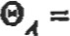

6LEJ pa(L2 -d)

6LEi

1. End Supports • Uniform Load

-5WL4

 (atL/2) 384E1

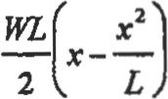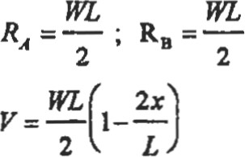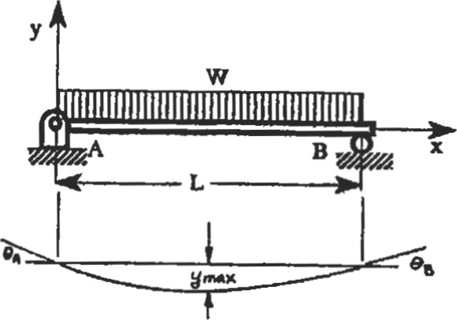 =——, (atL/2) 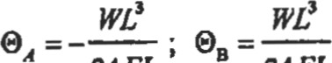24E1 24E1

1. One End Supported and One End Fixed - Intermediate Load

P 3b2 L-b3

|  |
| --- |
|  |
| 4E1 |

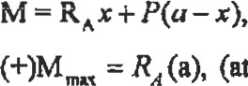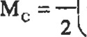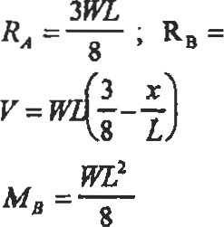M=RA (AtoB) = -.0098— Rc =P-RA

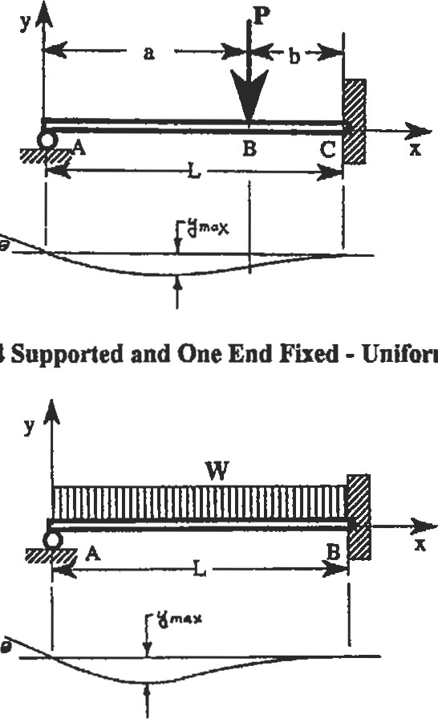

8.

One

End

Uniform

Load

(B to C) v = RA, (AtoB)(atB when b =.586L).

= RA (ut B when a =.366L)

V=RA-P, (B toc)

(-)M = -Mc , (when b -.4227L)— P b'+2bL2 -3b2 LL

WL 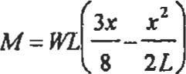

= -.0054—-

9WL2

, (atx—-3L/8) (for x =.4215L).

128

(  -—, (atB) 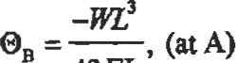48E1

|  |  |  |  |
| --- | --- | --- | --- |
| 9. Both Ends Fixed - Intermediate Load | Pb2 | -pab2 | Ifa>b |

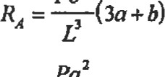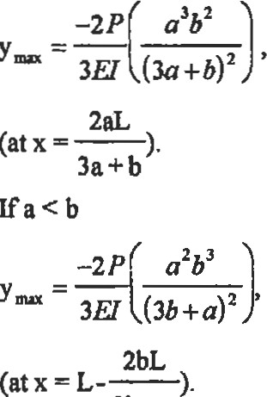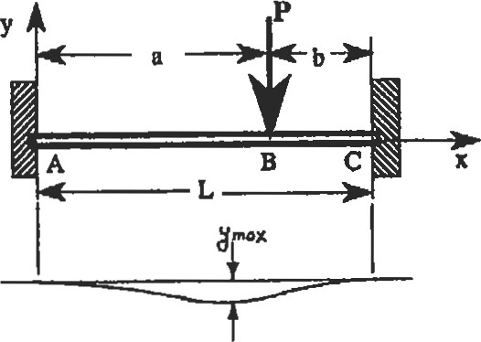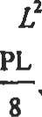+ RAZ,

—Pab2

RC = —(3b+a) + RAX P(x-a), (BtoC)

v = RA, (AtoB) —Pab2

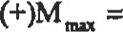 +R,a, (atB) V=RA-P, (Bt0C)

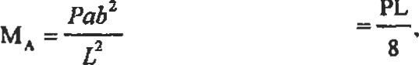(for a = L/ 2)

Pa2b (-)MDA = MA = -.1481PL, (fora = L/ 3)

(-)MDLX = Mc = -.1481PL, (fora=2L/3) 3b+a

10. Both Ends Fixed - Uniform Load

' (for x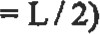

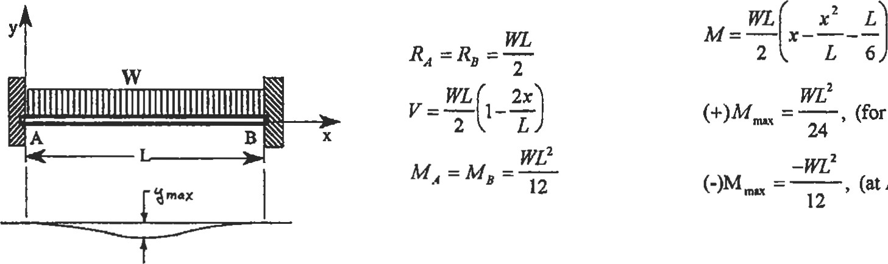

(for

x

=

L

/

2)

A

and

B)

 384E]

##### REFERENCES

1. Dept. of Defense and Federal Aviation Administraüon, Mil-Hdbk-5D, Metallic Materials and Elementsfor Aerospace Vehicle Structures, Vol. 1—2, Philadelphia: Naval Publications and Forms Center, 1983.
2. Aerospace Structural Metals HanÖook, Vol. 1—5, 1994 ed. W. Brown Jr., H. Mindlin, and C. Y. Ho (Eds.). West Lafayette, m: CNDAS / USAF CRDA Handbooks operations Purdue University.
3. Wang, C., Applied Elasticity. New York: McGraw-Hill Book co., 1953, pp. 30-31.
4. Young, W. C., Roark's Formulasfor Stress and Strain, 6th Ed. New York: McGraw-Hill Book co., 1989.
5. Hsu, T. H., Stress and Strain Data Hmdbook Houston: Gulf Publishing co., 1986, pp. 364-366.
6. Seely, F. B. and Smith, J. 0., Advanced Mechanics of Materials, 2nd Ed. New York: John Wiley & Sons, Inc., 1952, p. 415.
7. Peterson, R. E., Stress Concentration Factors. New York: John Wiley & Sons, Inc., 1974.
8. Hsu, T. H., Stuctural Engineering & Applied Mechanics Data Handbook, Volume 1: Beams. Houston: Gulf Publishing Co., 1988.
9. Higdon, A., Ohisen, E. H., stiles, W. B., and Weese, J. A., Mechanics of Materials, 2nd Ed. New York: John WIIey & Sons, Inc., 1967, p. 236.
10. Perry, D. J. and Azar, J. J., Aircraft Structures, 2nd Ed. New York: McGraw-Hill Book co., 1982, p. 313.
11. Shigley, J. E., Mechanical Engineering Design, 3rd Ed. New York: McGraw-Hill Book co., 1977, p. 208.
12. Gleason Works, Gleason Curvic@ Coupling Design Manual. Rochester, NY: Gleason Works, 1973.
13. Machine Design 1993 Basics of Design Engineering Reference Volume, vol. 65, No. 13, June 1993, p. 271.
14. Dann, R. T. "How Much Preload for Fasteners?" Machine Design, Aug. 21, 1975, pp. 66—69.
15. Franco, P. R. "Are Your Fasteners Really Reliable?" Machine Design, Dec. 10, 1992, pp.66-70.
16. MacGregor, C. W. and Symonds, J. "Mechanical Properties of Materials" in Marks ' Standard Handbookfor Mechanical Engineers, 8th ed. T. Baumeister, E. A. Avallone, and T. Baumeister HI (Eds.). New York: McGraw-Hi11 Book co., 1978, pp. 5-11.

|  |  |  |  |  |  |
| --- | --- | --- | --- | --- | --- |
| Introduction | 330 | Inspection Techniques | | | 345 |
| Stages of Faågue | 330 | Fluorescent Penetrant Inspection (FPI) | | | 345 |
| Design Approaches to Fatigue | 331 | Magnetic Particle Inspection (MPI) | | | 345 |
| Crack Iniüadon Analysis | 331 | Radiography | | | 345 |
| Residual Stresses | 332 | Ulü•asonic Inspection | |  | 346 |
| Notches | 332 | Eddy-Cunent Inspction | |  | 347 |
| Real World Loadings | 335 | of Failed Parts | |  | 347 |
| Temperature Interpolation | 337 | Nonmetallic Materials | |  | 348 |
| Material Scatter | 338 | Fatigue Testing |  |  | 349 |
| Estimating Fatigue Properties | 338 | Liability Issues |  |  | 350 |
| Crack Propagation Analysis  K-—The Stress Intensity Factor  Crack Propagation Calculations  Creep Crack Growth | 338  339  342 | References. |  | | 350 |

### Fatigue

J. Edward Pope, Ph.D., Senior Project Engineer, Allison Advanced Development Company

#### INTRODUCTION

Fatigue is the failure of a component due to repeated applications of load, which are referred to as cycles. An example of fatigue failure can be generated using a paper clip. Bending it back and forth will cause failure in only a few cycles. It has been estimated that up to 90% of all designrelated failures are due to fatigue. This is because most design problems are worked out in the development stage of a product, but fatigue problems may not appear until many cycles have been applied. By this time, the product may already be in service.

In the 1840s, the railroad industry pushed the limits of engineering design, much as the aerospace industry does today. It was noted by those in the field that axles on railroad cars failed after repeated loadings. At this time, the concept of ultimate stress was well understood, but this type of failure was clearly something new and puzzling. The phenomenon was termed fatigue because it appeared that the material simply became tired and failed. August Wohler, a German railroad engineer, performed the first thorough investigation of fatigue in the 1850s and 1860s. He showed that fatigue life was related to the applied load.

The basic principles discovered by Wohler are still valid today, although much additional knowledge has been gained. Many of these lessons have been learned the hard way. Some of the more notable fatigue problems include:

* World War Il libefiy ships, which sometimes broke in half. • Two Comet aircraft, the world's first passenger jet, lost due to fatigue failure which originated at the corner of a window.

|  |
| --- |
| STAGES OF FATIGUE |

* Several USAF F-l I l aircraft, lost in the 1960s due to the unforgiving nature of titanium.

Fatigue failure generally consists of three stages (see Figure l):

I. Crack initiation (may be multiple initiation sites)

1. Stable crack growth
2. Unstable crack growth (fast fracture)

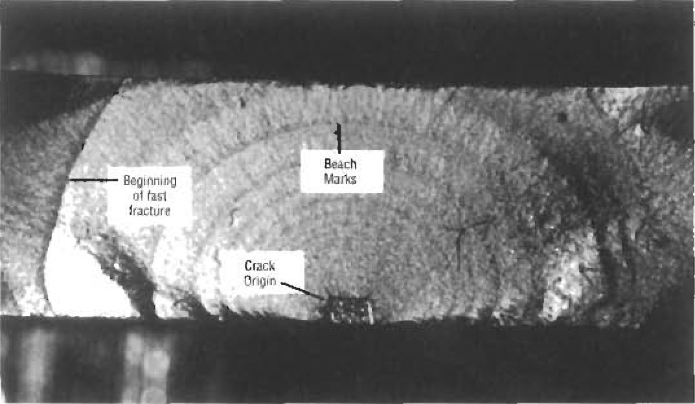

Figure 1 . Typical fatigue fracture surface. (Courtesy of

A. E Grandt, Jr. )

Although cracks may be created during manufacturing, they generally do not initiate until after a considerable period of usage. Cracks commonly form at metallurgical defects such as voids or inclusions, or at design features such as fillets, screw threads, or bolt holes. A crack can initiate at any highly stressed location.

After a crack has initiated, it will grow for a while in a stable manner. During this stage, the crack will grow a very short distance during each load cycle. This creates patterns known as "beach marks" because they resemble the patterns left in sand by wave action along a beach. As the crack becomes larger, it usually grows at an increasingly rapid rate.

Final failure occurs very quickly. For small components, it happens when the cross-sectional area has been reduced by the crack so much that the applied stress exceeds the ultimate strength of the material. In larger components, fast fracture occurs when the fracture toughness of the material has been exceeded, even though the remaining cross-sectional area is still large enough to keep the applied stress well below the ultimate strength. This will be explained in the section on crack propagation.

#### DESIGN APPROACHES TO FATIGUE

|  |  |
| --- | --- |
| Fatigue is dealt with in different ways, depending on the application:   1. Infinite life design 2. Safe life design 3. Fail safe design 4. Damage tolerant design   In Wohler's original work on railroad axles, he noted that there is a st-ess below which failure will not occur. This stress level is referred to as the fatigue strength or endurance limit. The simplest and most conservative design approach is to keep the stress below this level and is called infinite life design. For some applications, the cycles accumulate so rapidly that this is virtually the only approach. A gear tooth undergoes one cycle each time it meshes with another gear. If the gear rotates at 4,000 rpm, each tooth will experience nearly a quarter cycles during every hour of operation. Vibratory stresses must also be kept below the endurance limit, since these cycles mount up even faster. This type of loading is referred to as high cyclefatigue, or HCF. The term low cyclefatigue, or LCF, is used to describe applications in which the load is applied more slowly, such as in steam turbines. One cycle is applied when the engine is started and stopped, and the engine may run continuously for months at a time.  In the aerospace business, the excessive weight required to design for infinite life is prohibitive. With the safe life design approach, a life is calculated which will cause a small | percentage of the parts (typically I out of 10,000) to initiate a crack. All parts are removed from service when they reach the desiY1 life, even though the vast majority show no evidence of cracking. approach has been used in the aircraft and turbine engine industries. When the design life is calculated, the analysis must account for significant scatter in the applied loads and fatigue properties of the materials.  In some instances, design precautions can be taken such that the failure of a particular component will not be catasu•ophic. This is known asfail safe design. After failure, the component can be replaced. This often involves redundant systems and multiple load paths. An obvious example of this approach is a multi-engine plane. If one engine fails, the others can still provide power to keep the plane flying. In the design of the aircraft and engine, it is necessary to ensure that debris from the failure of one engine will not take out vital systems. In one airline accident, fragments from a turbine wheel burst in one engine knocked out all three hydraulic systems which were placed closely together at one point along the fuselage.  Damage tolerant design assumes that newly manufactured parts may have cracks already in them. The design life is based on the crack growth life of the largest crack that may escape detection during inspection. This approach has been championed by the U.S. Air Force for many years. It puts a greater emphasis on the crack growth properties of the material, while the safe life approach emphasizes the crack initiation properties. It also requires good inspection capability. |

#### CRACK INITIATION ANALYSIS

The first step in calculating crack intitiation life is to determine the stresses in a component. Life is related to the range of stress, as shown in Figure 2 (Life can also be related to su•ain range). These are known as S-N curves, and are plotted on log-log paper. While the is the major factor in determining life, the ratio of the minimum to the maximum stress, also known as the R ratio, is a secondary factor. For a given alternating stress, increasing the R ratio will decrease the crack initiation life. For example, a component with stresses varying from 50 to 100 ksi will have a lower life than a component with varying from O to 50 ksi.

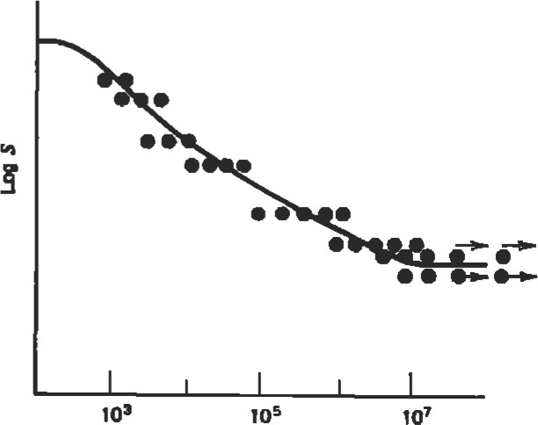

Figure 2. Typical S-N (log stress versus log life) plot [14].

(Reprinted with permission of John Wiley & Sons, Inc.)

##### Residual Stresses

|  |
| --- |
| d |
|
| Depth below surface |

|  |  |
| --- | --- |
| may be exposed to a compressive sn•ess that is large enough to cause yielding, leaving a tensile residual stress. Tensile residual stresses increase the R ratio, and therefore lower crack initiation life. | Figure 3. Typical distribution of residual stress under a shot-peened surface [14]. (Reprinted with pennissjon of John Wiley & Sons, Inc.) |

The designer can sometimes use the R ratio effect to his advantage. Surface ueaünents such as shot-peening and carburizing create residual stresses. Residual stresses are o sometimes referred to as self-stresses. Figure 3 shows how the residual sffess varies below the surface. One seldom gets something for nothing, and residual stresses are no exception. Although the stress at the surface is significantly compressive, it is counterbalanced by tensile stress below the surface. Fortunately, this condition is generally a very good trade because most cracks iniüate at the surface.

Residual stresses can also Educe crack initiation life. Im- 8 proper machining, such as grinding burns, can cause large tensile residual su•esses. While in service, a component

##### Notches

In most cases, cracks initiate at some kind of notch or stress concentrator. Typical examples include:

* Fillets
* Bolt holes
* Splines
* Fitted assemblies
* Keyways

Figure 4 shows how the negative effects of notches can be lessened. These strategies can be summed up as follows:

* Allow the stress to flow smoothly through the component (think of stresses as flowing water).
* Provide generous fillets and avoid sharp comers.

' Increase the cross-section where the notch occurs. The sffess concentration factor will be just as high, but the nominals tress it is applied to will be lowered.

The first example in 4 may seem strange at first. How can the stress concentration effect of a hole be lowered by drilling more holes? The two smaller holes provide for a smoother flow of su•ess around the larger hole. Figure 5 shows that this could significantly lower the stress concentration factor. Because, as a rule of thumb, a 10% decrease in sü•ess doubles the crack initiation life, this could lead to a dramatic improvement in the durability of the component. A similar effect could be achieved by creaüng an elliptical hole instead of a round one. It should be pointed out that neither strategy should be applied unless the single round hole results in insufficient crack initiation life. Extra holes mean extra expense, and no one wants to drill ellipücally shaped holes. The best design is the one that meets the criteria at the lowest cost. Keep the design simple whenever possible.

Fatlgue Notch Factor

The stress concentraüon factor is normally represented by KC and relates the peak stress to the nominal stress:

Opeak = KtOnominal

For crack initiation life calculations, the fatigue notch factor (Kf) is applied to the nominal stress rather than the sü•ess concenu•ation factor. These two factors are related by the equation:



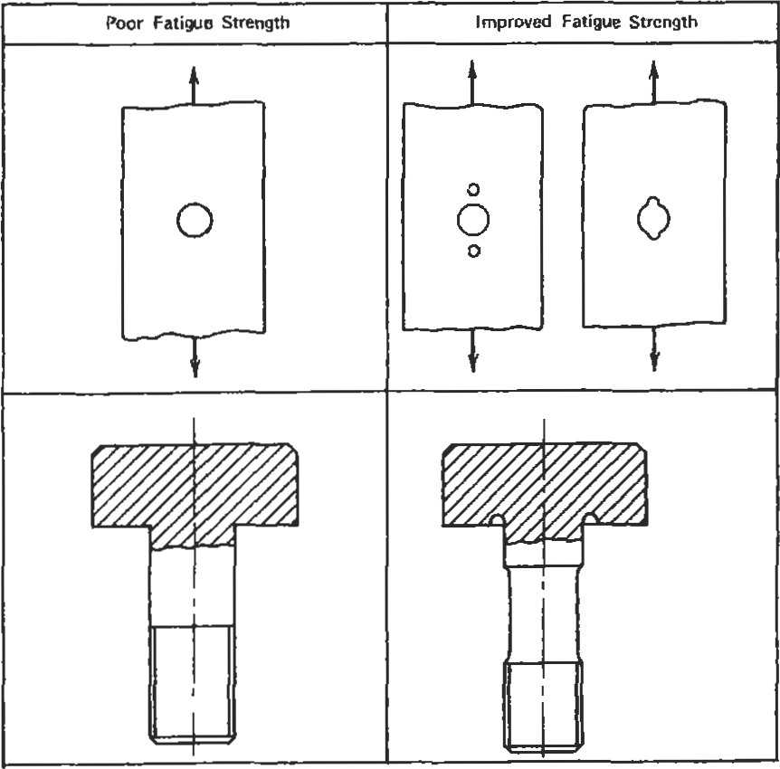Figure 4. Good and bad design practices [15].

|  |  |
| --- | --- |
| Poor Fatigue Strength | Improved Fatigue Strength |
| Shoulders  Sharp corners | collar  fillet  radius  fillet  fitted  Undercut  radiused  fillets  Stres—  relieving  grooves |
| Holes | Enlarged section at hole    Stress—relieving grooves |
| Grooves | Stress—relieving grooves |

Figure 4. (Continued)

|  |  |
| --- | --- |
|  |  |
| Fitted Assemblies    Wheel, gear, etc. | Generous radius  Increase in Grooves in journal size shaft    Fillets on Grooves in hub hub |
| Keyways    Sharp corners | Increased shaft size |

Figure 4. (Continued)

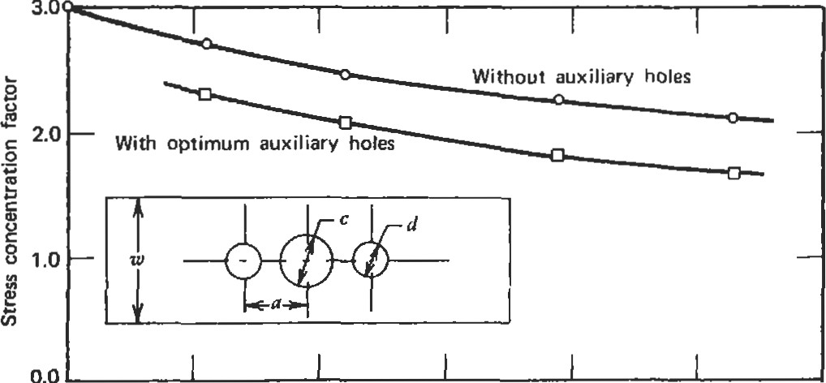

0.0 0.1 0.2 0.3 0.4 0.5 0.6

Central hole diameter—to—plate width ratio, c/u Figure 5. Stress concentration factors with and without auxiliary holes [16]. (Reprinted with permission of Society for Experimental Mechanics.)

##### 3M

The notch sensitivity factor "q" is a material property which varies with temperature. Its value ranges from I (fully notch sensitive) to O (notch insensitive). The value of q should be assumed to be 'l if it is not known. This will give a conservative estimate of crack iniüation life.

Localized Yielding

Cracks generally initiate at a notch where there is some localized plastic yielding. Typically, the designer has only elastic from a finite element model. Fortunately, elastic sü•esses are sufficient to make a good approximation of the true stresses as long as the yielding is localized. There are two methods for making this approximation:

* Neuber method
* Glinka method

Figure 6 graphically compares the two methods. Each diagram shows a plot of stress versus strain. For both methods, the area under the elastic stress-strain curve (Al) is calculated. With the Neuber method [1] a point on the üue curve is found such that the diangular area A2 equals Al. With the Glinka method [2], a point on the true stress-strain curveis found such that the area under that curve (A3) equals Al. The Neuber method is more commonly used in indusüy, and has an advantage in that it can

— Elastically Calculated Stress

* 1. Stress

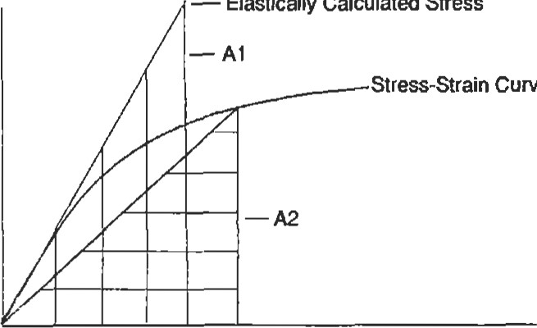

Curve

Strain

— Elastically Calculated Stress

* 1. Stress

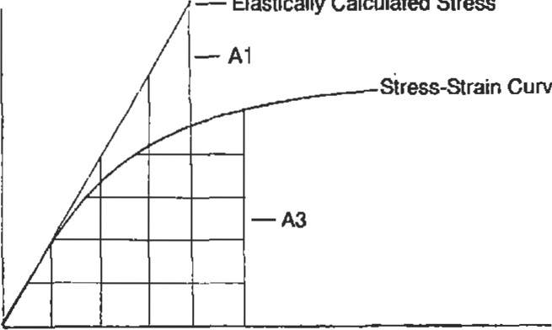

Curve

Strain

Figure 6. Neuber (A) and Glinka (B) methods of computing true stresses from elastically calculated variables.

be solved directly. The Glinka method is slightly more accurate, but the calculation is a little more diffcult because the area under stress sü•ain must be integrated. Both methods requi.re an iterative solution. The should always remember that these methods are limited to cases where diere is only localized yielding. For simations involving large-scale yielding, plastic finite element analysis is required. The Ramberg-Osgood equation can be used to define the relationship between true stress and true sffain:

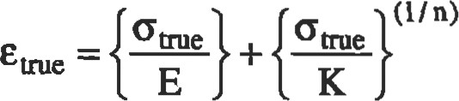

where: emxe = üue strain

= true stress

E = modulus of elasticity K = monotonic strength coefficient n = strain hardening exponent

The pararneters K and n have different values for the iniüal monotonic loading and the stabilized cyclic loading. The monotonic and cyclic behaviors may be very different, as Figure 7 illustrates. In general, if the raüo of the ultimate strength to the .2% yield strength is high material will cyclically harden Waspaloy in Figure 7). If the raüo of the ultimate strength to the .2% yield strength is low (<1.2), the material will cyclically soften (SAE 4340 in Figure 7) [3]. For most crack initiation analysis, adequate results can be obtained by using the monotonic K and n on the initial loading, and the cyclic values for all subsequent loadings. The transitional behavior from monotonic to cyclic is seldom significant.

|  |  |  |  |  |  |  |  |
| --- | --- | --- | --- | --- | --- | --- | --- |
| in./in. | | |  | | --- | | Cyclic O  Monotonic | | | |  | | --- | | Cyclic  Monotonic  Man-Ten Steel | | |
| |  | | --- | | Cyclic  Monotonic  4340  BHN) | | | |  | | --- | | Cyclic  %notonic | | |  | |

Figure 7. Typical monotonic and cyclic stress-strain curves. (Copyright American Society for Testing and Materials. Reprinted with permission.)

|  |
| --- |
| Real World Loadings |

For tensile bars, the cycles which are applied are quite obvious. In real world applications, the loading can be quite complex. For fatigue analysis, the loading is assumed to be a combination of cycles. The largest one is referred to as the major cycle, and all others are minor cycles.

Cycle Counting

Consider Figure 8(A), which represents the stresses that might occur at a parücular location on a compressor wheel of a gas turbine engine during a typical mission. It is obvious that the major cycle will have a range from O to 50 ksi. However, the is not monotonically increased to 50 ksi and then monotonically decreased back to O ksi. This erratic path between start-up and shut-down contains several minor cycles. A method is required to determine the cyclic content of this mission. The best known method is rainflow counting, which was named because it resem-

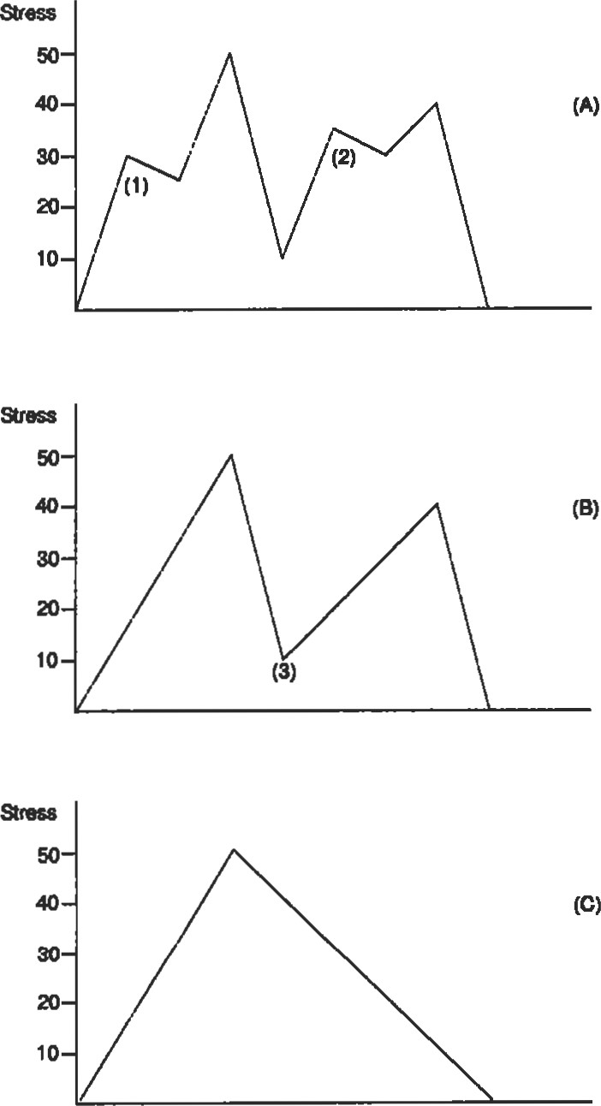

Figure 8. Evaluating cyclic content of a mission by the range-pair method.

bles the flow of rainwater off pagoda roofs in Japan. The simplest method to learn is the range-pair method, which gives the same result. To use the range-pair method, start by counting the small cycles, such as the 25—30 ksi (1) and 30—35 ksi (2) in A of Figure 8. After these are eliminated, the mission looks like B. After the 10-40 ksi (3) cycle is counted and removed, all that remains is the 0—50 ksi major cycle in C. Therefore, the final result is:

(1) 0—50 ksi major cycle:

(1) 10—40 ksi minor cycle:

(1) 30—35 ksi minor cycle: (l) 25—30 ksi minor cycle.

No matter what method is used to count cycles, it is important to get the major cycle correct. Fatigue is nonlinear, one 0—50 ksi cycle is far more damaging than a 0—25 ksi plus a 25—50 ksi cycle.

It should be pointed out that the cycle counting should always be done on stress. Sometimes in the gas turbine indusüy, cycle counting is based on power setting or rotational speed. This can lead to errors if is not a linear function of these variables.

The analyst should not be worried if different parts that are subjected to the same mission wind up having very different cyclic content. This usually occurs because the maximum and minimum stress values occur at different points in the mission. For one component, the extreme stress values may be due to thermal gradients which occur during ffansient operation. For another component, they may be due to rotational speed and occur when rpm is at a maximum or minimum. Different locations of the same component can also have different cyclic content.

Life Calculations with Minor Cycles

Once the cyclic content has been deterrnined, the crack initiation life of this mixture must be determined. This is done with Miner's Rule [4], which is based on the idea that a certain amount of damage is done on each cycle. The damage is the reciprocal of the crack initiation life. When the sum of the damage for all applied cycles equals one, crack initiation is assumed to occur. For example: During each mission, a component is subjected to:

1 major cycle of 0—100 ksi

15 minor cycles of 0—85 ksi

If the crack initiation life is:

10,000 cycles at 0—100 ksi

100,000 cycles at 0—85 ksi

then the damage done during each mission is:

1/10,000 + 15/100,000 = . 00025

Therefore, the component will last ll. 00025 or 4,000 missions. Conservatism can be added to this calculation by assuming that failure occurs at values lower than one.

There are numerous arücles in technical journals pointing out cases where Miner's Rule is inadequate. Most of these cases involve sequence loadings which occur infrequently in real world applications. These are cases where a large cycle is applied for a while, then a smaller cycle is applied until a crack initiates (A of Figure 9). In this case Miner's Rule over estimates the crack initiation life. For cases where the smaller cycles are applied first, Miner's Rule underestimates the crack initiation life (B of Figure 9). In most field applications, the applied loading consists of a mission which is repeated until the component is retired from service. Therefore, the smaller cycles are mixed among the larger ones (C of Figure 9). In this case, Miner's Rule is perfectly satisfactory. Keep in mind that the scatter in crack initiation life is quite high. It is considered good correlation when the calculated life is with a factor of two of the actual life. It is a waste of time to attempt overly precise calculations. Fatigue lives should never be considered more than ballpark estimates.

Multiaxial Stresses

For applications involving uniaxial loading, the value to use for stress is obvious. In many applications, a multiaxial state of stress occurs. To determine the maximum stress point in a mission, calculate the equivalent at the critical points. Since equivalent stress is always a positive value, it must be determined whether each is a tensile or compressive sffess. If the first invariant (sum of principal stresses) is posiüve, then the equivalent stress is considered to be tensile. Otherwise, it is assumed to be compressive.

When determining the stress range between two conditions, it should be calculated from the ranges of the individual stress components [5]:

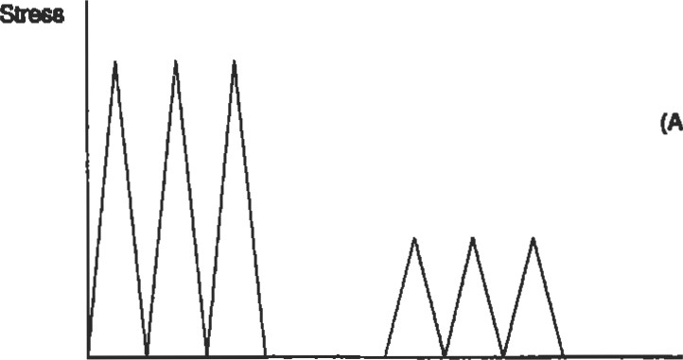

(A)

Strew

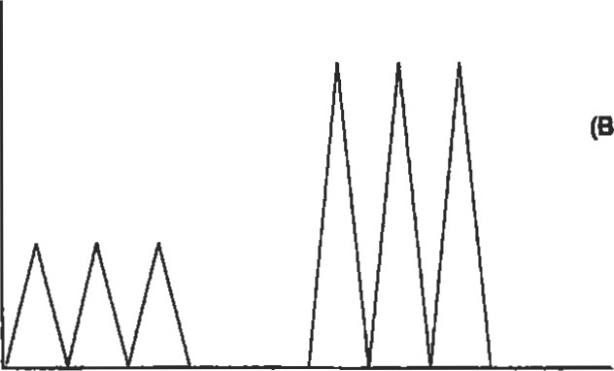

(B)

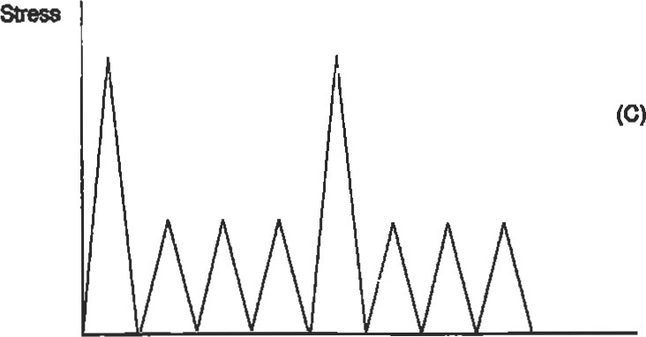

Figure 9, Miner's Rule will overestimate crack initiation life in case A, underestimate life in case B, and provide a reasonable estimate in case C.

|  |
| --- |
| .5 x {{Aox — Aoy}2 + {Aoy — AGz} 2  + - + + ATy2z + ATA}} |

Ao ¯

eq

where: AGR = ox (at condition l) — ox (at condition 2) Aoy = ox (at condition 1) — oy (at condition 2) Aoz = ox (at condiüon 1) — (at condition 2)

AT = T xy (at condiüon l) — Txy (at condiüon 2)

AT = Tyz (at condiüon 1) — (Tyz (at condition 2)

ATA = Tzx (at condition 1) — Tzx (at condition 2) is calculated by:

smin = S eq

If this results in a cycle with a compressive mean stress, then:



seq

Smin = — .5 x Aoeq

These values can then be used to calculate life based on uniaxial test data.

Vlbratory Süesses

In many applicadons, components are subjected to vibratory loading. This type of loading is referred to as high cycle fatigue, or HCF. Since the number of applied cycles mounts very rapidly (a component vibrating at 1,000 Hertz will accumulate 3. 6 million cycles in one hour of operation), the vibratory sfress must be less than the endurance limit, or failure will occur. Testing to  the endurance limit is expensive, and is usually only done at an R ratio of zero. If the endurance limit at R = O is not available, it can be estimated to be 45% of the ulümate sffength of the material. In field usage, the vibratory stress generally occurs on top of a steady-state stress.

To estimate the endurance limit at R ratios above zero, the Goodman Diagram is used. This requires only two parameters:

Figure 10  how the Goodman Diagram is constructed. The ultimate strength is plotted along the X axis (A), while the endurance limit is plotted on the Y axis (B). These points are then connected by a straight line (C). A component should not fail as long as the combination of vibratory and constant sü•ess is below this line. Points above this line will have less than infinite crack initiation life. There are to the Goodman Diagram, but most of these are refinements of the line connecüng points A and B in figure 10. The Goodman Diagram is most commonly used in indusü•y, and is a little more conservative than the others.

Stress

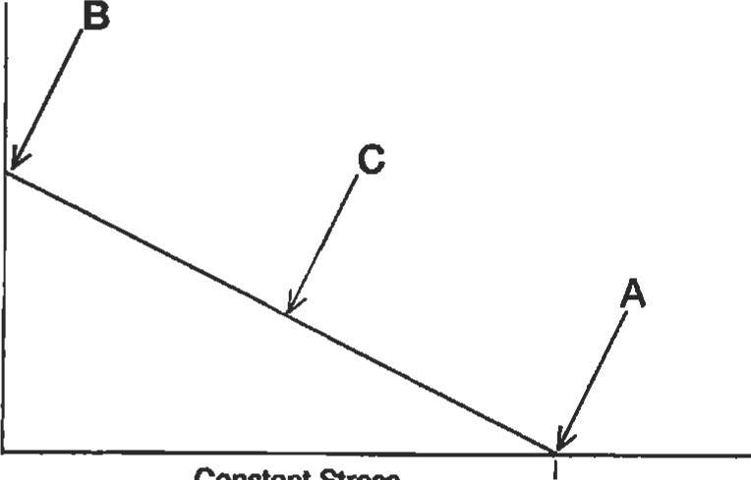

Constant

Stres

Endurance — Limit

|  |  |
| --- | --- |
| • Endurance limit at R = O Ultimate tensile strength | Figure 10. Goodman diagram. |
| Temperature Interpolation |  |

Ultimate

Fatigue testing is done at discrete temperatures, and the operating temperature of the component will fall within the range of test values. To interpolate between S-N curves:

• Calculate fatigue life at both temperatures.

' Interpolate between temperatures based on log of life.

log(Nt) = log(Ntl) + {log(No) - - tl)}

where: t = component temperature at critical ti = lower Walker LCF model temperature t2 = higher Walker LCF model temperature Nt = component life:

Ntl = life at ti

###### No = life at t2

If fatigue data is available at only one temperature, it can be scaled to another temperature by using the ratio of the ultimate strengths at the two temperatures.

Callowable (T2 ) = Callowable (Tl ) X

If it is necessary to use this method to scale from a lower to a higher temperature, the result should be used with exü•eme caution.

|  |  |
| --- | --- |
| Material Scatter |  |
| Since designers want to ensure that only a very small fraction of their components fail, material scatter must be taken into account. This is generally done by specifying that —30 material should be used. Only one out of about 800 specimens should have fatigue properties below this level. Three rules of thumb are commonly used to account for material scatter and estimate minimum material properties: | 1. The simplest is to divide the calculated life by a factor of 3. 2. For cast materials, use 70% of the calculated allowable stress. 3. For forged materials, use 85% of the calculated alIowable stress. |
| Estimating Fatigue Properties |  |

Often, an engineer has to make preliminary design decisions when no fatigue data is available. Fortunately, the Modified Universal Slopes Equation [61 allows rough life estimates to be made based only on values from tensile bar data:

-.53 .82 Ae = .0266D.155 Cult Nf 56 +1.17 cult Nf 09

where: Ae = total range

Nf = fatigue life

D = ductility

= ultimate tensile sffength

The ductility and ultimate strength values used in this equation should be at the temperature for which the fatigue life will be calculated. This equation should be used only in the sub-creep temperature range (up to about h the absolute melting temperature of the material). The original Universal Slopes Equation was developed by Manson and Hirschberg in 1965. The modified version shown here is slightly better. Both models were compared with test data from 47 different engineering materials, which included steel, aluminum, and titanium alloys. The modified version was shown to be slightly better, although the difference is quite small [6]. The life estimates from this equation were within a factor of 10 of the lives for the test specimens. (Ihis correlaüon is better than it might first appear, since the ratio of average life to minimum life is approximately 3.)

|  |
| --- |
| CRACK PROPAGATION ANALYSIS  Most of the crack growth analysis that is commonly performed in industry is based on linear elasticfracture mechanics a-EFM). As a general rule, LEFM is considered to be valid as long as the plastic zone in front of the crack is less than ho the crack lengül. This is adequate for most analyses since components with large amounts of cyclic yielding do not have enough life for practical applications. Mode 1 Bode 11 111 Elasüc-plastic fracture mechanics is quite complex, and is  Figure 11. Crack propagation modes. well beyond the scope of this book.  There are three modes of crack propagation (Figure 11): |

A useful feature of this equation is that it can show the effects of processes or operational factors that alter the ducülity or ultimate sü•engths. Exposure to nuclear radiation reduces ductility, and this model shows the accompanying reduction in fatigue life. The effect of ductility and ultimate strength on fatigue life depends on the life region of interest. Below 1,000 cycles, ductility has the dominant influence upon crack initiation life. For greater lives, ultimate strength is more important.

l. Mode I is relative displacement of the crack surfaces perpendicular to the crack plane, which opens the crack.

1. Mode Il is relative displacement of the crack surfaces in the crack plane and perpendicular to the crack front, which shears the crack.
2. Mode is relative displacement of the crack surfaces in the crack plane and parallel to the crack front, which tears the crack.

Mode I is the most common and the only one considered in this book.

Crack propagation analysis is a relatively new discipline. The U. S. Air Force has mandated its usage to ensure damage tolerance. In a nutshell, USAF requires that crack

* Assumes that new components have cracks which are at the limit of your company's inspection techniques. If a .050-inch crack is the smallest crack you can reliably detect, an initial flaw size of .050 inches must be assumed. Design engineers and inspectors always like to say things like, "We can detect cracks as small as .010 inches long." The crack propagation analyst should always reply with, "What I really need to is the size of the largest crack you might miss."
* Shows that these cracks will not grow to failure until the component has been inspected twice. If the component will be inspected every 1,000 cycles, the analysis must show a crack propagation life of 2,000 cycles.
* Is only required on items which are "fracture critical."

|  |  |
| --- | --- |
| propagation analysis: | cause loss of the aircraft if they should fail. |
| K—The Stress Intensity Factor |  |

"Fracture-critical components are those that would

The stress intensity factor (K) is crucial to fracture mechanics. It is calculated by the formula [7]:



where: o = a = crack length

B = a geometry factor

The parameter K defines the stress field directly ahead of the crack tip, perpendicular to the crack plane (Figure 12).

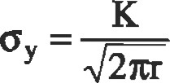

2m

This equation is only valid a short distance ahead of the crack. Two cracks with very different geometries and very different loadings will have similar fields near their crack tips if they have the same intensity factors. The stress intensity factor also determines the behavior of the crack:

* If Kmax exceeds the fracture toughness, fast fracture occurs.
* If AK is less than AEG (threshold suess intensity factor), no crack growth occurs.

' If AK is greater than AKå, but Kmar is less than the fracture toughness, stable crack growth under cyclic loading occurs.

I Load

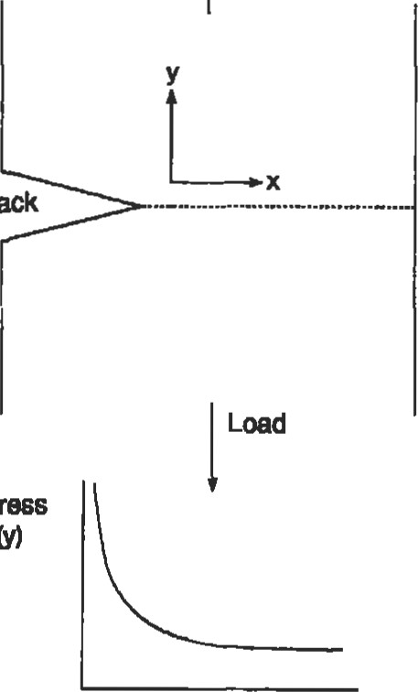

Crack

Stress

Distance Ahead of Crack Tip (x)

Figure 12. Stress distribution ahead of crack tip.

The stress intensity factor K should not be confused with the unrelated sfress concentration factor Kt. The units for K are:

(stress) x (length)'

For the English system, this is typically (kS1) (inches)'. For the metic system, it is typically (mpa) (meters)'. The conversion factor from the metric to the English system is: 1 (mpa) (meters)' = .91 (ksi)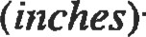

Fast FracWre

As stated earlier, fast fracture will occur when the stress intensity factor exceeds the fracture toughness. Fracture toughness is a material property that is dependent on temperature and component thickness.

Figure 13 shows that decreasing temperature decreases the fracture toughness. This is due to the lower ducülity at lower temperatures. Figure 14 shows that increasing thickness decreases the fracture toughness. This is because thin specimens are subject to plane stress, which allows much more yielding at the crack tip. As specimen is in-

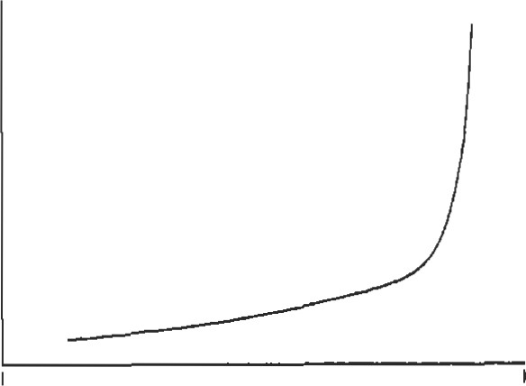Fræture

Toughness

-200 F Room

Temperature

Temperature

Figure 13. Effect of decreasing temperature on fracture toughness.

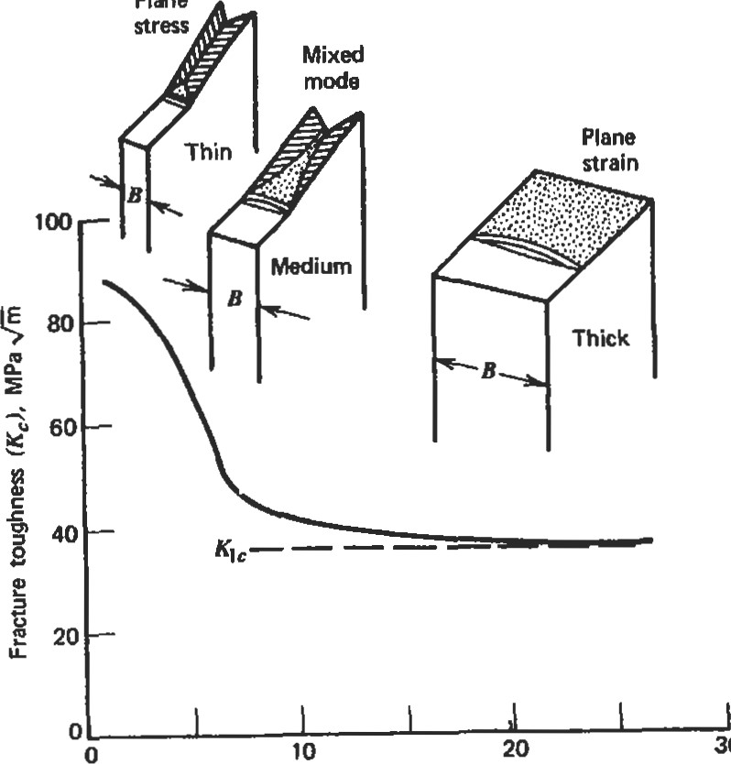

Plane

30

Thickness (B), mm

Figure 14. Effect of specimen thickness on fracture toughness [141. (Reprinted with pemisjon of,bhn Wiley & Sons, Inc.)

creased, it asymptotically approaches a minimum value. This is the value that is quoted as the fracture toughness. The actual fracture toughness for thin specimens may be somewhat geater than KIC.

Figure 15 shows how fracture toughness varies with yield strength for aluminum, titanium, and steels. Note that for all three, alloys which had very high yield strengths had relatively low values of fracture toughness. Also, because ere su•ess intensity factor is a ftmcüon of crack length to the .5 power, reducing the fracture toughness by a factor of 2 will reduce the the critical crack size by a factor of 4. Therefore, a designer who considers specifying an alloy with a high yield stength should realize he may be significantly reducing the crack size. In field service, this could result in sudden failures instead of components being replaced after cracks were discovered.

Threshold Stress Intensity Factor

If the sffess intensity factor range does not exceed the value, dien a crack will not propagate. ASTM defines the threshold value to be where the crack yowth per cycle(da/dn) drops below 3 x 10-9 inches per cycle. Unlike fracture toughness, the threshold stress intensity factor, AKth, is dependent upon the R ratio.

Threshold behavior is very important for components which must endure of cycles. In analysis, it can be used to make very conservative estimates. If the applied is known, a flaw size can be assumed, and the stress intensity factor can be calculated. As long as the threshold value exceeds AK, no crack growth can occur. If the sü•ess

MPa

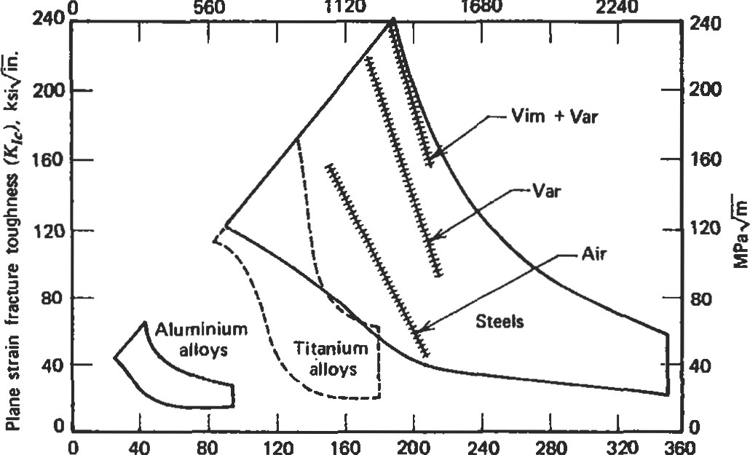

1120

1680

Yield strength ksi

Figure 15. Fracture toughness versus yield strength for various classes of materials [181.

intensity factor range exceeds AKth, then more detailed analysis must be made to determine the number of cycles the component can be expected to last in service.

Sometimes, after many parts have been released for field service, a problem will be discovered in the manufacturing process. The question is then raised, "Do we need to replace these parts immediately, or can we safely wait and replace them during the next overhaul?" Obviously, the first approach is safer, but may be extremely costly. However, if the parts are left in service and fail, the consequences can be devastating. Therefore, any analysis which is done must err on the conservative side. In these instances, the stress intensity factor is often calculated and compared to the AKth.

Estimates of treshold stress inteßity factor. Testing to obtain AKth is quite time-consuming and, consequently, quite expensive. Cracks have to be propagated in a specimen, and then the load is slowly decreased until the crack stops propagating. Fortunately, there are some ranges available for different classes of materials at room temperature. These are shown in Figures 16 through 20. It may be necessary to adjust these values to use them at elevated temperatures, which may be done by scaling the threshold value based on the ratio of Young's modulus. For example, a threshold value for steel is needed at:

* An R ratio of .4
* A temperature of 500 degrees

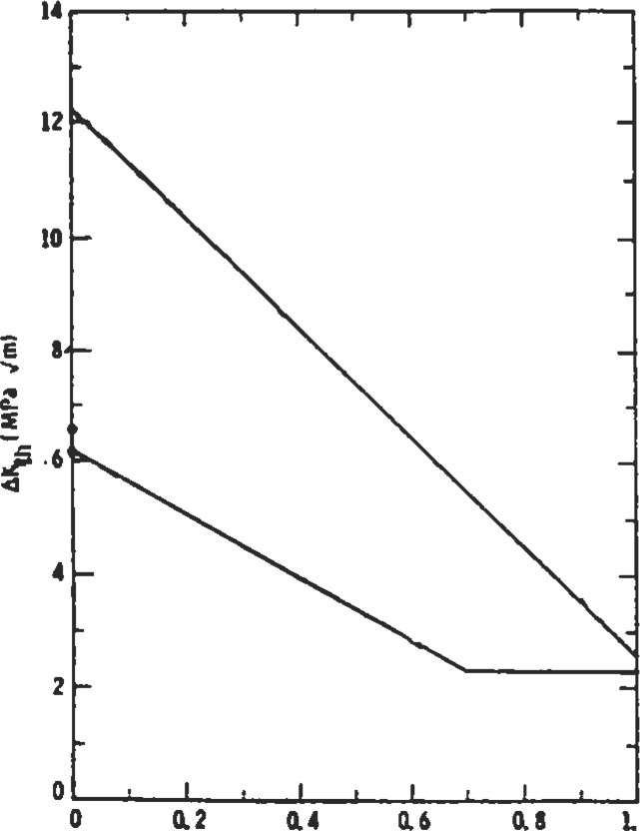

1.0

R-RAio

Figure 16. Relationship between threshold stress intensity range and R ratio in iron alloys [17]. (With permission of Elsevier Science Ltd.)

From Figure 16, the minimum threshold stress intensity factor is 4.0 at room temperature. If Young's modulus is 25 x 106 at 500 degrees and 30 x 106 at room temperature, the minimum stress intensity factor at 500 degrees should be 4.0 x (25/30) = 3.33.

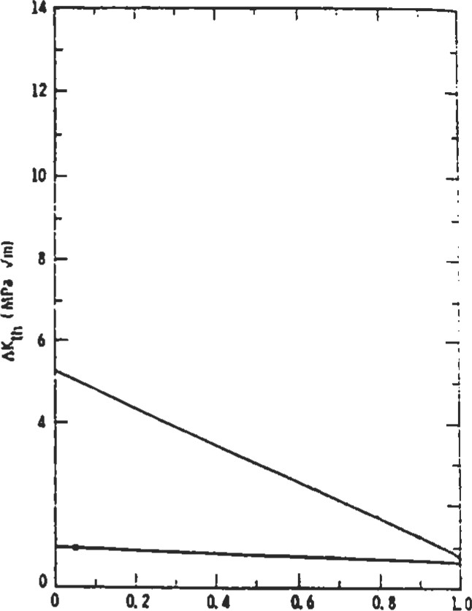

R-rMb

Figure 17. Relationship between threshold stress intensity range and R ratio in aluminum alloys [17]. (With permission of Elsevier Science Ltd.)

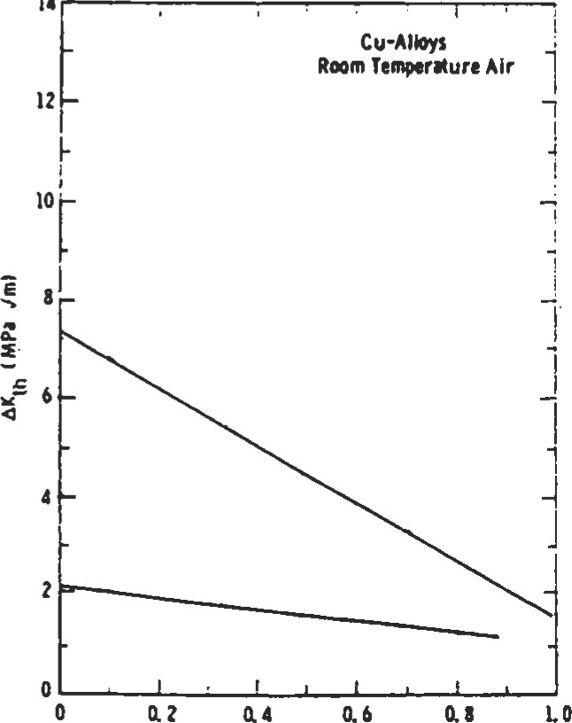

R•rdio

Figure 18. Relationship between threshold stress intensity range and R ratio in copper alloys [17]. (With permission of Elsevier Science Ltd.)

|  |  |  |  |  |
| --- | --- | --- | --- | --- |
| R-ratb 1.0 R -ratio 1. 0  14  0.8  Figure 19. Relationship between threshold stress in- Figure 20. Relationship between threshold stress intensity range and R ratio in nickel alloys [17]. (With per- tensity range and R ratio in titanium alloys [17]. (With per-   |  |  | | --- | --- | | mission of Elsevier Science Ltd.) | mission of Elsevier Science Ltd.) | | Crack Propagation Calculations |  | |

If the stress intensity factor is below the fracture tough-

ness, and the range of the stress intensity factor is greater than the threshold value, the crack will grow in a stable manner. This is often referred to as "Subcritical crack growth." Three approaches are commonly used to relate the crack growth rate to the stress intensity factor (Cn indicates the material constant): ' Paris law [8]:

da

 = (AK)C2

dn

This law assumes that the data can be fit as a straight line on a log-log plot. This usually gives a fair definition of the curve. It usually does not model the crack growth rate well at low and high values of AK.

• Modified Paris law: This model seeks to overcome the limitations of the Paris law by using three sets of coefficients which are used over three ranges of stress intensity factors.

' Hyperbolic sine model: This model strives to use one relationship that is applicable over the entire range of stress intensity factors, and accurately models the crack growth rate at low and high values of AK.

da

log = q sinh + dn

The analyst should realize that because cracks tend to grow at a continually increasing rate, most of the life occurs when the cracks are quite small. Therefore, it is important to accurately model the crack growth rate at small values of AK, but usually not important at near-fracture values. The exponent of the Paris law can be quite useful for determining the effect of a change in stress on crack growth life. Since AK is proportional to the applied stress range, The change in crack growth life may be estimated by:

Life2 = Lifel 

02

If the stress is increased 10%, and the Paris law exponent is 4, the crack growth rate will be increased by (1.10)4, which means it will grow I .46 times faster. Therefore, the crack propagation life will be reduced by a factor of ( 1/1.46) to 68% of its previous value.

Crack growth under cyclic loading for a given material is dependent upon three variables:

1. AK
2. R ratio (Kmin/Kmax)
3. temperature

The crack growth data is typically shown on a log-log plot, such as shown in Figure 21. The crack propagaüon rate increases with increased stress intensity factor range and higher R ratios.

In the absence of more specific data, Barsom [9] recommends using these rather conservative equations:

• Ferritic-pearlitic steels:

da 3 — (in. [cycle) = 3.6 x 10-10 (AK) dn

e Martensitic steels:

da 225 — (in. [cycle) = 6.6 x 10-9 (AK) dn

' Austentitic stainless steels:

da 325 — (in. /cycle) = 3.0 x 10-10 (AK) dn

Stress intensity factor range, AK, ksi F.

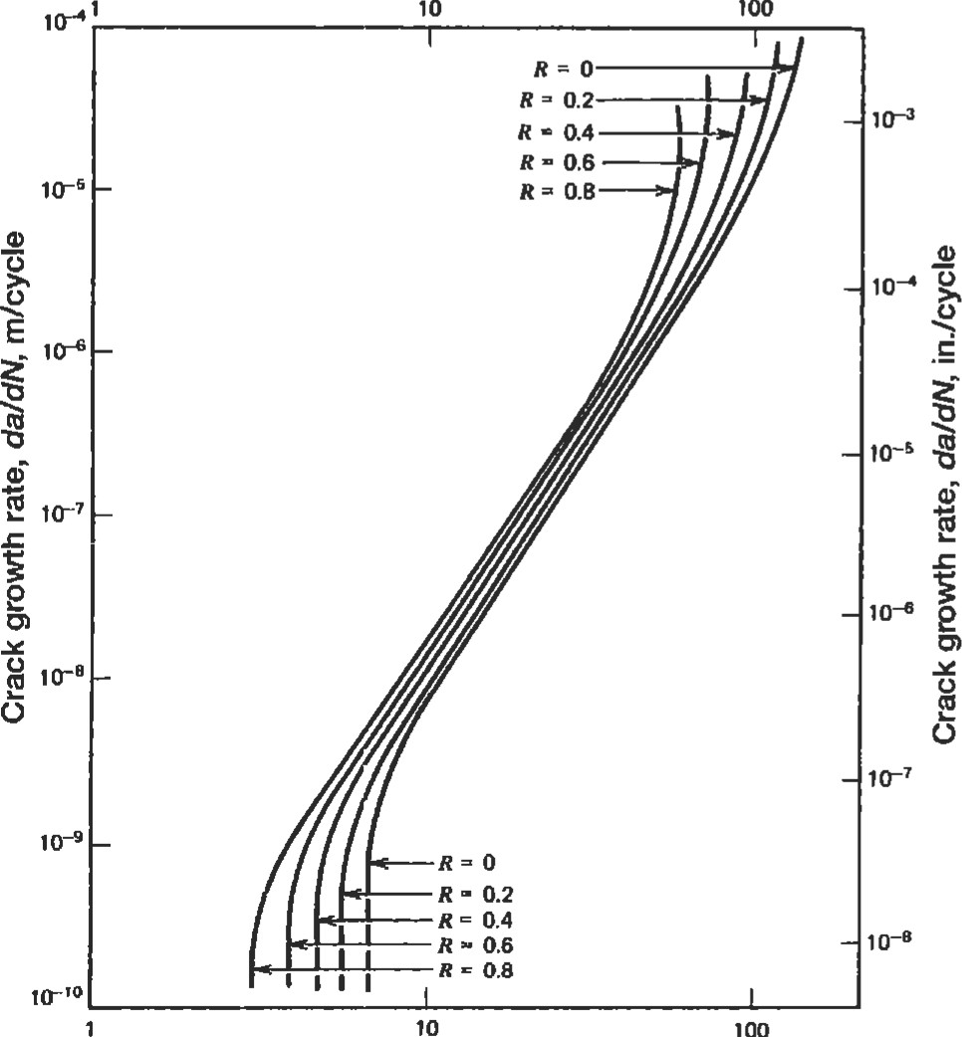

Stress intensity factor range, AK, MPa

Figure 21. Increasing the R ratio increases the crack growth rate [14]. (Reprinted with permission of John Wiley & Sons, Inc.)

When the minimum stress intensity factor is negative, a value of 0 should be used to calculate AK. This is because crack propagation does not occur unless the crack is open at the tip. If the amount of compression is small (R > —.5), then crack growth data at R = O (or .05) may be used with no significant loss in accuracy. If the amount of compression is large, (R < —l), it may be wise to obtain data at the appropriate R ratio. Crack propagation at compressive R ratios is seldom done because the most commonly used test specimen, known as the compact tension (CT) specimen, can only be tested in tension.

Estiution of K

For a fairly uniform sü•ess field, the analyst can K quite easily. Common crack types are shown in Figure

22. Approximate values of ß are:

Crack Type

0.71 corner or surface cracks

1.00 center cracked panels

1.12 through cracks

These values will change when the crack approaches a free surface. Typically, this is not a significant effect until the crack is about 40% of the way through the secüon for comer and surface cracks. It is much more significant for center and through cracks because of the loss of cross-sectional area.

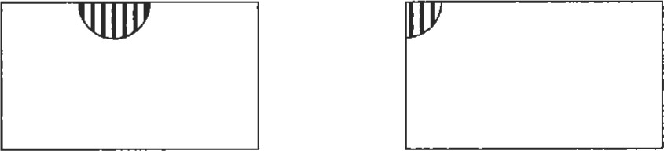

|  |  |
| --- | --- |
| (a) Surface Crack | (b) Corner Crack |



(c) Center Cracked Panel (d) Edge Crack

Figure 22. Common crack types.

#### "4

Computer codes which calculate crack growth use two approaches:

1. The cycle-by-cycle approach is the simplest, but it can be excessively time-consuming for slow-growing cracks. With this method, the stress intensity factors and crack growth for one cycle is calculated. The crack length is then increased by this amount and the process is repeated unül the desired crack length is reached or the fracture toughness is exceeded.
2. With the step method, the number of cycles to grow the crack a certain distance (or step) is calculated after the crack growth rate is determined. This method generally requires significantly fewer iteraüons than the cycle-by-cycle method. Care must be taken in selecting the step size. If the step is too large, accuracy can be lost. If the step is too small, too much computer time will be required. For iniüal crack sizes around .015 inches, .001 makes a good step size.

Any engineer can write a simple computer code to perform these iteraüons. All that is required is a stress intensity factor solution and a relationship between the stress intensity factor range and crack growth rate.

For simple cases, the crack growth life can be calculated by simple For example:

* If da/dn= 2.0 x
* K = .71
* Solving for dn and integrating from initial crack size Ai and final crack size Af gives:

1

5 5 — Ai¯1 5)

##### (-1.5) (2 x 10-12 ) (50 .71)

•For an initial crack size of .015 inches and a final crack size of .050 inches, the crack growth life would be 153,733 cycles.

Plastic Zone Size

Because a crack is assumed to be infinitely sharp, the elastic stresses are always infinite at the tip, but drop off very quickly. Yielding always occurs in the region ahead of the crack tip, which is referred to as the plastic zone. The size of the plastic zone under plane stress conditions can be estimated by:

2

1 AK



27t O

Under plane strain, the plastic zone is approximately onefourth as large. The plastic zone is important for a number of reasons:

* For LEFM calculations to be valid, the crack length should be at least 10 the length of the plastic zone.
* Anyone testing to determine crack growth properties should realize that large and sudden changes in the loads can affect the plastic zone ahead of the crack and significantly alter the crack g•owth properties.

|  |
| --- |
| Creep Crack Growth |

* It is possible with a single overload to sigificantly reduce the crack gowdl rate, or even arrest the crack. 'Ibis can occur because the overload causes addidonal yielding in front of the crack, which inhibits its future vowth through the region. Keep in mind that during the single overload, the crack yew at a geater rate, so it is not tain what the net effect of the overload will be.

Creep crack growth (da]dt) occurs when a tensile is applied for an extended at a high temperature. ms process should not be confused with creep, which is an inelastic straining of material over Creep crack growth can be detected by metallurgical investigation of the crack surfaces:

* When cyclic crack yowth dominates, the crack grows across the grains (transgranular).

' When creep crack growth dominates, the crack grows along the grain boundaries (intergranular).

Several points should be made comparing creep and cyclic

crack growth:

* The rate of creep crack growth is related to the steadystate K, while cyclic crack growth rate is based on AK
* Creep crack growth is üme dependent, while cyclic crack growth is not.
* The threshold value for creep crack growth is much higher than it is for cyclic crack growth.
* Temperature has a much greater influence on creep crack gowth than on cyclic crack growth.

|  |
| --- |
| .345  INSPECTION TECHNIQUES  Several inspection methods are available, each with its own positive and negative aspects.  Fluorescent Penetrant Inspectlon (FPI) |

|  |
| --- |
| Magnetic Particle Inspection (MPI) |

With fluorescent penetrant inspection (FPO, a fluorescent dye penetrant is smeared on a surface to be checked for cracks. The surface is then cleaned off and placed under a black light. Lines will be observed where the dye seeped into cracks. The advantages of this method are that it is simple and requires no elaborate test apparatus. The disadvantages are that it is applicable only to surface cracks, may only be used on a relatively smooth surface (rough surfaces will give many false indications of cracks), and is very operator-dependant. The human observer is the weak link in this system. Studies show that crack detection capability varies widely from person to person. These studies also show that a given person's capability will vary from one day to another. If the surface crack is in a residual compressive sü•ess field, it will be very difficult to detect because the crack faces wm be pressed tightly together. This will make it difficult for the dye penetrant to seep into the crack.

|  |  |
| --- | --- |
| Radiography |  |

Magnetic particle inspection (NfPI) is similar to FPL but it can be used only on ferrous metals. With this method, a liquid containing magneüc particles is applied to the surface being tested. A magnetic field is then produced in the component by induction or passing an electric component through it. Surface or near-surface cracks will disrupt the magnetic flux lines and cause the magnetic particles to collect around them. MPI is more reliable than FPI, especially for detecting cracks in residual compression and cracks which are filled with foreign matter. These may block the dye peneü•ant from entering the crack, but die magnetic field is still disrupted. MPI also has limited capability to detect cracks just below the surface. In general, MPI is superior to FPI and should be used when possible.

Radiography utilizes peneü•ating radiation (typically xrays) to detect cracks. The basic concept is that where less material exists, less radiation will be absorbed. The unabsorbed radiation is measured after passing through the test arücle (Figure 23). Radiography is used to detect internal cracks or voids, but it is not good at detecting cracks oriented perpendicular to the radiation beam. This is because there is very little difference in the amount of absorbed radiation between parallel paths. It is also widely used to inspect welds and determine whether two pieces have been joined together solidly or are merely attached at the surface (Figure 24).

X-Rays

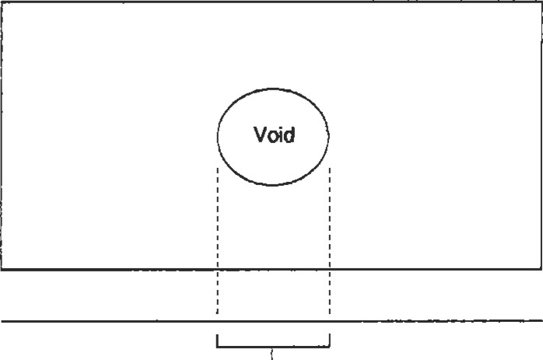

Film

More radiation is received here because there was less material along the path to absorb tie x-rays

Figure 23. Radiographic inspection for cracks.

|  |
| --- |
| "6 mumb  Bad Weld Good Weld  Figure 24. Radiography is often used to inspect welds.  Ultrasonic Inspection |

Ultrasonic inspection utilizes high-frequency sound waves which are reflected by The return signal is measured and analyzed to detect cracks. A great deal of energy is reflected at both surfaces of the component. This creates two dead zones where acousüc reflections caused by cracks cannot be distinguished from those caused by the component surfaces. The return signal for an uncracked component will look like Figure 25: Peak A represents the echo from the front wall, and peak B represents the back wall echo. Crack A in Figure 26 would reflect a porüon of the signal and cause another peak between A and B. Crack B would reflect some of the wave at an angle and, therefore, would not cause another peak. Its existence could be deduced, however, because the back wall echo would be significantly curtailed. Any increase in the return signal between these two peaks indicates a discontinuity in

|  |
| --- |
| A- (Front Wall Echo)  B - (Back Wall |

Return

Signal

Echo)

Time

Figure 25. Ultrasonic return signal for an uncracked component.



Generator/Receiver

Dead Zone



(A) (B)

Dead Zone

Figure 26. Effect of crack orientation on detectability: (A) crack reflects signal back to receiver; (B) crack deflects signal, reducing back wall echo; (C) crack cannot be detected.

the component. Crack C would be extremely diffcult to detect, since it would have little effect on the retum signal because of its orientation.

Ultrasonic inspection is very accurate and can be used to inspect thick sections. It is limited to detecting internal cracks away from specimen surfaces. It requires a flat surface through which to apply the energy. Reference standards are required, making this method unusable for one-of-a-kind inspections. For some materials, grain boundaries, precipitates, or other internal inhomogeneities reflect so much acoustic energy, that crack detection is extremely difficult.

Eddy-Current Inspection

|  |  |
| --- | --- |
| Evaluation of Failed |  |

Eddy-current inspection can be performed on materials that conduct electricity. This method is based on the principle that cracks distort the eddy-currents which occur in a sample when current is passed through a nearby coil. Both surface and near-surface cracks may be detected reliably. Perhaps the most important feature of eddy-current inspection is that it can be automated. This improves accuracy significantly, and reduces cost if the inspections will be done in volume. The negative aspects are that special machinery and reference standards (showing the signals for cracked and uncracked parts) are necessary, making it impractical for one-of-a-kind inspections.

If a failure occurs, all relevant informaüon about the event should be recorded as quickly as possible. Seemingly minor details may help pinpoint the cause of the failure. If a turbine wheel fails when power is being increased or decreased, it may indicate that thermal gradients are responsible. Any failed parts that can be should be handled with extreme care. The parts should not be cleaned until they have been examined thoroughly, because surface debris may yield important clues. Paint on a cracked surface might indicate that the crack occurred during the manufacturing process, and was present when the component was placed into service. Oxidaüon on a cracked surface may indicate how long that surface was exposed to the environment. Important regions should be photographed for future reference. From the pri.mary crack (the one responsible for failure), attempts should be made to determine:

* Crack origin (there may be more than one)
* Critical crack size
* Crack growth rate (if striations are present)

The critical crack size and crack growth rates may be used to make rough estimates of the loads present. Secondary cracks (ones not responsible for failure) may also be used for this purpose. The surfaces of the primary crack are often too damaged for meaningful evaluation after failure. Secondary cracks, whose surfaces are more protected, may be more useful for post-failure examination. Examining the microstructure of the component, including regions not near the fracture surface, can indicate what conditions it was subjected to during operation. The microstructure of some materials changes when they are subjected to high temperatures. Armed with this knowledge, it might be possible to determine that the operaüng temperature exceeded a certain level. Small specimens may be

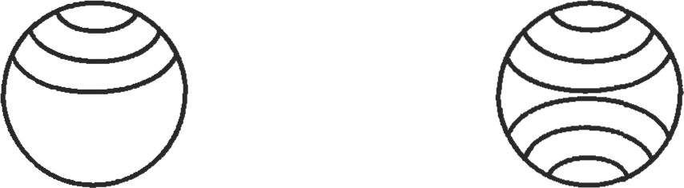

(a) Tension (b) Bending

Figure 27. Failure surfaces of round bars subjected to (A) tensile loading and (B) bending.

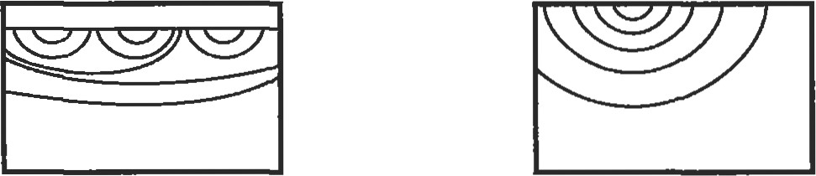

(a) Notched (b) Unnotched

Figure 28. Failure surfaces of notched and unnotched rectangular bars.

cut from a failed component and tested to determine if the material properties are within specifications. Keep in rnind that different regions of the same component can have significantly different properties.

The fracture surface may also indicate the type of load. Figure 27 shows failure surfaces for round bars subjected to tensile loading and to bending. In bending, there is a tendency to initiate cracks at the top and bottom, since the sffesses will be highest at these two locations. Figure 28 compares the cross-section of notched and unnotched rectangular bars. The notch creates a local area of high stress, and multiple cracks tend to initiate in this region. Eventually, these cracks generally coalesce into a single large crack. For cases of uniform stress, the tendency is towards a single crack.

|  |
| --- |
| mumb  NONMETALLIC MATERIALS |

This chapter has focused on metals, which are widely used for structural components. A few comments will be made about plastics, composites, and ceramics as well. The properties of vao.r greatly, but the same methodology that is used for metals can often be used for plastics. Dr. Grandt has done numerous experiments on polymethylmethacrylate and polycarbonate [101. His research indicates that crack growth in these plastic materials can be related to the stress intensity factor, just as it is in metals.

Composites are being used more frequently for süuctural components. Faügue of composite materials is a very complicated subject, which will not be dealt with in this book. Complications in fatigue analysis arise because:

* The material is not homogeneous.
* Residual stresses are present due to the difference in thermal expansion coefficients between the fibers and matrix materials.

Once cracks initiate, the fibers often act as barriers to crack growth.

Compared to metals, fatigue strengths are generally higher (relative to their ulti.mate strengths) for composites under uniaxial tensile loading (R > O). The opposite is true when compressive or fully reva•sed (R < -l)loading is applied [11]. Inspecüon of composites is diffcult because cracking is more likely to occur internally than it is for metals.

Ceramics offer strength, light weight, and outstanding temperature resistance, but have been shunned in the past due to their brittleness. A great deal of effort is currently being expended to develop ceramics with improved toughness. If we assume that ceramic materials have no ductility, then some simple analysis can be done. When ceramic components are manufactured, they always have some flaws in them. Since their is assumed to be negligible, no subcritical crack growth can occur. If the load is increased to the point that the stress intensity factor at one of these inherent defects exceeds the fracture toughness, fast fracture will occur. At a given stress level, a certain percentage of ceramic components will fail immediately, while the rest will not fail no matter how many times the load is applied. This makes the standard S-N curves that are used

Probability of Failure

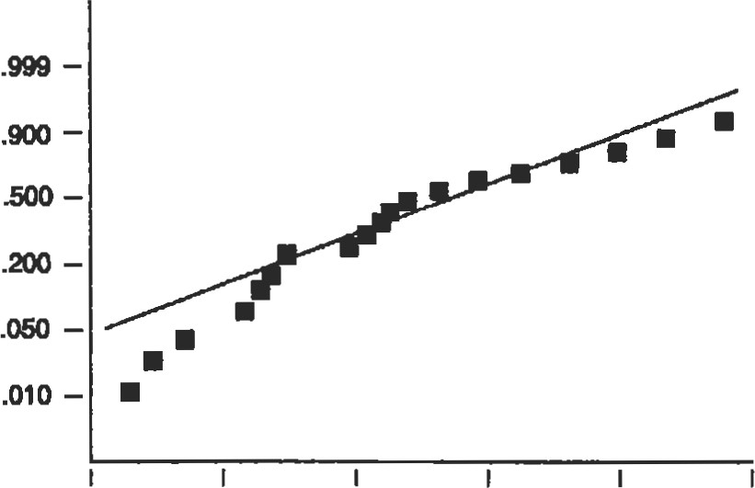

55 60 65 70 75 eo

Stress

Figure 29. Wpical probability of failure versus stess plot.

to calculate lives for metals useless. Instead, a probabilistic method is applied. The probabilit)' ofsun'ival (POS) is plotted against strength (Figure 29). Since larger components have more material, and therefore a greater probability of containing a large flaw, failure must be normalized to account for size. Ln test specimens, the failures are generally classified as either surface (failures originating at the surface) or volume (failures originating internally). Separate Weibull curves are calculated for each type of failure. When this informaüon is used to calculate the life of a component, its total probability of survival is the product of its POS for surface and volume flaws:

POS ¯ POSsurfwe X POSvolume

A positive aspect of the lack of ductility in ceramics is that they can be "proof-tested." Because an applied load to a component with no ducülity will do no damage unless it causes fast fracture, parts can be tested at a load equal to the highest load (multiplied by an appropriate safety factor) that they will experience in sewice. Those that survive should not fail in service tmless they are subjected to an even greater load. This means that if the specimens in Figure 29 are subjected to a stress of 60 ksi, the three weakest specimens would fail, but those remaining would be undamaged. This approach should not be used with metals, because they undergo crack gowth.

|  |
| --- |
| FATIGUE TESTING |

Fatigue testing can be difficult and can yield misleading data if not done correctly. Numerous small companies specialize in generating fatigue data, and their services might be useful to those without proper facilities or experience. Companies that decide to generate their own fatigue data should carefully review the pertinent ASTM guidelines:

l . Low Cycle Fatigue (ASTM Standard E606-80). 2. High cycle Fatigue (ASTM Standard E466-82).

1. Statistical Analysis of Linear or Linearized Stress-Life and Strain-Life Fatigue Data (ASTM Standard E739-91)
2. Plane-Strain Fracture Toughness Test Method (ASTM Standard E399-90).
3. Fatigue Crack Growth and Threshold Crack Growth Test Method(ASTM Standard E647-91).
4. Creep Crack Growth Test Method (ASTM Standard E1457-92).
5. Surface Fatigue Crack Growth Test Method (ASTM Standard E740-88).

It is particularly important to exercise care when testing to determine MG. High loads are required to iritiate a crack for testing purposes. If these loads are not reduced gradually after initiation but before taking measurements to determine AKth, the tests may show the threshold value to be much higher than it actually is. Obviously, this could have very serious consequences.

Every effort should be made to keep the test specimens as similar to the actual hardware as possible. Seemingly unimportant details, such as how a surface is machined, may induce residual stresses or create small cracks which drastically alter the fatigue life. Figure 30 shows how the surface factor (Cf) is related to tensile strength and machining operations [12]. If it is necessary to use test data based on specimens with a different surface finish than actual components, the calculated life should be corrected:

Cf (actual hardware)

N actual calculated X

Cf (test specimens)

Hardness. Bhn

120 160 200 240 280 320 360 400 440 480 5m

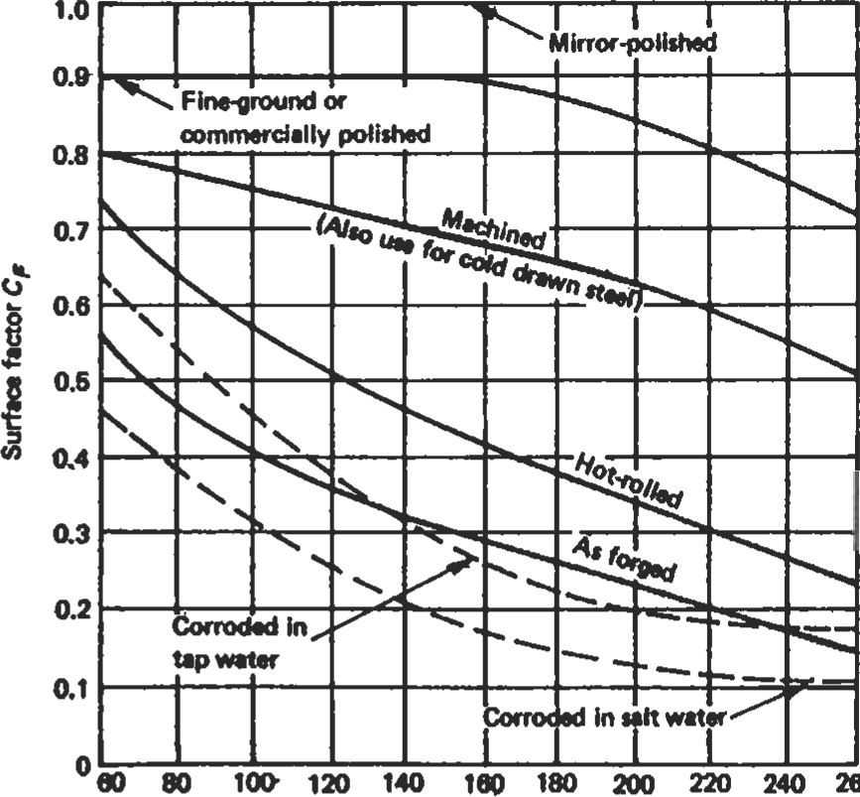

260

Tensih steogth Sue ksi

Figure 30. Surface factors for various machining operations [13]. (Reprinted with pennission of Prenåce-Hall, Inc.)

where: Nactual = actual life of component:

Ncalculated = calculated life based on test specimen data

Environmental Effects

Fatigue can be accelerated significantly by aggressive environments. This is especially true when the loads are applied and maintained for long periods of time. These effects are difficult to quantify. The best rule is to attempt to simulate environmental conditions during fatigue testing as closely as possible. Aggressive environments may include everything from salt air for carrier-based aircraft to nuclear radiation for electrical generating plants.

|  |
| --- |
| 350 Thumb  LIABILITY ISSUES |

Because fatigue analysis involves calcul±g component lives, die analyst is likely to be involved in litigation at some time during his When writing reports, several items should be remembered:

* Be accurate. If it is necessary to make assumptions (and usually it is), state them clearly.
* The plaintiffs will have access to all of your reports, memos, photographs, and computer files. Nothing is sacred.
* Do not "wave the bloody arm." This refers to unnecessarily describing the results of component failure. Say "this component does not meet the design criteria," instead of 'this component will fail, causing a crash, which could KII hundreds of people" (you may verbally express this opinion to gain someone's attention).
* Limit the report to your areas of expertise. If you decide to discuss issues outside your area, document your sources.
* Do not make recommendations urdess you are sure they will be done. If you receive a report or memo that makes recommendations which are unnecessary or inappropriate, explain in writing why they should not be followed and what the proper course of action should be. If they are appropriate, make sure they are carried out. This is kiown as "closing the loop."
* Avoid or use with exüaeme care these words: defect, flaw, failure.

•If errors are detected in your report after it is published, correct it in writing immediately.

|  |
| --- |
| REFERENCES |

Engineers should not avoid writing reports for fear they may be used against them in a law suit. If a report is accurate and clearly written, it should help the defense.

1. Neuber, H., "Theory of Stress Concenü•ation for ShearStrained Prismatical Bodies with Arbitrary Nonlinear Stress Strain Laws, "Trans. ASNE, J. AppL Mech, Volume 28, Dec. 1961, p. 544.
2. Glinka, G., "Calculation of Inelastic Notch-Tip StrainStress Histories Under Cyclic Loading," Engineering Fracture Mechanics, Volume 22, No. 5, 1985, pp. 839-854.
3. Smith, R. W., Hirschberg, M. H. , and Manson, S. S., Behavior of Materials Under Cycling in Low and Intermediate Life Range," NASA TN D1574, April 1963.
4. M. A., 'Cumulative Damage in Fatigue," Trans. ASNfE, J. Appl. Mech, Volume 67, sept. 1945, p. A159.
5. Marin, J., "Interpretation of Fatigue Strengths for Combined Stresses," presented at The American Society of Mechanical Engineers, New York, Nov. 28—30, 1956. 6. Muralidharan, U. and Manson, S. S., "A Modified Universal Slopes Equation for the of Fatigue Characteristics of Metals," Joumal of Engineering Materials and Technology, Volume 110, Jan. 1988, pp. 55-58.
6. Irwin, G. R., "Analysis of and Strains Near the End of a Crack Transversing a Plate," Trans ASME, J. Appl. Mech, Volume 24, 1957, p. 361.
7. Paris, P. C. and Erdogan, E, "A Critical Analysis of Crack Law," Trans. ASNÆ, J. Basic Engr., Volume 85, No. 4, 1963, p. 528.
8. Barsom, J. M., 'Fatigue-Crack Propagation in Steels of Various Yield Su•engths," Trans. ASME, J. Eng. Ina, Ser. B, No. 4, Nov. 1971, p. 1190.
9. Troha, W. A., Nicholas, T., Grandt, A. E, 'Observations of Three-Dimensional Surface Flaw Geometries During Faügue Crack Growth in PMMA," Surface-Crack Growth: Models, Experiments, and Structures, ASTM STP 1060, 1990, pp. 260-286.
10. McComb, T. H., Pope, J. E., and A. E, and Coalesence of Mulüple Fatigue Cracks in Polycarbonate Test Specimens," Engineering Fractuæ Mechanics, Volume 24, No. 4, 1986, pp. 601-608.
11. Stinchcomb, W. W., and Ashbaugh, N. E., Composite Materials: Fatigue and Fracture, Fourth Volume, ASTM STP 1156, 1993.
12. Deutschman, A. D., Michels, W. J., and Wilson, C. E., Machine Design Theory and Practice. New Jersey: Prentice Hall, 1975, p. 893.
13. Fuchs, H. O. and Stephens, R. 1., Metal Fatigue in Engineering. New York: John Wiley & Sons, Inc., 1980.
14. Mann, J. Y., Fatigue ofMaterials. Victoria, Australia: Melboume University Press, 1967.
15. Erickson, P. E. and Riley, W. E, Experimental Mechanics, Vol. 18, No. 3, Society of Experimental Mechanics, Inc., 1987, p. 100.
16. Liaw, et al., "Near-Threshold Fatigue Crack Growth," Actametallurgica, Vol. 31, No. 10, 1983, Elsevier Science Publishing, Ltd., Oxford, England, pp. 1582—1583.
17. Pellini, W. S., 'Criteria for Fracture Conu•ol Plans," NRL Report 7406, May 1972.

Recommended Reading

Metal Fatigue in Engineering by H. O. Fuchs and R. I. Stephens is an excellent text on die subject of fatigue. Most of the chapters contain "dos and don'ts" in design that vide excellent advice for the working engineer. Metals Handbook, Volume 11: Failuæ Analysis and Prevention by the AnHican Society for Muls deals with metallmgical aspects, failure analysis, and crack inspecüon methods. Analysis and Representation ofFatigue Data by Joseph B. Conway and Lars H. Sjodahl explains how to regress test data so that it can be used for calculaüons. Composite Material Fatigue md Fracture by Sünchcomb and Ashbaugh, ASTM STP 1156, deals with the many complicaüons that arise in fatigue calof composites. Stress Intensity Factors Handbook, Committee on Fracture Mechanics, The Society of Materials Science, Japan, by Y. Murakami is the most complete handbook of stress intensity factors, but is quite expensive. The Sows Analysis ofCracks HanÖæk, by H. Tada, P. Paris, and G. Irwin, is not as complete nor as expensive.



### Instrumentation

Andrew J. Brewington, Manager, Instrumentation and Sensor Development, Allison Engine Company

Introduction353

Temperature Measurement354

Fluid Temperature Measurement354 Surface Temperature Measurement358 Common Temperature Sensors358

Pressure Measurement359

Total Pressure Measurement360

Static/Cavity Pressure Measurement361

Strain Measurement 362

The Electrical Resistance Strain Gauge 363

Electrical Resistance Strain Gauge Data Acquisition 364

Liquid Level and Fluid Flow Measurement 366

Liquid Level Measurement 366

Fluid Flow Measurement 368

References 370

352 Insoumentaüon

#### INTRODUCTION

The design and use of sensors can be a very challenging field of endeavor. To obtain an accurate measurement, not only does the sensor have to possess inherent accuracy in its ability to transfer the phenomenon in quesüon into a readable signal, but it also must:

* be stable
* be rugged
* be immmune to environmental effects
* possess a sufficient üme constant
* be minimally inüusive

Stability implies that the sensor must consistently provide the same output for the same input, and should not be confused with overall accuracy (a repeatable sensor with an unknown calibration will consistently provide an output that is always incorrect by an unknown amount). Ruggedness suggests that the environment and handling will not alter the sensor's calibration or its ability to provide the correct output. Immunity to environmental effects refers to the sensor's ability to respond to only the measurand (item to be measured) and not to exfraneous effects. As an example, a pressure sensor that changes its output with temperature is not a good sensor to choose where temperature changes are expected to occur, die temperature-induced output will be mixed inexü•icably with the pressure data, resulting in poor data. Suficient time constant suggests that the sensor will be able to track changes in the measurand and is most critical where dynamic data is to be taken.

Of the listed sensor requirements, the most overlooked and probably the most critical is the concept of minimal intrwion. This requirement is important in that the sensor must not alter the environment to the extent that the measurand itself is changed. That is, the sensor must have suffciently small mass so that it can respond to changes with the required time constant, and must be sufficiently low in profile that it does not perturb the enviromnent but responds to that environment without affecting it. To properly design accurate sensors, one must have an understanding of material science, su•uctural mechanics, electrical and elecu•onic engineering, heat transfer, and fluid dynamics, and some significant real-world sensor experience. Due to these challenges, a high-accuracy sensor can be rather expensive to design, fabricate, and install.

Most engineers are not suffciently in all the disciplines mentioned above and do not have the real-world sensor experience to make sensor designs that meet all the application requirements. Conversely, if the design does meet the requirements, it often greatly exceeds the requirements in some areas and therefore becomes unnecessarily costly. Luckily, many of the premier sensor manufacturers have design literature available based on research and testing that can greatly aid the engineer designing a sensor system. Sensor manufacturers can be found through listings in the Thomas Registry and Sensor magazine's "Yearly Buying Guide" and through related technical societies such as the Society for Experimental Mechanics and the Insffument Society of America. A good rule of thumb is to trust the literature provided by manufacturers, using it as a design tool; however, the engineer is cautioned to use common sense, good engineering judgment, and liberal use of quesüons to probe that literature for errors and inconsistencies as it pertains to the specific objectives at hand. See "Resources" at the end of this chapter for a listing of some vendors offering good design support and additional background literature useful in sensor design and use.

It is important to understand the specific accuracy requirements before proceeding with the sensor design. In many instances, the customer will request the highest accuracy possible; but if the uuth be a much more reasonable accuracy will suffice. At this point, it becomes an economic question as to how much the improved accuracy would be worth. As an example, let us say that the customer requests a sffain measurement on a part that is operating at an elevated temperature so that he can calculate how close his part is to its yield stress limit in service. That customer will undoubtedly be using the equation:

#### = Ee

where e is strain, E is the material's modulus of elasticity, and o is the sü•ess. Depending on the material in question, the customer may have a very unclear understanding of E at temperature (that is, his values for E may have high data scatter, and the variation of modulus with temperature may not be within 5—10%). In addition, he will, by necessity, be using a safety factor to ensure that the part will survive even with differing material lots and some customer abuse. In a case such as this, an accurate, highcost strain measurement (which can cost an order of magnitude higher than a less elaborate, less accurate measurement) is probably not justified. Whether the strain data is

#### 3" numb

O. 1% accurate or 3% accurate probably will not change the decision to approve the part for service.

Although there are a wide variety of parameters that can be measured and an even wider variety of sensor technologies to perform those measurements (all with varying degrees of vendor literature available), there are a few basic measurands that bear some in-depth discussion. The remainder of this chapter deals with:

* fluid (gas and liquid) temperature measurement

surface temperature measurement

' fluid (gas and liquid) total and staüc pressure measurement

' strain measurement

* liquid level and fluid (gas and liquid) flow measurement

|  |
| --- |
| TEMPERATURE MEASUREMENT |

These specific measurands were chosen due to their fundamental natme in measurement systems and their wide use, with consideration given to the obvious scope limitations of this handbook.

Temperature measurement can be divided into two areas: fluid (gas and/or liquid) measurement and surface measurement. Fluid measu.rement is the most diffcult of the two because (1) it is relatively easy to perturb the flow (and therefore, the parameter needing to be measured) and (2) the heat fransfer into the sensor can change with environmental conditions such as fluid velocity or fluid pressure.

|  |
| --- |
| Fluid Temperature Measurement |

After these two measurement areas are investigated, a short of this chapter will be devoted to an introduction to some common temperature sensors. Because the sensing device is located directly at the measurand location, it is important to understand some of the sensor limitations that will influence sensor attachment design.

Fluid temperature measurement can be relatively easy if only moderate accuracy is required, and yet can become extremely dffcult if high accuracy is needed. High accuracy in dlis case can be intQreted as ±O.20F to ±IOOF or higher depending on the error sources present., as will be seen later. In measuring fluid temperature, one is usually interested in obtaining the total temperature of the fluid. Total temperature is the combination of the fluid's static temperature and the ext-a heat gained by bringing the fluid in question to a stop in an isenü•opic manner. This implies stopping the fluid in a reversible manner with no heat out of the system, thereby recovering the fluid's Knetic energy. Static temperature is that temperature that would be encountered if one could ü•avel along with the fluid at its exact velocity. For isenü•opic flow (adiabaüc and reversible), the total temperature (TO and the static temperamre (TO are related by the equation:

#### = 1/11 + h(y- 1)M2]

where y is the ratio of specific heats (cp/cv) and equals 1.4 for air at 15 0C. M is the mach number. The isenfropic flow tables are shown in Table 1 for 7=1.4 and provide useful ratios for estimating total temperature measurement errors.

In measuring Tt, there are three "configuration," or physiCal, error sources independent of any sensor-specific errors that must be addressed. These are radiation, conduction, and flow velocity-induced errors. Each of these errors is driven by heat üansfer coeffcients that are usually not well defined. As a result, it is not good practice to attempt to apply afterthe-fact  for the above errors to previously tained data. One could easily over-correct the data, with the result being further from the üuth than the original, unaltered data. Instead, it is better to assume worst-case heat transfer condiü)ns and design the instrumentation to provide acceptable accuracy under those conditions. Radiation error is governed by:

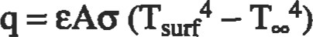

where q is the net rate of heat exchange between a surface of area A. emissivity e, and temperature and its surroundings at temperature Too (G being the Stefan-Boltzmann constant and equal to 5.67 x 10-8 WIm2 x K4). It is appar-

Table 1 isentropic Flow Tables (y1.4)

|  |  |  |  |  |  |  |  |
| --- | --- | --- | --- | --- | --- | --- | --- |
| M | ps/pt | TsTht |  |  | ps/pt |  |  |
| . 10  16  . 17  . 18  . 19    . 34)  .31  . 32  : 39  . 35  . 36  37  : 39  . 41  . 42  . 44  . 45  . 40  , 47  . 48  . 49  : 51  . 52    . 57 | 9097  . 9990  . 9080      .0776  . 9751    . 9575  .9470  .9133  .0355  . 0188  . 0052  . 9004  . 8907  . 8857  , 8755  . 8703  . 8596  8541  . 8486  . 8130  .8374  .8317  . 8142 | ı, 0000  ı.oooo    . 9971  : 9913  .9921  .9913  .9895  .9846    .9774  . 9761  . 9747  .9675  . 9611  : 9577  . 9542  .9524  : 9487  . 9830  .0410  : 9370  , 9049 | 57. 8738  19.3005 14.4815  ı t. 5914 9. M59  8.2915  7.2616  6.4613  5.8218  5. 2992  4.8643  4.49"  4. 1824  3.9103  3.6727  3.4635  3.2779 3, ıım  z 9635 z 8293 2.7076  2.ö968  2.4966    2. msn  1.9765 9219 j. 8707 L 8229  h. 7358  n. 6961  ı. 6234  1.5587  ı. 5289  ı. 4740  î. 4487  1.4018  n. 3801 1.3505  ı: 2130 ı. mos | : 71    ı. 01    ı, 10 1.11  ı. 12 ı: 14  ı, 15 ı. 16  ı. 17  ı. 18  ı. 19 | . 7840  , 7778  . 7716  . 7654  . 7591  . 7528  . 7465  . 7401  . 7338  . 7274  .72W  . 7145  .7080  . 7016  . 6951  . 6821  . 8756  .6625  . 6495  . 6235  • 6170  . 6106  . 5913  . 5849  .5785  . 5721  . 5595  . 5532  .500  . 5283  . 5221  .5160  . 5QJ9  . 4979  .4919  . 40  . 4742  , 4668  .4511  .4455  .4398  .4343  . 4287  .4B2  . 4178 | 9328  : 9199  . 9176  .9153  , 9131  .9107  , 9061  .9037  . 9013  . 8915  .8815  .8789  .8763  . 8737  . 8711  . 8659  . 8632  : 8579  .8552  .8525  .8.4R  . 8471  . 8444  . 8416  . 8361  . 833,3  .8Z78  .8250  .8222  .8193  . 8136  . 8137  . 8108  .8M2  .7994  .7937  . 7861  . 7822 | ı. 1882 ı, 1767 1. 1637  ı. 1552  ı. 1452  ı. 1356  ı. 1265 1. 1179  ı. 1018  ı. 0904 1.0873    ı, 0570 1.0619 1.0471  ı. 0425 ı. 0382  ı: om  1.0237  1. om  1. ons 1.0129  ı. 0108  I.(MI  1.0022  ı. 0001  ı. 000 1.000  ı, 001 ı. 001  1.002 1.003  ı. 004 1.005  1.008  t. 010  ı. 013  ı. 015 t. 017 ı: 023 |

Source: John [271, adapted from NACA Report 1135, "Equations, Tables, and Charts for Compressible How, n AMES Research Staff.

ent from this equation that if either the absolute value of Ts — Tsur is large or both TS and Tsur are large, then the radiation error can be significant. This is a rule that holds for all conditions but can be funher exacerbated by those situations where extremely slow flow exists. in this situation, it becomes difficult to maintain sufficient heat tansfer from the fluid to the sensor to overcome even small radiative flux. Obviously, radiative heat transfer can never raise the sen-

ntumb

sor temperature above that of the highest temperature body in the environment. If all of the environment exists within a temperature band that is a subset of the accuracy requirements of the measurement, radiation errors can be summa.rily dismissed.

Conducüon errors are present where the mounting mechanism for the sensor connects the sensor to a surface that is not at the fluid's temperature. Since heat by conducdon can be quite large, these errors can be considerable. As with radiaüon errors, conditions of extremely slow flow can yeatly compound conduction error because heat ü-ansfer from the fluid is not sufficiently large to help counter the conducüon effect.

Velocity-induced errors are different from radiation and conduction in that some fluid velocity over the sensor is good while even the smallest radiation and conducdon effects serve to degrade measurement accuracy. Fluid flow over the sensor helps overcome any radiation and conüzction heat ü•ansfer and ensures that the sensor can respond to changes in fluid temperature. However, as mentioned earlier, total temperature has a component related to the fluid velocity. A bare, cylindrical sensor in cross flow will 'Yecoved' approximately 70% of the difference between Tt and Ts. At low mach numbers, the difference between Tt and Ts is small, and an error due to velocity (i.e., the amount not recovered) of 0.3 (Tt — Ts) may be perfectly acceptable. For higher-velocity flows, it may be necessary to slow the fluid. This will cause an exchange of velocity (kinetic energy) for heat energy, raising Ts and hence the sensor's indicated temperature, Ti (Tt remains constant).

A shrouded sensor, as shown in Figure 1, can serve the purpose of both slowing fluid velocity and acting as a rashield. With slower velocity, Ts is higher, so Ti = 0.7 (Tt — Ts) is higher and closer to Tt. The shield, with fluid scrubbing over it, will also attempt to come up to the fluid temperature. Most of the environmental radiation flux that would have been in the field of view of the sensor now can only "see" the shield and, therefore, will affect only the shield temperature. In the sensor's field of view is now limited to a small forward-facing cone of the original environment, with the rest of its field of view being the shield and/or sensor support structure. Since the shield and support snucture are at nearly the same temperature as the sensor, there is little driving force behind any shield-sensor radiation exchange, and the sensor is protected from this error. Conduction effects are minimized by the slender nature of the sensor (note that the sensor has a "length divided by diameter" [I-JD] ratio of 10.5).

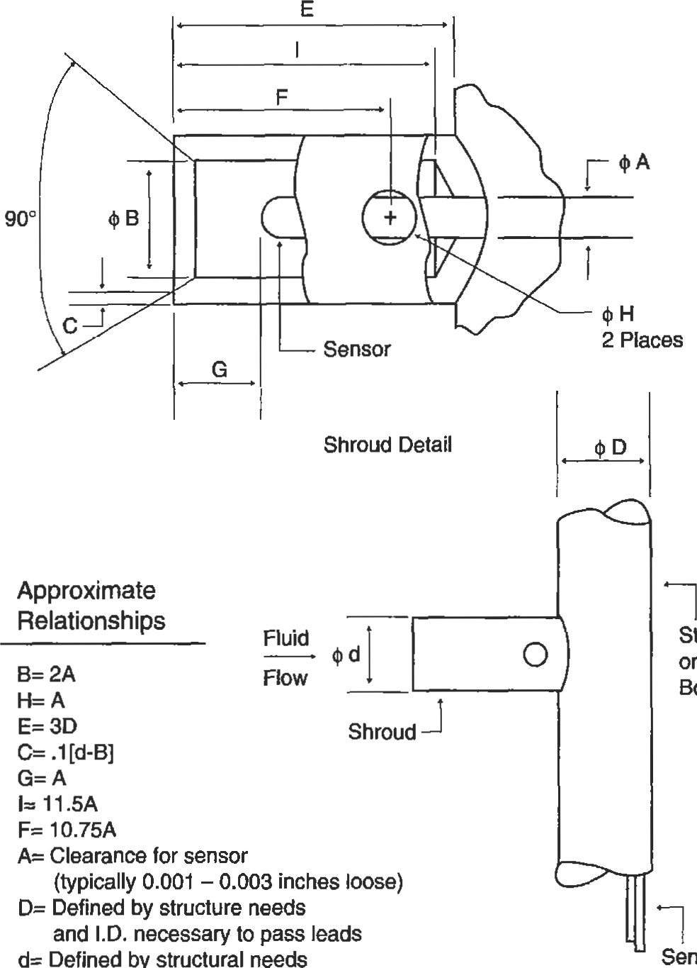

Defined

by

Sensor

(typically

.5

B)

Leadwires

Stem

Body

Flgure 1. Parametric design: single-shrouded toul temperature probe.

Figure 1 shows a general sensor configuration suited for mach 0.3 to 0.8 with medium radiation effects. This design is somewhat complicated to machine and would be considerably more expensive than the sensor configuration shown in Figure 2. Differing fluid velociües and environment temperatures would require changing Figure I by altering bleed hole diameters (H), adding other concentric radiation shields, and/or lengthening sensor IJD ratios. In Figure 2, the sensor hangs in a pocket cut from a length of support tube. Ihis arrangement offers some radiation shielding (but decidedly inferior to that in Figure 1) and some velocity recovery. The placement of the sensor wifin the cutout will greatly influence the flow velocity over the sensor and hence its recovery. In fact, depending on flow environmental conditions (vibration, flow velocity, particles within the flow, etc.) the sensor may shift within the pocket during use causing a change in reading that does not correspond to a change in fluid conditions. The probe in Fig-

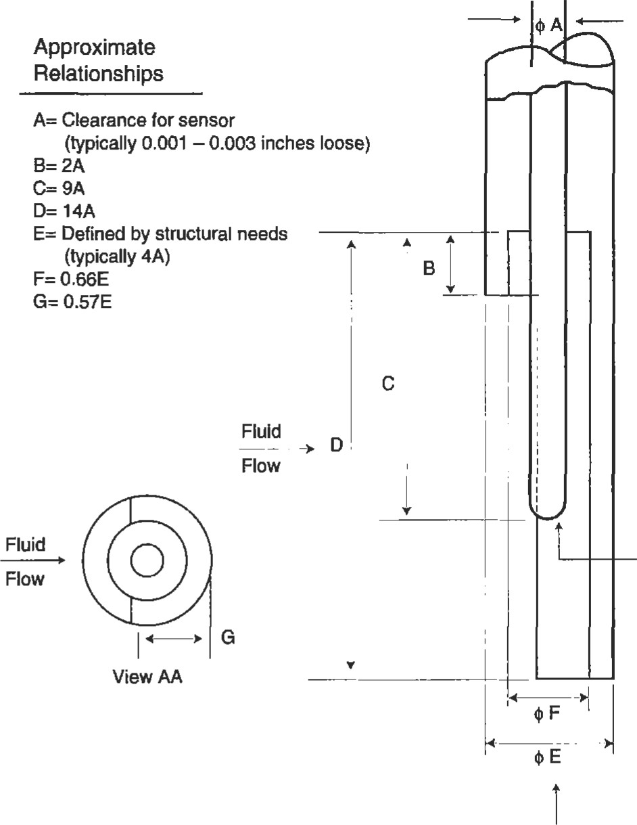ure 2, therefore, is better suited for mach 0.1 to 0.4 in areas with low radiation effects.

Figure 3 shows a compromise probe configuration in terms of cost and performance. It is designed for mach 0.1 to 0.4 with medium radiaüon effects. The perforaüons will slow the flow somewhat less than the probe in Figu.re 1 and will reduce radiadon effects better than the probe in Figure 2. This configuration does, however, have a significant advantage where flow direction can change. While the probe in Figure 3 has stable recovery somewhat independant of flow yaw angle, the probe in Figure 2 is very susceptible to pitch angle and moderately susceptible to yaw variations. By comparison, the probe in Figure 1 is rather insensitive to yaw and pitch variaüons up to ±30.

Sensor

View AA

Figure 2. Parametric design: half-shielded total temperature probe.

Approximate

Relationships



A— Clearance for sensor

(typically 0.001 — 0.003 inches loose)

Defined by structural needs

(typically 5.5A)

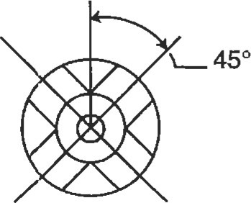C= Defined by structural needs and requirement to flow sufficient fluid over sensor (typically 3A)

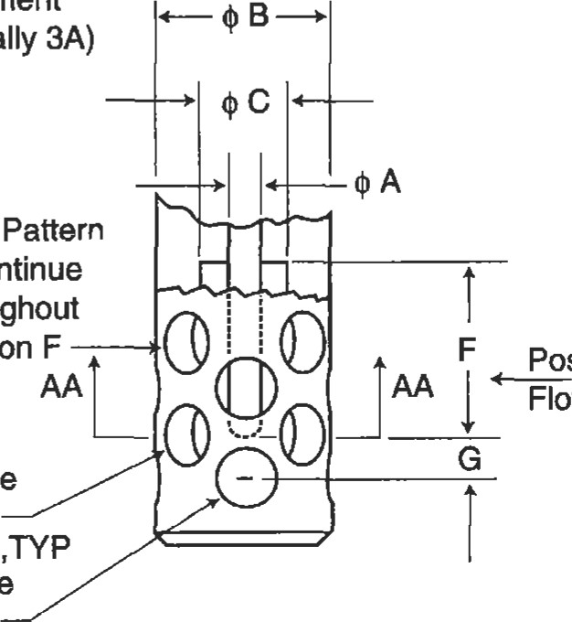

*Hole

to

continue

throughout

Section

1.5A

Possible Huid

Possible Fluid

Flow Direction

Flow Direction

$D Through one wall, 4 places equally spaced,TYP

S AA-AA $E Through one wall, 4 places equally spaced,TYP

Figure 3. Parannetric design: muttiflow direction total temperature probe.

Thumb

Surface Temperature Measurement

|  |  |
| --- | --- |
| Surface temperature measurement can be somewhat easier than fluid temperature measurement due to fewer configuration error sources. Radiation effects can, to a large extent, be ignored, as a sensor placed on a surface will see the same radiative flux as the surface beneath it would if the sensor were not present. The only exception to this would occur in high radiative flux environments where the sen- | fluid and surface. Sensors that are of minimal cross-section or are embedded into the surface of interest minimize velocity errors. Embedding is preferred over surface mounting because of the superior heat transfer to the sensor along the increased surface area of the groove (see Figure 4).  fill (e.g., epoxy) |

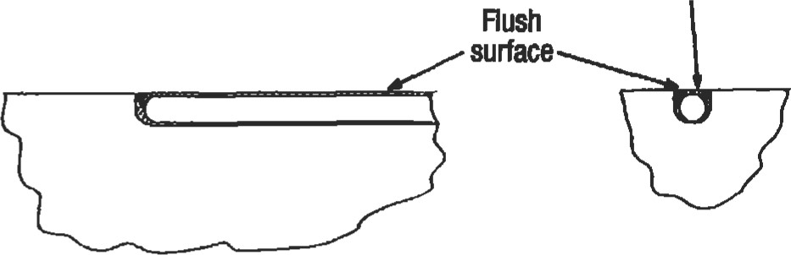sor has a significantly different emissivity than that of the surface to be measured. Error sources, then, for surface temperature measurement are constrained to conducüon and velocity-induced effects.

Conduction errors occur when the sensor body contacts an area of different temperature than that being measured.

|  |  |  |
| --- | --- | --- |
| The sensor then acts as an external heat transfer bridge be- | Embedded Sensor |  |
| tween those areas, ultimately altering the temperature to be | I-arge profile can dism | Minimal |
| measured. As with fluid temperature measurement, a suf- | now field and promote Joint | contact |
| ficient sensor LID ratio (between 8 and 15) will help en- | convective heat transfer. (e.g., epoxy) | area |

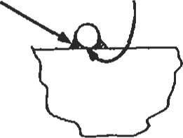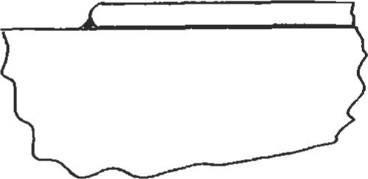Result: poor surface temperature reading sure that conduction errors are minimized.

Velocity errors are present when the sensor body rests above the surface to be measued and, acdng like a fin, transfers heat between the surface and the surrounding fluid. This can occur in relatively low-flow velocities but is obvious-

|  |  |
| --- | --- |
| ly worse with increasing fluid speed. Even at low speeds the sensor can serve to trip the flow, disrupting the normal boundary layer and increasing local heat transfer between | Surface Mounted Sensor  Flgure 4. Embedded versus surface mounting technique for surface temperature measurement. |

Common Temperature Sensors

The most common temperature sensor is the thermocouple (TIC). In a TIC, two dissimilar metals are joined to form a junction, and the remaining ends of the metal "leads" are held at a reference (known) temperature where the potenüal between those ends is measured. When the junction and reference temperatures are not equal, an elecforce (emf) will be generated proportional to the temperature difference. The single most important fact to remember about thermocouples is that emf will be generated only in areas of the TIC where a temperature gradient exists. If both the TIC junction and reference ends are kept at the same temperature Tl, and the middle of the sensor passes through a region of temperature T2, the emf generated by the end of the T/C as it passes from Tl to T2 will be directly canceled by the voltage generated by the lead end of the T/C as it passes from T2 to Tl. Bodl voltages will be equal in magnitude but opposite in sign, with the net result being no output (see Example 1). Further explanation of thermocouple theory, including practical usage suggestions, can be found in Dr. Robert Moffat's The Gradient Approach to Thermocouple Cimuitry [21.

Thamocouples are inexpensive and Elatively accurate. As an example, chromel-alumel wire with special limits of error has a 0.4% initial æcuracy specificatiom TICS can be obtained in differing configurations from as small as sub-O.OOl-inch diameter to larger than 0.093-inch diameter and can be used from cryogenic to 4,2000F. However, If very high accuracy is required, TICS can have drawbacks in that output voltage drift can occur with temperamre cycles and sumcient üme at high temperature, resulting in calibration shifts.

Two other commonly used temperature sensors are resistance temperature devices (RTDs) and thermistors, both Example 1

The Gradient Approach to Thermocouple Circuitw

Voltmeter

|  |  |  |  |  |  |  |
| --- | --- | --- | --- | --- | --- | --- |
|  | Chromel |  | Chromel |  |  |  |
| Alumel |  | Alumel |  |  |
|  |  |  |  |  |

5000F 7500F 320F 700F

Example of a Type K (Chromel-AlumeI) fremocouple with its junction at 5000F and reference temperatRB of 320F where a splice to the copper leadwires is made. In this example, the themocouple passes mrough a region of higher temperamre (75000 on its way to the 320F reference.

The voltage (9 read at the voltmeter can be represented as a summaüon of the individual emfs (e) generated along each discrete length of wire. The emf generated by each section is a function of the thermal emf coefficient of each material and the temperature gradient through which it passes. Therefore:

323F 750CF 500* 7500F

ECHR + ECHR + e AL

70CF 320F 750T 500T

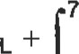320F ecu 750CF 32OF

Rearranging and expanding, we see:

323F 32CF 5000F 750T

Ecu ¯ ECHR + 

700F 70DF 320F 500CF

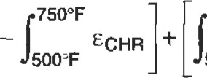 750T 7500F 32CF

EAL ¯ e AL

500'F 500CF 5000F

500CF



eAL

320F 500*

If the far left temperature zone was at 320F instead of 5000F, all equations would remain the same but the final form could be further reduced to the following:

320F

CCHR 4329F 32F

Theory based on Moffat [21.

of which have sensing elements whose resistance changes in a repeatable way with temperature. RTDs are usually constructed of platinum wire, while thennistors are of integrated circuit chip design. RTDs can be used from —4360F to +2,5520F, while thermistors are usually relegated to the —1030F to +5720F range. Each of these sensors can be very accurate over its specified temperature range, but both are sensitive to thermal and mechanical shock. Thermistors do have an advantage in very high resistance changes with temperature, however, those changes remain linear over a relatively small temperature range.

One other surface temperature measurement technique that bears menüon is pymmetery, which can be used to measure surface temperatures from +1,2000F to +2,0000F. When materials get hot they emit radiation in various amounts at various wavelengths depending on temperature. Pyrometers use this phenomenon by noninü•usively meaSuring the emitted radiation at specific wavelengths in the infrared region of the spectra given off by the surface of interest and, provided the surface's emissivity is known, inferring it's temperature. The equation used is

##### P=eoT4

|  |
| --- |
| PRESSURE MEASUREMENT |

where P is the power per unit area in W/m2, e is the emissivity of the part, o is the Stefan-Boltzmann constant (5.67 * 10-8 W/(m2K4), and T is the temperature in K. Pyrometers use band-pass filters to allow only specific wavelength photons to reach silicon or InGaAs photodiodes, which then convert the incoming photons to electrons yielding a current that is proportional to the temperature of the part in question. These sensors are not influenced by the above-mentioned physical error sources (because they are nonintrusive) but can be greatly affected by incorrect emissivity assessments, changes in emissivity over time, and reflected radiation from other sources such as hot neighboring parts or flames.

Pressure measurement can be divided into two meas: total pressure and static (or cavity) pressure. In most cases it won't be practical to place a pressure dansducer directly into the fluid in question or even mount it directly to the flowcontaining wall because of the vibration, space, and temperature limitations of the transducer. Instead, it is common practice to mount the open end of a tube at the sensing location and route the other end of the tube to a separately

##### numb

|  |
| --- |
| Total Pressure Measurement |

mounted  Due to this consideration, the remainder of this section concentrates on tube mounting design considerations. Pressure ffansducers can be chosen as stock vendor supplies that simply meet the requirements in terms of accuracy, frequency response, pressure range, over-range, sensiüvity, temperature shift, nonlinearity and hysterisis, resonant frequency, and zero offset, and will not be further discussed here.

As with temperature, fluid pressure readings can be static or total. Static pressure (PO is the pressure that would be encountered if one could travel along with the fluid at its exact velocity, and total pressure (PD is that pressure found when flow is stopped, trading its kineüc energy for pressure rise above Pg. Ps and Pt are related by the equation:

PIPS = [1 + h (y—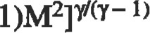

where y is the ratio of specific heats (cp/cv) and equals 1.4 for air at 15 0C. M is the mach number. See Table 1 for tabular form of this equation.

The most common method of measuring Pt is to place a small tube (pressure probe) within the fluid at the point of interest and use the tube to guide pressure pulses back to an externally mounted pressure fransducer. Error sources for this arrangement include irmerent errors within the pressure transducer, response dme errors for nonconstant flow conditions, and errors based on incorrect tube alignment into the flow and/or configuration.

In order to minimize response lags, the pressure transducer should be mounted as close as practical to the point of measurement. Also, the tube's inner cross-sectional area should not be significantly smaller than pressure reference volume, located immediately in front of its measuring diaphragm. increases in the tube's cross-sectional area between the sensing point and the transducer will slow response üme. Finally, the tubing should be seamless when possible and have minimal bends. All necessary bends should be constructed with a minimum inner radius of 1.5 frnes the tube's outer diameter (for annealed metallic tubing).

For the tube to correctly recover the full Pt, it is critical that the sensor (tube) face directly into the flow. Often it may not be possible to know flow direction accurately, or the flow angle is known to change during operation. In these cases, modifications to the tube sensing end must be used to correct for flow angle discrepancies. In Figure 5, four tube end arrangements are shown: (a) shows a sharp-edged impact tube; (b) adds a shield; (c) is a tube with an inner to outer diameter ratio of 0.2 and a 15 0 chamfer; and (d) is a cylinder in cross flow with a capped end and a small hole in its wall. As shown in Figure 0.2, each of these arrangements has a differing ability to accept angled flow and still Pt accurately to its transducer.

While the head modifications compensate for improper flow angle, anodier error can occur if pressure gradients exist within the flow. In the subsonic flow regime discussed here, the flow can sense and respond to the presence of the pressure probe it. As a result, the flow will turn and shift toward the lower pressure area when presented with the blockage of the pressure probe. By ensuring that the length of tube along the flow direction is at least three the width of the body to which the tube is mounted (with the body perpendicular to the flow direction), this effect can be minimized (see Figure 6).

Subsonic

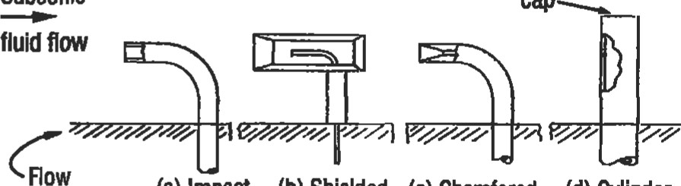

cap

(a) Impact (b) Shielded (c) Chamfered (d) Cylinder Containing Tube Square Tube Tube in cross flow

Wall

Edge

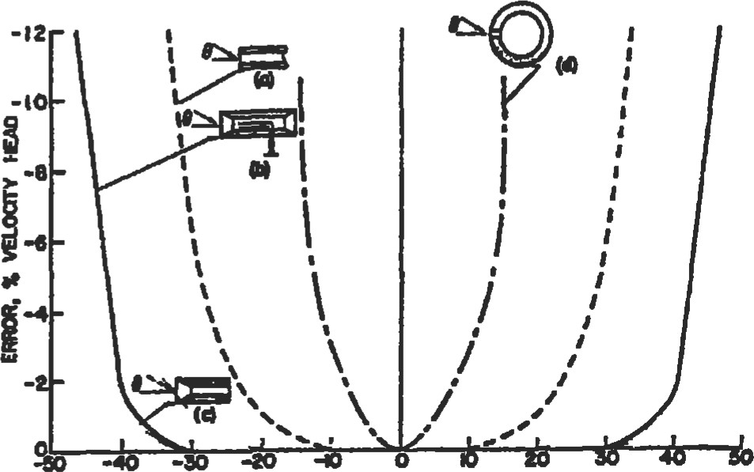

##### "*E. e. Des

Figure 5. TOW pressure probe, tube end and error with respect to flow angle [ll. (Counesy of lnstument Society ofAmeica. RepHnted by pemWon.)

|  |
| --- |
| Pressure Gradient  2 5 6  Displacement  of  Pressure  1  4  3  Ratio of Length of Sensing  Element to Diameter of Support (b)  Figure 6. Total pressure probe errors of pressure gradient displacement due to sensing tube length [1]. (Courtesy of Instrument Society of America. Reprinted by pemission.)  Static/CavIty Pressure Measurement |

While it is difficult to measure static pressure (P) accurately within the flow (as any indusive sensor will recover a significant portion of Pt — Ps, and the Ps probes that have been designed are sensitive to flow angle), it is relatively easy to measure Ps using a hole in the wall that contains the flow. Either the pressure ffansducer can be directly mounted to die wall or, more commonly, a tube will be placed flush with the inner wall at the sensing end with a pressure ü•ansducer connected to the opposite end.

Error sources in obtaining accurate pressure measurements fall into the same categories as diose of toul pressure, with inherent errors caused by the pressure ü•ansducer, response-time errors for non-constant flow conditions, and errors based on incorrect tube alignment at the wall. Response-time errors are very similar to those found in total pressure measurement systems. To reduce response-frne errors, keep all tubing lengths as short as possible and minimize bending. For all necessary bends, keep a minimum inner radius of 1.5 times the tube outer diameter (for annealed, seamless, metallic tubing). Finally, minimize all increases in the tube cross-sectional area between the sensing point and the sensor.

Static pressure errors related to configuration are somewhat more complex. As shown in Figure 7, the size of the pressure port diameter (tube inner diameter in most

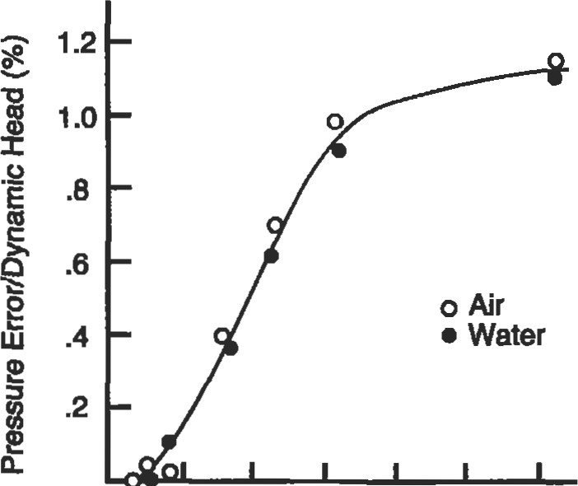

o • .02 .04 .06 .08 .10 .12

Hole Size (Inches)

Figure 7. Errors in static pressure reading as a function of hole size for air and water (Reprinted by permission of ASME.)

cases) can produce errors and must be balanced against practical machining considerations and flow realities. While a 0.010-inch inner tube diameter may provide a very accurate reading, it may not be practical to obtain tubing of that size or to machine the required holes. In addiüon, if the flow field consists of highly viscous oil or air with high partic-

ulate count (soot, rust, etc.) then a 0.010-inch diameter orifice would impede pressure pulse propagation and/or would plug completely.

Not only is static pressure port diameter a consideration, but changes in that port diameter along its length close to the opening to the flow field can also be a source of error. It is a good rule of thumb not to allow changes in the static pressure port diameter to occur within a length of 2.5 times the static pressure port diameter itself. For example, if a 0.020-inch diameter hole is added to a pipe for the purpose of measuring static pressure in the pipe, then the 0.020 hole should remain that size, with no interruptions or steps for at least 0.050 inches away from the opening to the pipe. A length of 3.0 to 5.0 times the hole diameter is preferred where practical. See ASME Power Test Codes, Supplement on Instruments and Apparatus: Part 5, Measurement of Quantity of Materials, Chapter 4: Flow Measurement, copyright 1959.

A final effect to be considered concerns that of orifice edge and hole angle with respect to the flow path (see Figure 8). It is best to keep the hole perpendicular to the flow and retain sharp edges. Failure to remove burrs created during hole machining can give negative errors of of dynamic head, while failure to completely remove the burrs (e.g., burr area cannot be detected by touch but is visibly brighter than surrounding area) can give negative errors up to 2% of the dynamic head. For these reasons, the note to "remove burrs but leave sharp edges" should always be used when calling out the machining of static pressure ports holes on a drawing. See "Influence of Orifice Geometry on Static Pressure Measurement," R. E. Rayle, ASME Paper Number 59-A-234.

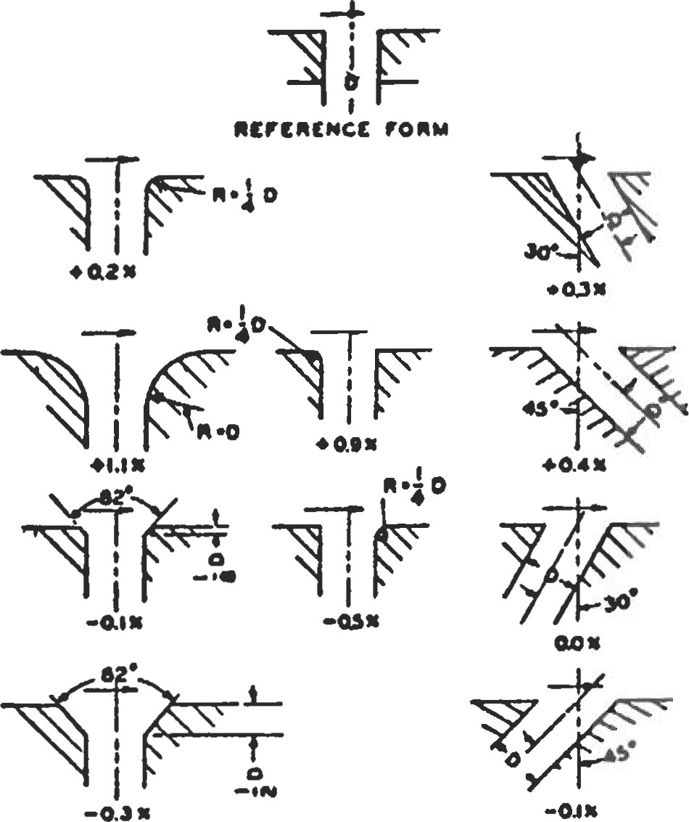

|  |
| --- |
| STRAIN MEASUREMENT |

Figure 8. Effect of orifice edge form on static pressure measurements (variation in percent of dynamic head) [4]. (Reprinted by permission of ASME.)

It is often necessary to discern the stress within a component of interest. As there are no practical ways to obtain sfress information directly, it is customary to measure strain (e) and, using the material's known modulus of elasticity (E), calculate the stress (o) via the equation:

#### o=Ee

Strain is simply the change in length (AL) of a material divided by the length over which that change is measured (gauge length, L). As an example, if the original length between two known points on a surface of interest is I .0000 inches, and the length measured under loading is found to be I .0001 inches, then the change in length is 0.0001 and the gauge length is 1.0000. The strain is therefore:

AWL = 0.0001/1.0000 = 0.0001 strain

As strain numbers are usually very small, it is customary to use the units of microstrain (NE), which are 106 times normal strain values. The above example would be read as 100ge.

The following sections highlight the electrical resistance strain gauge and its common data acquisition system. Additionally, some effort is made to discuss compensation techniques to provide a customer-oriented output useful in a variety of conditions.

|  |
| --- |
| The Electrical Resistance Strain Gauge |

The most common strain measurement transducer is the electrical resistance strain gauge. In this sensor, an electrical conductor is bonded to the surface of interest. As the surface is strained, the conductor will become somewhat longer (assuming the strain field is aligned longitudinally with the conductor) and the cross-sectional area of the conductor will deczease. Additionally, the specific resistivity of the material may change. The summation of these three effects will result in a net change in resistance of the conductor, which can be measured and used to infer the strain in the surface. The relationship that ties this change in resistance to strain level is:

GF = [AR/R]/e

where GF is the gauge factor of the specific gauge, AR is the change in gauge resistance, R is the initial gauge resistance, and e is the strain in inches/inch (not PE).

Electrical resistance strain gauges can be purchased in a variety of sizes as fine wire grids (e.g., 0.001-inch diameter) but are more commonly available as thin film foil patterns. These foil gauges offer high repeatability, a wide variety of grid sizes and orientations, and a multitude of solder tab arrangements. Multiple gauge alloys are available, each with characteristics suited for a between fatigue life, stability, temperature range, etc. The gauges can also be purchased with self temperature compensation (STC) which serves to match the general coefficient of thermal expansion of the to which the gauge will be bonded, thereby reducing the "apparent strain" (see the Full Wheatstone Compensation Techniques section). In addition to multiple alloys, there are multiple gauge backing materials from which to choose. The gauge backing serves to both electrically isolate the gauge from ground and to transfer the strain to the alloy grid. Finally, gauges can be purchased with the grid exposed or fully encapsulated for grid protection. Once these choices are made, it is still necessary to pick the proper cement, leadwire, and solder.

As was sffessed in the introduction, relying on the technical expertise of a competent vendor is critical in obtaining usable results with an unfamiliar sensor system. This is particularily true with stain gauge application. There are so many variables, choices, and error sources that, without solid technical counseling, the chances for obtaining poor data are relaüvely high. It is beyond the scope of this chapter to go through the finer points of gauge application, especially with the excellent vendor literature available. However, some common failure points in gauge application include the areas of improper cleanliness of the part (and the hands of the gauge applicaüon technician), improper part surface finish, and poor solder joints or incomplete flux removal.

Keeping the gauge area on the part clean and free of oxides is critical to obtaining a good gauge bond. Once the area is clean, install the gauge in a timely manner so as not to allow the area to pick up dirt. Perform the cleaning and gauge application in a draft-free, air-conditioned area when possible. This will provide the air with some humidity conffol and filtering. Not only does the part need to be cleaned, but it is also good practice to have the technician wash his hands prior to beginning each gauge application. This will reduce contamination of the gauge area with dirt, oil, and salts from the skin.

Additionally, if the part surface has a rough surface finish in the gauge area, an inconsistent adhesive line thickness can exist across the gauge. This can yield poor strain ü•ansfer to the gauge, especially if the part is subject to temperature excursions where thermal expansion mismatch between the part and cement can cause unwanted grid deflection. Problems can also exist, however, if the part has a surface finish that is smooth like glass. In this case, insufficient tooth may exist to obtain maximum cement adhesion, resulting in gauge slippage at high strains or under high cycle fatigue. Again, follow the manufacturer's recommendations (usually, 60 gin, rms is the recommended surface finish).

Finally, it is common practice to use some flux to aid in soldering the lead wires to the strain gauge tabs to assure proper solder wetdng. However, flux resiåne that is not completely removed can serve to corrode the metals and eventually cause shorts to ground. What is insidious about this failure mode is how slowly it works. Flux residue can go unnoticed as the gauge is checked, covered with protective coatings, and delivered to test. Then, during the test phase when critical data are being taken, the gauge can develop intermittent signal spikes and drop-outs, eventually resulting in low resistance to ground.

|  |
| --- |
| Electrical Resistance Strain Gauge Data Acquisition |

One common method for measuring the gauge resistance changes caused by strains is the Wheatstone Bridge completion circuit. This circuit can have one, two, or four active legs corresponding to single-gauge configuration (i.e., % bridge), two-gauge configuration (i.e., h bridge), and four-gauge configuration (full bridge). Figure 9 shows h, h, and full bridge arrangements together with their representative output equations. Let us examine the full bridge configuration.

|  |  |  |
| --- | --- | --- |
| Bridge/Strain Arrangement | Description | Output vo/V (mVN)  at Gage Factor. F, when  E expressea as m.crostrain |
|  | Single active gage in uniaxial tension or compression. | Vo Fex  V - 4 + 2FC x 10-6 |
| V -e | Two active gages with equal and opposite strains — typical of bending-beam arrangement. |  |
| -ve | Four active gages in uniaxial stress field —two aligned with maximum principal strain, two "Poisson" gages (column). | -3 |
|  | Four active gages with pairs subjected to equal and opposite strains (beam in bending or shaft in torsion). | Vo -3  — = 10 |

Figure 9. Full, one-half, and one-quarter active bridge arrangements with output voltage equations. (Courtesy of Measurements Group, Inc., Raleigh, NC.)

In a simple, uniform canülever beam with a single load on the free end deflecting the beam downward, the top surface of the beam is in tension and the bottom of the beam is in compression (Figure 10). As shown, üle neutral axis of the beam is located along the beam's centerline which implies that the on the beam's top surface is equal in magnitude to the strain on the beam's bottom surface. To determine the strain in the beam, gauges #1 and #2 should be placed on the top surface of the beam and gauges #3 and #4 should be placed on the bottom. All four of the gauges should be oriented longitudinally along the beam at the same distance from the fixed end. The gauges should then be wired as shown in Figure 11.

From Figure 10 we can see that the calculated strain along either surface's outer fibers at the strain gauge loca-

Top View

Therefore Plc

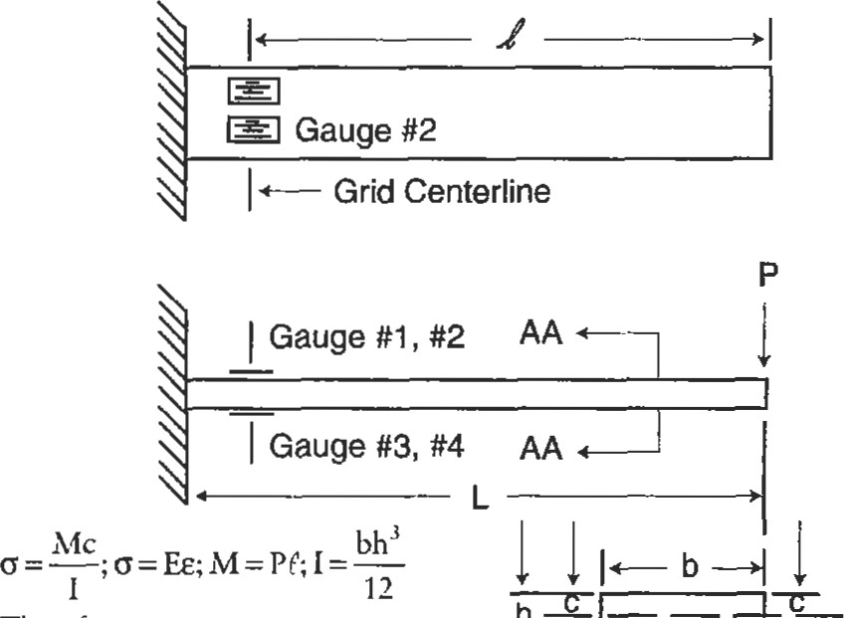

FZF

EE3

-T

|  |  |
| --- | --- |
| El | Neural |
| where P = 25 lbs  = 6.25 inches | Section AA-AA Axis |
| L = 7.00 inches b = 1.00 inch h = 0.25 inches c = 0.125 inches | Scale 2x |

e 0.0005 in/in 500 

Figure 10. Simple uniform cantilever beam with full bridge to measure bending.

tion equals 500YE. Each single 350 Q gauge (with a gauge factor of 2.1), placed longitudinally in this location, would see a resistance change of:

AR = R(e) GF

AR = = 0.3675 ohms

Therefore, the two gauges in compression each read 349.6325 under load while the two gauges in tension each read 350.3675 under load. With an input voltage of 5.0 volß, the output voltage equals 5.25 mV (see Figure 11).

To have the Wheatstone Bridge perform properly, the bridge must be balanced. That is, each leg must have the resistance, otherwise, a voltage ouQut will be present under zero snain condiüons. Unbalanced situations occur due to inherent resistance differences between gauges in the bridge coupled with resistance differences due to different length internal bridge wires. Balancing can be performed extemal to the bridge with the use of many readout devices; however, it can also be handled within the bridge cimuiEy, simplifying future data acquisition concems. Special resistors can be bonded within the circuit and then trimmed to leave the bridge output at just a few microstrain under zero load.

power

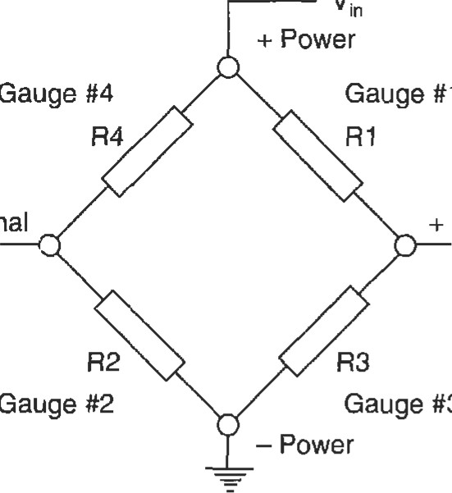

#1

#3

—

Signal

2

Signal

For 350 Q. gauges, CIF = 2. l, Strain in each element =500 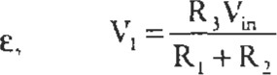and 5.OV Then

 = 2.502625V and 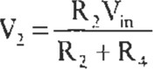

= 2.497375V and

VI - = = 5.25 mV

Figure 11. Wheatstone wiring diagram for beam in bending; calculations for beam in Figure 12.

Full Wheatstone Bridge Compensation Techniques

If the beam in Figure 10 is to be used at elevated (or reduced) temperatures, further compensation for "apparent strain" (eapp) and '%nodulus" may be used to optimize the data for the customer. Apparent strain compensation helps account for strain output resulting from no-load temperature excursions. These extraneous readings are caused by (1) temperamre coemcient of (TCR) changes in the gauges and wiring of the bridge and (2) differences in thermal expansion between the component being insuumented and the gauge itself. Modulus compensation attempts to account for additional extaneous strain output at temperature caused by both changes in the strain sensor's gauge factor (GF) with perature and changes in component modulus of elasücity (E), allowing the data to represent only the due to load. 'Ihis last compensation allows the design engineer to use the data without having to know specific time-temperature history to input varying E and GF values to get n•ue sffess.

As further clarification of this compensation issue, it may be viewed as follows: If the part can be taken through a temperature excursion in a no-load condition and the gauge output remains essentially zero, then the gauge requires no (further) eapp compensation. If the part can be taken through a temperature excursion under load and the gauge output represents accurately the load conditions independent of temperature, then the sensor requires no (further) modulus compensation.

Apparent strain can be corrected by ( 1) using the correct STC (self temperature compensating) gauges, (2) compensating with the addiüon of special wire segments or trimmable bondable foil patterns within the bridge itself, or (3) both. The compensating wire or foil pattern used in (2) and (3) is chosen such that its TCR will serve to balance the undesirable TCR changes in the bridge wiring and gauges. This compensation step is required if the STC gauges don't accurately match the part's coefficient of thermal expansion, or if higher accuracy is required than offered by the generalized STC gauges.

Compensation by addition of wire or foil resistors can be accomplished by starting with a balanced bridge bonded to the component of interest. Attach the bridge to a quality strain output measurement device (it should read very close to zero microsffain if balanced well) and place temperature sensors on the component in various locations. Place the component in an oven, or other environmental chamber, that can duplicate the expected operating temperature. Subject the component to a temperature that will stabilize the gauge/epoxy system (preferably 25 0 to 500F above the expected operating temperature). The part should remain at this temperature until the strain output varies by less than 2 microstrain per hour for two consecutive hours. Return the component to room temperature. When the part is cooled and isothermal, record the strain output. Finally, subject the component to its operating temperature and record the strain output change from the last reading. This is the uncompensated eapp.

At this point resistors of appropriate TCR need to be added to the correct bridge legs to balance the uncompensated eapp. It is known that

AR = R(e) GF

Rewriting and expanding this equation, we see that:

= R(eapp) GF/AT (TCR)

where Rco is the additional compensating resistance to be added, R is the bridge resistance, AT is the change in temperature from room temperature to operating temperature, and TCR is the temperature coefficient of resistance of (e.g., TCRBal = 0.0025 0F-l ). Returning to Figure Il, if the eapp reading showed that V2 had a higher potential than VI, then we can infer that resistance should be added to the leg containing either R4 or R3. After the resistor has been correctly inserted, it is good practice to recheck the eapp at temperature.

Unlike apparent stain compensation, which involves placing a special resistor within the bridge circuit itself, modulus compensation involves placing two resistors, one in each of the power legs leading to the bridge. These resistors should be placed as close to the bridge as possible so as to be within the same thermal environment, thereby responding to temperature changes with resistance changes that adjust the bridge input voltage. Although it is best to test the bridge output at temperature under known load to calculate modulus compensation, it is often not practical. Therefore, the following formula may be used to estimate the resistances required:

##### R(GF2El - GFlE2)

GFIEQ + (GFI x El x TCR (T2 - Tl)) -

|  |
| --- |
| LIQUID LEVEL AND FLUID FLOW MEASUREMENT |

where Rmc = the resistance to be split equally between the positive power and negative power legs (Q), R = the bridge resistance (Q), Tl = room temperature (OF), T2 =bridge operating temperature (OF), El = the component material modulus of elasticity at Tl (psi), E2 = the component material modulus of elasticity at T2, GFI = the gauge factor of the bridge gauges at Tl, GF2 = the gauge factor of the bridge gauges at T2, and TCR = the temperature coefficient of resistance of the compensating resistors (OF-I ).

|  |  |
| --- | --- |
| and practices. | tom systems can be obtained from the reference literature. |
| Liquid Level Measurement |  |

The measurement of liquid level and fluid flow rate is required in virtually all aspects of industrial process control and power generation/conversion. Due to the widespread need for these measurements and the similar nature of virtually all liquid storage and fluid delivery (piping) systems, common sensor solutions are readily available from a well-established vendor base. These sensor packages can meet a wide variety of price and accuracy requirements and can be tailored to almost any liquid, regardless of properties. In addition, much work has been done by the technical societies to standardize on measurement methodologies As a result of these readily available systems and standards, this chapter will not fundamental theory or practices necessary to custom-design specialized sensor packages. Instead, it will simply outline some of the more common level and flow systems available, detailing cost, accuracy, and environmental considerations where applicable and suggesting general rules to use in a selection. The sensor vendors will be familiar with the vast majority of level and flow problems and be able to recommend "offthe-shelf" solutions. Should highly specialized cases occur, additional information on the design and development of cus-

Level sensors relay information regarding the interface between a liquid and a gas (often air) or the interface between two liquids of differing specific gravities. The sensors can be point-specific or continuous-reading. Pointspecific level sensors trip a switch when the liquid interface reaches a set point. These switches might activate alarms, open valves, turn on pumps, etc. Continuous-reading level sensors relay values corresponding to interface position within an operating range. The information from continuous-reading sensors may be used as diagnostic data or as input to a control system.

Level sensors rely on measuring buoyant forces, pressures, timing of ultrasonic pulses, etc., to infer the location of the interface in question. These sensors range from simple floats that move with the interface (as used in a sump pump), to more complex sensors measuring capacitance fluctuations as the fluid changes height between conductive "plates." In this chapter we will quickly compare the following most common level sensors: float, displacer, delta-pressure systems, capacitance, and ultrasonic.

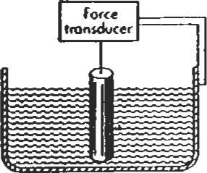The simplefloat sensor relies on the buoyant force of the liquid in question to maintain the float at a specific relation to the liquid interface. In Figure 12 (a) a float switch is attached to a moüon transducer providing a continuous reading system. In the sump pump reference above, the float is attached to a switch, creating a point-specific system. These switches can be designed so that a permanent magnet on the end of the float rod actuates a hermetically sealed reed switch, making a very rugged system. Float sensors are generally economical, rugged, repeatable, and us (b)

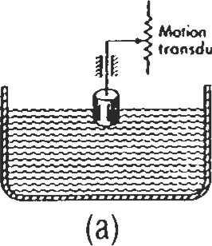

transducer

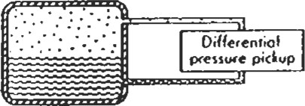 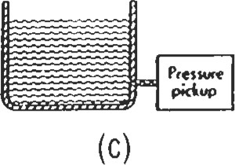 (d)

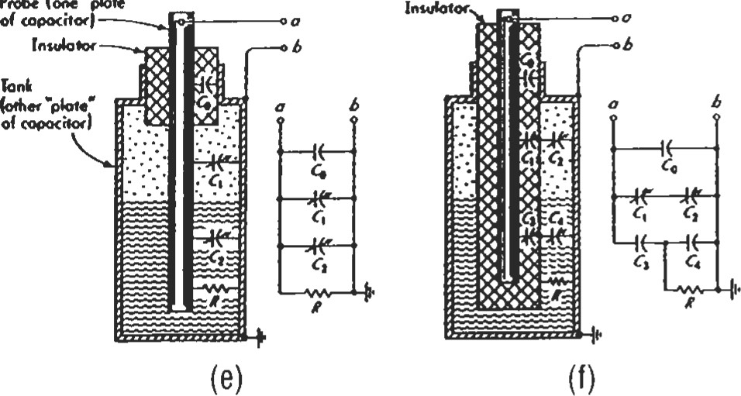

Probe

•pbte-

Figure 12. Various liquid level measurement meters [9]. (Reprinted by permission of McGraw-Hill Book Co.)

able with a wide variety of fluids. They are relatively insensitive to shock and vibration. Some particularily inexpensive float switches, however, may fail after a time in service due to their economical construction. If very low-cost float switches are chosen, it may be prudent to install two independent sensor systems to minimize risks.

The displacer sensor, Figure 12 (b), is related to the simple float in that it relies on the fluid's buoyant force and is usable with many fluids. Unlike the float, however, it does not follow the liquid interface. Instead, the changing interface alters the buoyant force on the quasi-stationary displacer, and that change in force is read on an attached force transducer. The displacer's construction allows for accurate resolution of small level changes, but its force transducer can make it more sensitive to shock and vibration.

Delta-pressure systems, Figures 12 (c) and (d), use the hydrostatic pressure of the liquid to infer the interface location. The pressure force of the column of fluid is a function of the liquid level times the fluid's specific weight. With the open container situation, the pressure gauge should be chosen to measure "gauge pressure." If an absolute pressure gauge were chosen, it would measure the weight of both the liquid and the column of air above it (barometric pressure); changes in the barometer would adversely affect the repeatability of the system.

The pressure vessel situation requires the use of a differential pressure sensor to compensate for the column of vapor over the liquid interface. Both of these techniques can be used in limited slurries and corrosives if proper precautions such as liquid seals, water purge, or air purge are used to isolate the pressure meter from the process.

Capacitance-based sensors use a probe and the wall of the vessel as two plates of a capacitor with the liquid medium between as a dielectric. As the liquid level changes, the effective capacitance between the "plates" is altered in a repeatable manner. For fluids that are nonconducting (dielectric constant < 4) the probe can be inserted directly into the liquid—see Figure 14 (e). For conductive fluids, the probe must be insulated to keep the liquid from short-circuiting the system—see Figure 12 (f). Should the vessel be nonconducting, a second probe can be inserted into the fluid to act as the second capacitor plate.

Capacitance level sensors can be used with many common liquids (including many liquid metals and corrosives) and granular solids. They can be operated through a wide temperature and pressure range. In the case where nuid turbulence is possible, the probe(s) must be designed so as not to move. Even small changes in the probe's position will alter the effective distance between capacitor plates and will appear to the sensor as a level change!

Ultrasonic level sensors transmit and then read high-frequency pressure pulses to infer interface levels. In the case of noncontacting sensors, Figure 13 (a), the ultrasonic beam strikes the fluid surface and the echo is detected by the sensor, creating a continuous reading sensor. As in sonar, the timing of the signals indicates the distance between the probe and the "surface" that created the echo. Some of these sensors utilize additional software that creates a running average of the distance signals being received. New signals are compared to this running average and to new signals; in this way, spurious signals and noise can be

Non-Contact Sensor Contact Sensor

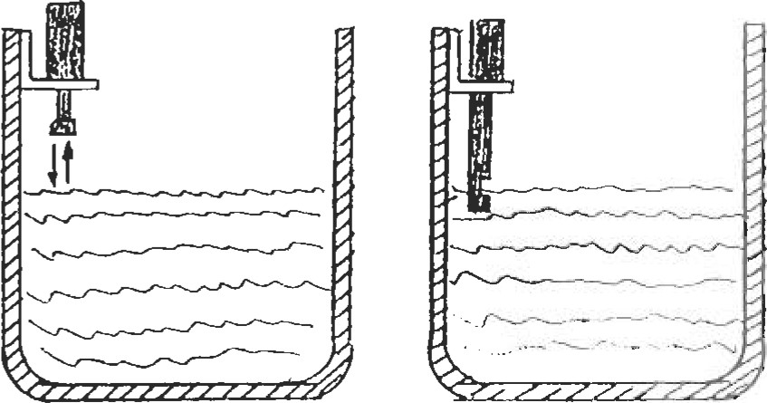

(b)

Figure 13. Ultrasonic liquid level measurement sensors. identified and rejected. As noncontacting sensors, these ultrasonic sensors are of great value when highly corrosive liquids and/or adverse environmental conditions exist. Their accuracy and repeatability, however, drop as a function of the distance between probe and the liquid interface.

Contact ultrasonic sensors, Figure 13 (b), contain a gap between the point at which the high-frequency pulse is generated and a point farther along the probe where that pulse is detected. The sensor is positioned so that the gap is located in a known point in the fluid vessel. When the liquid rises to the point where it fills this gap, the signal eas-

i.ly propagates from the pulse generator to the detector. When the liquid level falls, the signal is attenuated, resulting in a relay switching. In order to compensate for some surface turbulence and agitation, delay logic is built into the probe circuitry so the relay will not switch immediately.

|  |
| --- |
| Fluid Flow Measurement |

These contact sensors are usable with most fluids, however, highly aerated fluids can cause the signal to remain attenuated even when the fluid is filling the gap. Additionally, highly viscous liquids may cause errors should the fluid remain in the gap after the liquid interface level has dropped.

There are an exhaustive number of flow meters available on the market to fit virtually any flow measurement need. The most common flow meters can be divided into the four main areas of differential pressure, positive displacement, velocity, and mass. Differential flow meters include orifice, target, venturi, flow nozzle, pitot tube, elbow, and variable-area meters. Piston, oval gear, and rotary vane meters are types of positive displacement flow meters. Velocity meters include turbine, vortex, electromagnetic, and ultrasonic variations. Finally, Coriolis meters measure the mass rate of flow directly and are the most cornmon of the

mass meters.

The most common flow meter in use today is the orifice meter, primarily because of its wide pressure and temperature operating range, low cost, and reasonable accuracy. In Table 2, a comparison of all of the above meters is outlined, stressing summary characteristics. This table can be used in making an initial selection of the few meters that should be pursued in greater detail for the required application. Should an orifice meter, venturi, or flow meter be selected, ASME has some excellent literature available to aid in the selection and design (e.g., Fluid Meters, 6th ed., ASYfE, 1971, and ASME Power Test Codes, Supplement on Instruments and Apparatus: Part 5, Measurement of Quantity of Materials, Chapter 4: Flow Measurement, copyright 1959). Additional information on the selection and design of custom systems can be obtained from the reference literature.

Orifices are thin, flat plates of metal placed between flanges of the flow-carrying pipe so as to block flow. These plates have specific configuration openings machined into them that allow the flow to pass through. Static pressure taps on each side of the plate allow the measurement of the differential pressure caused by the flow obsfrucüon. By knowing the size and configuration of the opening in the orifice plate and the two pressure readings, the flow rate can be deduced. The orifice is especially subject to errors due to wear and abrasion.

Target meters measure the force imparted on a target placed in the flow. The force is the upstream pressure minus the downstream pressure integrated over the area of the target, and is therefore directly related to the flow rate.

Venturi meters are a section of piping that has a gradually inward-sloping entrance section (approximately 21 0 included angle), a straight section of reduced diameter, and a gradually sloping exit section (approximately 80 included angle). Static pressure measurements taken prior to the entrance section and at the reduced diameter "throat" allow calculadon of the flow rate. The venturi offers reduced abrasion characteristics when compared to the orifice meter.

Flow nozzles are literally nozzles inserted concentrically into the flow path to gradually reduce the pipe area and then dump the flow back to the original pipe diameter. Flow nozzles possess the same general accuracy and resistance to abrasion advantages of the venturi while offering a shorter installed length and a cheaper price. These nozzles, however, are more costly than orifices, have pressure recovery performance between that of the orifice and venturi, and are somewhat difficult to install.

Pitot tubes use total and static pressure readings at a single flow stream, via an inserted probe, to determine flow velocity and flow rates. As stated in the Staüc Pressure Measurement section, it is difficult to measure Ps in a flow field due to flow angle sensitivity of the inserted probes. If the flow field is very well established, pitot tubes that measure total pressure at their tips and static pressure along the

Table 2

Comparison of Flow Meters

|  |  |  |  |  |  |  |  |  |  |  |  |  |  |  |  |
| --- | --- | --- | --- | --- | --- | --- | --- | --- | --- | --- | --- | --- | --- | --- | --- |
| Flow  Meter | GAS |  |  | LIQUIDS |  |  | Approx. max.  temperature  OF | Approx. max. pnssure  (psig) | Accuracy uncalibrated including  &ansmitter | Reynolds number | Ape size, In. | Requlæd upstream pipe, diem. | Pressun | Range | Relative cost |
| clean dirty | clean | dirw | vlscoug | corosive | slurry |
| Orifice, square-edged |  |  | x |  | x |  | to 1 ,OOO  (transmitter to  250) | to 6000 |  | RD > 1,000 | > 1.5 | 10-30 | medium |  | low |
| Target |  |  |  |  | x | x |  |  |  | RD > 100 | > .5-.4 | 10-00 | medium | 4:1 | medium |
| Venturi | x |  | x | x | x | x |  |  | *1-2% URV | RD > 75,000 |  | 5-20 | low | 4:1 | medium |
| Flow noule  Pitot tube | x |  | x | x | x x |  |  |  |  | RD > 10,000 no limit |  | 10-30  20-30 | medium very low | 4:1 | medium low |
| Elbow | x |  | x |  | x | x |  |  |  | RD > 10.000 |  | 30 | very low |  | low |
| Electromagnetic |  |  |  |  |  |  | 360 | 4500 | *0.5% of rate | no limit | .1-72 | 5 | none | 40:1 | hlgh |
| Mass flow meter (codolis) | x |  |  |  | x | x | < 570 | <2000 | *0.4% of rate | no limit |  | none | low | 10:1 | high |
| displacement |  |  |  |  | x |  | gas: 250 liquid: 600 | '1400 | gas: % URV liquid: *0.5% of rate | '8,000 cSt |  | none | high | 10:1 | medium |
| Turbine |  |  |  |  | x |  | 500 | '3000 | gas: *0.5% of rate liquid: % or rate | '2-15 cSt | .25-24 | 5-10 | high | 20:1 | high |
| Ultrasonic  (time of flight) |  |  |  | x |  |  | 500 | pipe rating | URV to  *5% of rate | no limit |  | 5-30 | none | 20:1 | high |
| Ultrasonic  (Doppler) |  |  |  | x |  |  | 250 | pipe rating | of URV | no limit |  |  | none | 10:1 | hlgh |
| Variable area |  |  |  |  | x |  | glass: '400 metal: '1000 | glass: 350 metal: 720 | *0.5% of rate to % URV | to highly viscous fluid |  | none | medium | 10:1 | low |
| Vortex | x |  | x |  | x |  | '750 | 4500 | of rate | > 10,000 | .5-16 | 10-20 | medium | 10:1 |  |

• Designed for this application x Normally applicable

(no symbol) Not designed for this application

*URV: upper range value of the flow (fomeHy full-scale now rate)

Sources: Adapted from Miller by pemlssion of McGraw-Hill Book Co., and Plant Engineering, Nov. 21, 1Æ4, copyright O Cahners Publishlng Co., by

probe bodies can be used. When flow profiles change within the pipe, a single-point pitot tube can show errors due to both improper Ps values and the fact that the single-point measurement no longer represents the üue average velocity. Averaging pitot tubes, which sample multiple locations in the flow, are often used as a more accurate measure of the flow field velocity.

Elbow meters use the principle that fluid flowing along the outer path of a turn will exert a centrifugal force that is proportional to fluid velocity. Static pressure taps are placed in the inner radius and outer radius of the elbow.

Variable-area meters have a float, suspended in a vertical section of slightly diverging "pipe" diameter. The diverging flow section allows flow to pass by the float on the sides. The float's position in that section is a function of the flow rate and always seeks the equilibrium point where the differential pressure on the float is balanced by the force of gravity on the float.

Positive displacement flow meters separate the flow into established sections of known volume as the flow passes through the meter. By counting the throughput frequency of those sections, the flow rate is deduced.

'IUrbine meters utilize a free-wheeling rotor placed within the flow sffeam. As flow rate increases, the rotor speed increases. By measuring the frequency of the rotor, the flow rate can be calculated. Potential error sources for turbine meters include calibration shifts due to blade wear, bearing wear (and its associated increase in friction), and overspeed when packets of vapor enter the meter.

Vortex meters utilize the approximately sinusoidal pressure (and velocity) changes that are caused by moving vortices shed by a bluff-body placed in the flow sfream. The frequency of the vortex shedding is a function of the fluid velocity and, therefore, can be used to determine fluid flow rate.

Electromagnetic now meters use the principle of induction whereby a conductor moving in a magnetic field generates a voltage proporüonal to its velocity through the field. With this sensor, the fluid acts as the conductor and the meter houses the electromagnet that creates the magnetic field. The walls of the pipe contain elecffodes that sense the induced voltage, allowing the fluid velocity to be calculated.

Ultrasonic (time of flight) meters send high-frequency pressure waves across the pipe at an acute angle to the flow. 'Ihe time it takes for the pulse to return is a function of the velocity of the flow as it speeds or slows the signal. The signal is proportional to the average velocity along the line of the pressure pulse. Often, multiple pressure pulse paths are utilized to provide a better average flow rate.

Ulfrasonic (Doppler) meters rely on particulate matter within the flow to reflect the pressure pulse back to the receiver. The frequency of the collected signal is interrogated to determine its shift and, by the Doppler principle, the fluid flow rate is calculated.

|  |
| --- |
| REFERENCES |

Coriolis meters cause the fluid to both translate and rotate about a point which results in Coriolis acceleration. A common form of this meter uses a U-shaped flow tube that is fixed at the ends and vibrated at its natural frequency like a canülever. When the tube is moving upward the fluid flowing into the tube resists the movement by pressing down on the tube. The fluid flowing out of the tube has been forced up and resists moving back down to exit by pressing up on the tube. As the fluid entering presses down and the fluid exiting presses up, the tube twists. During the downward motion of the U-shaped tube, the forces are reversed and the angle of twist reverses also.

1. Gettelman, C. C. and Krause, L. N., 'Consideraüons Entering into the Selection of Probes for Pressure Measurement in Jet Engines," ISA 1952 Proceedings— Paper No. 52-12-1.
2. Moffat, R. J., "The Gradient Approach to Thermocouple Circuitry," originally published by Reinhold Publishing Company in Temperature—lts Measuæment and Control in Science and Industry, Vol. 3, Part 2.
3. Krause, L. N. and Gettelman, C. C., "Effect of Interaction Among Probes, Supports, Duct Walls, and Jet Boundaries on Pressure Measurements in Ducts and Jets," ISA 1952 Proceedings—Paper 52-12-2.
4. Rayle, R. E., "Influence of Orifice Geometry on Static Pressure Measurements," Paper 59-A-234.
5. Miller, R. W., Flow Measuæment Engineering Hmdbook, 2nd Ed. New York: McGraw-Hill Book co., 1989.
6. Availone, E. A. and Baumeister, T., m, Mark's Stmdard Handbook for Mechanical Engineers, 9th Ed. New York: McGraw-Hill Book co., 1978.
7. Buckwith, T. G., Buck, N. L., and Marangoni, R. D., Mechanical Measurements, 3rd Ed., Redding, MA: Addison-Wesley Publishing Co., Inc., 1982.
8. Benedict, R. P., Fundamentals ofTemperature, Pressure, and Flow Measurements, 3rd Ed. New York: John Wiley & Sons, Inc., 1984.
9. Doebelin, E. 0., Measurement Systems Application and Design, 4th Ed. New York: McGraw-ffll Book Co., 1990.
10. Fluid Meters: Their Theory and Application, 6th Ed., ASNE, 1971.
11. ASME Power Test Codes, Supplement on Instruments andApparatus: Part 5, Measurement of Quantity of Materials, Chapter 4: Flow Measurement, copyright 1959.
12. Cheremisinoff, N. P. and Cheremisinoff, P. N., Flow Measurementfor Engineers and Scientists. New York: Marcel Dekker, Inc., 1988.
13. Flow and Level Handbook, Volume 28, Omega Engineering, Inc., 1992.
14. Temperature Handbook, Volume 28, Omega Engineering, Inc., 1992.
15. ANSI/MC96.1-1982, 'Temperature Measurement Thermocouples," ISA, 1982.
16. ANSVASNE: MFC-2M-1983 (R-1988), "Measurement Uncertainty for Fluid Flow in Closed Conduits," Bk. No. K00112, 1983, p. 71.
17. ASME:MFC-3M-1989, "Measurement of Fluid Flow in Pipes Using Orifice, Nozzle, and Venturi," Bk. No. K000113, 1985, p. 63.
18. ANSI/ASME:NFC-4M-1986, "Measurement of Gas Flow by Turbine Meters," Bk. No. K0018, 1986, p. 18.
19. ANSI/ASNE: NFC-5M-1985 (R-1989), 'Measurement of Liquid Flow in Closed Conduit Using Transit 'lime Ulfrasonic Flowmeters," Bk No. K0015, 1985, p. 14.
20. ASNEJANSI: B/FC<M-1987, "Measurement of Liquid Flow in Pipes Using Vortex Flow Meters," Bk. No. K00117, 1987, p. 11.

Instrumentaion

1. ASME: PTC 19.3, "Instruments and Apparatus: Temperature Measurement," (R 1986), Bk. No. C00035, p. 118.
2. ISA-RP16.5, "Installation, Operaüon, Maintenance Insnuctions for Glass Tube Variable Area Meters (Rotameters)," 1961, p. 6.
3. ISA-RP31.1 (ANSVISA RP31.1-1977), "Specification, Installation, and Calibration of Turbine Flowmeten," 1977, p. 21.
4. ISO: R541-1967, "Measurement of Fluid Flow by Means of Orifice Plates and Nozzles."
5. ISO: 3966-1977, 'Measurement of Fluid Flow in Closed Circuits—Velocity Area Method Using Pitot Static Tubes."
6. Bentley, J. P., Principles ofMeasurement Systems, 2nd Ed., White Plains, NY: Longman Scientific & Technical, 1983.
7. John, James, E. (Ed.), Gas Dynamics, 2nd Ed. Needham Heights, MA: Allyn & Bacon, Inc., 1984.

Resources

The following sensor vendors offer excellent technical support:

OMEGA Engineering, Inc. (temperature, pressure, level, flow, data systems, etc.) P.O. Box 2349

Stamford, CT 06906, USA

800-872-9436

Watlow Gordon (temperature measurement products)

5710 Kenosha Street

Richmond, IL 60071, USA

815-678-2211

Measurements Group, Inc. (strain sensors, data systems, etc.)

P.O. Box 27777

Raleigh, NC 27611, USA

919-365-3800

#### Engineering Economics

Lawrence D. Norris, Senior Technical Marketing Engineer—Large Commercial Engines, Allison Engine Company, Rolls-Royce Aerospace Group

Time Value of Money: Concepts and Formulas .... 373

|  |  |
| --- | --- |
| Simple Interest vs. Compound Interest  Nominal Interest Rate vs. Effective Annual | 373 |
| Interest Rate ............  Present Value of a Single Cash Flow To Be Received | 374 |
| in the Future .... | 374 |
| Future Value of a Single Investment | 375 |
| The Importance of Cash Flow Diagrams  Analyzing and Valuing Investments/Projects with | 375 |
| Multiple or Irregular Cash Flows | 375 |
| Perpetuities | 376 |
| Future Value of a Periodic Series of Investments | 377 |
| Annuities, Loans, and Leases ..... ...  Gradients (Payouts/Payments with Constant | 377 |
| Growth Rates) | 378 |

Analyzing Complex Investments and

Cash Flow Problems 379

Decision and Evaluation Criteria for Investments and

Financial Projects380

Payback Method380

Accounting Rate of Return (ROR) Method381

Internal Rate of Return (IRR) Method382

Net Present Value (NPV) Method383 Sensitivity Analysis384

Decision Tree Analysis of Investments and

Financial Projects385 Accounting Fundamentals389

References and Recommended Reading393

372

##### TIME VALUE OF MONEY: CONCEPTS AND FORMULAS

|  |
| --- |
| Simple Interest vs. Compound Interest |

The value ofmoney is not constant, but changes with time. A dollar received today is worth more than a dollar received a month from now, for two reasons. First, the dollu received today can be invested immediately and emen interest. Second, the purchasing power of each will decrease during times of inflation, and consequently a dollar received today will likely purchase more than a dollar next month. Therefore, in the capital budgedng and decision-making process for any engineering or financial project, it is important to understand the concepts ofpresent value, futuæ value, and interest. Present value is the "current worth" of a dollar amount to be received or paid out in the future. Future value is the 'future worth" of an amount invested today at some future dme. Interest is the cost of borrowing money or the retum from lending money. Interest rates vary with üme and are dependent upon both risk and inflation. rate of interest charged, and the rate of return expected, will be higher for any project with considerable risk than for a "safe" invesünent or project. Similarly, banks and investors will also demand a higher rate of return during periods of monetary inflation, and interest rates will be adjusted to reflect the effects of inflation.

Simple interest is interest that is only earned on the original principal borrowed or loaned. Simple interest is calculated as follows:

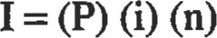

where: 1= simple interest

P = principal (money) borrowed or loaned i = interest rate per time period (usually years) n = number of time periods (usually years)

Exhibit 1

Comparison Between $5,000 Invested for 3 Years at 12%

Simple and 12% Compound Interest

|  |  |  |  |
| --- | --- | --- | --- |
| End of Year | Simple  Interest  Earned | Interest  Cumulative  Interest Earned | Investment Balance |
| 1  2  3 | $0.00  $5,000.00 x .12 = $600.00  $5,000.00 x .12 - $600.00  $5,000.00 x .12 = $600.00 | $0.00  $600.00  $1 ,200.oo  $1 ,800.oo | $5,000.00  $5,600.00  $6,200.00  $6,800.00 |
| End of Year | Compound Interest (Mnual Compounding)  Interest Cumulative  Earned Interest Earned | | Investment Balance |
| 1  2  3 | $0.00 $0.00  $5,000.00 x .12 = $600.00 $600.00  $5,600.00 x .12 = $672.00 $1 ,272.oo  $6,272.00 x .12 = $752.74 $2,024.64 | | $5,000.00  $5,600.00  $6,272.00  $7,024.64 |

Compound interest is interest that is earned on both the and interest. When interest is compounded, interest is earned each üme period on the original principal and on interest accumulated from preceding üme periods. Exhibits 1 and 2 illustrate the difference between simple and compound interest, and show what a dramatic effect interest compounding can have on an investment after a few years.

E)d-tibit 2

Compaison of Simple vs. Compound Interest

Investment

Balance

$90,000

|  |  |  |  |  |  |  |
| --- | --- | --- | --- | --- | --- | --- |
|  |  | |  |  |  |  |
|  |  | +12% Simple Interest  -0-12% Interest  Compounded  Annually | | |  |  |
|  |  |  |  |
|  |  |  |  |
|  |  | |  |  |  |  |
|  |  | |  |  |  |  |
|  |  | |  |  |  |  |
|  |  | |  |  |  |  |
|  | | |
|  | | |  |  |  |  |

$80,000

$70,000

$60,000

$50,000

$40,000

$30,000

$20,000

$10,000

$0

5 10 16 20 26

Investment Length (yearO

|  |
| --- |
| 374  Nominal Interest Rate vs. Effective Annual Interest Rate |

Almost all interest rates in the financial world now involve compound rates of interest, rather than simple interest. Compound interest rates can be quoted either as a nominal rate of interest, or as an effective annual rate of interest. The nominal rate is the stated annual interest rate compounded periodically (at the stated compounding time interval). The effective annual rate is the rate that produces the same final value as the nominal rate, when compounded only once per year. When the compounding period for a stated nominal rate is one year, then the nominal rate is the same as the effective annual rate of interest. The following formula can be used to convert nominal interest rates to effective annual rates:

where: i.eff= effective annual rate inom = nominal rate c = number of compounding periods per year

Note: interest rates are expressed as fractions 12) rather than percentage (12%).

For continuous compounding, natural logarithms may be used to convert to an effective annual rate:

ieff = eicont — I

|  |
| --- |
| c ieff =-1 Note: interest rates are expressed as fractions (.12) rather than percentage (12%).  Present Value of a Single Cash Flow To Be Received in the Future |

where: icont = continuous compounding rate

How much is an amount of money to be received in the future worth today? Stated differently, how much money would you invest today to receive this cash flow in the future? To answer these questions, you need to know the present value of the amount to be received in the future. The present value (PV) can easily be calculated by discounting the future amount by an appropriate compound interest rate. The interest rate used to determine PV is often referred to as the discount rate, hurdle rate, or opportunity cost of capital. It represents the opportunity cost (rate of return) foregone by making this particular investment rather than other alternatives of comparable risk.

The formula for calculating present value is:

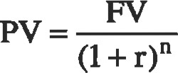

where: PV = present value

FV = future value

r = discount rate (per compounding period) n = number of compounding periods

Example. What is the present value of an investment that guarantees to pay you $ 100,000 three years from now? The first important step is to understand what risks are involved in this investment, and then choose a discount rate equal to the rate of retum on investments of comparable risk. Let's say you decide that 9% effecüve annual rate of interest (9% compounded annually) is an appropriate discount rate.

$100,000

3 = $77,218

(1 + .09)

Thus, you would be willing to invest $77,218 today in this invesment to receive $100,000 in three years.

|  |
| --- |
| Future Value of a Single Investment |

Rearranging the relationship between PV and FV, we have a simple formula to allow us to calculate the future value of an amount of money invested today:

Enmple. What is the future value of a single $10,000 lump sum invested at a rate of return of 10% compounded monthly (10.47 effective annual rate) for 5 years? Note that monthly compounding is used in this example.

where: FV = future value

PV = present value r = rate of return (per compounding period) n = number of compounding periods

FV = $10,000 (1 + .10/12)60 = $16,453

|  |  |  |
| --- | --- | --- |
| |  |  | | --- | --- | | The Importance of Cash Flow Diagrams |  |   Many financial problems are not nearly as simple as the $1 oo,ooo two previous examples, which involved only one cash outflow and one cash inflow. To help analyze financial problems, it is exü•emely useful to diagram cash flows, since most prob lems are considerably more complex than these previous ex- |

|  |  |  |  |
| --- | --- | --- | --- |
| 1 |  | 2 |  |
|  | years æ90/o |  | 3 |

The $10,000 investment grows to $16,453 in five years.

amples, and may have mulfiple, repetitive, or irregular cash flows. The cashflow diagram is an imporünt tool which will help you understand an investment project and the ti.ming of its cash flows, and help with calculad.ng its PV or FV. The cash flow diagram shown represents the earlier example (in which PV was calculated for an investment that grew to $100,000 after annual compounding at 9% for 3 years).

|  |
| --- |
| Analyzing and Valuing InvestmenWProjects with Multiple or Irregular Cash Flows |

The cash flow diagram is divided into equal time periods, which correspond to the compounding (or payment) periods of the cash flows. Note that this diagram is also presented from the investor's (lender's) point of view, since the initial investment is a cash outflow (negafr.ze) and the final payoff is a cash inflow (positive) to the investor. The diagram could also have been drawn from the borrower's point of view, in which case the PV would be a cash inflow and therefore positive. Before drawing a cash flow diagram, you must first choose which viewpoint (lender or borrower) the diagram will represent. It is then extremely important to give each cash flow the correct sign (posiüve or negative), based upon whichever point of view is chosen. Other examples of cash flow diagrams will be presented in additional sample problems in this chapter.

Many investrnents and financial projects have multiple, periodic, and iregular cash flows. A cash flow diayam will help in understanding the cash flows and with their analysis. The value of the investment or project (in current dollars) may then be found by discounting the cash flows to determine their present value. Each cash flow must be discounted individually back to time zero, and then summed to obtain the overall PV of the invesment or project. This discounted cashflowformula may be written as:

376

###### pv=E

where: PV = present value

Ci = cash flow at time i n = number of periods r = discount rate of return (opportunity cost of capital)

|  |  |
| --- | --- |
| Step 1: Cash flow diagram: | Thus, you should be willing to invest a maximum of $5,044.74 in this project. |
| Perpetuities |  |

Example. How much would you be willing to invest today in a project that will have generated positive annual cash flows of $1,000, $1,500, $2,400, and $1,600, respectively, at the end of each of the first 4 years? (Assume a 10% annual rate of return can be earned on other projects of similar risk.)

2400

|  |  |  |  |
| --- | --- | --- | --- |
| 1000 | 1500 |  |  |
|  |  | | |

1600

PV=7

Step 2: Discount cash flows into current dollars (present value):

1,000 1,500 2,400 1,600

(l + .1)1 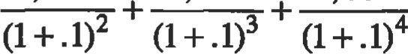

= $5, 044.74

A perpetuity is an asset that provides a periodic fixed amount of cash flow in perpetuity (forever). Endowments and trust funds are often set up as perpetuities, so that they pay out a fixed monetary amount each year to the beneficiary, without depleting the original principal. For valuation purposes, some physical assets such as an oil well, natural gas field, or other long-lived asset can also be ü•eated as a perpetuity, if the asset can provide a steady cash flow steam for many years to come. The cash flow diagram for a perpetuity is represented here:

C (equal cash flow each period)

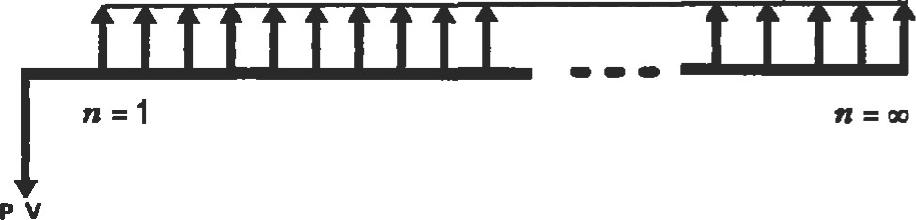

The value of a papetuity can be found by fris simple forrnula:

c

PV ¯

perpetuity r

where: C = cash flow per period r = discount rate of return (per time period)

A gmwing perpetuity is a cash flow stream that grows at a constant rate. The formula to value a growing perpetuity expands the basic perpetuity formula to include a growth rate for the cash flow stream:

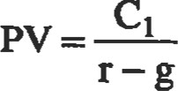

where: Cl = iniüal cash flow r = discount rate of retum (per time period) g = growth rate of cash flows (per dme period)

Ern.le. An oil well has been producing an average of 10,000 barrels per year for seva•al yem•s. Recent estimates by geologists show that ülis well's oil field is not large enough to jusüfy addiüonal drilling, but can maintain the existing well's production rate for hundreds of years to come. Assume that the recent price of oil has averaged $20 per barrel, oil prices are historically estimated to grow 3% a year forever, and your discount rate is 10%. Also assume that nuintenance costs me insignificant, and die land has no value other than for the oil. What is the current monetary value of this oil field and well, if the owner were to sell it?

Solution:

(10,000 x 20)

= $2, 857,143

.10-.03

|  |  |  |  |  |  |  |  |  |  |  |  |  |  |  |  |  |  |  |  |  |  |  |  |  |  |  |  |  |  |  |  |  |  |  |  |  |  |  |  |  |
| --- | --- | --- | --- | --- | --- | --- | --- | --- | --- | --- | --- | --- | --- | --- | --- | --- | --- | --- | --- | --- | --- | --- | --- | --- | --- | --- | --- | --- | --- | --- | --- | --- | --- | --- | --- | --- | --- | --- | --- | --- |
| Future Value of a Periodic Serles of Invesmenb   |  |  | | --- | --- | | Both individual investors and companies often set aside a fixed quantity of money every month, quarter, or year, for some specific purpose in future. This quantity of money then grows with compound interest until it is with&awn and used at some future date. A cash flow diagram for a periodic investment is shown. | where: C = cash flow invested each time period r = fractional compound interest rate (each üme period) t = number of time periods (length of investment)  Example. A self-employed contract engineer has no company-paid retirement plan, so he decides to invest $2,000 per year in his own individual retirement account (RA), |  |  |  |  |  |  |  |  |  |  |  |  |  |  |  | | --- | --- | --- | --- | --- | --- | --- | --- | --- | --- | --- | --- | --- | --- | | 0 1 2 | | | | | | | | | | | | | | |  |  |  |  |  |  |  |  |  |  |  |  |  |  |   which will allow the money to accumulate tax-free unül it is withdrawn in the future. If he invests this amount every year for 25 years, and the invesünent eams 14% a year, how much will the invesünent be worth in 25 years?   |  |  | | --- | --- | | C (fixed investment each ime period) | Solution: | | It can easily be calculated how much these periodic, | $2, 000  + .14)25 - = $363,742 | | fixed  each period will accumulate with compounding inta•est to be in the future. In other words, we | .14 | | want to determine the future value (FV), which can be cal- | The periodic investment of $2,000 each year over 25 years | | culated using the following formula: | will grow to $363,742 if a 14% rate of return is achieved. This example the "power of compounding." A |   total of only $50,000 was invested over the 25-year period, yet the future value grew to over 7 times this amount.  Annuities, Loans, and Leases |

The value of the oil field and well should be $2,857,143 based upon these assumptions.

An annuity is an asset that pays a constant periodic sum of money for a fixed length of Bank loans, mortgages, and many leasing conu-acts are similar to an annuity in that they usually require the borrower to pay back the lender a constant, periodic sum of money (principal and interest) for a fixed length of Loans, mortgages, and leases can therefore be considered "reverse" annuities, as shown by the cash flow diagrams.

37B

Cash Flow Diagrams: Annuity

C (lovel cash now •ach period)

|  |  |  |  |  |  |  |  |  |  |  |  |  |  |  |  |  |
| --- | --- | --- | --- | --- | --- | --- | --- | --- | --- | --- | --- | --- | --- | --- | --- | --- |
| o |  |  |  |  |  |  |  |  |  |  |  |  |  |  |  |  |
|  | | | | | | | | | | | | | | | | |

PV

Cash Flow Diagrams: Reverse Annuity

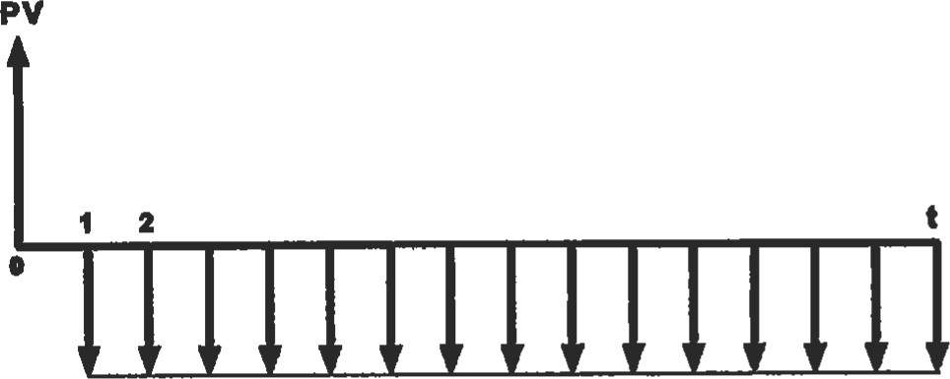

C (level cash flow each period)

The relationship between the value (PV) of the annuity/loan/lease, its periodic cash flows, and the interest or discount rate is:

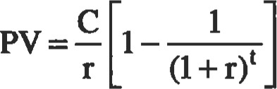

where: C = cash flow received/paid each time period r = interest or discount rate (per time period) t = number of time periods (üme length of the annuity)

This formula may be used to determine the PV of the annuity, or conversely, to determine the periodic payouts or payments when the PV is known. It should be noted that the future value (FV) at time "t" will be zero. In other words, all the principal of the annuity will have been expended, or all the principal of the loan or lease will have been paid off, at the final fime period. Financial calculators are also pre-programmed with this formula, and can simplify and expedite annuity, loan, and other cash flow problem calculations.

Example. Oil pipeline equipment is to be purchased and installed on a working pipeline in a remote location. This new equipment will have an operational life of 5 years and will require rouüne maintenance once per month at a fixed cost of $100. How much would the oil company have to deposit now with a bank at the remote locaüon to set up an annuity to pay the $100 a month maintenance expense for 5 years to a local contractor? Assume annual interest rates are 9%.

Solution:

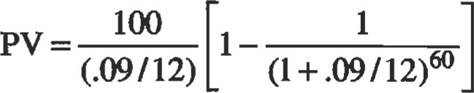= $4,817.34

Example. Apex Corp. borrows $200,000 to finance the purchase of tools for a new line of gears it's producing. If the terms of the loan are annual payments over 4 years at 14% annual interest, how much are the payments?

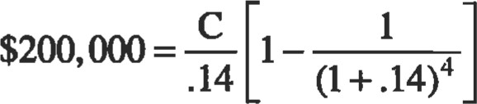

Solution:

|  |
| --- |
| Gradients (Payouts/Paymenb with Constant Growth Rates) |

C = $68,640.96 per year

A gradient is similar to an annuity, but its periodic payouts increase at a constant rate of growth, as illustrated by its cash flow diagram. A gradient is also similar to a growing perpetuity, except that it has a fixed length. nie cash flow diagram for a gradient loan or lease is simply the inverse of this cash flow diagram, since the Ioannease payments will be negative from the borrower's point of view. The PV of a gradient may be found by:

Constant Growth Rate g

|  |  |  |  |  |  |  |  |  |  |  |
| --- | --- | --- | --- | --- | --- | --- | --- | --- | --- | --- |
| c |  |  |  |  |  |  |  |  |  |  |
|  | time period | | | | | | | | | |

Gradient

|  |
| --- |
| where: Cl = inü cash flow at the end of first time period when g r r = rate of retum (discount rate) n = number of time periods or g = fractional yowth rate of cash flow per period when g = r  Analyzing Complex Investnents and Cash Flow Problems |

No matter how complex a financial project or invesünent is, the cash flows can always be diagrammed and split apart into separate cash flows if necessary. Using the discounted cash flow (DCF) formula, each cash flow can be discounted individually back to dme zero to obtain its present value (PV), and then summed to determine the overall valuation of the project or investment. It may also be possible to simplify things if you can identify a series of cash flows in the complex invesünent. Cash flow series can be discounted using either annuity or perpetuity formulas, and then added together with the PV of any singular cash flow.

When analyzing any complex cash flow problem, it is important to remember the basic time value of money (TVM) concept (i.e., the value of money changes with time). Therefore, if you wish to add or compare any two cash flows, they both must be from the same time period. Cash flows in the future must be discounted to their present value (PV) before they can be added or compared with current cash flows. Alternatively, current cash flows can be compounded into the future (FV) and then added or compared with future cash flows.

Example. An automofr,'e components company has been asked by a large automobile manufacturing company to increase its production rate of components for one particular car model. Sales of this car model have been much higher than expected. In order to increase its production rate, the components company will have to purchase additional specialized machinery, but this machinery will easily fit into its existing facility. The automobile manufacturer has offered to sign a contract to purchase all the additional output that can be produced for 4 years, which will increase annual net revenues by $300,000 without any additional administrative overhead or personnel expense. The added

machinery will cost $450,000 and will require maintenance every 6 months at an estimated cost of $20,000.

The machinery will be sold at the end of the 4-year period, with an estimated salvage value of $80,000. Ifthe company requires a minimum rate of return of 20% on all investments, should it sign the contract, purchase the machinery, and increase its production rate ? (Depreciation and tax effects are not considered in this example.)

Step 1: From the point of view of the automotive components company, the cash flow diagram will be:

$ 3 8 O K

|  |  |  |  |  |  |  |  |  |  |  |
| --- | --- | --- | --- | --- | --- | --- | --- | --- | --- | --- |
| o | .5 | $300  1 | K | 1.5 | $ 3  2 | 0 0 K | 2.5 | $ 3 0 0  3 | K | 3.5 |
|  | $20 K | $ 20K | | $20K | $ 20K | | s 20 K | S 20 K | | 4 yr.  *20K |

$ 460 K

Step 2: Separate the overall cash flow diagram into individual components and series, and then determine the PV of each future cash flow or series of flows by discounting at the required annual rate of return of 20%:

ANNUITY

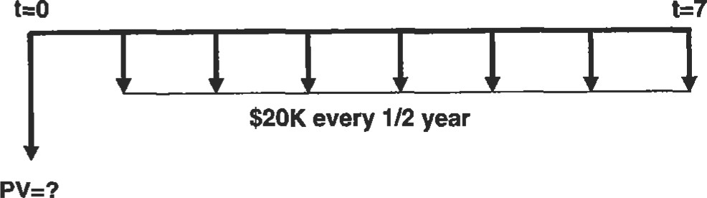

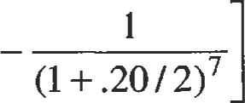$20, 000

PV1 = $97, 368 (negative)

.20/2

380 numb

ANNUITY

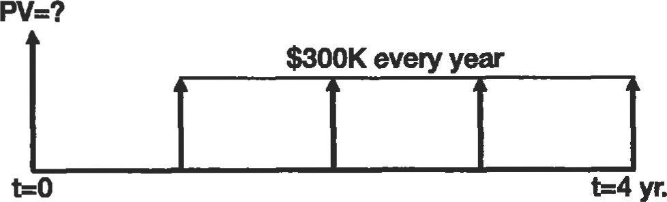

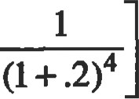$300,000

1-= $776,620 (positive)

.2

SINGLE CASH FLOW FROM SALVAGE VALUE

$80K

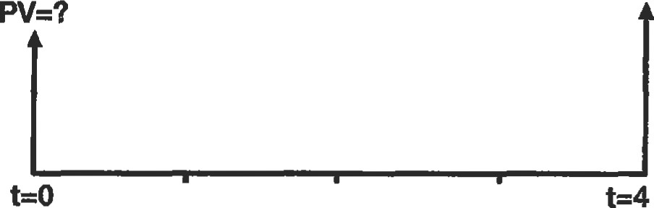yr.

$80,000

  = $38, 580 (positive)

4

(1 + .2)

Step 3: Sum the PV of all cash flows to obtain the project's overall PV from allfuture cash flows:

PV = $776,620 + $38,580 - $97,368

= $717,832 (positive)

Step 4: Compare the PV of the future cash flows with the project's initial cash flow (initial investment):

The $717,832 PV of the project's future cash inflows (positive) is clearly greater than the $450,000 (negative) initial investment. Thus, this project has a positive netpresent value (NPV) because the PV of the future cash flows are greater than the initial A positive NPV means that the rate of return on the invesment is greater than the rate (20%) which was used to discount the cash flows.

|  |
| --- |
| DECISION AND EVALUATION CRITERIA FOR INVESTMENTS AND FINANCIAL PROJECTS |

Conclusion: The company should buy the additional machinery and increase its production rate.

|  |
| --- |
| Payback Method |

How should you decide whether or not to make an investment or go forward with a financial project? If you also have a number of alternative investment how do you decide which is the best alternaüve? How do you evaluate an invesment's performance some time period after die invesment has been made and the project is up-and-running? There are a number of analysis techniques that can help with these quesüons. Four separate methods are presented here, although each method varies in its effectiveness and complexity. There are also additional methods and techniques that can be found in other engineering economics, finance, and accounüng textbooks. However, most modem books and courses in these fields of study recommend the net present value (NPV) method as the most effective and accurate technique of evaluating potential investments and financial projects. Accounting measures such as rate ofretum (ROR) on an investnent or ætum on equity (ROE) are useful to evaluate a project's financial results over a specific time period, or to compare results against competitors.

'Ihe payback method is a simple technique diat determines the number of years before the cash flow from an investment or project "pays back" the iniüal investment. Obviously, the shorter the length of time it takes a project to pay off the initial investment, the more lucrative the project.

Enn.le. A company wants to add a new product line and is evaluating two types of manufacturing equipment to produce this new line. The first equipment type costs $700,000 and can produce enough product to result in an estimated $225,000 in additional after-tax cash flow per year. The second type of equipment is more expensive at $900,000, but has a higher output that can bring an estimated $420,000 per year in after tax cash flows to the company.

Which type of equipment should the company buy?

Based upon this payback analysis, equipment type 2 should be purchased.



|  |  |
| --- | --- |
| Solution:  Equipment Type 1  Payback Period =  per year  = 3.11 years  Equipment "IYpe 2  Payback Period =  per year  = 2.14 years | advantages that need to be mentioned. First, the payback method does not evaluate any cash flows that occur after the payback date, and therefore ignores long-term results and salvage values. Secondly, the payback method does not consider the time value of money (NM), but assumes that each dollar of cash flow received in the second year and beyond is equal to that received the first year. Thirdly, the payback method has no way to take into account and evaluate any risk factors involved with the project. |
| Accounting Rate of Return (ROR) Method |  |

The advantage of the payback method is its simplicity, as shown in the example. However, there are several dis-

The accounting rate ofreturn for an existing company or project can be easily calculated directly from the company's or project's quarterly or annual financial accounting statements. If a (rather than exisüng) project is to be evaluated, financial results will have to be projected. Since ROR is an accounting measure, it is calculated for the same üme period as the company or project's income statement. The rate of retum on an invesünent is simply the net income generated during this time period, divided by the book value of the investment at the start of the time period.

Net Income

R.O.R. =

Net Investment (book value)

Net income is an accounting term which is defined as 'fevenues minus expenses plus gains minus losses" (i.e., the "bottom line" profit or loss on the income statement). Net investment is the "book value" of the investment, which is the original investment amount (or purchase price) less any depreciation in value of the investment.

Ex—e. Company XYZ invested $500,000 in plant and equipment four years ago. At the end of year 3, the company's financial statements show that the plant and equipment's value had depreciated $100,000, and had a listed book value of $400,000. If company XYZ has a net income of $60,000 during its 4th year of operation, what is its ROR for this time period?

Solution:

60, 000

R.O.R. = -0.15 (15%)

400,000



Like the payback method, the advantage of the accounting ROR is that it is a simple calculation. It is especially simple for an existing company or project when the accounting statements are already completed and don't have to be projected. One disadvantage of ROR is that it doesn't consider TVM when it is used for more than one üme period. It also uses accounting incomes rather than cash flows, which are not the same (see Accounting Fundamentals in this chapter). Another disadvantage is that ROR is a very subjective method, because the ROR is likely to vary considerably each time period due to revenue and expense flucmations, accumulating depreciaüon, and declining book values. (Some textbooks recommend averaging ROR over a number of time periods to compensate for fluctuations and declining book values, but an "averaged" ROR still does not consider TVM.)

In general, accounting measurements such as ROR are best used for evaluating the performance of an existing company over a specific annual or quarterly time period, or for comparing one company's performance against another. Net present value (NPV) and internal rate of return (IRR) are superior methods for evaluating potential investments and financial projects, and in making the final decision whether to go ahead with them.

|  |
| --- |
| 382  Internal Rate of Return (IRR) Method |

Internal rate of return (IRR) is an investment profitability measure which is closely related to net present value (NPV). The IRR of an investment is that rate of return which, when used to discount an invesment's future cash flows, makes the NPV of an investment equal zero. In other words, when the future cash flows of an investment or project are discounted using the IRR, their PV will exactly equal the initial investment amount. Therefore the IRR is an extremely useful to know when you are evaluating a potential investment project. The IRR tells you the exact rate of return that will be earned on the original investment (or overall project with any additional investments) if the projected future cash flows occur. Similarly, when analyzing past investments, the IRR tells you the exact rate of return that was earned on the overall investment. The IRR decision rule for whether or not to go ahead with any potential investment or project being considered is simple: If the IRR exceeds your opportunity cost of capital (rate of return that can be earned elsewhere), you should accept the project.

The following example will make it clear how the IRR of an investment is calculated. It is highly recommended that a cash flow diagram drawn first before üying to calculate the IRR. Particular attention should be paid to make sure cash inflows are drawn as posidve (from the investor's point of view) and cash outflows are drawn as negative. It is also recommended that a financial calculator (or computer) be used to save time, otherwise an iteration procedure will have to be used to solve for the RR.

Example. Acme Tool and Die Company is considering a project that will require the purchase of special machinery to pmduce precision molds for a major customer, Gigantic Motors. The project will last only four years, after which Gigantic Motors plans to manufacture its own precision molds. The initial investment for the special machinery is $450,000, and the machinery will also require a partial overhaul in three years at an estimated cost of $70,000. Projected after-tax cash flows resulting from the project at the end of each of the four years are $140,000, $165,000, $185,000, and $150,000, respecfrvrely. These projections are based upon a purchase agreement that Gigantic is prepared to sign, which outlines the of molds it will buy. Expected salvage value from the machinery at the end of the four-year period is $80,000.

Should Acme proceed with this project, if its opportunity cost of capital is 23%?

Step 1: Cash flow diagram:

$80K

$150K

$185K

|  |  |  |  |  |  |  |
| --- | --- | --- | --- | --- | --- | --- |
| $140K |  |  | $165K |  |  |  |
|  | | 2 | | 3  $70K | | 4 |

$450K

Step 2: Write an equation which sets the original invesünent equal to the PV of future cash flows, using the discounted cash flow formula. Solve for r, which is the IRR. (This is a simple process with a financial calculator or computer, but otherwise requires iteration with any other calculator).

140,000 165,000 (185,000 -70,000)

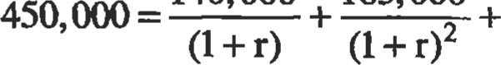

(150,000 + 80, 000)

Solving for r uR):

IRR = 0.1537 (15.37%)

Step 3: Apply decision rule to results: Since the RR for this project is 15.37%, and Acme's required rate of return (oppormnity cost of capital) is 23%, Acme should not proceed with this project.



RR has a number of disünct advantages (as does NPV) over both the payback and ROR med10ds as a decision-making tool for evaluating potential investments. The first advantage is that the RR calculation takes into account TVM. Secondly, RR considers all cash flows throughout the life of the project (including salvage values), rather than looking at only one time period's results like accounüng ROR does, or the years until the initial invesünent is paid off like the payback method. Therefore, IRR is an objective crit+ rion, rather than a subjective criterion, for making decisions about investment projects. Thirdly, IRR uses actual cash flows than accounüng incomes like the ROR method. Finally, since RR is calculated for the enfre life of the project, it provides a basis for evaluating whether the overall risk of the project is justified by the IRR, since the IRR may be compared with the IRR of projects of similar risk and the opportunity cost of capital.

'Ihe IRR method has several disadvantages compared to the NPV though only one disadvantage is mentioned here for purposes of brevity. Further information about potential problems with the IRR method (compared to NPV) may be obtained from most finance textbooks. One major problem with IRR is the possibility of obtaining mulüple rates of return (multiple when solving for the RR of an investment. This can occur in the unusual case where cash flows change erratically from positive to negative (in large quantities or for sustained periods) more than once during the life of the investment. The graph in the following example illustrates how multiple RR roots can occur for investments with these types of cash flows. The second gaph is for comparison purposes, and typifies the IRR calculation and graph for most investments. (Normally, NPV declines with increasing discount rate, thus giving only one IRR "root".) When multiple "roots" are obtained using the RR it is best to switch to the NPV method and calculate NPV by discounting the cash flows with the opportunity cost of capital.

Example. A project under consideration requires an initial investment/cash flow of $3,000 (negative) and then has cash flows of $26,000 (positive) and $30,000 (negative) at the end of the following two years. A graph of NPV versus discount rate shows that two different IRR "roots" exist. (IRR is the point on the curve that intersects the hor-

Illustration of Multiple I.RRs

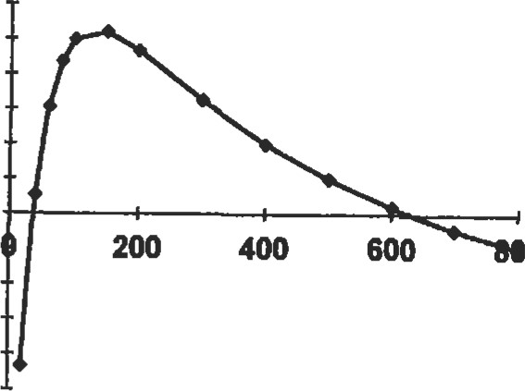

(This

Example)

Discount

Rate

(%)

3000

2500

2000

1500

1000

500

NPV

(S)

o

-500

-1000

-1500

-2000

-2500

Illustration of Single I.R.R. Root

(Previous Example - Acme Tool & Die)

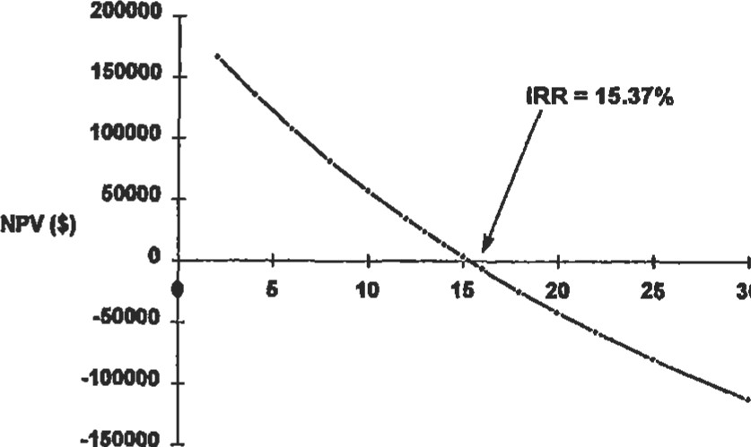

30

Discount Rate (%)

izontal axis at NPV = O.) The second graph is from the previous example, showing that most "normal" investments have only one IRR root.

|  |
| --- |
| Net Present Value (NPV) Method  Net present value (NPV), as its name suggests, calculates n the net amount that the discounted cash flows of an investment exceed the initial investment. Using the discounted cash flow (DCF) formula, the future cash flows are discounted by the rate of return offered by comparable in- where: Co = initial cash flow (negative for a cash "outflow") vestment alternatives (i.e., the opportunity cost of capi- Ci = cash flow in time period i tal), and then summed and added to the initial investment n = number of time periods amount (which is usually negative). r = opportunity cost of capital/discount rate |

The IRR for this example is both 37.1% and 629.6%, as NPV equals zero at these two discount rates.

Though similar to the IRR method, NPV does not calculate an investment's exact rate of return, but instead calculates the exact dollar amount that an investment exceeds, or fails to meet, the expected rate of retum. In other words, if an investment provides a rate of return exactly equal to the opportunity cost of capital, then the NPV of this investment will be zero because the discounted future cash flows equal the iniüal investment. Thus, NPV provides an excellent decision criterion for investments. An investment with a positive NPV should be accepted, since it provides a rate of return above the opportunity cost of capital. By the same reasoning, an investment with a negative NPV should be rejected. NPV also does not suffer from any of the drawbacks of the payback, accounting ROR, or RR methods. Because of this, NPV is the method most recommended by financial experts for making investment decisions. IRR is still useful to determine the exact rate of return for an investment, but NPV has none of the problems that IRR may have with unusual investments (such as the "multiple root" problem illustrated previously).

The following example shows how NPV is used to decide between investment alternatives.

Example. A company must choose between two alternative manufacturing projects, which require d.iffeænt amounts of capital investment and have different cash flow patterns. The company's opportunity cost of capital for projects of similar risk is 15%. Which project should it choose?



Project

A -$125,000 $31,000 $43,000 $48,000 $51 ,ooo B -$210,000 $71,000 $74,000 $76,000 $79,000

Solving with the NPV formula:

NPV(A) = -$4,809

NPV(B) = $2,833

|  |
| --- |
| SENSITIVITY ANALYSIS |

Conclusion: The company should choose project B. Despite a higher iniüal cost than A, Project B earns $2,833 more than its required rate of remm of 15%. Incidentally, RR also could have been used, since future cash flows are all positive, and therefore no multiple roots exist. Project A's IRR is 13.23%; Project B's IRR is 15.65%.

The previous secüons of this chapter show how to analyze investments and financial projects. These analysis methods can help quantify whether or not an investment is worthwhile, and also help choose between alternative invesünents. However, no matter what method is used to analyze a financial project, that method, and the decision about the project, will ultimately rely upon the projections of the project's future cash flows. It is, therefore, extremely important that the future cash flows of any financial prow ject or invesment under consideraüon be forecast as accurately and realistically as possible. Unfortunately, no matter how precise and realisüc you try to be with your projections of cash flows, the future is never certain, and actual results may vary from what is projected. Ihus, it is often useful to perform a sensitivity analysis on the investment or financial project.

Sensitivity analysis is a procedure used to describe analytically the effects of uncertainty on one or more of the parameters involved in the analysis of a financial project. The objective of a sensitivity analysis is to provide the decision maker with quantitative information about what financial effects will be caused by variations from what was projected. A sensitivity analysis, once performed, may influence the decision about the financial project, or at least show the decision maker which parameter is the most critical to the financial success of the project. The NPV method lends itself nicely to sensitivity analysis, since the discount rate is already fixed at the opportunity cost of capital. One parameter at a time can be varied in steps (while the other parameters are held constant) to see how much effect variance has on NPV. A financial calculator or computer spreadsheet program will greatly expedite the multiple, repetitive calculations involved in this analysis. Plotting the results graphically will help show the sensitivity ofNPV to changes in each variable, as illustrated in the following example.

Example. A-I Engineering Co. is contemplaüng a new project to manufacture sheet metal parts for the aircraft industry. Analysis of this project shows that a $100,000 invesünent will be required up front to purchase additional machinery. The project is expected to run for 4 years, rein estimated after-tax cash flows of $30,000 per year. Salvage value of the machinery at the end of the 4 years is estimated at $32,000. A-I 's opportunity cost of capital is 15%. Perform a sensitivity analysis to determine how variations in these estimates will affect the NPV of the project.

Step 1: Cash flow diagram:

$62K

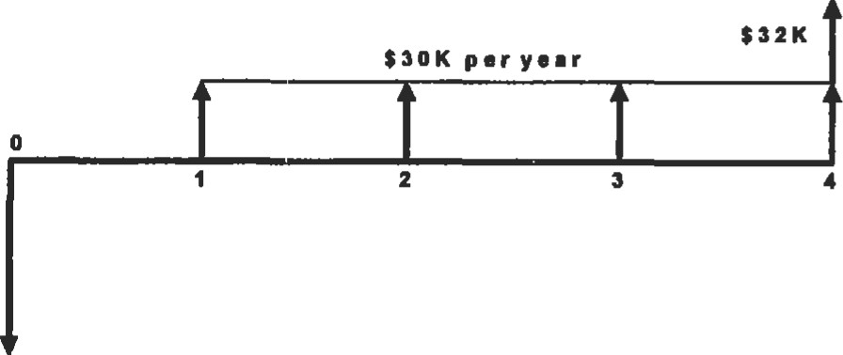

$100K

Step 2: Calculate baseline NPV:

30,000 30,000 30,000



 1 (1 + .15)2 + (1 + .15)

(1 + .15)

62,000

4 = $3,945.45

(l + .15)

Step 3: Change salvage value, annual cash flow revenues, and initial investment amount in steps. Calculate NPV for each step change.

Step 4: Plot values to illustrate the NPV sensitivity to changes in each variable.

Change in NPV ($) Caused by % Change in Parameter Value ($)

30000

|  |  |  |  |  |  |
| --- | --- | --- | --- | --- | --- |
|  |  |  | NPV (S) |  |  |
|  |  |  |  |  |  |
|  |  |  |  |  |  |
|  |  |  |  |  |
|  |  |  |  |  | %Change |
|  | |  |  |  |  |
|  |  |  |  |  |  |
|  |  |  |  |  |  |
|  | *Initlal Investment OSatvage Value  &Annua1 Revenues | |  |  |  |
|  |  |  |  |

25000

20000

15000

10000

-10000

-15000

-20000

-25000

-20 10 20 30

|  |
| --- |
| DECISION TREE ANALYSIS OF INVESTMENTS AND FINANCIAL PROJECTS |

Conclusion: The graph shows that this project's NPV is equally sensitive to changes in the required iniüal investment amount (inversely related), and the annual revenues (after-tax cash flow) from the project. This is easily seen from the slope of the lines in the graph. The graph also shows that NPV is not affected nearly as much by changes in salvage value, primarily because the revenues from salvage value occur at the end of the fourth year, and are substantially discounted at the 15% cost of capital. In conclusion, this sensitivity analysis shows A-I Machinery that it cannot accept anything more than a 5% increase in the initial cost of the machinery, or a 5% decrease in the annual cash flows. If these parameters change more than this amount, NPV will be less than zero and the project will not be profitable. Salvage value, however, is not nearly as critiCal, as it will take more than a 20% decrease from its estimated value before the project is unprofitable.

Financial managers often use decision trees to help with the analysis of lace projects involving sequenüal decisions and variable outcomes over time. Decision trees are useful to managers because they gaphically portray a large, complicated problem in terms of a series of smaller problems and decision branches. Decision trees reduce absu-act thinking about a project by producing a logical diagram which shows the decision options available and the corresponding results of choosing each option. Once all the possible outcomes of a project are diagrammed in a decision tree, objective analysis and decisions about the project can be made.

Decision also allow probability theory to be used, in conjunction with NPV, to analyze financial projects and investments. It is often possible to estimate the probability of success or failure for a new venture or project, based upon either historical data or business experience. If the new venture is a success, then the projected cash flows will be considerably higher than what they will be if the project is not successful. The projected cash flows for both of these possible outcomes (success or failure) can then be multiplied by their probability estimates and added to determine an expected outcome for the project. This expected outcome is the average payoff that can be expected (for multiple projects of the same type) based upon these probability estimates. Of course, the actual payoff for a single financial project will either be one or the other (success or

failure), and not this average payoff. However, dis average expected payoff is a useful number for decision making, since it incorporates the probability of both outcomes.

If there is a substantial time lapse between the time the decision is made and the time of the payoff, then the time value of money must also be considered. The NPV method can be used to discount the expected payoff to its present value and to see if the payoff exceeds the iniüal invesment amount. The standard NPV decision rule applies: Accept only projects that have positive NPVs.

The following example illustrates the use of probability estimates (and NPV) in a simple decision tree:

Enmple. A ücket scalper is considering an investment of $ 10,000 to purchase tickets to the finals of a major outdoor tennis tournament. He must order the ückets one year in advanqe to get choice seats at list price. He plans to resell the ückets at the gate on the day of the finals, which is on a Sunday. Past experience tells him that he can sell the ückets and double his money, but only if the weather on the day of the event is good. If the weather is bad, he knows from past experience that he will only be able to sell the dckets at an average of 70% of his purchase price, even if the event is canceled and rescheduled for the following day (Monday). Historical data from the Farmer's Almanac shows that there is a 20% probability of rain at this time of year. His opportunity cost of capital is 15%. Should the ticket scalper accept this financial project and purchase the tickets?

Step 1: Consüuct the decision tree (very simple in this example).

Pecl$ion Tree

$20,000

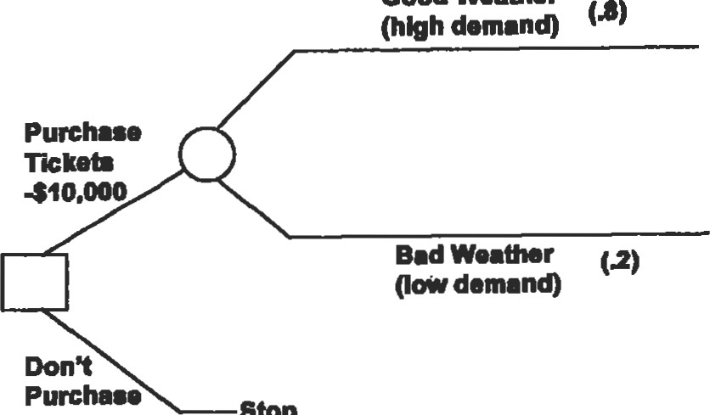

Good

Weather

Ticket.

Stop

$7,000

Docblon Bmnch O Probabili* Branch

Step 2: Calculate the expected payoff from purchasing the tickets:

Expected payoff = (probability of high demand) x (payoff with high demand) + (probability of low demand) x (payoff with low demand)

= (.8 x 20,000) + (.2 x 7,000) = $17,400

Step 3: Calculate NPV of expected payoff:

$17,400

NPV= -10, + 1 $5,130

(1 + .15)

Remember that the cash flow from selling the tickets occurs one year after the purchase. NPV is used to discount the cash flow to its present value and see if it exceeds the initial investment.

Conclusion: The ticket scalper should buy the tickets, because this project has a positive NPV.



The preceding example was relatively simple. Most financial projects in engineering and manufacturing applications are considerably more complex than this example, therefore, it is useful to have a procedure for setting up a decision tree and analyzing a complex project.

Here is a procedure that can be used:

1. Identify the decisions to be made and alternatives available throughout the expected life of the project.
2. Draw the decision tree, with branches drawn first for each alternative at every decision point in the project. Secondly, draw "probability branches" for each posSible outcome from each decision altemative.
3. Estimate the probability of each possible outcome. (Probabilities at each "probability branch" should add up to 100%.)
4. Estimate the cash flow (payoff) for each possible outcome.
5. Analyze the alternaüves, starting with the most distant decision point and working backwards. Remember the time value of money and, if needed, use the NPV method to discount the expected cash flows to their present values. Determine if the PV of each alternaüve's expected payoff exceeds the initial invesünent (i.e., positive NPV). Choose the alternative with the highest NPV.

The following example illustrates the use of this procedure:

Example. Space-Age Products believes there is considerable demand in the marketplace for an electric version of its bm•becue grill, which is the company's main product. Currently, all major brands of gills produced by Space-Age and its competitors are either propane gas grills or gills. Recent innovations by Space-Age have allowed the development of an electric grill that can cook and sear meat as well as any gas or charcoal grill, but without the problems of an open flame or the hassle of purchasing propane gas bottles or bags of charcoal.

Based upon test markefing, Space-Age believes the prob ability of the demand for its new grill being high in its first year ofproducüon will be 60%, with a 40% of low demand. If demand is high the first year, Space-Age estimates the proÜility of high demmd in subsequent years to be 80%. If the demand the first year is low, it estimates the probability of high demand in subsequent years at only 30%.

Space-Age cannot decide whether to set up a large production line to produce 50,000 grills a month, or to take a more conservative approach with a small production line that can produce 25,000 grills a month. If demand is high, Space-Age estimates it should be able to sell all the grills the large producüon line can make. However, the large production line puts considerably more investment capital at risk, since it costs $350,000 versus only $200,000 for the small line. The smaller production line can be expanded with a second production line after the first year (if demand is high) to double the production rate, at a cost of an additional $200,000.

Should Space-Age initially invest in a large or small production line, or none at all? The opportunity cost ofcapitalfor Space-Age is 15%, and cashflows it projectsfor each outcome are shown in the decision tree. Cash flows shown at the end ofyear 2 are the PV ofthe cashflows ofthat and all subsequent years.

Steps 1—4 ofprocedure: (Consu•uct decision free and label with probabilities and cash flow projections).

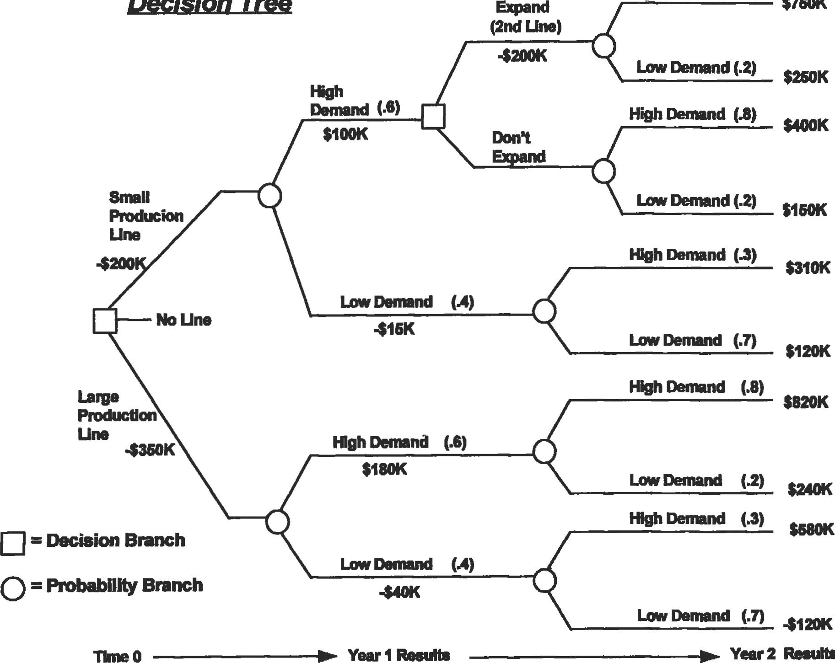

$760k

Decision

Tree

Resub

"gh

Demand

(18)

Step 5: Analysis of alternatives:

1. Start the analysis by working backwards from the WH side of the decision free. The only decision that Space-Age needs to make at the start of year 2 is deciding whether or not to expand and install a second producfion line if demand is high the first year (if the decision was for a small production line).

Expected payoff of expanding with a second small production line (at the end of year 2):

= (.8 x $750 K) + (.2 x $250 K) = $650,000

Expected payoff without the expansion (at the end of year 2):

= (.8 x $400 K) + (.2 x $150 K) = $350,000

To decide if expansion is woråwhile, the NPVs of each altemative (at end of year 1) must be compared:

$650 K

NPV (with 2nd line) = -$200 K + 1

(1 + .15) = $365,217

$350 K

NPV (without 2nd line) = $0 + 1

(1 + .15)

= $304,348

These NPV amounts show that Space-Age should clearly expand with a second small production line (if its initial decision at time 0 was to open a small production line and the demand was high the first year). Now that this decision is made, the $365,217 NPV of this expansion decision will be used to work backwards in üme and calculate the overall NPV of choosing the small production line.

1. The end of year 2) demand is low the first year with the small production line:

= (.3 x $310 K) + (.7 x $120 K) = $177,000

This expected payoff must be discounted so that it can be added to the projected cash flow of year 1:

$177,000

-$153,913

(l + .15)

1. The expected payoff (at the end of year 1) for the small production line can now be determined:

= [.6 x ($100,000 + $365,217)] + [.4 x (415,000 + $153,913)] = $334,695

Notice that the cash flow for year 1 is the sum of the first year's projected cash flow plus the discounted expected payoff from year 2.

1. Calculate the NPV (at üme O) of the small producdon line option:

$334, 695

NPV = $200,000 + = $91,039

(1 + .15)

1. Calculate the NPV (at üme O) of the large production line opüon. (Since there are no decisions at the end of year l, there is no need to determine intermediate NPVs, and the probabilities from each branch of each year can be multiplied through in the NPV calculation as follows:

(.6) ($180 K) + (.4) K)

NPV - K +

(.6) [(.8) ($820 K) + (.2) ($240k)] + (.4) [(.3) ($580 K) + (.7) (-$120 K))

(1+.15)2

Solving: NPV = $76,616

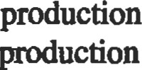(D Conclusion: Both tie NPVs of the luge and small ducüon lines are positive, and thus both production lines would be profitable based upon Ole expected payoffs. However, the NPV of the small line is higher than the NPV of the large line ($91,039 vs. $76,616). Therefore, Space-Age's decision should be to set up a small production line, and then expand with a second line if the demand for electric grills is high in the first year of producüon.

|  |
| --- |
| ACCOUNTING FUNDAMENTALS |

Regardless of whether a person is managing the finances of a small engineering project or running a large corporation, it is important to have a basic understanding of accounting. Likewise, it is also impossible to study engineering economics without overlapping into the field of accounting. This section, therefore, provides a brief overview of accounüng fundamentals and terminology.

Accounting is the process of measuring, recording, and communicating information about the economic activities of accounting entities (financial projects, partnerships, companies, corporations, etc.). Public corporations, and most other types of companies, issue financial statements from their accounting data on a periodic basis (usually quarterly and yearly). These financial statements are necessary because they provide informaüon to outside investors and creditors, and assist a company's own management with decision making. Four primary types of financial statements are normally issued:

* Balance sheet
* Income statement
* Statement of changes in retained earnings
* Statement of cash flows

The balance sheet provides informaüon (at one particular instant in time) about financial resources of a company, and claims against those resources by creditors and owners. The balance sheet's format reflects the fundamental accounting equation:

Assets = Liabilities + Owner's Equity

Assets are items of monetary value that a company possesses, such as plant, land, equipment, cash, accounts receivable, and inventory. Liabilities are what the company owes its creditors, or conversely, the claims the creditors have against the company's assets if the company were to go bankrupt. Typical liabilities include outstanding loan balances, accounts payable, and income tax payable. Owner's equity is the monetary amount of the owner's claim against the company's assets. (Owner's equity is also referred to as stockholder's equity for corporations that issue and sell stock to raise capital.) Owner's equity comes from two sources: (1) the original cash investment the owner used to start the business, and (2) the amount of profits made by the company that are not distributed (via dividends) back to the owners. These profits left in the company are called retained eamings.

There are numerous asset, liability, and owner's equity accounts that are used by accountants to keep track of a company's economic resources. These accounts are shown in the following "balance sheet" illustration, which is a tyr ical balance sheet for a small manufacturing corporation.

Noüce in this illustraüon that the balance sheet's total assets "balance" with the sum of liabilities and owner's equity, as required by the fundamental accounting equation. There are also a number of addiüonal revenue md evense accounts that are maintained, but not shown in the balance sheet. The balances of these revenue and expense accounts are closed out (zeroed) when the financial statements are prepared, and their amounts are carried over into the income statement. The income statement is the financial statement that reports the profit (or loss) of a company over a specific period of time (quarterly or annually). The income statement reflects another basic and fundamental accounting relationship:

Revenues — Expenses = Profit (or Loss)

A sample "income statement" for our typical small corporation is illusü•ated.

The income statement ünply subtracts the company's expenses from its revenues to arrive at its net income for the period. Large companies and corporations usually separate their income statements into several sections, such as income from operations, income or loss from financial acüvities and discontinuing operations, and income or loss from extraordinary items and changes in accounting principles.

Companies frequently show an expense for depreciation on their income statements. Depreciation is an accounting method used to allocate the cost of asset "consumption" over the life of the asset. The value of all assets (building, equipment, patents, etc.) depreciate with time and use, and depreciation provides a method to recover invesment capital by expensing the portion of each asset "consumed" during each income statement's time period. Depreciation is a noncash expense, since no cash flow actually occurs to pay for this expense. The book value of an asset is shown in the balance sheet, and is simply the purchase price of the asset minus its accumulated depreciation. There are several methods used to calculate depreciation, but the easiest and most frequently used method is straight-line depreciation, which is calculated with the following formula:

|  |  |  |
| --- | --- | --- |
| XYZ  Balance  As ofMarch  ASSETS  CurrentAsses:  Cash  Accounts Receivable Inventory  Tot/ CurrentAsseG  Property, Plant, & Equipment:  Building less Accumulated Depreciation Equipment less Accumulated Depreciation  Land  Toül Property, Plant, & Equipment Total Assets  Liabilities  Current Liabilies:  AccounG Payable  Salaries Payable  Interest Payable  Income Tax Payable  Toül Current Liabiliües  Long-Term Liabiliies:  Notes Payable  Toül Liabilities  Owner's (Stockholder's) Equity  Capital Stock  Retained Earnings  TOEI OwnerS Equity  Total Liabilities & Owner's Equity | Company  Sheet  31, 1994  $600,000.00  ($250,000.00)  $300,000.00  ($125,000.00)  $275,000.00  $195,000.00  $13,000.00  $36,000.00  $200,om.oo  $102,000.00 | $25,000.00  $268,000.00  $163,000.00  $456,000.00  $350,000.00  $175,000.00  $100,000.00  $625,000.00 |
|  |
| $519,000.00  $260,000.00  $779,000.00  $302,000.00 |
|  |
|  |

= Cost — Salvage Value Depreciation Expense 

Expected Life of Asset

|  |
| --- |
| XYZ Company  Income Sütement  For fie QuarÉr Ended %rch 31, 19g  Sales Revenues  Less: Cost of Goods sold  Gross Margin  Less: Operating Expenses  Selling expenses $295,000.00  Salaries expense $526,000.00 Insurance expense $32,000.00 Property Taxes $27,000.00  Deprecjaion, Equipment $35,000.00  Depreciation, Building $70,000.00 ($985,000.00)  Income from Operaions $90,000.00  Other Income  Sale of Assets $16,000.00  Interest Revenue $2,000.00 $18,000.00  $108,000.00  Less: Interest Expense  ($22,000.00) Income before Taxes $86,000.00 Less: Income Tax Expense ($34,400.00)  Net Income |
|

|  |
| --- |
| XYZ Company  Statement of Changes in Retained Earnings  For üe Quarer Ended %rch 31,  Reuined Earnings, Dec. 31, 1993 $50,400.m  Net Income, 1, $51,600.00  Reuined Earnings, March 31, $102,000.00 |
|
|

Straight-line depreciation allocates the same amount of depreciation expense each year throughout the life of the asset. Salvage value (residual value) is the amount that a company can sell (or trade in) an asset for at the end of its useful life. "Accelerated" depreciation methods (such as sum-of-the-years' -digits and declining balance methods) are available and may sometimes be used to expense the cost of an asset faster than straight-line depreciation. However, the use of accelerated depreciation methods is governed by the tax laws applicable to various types of assets. A recent accouufrg textbook and tax laws can be consulted for further information about the use of accelerated depreciation methods.

The profit (or loss) for the period of the income statement is carried over as retained earnings and added to (or subtracted from) owner's equity, in the "statement of changes in retained earnings" illustration.

Ifthe company paid out any dividends to its stækholders during this time period, that amount would be shown as a deduction to retained earnings in this financial statement. This new retained earnings amount is also reflected as the retained earnings account balance in the current balance sheet.

The last financial statement is the statement of cash flows, which summarizes the cash inflows and outflows of the company (or other accounting entity) for the same time period as the income statement. This statement's purpose is to show where the company has acquired cash (inflows) and to what activities its cash has been utilized (outflows) during this time period. The statement divides and classifies cash flows into three categories: (l) cash provided by or used by operating activities; (2) cash provided by or used by investing activities; and (3) cash provided by or used by financing activiües. Cash flow from operations is the cash generated (or lost) from the normal day-to-day operations of a company, such as producing and selling goods or services. Cash flow from investing activiües includes selling or purchasing long-term assets, and sales or purchases of invesünents. Cash flow from financing acdviües covers the issuance of long-term debt or stock to acquire capital, payment of dividends to stockholders, and repayment of principal on long-term debt.

The statement of cash flows complements the income staten•mt, because although and cash flow related, their amounts are seldom equal. Cash flow is also a better measure of a company's performance than net income, because net income relies upon arbitrary expense allocations (such as depreciation expense). Net income can also be manipulated by a company (for example, by Educing R&D spending, reducing inventory levels, or changing accoundng methods to make its 'bottom line" look better in the shortterm. Thaefore, analysis of a company's cash flows and cash flow trends is frequently the best method to evaluate a company's performance. Additionally, cash flow rather than net income should be used to determine the rate of remrn eamed on the initial investment, or to determine the value of a company or financial project. (Value is determined by discounting cash flows at the required rate of retum.)

The statement of cash flows can be prepared directly by reporting a company's gross cash inflows and outflows over a üme period, or indirectly by adjusting a company's net income to net cash flow for the same time period. Adjustments to net income are required for (1) changes in assets and liability account balances, and (2) the effects of noncash revenues and expenses in the income statement.

For example, in comparing XYZ Company's current balance sheet with the previous quarter, the following information is obtained about current assets and liabiliües:

* Cash increased by $10,000
* Accounts receivable decreased by $5,000

' Inventory increased by $15,000

* Accounts payable increased by $25,000 ' Salaries payable increased by $5,000

|  |
| --- |
| XYZ Company  Seement of Cash Flow  For QuarW Ended Erch 31,  Net hcome $51,600.00  Mjustnena reconcile net income to cash dowfrom op. aciviües:  Decrease in accouno receivable $5,000.00 Increase in invenbry ($15,000.00 Increase in account payable $25,000.00 Dea•eese in salaries payable $5,000.00 Depreciaion expense, equipment $35,mo.oo  Depreciaion expense, building $70,000.00  Adjustnent:  $125,000.00  Net cash flow from opgaüng ac"üos:  $176,600.00  Cesh 60B from finencing aciviies:  Reirement of long-erm debt (noes payable) ($166,600.00)  Net cash fowfrom fnanclng acdvlües: ($166,600.00)  Net In cash: $10,000.00  Cash accomt balance, Dec. 31, 1993 $15,000.00  Cash account balance, March 31, $25,000.00 |
|

|  |
| --- |
| REFERENCES AND RECOMMENDED READING |

Addiüonally, the balance sheets show that the company has paid off $166,600 of long-term debt this quarter. This information from the balance sheets, along with the noncash expenses (depreciation) from the cun•ent income statement, are used to prepare the "statement of cash flows." The example demons&ates the value of the statement of cash flows because it shows precisely the sources and uses of XYZ Company's cash. Additionally, it reconciles the cash account balance from the previous qua.rter to the amount on the current quarter's balance sheet.

Englneerlng Economics

1. Newman, D. G., Engineering Economic Analysis. San Jose, CA: Engineering Press, 1976.
2. Canada, J. R. and White, J. A., Capital Investment Decision Analysis for Management and Engineering. Englewood Cliffs, NJ: Prentice-Hali, 1980.
3. Park, W. R., Cost Engineering Analysis: A Guide to Economic Evaluation of Engineering Projects, 2nd ed. New York: Wiley, 1984.
4. Taylor, G. A., Managerial and Engineering Economy: Economic Decision-Making, 3rd ed. New York: Van Nostrand, 1980.
5. Riggs, J. L., Engineering Economics. New York: McGraw-Hi11, 1977.
6. Barish, N., Economic Analysis for Engineering and Managerial Decision Making. New York: McGrawHill, 1962.

Finance

1. Brealey, R. A. and Myers, S. C., Principles of Corporate Finance, 3rd ed. New York: McGraw-Hill, 1988.
2. Kroeger, H. E., Using Discounted Cash Flow Effectively. Homewood, IL: Dow Jones-Irwin, 1984.

Accounting

1. Chasteen, L.G., Flaherty, R.E., and O'Conner, M.C. Intermediate Accounting, 3rd ed. New York: McGrawmil, 1989.
2. Eskew, R.K. and Jensen, D.L., Financial Accounting, 3rd ed. New York: Random House, 1989.

Addltional References

Owner's Manual from any Hewlett-Packard, Texas Instruments, or other make business/financial calculator.

Note: A business or financial calculator is an absolute must for those serious about analyzing invesments and financial projects on anything more than an occasional basis. In addiüon to performing simple PV, FV, and mortgage or loan payment calculations, modem financial calculators can instantly calculate NPVs and IRRs (including multiple mots) for the most complex cash flow problems. Many calculators can also tabulate loan amortization schedules and schedules, and perform statistical analysis on data. The owner's manuals from these calculators are excellent resources and give numerous examples of how to solve and analyze various invesünent problems.

##### Appendix

Lawrence D. Norris, Senior Technical Marketing Engineer—Large Commerciaf Engines, Allison Engine Company, Rolls-Royce Aerospace Group

Conversion Factors395 Decimal Multiples and Fracdons of Sl units 399 Systems of Basic Units399 'Ibmperaiure Conversion Equations 399

Appendix

|  |  |  |  |  |  |  |  |
| --- | --- | --- | --- | --- | --- | --- | --- |
| Conversion Factors | |  | |  | |  | |
| Category | | Multiply | | By | | To Obtain | |
| Acceleration | ftJsec2 | | 0.3048 | | m/sec2 | |
|  | in/sec2 | | 0.0254 | | m/sec2 | |
|  | m/sec2 | | 3.2808 | | ft/sec2 | |
|  | m/sec2 | | 39.3701 | | in/sec2 | |
| Angle | degrees | | 6.0000 | | minutes | |
|  | degrees | | 1.745328 x 10-2 | | radians | |
|  | degrees | | 2.777778 x 10-3 | | revolutions | |
|  | degrees | | 3600.00 | | seconds | |
|  | minutes | | 0.1667 | | degrees | |
|  | radians | | 57.2958 | | degrees | |
|  | revolutions | | 360 | | degrees | |
|  | seconds | | 2.77778 x 10-4 | | degrees | |
| Area | ft2 | | 0.0929 | | m2 | |
|  | In2 | | 6.4516 x 10-4 | | m2 | |
|  | yard2 | | 0.8361 | | 2  m | |
|  | mile2 | | 2.590 x 106 | | m2 | |
|  | acres | | 4.047 x 1 03 | | m2 | |
|  | m2 | | 10.7643 | | ft2 | |
|  | m2 | | 1550.0 | |  | |
|  | m2 | | 1.1960 | | yard2 | |
|  | m2 | | 3.861 ox 10-7 | | mile2 | |
|  | m2 | | 2.471 x 10--4 | | acres | |
|  | acres | | 0.4047 | | hectares | |
|  | acres | | 4.356 x 1 04 | | ft2 | |
|  | acres | | 4.047 x 103 | | m2 | |
|  | acres | | 1.562 x 10-3 | | mile2 | |
| Density | gram/cm3 | | 1000 | | kg/m3 | |
|  | Ibm/ft3 | | 16.0185 | | kg/m3 | |
|  | Ibm/gallon (U.S. liquid) | | 119.826 | | kg/m3 | |
|  | slug/ft3 | | 515.379 | | kg/m3 | |
|  | kg/m3 | | 0.001 | | gram/cm3 | |
|  | kg/m3 | | 0.0624 | | lbm/ft3 | |
|  | kg/m3 | | 8.3454 x 10-3 | | Ibm/gallon (U.S. liquid) | |
|  | kg/m3 | | 1.9403 x | | slug/ft3 | |
| Energy/Work | Btu | | 1055.06 | | joule | |
|  | erg | | 1 .ooo x 10-7 | | joule | |
|  | ft-lb | | 1.3558 | | joule | |
|  | kilowatt-hour | | 3.600 x 106 | | joule | |
|  | calorie | | 4.1859 | | joule | |
|  | newton-meter | | 1 .ooo | | joule | |
|  | watt-second | | 1 .ooo | | joule | |
|  | joule | | 9.4781 x 10-4 | | Btu | |
|  | joule | | 1.000 x 107 | | erg | |

(table continued on next page)

396 Rules of Thumb for Mechanical Engineers

###### Category Multiply By To Obtain

|  |  |  |  |
| --- | --- | --- | --- |
| Energy/Work (cont'd) | joule | 0.7376 | ft-lb |
|  | joule | 2.7778 x 10-7 | kilowatt-hour |
|  | joule | 0.2389 | calories |
|  | joule | 1 .ooo | newton-meter |
|  | joule | 1 .ooo x 107 | dyne centimeters |
|  | joule | 1 .ooo | watt-second |
|  | Btu | 2.930 x 10-4 | kilowatt-hours |
|  | kilowatt-hours | 3412.97 | Btu |
|  | Btu | 253.0 | calories |
|  | calorie | 3,953 x 10-3 | Btu |
|  | kilowatt-hour | 2.655 x 106 | ft-lb |
|  | ft-lb | 3.766 x 10-7 | kilowatt-hour |
| Force | dyne | 1.000 x 10-5 | newton (N) |
|  | pound (1b) | 4.4482 | newton |
|  | newton (N) | 1 .OOO x 105 | dyne |
|  | newton | 0.2248 | pound (1b) |
| Length | foot (ft) | 0.3048 | meter (m) |
|  | inch (in) | 2.540 x 10-2 | meter |
|  | yard | 0.9144 | meter |
|  | micron | 1 .OOO X | meter |
|  | mile (mi) | 1.6093 x 103 | meter |
|  | mile, nautical (nm) | 1.8520 x 103 | meter |
|  | meter (m) | 3.2808 | foot (fi) |
|  | meter | 39.3701 | inch (in) |
|  | meter | 1.0936 | yards |
|  | meter | 1 x 106 | micron |
|  | meter | 6.2139 x | mile (mi) |
|  | meter | 5.3996 x 104 | mile, nautical (nm) |
|  | mile, nautical (nm) | 1.15076 | mile |
|  | mile | 0.86896 | mile, nautical |
|  | mile | 5280 | foot |
|  | mile | 1760 | yard |
| Mass | pound mass (lbm) | 0.4536 | kilogram (kg) |
|  | slug | 14.5939 | kilogram |
|  | ounce | 2.83495 x 10-2 | kilogram |
|  | ton (metric) | 1000.00 | kilogram |
|  | ton (2000 Ibn,) | 907.185 | kilogram |
|  | kilogram (kg) | 2.2046 | lbm |
|  | kilogram | 0.0685 | slug |
|  | kilogram | 35.2739 | ounce |
|  | kilogram | 0.0010 | ton (metric) |
|  | kilogram | 1.1023 x 10-3 | ton (2000 lbm) |
|  | pound mass | 16 | ounce |
|  | ounce | 0.06250 | pound mass |
| Moment (Force) | foot-pound (ft-lb) | 1.35582 | newton-meter (N-m) |
|  | dyne-centimeter | 1 .ooo x 10-7 | N-m |
|  | newton-meter (N-m) | 0.73756 | foot-pound (ft-lb) |
|  | newton-meter | 1 .ooo x 107 | dyne-centimeter |

|  |  |  |  |
| --- | --- | --- | --- |
| Category | Multiply | By | Appendix 397  To Obtain |
| Moment of inertia (Aru)  Moment of Inertia (Volume)  Moment of inertia (Mass)  Power  Pressure and Stress | meter4 foot4 meter4 in4  mete+ foot5 meter5 in5  m2-kg ft2-lb m2-kg in2-lb  Btu/hour ergsecond ft-lb/second horsepower (HP) calories/second joule/second watt (W) watt watt watt watt watt ft-lb/second horsepower ft-lb/second calories/second horsepower Btu/minute  atmosphere bar cm. of Hg (OOC) in. of Hg (OOC) in. of H20 (40C) dyne/cm2 Ib/ft2  Ib/in2 (psi) kilogram/cm2 (kg/cm9 newton/meter2 (n/m9 pascal (Pa) pascal pascal pascal pascal pascal pascal | 115.8618  8.63097 x 10-3  240251 x 106  4.16232 x 10-7  380.1239  263072 x 10-3 9-45870 x 107 ı -05723 x 10-8  23.73034  4.214013 x 10-2  3417.171  2.926397 x 104  0.29307 1.000 ı .35582 745.699 4.186 ı .ooo 3.41214 ı .ooo x 107 0.737562 ı .34102 x 10-3 0.2389 ı .ooo  1.818x104  550.06  0.32394  3.087  42.426  0.02357  ı x 105 ı .ooo x 105 1333.22  3.386 x 103  249.10  0.10000  47.88026  6894.757 9.8067 x 104 ı .ooo ı .ooo  9.86923 x 10-4 ı .ooo x 10-5 7.50064 x ı o-4  2.953 x 10-4  4.014 x 10-3  10,000 | foot4  in4 meter4  foot5 meter5 İn5 meter5  ft2-Ib m2-kg in2-Ib m2-kg  watt (W) watt watt watt watt watt Btu/hour erg/second ft-lb/second horsepower calories/second joule/second horsepower ft-lb/second calories/second ft-lb/second Btu/minute horsepower  pascal (Pa) pascal pascal pascal pascal pascal pascal pascal pascal pascal n/m2 atmosphere bar cm. of Hg (OOC) in. of Hg (OOC) in. of H20 (40C) dyne/cm2 |

(table conîinued on nexîpage)

398 Rules of Thumb for Mechanical Engineers

###### Category Multiply By To Obtain

Pressure and Stress (cont'd) pascal pascal pascal bar atmosphere in. of Hg (OOC) lb/in2 (psi) in. of H20 (40C) lb/in2 (psi)

|  |  |
| --- | --- |
| Velocity | feet/second (Wsec) inch/second (in/sec) kilometer/hour (km/hr) knot (nautical mi/hr) miles/hour (mi/hr) meters/sec (m/sec) m/sec m/sec m/sec m/sec |
| Volume | foot3 gallon (U.S. liquid) imperial gallon (U.K. liquid) |

inch3 cord board foot liter quart (U.S. liquid) barrel (U.S. liquid) centimeter3 (cm3) fluid ounce (U.S. liquid) bushel (U.S. dry) peck (U.S. dry) meter3 meter3 meter3 meter3 meter3 meter3 meter3 meter3 meter3 meter3 meter3 meter3 meter3 imperial gallon (U.K. liquid) gallon (U.S. liquid) gallon (U.S. liquid) liter

0.020885

1.450377 x 10-4

1.0197 x 10-5

0.9869

1.0132

0.4912

2.0358

0.03613

27.678

0.30480

2.5400 x 10-2

0.27777

0.514444

0.447040

3.28084

39.38008

3.60010

1.94385 223694

2.831685 x 10-2

3.785412 x 10-3

4.546087 x 10-3

1.638706 x 10-5

3.62456

2.359737 x 10-3

1 x 10-3

9.463529 x 10-4

0.1589873

1 .OOO x 10-6

2.957353 x 10-5

3.523907 x 10-2

8.809768 x 10-3

35.314662

264.1720

219.9694

6.102376 x 1 04

0.275896

423.77604

1 ooo.oo

1056.688

6.289811

1 .ooo x 106

3.381402 x

28.37759

113.5104

1.20095

0.83267

3.785

0.2642

lb/ft2 lb/in2 (psi) kg/cm2 atmosphere bar lb/in2 (psi) in. of Hg (OOC) lb/in2 (psi) in. of 1-120 (40C)

meters/sec (m/sec) m/sec m/sec m/sec m/sec ft/sec in/sec km/hr knot mi/hr

meter3 meter3 meter3 meter3 meter3 meter3 meter3 meter3 meter3 meter3 meter3 meter3 meter3 foot3 gallon (U.S. liquid) gallon (U.K. liquid) inch3 cord board foot liter quart (U.S. liquid) barrel (U.S. liquid) centimeter3 fluid ounce (U.S.) bushel (U.S. dry) peck (U.S. dry) gallon (U.S. liquid) gallon (U.K. liquid) liter gallon (U.S. liquid)

Appendix

|  |  |  |  |
| --- | --- | --- | --- |
| Systems of Basic Unlts |  |  |  |
| Designation | English (FPS) | System  Metric (MI(S) | International (SD |
| Length  Mass  Tme  Electric Cunnt  Temperatuæ  Luminous intensity | foot (t) pound (Ibrr) second (sec) ampere (A) degree Fahrenheit (O F) candela (cd) | meter (m) kilogram 00) second (s) ampere (A) degree Celsius (oc) candela (cd) | meter (m) kilogram (kg) second (s) ampere (A) degree Kelvin (0 19 candela (cd) |
|  | |  |  |
| Decimal Multiples and Fractions of Sl Units | |  |  |

Factor Prefix Symbol Factor Prefix Symbol

101 deka 10¯1 deci d

|  |  |  |  |  |  |
| --- | --- | --- | --- | --- | --- |
| 102 | hecto | h | 10-2 | centi | c |
| 103 | kilo | k | 10—3 | milli | m |
| 106 | mega |  | 10-6 | micro |  |
| 109 | giga |  | 10-9 | nano | n |
| 1012 | tera |  | 10-12 | pico | P |
| 1015 | peta | p | 10-15 | femto |  |

1018 exa 10-18 atto

Temperature Conversion Equations



(OF) = 9/5(0C) + 32 (oc) = 5/9(0 F - 32) (0 K) = oc + 273.15 (O R) = 9/5(0C) + 491 .67

= 9/5(0 K - 255.37) = O K - 273.15 = 5/9(0 F + 459.67) = OF + 459.67

= O R - 459.67 = 5/9(O R - 491 .67) = 5/9(O R) = 9/5(OK)

Absolute temperature = —273.15C = -459.6TF = O.mK = O.WR

Freezing point of water O.OOOC = +32.000F = +273.150K = +491.670R

Boiling point of water = +1m.oooc = +212mOF = +373.150K = +671.6TR

#### Index

Accelerometers, 247

Accounting rate of retum (ROR) method, 381

Aluminum alloys, 268

Anemomeü•y, 14

Annuities, 377

Axial pumping screw, 86

Axial shaft movement, 80

Bearing clearance. 172—173

Bearing defect frequencies, 256

Bearings

load and speed analysis contact suesses, 157 effects of speed, 159—160 equivalent loads, 156—157 preloading, 157—158 special loads, 158-159 lubrication cleaning, 165—166 greases, 161 lubricant selection, 162—163 lubricating methods, 163—164 oils, 161 preservation, 165—166 relubrication, 164—165

storage, 165—166 mounting bearing clearance, 172—173 housings, 169—171 seals, 174

shafting, 166—168 radng and life ABMA definiüons, 152-153 fatigue life, 153—54 life adjustment factors, 154—156 sleeve bearings, 175—177 types of bearings ball bearings, 146--147 materials, 151—152 roller bearings, 147—149 sundardization, 149—151

Beating, 239

Bemoulli's equation, 6

Boundary layer concepts, 16

Brayton cycle. 62

Bulk modulus, 3 Buoyancy, 5

Carnot cycle, 60

Cash flow diayams, 375

289-290

Cathodic protection, 197—205

Ceramics, 284

Coatings, 273-275

Compatibility, 297

Composite wall conduction, 21—22

Compressibility, 3

Compressors centrifugal compressor calculations, 120—123 compressor horsepower determination, 117—119 definitions, 110 engine cooling water requirements, 124 estimate fuel requirements for intemal combustion engines, 124 HP required to compress natural gas, 123 reciprocating compressors, 110—116

Contact stresses, 157

Continuity equation, 5

Convection coeffcient values, 26

Coriolis meters, 370

Corrosion, 276--279, 291

Damping, 239—240

Darcy equation. 9

Decision tree analysis, 385—388

Degrees of freedom, 240, 243—246

Density, 2, 53

Dimensionless numbers, 23

Double seals, 73, 85

Drag,Drivers 16

gas enønes: fuel rates, 132

gas expanders: available energy, 132

gas u.låines: fuel rates, 130—131 motors: efficiency, 126 motors: overloading, 129 motors: relative costs, 128—129 motors: service factor, 127—128 motors: starter sizes, 127 motors: useful equa.tions, 128 steam turbines: emciency, 129—130

steam tuåines: steam rate, 129

Eddy-current inspection, 347

Effective annual interest rate, 374

Elbow meters, 370

Electromagnetic flow meters, 370

Emissivity, 27

Energy equation, 6

Engineering economics accounting fundamentals, 389—393 decision and evaluation criteria accounting rate of remrn (ROR) method, 381

internal rate of retum (IRR) method, 382—383 net present value (NPV) method, 383—384 payback method, 380—381 sensiüvity analysis, 384—385 decision nee analysis, 385—388 time value of money

analyzing complex investments and cash flow problems, 379—380 annuities, 377 cash flow diagrams, 375 future value of a periodic series of investments, 377

future value of a single investment, 375

gradients, 378-379

leases, 377-378

loans, 377

nominal interest rate vs. effective annual interest rate, 374

perpetuities, 376—377

present value of single cash flow to be received in the future, 374

simple interest vs. compound interest, 373 valuing investmenb with multiple or irregular cash flows, 375—376

Enthalpy, 54

Entropy, 54

Equation of moüon, 240

Equilibrium, 297

Ericsson cycle, 65

Euler's equation, 5

Failure analysis, 290

Fatigue crack initiation analysis, 331 estimating fadgue properties, 338—339 material scatter, 338

notches, 332-334 real world loadings, 335—337 residual 332 temperature interpolation, 337 crack propagation analysis crack propagation calculations, 342—344 creep crack growth, 344

K (sü•ess intensity factor), 339—342 design approaches to fatigue. 331 fatigue testing, 349

inspection techniques eddy-current inspection, 347

evaluation of failed parts, 347

fluorescent penetrant inspection (FPI), 345

magnetic particle inspection (MPI), 345

radiography, 345—346 ulu•asonic inspection, 345 liability issues, 350 nonmetallic materials, 348

stages of fatigue, 330

Finite element analysis, 246, 320—327

Flexible rotor, 71

Flexible stator, 72

Flow maps, 46-48

Flow nozzles, 368

Fluids advanced fluid flow concepts dimensional analysis and similitude, 7 equivalent diameter and hydraulic radius, 8 nondimensional parameters, 7—8 basic equations

Bernoulli's equation, 6

402 Rules of Thumb for Mechanical Engineers

energy equation, 6 moment-of-momentum equation, 6 momentum equation, 6 boundary layer concepts, 16 drag, 16

fluid measurement flow rate measurement, 14 hot-wire and thin-film anemometry, 14 open-channel flow measurements, 15

pressure and velocity measurements, 13—14 viscosity measurements, 15—16 fluid properties bulk modulus, 3 compressibility, 3 density, 2 fluid pressure, 2 gas, 3 liquid viscosity, 3

specific gravity. 2 specific volume, 2 specific weight, 2 surface tension, 2 units and dimensions, 3 vapor pressure, 2 oceanographic flows, 17 open-channel flow frictionless open-channel flow, 11—12 hydraulic jump, 12—13 laminar open-channel flow, 12 turbulent open-channel flow, 12

pipe flow

Darcy-Weisbach equation, 9 losses in pipe fittings and valves, 10 pipes in parallel, 10 pipes in series, 10

Fluorescent penetrant inspection (FPI), 345

Flush flanges, 315

Forming, 288—289

Fourier series, 240-241

Free vibration, 240

Frequency, 240

Fricüon, 235

Future value, 375, 377

Gears bevel gear design, 139—141 buying gears and gear drives, 144 cylindrical worm gear design,• 141-142 geu types, 143—144 materials, 142 ratios and nomenclature, 134 spur and helical gear design, 134—139

Gland rings, 79

Gradients, 378—379

Grashof number, 23

Hardness testing, 286-287

Harmonic frequencies, 241

Harmonic/spectral analysis, 240

Heat, 58

Heat dansfer conduction combined heat coefficient, 22 composite wall conduction, 21—22 critical radius of insuladon, 22 single wall conduction, 19—21 convection correlations, 24—25 dimensionless numbers, 23 typical convection coefficient values, 26 finite element analysis boundary condiüons, 29 2D analysis, 30 evaluating results, 31—33 analysis, 30—31 flow regimes and pressure drop estimating pressure drop, 48—50 flow maps, 46-48

flow regimes, 42-45 heat exchanger classification miscellaneous data, 42 shell-and-tube exchangers, 36—38 shell configuration, 40—41

a.lbe arrangements and bames, 38-40 types of heat exchangers, 33—36 radiation emissivity, 27 radiation shields, 29 view factors, 27—28

Hydraulic jump, 12—13

Ideal gas, 55

Insü•umentation fluid flow measurement, 368—370 liquid level measurement, 366—368 pressure mea.surement electrical resistance strain gauge, 363

stadc/cavity pressure measurement, 361—362 total pressure measurement, 360-361 süain measurement electrical resistance strain gauge, 363—366 temperature measurement common temperature sensors, 358—359 fluid temperature measurement, 354—357 surface temperature measurement, 358

Interest rate, 373-374

Internal energy, 53

Intemal rate of return (IRR) method, 382—383

Joining, 270-273

Joint effciencies, 217—218

K (stress intensity factor), 339—342

Laminar open-channel flow, 12

Lagrange's equation, 246

Laplace ransform, 246

Latent heats, 54

Leases, 377-378

Liability issues, 350

Life adjustment factors, 154-.156

Life factors, 234

Lift, 16

Loadings, 208—2W

Loans, 377

Magnetic panicle inspection (MPI), 345

Manometers, 4

Mass, 53

Materials case studies corrosion, 291

failure analysis, 290

casting, 289—290 ceramics, 284 classes of materials, 260 forning, 288-289 mechanical testing

creep and stress rupture tesung,• 287-288

fatigue testing, 285—286

hardness testing, 286—287 tensile tesdng, 284—285

aluminum alloys, 268 cast iron, 265 coatings, 273—275 corrosion, 276—279 joining, 270—273 powder metallurgy, 279—280 stainless steels, 266—267 steels,

superalloys, 268

tool steels, 2«---265 polymers, 281—283 Mechanical seals calculation seal chamber pressure seal chamber bore 81 seal charnber face run-out, 81 design principles seal balance rado, 74 seal face pressure, 76 seal hydraulics, 75 seal lubrication, 76 tandem seals, 74 desirable design gland rings, 79 sleeves, 79 equipment considerations odal shaft movement, 80 equipment checks, 80 radial shaft movement, 80 flow rate calculation, 89—90 integral pumping feamres

axial pumping screw, 86 piping  87

radial pumping ring, 86 materials of consu•uction seal face compatibility, 78 seal face materials, 77 secondary sealing materials, 78

mechanical seal classifications, 68 mechanical seal components, 67 seal arrangements double seals, 73 single outside seals, 73

seal desiY1s balanced seals, 71 flexible rotor, 71 flexible stator, 72 non-pusher seals, 69—70 pusher seals, 68—69 unbalanced seals, 70—71 seal flush plans double seals, 85

multistage pumps, 82 single seals, 83—84 single-stage pumps, 82 tandem seals, 84

sealing points, 67 seal system heat balance, 87—89

Mode shapes, 241

Moment-of-momentum equation, 6

Momentum equation, 6

Motors. See Drivers.

Natural frequency, 241, 251, 254

Net positive suction head (NPSH) and cavitation, 96

Net present value (NPV) method, 383—384

Node point, 241

Nominal interest rate, 374

Nondimensional parameters, 7—8

Nonmetallic materials, 348 Nusselt number, 23

Oceanographic flows, 17

Otto cycle: a power cycle, 63

Payback method, 380—381

Performance curves, 98—99

Perpetuities, 376—377

Phase angle, 241

Pig-based monitoring systems, 195

Pins, 318

Piping pipe line condition monitoring cathodic protection, 197—205 coupons, 196 manual investigation, 196 pig-based monitoring systems, 195 process plant pipe

 Rules of Thumb for Mechanical Engineers

calculations, 189 definitions, 179—187 pipe specifications, 187—188 sizing, 179-187 storing pipe, 188—189 transponation pipe lines gas pipe lines, 190—191 liquid pipe lines, 192—194 steel pipe design, 190

Pitot tubes, 368, 370

Polymers, 281—283

Powder metallurw, 279—280

Prandtl number, 23

Present value, 374

Pressure vessels failures in pressure vessels, 207—208 joint effciencies, 217—218 loadings, 208—209 materials selecdon guide, 224 maximum length of unsüffened shells, 221 procedure 1: general vessel formulas, 213—214 procedure 2: sü•esses in heads due to internal pressure, 215—216 properties of heads, 218—220 stress, 209-212 s&ess analysis, 206—207 useful formulas for vessels, 222—224 volumes and surface areas of vessel sections, 220

Pumps cenüifugal pumps, 95 design guidelines, 100—102 net positive suction head OPSH) and cavitation, 96 performance curves, 98—99 pump and head tennin0100', 93 pump design parameters and formulas, 93 pumping hydrocarbons and other fluids, % pumping power and emciency, 97 pump similitude, 98 reciprocating pumps, 103—109 recimuladon, 97

series and parallel pumping, 99

specific speed of pumps, 97

types of pumps, 94

Radiation shields, 30

Radiogaphy, 345—346

Rankine cycle, 61

Resonance, 242

Reversed Rankine cycle, 61—62

Reynolds number, 23

Rivets, 318

Roller bearings, 147—149 Rotating disks, 310—313

Rotating shafts, 313—314

Rotating unbalance, 242

Saint-Venant's principle, 291 Seals. See Mechanical seals.

Sensors. See Instrumentation.

Shafting, 166-168

Simple harmonic moüon, 242

Simple interest vs. compound interest, 373

Sleeves, 79

Specific yavity, 2 beat, 54

Specific speed of pumps, 97

Specific volume, 2, 53

Specific weight, 2

Stainless steels, 266—267 Steel pipe desu 190 steels, 262-264 Stirling cycle, 64 Stress and su•ain beam analysis of beam bending equations, 307 bending, 307—308 short beams, 307 torsion, 308 creep rupture, 320 approaches to fatigue, 331

desiY1 criteria for shuctural analysis, 305

guidelines for effecfr,re criteria, 305

strength desiYi factors, 305—306

finite element analysis, 320--327

flange analysis

flush flanges, 315

undercut flanges, 316

ftndamentals of suess and su•ain compatibility, 297 definitions, 295—297 equilibrium, 297 plane strain, 298 Saint-Venam's principle, 297 superposition, 298

298—299

mechanicd fasteners pins, 318 rivets, 318

threaded fasteners, 317—318 press fits between cylinders, 310 pressure vessels dlick-walled cylinders, 3W thin-walled cylinders, 309 rotaüng equipment rotaing disks, 310—313 rotating shafts, 313—314 stages of fatigue, 330

suess concenEation factors, 299—304 welded and brazed joints, 319 factors, 299-—3u

Superalloys, 268

Superposition, 298

Surface roughness, 233—234

Surface temperature measurement, 358

Surface tension, 2

Surge, 16

Target meters, 368

Temperatu•e, 53

'Ihennodynamics first law of thermodynamics, 58 for closed systems, 58 heat, 58 for open systems, 58 work, 58 second law of thermodynamics, 59 reversible processes and cycles, 59 thermodynamic temperature scale, 59 useful expressions, 59 thermodynamic cycles basic systems, 60

Brayton cycle: a gas turbine cycle, 62

Carnot cycle, 60 diesel cycle: another power cycle, 63—64 gas power cycles with regeneration, 64—65 Otto cycle: a power cycle, 63

Rankine cycle: a vapor power cycle, 61 reversed Rankine cycle: a vapor refrigeration cycle, 61-62

systems integration, 60 thermodynamic essentials determining properties, 55—56 phases of a pure substance, 52 thermodynamic 53—56 types of processes, 56—57 types of systems, 56

Zenth law of thermodynamics, 57—58

Torsion, 308

Tribology contact mechanics effect of fricfion on contact stress, 231

three-dimensional (point) Hertz contact, 229 two-dimensional (line) Hertz contact of cylinders, 227—229 yield and shakedown criteria for contacts, 232—233

friction, 235 lubrication, 236

topography of engineering surfaces life factors, 234 surface roughness, 233—234 wear, 235-236

Turbines. See Drivers.

Ulüasonic inspection, 345

(Doppler) meters, 370

Uln•asonic (time of flight) meters, 370

Van der Waals equation, 55 Vapor pressure, 2

Variable-area meters, 370

Venturi meters, 368



bearing defect frequencies, 256 bending (transverse) vibration of uniform beams, 253 definitions, 239-242 and torsional vibration of uniform beams, 252 multiple degree of freedom systems, 245—246 natural frequencies of multiple DOF systems, 254 natural frequencies of simple systems, 251 one degree of freedom system, 243—245 planetary gear mesh frequencies, 255 rolling element bearing frequencies, 256 spring stiffess, 250 diagnostic frequencies, 257

vibration measurements, 246

Volume, 53

Vortex meters, 370

Water hanuner, 16

Welded and brazed joints, 319

Work, 58

Reciprocating

Compressors

OPERATfOtO

MAINTENANCE

Reciprocating

Compressors

Operation and Maintenance

Heinz P. Bloch and John J. Hoefner or anyone responsible for purchasing, servicing, or operating reciprocating compressors, this text covers the fundamentals and describes maintenance techniques. It discusses the theory of operation and explains how to install, troubleshoot, overhaul, and repair of all types of compressors. The troubleshooting section examines compressor problems and supplies diagnostic tests to help you identify and eliminate these problems.

1996. 420 pages, figures, photographs, index, appendix. 6" x 9" hardcover.

ISBN 0-88415-525-0 #5525 $85

An Introduction to

Machinery

Reliability

Assessment

Second Edition

Heinz R Bloch and Fred K. Geitner ere is the ultimate reference on ascertaining the life and function of process components. Packed with graphs, figures, photos, and checklists, this single volume contains dozens of assessment techniques based on probability and statistical analysis.

1994. 448 pages, figures, photographs, tables. checklists. glossary, index, 6" x 9" hardcover.

ISBN 0-88415-172-7

$69

Excellence in Publishing

Since1916

MORE

### ITLES

MECHANICAL

NGINEERS

dp Gulf bc Publishing Company

introduction so qtUM}lUIY

WejbUll

|  |
| --- |
| Visit Your Favorite Bookstore |

Or order directly from: Gulf Publishing Company

P.O. Box 2608 • Dept JN

Houston, Texas 77252-2608

713-520-4444 FAX: 713-525-4647 Send payment plus $8.65 ($9.95 if the order is $60 or more, $11.55 for orders of $75 or more) shipping and handling or credit card information. CA, IL, NJ, PA, and TX residents must add sales tax on books and shipping total.

Price and availability subject to change without notice.

Thank you for your order!

The Industrial Operator's

Handbook

Petroleum and Chemical

Industries Edition

H.C. Howlett 11 hrough a series of case studies and the lessons drawn from them, you will probe the methods of failure by which most industrial accidents occur and explore a common-sense strategy for systematic industrial operations. This book evaluates the twelve vital operating skills that every operator and leader should master.

A special supplement addresses practices for compliance with OSHA 1910 regulations governing process safety management and mechanical integrity of equipment and systems.

1996. 344 pages, x 1 1" hardcover.

ISBN 0-88415-413-0 5413

$95

The New Weibull Handbook

Second Edition

Robert B. Abemethu his second edition expands on the first to include the author's latest research findings, most notably, which numerical method is best and when. Special methods, such as Weibayes, are presented with actual case studies. Engineers responsible for reliability, safety, supportability, maintainability, materials, warranties, life cycle cost, design, structures, instrumentation and logistics will find this book extremely useful.

1996. 252 pages, figures, tables, 872" x 1 1" lay-flat paperback.

ISBN 0-88415-507-2 #5507

$89

MECHANICAL

OF THUMB

#### FOR MECHANICAL ENGINEERS

Save time with •tms collection of straightforward, conmon-sense techniques that provide quick solutions to your engineering problems. Rules of Thumb for Mechanical Engineers assembles hundreds of shortcuts, calculations, practical "how-to" methods, and concise background reviews into one convenient volume. Whether you're concerned with design, selection, or performance, you'll find fast, accurate answers here—all without wading through pages of theory.

Experts from all engineering disciplines packed this book's sixteen chapters with design criteria and practical tips. You'll find easy-to-read descriptions on fluids, heat transfer, thermodynamics, seals, pumps and compressors, drivers, gears, and bearings, as well as piping and pressure vessels. The book also covers tribology, vibrations, materials, stress and fatigue, instrumentation, and engineering economics.

Using mechanical drawings, engineering diagrams, plus charts and graphs of realworld data, the chapters consolidate hours of details into "at-a-glance" illustrations. Mechanical engineers, maintenance engineers and personnel, and anyone involved in the operation of facilities and equipment will keep this volume on their desktop.

Wout Casing 3.0

1. 1
2. Voltage

Boikr

2 mp 1

ofstrwture

Win

##### About the Editor

J. Edward Pope holds an M.S. in mechanical engineering and a Ph.D. in aeronautical and astronautical engineering from Purdue University, He has more than twenty years of experience in the gas turbine indust•y, specializing in heat transfer, fatigue, and stress analysis.

Product #5790

ISBN a-gag IS-?90-3

|  |  |  |
| --- | --- | --- |
| Gt | PINLISIIIXG COMEX N h 1300K DINas10N |  |
|  | P.O. Box 2608 | 9 |

###### 77252-2608